𝟏: Problem Statement

We have a web application deployed in aws with simple architecture using ec2 instance, RDS, nat gateway, Load balancer and Route 53.
We have problems in terms of high availability and application performance. A brief summary is as below:
1. Latency due to static contents
2. No CDN to improve the loading speed
3. No auto scaling implemented in two zones where the app is deployed

2: Business case
The web application is shopping cart with which is doing some major business in the E-commerce sector. So it should be performance optimized and highly available to meet the SLA and uptime to avoid business loss which affects overall revenue.

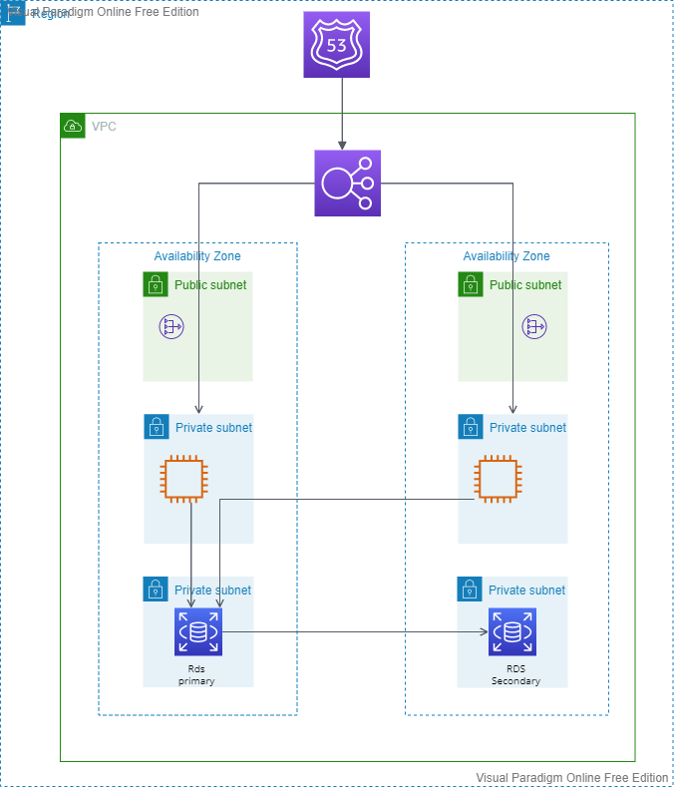
3: Current System architecture
Below diagram shows the current architecture.
The current infra is having an RDS master-slave deployed with two availability zones.
Two ec2 instances in two availability zones which connected load balancer. The load balancer name configured as a CNAME record in route53 hosted zone.

4: Proposed solution
We need to split the infra into three stacks DB, App and Web . This is to improve the traffic handling and to effectively manage resources needed for the ec2 instances.
We can use content caching to improve the site loading speed since there is a lot of static content which takes longer time to load.
Also we can use query caching mechanisms to improve the DB services. To make the ec2 instances to handle the number of requests during the peak time, we can use auto scaling.
Also to improve security we can use firewall and DDoS protection systems.

5: What are the new Services and Why those Services ?

To improve the performance we need to implement below solutions:
Edge caching with Amazon CloudFront – Edge caches high-volume content to decrease the latency to customers.
AWS Auto Scaling groups for redundancy and decoupling of services.
Caching with Amazon ElastiCache – Provides caching services with Redis or Memcached to remove load from the app and database, and lower latency for frequent requests.
Static storage and backups with Amazon Simple Storage Service (Amazon S3) – Enables simple HTTP-based object storage for backups and static assets like images and video.
For security enhancements:
Edge security for Amazon CloudFront with AWS WAF – Filters malicious traffic, including cross site scripting (XSS) and SQL injection via customer-defined rules.
DDoS protection with AWS Shield – Safeguards your infrastructure against the most common network and transport layer DDoS attacks automatically.
By implementing the above mentioned technologies in our infra, it will improve the performance, reliability and redundancy.

6: Proposed Architecture
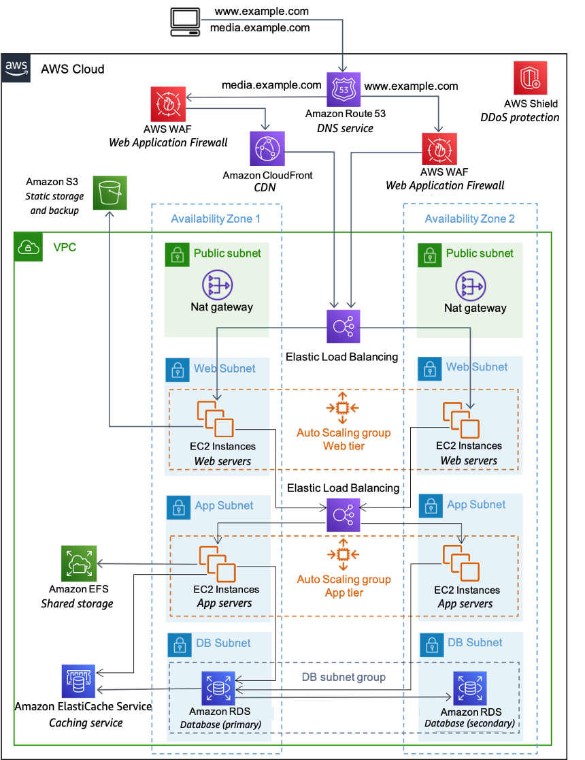

7: Advantages of Proposed architecture
Less speed to load the site and its contents.
Improved content caching, security from malicious queries and malicious traffic and sql injection attacks.
Horizontal auto scaling will help to handle the peak time computing load.
SQL query caching using Elasticache will reduce the backend communication latency.
EFS shared storage will be a shared mount and the files will accessible by all instances in the ASG.
The segregation of app and web servers will help to chose the instance classes based only on needed computing power.
WAF firewalls will help to improve the security.
Cloudfront will be the cdn and will be the content caching mechanism.
AWS shield will provide DDoS protection.
AWS S3 will be a cheap and reliable storage option for image and media files, so it will reduce the storage overhead in the computing nodes.

8: Conclusion
Even though the proposed architecture will cost some pennies more, when comparing with the current architecture , it will provide a better SLA and uptime which will help to imrpove the overall business. So the money spending on the infra will be an extra fuel for the revenue from the web application.

9. Q &A

