𝟏: Problem Statement
Even though we deployed the java application with eks, we have a lack of solid logging solution since its an important part of a distributed infrastructure. If there is no centealized logging is configured in a k8s infra,it will be very difficult to monitor the application logs and maintaining the disk space of the k8s nodes.

2: Business case
The infra design we provided in the solution-2 needs a logging solution to track and monitor the application and cluster logs. It's very important to monitor and maintain the performance and health of your scalable Kubernetes environments, It will helm us to track incidents, and RCA also will help to reduce disk space consumption in terms of logs.

3: Current System architecture
In current system we are monitoring container logs using kubectl cli only.

4: Proposed solution
Logging and monitoring for Amazon Elastic Kubernetes Service (Amazon EKS) has two categories: the control plane logs and the application logs. Amazon EKS control plane logging provides audit and diagnostic logs from the control plane to Amazon CloudWatch Logs groups in your AWS account. To collect application logs you must install a log aggregator, such as Fluent Bit, Fluentd, or CloudWatch Container Insights, in your Amazon EKS cluster.

Fluent Bit is an open-source log processor and forwarder that is written in C++, which means that you can collect data from different sources, enrich them with filters, and send them to multiple destinations. By using this guide's solution you can enable aws-for-fluent-bit or fargate-fluentbit for logging

There are multiple options to implement this but in the simplest solution we are providing below, we use Fluent Bit as the log collector and forwarder to send application and cluster logs to CloudWatch. You can then stream the logs to Amazon OpenSearch Service by using a subscription filter in CloudWatch.

5: What are the new Services and Why those Services ?
The diagram shows the following workflow when application logs from Amazon EKS clusters are streamed to Amazon OpenSearch Service:

1. The Fluent Bit service in the Amazon EKS cluster pushes the logs to CloudWatch.

2. The AWS Lambda function streams the logs to Amazon OpenSearch Service using a subscription filter.

3. You can then use Kibana to visualize the logs in the configured indexes.

4. You can also stream logs by using Amazon Kinesis Data Firehose and store them in an S3 bucket for analysis and querying with Amazon Athena.

6: Proposed Architecture

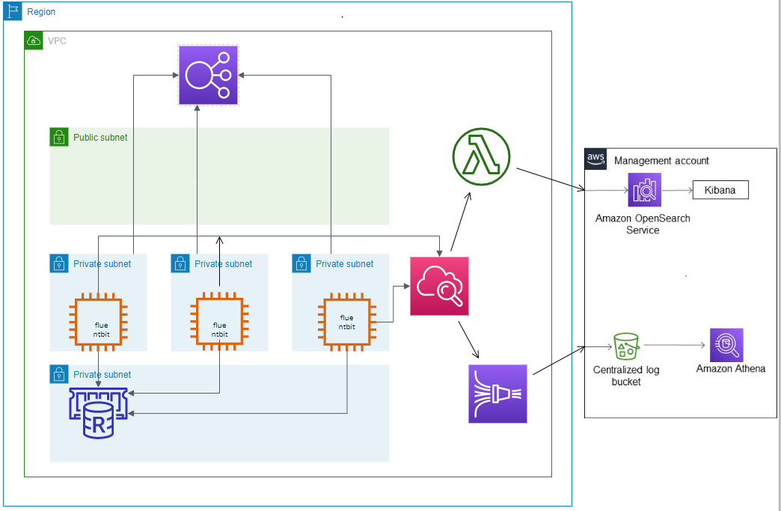

7: Advantages of Proposed architecture
Above mentioned logging architecture automatically streams logs from eks cluster to a centralized logs server. I will help us to easily monitor the logs in any case. There is no need to use cli and we will have a UI for the purpose.
We can filter the logs using fluentbit configuration, so we will only get necessary and critical logs to monitor.
We can use this for monitoring purpose also using log based triggers.

8: Conclusion
It will add additional cost to the budget but it will be better to have a centralized logging instead of without logging in place. It will provide us a better grip in the application and infra issues tracking.

9. Q &A

