𝟏: Problem Statement
We have a java application which contains three micro services which runs as daemons in three ec2 instances. We have below disadvantages in current architecture,
1. Since they are running on stand alone ec2 nodes, we need more time for administration and maintaining the application.
2. The startup script creating problems sometime by not re-newing the PID while restarting or OS reboots.
3. The EC2 nodes consuming disk space for logging and we need to maintain a proper logrotation configuration to manage this.
4. Also when the application is ideal there is a wastage of resources for which we are still getting billed.

2: Business case
The application is an IOT based E-commerce project and its Stateful. So it should be performance optimized and highly available to meet the SLA and uptime. Also we need to optimize the architecture by containerizing the application, so that we can reduce resource consumption and thus reduce the billing also.

3: Current System architecture
Below diagram shows current architecture which contains three ec2 nodes in which the java daemons are running. The ec2 nodes are connected to load balancer and there is an Amazon elasticache redis database as backend to save the session state.
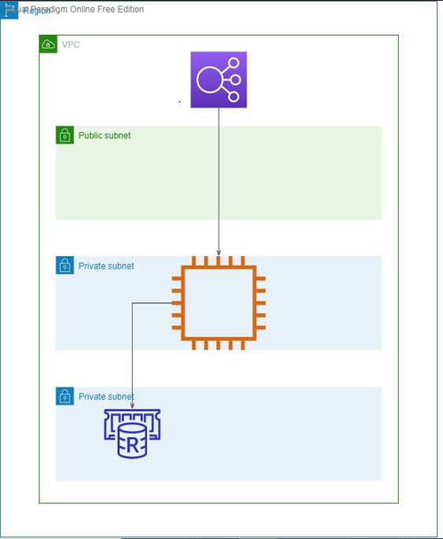

4: Proposed solution
Dockerize the java application and deploy into kubernetes cluster based on aws eks. This will give us below advantages:
a. Reduce over resource consumption and thus the ec2 instance sizes of eks
b. More control on scalability
c. High availability as an inbuilt feature since kubernetes pods will get recreate in case of failures
d. easy to update patches and application packages
e. Enhancements using CI/CD and Gitops and log management
f. Less headache for maintaining the application

5: What are the new Services and Why those Services ?
1. There is a VPC composed of three public subnets, three subnets used for the application and three subnets reserved for the database.
2. For this application, there is an Amazon ElastiCache Redis database that stores the user sessions and state.
3. The Amazon EKS Cluster is created with a Managed Node Group containing three t3.micro instances per default. Those instances run the three Java containers.
4. To be able to access the website that is running inside the containers, Elastic Load Balancing is set up inside the public subnets.The Elastic Load Balancing (Classic Load Balancer) will automatically be created by Amazon EKS, when the application is deployed.

6: Proposed Architecture
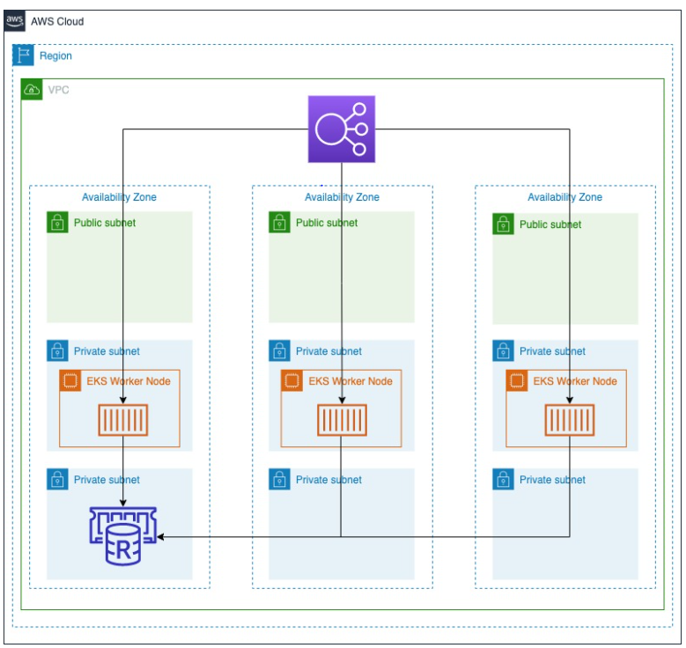
7: Advantages of Proposed architecture
Horizontal auto scaling will help to handle the peak time computing load.
State maintaining using Elasticache redis will reduce the session loading time.
The containerized architecture will help us to improve the application stability.
The subnet segregation of private and public subnets will give more control on security.

8: Conclusion
Even though the proposed architecture will cost some pennies more, when comparing with the current architecture , it will provide a better SLA and uptime which will help to imrpove the overall business. So the money spending on the infra will be an extra fuel for the revenue from the web application.

9. Q &A

