**Synopsis**

**Title of the Project:**

Student Space

**Description**

Student space project is web portal where students and Admin can login to that website, each student and Admin have different dashboard. Student have the option to see their Attendance details and their personal information’s. And Admin have the options to add the student, view student Details, take attendance for the particular subjects. This project helps to make the attendance taking procedure in the college. And it helps to the student to track their attendance.

**Objective/Scope of the Project**

This is helpful For the lectures to automate the attendance tracking of the student, instead of entering the details manually. While taking the attendance through this web application it stores the details to the database and automatically calculate the attendance report .the report can check by the admin and students.

**TOOLS USED**

**Programming Language:**

**Front End:** HTML, CSS, BOOTSTRAP, JAVA SCRIPT

**Server Side:** PHP

**Database:** Maria DB

**Hardware requirements:**

* **Processor:** Dual core or higher
* **RAM:** Minimum 1 GB
* **Hard disk:** Minimum 40 GB
* **Operating system:** Windows Based ,Unix Based Operating System

**Software requirements:**

* **IDE:** Visual Studio
* **Software**: XAMPP
* Apache server
* MySQL server
* **Browser:** Google Chrome, Mozilla Firefox, Microsoft Edge, etc…

**CHAPTER: 1**

**INTRODUCTION**

* 1. **PROJECT OVERVIEW**

Student space project is web portal where students and teachers can login to that website, each student and teachers have different dashboard. Student have the option to see their Attendance details and their personal information’s. And teachers have the options to add the student, view student Details, take attendance for the particular subjects. This project helps to make the attendance taking procedure for teachers. And it helps to the student to track their attendance.

* 1. **PURPOSE OF THE PROJECT**

Student space is the project to take and manages the student attendance and some personal details.

This will helps teachers to manage the student attendance details.

Teachers can easily track the student attendance

**CHAPTER: 2**

**LITERATURE SURVEY**

**2.1 EXISTING AND PROPOSED SYSTEM**

**2.1.1 EXISTING SYSTEM**

According to a survey the most of the colleges uses the paper or book to take and maintain the record of the attendance.it is some time very hard to compute the attendance and maintain the attendance details in the college or the particular department, here Students can’t track their attendance details.

**2.1.2 PROPOSED SYSTEM**

In the proposed system, it mainly deals with the web based Attendance system.it helps to take attendance off the students of the particular department.in this also teachers easily track the attendance of the students, who comes under the particular department, also students can check about their attendance details and personal details.

**2.3 TOOLS AND TECHNOLOGIES USED**

**2.3.1 MY SQL**

**MySQL is a relational database management system (RDBMS) developed by Oracle that is based on structured query language (SQL).**

A database is a structured collection of data. It may be anything from a simple shopping list to a picture gallery or a place to hold the vast amounts of information in a corporate network. In particular, a relational database is a digital store collecting data and organizing it according to the relational model. In this model, tables consist of rows and columns, and relationships between data elements all follow a strict logical structure. An RDBMS is simply the set of software tools used to actually implement, manage, and query such a database.

**2.3.2 PHP**

PHP started out as a small open source project that evolved as more and more people found out how useful it was. Rasmus Lerdorf unleashed the first version of PHP way back in 1994.

* PHP is a recursive acronym for "PHP: Hypertext Preprocessor".
* PHP is a server side scripting language that is embedded in HTML. It is used to manage dynamic content, databases, session tracking, even build entire e-commerce sites.
* It is integrated with a number of popular databases, including MySQL, PostgreSQL, Oracle, Sybase, Informix, and Microsoft SQL Server.
* PHP is pleasingly zippy in its execution, especially when compiled as an Apache module on the UNIX side. The MySQL server, once started, executes even very complex queries with huge result sets in record-setting time.
* PHP supports a large number of major protocols such as POP3, IMAP, and LDAP. PHP4 added support for Java and distributed object architectures (COM and CORBA), making n-tier development a possibility for the first time.
* PHP is forgiving: PHP language tries to be as forgiving as possible.
* PHP Syntax is C-Like.

**2.3.3 HTML**

HTML is an acronym which stands for **Hyper Text Markup Language** which is used for creating web pages and web applications. Let's see what is meant by Hypertext Markup Language, and Web page.

**Hyper Text:** Hypertext simply means "Text within Text." A text has a link within it, is a hypertext. Whenever you click on a link which brings you to a new webpage, you have clicked on a hypertext. Hypertext is a way to link two or more web pages (HTML documents) with each other.

**Markup language:** A markup language is a computer language that is used to apply layout and formatting conventions to a text document. Markup language makes text more interactive and dynamic. It can turn text into images, tables, links, etc.

**Web Page:** A web page is a document which is commonly written in HTML and translated by a web browser. A web page can be identified by entering an URL. A Web page can be of the static or dynamic type. With the help of HTML only, we can create static web pages.

**2.3.4 CSS**

Cascading **S**tyle **S**heets, fondly referred to as CSS, is a simple design language intended to simplify the process of making web pages presentable.

CSS handles the look and feel part of a web page. Using CSS, you can control the color of the text, the style of fonts, the spacing between paragraphs, how columns are sized and laid out, what background images or colors are used, layout designs, and variations in display for different devices and screen sizes as well as a variety of other effects.

CSS is easy to learn and understand but it provides powerful control over the presentation of an HTML document. Most commonly, CSS is combined with the markup languages HTML or XHTML.

**2.2 REQUIREMENTS ANALYSIS**

**2.4.1 PROGRAMMING LANGUAGE TO BE USED:**

➢ Front-end language: HTML/CSS

➢ Back-end languages: PHP

➢ Database: MySQL

**2.4.2 HARDWARE REQUIREMENTS:**

➢ Minimum of 512 MB RAM

➢ Minimum of 20 GB hard drive space

➢ Compatible operating systems:

• X86 Linux operating systems

• 64-bit Windows operating systems (7-lateast)

➢ Intel x86 or compatible processor

**2.4.3 SOFTWARE REQUIREMENTS:**

➢ **IDE:** Visual Studio Code

➢ **Browser:** Google Chrome, Mozilla Firefox

➢ **Software to manage database:** MySQL

**CHAPTER 3**

**SOFTWARE REQUIREMENTS SPECIFICATION**

**3.1 INTRODUCTION**

SRS totally characterizes the entire venture and the product and how it will be relied upon to performed. A Software Requirement Specification is a whole elaboration of the real constancy and climate for programming under measure. To characterize the customer necessities, designer should have the flawless and clear data about item which must be built. It is the fundamental stage for the application progress activity. SRS is the whole meaning of the presentation of association should be set up.

Attributes of SRS:

• Understanding the necessities

• Verification is finished

• Unambiguous

• Consistent is kept up

• Fully Complete

**3.2 FUNCTIONAL REQUIREMENTS**

* **Admin**

Admin who manages the main activity of the web page, who can take the attendance of the student, also add the student details, view the student details. View all the students added by the admin, the admin can check the attendance status of the student, add the subject.

* **Students**

Student are the normal user where students have to login to see their particular details, like personal details ,attendance details etc…,Students also have the option to login to the student dashboard, with the provided username and password.

**3.3 NONFUNCTIONAL REQUIREMENTS**

The applicability of a structure or one of its components is described by a practical needs record. It also depends on the type of programming, target audience, and platform on which the product is used. While useful client requirements may be high-level declarations of what the framework should accomplish, useful framework requirements should also clearly depict what the structure should do.

**Performance**

This page can provide the best response time to the users, because it is used by the teachers and limited students so because of the less traffic the response time became better.

**Usability**

**This can use very easily by the users, because it uses the simple interface which everyone can easily understand use it without any confusion, it provides the user friendly environment to the users.**

**Scalability**

**This is also support the future updates to the system, if the hardware updated, it supports to the new specification.**

**Portability**

It is also portable, because it uses the simple programming language, it can work on any systems.

It only needs some software to run this project.

ER-Diagram

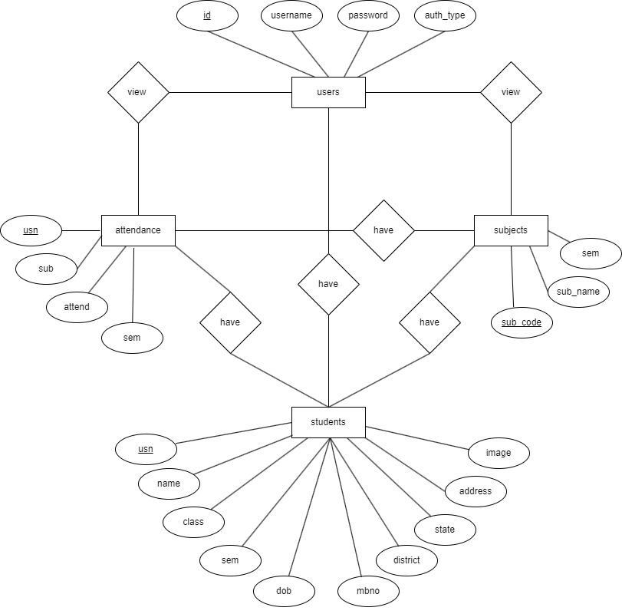

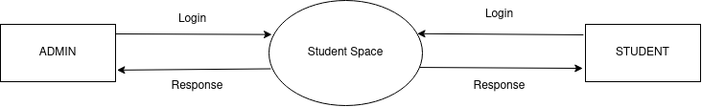**DFD Diagram: Level 0**

This is the level 0 DFD diagram, which shows the students and admin logging in using the student space to retrieve the some of the details

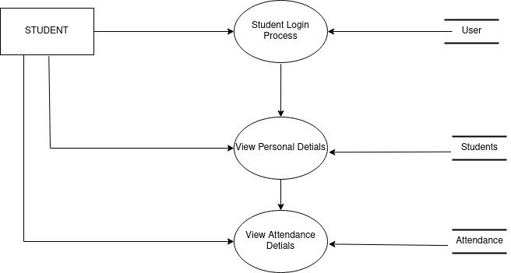**DFD Diagram: Level 1.1**

This is the level 1 diagram, in that level 1.1 diagram which shows the flows of the students in the student space.in here the student using the credentials to login to the page and viewing the personal information and attendance details.

**DFD Diagram: Level 1.2**

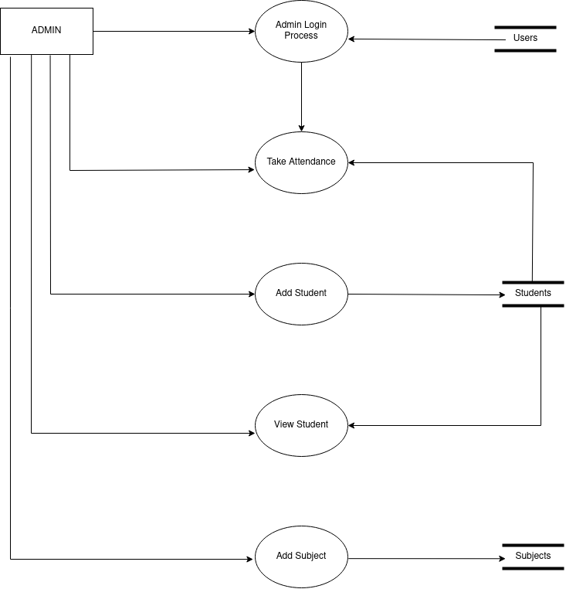

This is the level 1 diagram, in that level 1.2 diagram which shows the flow of the admin.here admin login and after retrieve the related details in the admin dashboard.

**Implementation**

* **1 Login page**
* The login page is used by both Admin And students
* According to the credentials it redirect them to the respective dashboard
* It contain two input text for enter the user name and password
* It also contain a button in the page
* The button is pressed by the users
* If the user don’t fill the fields it displays the error message that please enter the username and password
* These are placed inside the card
* In the top of the card the logo is placed
* The card Is placed middle of the page
* This page is completely responsive
* If the user entered wrong username and password then the page displays the invalid credentials entered.
* This page is built with the html,bootstrap and css.

* **2 Admin**
* **2.1 Dashboard**
* After the admin login in the login page it redirect the admin to the admin dashboard.
* The admin dashboard contains a side bar with many option
* And the admin page contains the some cards which contains the different details of the student and other.
* The dashboard have the heading ‘dashboard’ in the top of the page
* The side bar can be expand and compress.
* By default it is in the compressed stage.
* The admin can expand the side bar by pressing the burger icon.
* The side navbar contains the different icons, which is represent the different option for the admin.
* The first option is the take attendance, with the icon, while pressing the icon it redirect the admin to the attendance page
* Second one is the add student with an icon, while the admin press that, it redirect to the adding the new student page, where the admin can add the new student.
* Third is the view student details with icon, it redirect the admin to the student details page where all the student details is displayed
* **2.2 Take Attendance**
* Attendance taking page contains the a table, which contains the Sno,USN,Name,and a radio buttons for mark the present and absent
* it contains the heading in the page ‘Student Attendance’
* in this page it displays the current time and date
* it have an dropdown to select the subject for the attendance
* each student contain two radio button for marking the present and absent.
* According to the present and absent the color of the radio button color changes.
* By default the present button is checked.
* The present button color is with green
* And the absent button color with red while selected.
* This page have a submit button, after mark the attendance the admin can press the button then the attendance will recorded to the database.
* **2.3 Add Student**
* The add student page contains the a card
* Inside the card the input fields are placed
* The card have the heading as ‘enter the student details’
* The form is used to pass the data
* The form contains the full name if the student
* Usn of the student
* Class of the student to select
* Current semester of the student to select
* Date of birth of the student to pic from the calendar
* District of the student to pic
* State of the student to pic
* Mobile number of the student
* Address of the student
* Image/photo of the student
* These all fields are required field
* The admin can’t leave the fields the as empty
* If the admin entered all the fields then it allow to insert the details to the database
* If the admin enter the already existing student usn it displays the waring message that the ‘student already exists’
* Or it display the message that ‘new student
* **2.3 View student**
* After adding the students the admin can view the students in the view student page
* The name,usn,image of the student will be displayed in that page
* The details are displayed inside the card
* It have a button called view
* While pressing the that button it redirect the admin to the view the particular information of the student.
* This page is fully responsive
* It changes the alignment of the cards depends on the display size.
* **2.3 Particular Student information**
* while the admin click the view button in the view student page, it redirect the admin to this page
* it contains the Some personal details of the student
* the personal details are displayed is the data entered while adding the student
* the student details are displayed in the card along with image of the student
* in this page it also have the attendance details of the student
* it contains a progress bar to indicate the percentage of the attendance
* progress bar is used to display the percentage of the attendance in the more graphical way
* it display the suitable message depending on the percentage of the attendance, like in attendance shotage,clear full attendance.