**Note for COVERGO Senior Software QA Engineer (Automation)**

**Take-home Task**

Hello, I want to represent you a sample of the test automation project. I did it for my own website zelenstroy.online. Nature is my passion, so I develop this site in my free time. Check it out)

In the test project, I used different types of testing. Because I’m sure that all the projects are different and require different approach to test. I have experience with different frameworks, tools, and programming languages. I understood that the main thing is to choose the right approach and architecture. It can be done only after the complex analysis of a certain project.

In this project, I chose Playwright tool with TypeScrypt. Playwright is new and powerful tool from Microsoft. I know that you want to add the cucumber framework above, but I have experience with cucumber development and it takes 2 times more resources (time, people, money) for a test automation project. That’s why you should think twice and find a very important reason to use it. But I added the duplicate for login tests just to show that I can play with Cucumber too.

**User scenarios**

1 – successful login

1. Go to the Main page
2. Click the Login icon
3. Fill the email and password fields with correct params
4. Click the login button
5. Check the user title

2 – unsuccessful login

1. Go to the Main page
2. Click the Login icon
3. Fill the email and password fields with incorrect params
4. Click the login button
5. Check the error message

3 – Main page default state

1. Go to the main page
2. Check title
3. Check that htp button enabled
4. Check that home link enabled
5. Check that effective landscape link enabled
6. Check that blog link enabled
7. Check that contacts link enabled

4 – Contact

1. Go to the contact page
2. Enter message in the contact form
3. Click submit button
4. Check that submit message appears

5 – Make order Positive

1. Go to the Good deeds page
2. Select the product
3. Select the amount
4. Click the ADD TO BASKET button
5. Click the CHECKOUT button on the basket sidebar
6. Fill in billing details
7. Click the PLACE ORDER button
8. Check the order details and confirmation message

6 – Make order Negative

1. Go to the Good deeds page
2. Select the product
3. Select the amount
4. Click the ADD TO BASKET button
5. Click the CHECKOUT button on the basket sidebar
6. Fill in billing details exept City field
7. Click the PLACE ORDER button
8. Check that the order has not been submitted and error message appears

7 – Our projects in blog

1. Go to the blog page
2. Select the “our projects” category
3. Check the Terraverde project is present

8 – Mobile version

1. Go to the main page
2. Change to mobile view
3. Check that the Main slider isn’t displayed

9.1 – Localization English

1. Go to the main page
2. Select the English language
3. Check the main menu links text are in English
4. Change the language to Spanish
5. Check the main menu links text are in Spanish

9.2 - Localization Spanish (this test will fall, because there is an error)

1. Go to the main page
2. Change the language to Spanish
3. Check the main menu links text are in Spanish

10 – API testing

1. Check the links of main menu via api

Get started by installing Playwright using npm or yarn.

Evaluate command in terminal:

*npm init playwright@latest*

<https://playwright.dev/docs/intro>

To run all tests evaluate command in terminal

*npx playwright test*

For Cucumber you just need to install Cucumber plugin for your IDE.

Cucumber tests should be ran separately.

System requirements

Node.js 16+

Windows 10+, Windows Server 2016+ or Windows Subsystem for Linux (WSL).

MacOS 12 Monterey or MacOS 13 Ventura.

Debian 11, Debian 12, Ubuntu 20.04 or Ubuntu 22.04.

Login tests comparison

cucumber 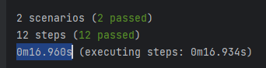

no cucumber 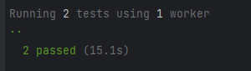

All test run time

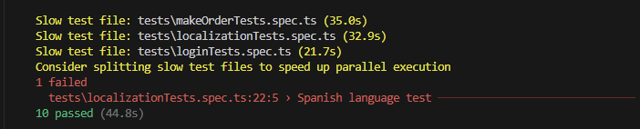

You will get HTML report automatically after testrun.