# USAGE DOCUMENT

**Project Name :** FTLABS – Django Rest API

**Author:** Sibi Shankar S

**Project Overview:**

This project is a Django Rest API which was developed in August 2020. If you access the API link you will get all the users with activity periods as response.

**Required Softwares:**

1. Python 3.8
2. Django 3.1
3. Django rest framework
4. MySQL client

**Implementation Steps:**

1. Created project and an application with django web framework
2. Created views, models & serializers

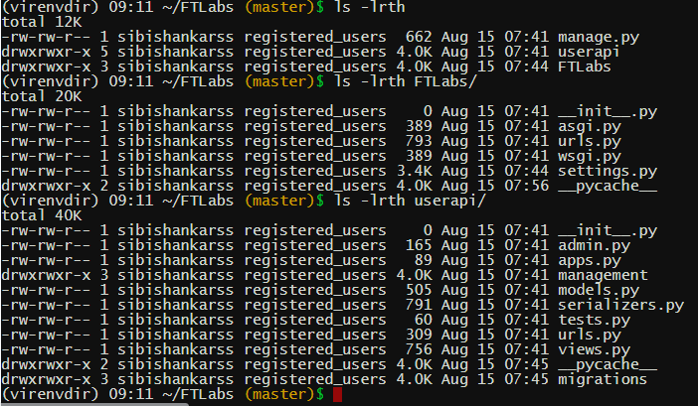

1. Created custom management commands and inserted data
2. Hosted in pythonanywhere(access with the link mentioned below)

**Screenshots:**

1. **Inserting data using custom management commands**







(Please check the generate_users.py in FTLabs/userapi/management/commands/)

1. **Response JSON**

GET /users/

HTTP 200 OK

Allow: GET, POST, HEAD, OPTIONS

Content-Type: application/json

Vary: Accept

{

"members": [

{

"id": 3,

"real_name": "Ajith",

"tz": "Asia/Kolkata",

"activity_periods": [

{

"start_time": "Aug 15 2020 01:39PM",

"end_time": "Aug 15 2020 03:08PM"

}

]

},

{

"id": 5,

"real_name": "John",

"tz": "Asia/Riyadh",

"activity_periods": [

{

"start_time": "Aug 15 2020 01:41PM",

"end_time": "Aug 15 2020 02:16PM"

},

{

"start_time": "Aug 15 2020 02:16PM",

"end_time": "Aug 15 2020 03:08PM"

}

]

},

{

"id": 2,

"real_name": "Salman",

"tz": "Asia/Kolkata",

"activity_periods": [

{

"start_time": "Aug 15 2020 01:39PM",

"end_time": "Aug 15 2020 03:19PM"

},

{

"start_time": "Aug 15 2020 03:19PM",

"end_time": "Aug 15 2020 04:45PM"

},

{

"start_time": "Aug 15 2020 04:45PM",

"end_time": "Aug 15 2020 04:53PM"

}

]

},

{

"id": 1,

"real_name": "Sharukh",

"tz": "Asia/Kolkata",

"activity_periods": [

{

"start_time": "Aug 15 2020 01:38PM",

"end_time": "Aug 15 2020 02:15PM"

},

{

"start_time": "Aug 15 2020 02:15PM",

"end_time": "Aug 15 2020 03:38PM"

}

]

},

{

"id": 4,

"real_name": "Vijay",

"tz": "UK/London",

"activity_periods": [

{

"start_time": "Aug 15 2020 01:40PM",

"end_time": "Aug 15 2020 01:55PM"

},

{

"start_time": "Aug 15 2020 01:55PM",

"end_time": "Aug 15 2020 02:05PM"

}

]

}

],

"ok": true

}

**Source Code and Hosted URL :**

github: https://github.com/sibishankarss/FTLabs.git

pythonanywhere: <http://sibishankarss.pythonanywhere.com/users/>

Note: Developed with oracle client, But hosted with MYSQL client