[TechTarget](http://www.techtarget.com/network)

* [SearchDataCenter](http://searchdatacenter.techtarget.com/)
* [Data center facilities](http://searchdatacenter.techtarget.com/resources/Data-center-design-and-facilities)
* [Get Started](http://searchdatacenter.techtarget.com/info/getstarted)
* Search the TechTarget Network
* [Home](http://searchdatacenter.techtarget.com/)

* [Data center facilities](http://searchdatacenter.techtarget.com/resources/Data-center-design-and-facilities)

* [Data center management](http://whatis.techtarget.com/glossary/Data-Centers)

* uninterruptible power supply (UPS)

http://cdn.ttgtmedia.com/rms/ux/responsive/img/gradient_bar.jpgDEFINITION

uninterruptible power supply (UPS)



Posted by: [Margaret Rouse](http://www.techtarget.com/contributor/Margaret-Rouse)

[WhatIs.com](http://whatis.techtarget.com/)

Contributor(s): Robert McFarlane, Toon Diegenant and Patrick Tierce

Sponsored News

* [How to scale corporate IT systems with Linux](http://www.empoweritinfrastructure.com/How-to-scale-corporate-IT-systems-with-Linux?asrc=SS_sdc_SN-214161)–IBM
* [A Cost-Effective Hadoop Cluster for Big Data Environments](http://www.convergedinfrastructure.com/A-Cost-Effective-Hadoop-Cluster-for-Big-Data-Environments?asrc=SS_sdc_SN-214161)–Dell
* [See More](http://searchdatacenter.techtarget.com/sponsored_communities)

Vendor Resources

* [UPS Functioning Modes: Alternatives for Unprecedented Efficiency](http://searchdatacenter.bitpipe.com/detail/RES/1401297937_374.html)–Emerson Network Power
* [Best Practices in Protecting the Technology Systems Revolutionizing Healthcare](http://searchdatacenter.bitpipe.com/detail/RES/1264111841_157.html)–Emerson Network Power

An uninterruptible power supply (UPS) is a device that allows a computer to keep running for at least a short time when the primary power source is lost. It also provides protection from power surges.



Download this free guide

Extend your UPS battery life

Top of Form

* Corporate Email Address:



Bottom of Form

By submitting your email address, you agree to receive emails regarding relevant topic offers from TechTarget and its [partners](http://www.techtarget.com/html/privacy_partners_0-c.html). You can withdraw your consent at any time. Contact [TechTarget](http://www.techtarget.com/html/about_contact_directions.html" \t "_blank) at 275 Grove Street, Newton, MA.

You also agree that your personal information may be transferred and processed in the United States, and that you have read and agree to the [Terms of Use](http://searchdatacenter.techtarget.com/about/copyright) and the [Privacy Policy](http://www.techtarget.com/html/privacy_policy.html).

Safe Harbor

A UPS contains a [battery](http://searchmobilecomputing.techtarget.com/definition/battery) that "kicks in" when the device senses a loss of power from the primary source. If you are using the computer when the UPS notifies you of the power loss, you have time to save any data you are working on and exit gracefully before the secondary power source (the battery) runs out. When all power runs out, any data in your computer's random access memory ([RAM](http://searchmobilecomputing.techtarget.com/definition/RAM)) is erased. When power surges occur, a UPS [intercepts the surge](http://whatis.techtarget.com/definition/surge-suppressor-surge-protector) so that it doesn't damage the computer.

UPS in the data center

Every UPS converts incoming [AC](http://whatis.techtarget.com/definition/alternating-current-AC) to [DC](http://whatis.techtarget.com/definition/DC-direct-current) through a rectifier, and converts it back with an inverter. Batteries or flywheels store energy to use in a utility failure. A bypass circuit routes power around the rectifier and inverter, running the IT load on incoming utility or generator power.

While UPS systems are commonly called double-conversion, line-interactive and standby designs, these terms have been used inconsistently and manufacturers implement them differently: At least one system allows any of the three modes. The Internat*i*onal ElectroTechnical Commission ([IEC](http://whatis.techtarget.com/definition/International-Electrotechnical-Commission-IEC)) adopted more technically descriptive terminology in IEC Std. 62040.

PRO+

Content

Find more PRO+ content and other member only offers,[here.](http://pro.techtarget.com/ProLP?Offer=PROContentBox)

* **E-Handbook**

[Data center improvements will buy you time to plan for what's next](http://searchdatacenter.techtarget.com/ehandbook/Data-center-improvements-will-buy-you-time-to-plan-for-whats-next)

* **E-Handbook**

[The real value of DCIM tools](http://searchdatacenter.techtarget.com/ehandbook/The-real-value-of-DCIM-tools)

* **E-Handbook**

[Data center infrastructure that supports big data](http://searchdatacenter.techtarget.com/ehandbook/Data-center-infrastructure-that-supports-big-data)

**Voltage and frequency independent (VFI)**UPS systems are called dual or double conversion because incoming AC is rectified to DC to keep batteries charged and drive the inverter. The inverter re-creates steady AC power to run the IT equipment.

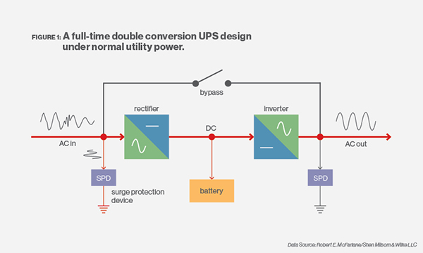Figure 1.

When power fails the [batteries](http://searchmobilecomputing.techtarget.com/definition/battery) drive the inverter, which continues to run the information technology (IT) load. When power is restored, either from the utility or a generator, the rectifier delivers [direct current](http://whatis.techtarget.com/definition/DC-direct-current) (DC) to the inverter and simultaneously recharges the batteries. The inverter runs full time. Utility input is completely isolated from the output, and bypass is only used for maintenance safety or if there's an internal electronics failure. Since there is no break in the power delivered to the IT equipment, vacuum fault interrupter (VFI) is generally considered the most robust form of UPS. Most systems synchronize the output frequency with the input, but that's not necessary, so it still qualifies as frequency independent.

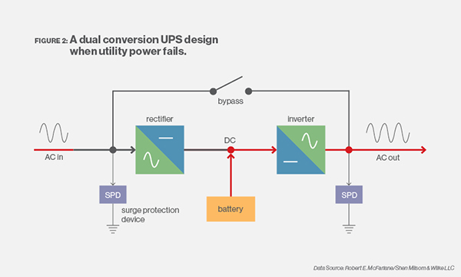Figure 2.

Every power conversion incurs a loss, so the wasted energy has historically been considered the price of ultimate reliability. The newest VFI systems claim better than 96% efficiency at nearly all loads.

**Voltage independent (VI)**, or true line interactive UPSes have a controlled output [voltage](http://whatis.techtarget.com/definition/voltage), but the same output frequency as the input. Frequency independence is rarely a concern with power in developed countries. Utility power feeds directly to the output and IT equipment, and the rectifier keeps the batteries charged. The inverter is paralleled with the output, compensating for voltage dips and acting as an active filter for voltage spikes and harmonics. Rectifier and inverter losses only occur when incoming power fluctuates. Flywheels and motor/generator sets also qualify as VI.

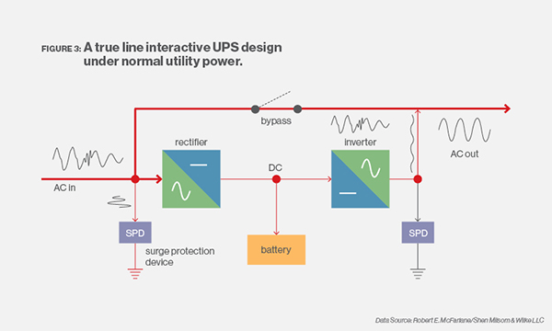Figure 3.

When incoming power fails, or the voltage goes out of range, the bypass quickly disconnects from the input and the battery drives the inverter. When input power is restored, the bypass re-engages the input, re-charges the batteries, and keeps output voltage constant. UPS vendors who use paralleled power sources claim no loss of reliability. The result is around 98% energy efficiency.

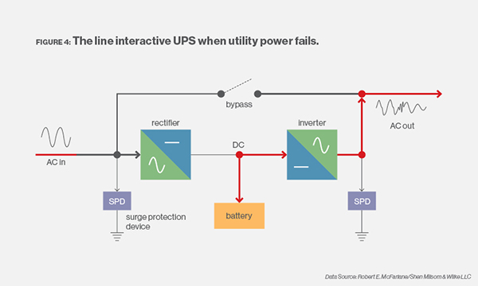Figure 4.

**Voltage and frequency dependent (VFD)**, or standby UPS, is operationally similar to VI and is sometimes mistakenly called line interactive. In conventional VFD systems the inverter is turned off, so it can take as long as 10 to 12 milliseconds ([ms](http://whatis.techtarget.com/definition/millisecond)) to start creating power. That break can crash servers, making legacy VFD UPSes a bad fit for data centers.

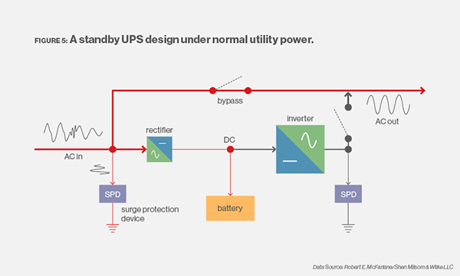Figure 5.

New VFD concepts have the inverter producing power within 2 ms after being activated. The bypass is normally engaged, just as with VI, so equipment operates directly from the utility or generator. Since the inverter isn't working until power fails, there is no voltage control or power consumed, enabling efficiencies as high as 99%. Power failure or voltage outside of range opens the bypass switch, disengaging input from output; the inverter starts operating from the batteries. The rectifier is only large enough to keep the batteries charged.

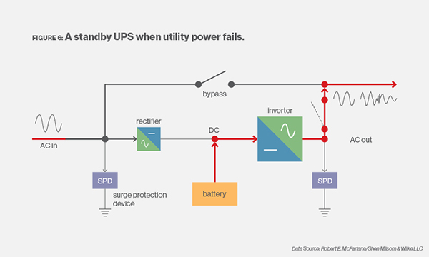Figure 6.

This was last updated in [April 2015](http://searchdatacenter.techtarget.com/archive/2015/4)

Continue Reading About uninterruptible power supply (UPS)

* [American Power Conversion is one of the leading makers of UPS devices.](http://www.apcc.com/)
* [Evaluating emergency power supply options](http://searchdisasterrecovery.techtarget.com/answer/Evaluating-emergency-power-supply-options)

Related Terms

[computerized maintenance management system (CMMS)](http://searchdatacenter.techtarget.com/definition/computerized-maintenance-management-system-CMMS)

A computerized maintenance management system (CMMS) is software that helps operations and maintenance staff identify and track ...[See complete definition](http://searchdatacenter.techtarget.com/definition/computerized-maintenance-management-system-CMMS)

[load shedding](http://searchdatacenter.techtarget.com/definition/load-shedding)

Load shedding is a reduction of power demand by a utility provider during peak or stressed times. Participants voluntarily reduce...[See complete definition](http://searchdatacenter.techtarget.com/definition/load-shedding)

[unified computing system (UCS)](http://searchconvergedinfrastructure.techtarget.com/definition/unified-computing-system-UCS)

A unified computing system (UCS) is a data center architecture that integrates computing, networking and storage resources and is...[See complete definition](http://searchconvergedinfrastructure.techtarget.com/definition/unified-computing-system-UCS)

Dig Deeper on Data center design and facilities

* [ALL](http://searchdatacenter.techtarget.com/definition/uninterruptible-power-supply#dd-tab1)
* [NEWS](http://searchdatacenter.techtarget.com/definition/uninterruptible-power-supply#dd-tab2)
* [GET STARTED](http://searchdatacenter.techtarget.com/definition/uninterruptible-power-supply#dd-tab3)
* [EVALUATE](http://searchdatacenter.techtarget.com/definition/uninterruptible-power-supply#dd-tab4)
* [MANAGE](http://searchdatacenter.techtarget.com/definition/uninterruptible-power-supply#dd-tab5)
* [PROBLEM SOLVE](http://searchdatacenter.techtarget.com/definition/uninterruptible-power-supply#dd-tab6)
* [What to know before using li-ion battery technology in a UPS system](http://searchdatacenter.techtarget.com/tip/What-to-know-before-using-li-ion-battery-technology-in-a-UPS-system)
* [Get to know ASHRAE 90.4, the new energy efficiency standard](http://searchdatacenter.techtarget.com/tip/Get-to-know-ASHRAE-904-the-new-energy-efficiency-standard)
* [New data center metrics to gauge energy, cooling efficiency](http://searchdatacenter.techtarget.com/tip/New-data-center-metrics-to-gauge-energy-cooling-efficiency)
* [Dell software biz jettisoned to advance EMC buy, users' views mixed](http://searchdatacenter.techtarget.com/news/450299115/Dell-software-biz-jettisoned-to-advance-EMC-buy-users-views-mixed)

Load More

 2 comments

[Oldest](http://searchdatacenter.techtarget.com/definition/uninterruptible-power-supply)

Top of Form

Send me notifications when other members comment.

**Register or**[**Login**](http://searchdatacenter.techtarget.com/definition/uninterruptible-power-supply)

E-Mail



http://go.techtarget.com/clicktrack-r/activity/activity.gif?activityTypeId=16&t=300039&t2=2240113866&t3=2240113859&t4=300191&t5=2240113863&a=2016-09-08%2005:42:33&g=214161&c=normal&r=280909