**Ethylene Dimerization: Development of Anti-Fouling Agents**

**Sibo Lin1, Motaz Khawaji2, Dana A. Wong,1 Mohamed Elanany2, Wei Xu2**

1Aramco Services Company: Aramco Research Center – Boston, Catalysis Technology Group, Cambridge, MA, USA, siboster@gmail.com

2 Saudi Aramco: Aramco Research Center – KAUST, Chemicals R&D Lab, Thuwal, Saudi Arabia

**Sibo Lin**

**Abstract:** Titanium- and aluminum-catalyzed ethylene dimerization to 1-butene (AlphaButol process) has been practiced industrially for decades, yet inevitable reactor fouling with polyethylene byproduct remains a fundamental challenge. Spectroscopic data has shown that a complex mixture of Ti(III) and Ti(IV) species are formed, depending on the Al/Ti ratio and presence of ligands such as tetrahydrofuran. This concomitant mixture of species has frustrated mechanistic analysis and rational prevention of reactor fouling. Herein, we utilize computational molecular modelling (extended tight binding theory and density functional theory as implemented in XTBDFT) to examine the mechanism of 1-butene and polyethylene formation with computational molecular modelling, and we develop novel anti-fouling agents that effectively reduce polyethylene formation while retaining 1-butene productivity. This technology has been patented and licensed across the industry.

**What will audience learn from your presentation?**

* Industrial vs academic research priorities
* Application of molecular modelling to improving catalysis
* Importance of conformational searching for mechanistic molecular modelling

**Biography of presenting author** (should not exceed 100 words)

Sibo Lin obtained his B.S. Chemistry degree from Indiana University in 2008, followed by his Ph.D. Inorganic Chemistry degree from Caltech in 2014. He spent 4 years as a postdoctoral fellow at MIT, and then moved across the street to start his industrial career at Aramco’s Boston Downstream Research Center (2018 – present), where he serves as a project lead, developing catalysts for olefin oligomerization and membranes for sour gas separations.

**Details of presenting author to be mentioned in certificate:**

Name: Sibo Lin

Affiliation: Aramco Services Company: Aramco Research Center -- Boston

Country: United States of America

**Other Details:**

Presentation Category: Oral

Session Name:

Email: sibo.lin@aramcoamericas.com

Alternative email: siboster@gmail.com

Contact Number:

Whatsapp Number:

Twitter/Facebook/LinkedIn:

Suggestion of speakers to be invited:

Recent Photograph: (High Resolution)

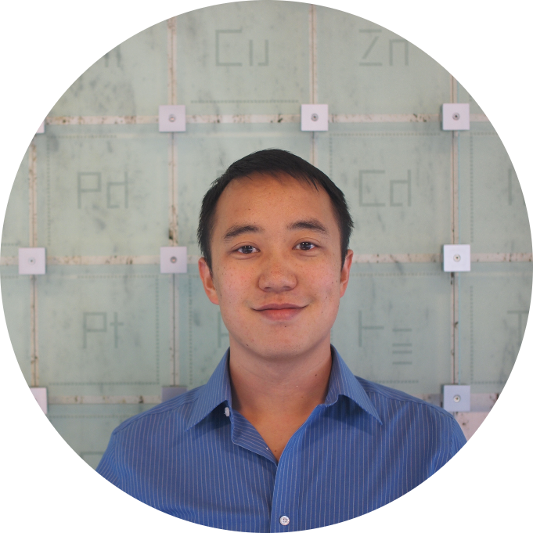

If you feel difficulty in inserting high resolution image in word document, please send it in email at [catalysis-tech@magnusconference.com](mailto:catalysis-tech@magnusconference.com)