Databases project draft

Group members:
- Arlind Disha
- Joni Begaj
- Orest Paja
- Arli Asllani
- Megi Mema

Topic: Management of supply and use of drugs in a hospital environment.

Introduction:
Managing medicine efficiently is essential for hospitals to ensure the availability of critical supplies for patient care. This project focuses on developing a Medicine Management System to streamline the management of the medicine catalogue, track inventory in real-time, and coordinate supplies from multiple vendors. Using SQL to make the database, the system aims to enhance efficiency and ensure seamless operations within the hospital.
Objectives:
- Catalogue Management: To create and maintain a comprehensive and searchable catalogue of all medicines available in the hospital.
- Inventory Tracking: To monitor medicine stock levels in real-time.
- Vendor Integration: To manage and track the supply of medicines from a predefined list of vendors, ensuring timely replenishment of stock.

Description of the database:

-Entities: Drug, Inventory, Supplier, Patient and DrugConsumption

-The above mentioned entities will keep track of:

- The types of drugs used and the dosage of drugs. It will keep track of legality whether they are allowed by law. The side effects will also be kept track of.
- The database will track the types of drugs in stock which will be done in batches. The supplier, quantity and expiry date will also be kept track of.
- The suppliers will have on system their contact info and a reliability rating.
- For the ease of doctors we will also keep track of the types of drugs consumed by the patient over time.

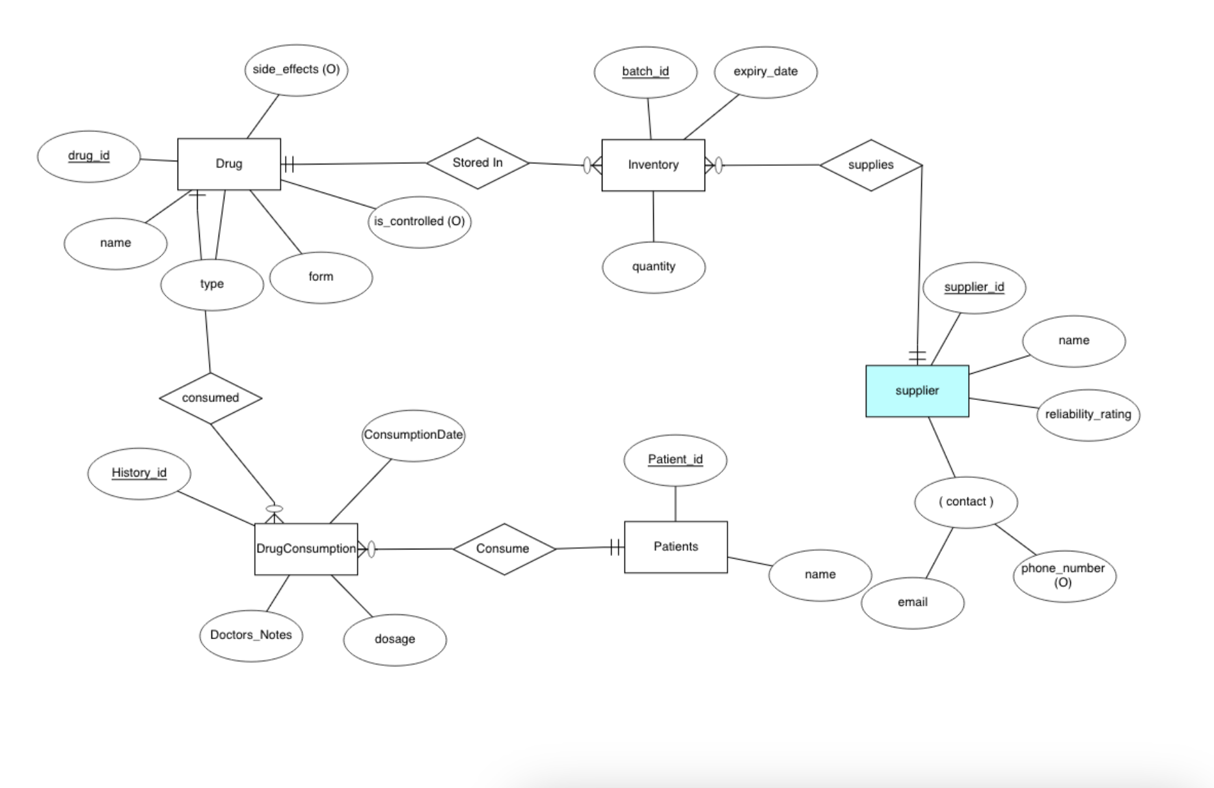
ER Diagram:

Explanation of ER diagram:

Entities and Attributes

1. Drug
- drug_id (Primary Key): Unique identifier for each medication
- name: Name of the medication
- type: Category or classification of the drug
- form: Physical form of the drug (e.g., tablet, liquid, capsule)
- side_effects (Optional): Potential side effects of the drug
- is_controlled (Optional): Indicates whether the drug is a controlled substance

2. Inventory
- batch_id (Primary Key): Unique identifier for each inventory batch
- expiry_date: Date when the medication expires
- quantity: Amount of batches available for a certain type of medicine

3. Supplier
- supplier_id (Primary Key): Unique identifier for each vendor
- name: Name of the supplier company
- reliability_rating: Rating that indicates supplier reliability
- contact (Composite Attribute):
  - email: Email address for contacting the supplier
  - phone_number (Optional): Phone number for contacting the supplier

4. Patients
- Patient_id (Primary Key): Unique identifier for each patient
- name: Patient's name

5. DrugConsumption
- History_id (Primary Key): Unique identifier for each consumption record
- ConsumptionDate: Date when the drug was consumed by the patient
- Doctors_Notes: Additional notes provided by the doctor
- dosage: Amount of medication administered to the patient

Relationships

1. Stored In
- Connects Drug and Inventory
- Indicates which drugs are stored in which inventory batches
- Cardinality: One drug can be stored in multiple inventory batches (1:N)

2. Supplies
- Connects Supplier and Inventory
- Tracks which supplier provided which inventory batch
- Cardinality: One supplier can provide multiple inventory batches (1:N)

3. Consume
- Connects Patients and DrugConsumption
- Records which patients have consumed medications
- Cardinality: One patient can have multiple consumption records (1:N)

4. Consumed
- Connects Drug and DrugConsumption
- Tracks which drugs have been consumed in each record
- Cardinality: One drug can appear in multiple consumption records (1:N)

