**Backend : Mapping Module Test Results**

(Postman has been used for testing all the api)

* Article is correctly mapped to ArticleDTO (see ArticleController#list and ArticleController#details) and is emitted as a JSON from the Controllers
* the collection of ArticleBlockDto in ArticleDTO is sorted after sortIndex in ArticleBlockDTO

[***http://localhost:8080/article/list***](http://localhost:8080/article/list)

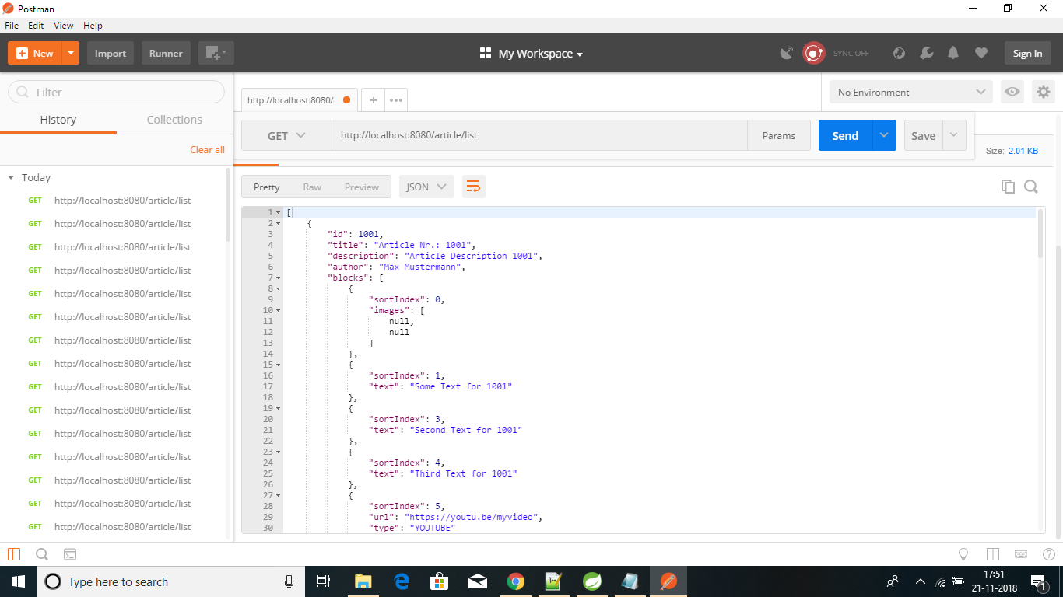

* When article found with particular article id

[***http://localhost:8080/article/2002***](http://localhost:8080/article/2002)

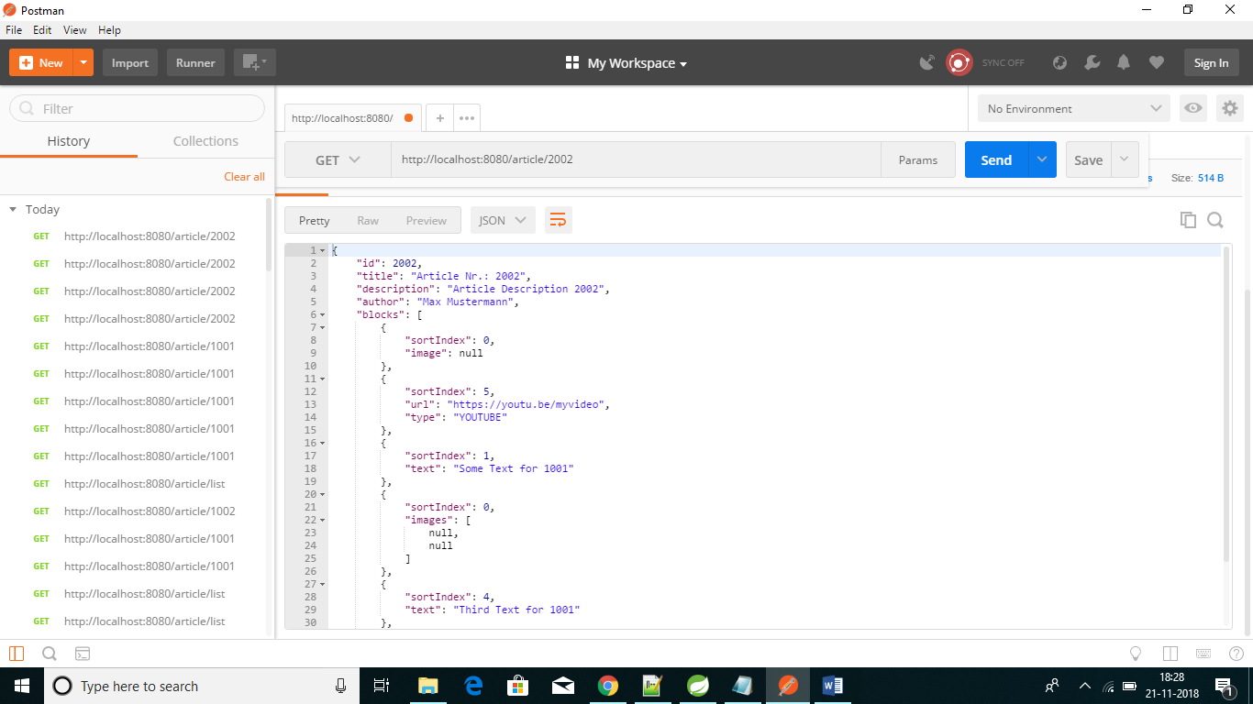

***http://localhost:8080/article/4004***

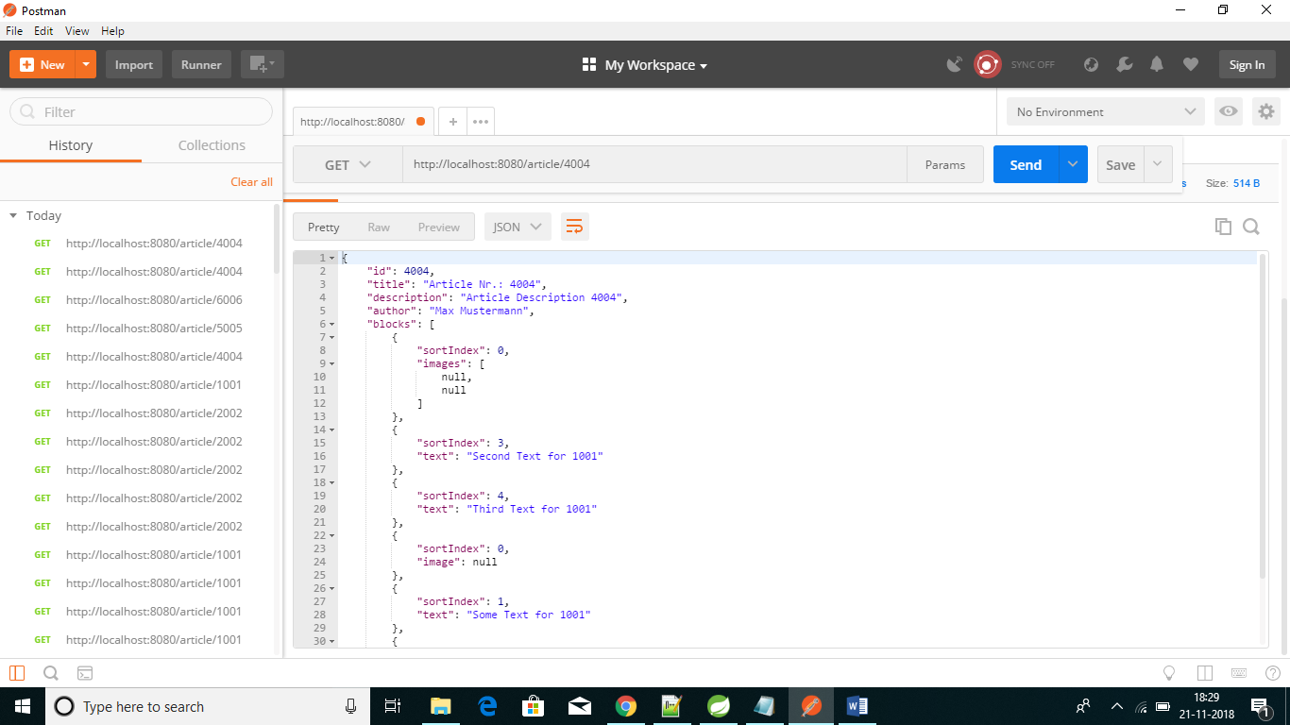

* in case an Article cannot be found via ID, a 404 shall be shown (see ArticleController#details)

<http://localhost:8080/article/10055>

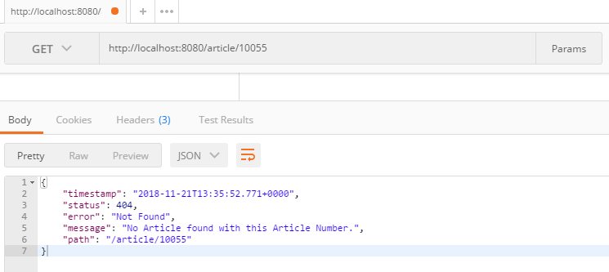

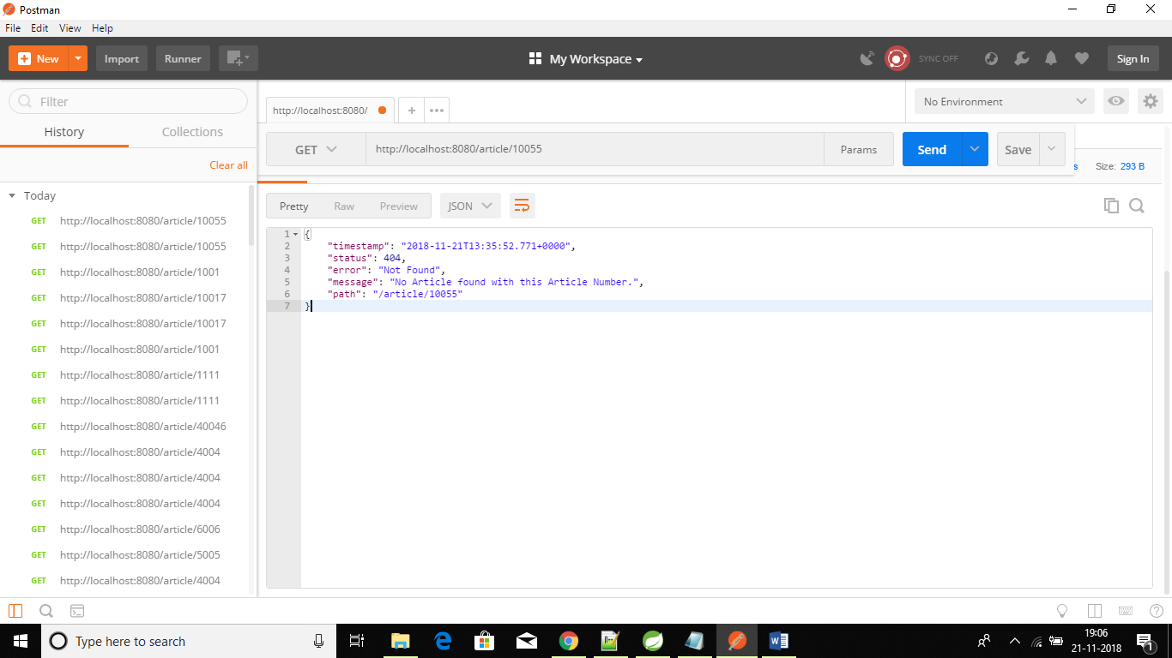

**Dependency Module Test Results**

* After an Inquiry has been created, EmailHandler#sendEmail(Inquiry) and PushNotificationHandler#sendNotification have to be executed.

Junit test case has been executed successfully in InquiryTest. After creating inquiry, it has also called EmailHandler#sendEmail(Inquiry) and PushNotificationHandler#sendNotification successfully.

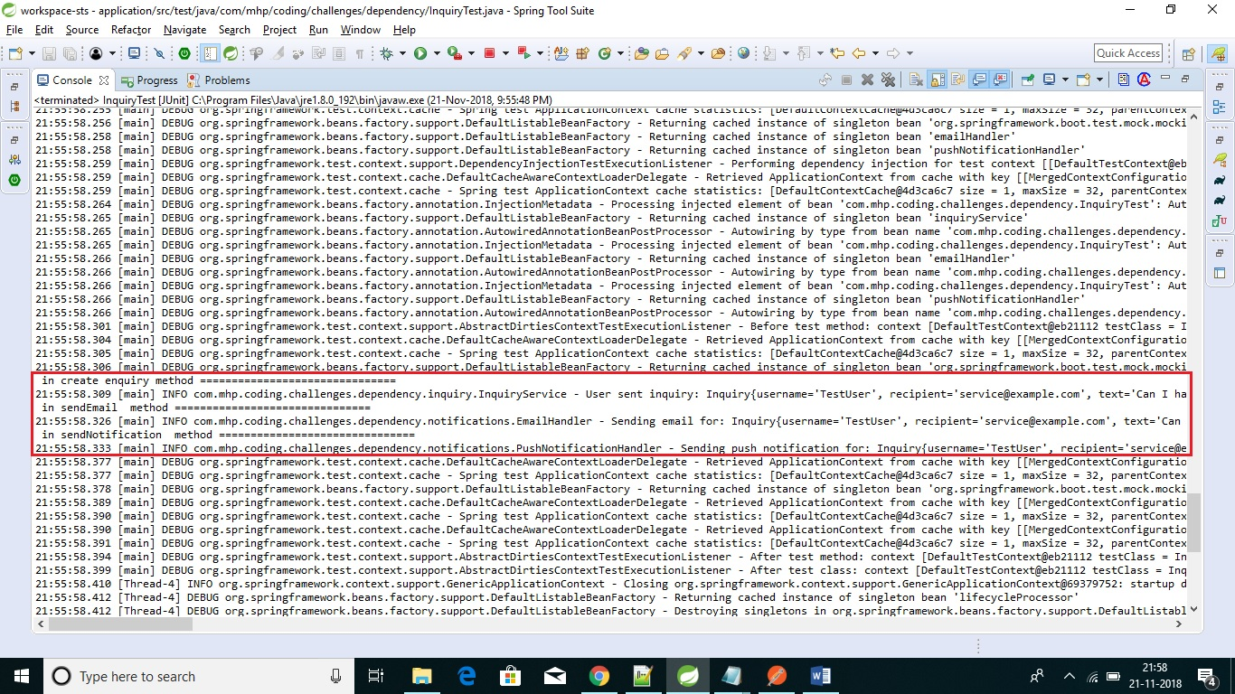

* the InquiryTest has to be successful

Log also printed the same message that Junit test case has been executed successfully after creating inquiry.

