Q1A:
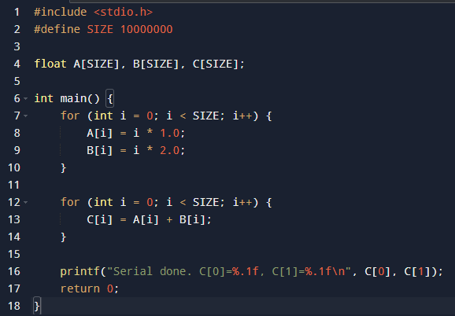
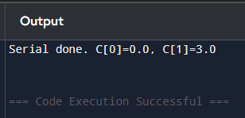

Q1B:
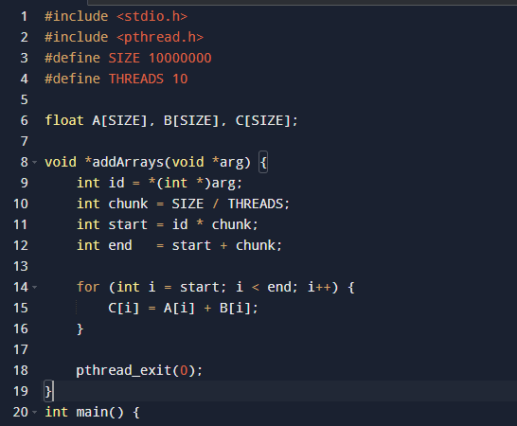
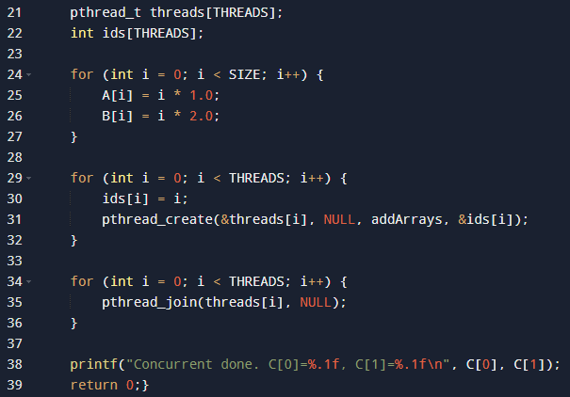
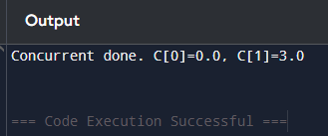
Q2:
#include <stdio.h>
#include <stdlib.h>
#include <pthread.h>

int nums[100];
int count;
double avg_result, max_result, min_result;
void *calcAvg(void *arg) {
double sum = 0;
for (int i = 0; i < count; i++)
sum += nums[i];
avg_result = sum / count;
pthread_exit(0);
}

void *calcMax(void *arg) {
max_result = nums[0];
for (int i = 1; i < count; i++)
if (nums[i] > max_result)
max_result = nums[i];
pthread_exit(0);
}

void *calcMin(void *arg) {
min_result = nums[0];
for (int i = 1; i < count; i++)
if (nums[i] < min_result)
min_result = nums[i];
pthread_exit(0);
}
int main(int argc, char *argv[]) {
count = argc - 1;
for (int i = 0; i < count; i++)
nums[i] = atoi(argv[i + 1]);
pthread_t t1, t2, t3;
pthread_create(&t1, NULL, calcAvg, NULL);
pthread_create(&t2, NULL, calcMax, NULL);
pthread_create(&t3, NULL, calcMin, NULL);
pthread_join(t1, NULL);
pthread_join(t2, NULL);
pthread_join(t3, NULL);
printf("The average value is %.0f\n", avg_result);
printf("The minimum value is %.0f\n", min_result);
printf("The maximum value is %.0f\n", max_result);
return 0;}
