Task 1: Create the following directory structure using a single command:
OSLAB2026 → LINUX → PRACTICE
Task 2: Create a file named intro.txt and write the text “Welcome to Linux Operating System”
into it.
Task 3: Create an empty file named copy.txt and copy the contents of intro.txt into copy.txt.
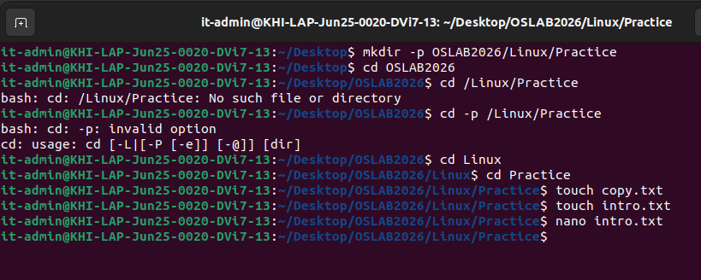
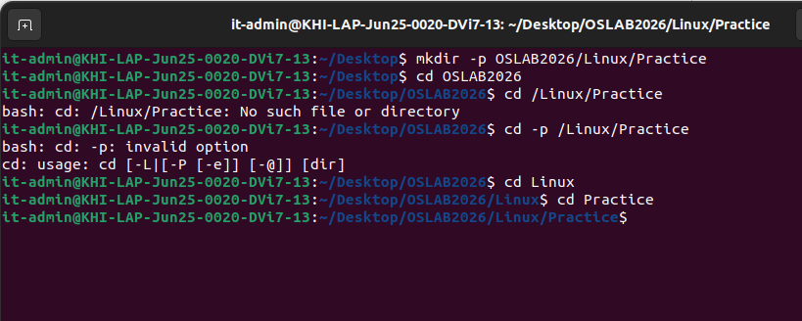
Task 4: Using one command line, move first to your home directory and then to your directory.

Task 3: Create an empty file named copy.txt and copy the contents of intro.txt into copy.txt.
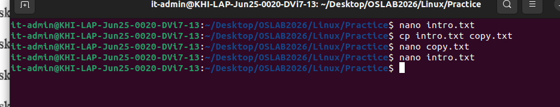
Task 4: Using one command line, move first to your home directory and then to your directory.
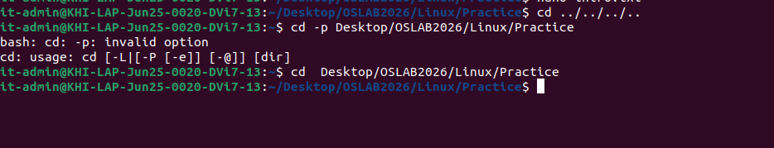
Task 5: Explain the difference between the cp and mv commands. Also, write the command to
move a file named notes.txt into a directory named docs.
Task 6: Rename the file intro.txt to linux_intro.txt.
Task 7: Display the contents of the file linux_intro.txt on the terminal using a suitable command.

cp = duplicate (source stays)
mv = relocate or rename (source changes location/name)
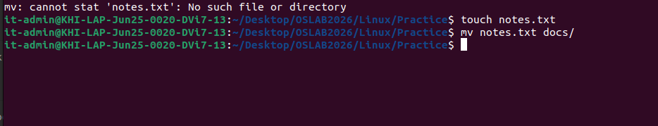
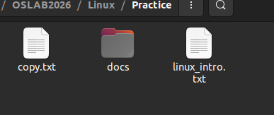
Task 8: List all files and directories in the current directory, including hidden files.
Task 9: Delete the file copy.txt. Then explain the difference between rm and rmdir.
rm : to remove files
rmdir: to remove dir

Task 10: Create a directory named backup and move all .txt files into it using a single command.

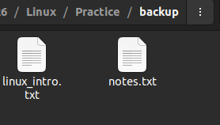
Task 11: Create a directory named projects inside your current directory.
Task 12: Inside the projects directory, create two subdirectories named project1 and project2 a single command.
using
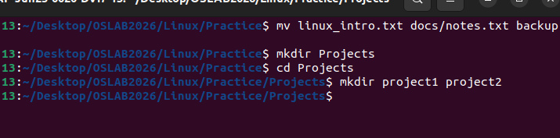

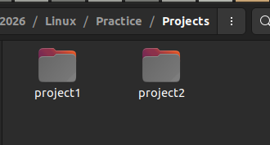
Task 13: Create a file named info.txt inside project1 and write the text “Operating System Lab

Work” into it.
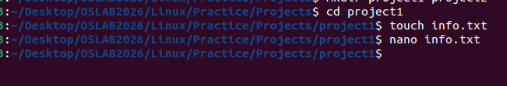
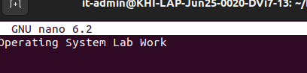

Task 14: Copy the file info.txt from project1 to project2.
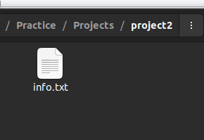
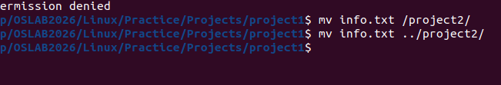

Task 15: Use a command to display the current working directory.
Task 16: Change the permissions of the file info.txt so that the owner has read and write
permissions only.
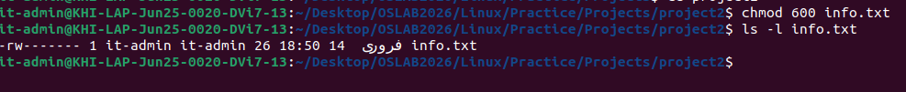

Task 17: Search for the word “Linux” inside the file info.txt using a command.
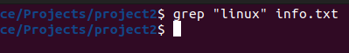
Task 18: Count the number of lines, words, and characters in the file info.txt.
Line:1
words:4
Text: 26
Task 19: Create a hidden file named .config and write any text into it.
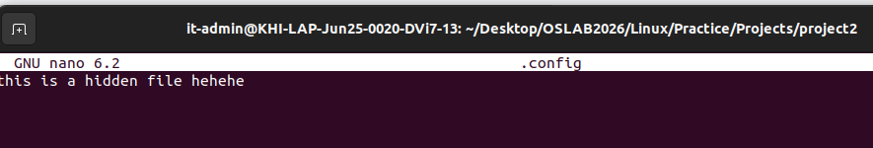
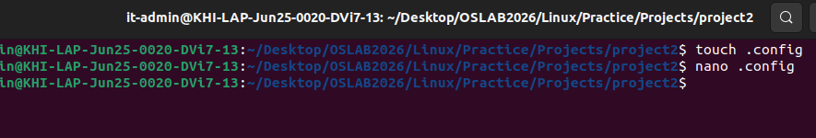
Task 20: Delete the directory project2 along with all its contents using a single command.

