1. Create a new user named student1 using CLI.
2. Set a password for the user student1.
3. Verify that the user student1 has been created successfully.

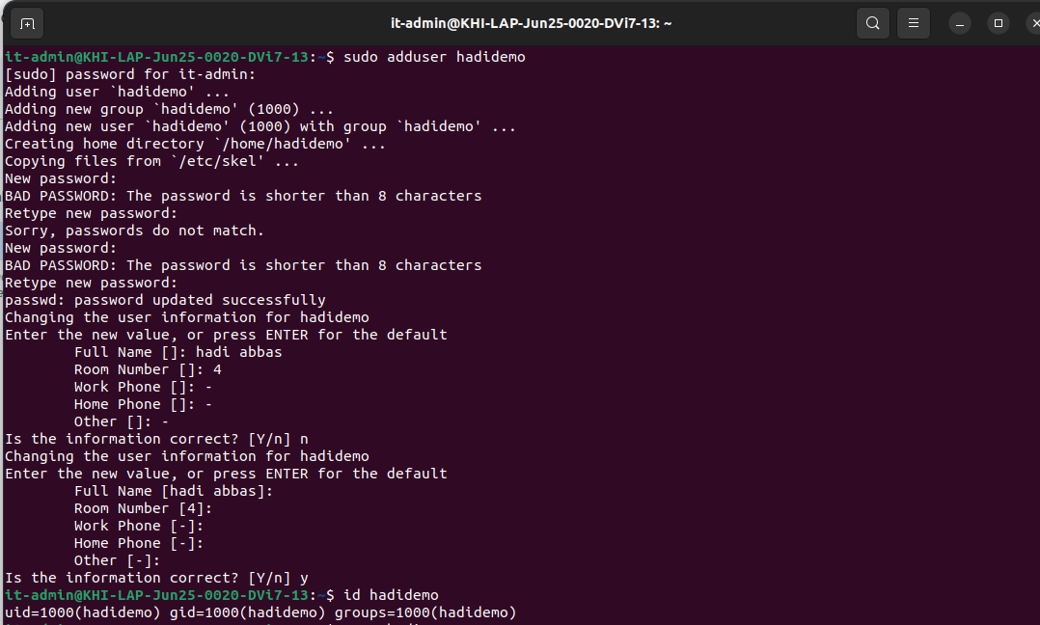

4. Login using the newly created user student1.
5. Display the currently logged-in user.
6. Create a directory named labwork in the home directory.
7. Navigate into the labwork directory.
8. Create a C source file named main.c.
9. Create another C source file named msg.c.
10. Create a header file named msg.h.

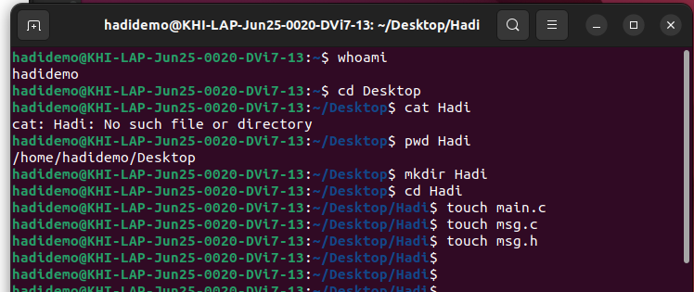
11. Write a C program where main.c calls a function defined in msg.c.

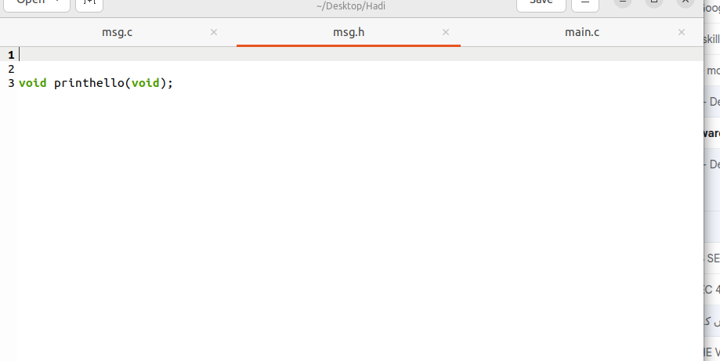
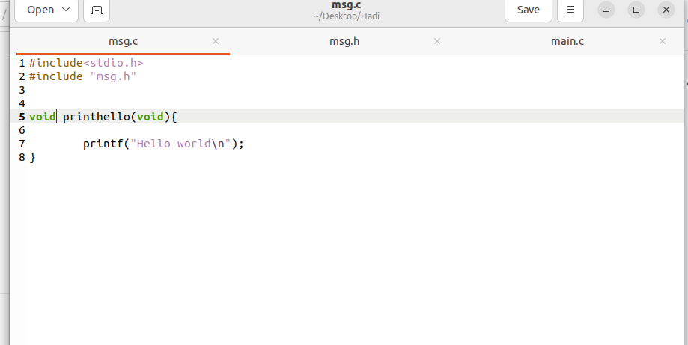
12. Compile both source files manually using gcc.
13. Execute the compiled program.

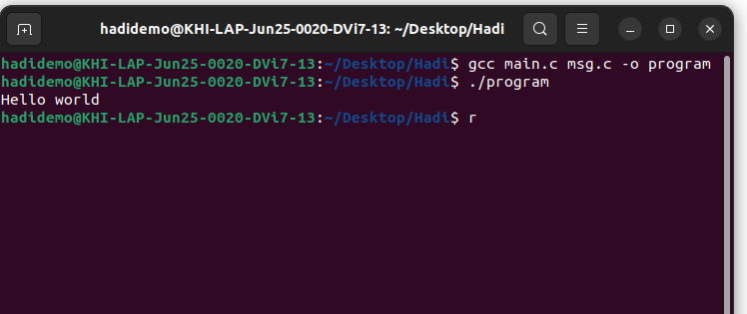

14. Create a file named file1.txt.
15. Write text into file1.txt.
16. Check the file permissions of file1.txt.
17. Change the permissions of file1.txt so only the owner can read and write.
18. Change the ownership of file1.txt to the root user.

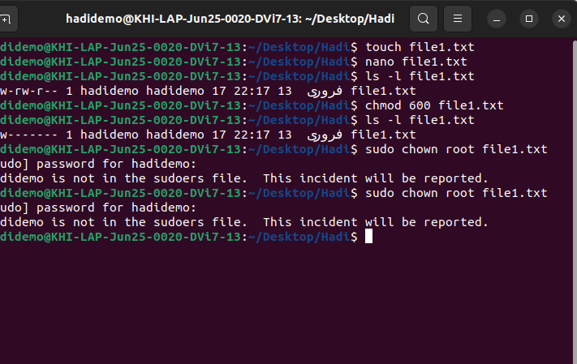

19. Create a Makefile to compile main.c and msg.c.
20. Use make and make clean to build and remove the executable.
