Task1:
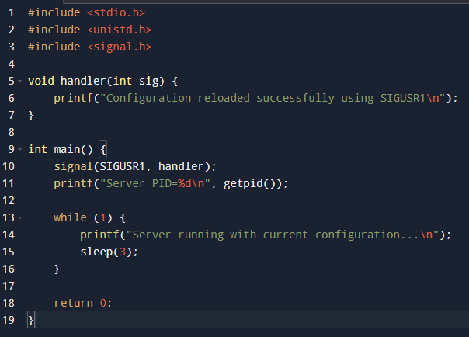
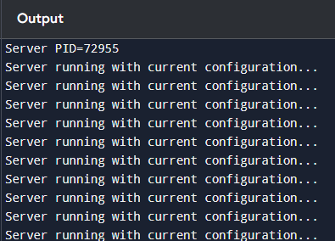

Task2:
#include <stdio.h>
#include <unistd.h>
#include <sys/types.h>
#include <sys/wait.h>
#include <signal.h>

void handler(int sig) {
int status;
pid_t pid = waitpid(-1, &status, WNOHANG);
printf("Worker terminated with PID=%d\n", pid);
}

int main() {
signal(SIGCHLD, handler);

for (int i = 1; i <= 3; i++) {
pid_t pid = fork();

if (pid == 0) {
printf("Worker %d started, PID=%d\n", i, getpid());
sleep(i * 2);
printf("Worker %d done, PID=%d\n", i, getpid());
return 0;
}
}

while (1) {
printf("Server running and monitoring workers...\n");
sleep(3);
}
return 0;
}
