LAB 6
TASK1:
#include <stdio.h> #include <stdlib.h> #include <string.h> #include <fcntl.h> #include <sys/stat.h> #include <unistd.h>

#define FIFO_REQ "/tmp/atm_request" #define FIFO_RESP "/tmp/atm_response" #define VALID_ACCOUNT "123456"
#define VALID_PIN "7890"
#define BALANCE 5000

int main() {
mkfifo(FIFO_REQ, 0666);
mkfifo(FIFO_RESP, 0666);

printf("[Server] Waiting for ATM requests...\n");

while (1) {
int req_fd = open(FIFO_REQ, O_RDONLY); char buffer[256];
ssize_t n = read(req_fd, buffer, sizeof(buffer) - 1); close(req_fd);
if (n <= 0) continue; buffer[n] = '\0';

printf("[Server] Received: %s\n", buffer);

char account[64], pin[64];
sscanf(buffer, "%63[^:]:%63s", account, pin);

char response[128];
if (strcmp(account, VALID_ACCOUNT) == 0 && strcmp(pin, VALID_PIN) == 0) snprintf(response, sizeof(response), "Valid, Balance: $%d", BALANCE);
else
snprintf(response, sizeof(response), "Invalid Credentials");

int resp_fd = open(FIFO_RESP, O_WRONLY); write(resp_fd, response, strlen(response)); close(resp_fd);

printf("[Server] Sent: %s\n\n", response);
}
return 0;
}

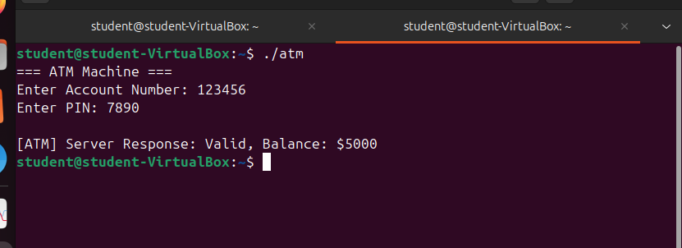
#include <stdio.h> #include <stdlib.h>

#include <string.h> #include <fcntl.h> #include <sys/stat.h> #include <unistd.h>

#define FIFO_REQ "/tmp/atm_request" #define FIFO_RESP "/tmp/atm_response"

int main() {
char account[64], pin[64];

printf("=== ATM Machine ===\n"); printf("Enter Account Number: "); scanf("%63s", account); printf("Enter PIN: ");
scanf("%63s", pin);

char request[256];
snprintf(request, sizeof(request), "%s:%s", account, pin);

int req_fd = open(FIFO_REQ, O_WRONLY); write(req_fd, request, strlen(request));
close(req_fd);

int resp_fd = open(FIFO_RESP, O_RDONLY); char response[128];
ssize_t n = read(resp_fd, response, sizeof(response) - 1); close(resp_fd);

response[n] = '\0';
printf("\n[ATM] Server Response: %s\n", response);

return 0;
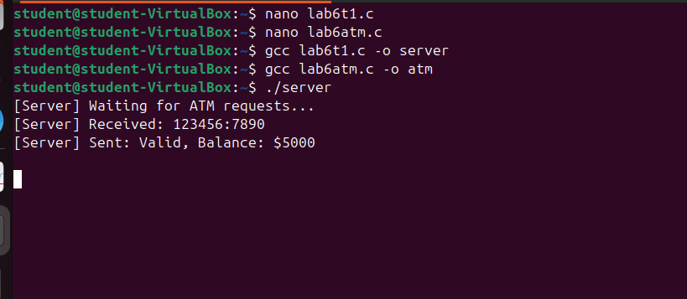
}

TASK2:
#include <stdio.h> #include <stdlib.h> #include <string.h> #include <unistd.h> #include <sys/wait.h>

int main() {
int pipefd[2]; pipe(pipefd);

pid_t pid = fork();

if (pid > 0) {
close(pipefd[0]);

float readings[][2] = {

{35.2f, 60.0f},
{41.5f, 75.0f},
{28.0f, 55.0f},
{43.0f, 80.0f},
{30.0f, 65.0f}
};

for (int i = 0; i < 5; i++) { char data[64];
snprintf(data, sizeof(data), "%.1f %.1f", readings[i][0], readings[i][1]); write(pipefd[1], data, strlen(data) + 1);
sleep(1);
}

close(pipefd[1]); wait(NULL);
} else {
close(pipefd[1]);

char data[64]; int num = 1;

while (read(pipefd[0], data, sizeof(data)) > 0) { float temp, humidity;
sscanf(data, "%f %f", &temp, &humidity);

printf("[Processor] Reading #%d -> Temp: %.1f C | Humidity: %.1f%%\n", num++, temp, humidity);

if (temp > 40.0f)
printf(" ALERT: High Temperature!\n\n");

else
printf(" Normal Weather Conditions.\n\n");
}

close(pipefd[0]);
}

return 0;
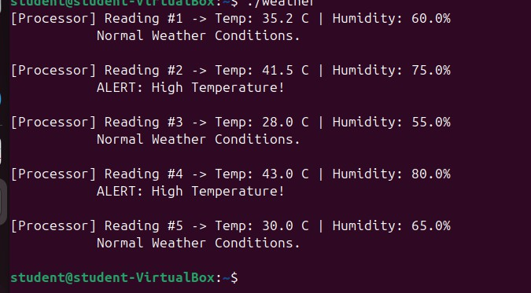
}

LAB 7
TASK1:
1.
AWT=7.25 MS ATAT=13.25MS

2.
AWT:3MS ATAT=8MS

3.
AWT=4.5MS ATAT=10MS

4.
AWT=12MS ATAT=18.5MS

5.
AWT=12.5MS ATAT=20MS

6.
AWT=7.25MS ATAT=12.75MS

7.
AWT=4MS ATAT=9.33MS

LAB8
TASK1:
#include <stdio.h> #include <pthread.h>

#include <time.h>

#define TOTAL 10000000
#define NUM_THREADS 5
#define PER_THREAD (TOTAL / NUM_THREADS)

int counter = 0;
pthread_mutex_t lock = PTHREAD_MUTEX_INITIALIZER;

long elapsed_ns(struct timespec s, struct timespec e) {
return (e.tv_sec - s.tv_sec) * 1000000000L + (e.tv_nsec - s.tv_nsec);
}

void *thread_increment(void *arg) { for (int i = 0; i < PER_THREAD; i++) {
pthread_mutex_lock(&lock); counter++;
pthread_mutex_unlock(&lock);
}
return NULL;
}

int main() {
struct timespec t_start, t_end; long serial_time, mt_time;

counter = 0;
clock_gettime(CLOCK_MONOTONIC, &t_start); for (int i = 0; i < TOTAL; i++) counter++;
clock_gettime(CLOCK_MONOTONIC, &t_end); serial_time = elapsed_ns(t_start, t_end);

printf("=== SERIAL ===\n");
printf("Start : %ld.%09ld\n", t_start.tv_sec, t_start.tv_nsec); printf("End : %ld.%09ld\n", t_end.tv_sec, t_end.tv_nsec); printf("Time : %.4f ms\n", serial_time / 1e6);
printf("Counter: %d\n\n", counter);

counter = 0;
pthread_t threads[NUM_THREADS];
clock_gettime(CLOCK_MONOTONIC, &t_start); for (int i = 0; i < NUM_THREADS; i++)
pthread_create(&threads[i], NULL, thread_increment, NULL); for (int i = 0; i < NUM_THREADS; i++)
pthread_join(threads[i], NULL);
clock_gettime(CLOCK_MONOTONIC, &t_end); mt_time = elapsed_ns(t_start, t_end);

printf("=== MULTITHREADED ===\n");
printf("Start : %ld.%09ld\n", t_start.tv_sec, t_start.tv_nsec); printf("End : %ld.%09ld\n", t_end.tv_sec, t_end.tv_nsec); printf("Time : %.4f ms\n", mt_time / 1e6);
printf("Counter: %d\n\n", counter);

printf("=== COMPARISON ===\n");
printf("Serial : %.4f ms\n", serial_time / 1e6);
printf("Multithreaded: %.4f ms\n", mt_time / 1e6); if (mt_time < serial_time)
printf("MT is %.2fx faster\n", (double)serial_time / mt_time); else
printf("MT is %.2fx slower (mutex overhead)\n", (double)mt_time / serial_time);

return 0;
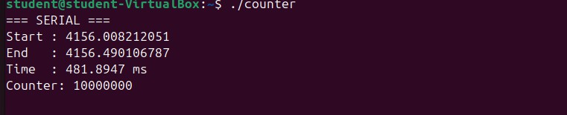
}

TASK2:
#include <stdio.h> #include <pthread.h> #include <time.h>

#define ARR_SIZE 1000000
#define NUM_THREADS 4
#define CHUNK (ARR_SIZE / NUM_THREADS)

int arr[ARR_SIZE]; long sum = 0;
pthread_mutex_t lock = PTHREAD_MUTEX_INITIALIZER;

long elapsed_ns(struct timespec s, struct timespec e) {
return (e.tv_sec - s.tv_sec) * 1000000000L + (e.tv_nsec - s.tv_nsec);
}

void *partial_sum(void *arg) { int tid = *(int *)arg;
int start = tid * CHUNK;
int end = start + CHUNK;

long local = 0;
for (int i = start; i < end; i++) local += arr[i];

pthread_mutex_lock(&lock); sum += local;
pthread_mutex_unlock(&lock); return NULL;
}

int main() {
for (int i = 0; i < ARR_SIZE; i++) arr[i] = i + 1;

struct timespec t_start, t_end; long serial_time, mt_time;

long serial_sum = 0;
clock_gettime(CLOCK_MONOTONIC, &t_start);
for (int i = 0; i < ARR_SIZE; i++) serial_sum += arr[i]; clock_gettime(CLOCK_MONOTONIC, &t_end); serial_time = elapsed_ns(t_start, t_end);

printf("=== SERIAL ===\n");
printf("Sum : %ld\n", serial_sum); printf("Time : %.4f ms\n\n", serial_time / 1e6);

sum = 0;
pthread_t threads[NUM_THREADS]; int tids[NUM_THREADS];
clock_gettime(CLOCK_MONOTONIC, &t_start); for (int i = 0; i < NUM_THREADS; i++) {

tids[i] = i;
pthread_create(&threads[i], NULL, partial_sum, &tids[i]);
}
for (int i = 0; i < NUM_THREADS; i++) pthread_join(threads[i], NULL);
clock_gettime(CLOCK_MONOTONIC, &t_end); mt_time = elapsed_ns(t_start, t_end);

printf("=== MULTITHREADED ===\n");
printf("Sum : %ld\n", sum);
printf("Time : %.4f ms\n\n", mt_time / 1e6);

printf("=== COMPARISON ===\n");
printf("Serial : %.4f ms\n", serial_time / 1e6);
printf("Multithreaded: %.4f ms\n", mt_time / 1e6);
printf("Speedup : %.2fx\n", (double)serial_time / mt_time);

return 0;
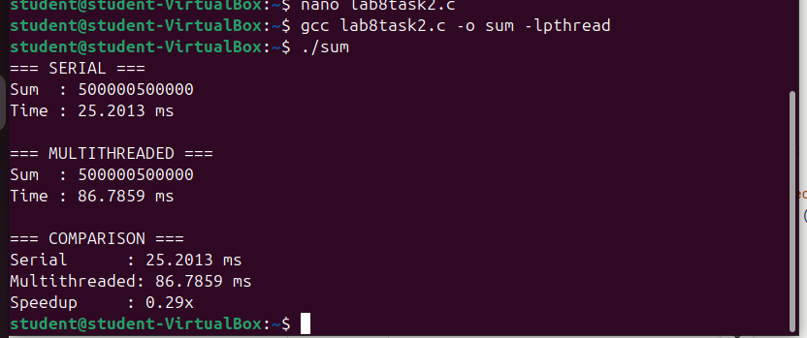
}

TASK3:
#include <stdio.h> #include <pthread.h> #include <time.h> #include <stdlib.h> #include <limits.h>

#define ARR_SIZE 1000000
#define NUM_THREADS 4
#define CHUNK (ARR_SIZE / NUM_THREADS)

int arr[ARR_SIZE];
int max_value = INT_MIN;
pthread_mutex_t lock = PTHREAD_MUTEX_INITIALIZER;

long elapsed_ns(struct timespec s, struct timespec e) {
return (e.tv_sec - s.tv_sec) * 1000000000L + (e.tv_nsec - s.tv_nsec);
}

void *find_max(void *arg) { int tid = *(int *)arg;
int start = tid * CHUNK;
int end = start + CHUNK;

int local_max = INT_MIN; for (int i = start; i < end; i++)
if (arr[i] > local_max) local_max = arr[i];

pthread_mutex_lock(&lock);
if (local_max > max_value) max_value = local_max; pthread_mutex_unlock(&lock);

return NULL;
}

int main() { srand(42);
for (int i = 0; i < ARR_SIZE; i++) arr[i] = rand() % 1000000;

struct timespec t_start, t_end; long serial_time, mt_time;

int serial_max = INT_MIN;
clock_gettime(CLOCK_MONOTONIC, &t_start); for (int i = 0; i < ARR_SIZE; i++)
if (arr[i] > serial_max) serial_max = arr[i];
clock_gettime(CLOCK_MONOTONIC, &t_end); serial_time = elapsed_ns(t_start, t_end);

printf("=== SERIAL ===\n");
printf("Max : %d\n", serial_max);
printf("Time : %.4f ms\n\n", serial_time / 1e6);

max_value = INT_MIN;
pthread_t threads[NUM_THREADS]; int tids[NUM_THREADS];
clock_gettime(CLOCK_MONOTONIC, &t_start); for (int i = 0; i < NUM_THREADS; i++) {
tids[i] = i;
pthread_create(&threads[i], NULL, find_max, &tids[i]);
}
for (int i = 0; i < NUM_THREADS; i++) pthread_join(threads[i], NULL);

clock_gettime(CLOCK_MONOTONIC, &t_end); mt_time = elapsed_ns(t_start, t_end);

printf("=== MULTITHREADED ===\n");
printf("Max : %d\n", max_value); printf("Time : %.4f ms\n\n", mt_time / 1e6);

printf("=== COMPARISON ===\n");
printf("Serial : %.4f ms\n", serial_time / 1e6);
printf("Multithreaded: %.4f ms\n", mt_time / 1e6);
printf("Speedup : %.2fx\n", (double)serial_time / mt_time);

return 0;



