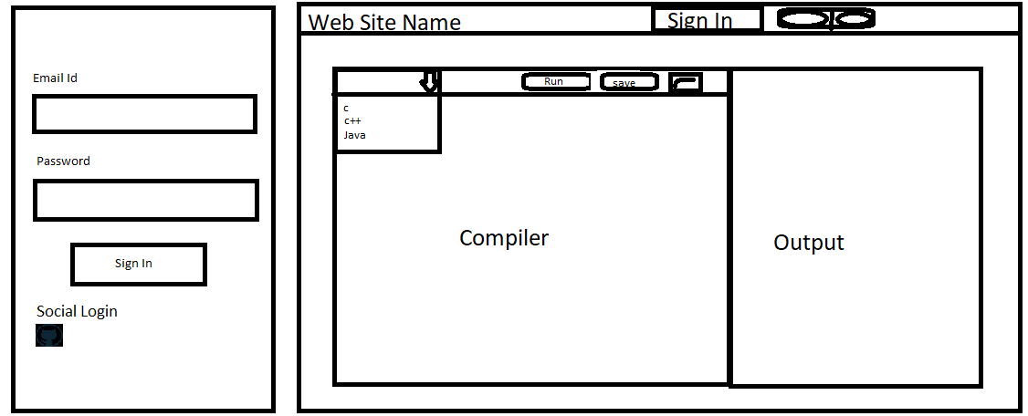

Points :-

* When Land on the website user can see the compiler to run their code using preferred language.
* Choose their preferred language.
* Run button can run the code. And Output is show us the result of code compilation.
* Save button can Save the code. But check the user is logged in or not. If not logged in, then user need to log in or sign up. User can also log in via their social media using GitHub.
* Output screen can show the output value.

Navigation

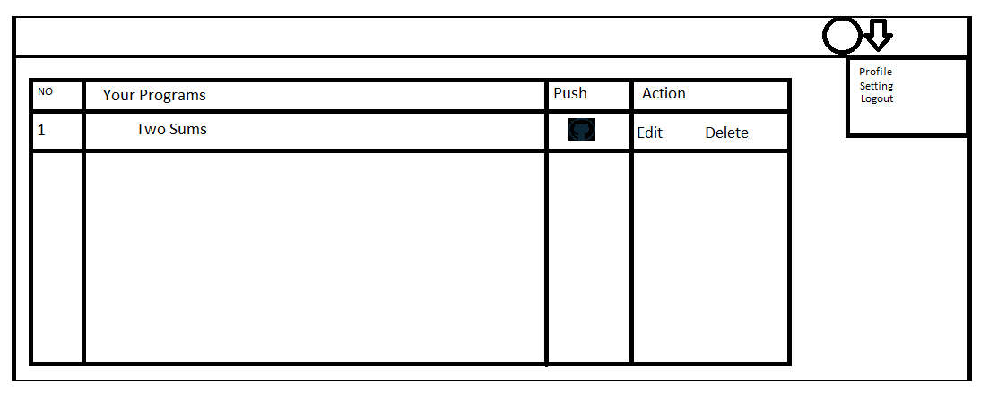

Points:-

* After Log in we can see a table where we fetch all of our saved code.
* There is a one function that is push button. Where user can push there code on github.
* Action column can edit or delete the code

**Code Save Page**

cancel

Save

Whole Code

Description Of the code

Name of the code