## Populating the Database from API url

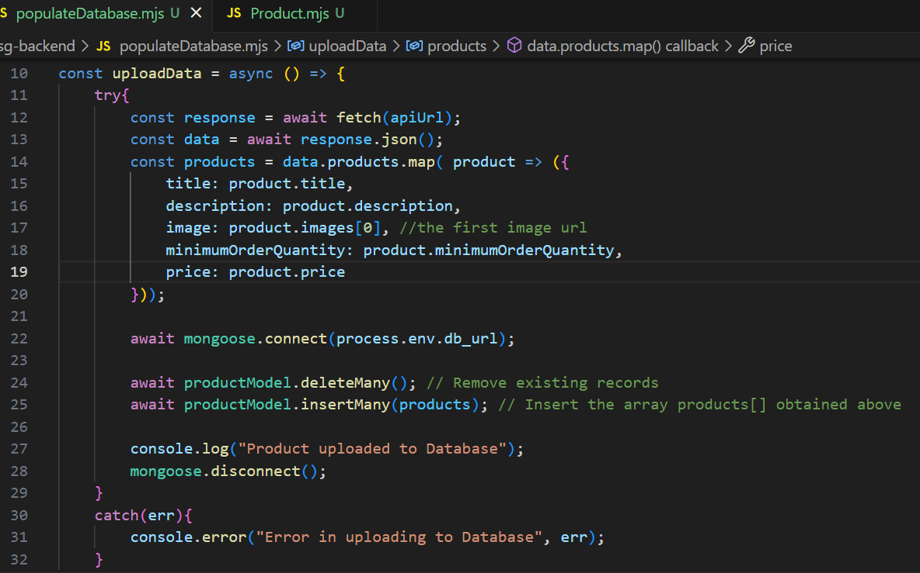



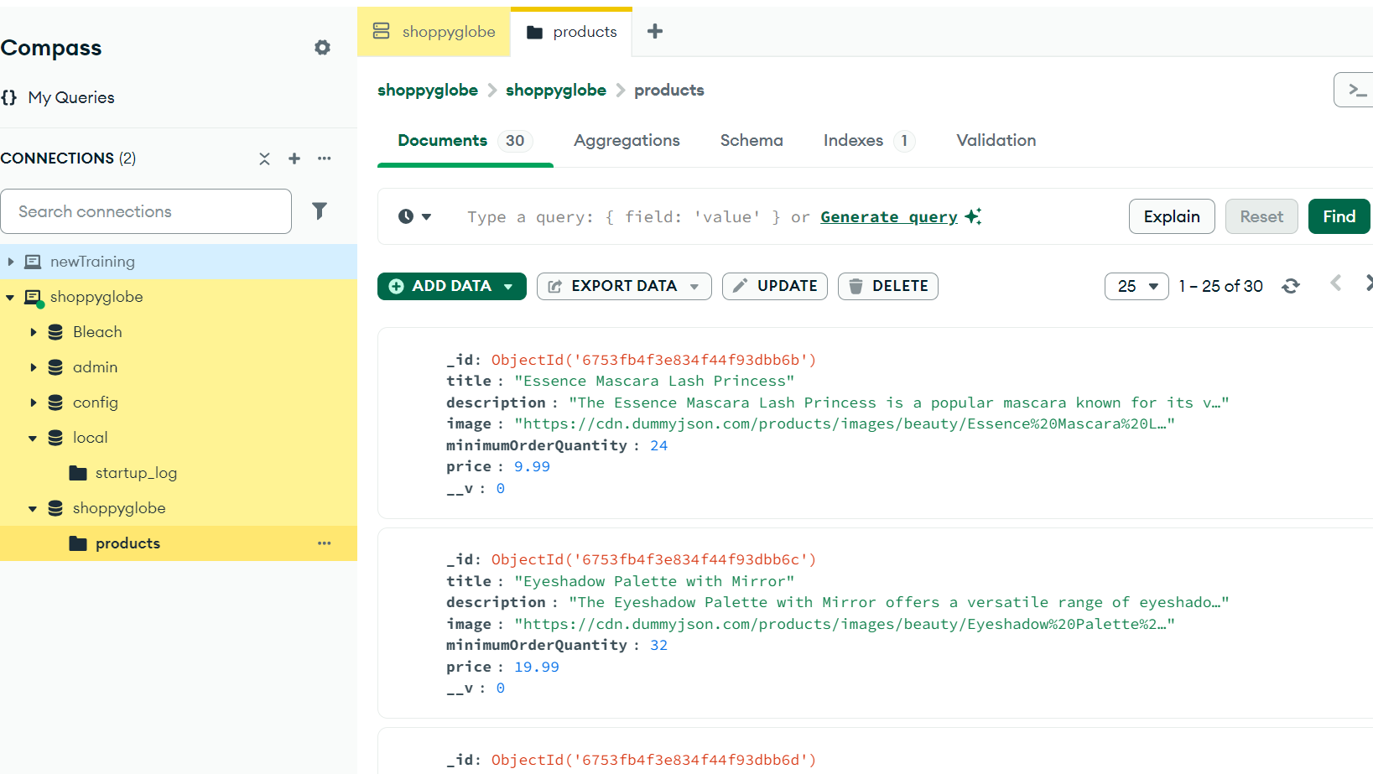

## GET /products: Fetch a list of products from MongoDB.

## GET /products/:id - Fetch details of a single product by its ID.

## POST /cart - Add a product to the shopping cart.

## PUT /cart/:id - Update the quantity of a product in the cart.

## DELETE /cart/:id - Remove a product from the cart.