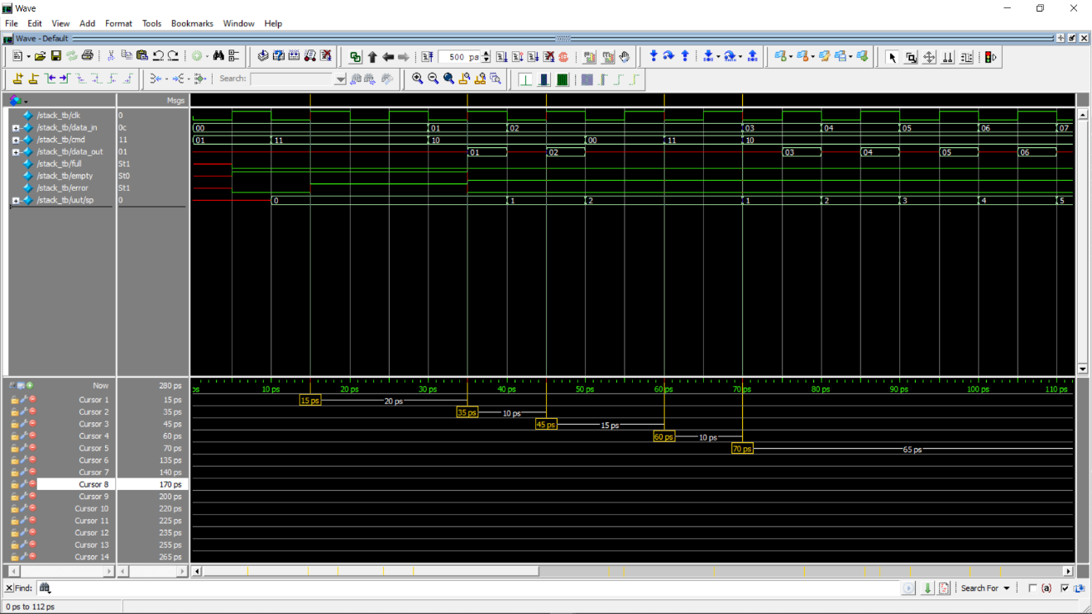堆疊作業的TB 4107064003葉舜良

@15ps, stack pointer @ 0, pop yields error and empty signal

@35ps, starting pushing, push 01,@45ps push 02.

@50ps ~ 70 ps , nop then pop stack pointer points to 1, then start pushing data

@70ps~135 ps, push data 03 04 05 06 07 08 09

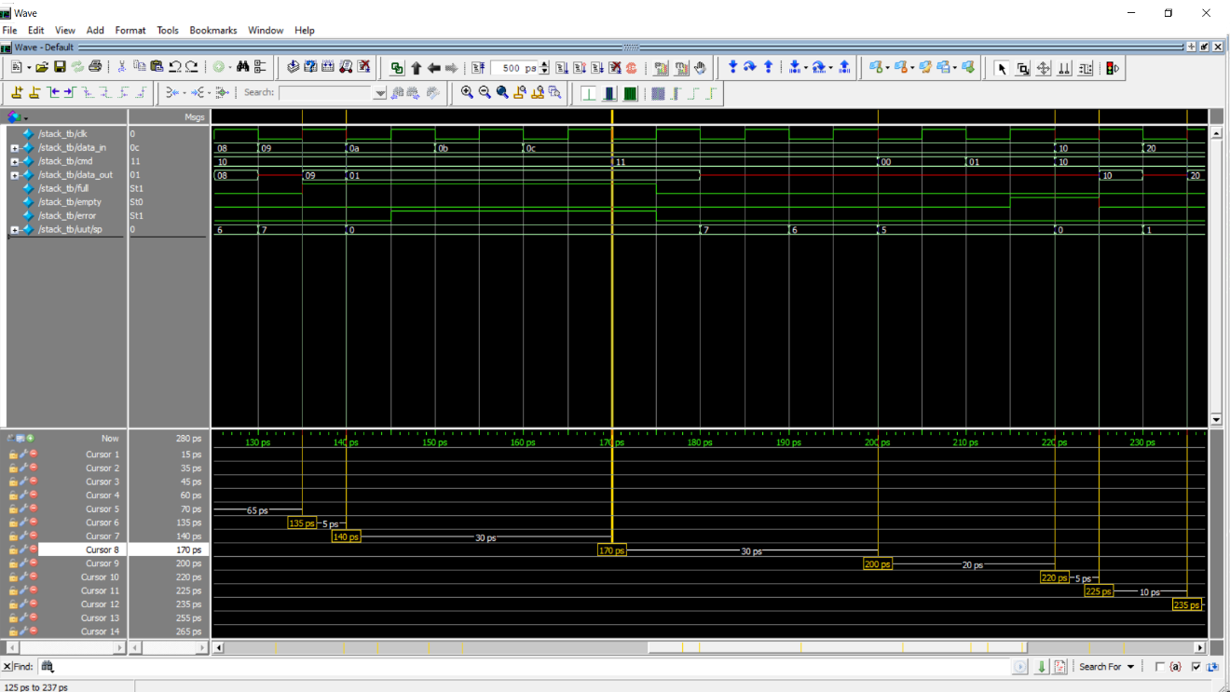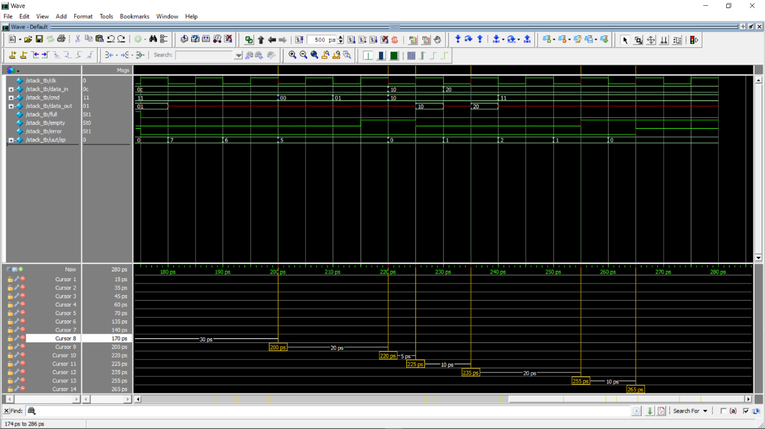@135ps stack is full.

@140ps, cmd push leads error signal rising.

@170ps~200ps, start popping

@210ps, nop + clear.

@220ps, push 10

@235 ps ,push 20. @255ps, finishing popping data. @265ps, already empty, raise error.