**Hardware accelerator for EV3a**

Student ID：7111064109 Name 林軒宇

Student ID：7111064108 Name 葉舜良

1. Introduction

Since EV3a algorithm has already existed. As a result, we would like to improve it performance by realizing a specific hardware architecture. Common technique in digital design involve pipelining, caching and so on. In this final project, we’ll be using these technique to reduce time complexity of EV3a algorithm.

1. Design Flow Chart

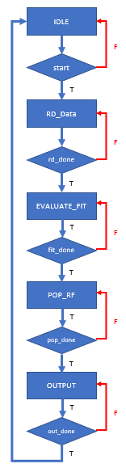 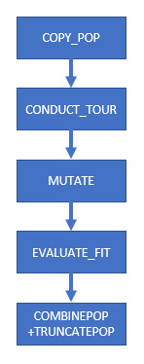

Fig. 2:POP_RF flow chart

Fig. 1:ASM Chart

1. Hardware specification

* Block diagram

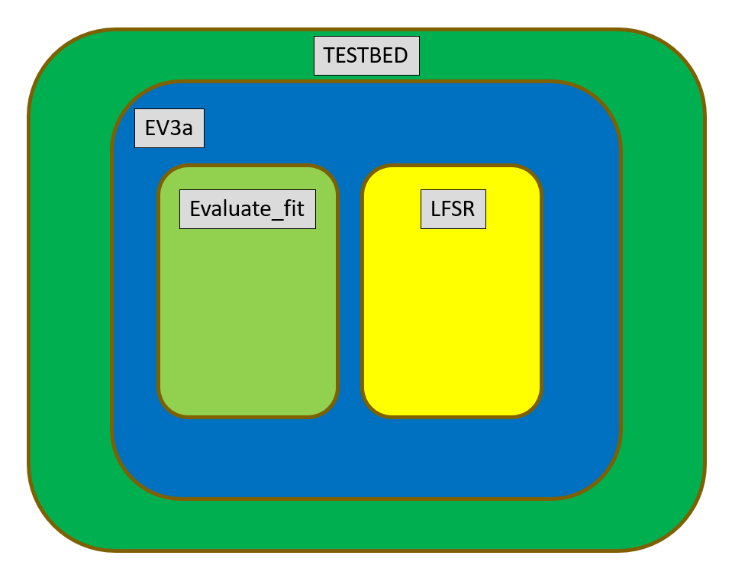

* Input-output interface

Evaluate fit

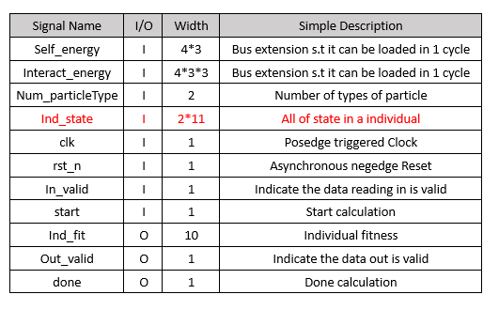

EV3a

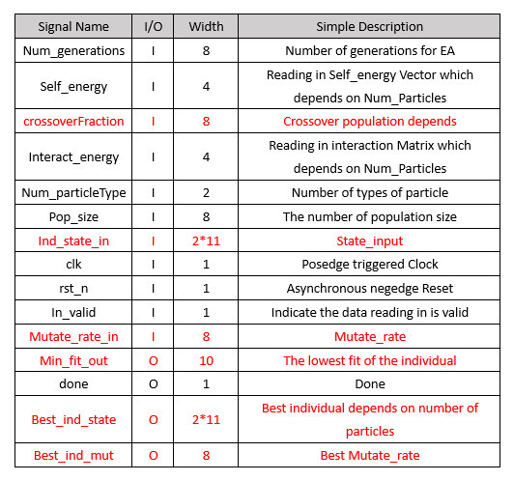

LFSR (linear feedback shift register)

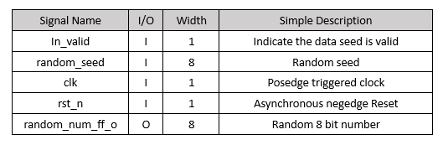

1. Expectation

We hope the output fitness will meet the expectation value. And the total calculation time(clk_period*clk_cycle time) can be as small as possible.

1. Reference

HW6 EV3a