

| Lee Sichello  Thunder-Clap Electronics  1234 Any St. Suite #15  Townsville, SK S4S5B9 | Tel: 306-529-7777  Fax: 306-555-1234  thunder_clap@electronics.ca |
| --- | --- |

**Prepared for: Eddy McDonald**

45 Nowhere Street, Regina, SK S4S0H3

tel (306) 589 9876

[eddy@mcdonald.ca](mailto:eddy@mcdonald.ca)

**Prepared by: Lee Sichello,** Thunder-Clap Electronics

987 Electric Avenue, Regina, SK S4S5B9

tel (306) 555 1234

[thunder_clap@electronics.ca](mailto:thunder_clap@electronics.ca)

**February 2nd, 2011**

**File Version:** 1.00A

**Proposal Number:** 5454-1

**Abstract**

Ed McDonald requested that a 'smart power bar' be designed to plug into a wall socket. Power usage on multiple sockets is to be logged and displayed on an LCD screen. Users must be able to input power costs per kWh and power bar is to make a slection of cost calculations for each outlet.

**Background**

There are a variety of energy meters available on the market but consumers are very limited in their options. The vast majority include only one outlet and are incapable of performing the cost calculations that many consumers find challenging.

**Proposal**

**Description**

A power bar will be created to measure the power usage for two 110 VAC electrical outlets on the module. Measurements will need to be logged in memory for averaging and cost calculations. To allow for input of local power costs, there will be a series of pushbuttons for user control. Users will have an option to input local power costs as well as a series of easily selectable options for what is displayed on the LCD screen. All displayed measurements and calculations must be within 10% error.

**Overview and Operation**

The user selectable options on the LCD screen for each device must include:

* Instantaneous current use
* Instantaneous power use
* Average energy use
* Total energy use
* Estimated cost per day of operation

Users will be able to page through these options at will.

Put simply, electrical power usage at any instant is the product of voltage and current. Since this device will be used with 110 V, 50Hz AC, only current will be measured. Any deviations from true 110 VAC residential power will be made up for by my 10% error margin.

Current sensing will be done via a series of current transformers (CT's). Current will be sampled, via and ADC, at a much higher frequency than the 50Hz supply power. By logging many samples each cycle, an RMS current calculation can be made and saved at regular time intervals (at least once a second), then samples may be cleared from memory. Each time RMS current is calculated, energy use will be calculated via:

**E = P**rms * **Time Elapsed**

Rather than keeping an indefinite running total of consumed energy, the unit will accumulate up to 0.01 kWh (the resolution of the screen) then increment. By keeping track of the energy consumed and the cost per kWh, it is straight forward to calculate the cumulative cost or forecast the cost per day of an appliance.

The unit will be powered up and acquiring data whenever plugged into a wall socket. If unplugged, all former data will be cleared from memory. This can also be achieved by means of a master reset button. Users can also reset the data for individual channels using the pushbuttons.

Upon startup, the device will enter a default mode of operation and remain there until the user interrupts it via the inputs. Interrupts include selecting display options and entering the “PROGRAM” mode to input local power costs.

**Operating Conditions and Safety**

Being a high voltage device, safety is a major concern. For this reason, the unit will be electrically isolated from the 110 VAC with the exception of the step-down transformer used in the power supply. The current transformers will provide this isolation.

To protect from over-current, the main input will be equipped with either a fuse or circuit breaker. The unit must be able to operate between 0 and 50 degrees Celsius (domestic use) with humidity up to 80%.

**Physical Packaging**

The prototype will be housed completely within a 10x6x3.5” aluminum project box. The box will have a single power cord for 110 VAC power connection.

**Budget**

The budget for the initial working prototype is a fixed cost of $3000. The production power bars must be under $100 though. If it is not built by the deadline, a discount of 10% per month will be given until the project is finished.

**Optional Additional Features**

For safety considerations, surge protection may be added to cut power in such an event. Also, ground-fault interruption could be implemented by measuring return current on the neutral main line. If this current is not equal to the sum of the currents in the devices, power should be cut and a signal LED triggered.

Time permitting, an on-board battery powered clock could be added to the unit. Then users could set the time and schedule times for devices to turn off/on throughout the day.

**Bill Of Materials**

1. Master Control Unit
   1. Microprocessor
      1. Wytec Dragon12 module (selected for its second hand availability)
   2. Analog Inputs
      1. Push Buttons
      2. Analog to Digital Conversion
         1. HC9S12 A/D 8 or 10 bit Sigma Delta ADC
         2. Input conditioning
            1. LM358 Low Power, Single Supply, Dual Operational Amp
            2. Resistors and capacitors as required to filter and scale input
   3. Digital Outputs
      1. Hitachi 44780 LCD Controller
   4. Power Supply
      1. Universal AC/DC Power Adaptor Supplies +5 to +7VDC power
2. Current Sense
   1. Current Transformers - (2) CT1015 , 1:1000, 15Amp
3. Wiring and Connectors
   1. Power Cable (110VAC) – 14 Guage, LIVE/NTRL/GND stranded wire’
   2. 1 Male, 2 Female Standard 110VAC Plugs
   3. Signal Jumpers – Connect Current Sense to MCU
4. Safety
   1. Circuit Breaker (8 Ohm)

**Logical and Physical Layout**

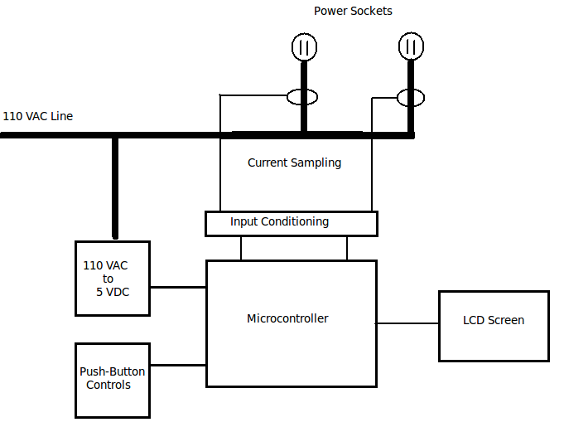

Logical Connection Diagram

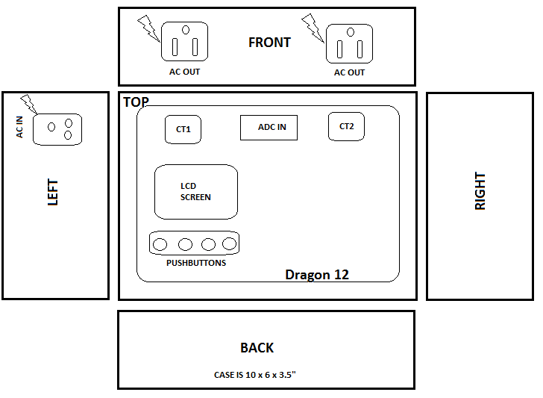

Physical Layout Diagram

**Input Conditioning**

The output from the CT’s is an AC voltage proportional to the current being used. In order to interface this with the ADC inputs, it must be scaled from 0-5V. To do this, the CT voltage is half-wave rectified, then passed through a single supply (+5V) op-amp which acts as a protective buffer. The half-waves are then smoothed to a DC signal by capacitors. The circuit looks as follows:

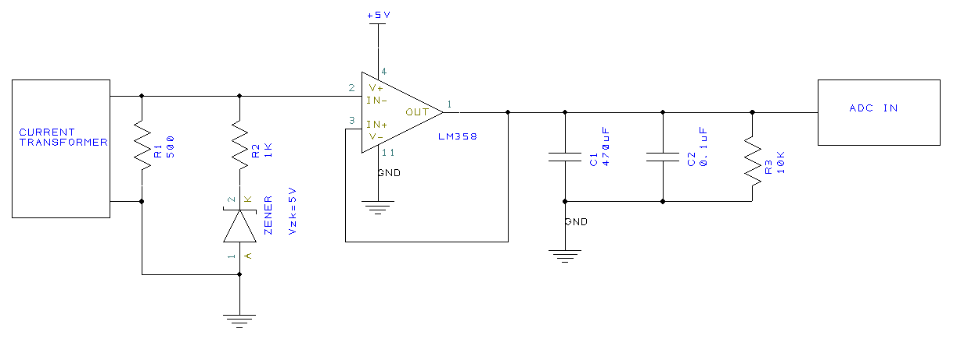

**LCD/Pushbutton Interface**

When plugged in, the unit will boot to a default mode. In this mode, it will simply display the average power use for outlet 1, as indicated below.

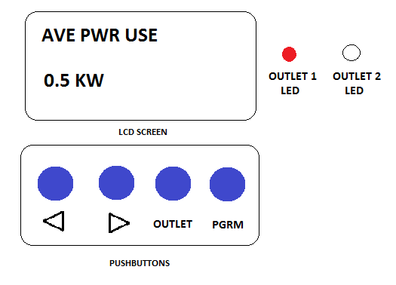

To change between outlets (indicated by LED’s) simply hit the OUTLET button. In order to clear the data for the present outlet, hold down the OUTLET button for 4 seconds. To toggle display options for the present outlet use the LEFT and RIGHT arrows. In order to program in the cost per kWh you are being charged, press the PGRM button then use the LEFT and RIGHT arrows to set the value. Once the value is set, hit PGRM again to return to normal display, or wait for 10 seconds.

**Software Design**

The main program of the firmware will initialize the hardware and interrupts, then wait for interrupts to set a proceed flag to continue. The interrupt routines will be used to perform measurements, do calculations and set flags for use in the main program. The interrupts used will be:

* Real-Time Interrupts
  + Sample current 5 times per 60Hz AC cycle (that is, every 3 ms), log data.
  + Calculate instantaneous current & power use, and update total energy use every 60 AC cycles (every 1s)
  + Estimate average energy use and cost per day every 180 cycles (every 3s)
  + Check pushbutton status (every 1ms)

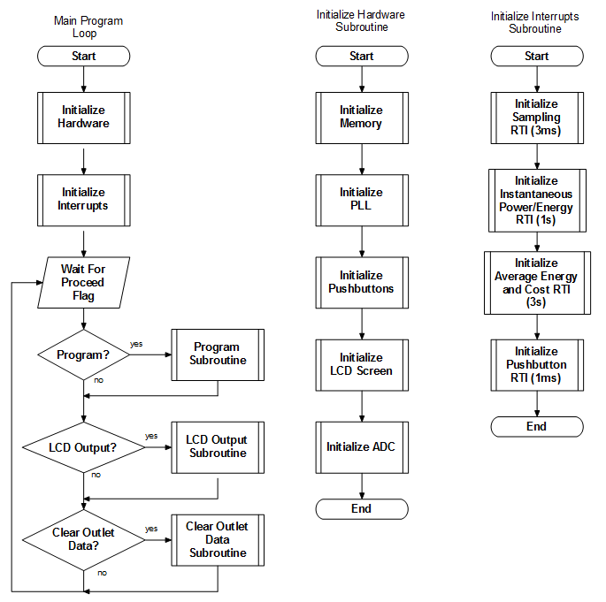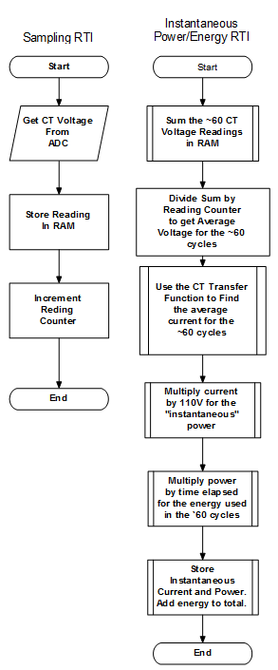

Flow Chart Of Main Program and Some RTI’s (more to come).

**System Testing**

Testing will be done using an in-line AC ammeter (to measure actual current flow) and a load with variable resistance. The current will be ramped up and the ammeter readings will be compared to the instantaneous current readings on the unit to ensure that the two are within a 10% agreement.

**Detailed Schedule**

1. Complete Input Conditioning circuit – by Mar 12
   1. Finish prototyping
   2. Develop transfer function for current vs. voltage output
   3. Solder together
2. Assemble project in aluminum housing – by Mar 17
   1. Wire in AC circuitry
   2. Fix input conditioning board and Dragon 12 in place
3. Push button interrupts – by Mar 20
   1. Program proper reaction for each button
4. Real-time interrupts – by Mar 25
   1. Aquire current samples
   2. Do power and cost calculations
5. Troubleshoot and Complete Unit – by Apr 3