

| Lee Sichello  Thunder-Clap Electronics  1234 Any St. Suite #15  Townsville, SK S4S5B9 | Tel: 306-529-7777  Fax: 306-555-1234  thunder_clap@electronics.ca |
| --- | --- |

**Prepared for: Eddy McDonald**

45 Nowhere Street, Regina, SK S4S0H3

tel (306) 589 9876

[eddy@mcdonald.ca](mailto:eddy@mcdonald.ca)

**Prepared by: Lee Sichello,** Thunder-Clap Electronics

987 Electric Avenue, Regina, SK S4S5B9

tel (306) 555 1234

[thunder_clap@electronics.ca](mailto:thunder_clap@electronics.ca)

**February 2nd, 2011**

**File Version:** 1.00A

**Proposal Number:** 5454-1

**Abstract**

Ed McDonald requested that a 'smart power bar' be designed to plug into a wall socket. Power usage on multiple sockets is to be logged and displayed on an LCD screen. Users must be able to input power costs per kWh and power bar is to make a slection of cost calculations for each outlet.

**Background**

There are a variety of energy meters available on the market but consumers are very limited in their options. The vast majority include only one outlet and are incapable of performing the cost calculations that many consumers find challenging.

**Proposal**

**Description**

A power bar will be created to measure the power usage for the 2 (or 3) 110 VAC electrical outlets on the module. Measurements will need to be logged in memory for averaging and cost calculations. To allow for input of local power costs, there will be a series of pushbuttons for user control. Users will have an option to input local power costs as well as a series of easily selectable options for what is displayed on the LCD screen. All displayed measurements and calculations must be within 10% error.

**Overview and Operation**

The user selectable options on the LCD screen for each device must include:

* Total energy consumed
* Average power levels
* Estimated cumulative operation cost
* Estimated cost per day of operation

Users will be able to page through these options at will.

Put simply, electrical power usage at any instant is the product of voltage and current. Since this device will be used with 110 V, 50Hz AC, only current will be measured. Any deviations from true 110 VAC residential power will be made up for by my 10% error margin.

Current sensing will be done via a series of current transformers (CT's). Current will be sampled, via and ADC, at a much higher frequency than the 50Hz supply power. By logging many samples each cycle, an RMS current calculation can be made and saved at regular time intervals (at least once a second), then samples may be cleared from memory. Each time RMS current is calculated, energy use will be calculated via:

**E = P**rms * **Time Elapsed**

Rather than keeping an indefinite running total of consumed energy, the unit will accumulate up to 0.01 kWh (the resolution of the screen) then increment. By keeping track of the energy consumed and the cost per kWh, it is straight forward to calculate the cumulative cost or forecast the cost per day of an appliance.

The following block diagram loosely illustrates the components and interfaces:

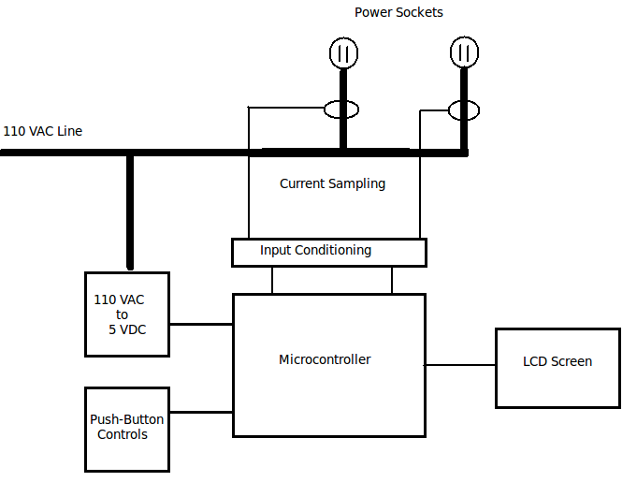

The unit will be powered up and acquiring data whenever plugged into a wall socket. If unplugged, all former data will be cleared from memory. This can also be achieved by means of a master reset button. Users can also reset the data for individual channels using the pushbuttons.

Upon startup, the device will enter a default mode of operation and remain there until the user interrupts it via the inputs. Interrupts include selecting display options or entering the “PROGRAM” mode to input local power costs.

**Operating Conditions and Safety**

Being a high voltage device, safety is a major concern. For this reason, the unit will be electrically isolated from the 110 VAC with the exception of the step-down transformer used in the power supply. The current transformers will provide this isolation.

To protect from over-current, the main input will be equipped with either a fuse or circuit breaker. The unit must be able to operate between 0 and 50 degrees Celsius (domestic use) with humidity up to 80%.

**Physical Packaging**

The size of the prototype power board must be under 35x20x10 cm. If a metal encloure is used, it must be grounded.

**Budget**

The budget for the initial working prototype is a fixed cost of $3000. The production power bars must be under $80 though. If it is not built by the deadline, a discount of 10% per month will be given until the project is finished.

**Optional Additional Features**

For safety considerations, surge protection may be added to cut power in such an event. Also, ground-fault interruption could be implemented by measuring return current on the neutral main line. If this current is not equal to the sum of the currents in the devices, power should be cut and a signal LED triggered.

Time permitting, an on-board battery powered clock could be added to the unit. Then users could set the time and schedule times for devices to turn off/on throughout the day.