**CS1021: Assignment #1**

My report on the first computing assignment is as follows:

I started with the keil uvision template found on blackboard and in time updated it with the new, updated template which included a message which gets displayed in the console upon running the program.

**1.1:**

The first part of the problem was rather simple as I was given a code which echoes back inputs to the console. The most obvious start was converting the input from ascii characters to hexadecimal by subtracting the number 0x30 from it. By multiplying the now hexadecimal number by 10 and adding it to a total we get the number inputted to be displayed proudly in R4. Every time the loop goes around with a new number the running total would increase by a factor of 10 and add the new number. This is a simple yet elegant solution to the problem at hand.

**1.2:**

To calculate the loop count we add 1 to R6 every time the loop runs. I also used a simple solution to calculate the sum of each of the numbers in the number inputted. To calculate the maximum or the biggest number out of the inputted number I first took the first number into R8. When the loop came back I compared the second number to the number now in R8, if the number is greater than the previous one it replaces it, otherwise the loop keeps on running and the same happens for the next and next number. The minimum number calculation commences with comparing the first digit to the largest hexadecimal number possible. If it its less than the other number it is now stored in R9. This repeats till the numbers over. The mean is a more sophisticated design. It compares the loop count to the sum count and proceeds to subtract the loop count from the sum. Every time is happens 1 is added to the mean count. This works in every test and with any digits.

**1.3:**

I wasn’t able to display the mean as all of my attempts proved unsuccessful. I did however manage to customise my console using fputs.

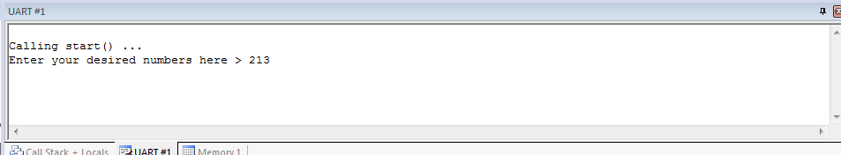

As you can see above I used the number 213 for testing purposes.

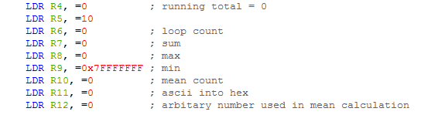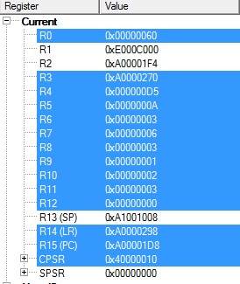

The total which is 213 is displayed in R4.

R5 was used in the process of calculating the total.

R6 displays the loop count which is 3 (1+1+1).

R7 holds the sum which is 6 (2+1+3).

R8 has the maximum number which is 3.

R9 has the minimum number which is 1.

R10 is the mean which is 2 ((2+1+3)/3)

The output is clearly correct and was also verified to be correct by the teaching assistants on Friday.