Q1.

1. O1 to MUX6

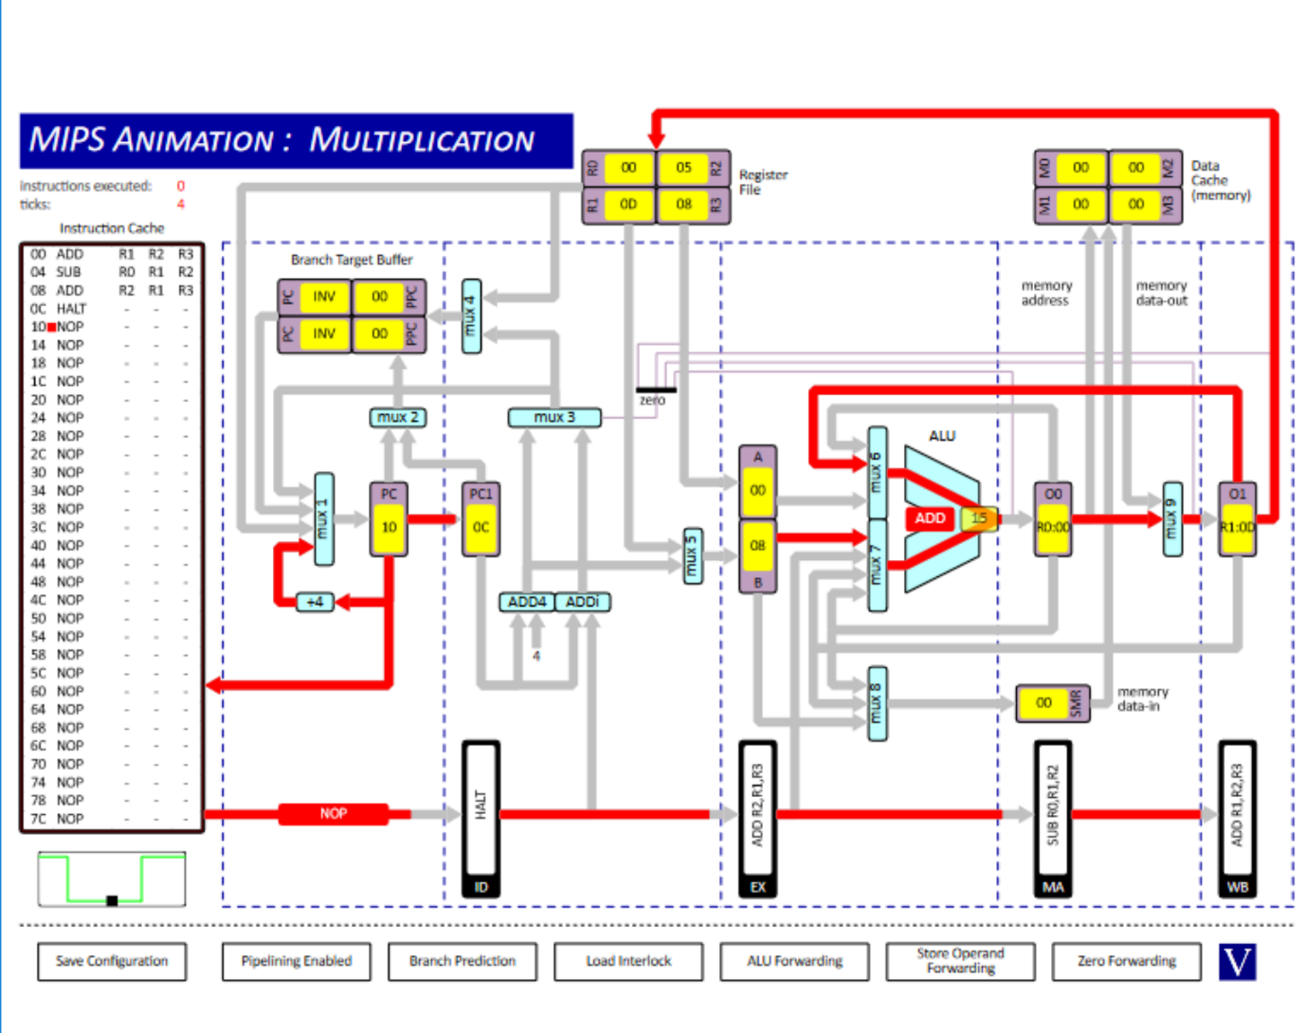

1. O0 to MUX7 and O1 to MUX6



1. O0 to MUX8

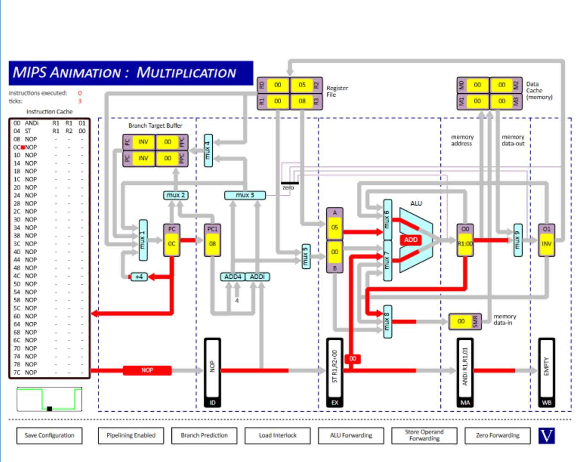

1. EX to MUX7

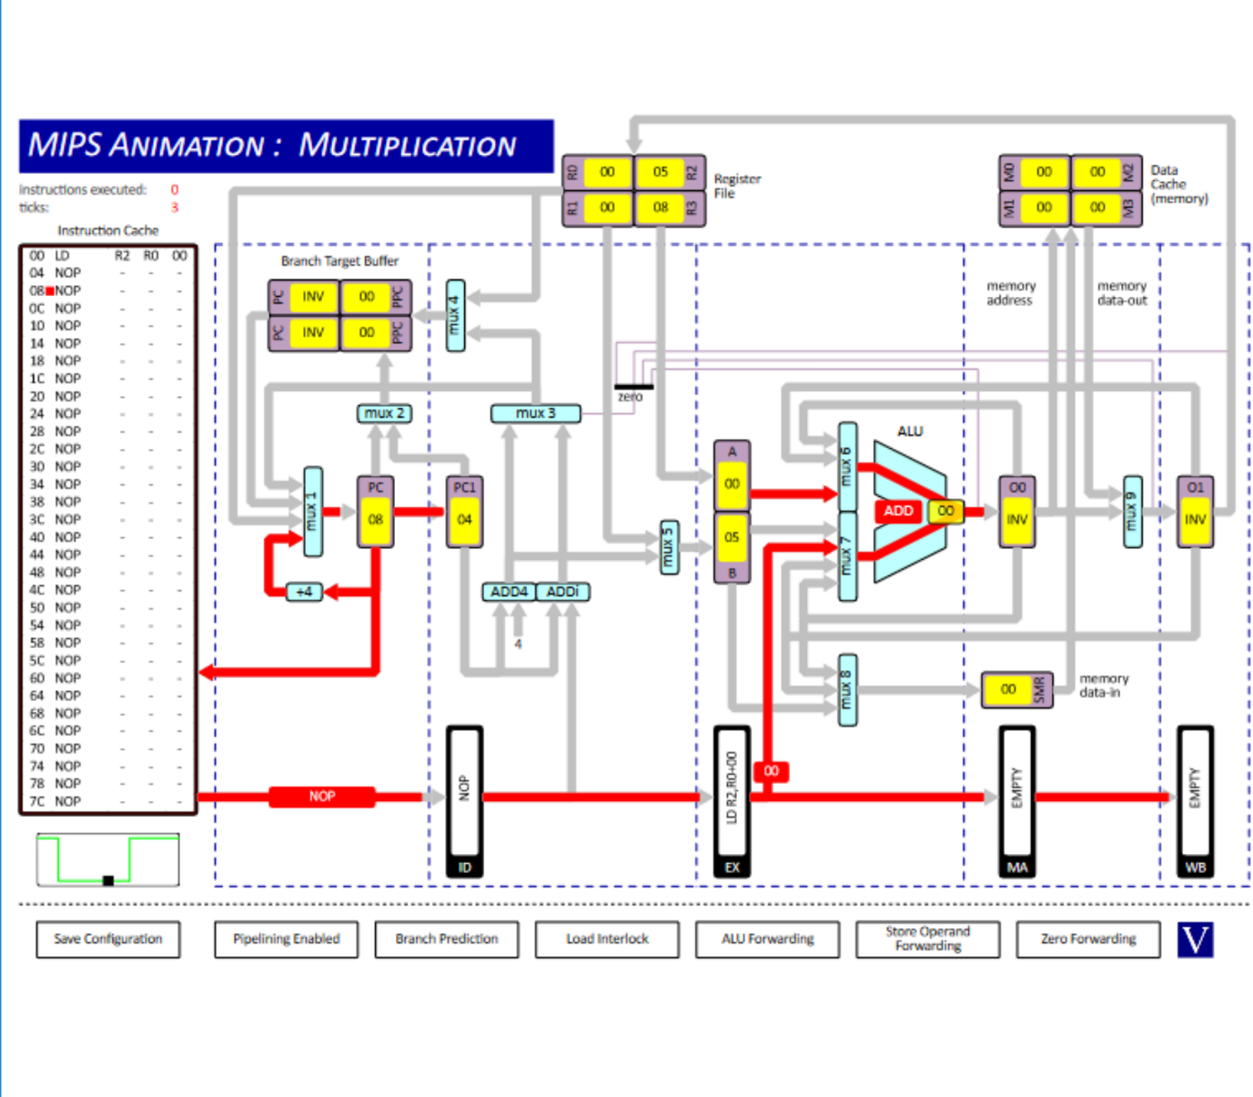

1. Data cache to MUX9

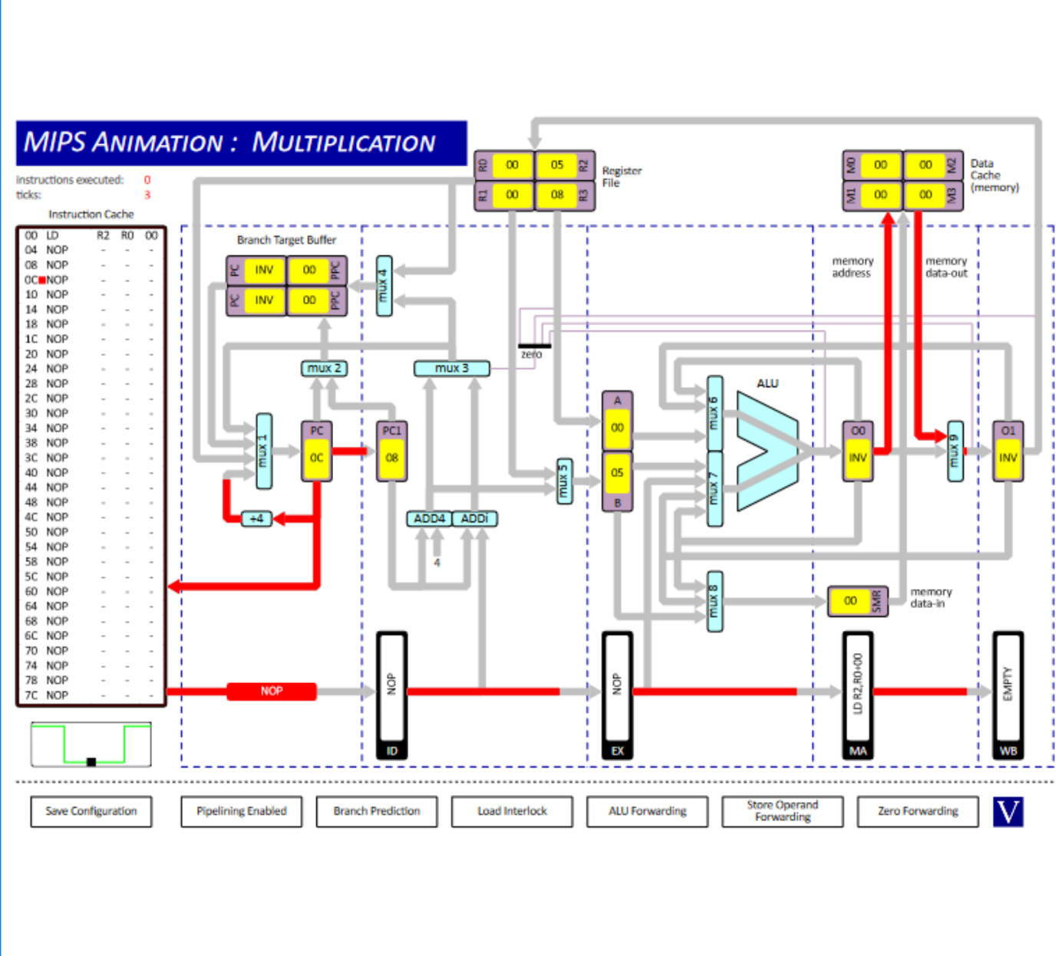

1. O0 to Zero detector

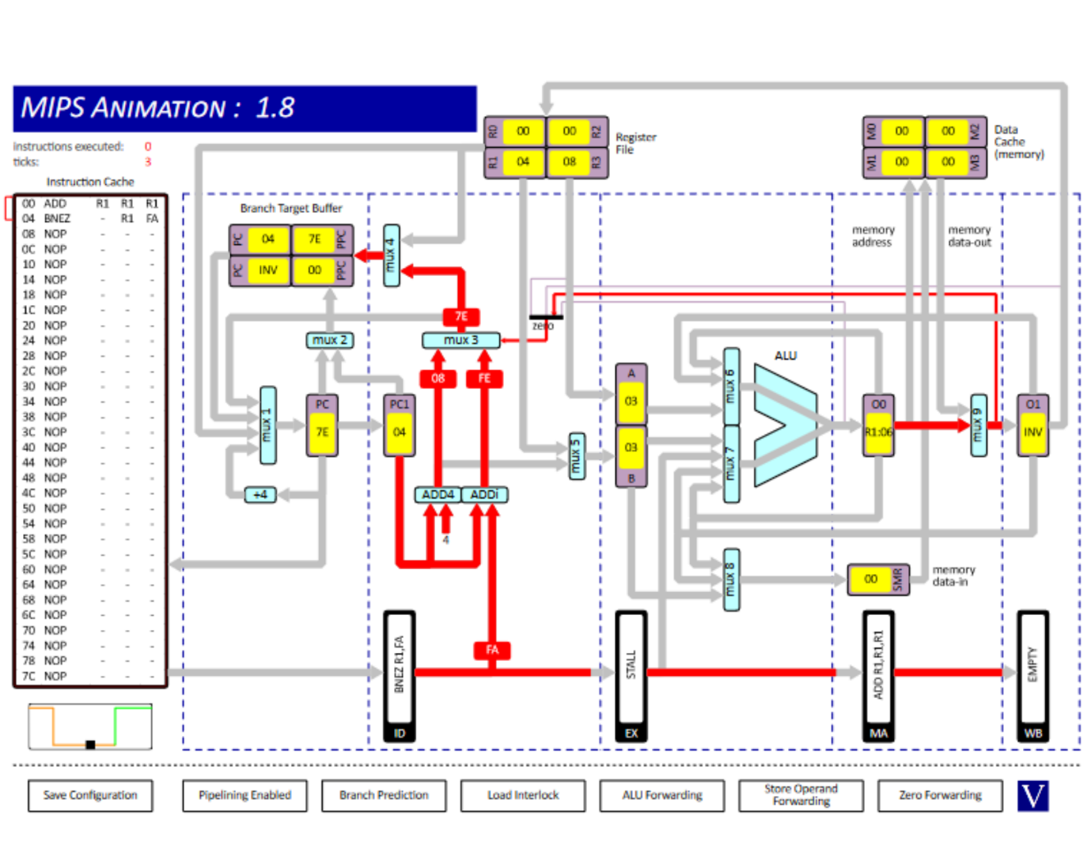

1. Register File to MUX1

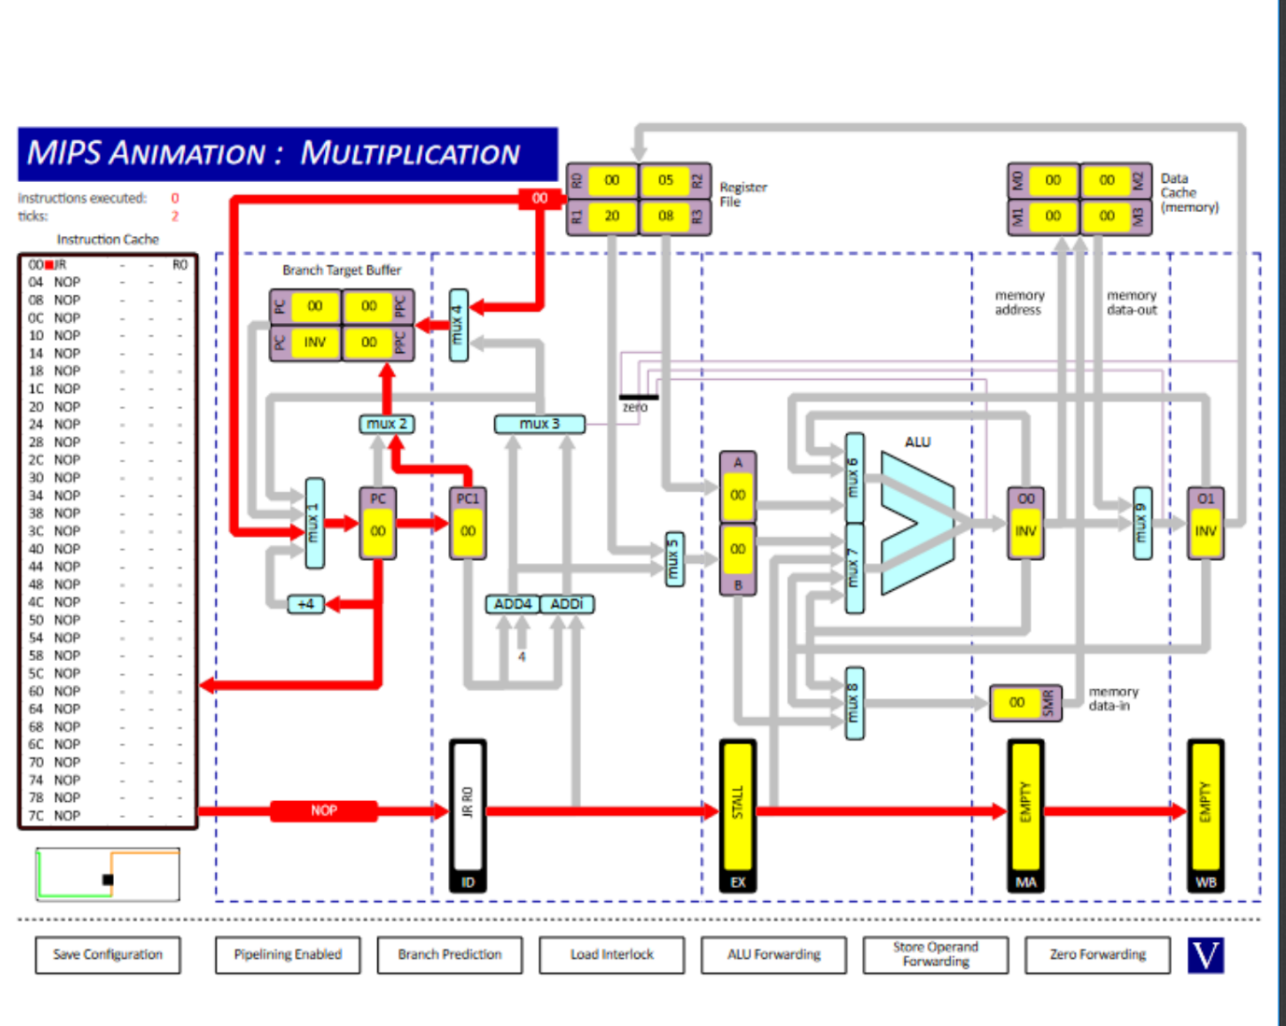

1. Branch Target Buffer to MUX1

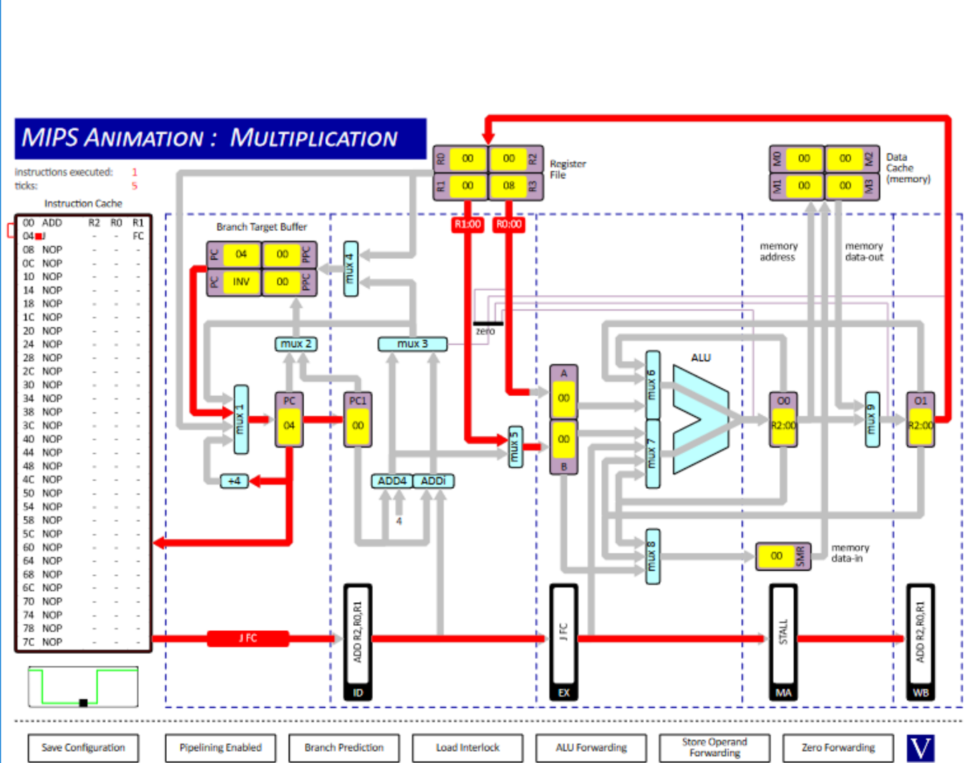

Q2.

1. Clock cycles with ALU Forwarding Enabled = 10

Result of r1 = 15

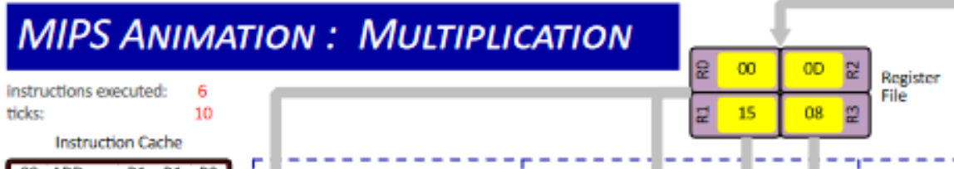

1. Clock cycles with Interlocks = 18

Result of r1 = 15

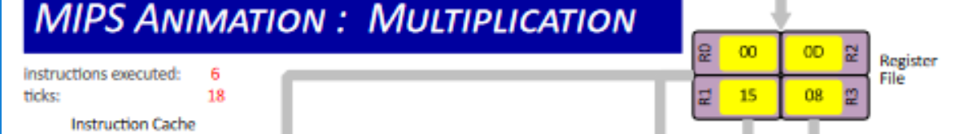

1. Clock cycles with No ALU Interlock = 10

Result of r1 = 6

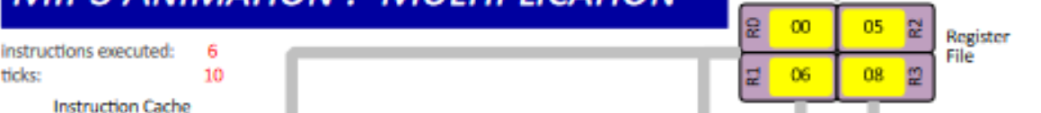

Q3.

1. Clock cycles until halt = 51

Instructions executed = 39

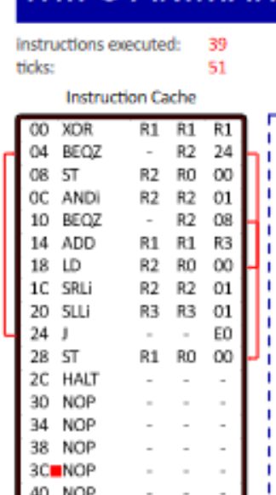

These 2 numbers aren’t equal because the first instruction requires 4 clock cycles. There are 2 ST instructions every jump and there are 4 jumps.

1. Clock cycles with Branch Interlock = 53

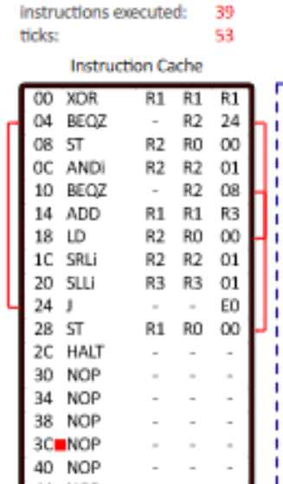

This number differs from part (i) as with branch interlock, there is a lack of Branch target buffer and a 1 tick delay is added instead, 2 clock cycles are needed because of this.

1. With Branch Prediction with 2 shift instructions swapped.

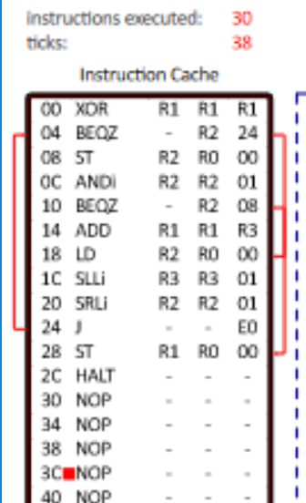

This time, there is 9 less instructions executed and 2 less jumps as there is a difference of 8 between instructions executed and clock cycles.

Execution time is quicker as less instructions.