**Rules and procedures**

Player first shuffles the deck and deals the cards in a facedown position into 13 different piles containing 4 cards each.

The piles are then arranged to resemble the position of the numbers on a clock. The extra pile, the 13th pile will then be placed in the middle. Starting from the top, in a clockwise direction, the piles are then numbered from 1 to 12, ending with the center pile numbered 13. A sample illustration is shown below.

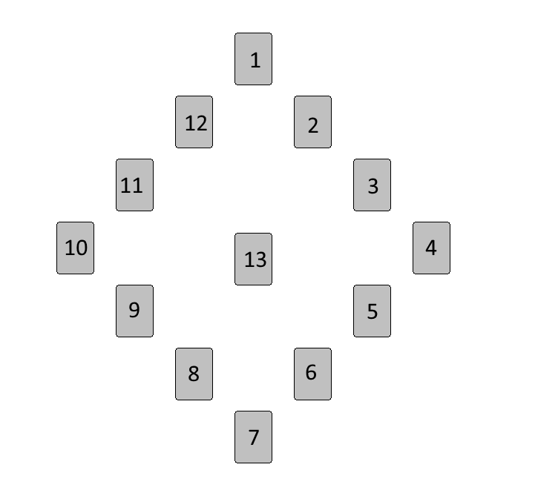

Once the cards are arranged into 13 piles and each pile contains 4 cards each, the player can begin playing Circle Solitaire!

To start the game, begin from the middle pile and turn over the top card of the pile. Take note of the value of the revealed card. The value of the card corresponds to the pile to place the card into. Place the card faceup underneath the pile number that corresponds to the card value. Face card values are as follows:

*Ace – Pile 1  
…  
Jack – Pile 11  
Queen – Pile 12  
King – Pile 13*

After a card has been placed under a pile, turn over the top card of that pile and place that card under its appropriate pile depending on the value of the card. This process is repeated and goes on until the game ends. If the last card turned over belongs to the same pile, the player will move on to the next pile following a clockwise direction, turning over the next available facedown card, place the card according to its value underneath the appropriate pile number and continues the game.

A player is victorious when all 13 piles are 4-of-a-kind. However, if the 4th King is turned face-up before the other piles are completed, the player loses.

**Resources**

A standard deck of 52 cards is used. 13 cards per suit, 4 suits in a deck excluding the joker cards.

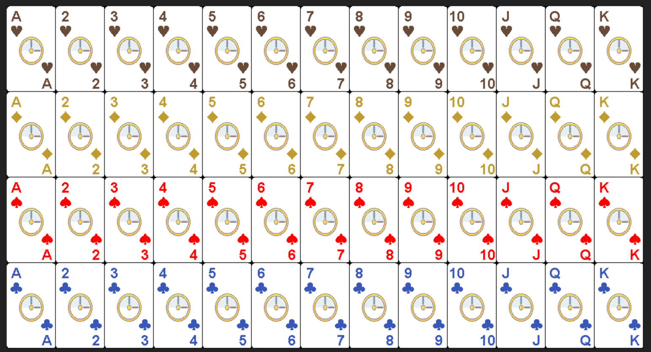

Game can be scaled up for more difficulty and longer game time, for every 52 cards added, each pile will be increased by 4, forming 13 piles of 8 cards in the case of 104 cards.