**Project Name: The Impact of Limited Gadget Access on Academic Performance of Second-Year IT Students at LSPU SCC**

**Member(s):**

Caravana, Andrei

Ducay, Jon Angelo

Glocino, Mike Calvin

Magsayo, Norwel Jake

Rosales, Mico

San Antonio, John Cyril  
Villanueva, Carlo

**Date:** **January 5, 2024**

**1. Introduction**

* Briefly describe the project and its goals.

The project titled "The Impact of Limited Gadget Access on Academic Performance of Second-Year IT Students at LSPU SCC" aims to investigate and understand how restricted access to electronic devices, or gadgets, affects the academic performance of second-year Information Technology (IT) students at Laguna State Polytechnic University - Santa Cruz Campus (LSPU SCC). The goal is to assess the relationship between the students' access to technology and their academic achievements, shedding light on potential challenges or benefits associated with limited gadget access in the academic context. The findings from this research could inform educational strategies and interventions to support the academic success of IT students facing constraints on technology use.

* What data are you visualizing? Where did it come from?

Name, Gadgets that students have and how the limited gadgets affects their academic performance.

* What questions are you hoping to answer with this visualization?

How much is the impact of having a limited gadget access if you are a IT student.

**2. Data**

* Describe the data set in detail:
* 9 column 24 rows
* Integers, String
* No missing values that we need to handle in this data.
* Data may be easily visualized by using Matplotlib to turn data into a bar graph and Pandas for data import.

**3. Visualization Technique(s)**

* Bar chart
* Bar charts are excellent for comparing quantities among different categories.
* A multitude of bar chart are used to display the percentages of various data sets.
* We load our data into Google Collab using mat plot lib and pandas for libraries.

**4. Implementation in Google Collab**

import pandas as pd

dataset = pd.read_csv("qwerty.csv")

print(dataset.head())

from matplotlib import pyplot as plt

import seaborn as sns

bar_df= df['Section'].value_counts().to_frame('count').reset_index()

bar_df= bar_df.sort_values('index')

bar_df.plot.bar(x='index', figsize=(14,8))

plt.xlabel("Section")

plt.ylabel("Count")

plt.title("Section")

bar_df= df['1. Do you own a personal laptop/computer?'].value_counts().to_frame('count').reset_index()

bar_df= bar_df.sort_values('index')

bar_df.plot.bar(x='index', figsize=(14,8))

plt.xlabel("Yes OR NO")

plt.ylabel("Count")

plt.title("Do you own a personal laptop/computer?")

bar_df= df['2. Do you have access to smartphone?'].value_counts().to_frame('count').reset_index()

bar_df= bar_df.sort_values('index')

bar_df.plot.bar(x='index', figsize=(14,8))

plt.xlabel("Yes OR NO")

plt.ylabel("Count")

plt.title("Do you have access to smartphone?")

bar_df= df['1. How often do you encounter challenging completing IT assignments or projects due to limited access to gadgets?'].value_counts().to_frame('count').reset_index()

bar_df= bar_df.sort_values('index')

bar_df.plot.bar(x='index', figsize=(14,8))

plt.xlabel("")

plt.ylabel("Count")

plt.title("How often do you encounter challenging completing IT assignments or projects due to limited access to gadgets?")

bar_df= df['2. Rate the impact of limited gadget access on your ability to actively participate in online IT classes'].value_counts().to_frame('count').reset_index()

bar_df= bar_df.sort_values('index')

bar_df.plot.bar(x='index', figsize=(14,8))

plt.xlabel("")

plt.ylabel("Count")

plt.title("Rate the impact of limited gadget access on your ability to actively participate in online IT classes")

bar_df= df['3. How has limited gadget access affected your grades or overall academic performance in IT-related subjects compared to peers with better access ? '].value_counts().to_frame('count').reset_index()

bar_df= bar_df.sort_values('index')

bar_df.plot.bar(x='index', figsize=(14,8))

plt.xlabel("")

plt.ylabel("Count")

plt.title("How has limited gadget access affected your grades or overall academic performance in IT-related subjects compared to peers with better access ? ")

* Pandas are used to import data into Google Collab.
* To display the data's bar graph form, use Mat Plot Lib.
* To examine the research data representation, only a bar graph and basic color are needed.
* These plots help visualize the distribution or counts of responses to various survey questions, allowing you to understand how survey participants answered each question. They provide a clear visual representation of the data, enabling insights into the impact of gadget access on different aspects of academic performance for second-year IT students.

**5. Results and Interpretation**

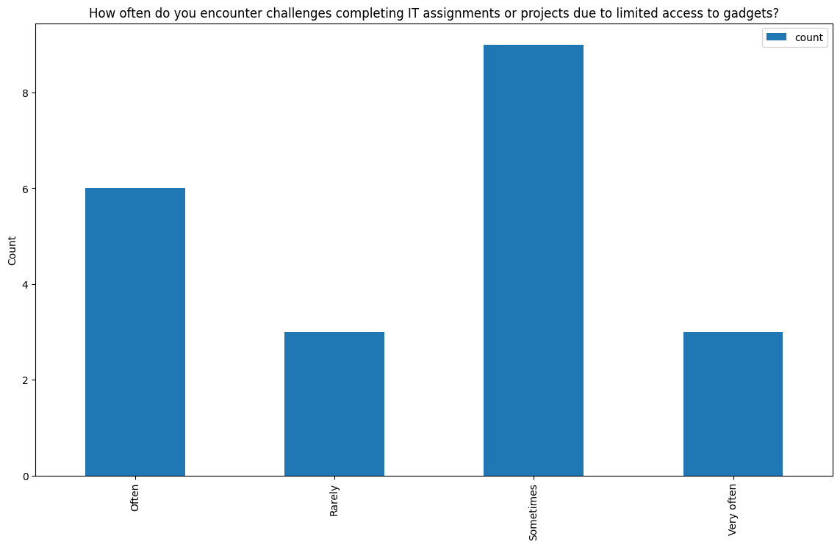

* This visualization provides a clear representation of how frequently survey participants face challenges in completing IT assignments or projects due to limited access to gadgets. The bar plot allows for easy comparison of response frequencies, highlighting the distribution of responses to this specific question among the survey participants.

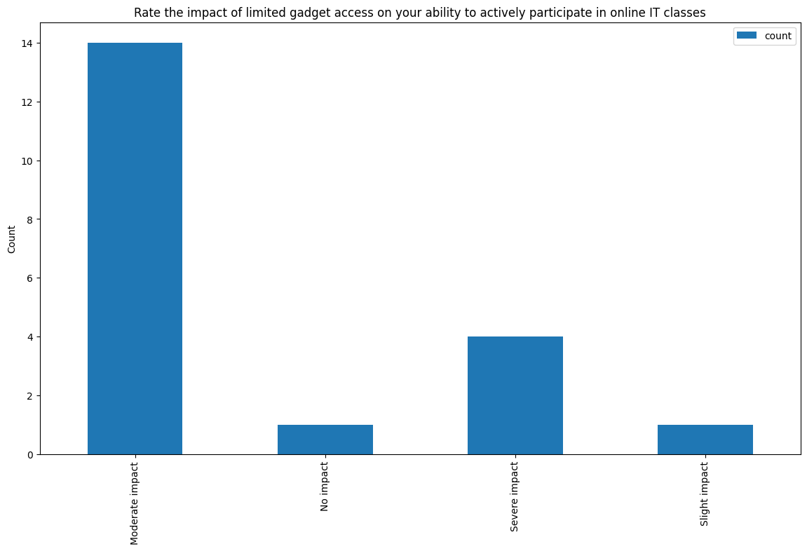

* This visualization offers a clear portrayal of how respondents evaluated the influence of limited gadget access on their active participation in online IT classes. By displaying response frequencies through a bar plot, it enables a straightforward comparison of how this particular factor impacts engagement in online classes among the surveyed individuals. This insight sheds light on the varying degrees to which limited gadget access affects students' ability to actively participate in their online IT coursework, offering valuable perspectives on the challenges they encounter in leveraging digital resources for effective learning.

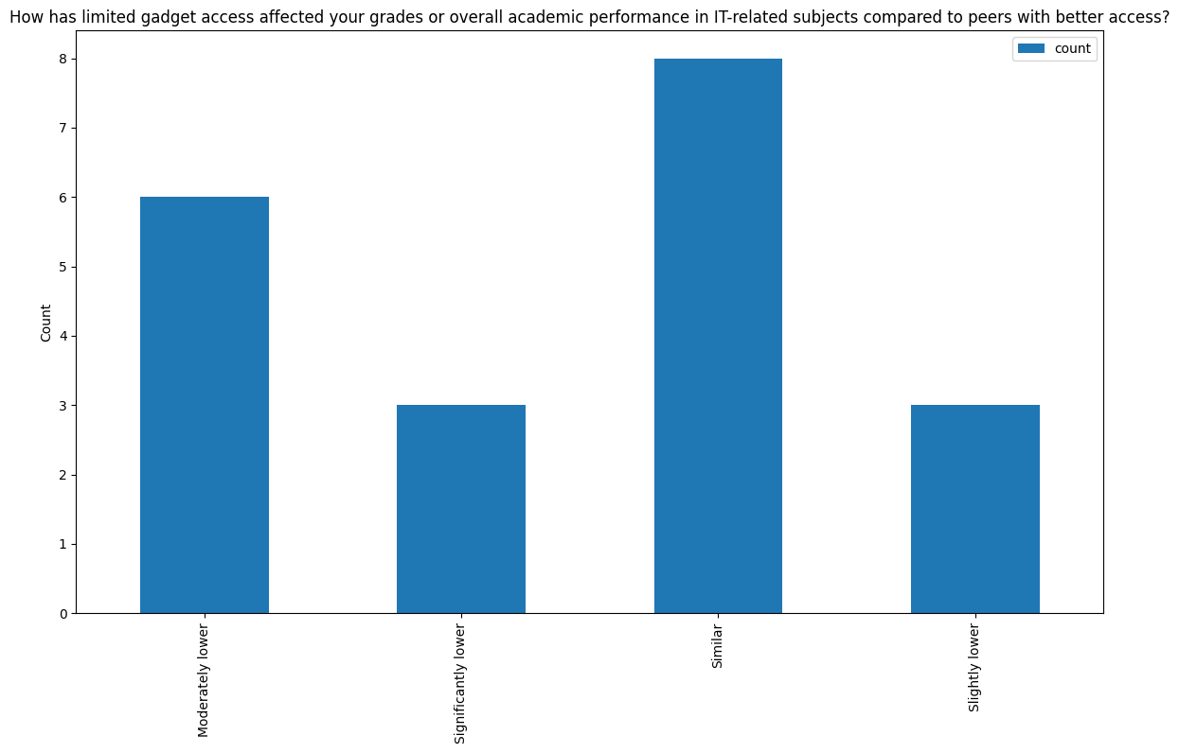

* This visualization illustrates the distribution of responses indicating how limited gadget access impacts the academic performance of individuals compared to peers with better access. By visualizing these insights through a bar plot, it offers a clear understanding of how the lack of gadgets affects academic performance in IT-related subjects relative to those with better resources, providing valuable perspectives on the challenges students face due to varying levels of access to technology.

**6. Conclusion**

* The visual representations underscore the profound influence of limited gadget access on the academic journey of second-year IT students at LSPU SCC. The findings emphasize the critical need for enhanced support and resources to ensure equitable academic opportunities for all students, irrespective of gadget accessibility.
* Expanding the project in these directions can further deepen our understanding of the implications of limited gadget access on academic performance and facilitate more inclusive and supportive learning environments for students.

**7. Appendix**

|  |  |  |  |  |  |
| --- | --- | --- | --- | --- | --- |
| **Column Name** | **Data Type** | **Data Format** | **Filed Size** | **Description** | **Example** |
| **Time Stamp** | **Date, Time** | **DD/MM/YYYY** | **10** | **Automatic Time and date based on respond** | **4/1/2024 10:41:00 AM** |
| **Name** | **Text** |  | **10** | **Full Name of Student** | **John Cyril D. San Antonio** |
| **Email** | **Text** |  | **20** | **Email of Student** | **Cyril@gmail.com** |
| **Section** | **Text/Int** |  | **6** | **Section of Student** | **BSIT – 2E** |
| **Do you own a personal laptop/computer?** | **Text** |  | **2** | **Yes or No** | **Yes** |
| **Do you have access to a smartphone?** | **Text** |  | **2** | **Yes or No** | **Yes** |
| **How often do you encounter challenges completing IT assignments or projects due to limited access to gadgets?** | **Text** |  | **50** | **Often**  **Rarely**  **Sometimes**  **Very Often** | **Sometimes** |
| **Rate the impact of limited gadget access on your ability to actively participate in online IT classes** | **Text** |  | **50** | **Moderate Impact**  **No Impact**  **Severe Impact**  **Slight Impact** | **No Impact** |
| **How has limited gadget access affected your grades or overall academic performance in IT-related subjects compared to peers with better access?** | **Text** |  | **50** | **Moderately Lower**  **Significantly Lower**  **Similar**  **Slightly Lower** | **Similar** |

**pd.read_csv('qwerty.csv').head()**

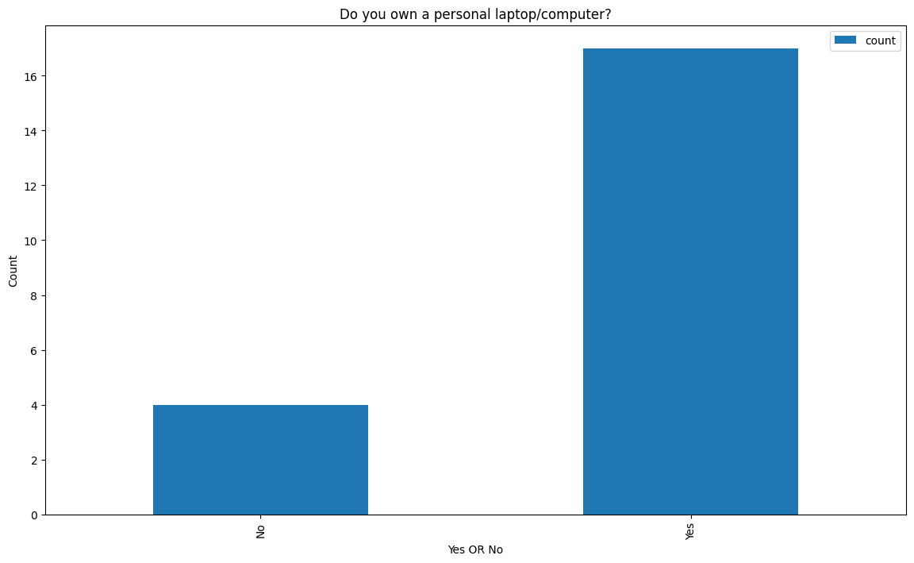

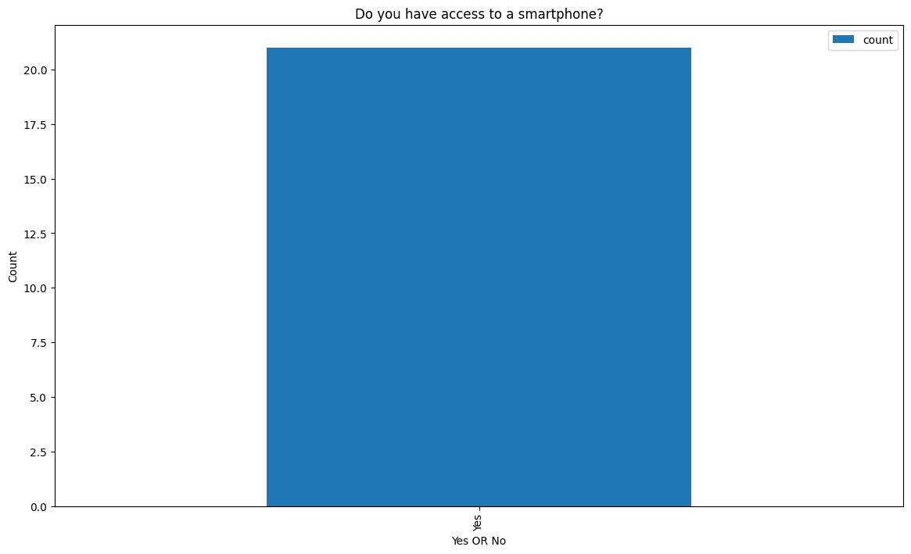

The code snippet provided demonstrates the creation of a bar plot depicting the ownership of personal laptops/computers among the surveyed students. The plot visualizes the count or frequency of 'Yes' and 'No' responses, offering insights into the gadget ownership status of the surveyed individuals.

This visualization serves as a segment of a broader analysis aiming to comprehend the educational background and technological resources available to students before entering the IT program.