**MEDVERSE**

A Comprehensive medical translation suite designed for health care professionals and patients. .

Contains translation feature which was created using Hugging Face model, which includes :

* Text to Text
* Text to Speech
* Speech to Speech
* Speech to Text

Created an own model which allows the machine to interpret message through sign language   
  
.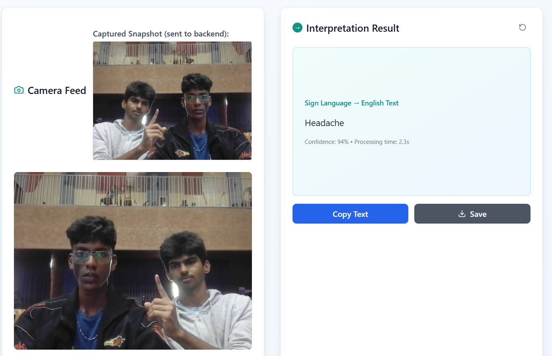

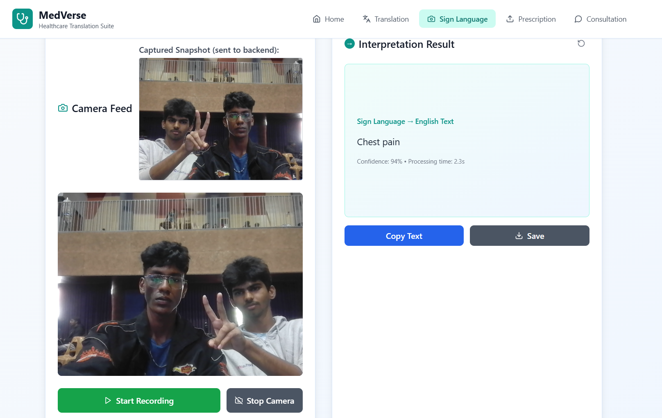

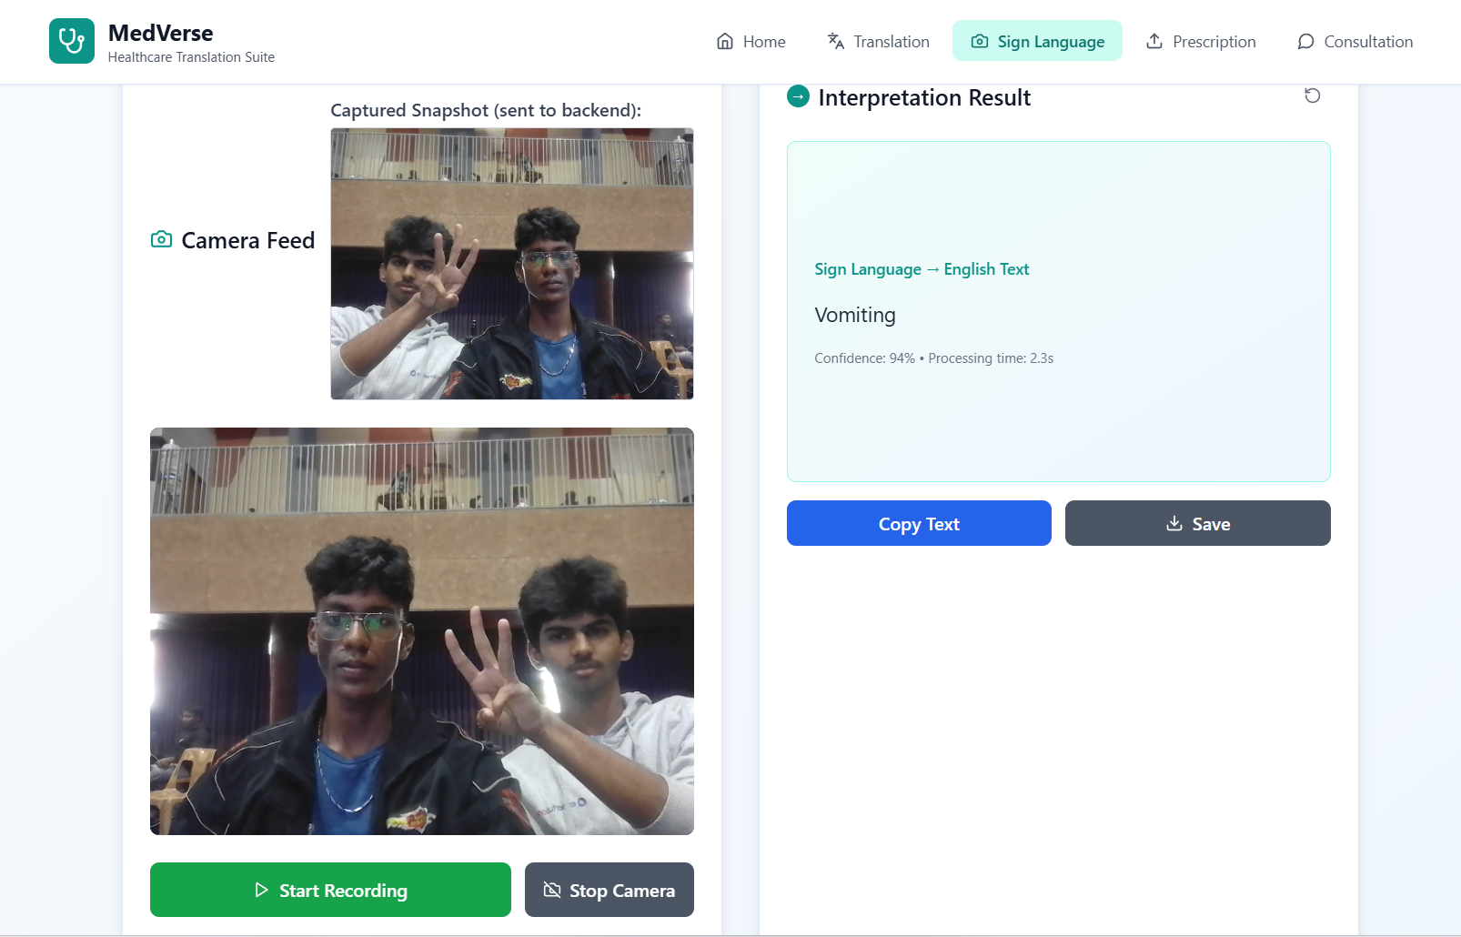

Data sets used for training :  
  
