EduFusionFormer - A Dynamic Hierarchical Transformer Framework for Multimodal Educational Administrative Behavior Analysis

Abstract
Administrative behavior analysis is an essential component in measuring the administrative effectiveness, workload, engagement, and decision-making process in modern educational settings. While multimodal deep learning methods have shown promising results in analyzing heterogeneous education data, the current methods lack joint modeling of administrative records, survey responses, text communications, and their evolution over time with dynamic determination of the relevance of each modality with interpretability of administrative behavior. Thus, this research introduces a new multimodal deep learning architecture called EduFusionFormer (Dynamic Hierarchical Transformer Framework for Multimodal Educational Administrative Behavior Analysis) for robust administrative behavior analysis. Firstly, EduFusionFormer converts heterogeneous administrative features into feature tokens with the help of Dynamic Feature Tokenizer, while the survey responses and textual documents are encoded through Survey Encoder and BERT embeddings correspondingly. Then, the Dynamic Modality Importance Learning (DMIL) module learns sample-wise modality importance for adaptive emphasis on informative administrative, survey, and textual representations. In addition, the Confidence-Guided Feature Reweighting method refines the modality representations according to the importance levels. These representations then go through the Hierarchical Cross-Modal Transformer, which gradually models interactions between Text-Survey and semantic-administrative modalities to learn higher order cross-modality dependencies. In order to incorporate longitudinal behavioral characteristics, the Temporal Behavioral Memory Encoder encodes temporal information related to monthly administrative behaviors. Moreover, the Cross-Modal Consistency Learning method evaluates the relationships and inconsistencies among heterogeneous modalities, while the Adaptive Fusion Aggregator fuses the refined representations with temporal and consistency information. Finally, the Multi-Task Classification Head classifies the fused representation for administrative behavior classification, while the Explainability Head provides modality, feature, temporal, and cross-attention attribution for interpretability. This framework classifies the administrative behavior into five classes: Average, Effective, Highly Effective, Needs Improvement, and Overloaded. The experimental evaluation proves the effectiveness of the proposed multimodal framework, while the ablation analysis can be conducted to evaluate the performance of its components, especially dynamic modality weighting, hierarchical cross-modal interaction, temporal behavioral modeling, and cross-modal consistency learning.
Keywords: Educational Administrative Behavior Analysis, Multimodal Representation Learning, BERT, Cross-Modal Fusion, Dynamic Modality Importance Learning, Temporal Behavioral Modeling.

1. Introduction
Increasingly, educational establishments depend on administrators who are supposed to manage various processes related to academic activities, coordinate institution resources, communicate with teachers and students, resolve issues and contribute to the efficient functioning of educational processes as a whole. Therefore, studying administrative behavior becomes a crucial part of data-oriented educational administration and decision making. Administrative effectiveness, workload, engagement, communication and behavioral patterns are reflected in diverse information resources that include administrative activity logs, survey responses, institutional communications and long-term behavioral logs. Contrary to traditional educational analytics focusing mainly on student performance or classroom behavior, analysis of administrative behavior requires the integration of multiple complementary information resources to have a holistic view on educational processes within the institution. This creates a need for sophisticated artificial intelligence solutions and multimodal representation learning able to model inter-relations between structured administrative data, subjective survey data, text documents and temporal behavior. Recently, several machine learning and multimodal learning solutions have been proposed to analyze complex behavioral patterns in educational environment. For example, Zheng et al. [1] suggested Automated Multimode Teaching Behavior Analysis (AMTBA) – a pipeline-oriented framework which combines speech, emotion, gaze, head pose and spatial information for automated analysis of teaching behavior. It showed the significance of integration of heterogeneous behavioral modalities and context preservation through the use of event-based segmentation instead of fixed-time windows. However, this approach mostly concentrates on teaching behavior obtained from audiovisual streams and does not consider the analysis of structured administrative data, survey information, text documents or long-term behavioral records of the administrators.
Patidar et al. [2] proposed Edulyze – a learning analytics system which unifies various classroom sensing systems (EduSense, ClassGaze, Moodoo). The system provides a schema for transformation of different sensing streams into a common analytical representation and allows conducting of multimodal educational case studies without creation of separate processing pipelines for each sensing system. This work shows the importance of integration of heterogeneous educational data sources and provides a good base for multimodal learning analytics. Nevertheless, Edulyze mostly serves as a system-agnostic analytics and data integration platform rather than end-to-end predictive transformer architecture and does not dynamically learn the importance of different modalities for individual administrative behavior predictions.
Moon et al. [3] studied multimodal learning analytics as a formative assessment mechanism which can help to understand collaborative dynamics in mathematics teacher education. Their study combined discourse, facial behavior, emotional information and performance data and used machine learning solutions (regression, Random Forest models) to find relationships between multimodal behavioral information and learning outcomes. It demonstrated that the combination of multiple behavioral channels provides richer predictive information than a usage of individual data sources. However, the analytical framework focuses on learner collaboration and formative assessment rather than on educational administrative behavior and the application of conventional machine learning solutions provides limited possibilities for learning complex cross-modal relations and dynamic adaptation of modality contributions.
Gong et al. [4] reported a theory-guided Transformer solution for interpretable student performance prediction by combining heterogeneous educational factors with theory-guided attention mechanisms. However, the supplied reference clearly indicates that the work was retracted; therefore, its results cannot be considered as supporting evidence in the present study. Nevertheless, this research direction shows the importance of one of the objectives in educational artificial intelligence: the combination of heterogeneous educational data with interpretable attention mechanisms which can provide richer insights than simple black-box output. In the current study, interpretability is especially important since administrative behavior analysis not only requires to predict a particular behavioral category but also to reveal which modalities and behavioral characteristics were used for this purpose.
More recently, Sridharan and Akilashri [5] proposed a multimodal learning analytics framework based on Multi-Scale Dilated Deep Temporal Convolution Network (MS-DDTCN) with an Improved Chameleon Swarm Algorithm for student behavior prediction. They emphasized the importance of temporal analysis of behavior for understanding of behavior evolution and applied multi-scale temporal processing to model behavior patterns occurring at different time scales. This research direction is important for analysis of administrative behavior since the administrators' behavior also evolves during the time rather than stays constant during the whole academic period. However, the framework mostly focuses on student behavior and temporal convolutional processing rather than on hierarchical cross-modal interaction of textual, survey and structured administrative data.
Nevertheless, despite the success of these solutions, there are still several important research problems in multimodal analysis of educational behavior. First, the current educational multimodal analytics research mostly focuses on classroom teaching behavior, student performance, learner collaboration or sensor-based behavioral analysis while comparatively little attention is paid to educational administrative behavior based on structured records, survey data and institutional text communications. Second, the current multimodal approaches often integrate heterogeneous data using predefined or relatively static fusion techniques which do not allow determining the most informative modality for an individual administrator or particular behavioral instance. Third, different educational modalities may have complementary or contradicting behavioral information; therefore, simple concatenation of representations may not correctly model the complex cross-modal relations and contradictions. Fourth, administrative behavior is naturally longitudinal, with workload, engagement, communications and operational activities varying during months. Independent treatment of each month may lead to loss of important behavioral evolution patterns. Fifth, while attention-based educational models can provide some level of interpretability, there is a need for a framework that can provide an integrated set of modality-level, feature-level, temporal and cross-modal explanation for the administrative behavior predictions.
To solve these problems, the present paper proposes EduFusionFormer (A Dynamic Hierarchical Transformer Framework for Multimodal Educational Administrative Behavior Analysis) – an end-to-end multimodal representation learning framework for analysis of heterogeneous administrative behavior which uses structured administrative data, survey data, text documents and monthly behavior information. Firstly, the heterogeneous administrative features are converted into learnable feature tokens using Dynamic Feature Tokenizer, while survey variables are processed by a dedicated Survey Encoder and institutional text information is encoded using pretrained BERT model. These modality representations are further processed by Dynamic Modality Importance Learning (DMIL) mechanism which estimates sample-specific modality confidence and determines the relative contribution of administrative, survey and textual information. Then, Confidence-Guided Feature Reweighting mechanism further refines modality representations depending on their learned confidence. The refined modality representations are further combined through Hierarchical Cross-Modal Transformer which gradually learns the interactions between Text and Survey representations and subsequently the interactions between the combined semantic representations and Administrative features. Such hierarchical approach allows the model to learn pairwise cross-modal relationships before building unified multimodal representation. To account for longitudinal nature of administrative behavior, Temporal Behavioral Memory Encoder is included to integrate monthly behavior information and learn temporal representations reflecting behavior evolution. In addition, Cross-Modal Consistency Learning component is included to model relationships between heterogeneous modalities and reveal the degree of their agreement or disagreement. The temporal and consistency-aware representations are adaptively combined through Adaptive Fusion Aggregator to produce the final multimodal representation for behavioral classification.
Finally, the proposed framework includes Explainability Head which provides modality-level and feature-level attribution along with temporal and cross-modal attention information. Multi-Task Classification Head produces main administrative behavior prediction and additional behavioral representations. The proposed framework classifies administrators into five behavioral categories: Average, Effective, Highly Effective, Needs Improvement and Overloaded. Thus, EduFusionFormer turns analysis of administrative behavior from conventional single-source classification problem into dynamic multimodal representation learning problem which can model heterogeneous information, temporal behavior evolution, cross-modal relationships and interpretable decision patterns. In summary, the proposed EduFusionFormer framework provides the unified solution for educational administrative behavior analysis based on dynamic modality selection, hierarchical cross-modal interaction, temporal behavior modeling, consistency-aware representation learning, adaptive fusion and explainability in one Transformer-based framework. This framework is aimed not only to produce accurate behavioral classification but also to provide interpretable insights into the factors and modalities which contribute to administrative behavioral outcomes.

The major contributions of this research are summarized as follows:
- A novel multimodal educational administrative behavior framework, EduFusionFormer, is proposed to jointly analyze structured administrative records, survey responses, textual institutional communications, and longitudinal behavioral information for five-class administrative behavior classification.
- A Dynamic Modality Importance Learning (DMIL) mechanism is introduced to estimate sample-specific modality importance and dynamically emphasize the most informative administrative, survey, and textual representations rather than assuming equal contributions from all modalities.
- A Hierarchical Cross-Modal Transformer is developed to progressively model Text–Survey and semantic–Administrative interactions, enabling the framework to learn higher-order relationships between heterogeneous educational administrative modalities.
- A Temporal Behavioral Memory Encoder is incorporated to capture the evolution of administrative behavior across monthly observations, allowing the framework to model longitudinal behavioral patterns rather than treating administrative records as independent static observations.
- A Cross-Modal Consistency Learning mechanism and Adaptive Fusion Aggregator are proposed to identify relationships and potential inconsistencies among heterogeneous modalities and dynamically integrate temporal and consistency-aware representations for robust behavioral classification.

2. Literature Survey
Ouhaichi et al. [6] (2024) investigated the design considerations of Multimodal Learning Analytics (MMLA) systems through an interview-based study involving researchers and practitioners in the field of multimodal educational technologies. Specifically, the study tried to address the deficiency of established guidelines in designing MMLA systems able to process heterogeneous data such as video, audio, and physical sensor information. Instead of suggesting a machine learning model, the authors applied deductive and thematic analysis of semi-structured interview transcripts in order to propose the MMLA Design Framework (MDF) in line with Human-Centered Learning Analytics principles. The study considered important issues of data management, human factors, privacy and ethical considerations, and choice of appropriate modalities in certain educational cases. Nonetheless, the work is purely theoretical and does not provide any end-to-end predictive architecture for automatic learning from heterogeneous educational data. Particularly, the study fails to consider dynamic modality weighting, cross-modal attention mechanisms, temporal behavioral representation, and automatic classification of educational behavior. Hence, the work raises the need for development of a practically applicable multimodal learning framework that will combine heterogeneous educational information and keep human-centered and interpretable design.
Bird [7] (2026) proposed a multimodal fusion framework based on Transformer models and computational linguistics for automatic determination of the complexity of educational literature. Specifically, the author used segmented text from 384 books having established Lexile scores, and converted those scores into UK Key Stage classes. Eight Transformer models were considered for semantic representation, while 500 neural network architectures were examined for traditional linguistic and grammatical features. Finally, the architecture included combination of the ELECTRA and Deep Neural Network, so that semantic and linguistic information could be combined. In terms of performance, the Transformer-only BERT model obtained F1-score of 0.75, while the multimodal ELECTRA and neural-network fusion had F1-score of 0.996. Nonetheless, the framework is specifically targeted for educational text-complexity assessment and is predominantly oriented on textual information. Thus, it does not model temporal learner behavior or dynamically estimate the importance of various educational modalities. Therefore, this study suggests an area of research for broader multimodal framework that will be able to combine heterogeneous educational information for behavioral analysis.
Sun et al. [8] (2025) suggested a multimodal learning analytics framework for personalized learning path planning in higher education that integrates Transformer models, adversarial training, and quantum state classification. The authors attempted to overcome the limitations of conventional personalization techniques that mainly utilize static information such as grades or text logs and thus do not take into account dynamically changing interests and behaviors of the learners. The framework integrates heterogeneous high-dimensional text, audio, and video data using Transformer-based processing, while adversarial training is used to increase robustness to abnormal or noisy information. Moreover, quantum state classification is included to overcome computational problems associated with high-dimensional multimodal educational data. According to the results, the model obtained accuracy of 0.95, recall of 0.91, and about 0.05 loss, while processing time was estimated at 56 seconds for the 18th training round. However, the framework is specifically designed for personalized learning-path generation and does not consider educational behavior classification. In addition, despite inclusion of several modalities, the framework does not have a mechanism of estimating the importance of separate educational modalities.
Wang [9] (2025) proposed the SRE-TransformerNet architecture, a hybrid Transformer-based approach for adaptive pedagogy under the uncertainty of student preferences. The work addresses the problem of recognition of evolving and ambiguous learning preferences in various educational settings. The authors used the large longitudinal dataset with 202,000 records collected from several educational institutions in Manchester from 2018 to 2024. The architecture includes combination of Swin Transformer, ResNet, and EfficientNet architectures, along with Adaptive Range Scaling, feature selection, and data balancing procedures. The model obtained accuracy of 0.988, F1-score of 0.987, AUC of 0.995, and recall of 0.986, demonstrating good ability to detect dynamic preferences. However, the architecture is mainly targeted at preference classification and adaptive pedagogy and not multimodal educational behavior analysis. Moreover, despite integration of several modalities, the framework does not explicitly include the mechanism of cross-modal relationships or explaining the contribution of particular modalities to the prediction.
Boufaida et al. [10] (2025) proposed a Temporal Sparse Attention-Gated Recurrent Unit (TSA-GRU) framework for learner behavior analytics in MOOCs. The work addresses the problem of modeling noisy and sequential learner interaction data while capturing short-term behavioral fluctuations and long-term learning trajectories at the same time. The framework integrates Temporal Sparse Attention with GRU-based sequential modeling and embedding transformation for identification of important learning events and filtering of irrelevant behavioral information. The model was tested on the 2009-2010 ASSISTments dataset, obtaining test accuracy of 95.60%, test loss of 0.0209, and convergence in five training epochs. Also, the authors reported improvement over the Bayesian Knowledge Tracing, Performance Factors Analysis, and MSA-GRU baselines. Nonetheless, the architecture is specifically aimed at learner interaction sequence and does not explicitly consider heterogeneous multimodal educational information. Besides, the recurrent architecture of the model lacks a dedicated cross-modal Transformer mechanism for learning cross-modal relationships. Therefore, the work raises the need for development of a framework that will be able to dynamically combine heterogeneous educational information.
Lin et al. [11] (2024) suggested an improved Real-Time Detection Transformer (RT-DETR) framework for student classroom behavior detection. The work addresses the difficulties in recognizing the student behaviors such as reading, writing, sleeping, and hand raising in challenging classroom environment including occlusions, irregular seat arrangement, poor illumination, and small targets. The authors constructed the custom FSCB dataset by merging real classroom observations and synthetic data. The framework substitutes the RT-DETR backbone with MobileNetV3 and introduces dynamic upsampling and position encoding for small-object detection improvement. As a result, the number of parameters of the architecture is decreased to one-tenth of the original RT-DETR architecture, while keeping comparable detection accuracy and increasing processing efficiency. Nonetheless, the approach is a purely computer-vision-based framework and thus depends on visual information. The framework does not consider other heterogeneous educational information such as textual, survey, or administrative data and does not model long-term behavioral dependencies. Thus, the study demonstrates the benefits of light-weight Transformer architectures for classroom behavior detection.
Zhou et al. [12] (2024) suggested a Multimodal Image Recognition System for student behavior analysis in university smart classrooms. The work addresses the limitations of conventional single-modality classroom behavior analysis by joint processing of visual and speech information. The researchers collected multimodal data from real university smart classrooms, which includes facial expressions, student movements, and classroom speech. The speech data was converted to two-dimensional representation using Short-Time Fourier Transform (STFT) and nonlinear phase-space reconstruction, and then combined with visual information. As a result of experimental evaluation on speech recognition, facial recognition, and speech-facial behavior recognition tasks, the proposed system outperformed unimodal and conventional weighted-fusion approaches while keeping the real-time capability. However, the proposed system specifically concentrates on audiovisual classroom observations and does not include structured educational records, textual information, and longitudinal behavioral information. Also, the fusion mechanism of the framework does not explicitly provide dynamic modality importance and cross-modal reasoning.
Kui et al. [13] (2024) suggested the TSSeer, a visual analytics system for exploration of correlations between teachers' multimodal emotions and students' behaviors in MOOCs. The work addresses the problem of understanding the impact of emotional state of the teacher on engagement of the students under the condition of involvement of large-scale teacher and student behavioral data. Specifically, teacher information includes facial expression and vocal characteristics, while student information includes synchronized learning behavior logs such as video play, pause, rewind, playback-speed changes, and drop-out events. Instead of development of a predictive neural network, the authors of TSSeer proposed the interactive level, correlation, and detailed temporal views for exploration of relationships between teacher emotions and learner behavior. For validation of the system, two usage scenarios and expert interviews with five instructors and pedagogical researchers were considered. Nonetheless, TSSeer is specifically designed for visual exploration and correlation analysis and therefore does not have an end-to-end deep learning architecture for automatic learning of multimodal representations and behavioral patterns.
Lee and Zhai [14] (2025) investigated the application of GPT-4V as a multimodal AI system for educational visual question answering. The authors aim to make visual educational analysis easier for educators and researchers without specialized programming and machine learning skills. Instead of conventional training dataset, GPT-4V is tested on real-world educational visual scenarios including historical photographs, instructional scenes, student-generated drawings, and classroom environments. GPT-4V is used for joint processing of visual information and natural-language questions and generation of descriptive responses. As a result, the following applications are suggested: lesson plan generation, pedagogy analysis, student engagement interpretation, learner data assessment, and classroom environment analysis. However, the work is mostly demonstrative and does not suggest a dedicated supervised learning architecture for prediction of educational behavior. Additionally, the work is based on a general-purpose multimodal large language model and therefore does not explicitly learn modality importance, behavioral memory, and cross-modal consistency for the particular task. Also, the authors recognize the need for human oversight because of possible AI hallucinations.
Davalos et al. [15] (2025) suggested a human-in-the-loop multimodal learning analytics framework that converts educational data traces into actionable reading assessment reports. The work addresses the limitation of conventional reading assessment where final scores demonstrate whether the learner has difficulties with reading and provide little information on behavioral reasons for that. The authors collected multimodal information from fifth-grade students including eye-tracking measurements, learning outcomes, assessment content information, and pedagogical frameworks. K-Means and Gaussian Mixture Models were used for identification of student reading behavior profiles, after which two GPT-4o agents were applied: LLM Report Curator generated structured reports, while LLM Report Evaluator assessed them for clarity, pedagogical relevance, and bias. As a result of the clustering, four distinct reading behavior profiles were identified, and teachers and LLM evaluators found generated reports useful and relevant. However, the framework is specifically targeted at reading assessment and does not include a predictive multimodal learning model. Also, the framework does not explicitly learn dynamic modality importance and cross-modal consistency for general educational behavior classification.
Korban et al. [16] (2025) suggested the Multi-Modal Transformer Network for Classroom Instruction Analysis for automatic analysis of complex instructional activities in untrimmed classroom videos. The work addresses the limitations of manual classroom observations and conventional action recognition approaches that have difficulties with long videos, overlapping activities, and simultaneous teacher-student interactions. The framework is based on real-world elementary classroom videos with annotations of instructional activities including teachers moving around the classroom, students working individually, students working in groups, and teacher seating. The Multi-Modal Transformer of the framework includes attention mechanisms to model cross-modal relationships and explicitly capture relationships between teachers and students, students and students, teachers and objects, and students and objects. The work reported state-of-the-art performance of the spatiotemporal action localization in educational environment, although exact numerical benchmark values are not provided in the supplied reference. Nonetheless, the architecture is specifically targeted at visual and motion information from classroom videos and does not include other structured educational information. Hence, the work demonstrates the importance of cross-modal Transformer attention but does not solve broader problem of heterogeneous educational behavior modeling.
Guo [17] (2025) suggested the Transformer-based real-time teaching quality assessment system using multimodal data fusion and behavior analysis in smart classrooms. The work addresses the limitations of conventional teaching-quality assessment methods that are based on manual observations and post-lecture surveys and therefore can be subjective and delayed. The framework processes synchronized visual and audio/speech information including student posture, facial attention, teacher movement, teacher tone, and instruction delivery. Transformer-based self-attention is used for processing of sequential classroom behavior, while multimodal fusion engine aligns audio and visual information to get more complete representation of teaching and learning interactions. The framework attempts to provide real-time teaching quality assessment. However, the exact numerical evaluation results are not provided in the supplied reference. Also, the framework remains focused on visual and audio data from smart classrooms and does not explicitly address longitudinal educational behavior, heterogeneous administrative information, and dynamic modality importance.
Kong et al. [18] (2025) suggested the EduSpatioNet, a spatiotemporal graph neural network framework for classroom behavior analysis and digital teaching-quality evaluation. The approach addresses the inability of isolated action recognition systems to capture spatial and temporal relationships between teachers and students. The authors use classroom video and sensor information that is converted into interaction graphs using YOLOv8 for entity detection and STGNN for modeling of evolving teacher-student relationships. The architecture uses multi-head attention, adaptive sampling, and hierarchical pooling to capture spatial and temporal dynamics of classroom. The reported model achieves 92% behavioral accuracy and 87% agreement with human expert evaluations, demonstrating the potential of graph neural networks for contextual classroom behavior analysis. However, EduSpatioNet is specifically focused on visual and sensor-based classroom interactions and does not include textual or structured educational information. Also, the graph representation of the framework is specifically targeted at spatial relationships, not cross-modal relationships and long-term behavioral memory.
Yu et al. [19] (2024) suggested a unified framework for conversion of raw classroom video into pedagogical insights, which addresses the problem of fragmentation of existing student behavior analysis systems. The approach combines temporal action detection and human pose estimation with large language models for transformation of observed student actions into structured pedagogical reports. The approach processes raw classroom video in order to detect behaviors such as sitting, standing, writing, and hand raising, and then uses the obtained behavioral information as input to the LLM that acts as an educational analyst. The system is intended to go beyond raw behavioral measurements and obtain pedagogical insights, with experimental validation showing the feasibility of end-to-end video-to-insight pipeline. However, the framework is specifically video-oriented and does not explicitly include other heterogeneous structured educational information such as surveys, administrative records, and textual learner information. Also, exact numerical classification metrics are not provided in the supplied reference. Thus, the work demonstrates the importance of conversion of behavioral signals obtained via AI into actionable educational information but leaves space for a unified multimodal predictive architecture.
Wang et al. [20] (2024) suggested SCB-DETR, a multi-scale deformable Transformer framework for student learning behavior detection in smart classrooms. The work addresses the problems of visual detection including student occlusion, substantial scale differences between front- and back-row students, image blurring, and dynamic movement. The custom Student Classroom Behavior (SCBehavior) Dataset was created for training and testing of the framework. The architecture includes LKNeXt backbone, Hybrid Feature Fusion Architecture (HFFA), and multi-scale deformable Transformer mechanism to selectively attend to relevant regions of image while retaining information on different spatial scales. The model achieves overall mAP of 0.626, which is 1.5% absolute improvement in mAP and 6% improvement in AP50 over the baseline. Nonetheless, SCB-DETR remains a visual behavior detection framework and therefore cannot exploit other heterogeneous educational information.

Table 1. Comparison of Existing Multimodal, Behavioral and Administrative Intelligence Methods with the Proposed EduFusionFormer
Ref. (Year) | Application Domain | Technical Approach / Model Backbone | Core Contribution | Key Technical Gap w.r.t. Proposed EduFusionFormer
[21] Ma (2024) | Multimodal learning / intelligent education | Transformer + NLP + MFCC + Faster R-CNN + Cross-Modal Knowledge Transfer | Integrates text, speech and visual representations through Transformer-based cross-modal knowledge transfer for intelligent learning applications. | Focuses mainly on cross-modal knowledge transfer and question answering; lacks administrative/behavioral feature fusion, temporal behavioral memory, confidence-guided reweighting, and explainable multi-task classification.
[22] Cosentino et al. (2025) | Embodied mathematics learning | MOVES + Generative AI + Multimodal Behavioral Analysis | Uses system logs and eye-tracking information with GenAI to provide personalized formative feedback during embodied learning activities. | Primarily evaluates an educational feedback system rather than developing an end-to-end predictive architecture; lacks dynamic modality weighting, cross-modal Transformer fusion, temporal memory and automated behavioral-state classification.
[23] Chen et al. (2025) | Educational assessment and personalized feedback | Multimodal Transformer + Cross-Modal Alignment + Cognitive Weakness Highlighter | Aligns visual assignment information with textual content and generates explainable, personalized feedback. | Concentrates on student assignment analysis; does not model longitudinal administrative behavior or integrate structured administrative, survey and textual behavioral information through a unified temporal architecture.
[24] Huang et al. (2025) | Student-state monitoring / educational edge intelligence | LightEdu-Net + CNN-Transformer + SNAM + CMAF + Knowledge Distillation | Provides noise-resilient multimodal student-state monitoring suitable for resource-constrained edge devices. | Prioritizes lightweight deployment and sensor-noise robustness; lacks rich cross-modal behavioral reasoning, temporal behavioral memory, consistency learning, and multi-task administrative-behavior prediction.
[25] Victor et al. (2025) | Consumer behavioral analytics | CNN-LSTM / GAN-RNN hybrid | Combines static demographic information with dynamic behavioral sequences to predict consumer behavior and provides feature-importance analysis. | Demonstrates static–temporal behavioral fusion but is designed for e-commerce, not educational administration; lacks multimodal educational text processing, cross-modal attention, modality importance learning, and pedagogical interpretability.
[26] Ludwig & Laske (2026) | Organizational behavior management | Organizational Behavior Management + Performance Management + Behavioral Systems Analysis | Provides a systematic framework for managing employee behavior, performance, safety, training and organizational systems. | Conceptual rather than computational; does not provide a deep multimodal predictive architecture, automated feature learning, temporal modeling, or quantitative behavioral classification.
[27] Criado et al. (2025) | AI in public administration | Macro–Meso–Micro Analytical Framework | Provides a multi-level framework for understanding AI adoption across institutional, organizational and individual dimensions of public administration. | Provides theoretical governance analysis rather than predictive learning; lacks multimodal representation learning, Transformer-based fusion, behavioral sequence modeling and automated classification.
[28] Zhan & Kong (2026) | Administrative management performance evaluation | Adaptive Deep Learning / AMPE-Net | Introduces adaptive deep learning for continuous organizational performance evaluation and real-time decision support. | Focuses on adaptive administrative performance evaluation but does not explicitly integrate heterogeneous text, survey and administrative modalities, cross-modal attention, temporal behavioral memory, or explainability mechanisms.
[29] Mohammedjany et al. (2025) | Multimodal behavioral analysis / cyberbullying detection | VGG16 + XLM-RoBERTa + BiGRU + Attention + CLIP + CentralNet | Combines visual and textual representations with attention and cross-modal learning to detect complex multimodal cyberbullying behavior. | Demonstrates strong multimodal text–image fusion but targets social-media cyberbullying; lacks educational administrative features, temporal organizational behavior modeling, modality confidence learning, and multi-task educational prediction.
[30] Fan (2025) | University educational administration | Deep Learning + Educational Administration Information Management System | Integrates deep learning into a university-wide administrative information management system covering enrollment, scheduling, academic performance and related operations. | Emphasizes system-level administrative integration rather than a specialized multimodal behavioral-learning architecture; lacks dynamic modality weighting, cross-modal Transformer learning, temporal memory, consistency learning and explainable multi-task prediction.
Proposed EduFusionFormer | Educational administrative and behavioral analysis | Dynamic Feature Tokenization + Survey Encoder + BERT Text Encoder + DMIL + Confidence-Guided Reweighting + Hierarchical Cross-Modal Transformer + Temporal Behavioral Memory + Cross-Modal Consistency Learning + Adaptive Fusion + Explainability Head + Multi-Task Classification | Unified multimodal framework that learns from administrative features, survey information and textual communication while dynamically determining modality importance, modeling cross-modal relationships, capturing temporal behavioral patterns, learning modality consistency and generating interpretable behavioral predictions.

The literature review shows that there has been considerable advancement in the areas of multimodal learning, behavioral analysis, adaptive educational intelligence, and administrative management within recent researches on educational AI. But all of these have been addressed separately from each other in most of the current methodologies. As explained in Section 2 and shown in Table 1, the current methodologies are mainly concentrated in the areas of multimodal learning, student-state monitoring, behavioral analysis, organizational management, and university administration, but very little has been done about assigning weights to the heterogeneous modalities and their temporal and cross-modal relationships. Moreover, there is no unified method for consistency learning and behavioral attribution in current methodologies. The proposed EduFusionFormer is based on the dynamic modality importance learning, hierarchical cross-modal Transformer fusion, temporal behavioral memory, cross-modal consistency learning, adaptive fusion, and multi-task prediction.

3. Proposed Methodology
EduFusionFormer (Dynamic Hierarchical Transformer Framework for Multimodal Educational Administrative Behavior Analysis) is an intelligent framework for comprehensive educational administrative behavior analysis and intelligent decision support. In contrast to traditional educational behavior analysis methods that leverage only one modality data, static feature fusion, and/or isolated temporal behavior model, this framework utilizes dynamic modality importance learning, confidence-guided feature reweighting, hierarchical cross-modal representation learning, temporal behavior modeling, cross-modal consistency learning, and explainable multi-task classification all together in an end-to-end framework. First, heterogeneous administrative records, survey, textual communications, metadata, and monthly behaviors are gathered, preprocessed, imputed, normalized, and encoded to get multimodal inputs. Administrative and survey features are converted to learnable feature tokens, while textual communications are encoded with the pretrained BERT model to get contextual semantic features. Then the modality-specific features are further processed with the Dynamic Modality Importance Learning (DMIL) block to adaptively determine the modality importance of administrative, survey, and textual modalities for each behavioral sample. Then Confidence-Guided Feature Reweighting reweights the modality features based on the corresponding confidence, followed by the Hierarchical Cross-Modal Transformer which learns interactions among Text–Survey and semantic–Administrative. Further, the multimodal representation is further improved by Temporal Behavior Memory Encoder that captures the longitudinal behavior patterns from the monthly behavior observation, while Cross-Modal Consistency Learning learns the agreement and relation between different modalities. Then the temporal and consistency-aware multimodal representation is further integrated by Adaptive Fusion Aggregator to form a unified representation. Finally, this fused representation is further processed with the Explainability Head and Multi-Task Classification Head to get interpretable modality and temporal features along with the behavioral prediction results in five categories of behaviors: Average, Effective, Highly Effective, Needs Improvement, and Overloaded. The entire pipeline of the proposed EduFusionFormer framework is shown in Figure 1.
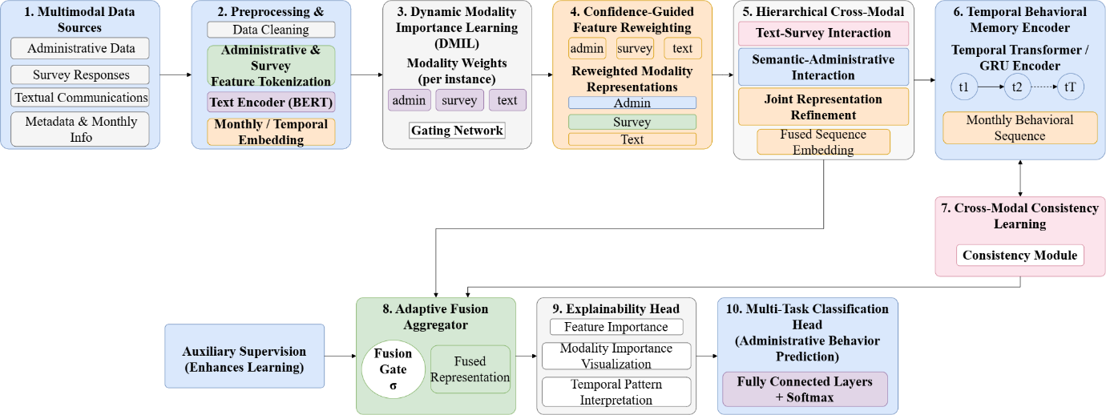
Figure 1. Overall pipeline of the proposed EduFusionFormer framework

3.1 Dataset Description
The suggested EduFusionFormer architecture is based on a Synthetically simulated multimodal dataset that aims to represent administrative behavior through complementary structured, survey-based, textual, and contextual information. The dataset includes four correlated data sources: monthly administrative dataset, textual communication, survey aggregates, and administrative logs. All four data sources contain common identifiers admin_id, month, and month_step allowing linking administrator-level information across the modalities. The monthly administrative dataset consists of 18,000 observations and 91 attributes representing 1,500 administrators observed over 12 months. Operational and behavioral features included in the dataset are meetings held and attended, reports submitted, approvals made, pending and overdue tasks, ongoing projects, response time, completion time, attendance, punctuality, working hours, decision-making activities, delegated tasks, interactions, budget request, and complaints resolved. The dataset contains 62,862 missing values but does not include duplicates. Textual communication dataset includes 35,201 documents described by 15 attributes. Each document is linked to an administrator and a corresponding month through common identifiers. The dataset includes six communication types: Circular, Official Email, Meeting Minutes, Faculty Communication, Notice, and Academic Report. The communication includes 15 communication topics such as accreditation preparation, examination schedule, students' welfare, hiring, research projects, faculty performance review, disciplinary policy, budget allocation, curriculum development, professional development, community outreach, digital learning, quality assurance, admission process, and infrastructure upgrade. Textual data also provides linguistic and communication attributes: urgency level, readability score, negative-word ratio, topic, and writing style. The dataset does not include duplicate documents and contains 3,699 missing values. Survey dataset includes 18,000 observations with 46 attributes that correspond to monthly administrator records. Each survey observation describes the aggregate responses corresponding to an administrator and month. The survey contains 20 respondents per record, while the minimum, maximum, and average number of respondents is 20. The survey variables include aggregate perceptions on communication, satisfaction, effectiveness, and other behavioral features. Administrative-log dataset consists of 18,000 observations with 25 attributes. The dataset shares common identifiers of administrators and time periods as other data sources. The data set includes operational activity features corresponding to administrative behavior. The dataset contains 10,273 missing values and does not include duplicates. Although the dataset is loaded and common keys are checked during the preprocessing, the current implementation of EduFusionFormer architecture uses the vector of selected administrative features of the monthly dataset as a principal administrative feature vector instead of concatenation of the complete administrative-log table. The dataset summary is presented in Table 2.

Table 2. Summary of the Multimodal Dataset
Data Source | Records | Attributes | Missing Values | Main Information
Monthly Dataset | 18,000 | 91 | 62,862 | Administrative and behavioral activities
Text Documents | 35,201 | 15 | 3,699 | Communication content and linguistic characteristics
Survey Aggregates | 18,000 | 46 | 0 | Aggregated perception and effectiveness measures
Administrative Logs | 18,000 | 25 | 10,273 | Administrative activity records
The label for our data, behavior_category, comprises of five categories of behaviors of the administrators: Average, Effective, Highly Effective, Needs Improvement, and Overloaded. Our entire dataset comprises of 18,000 observations. However, the dataset has an imbalanced distribution with Effective being the majority at 35%, Average being the next at 25%, Highly Effective at 20%, and Needs Improvement and Overloaded at 10% each.

Table 3. Behaviour Category Distribution
Behaviour Category | Samples | Percentage
Average | 4,500 | 25%
Effective | 6,300 | 35%
Highly Effective | 3,600 | 20%
Needs Improvement | 1,800 | 10%
Overloaded | 1,800 | 10%
Total | 18,000 | 100%
In the dataset, there are 1,500 unique administrators with 12 months, 8 departments, and 5 types of institutions. This is a longitudinal dataset at the level of administrator, which is crucial for the suggested model since multiple records can pertain to the same administrator in different months. In this case, random sampling of records may lead to the situation where information about the same administrator is present both in training and test datasets. Thus, the implementation performs administrator-level group-aware split using the admin_id column such that an administrator is included either in training, validation, or test dataset only. The multimodal nature of the dataset enables EduFusionFormer to capture complementary behavioral features. Administrative features capture the observable operational behavior of the administrator, survey features aggregate perception-based features, textual features capture semantic/communication-related features, and finally, metadata captures contextual features. The administrator-month alignment of heterogeneous data sources is crucial before feeding into the suggested multimodal model. The dataset distribution is described in Table 3.

3.2 Data Pre-processing
Before proposing the EduFusionFormer architecture, the heterogenous education administration data were preprocessed to create a uniform multimodal data representation that can be used as input for deep learning models. The preprocessing steps involved cleaning the data, removing any leakage, encoding features, splitting the data per administrator, imputing the missing values, normalizing the features, aggregating text, and performing BERT tokenization. The four datasets—monthly administration data, text, survey, and administration logs—were combined using the common identifiers admin_id, month, and month_step. First, target leakage variables such as leadership_score, communication_score, administrative_efficiency, stress_score, and engagement_score were removed from the dataset before modeling. The structured inputs were then categorized into 22 administration features, 43 survey features, and 6 metadata features, while the target behaviour_category is encoded in five classes: Average, Effective, Highly Effective, Needs Improvement, and Overloaded. Let the multimodal observation for administrator i at month t be represented as
$R_{i,t}=\{A_{i,t},S_{i,t},M_{i},T_{i,t},Y_{i,t}\}$ (1)
where $A_{i,t}$, $S_{i,t}$, $M_{i}$, $T_{i,t}$, and $Y_{i,t}$ represent administrative characteristics, survey characteristics, metadata, textual characteristics, and the behavioral target respectively. In order to avoid administrator characteristics from leaking to other sets, we utilized GroupShuffleSplit with the grouping variable being admin_id. The dataset was split into about 70% training set, 15% validation set and 15% test set and intersection checks proved that there was no overlap between administrators. Numerical data missing values were imputed using the median method, where the imputer was fitted only on the training set. Numerical data were then standardized using the Standard Scaler method and was fit only on the training set and then used for the validation and test sets. Standardized numerical data are represented by
$\hat{X_{i,t,j}}=\frac{X_{i,t,j}-μ_{j}}{σ_{j}}$ (2)
where μ and σ are the means and standard deviations of feature j in the training set. In the case of the textual modality, multiple records of communications related to the same administrator-month combination were summed up as one text input. This text was then tokenized using BERT-base-uncased with a sequence length of 256. Tokenization can be expressed as
$\left(I_{i,t},Q_{i,t}\right)=\text{BERTTokenizer}\left(T_{i,t},256\right)$ (3)
where $I_{i,t}$ is the token ID and $Q_{i,t}$ is the attention mask. Finally, all the representations of administrative data, survey data, metadata, and text were put together to create multimodal tensors using the customized Dataset and DataLoader class. Hence, each sample contains the structured feature, tokenized text, attention mask, month-step feature, and the behavioral target encoding. The entire preprocessing procedure can be described as
$R_{i,t}→\text{Cleaning}→\text{Encoding}→\text{Scaling}→\text{Text Tokenization}→X_{i,t}$ (4)
where $X_{i,t}$​ denotes the final multimodal input supplied to EduFusionFormer for cross-modal representation learning and five-class administrative behavioral classification.

3.3 Feature Extraction
The purpose of the feature extraction part of the proposed EduFusionFormer model is to create complementary representations from the different structured, survey, metadata, and text data modalities. As opposed to traditional methods for predicting educational behaviors based on one type of feature or simply concatenating different features, EduFusionFormer maintains the original modality structure and converts each feature cluster to latent representation. The generated features are later used in the dynamic modality and cross-modal learning parts of the model. Specifically, the normalized structured features are divided into administrative features $A_{i,t}$∈R²² and survey features $S_{i,t}$∈R⁴³, whereas the contextual administrator features are denoted as metadata $M_{i}$∈R⁶. The structured features are processed separately in order to maintain the properties of each modality. The structured modality representation can be defined as
$X_{i,t}=\left[A_{i,t}∥S_{i,t}∥M_{i}\right]$ (5)
where ∥ represents the concatenation operation for the corresponding modality-specific feature representation. These two sets of features are then fed to the Dynamic Feature Tokenizer that maps each numerical feature to a learnable latent embedding of size d=256. So for an input feature xj, the corresponding feature token is given by
$z_{j}=W_{j}x_{j}+b_{j}$ (6)
where $W_{j}$ and $b_{j}$ denote the trainable projections and $z_{j}$∈R²⁵⁶ is the resulting feature token. This procedure leads to 22 tokens for the administrative modality and 43 tokens for the survey modality, thus enabling the Transformer parts to work on individual features instead of considering one modality as a single vector. In the case of the textual modality, the aggregated administrator-month interaction is encoded by the pretrained BERT-base-uncased model. The tokenized textual sequence is converted to contextual embeddings and the CLS representation provides the semantic encoding of the respective textual modality. The text representation can be written as
$H_{i,t}^{\text{text}}=\text{BERT}\left(I_{i,t},Q_{i,t}\right)$ (7)
where $I_{i,t}$ and $Q_{i,t}$ represent the token IDs and attention mask, respectively, and $H_{i,t}^{\text{text}}$ corresponds to the context-based textual feature sequence. The BERT features are projected to the same 256-dimensional latent space that is used by the other structured modalities. Lastly, the modality-specific features are fed into the DMIL module to learn the relevance of these modalities for each particular administrator-month. As a result, the process of feature extraction generates structured administrative tokens, structured survey tokens, structured metadata features, and context-based textual features.

3.4 Proposed EduFusionFormer Architecture
The proposed EduFusionFormer model is a multimodal deep learning model for automatically analyzing educational administrative behavior. Contrary to existing educational behavior prediction methods that adopt either single modality or simply concatenate heterogeneous modal features together, EduFusionFormer takes into account administrative features, survey data, administrator meta-information, and text communication using different branches of representation learning. EduFusionFormer dynamically assigns weights to each modality depending on its significance, fine-tunes modality-wise representations with confidence-based feature reweighting, captures hierarchical cross-modal interactions with the help of Transformer's self-attention, learns monthly behavioral patterns using temporal memory, and identifies consistency across heterogeneous modalities. The generated representation is adaptively fused and further utilized for five-class behavioral classification along with additional behavioral outputs and explanation data. The overall architecture of the proposed EduFusionFormer model is shown in Figure 2.
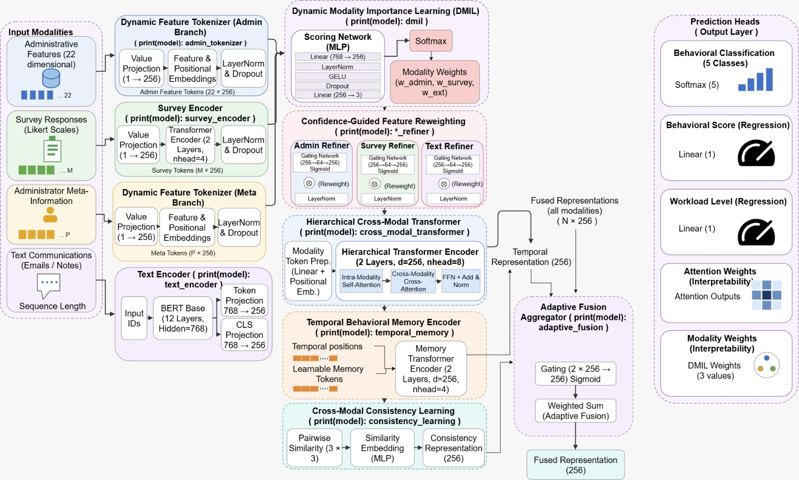

Figure 2. Overall Architecture of the Proposed EduFusionFormer Framework
Considering that each administrative feature vector $A_{i,t}$∈R²² is represented by a set of standardized administrative features, each scalar feature gets converted to a feature token through the Dynamic Feature Tokenizer approach. This involves projecting the scalars in a latent dimension d=256 and then combining it with the learnable feature and positional embeddings.
$Z_{i,t}^{A}=\text{LN}\left(W^{A}A_{i,t}+E^{A}+P^{A}\right)$ (8)
where $Z_{i,t}^{A}$∈R^{22×256}, $E^{A}$ is the learned feature embedding, and $P^{A}$ is the positional embedding. Hence, the tokenizer implemented creates 22 tokens per each administrator-month data point. Simultaneously, the Survey Encoder maps the 43 survey features into 43 feature tokens by means of value projection, learned feature embedding, positional embedding, and a two-layer Transformer encoder. Then, the generated tokens from the survey are aggregated to derive a survey embedding of dimensionality 256. A representation of the textual communication is derived with the help of the pre-trained BERT-base-uncased encoder whose contextual token representation is projected into the same 256-dimensional latent space. Consequently, all three primary modalities are embedded into a common feature space. The three embeddings obtained are further fed to the DMIL module. DMIL learns sample-specific weights for the three modalities and produces dynamically weighted representations according to
$\left[\tilde{A_{i,t}},\tilde{S_{i,t}},\tilde{T_{i,t}}\right]=\text{DMIL}\left(A_{i,t},S_{i,t},T_{i,t}\right), \sum_{m=1}^{3}{w_{m}}=1$ (9)
where $w_{m}$ stands for the learned importance of the administrative, survey, and textual modalities. The architecture ensures that the modality weights sum up to one for each sample. The modality-specific representations are further refined using Confidence-Guided Feature Reweighting technique that learns confidence gates for the administrative, survey, and textual representations. The confidence gates emphasize the reliable feature dimensions by weighting them more and suppress the irrelevant feature representations. The refined modality representations are used as input for the Hierarchical Cross-Modal Transformer. The first stage of the transformer conducts a bidirectional Text-Survey cross-attention in order for the textual representations to access the survey information and vice versa. The second stage of the Hierarchical Cross-Modal Transformer allows the created semantic representation to interact bidirectionally with the administrative representation and the two-layer Transformer encoder further conducts self-refinement of the combined representation. The hierarchical cross-modal representation is used as input to the Temporal Behavioral Memory Encoder that takes into account the month_step information and learns temporal memory tokens. In the implemented model, the temporal part contains 12 monthly positions and 16 memory tokens using multi-head attention mechanism in order to learn the behavioral changes during the observation period. The temporal representation can be represented as
$H_{i,t}^{\text{temp}}=\text{TBM}\left(H_{i,t}^{\text{cross}},m_{t}\right)$ (10)
where $H_{i,t}^{\text{cross}}$ is the hierarchical cross-modal embedding and $m_{t}$ is the month associated with that step. In order to capture the agreements and disagreements between the modalities, the Cross-Modal Consistency Learning module takes care of the administrative, survey, and text embeddings and creates the consistency embedding and similarity scores as well. The final consistency embedding is then combined with the temporal embedding using the Adaptive Fusion Aggregator that learns two weights for temporal and consistency representations.
$H_{i,t}^{\text{fusion}}=α_{i,t}H_{i,t}^{\text{temp}}+β_{i,t}H_{i,t}^{\text{cons}}, α_{i,t}+β_{i,t}=1$ (11)
Implementation has made these weights readily available for further analysis and interpretation. Final 256 dimensional fused representation is then given as input to both Explainability Head and Multi-Task Classification Head simultaneously. Explainability Head gives weights for modalities, fusion, temporal attention, cross-modal similarities, feature importance, and cross attention, which can help us analyze and understand the decision-making process of the model on different levels. Classification head starts by transforming the fused representation using a shared representation network and then predicts five-class behavioral prediction.
$\hat{y_{i,t}}=\text{Softmax}\left(W_{c}H_{i,t}^{\text{fusion}}+b_{c}\right)$ (12)
Where $\hat{y_{i,t}}$∈R⁵ is the probability of classes such as Average, Effective, Highly Effective, Needs Improvement, and Overloaded. Apart from the primary classification output, the designed classification head contains three auxiliary outputs for engagement, workload, and leadership. These auxiliary heads will generate one-dimensional outputs from the shared representations. Therefore, the overall model provides the following outputs: primary behavioral logits, 256-dim fused embedding, auxiliary behavioral outputs, modality and fusion weights, temporal attention, similarities, and cross-modal attention. The optimization function that will be used in the training process of the current notebook is the weighted cross entropy with label smoothing on the five-class primary classification logits. Consequently, even though the current architecture has auxiliary heads for engagement, workload, and leadership, they cannot be referred to as the auxiliary jointly optimized tasks unless there are auxiliary losses added to the training process.

Table 4. Architecture Summary of EduFusionFormer
Layer / Module | Configuration | Output Representation
Administrative Input | 22 standardized features | (22)
Dynamic Feature Tokenizer | Value projection + feature embedding + positional embedding; hidden size = 256 | (22,256)
Survey Input | 43 standardized features | (43)
Survey Encoder | 2 Transformer layers, 8 heads, hidden size = 256 | (43,256) + global (256)
Text Input | BERT-base-uncased; maximum length = 256 | (256,256)
Text Encoder | Pretrained BERT + projection to 256 dimensions | (256,256) + CLS embedding (256)
DMIL | Dynamic 3-modality importance weighting | 3 modality weights + three (256) embeddings
Confidence-Guided Reweighting | Separate confidence gates for Admin, Survey and Text | Three refined (256) embeddings
Hierarchical Cross-Modal Transformer | 8 heads; Text↔Survey followed by Semantic↔Admin; 2-layer refinement | Global embedding (256)
Temporal Behavioral Memory | 12 monthly positions; 16 memory tokens; 8 heads | Temporal embedding (256)
Cross-Modal Consistency | Three modality representations + similarity learning | Consistency embedding (256)
Adaptive Fusion | Temporal + consistency weighted fusion | Fused embedding (256)
Explainability Head | Feature, modality, temporal, fusion and cross-attention analysis | Multiple explanation outputs
Shared Classification Representation | Fully connected layers + LayerNorm + GELU | (256)
Main Classification Head | Fully connected layer → 5 classes | (5)
Auxiliary Heads | Engagement, workload and leadership | (1) each
The principal architectural configuration (Table 4) including the 22 administrative features, 43 survey features, BERT text branch, DMIL, hierarchical Transformer, 12-month temporal memory, consistency module, adaptive fusion, explainability head, and multi-task classification head—is explicitly implemented in the EduFusionFormer model.

Table 5. Parameter Distribution of EduFusionFormer
Module | Parameter Information
BERT Parameters | 14,766,336 trainable
New Module Parameters | 9,263,046 trainable
Classification Parameters | 266,504 trainable
Total Trainable Parameters | 24,295,886
Frozen Parameters | 94,715,904
Total Parameters | 119,011,790
The total number of parameters in the complete model is 119,011,790, with 24,295,886 of them being trainable and 94,715,904 being frozen (Table 5). The large frozen parameter number arises due to the pretrained BERT model. On the other hand, the newly designed components for the multimodal, temporal, consistency, explainability, and classification tasks make up the trainable parameters. As for the used optimization setup, the trainable parameters are split into three separate groups of learning rates to differentiate between BERT parameters, the new modules, and the classification layer. Thus, the language representation is fine-tuned conservatively compared to the newly initialized components.

3.5 Loss Function and Hyperparameter Configuration
The performance of the proposed EduFusionFormer depends on the multimodal architecture as well as the optimization algorithm adopted during the training stage. This is because the major goal of the framework is to perform classification of administrator behavior classes using heterogeneous data including administration, surveys, and text. The predictor function of the framework can be formulated as
$\hat{y_{i}}=f_{\text{EduFusionFormer}}\left(A_{i},S_{i},T_{i},m_{i}\right)$ (13)
where $A_{i}$, $S_{i}$, and $T_{i}$ represent the administrative, survey, and text-based representation of the i-th sample, respectively, while mi represents the time-month step information of the i-th sample. $f_{\text{EduFusionFormer}}$ is the name of the proposed model, and $\hat{y_{i}}$ stands for the estimated behavioral class probabilities. For the purpose of optimizing the classification process, the Cross Entropy loss function with label smoothing is used. The class weights are determined based on the distribution of classes in the training set, giving importance to minority classes during optimization. The loss function is expressed as
$L_{CE}=-\frac{1}{N}\sum_{i=1}^{N}{w_{y_{i}\sum_{c=1}^{C}{q_{i,c}\log\left(p_{i,c}\right)}}}$ (14)
where N is the number of training samples, C=5 is the number of behavioral classes, w_{yi} is the balanced class weight corresponding to the actual class, $p_{i,c}$ is the prediction probability for class c, and $q_{i,c}$ is the smoothed target distribution. The adopted setup makes use of a label smoothing factor of 0.10 along with balanced class weights. Model parameters are optimized using AdamW, where the learning rate for the pretrained BERT model, EduFusionFormer components, and classifier are different from each other. This way, while updating the pretrained language representation model, it can be done carefully without changing much, whereas the newly created multimodal components have the liberty to learn faster. Adopted learning rates are 5×10−6, 1×10−4, and 2×10−4, respectively, with a weight decay of 1×10−4. AdamW uses β1=0.9, β2=0.999, and ϵ=10−8.
To determine the learning rate, the framework relies on a cosine learning rate schedule with linear warm-up. The number of training steps required for the warm-up phase is equal to 10 percent of the total number of training steps, beyond which the cosine learning-rate schedule takes effect. The total number of training steps is computed using the number of training batches and the number of epochs set by the user. In addition, gradient clipping with a maximum norm of 1.0 is used along with automatic mixed precision in cases where CUDA is available. Early stopping is done based on the validation macro-F1 score, as the macro-F1 gives the same weight to all five behavioral classes compared to accuracy. Hence, macro-F1 is a better measure for early stopping considering the class imbalance problem in this case. Early stopping is performed with a patience of 5 epochs, and the checkpoint with the highest validation macro-F1 score is kept.
After training, the EduFusionFormer model is then tested on the unseen dataset based on accuracy, macro precision, macro recall, macro-F1, and multi-class ROC-AUC. Apart from prediction performance, interpretability information is also generated by this framework in the form of modality weight, temporal attention, cross-modal similarity, fusion weight, feature importance, and cross-attention. The entire set of hyperparameters used in this framework is shown in Table 6.

Table 6. Hyperparameter Configuration of the Proposed EduFusionFormer
Hyperparameter | Value
Model | EduFusionFormer
Text Encoder | BERT-base-uncased
Maximum Text Length | 256 tokens
Batch Size | 32
Administrative Features | 22
Survey Features | 43
Hidden Dimension | 256
Attention Heads | 8
Survey Transformer Layers | 2
Temporal Memory Tokens | 16
Temporal Positions | 12 months
Feed-Forward Dimension | 512
Dropout Rate | 0.30
Number of Classes | 5
Loss Function | Weighted Cross-Entropy
Label Smoothing | 0.10
BERT Learning Rate | 5×10−6
New Module Learning Rate | 1×10−4
Classifier Learning Rate | 2×10−4
Optimizer | AdamW
Weight Decay | 1×10−4
Adam β1​ | 0.9
Adam β2​ | 0.999
Adam ϵ | 1×10−8
Learning-Rate Scheduler | Cosine Schedule with Warm-up
Warm-up Ratio | 10%
Maximum Epochs | 30
Early Stopping Patience | 5
Gradient Clipping | 1.0
Mixed Precision | Enabled on CUDA
Best Model Selection | Highest Validation Macro-F1
Evaluation Metrics | Accuracy, Precision, Recall, Macro-F1, ROC-AUC
Explainability | Modality Weights, Temporal Attention, Cross-Modal Attention, Fusion Weights
Framework | PyTorch + Hugging Face Transformers
This technique creates a compromise between fine-tuning the trained language encoder steadily and the efficient training of the new multimodal parts. Weighing of the Cross-Entropy loss function corrects for the imbalanced classes, whereas label smoothing contributes to robust classification. The differential AdamW learning rate prevents overly aggressive changes in the pretrained language representations and allows the new fusion and temporal modules to train effectively. Moreover, cosine learning rate warm-up contributes to steady training, whereas early stopping based on macro-F1 of validation decreases overfitting. Lastly, the outputs of attention and modality weights allow for analysis of the effect of the administrative, survey, text, temporal, and consistency data along with the behavior.

Algorithm 1. EduFusionFormer for Multimodal Administrative Behavioral Classification
Input:
Administrative feature set A
Survey feature set S
Textual communication records T
Administrator metadata M
Monthly behavioral information m
Behavioral category labels Y
Output:
Administrative behavioral predictions
Class probabilities
Modality importance weights
Temporal attention representations
Cross-modal attention maps
Adaptive fusion weights
Feature and modality explainability outputs
Step 1: Dataset Preparation
1. Load monthly administrative records, survey aggregates, textual communication records, and administrator metadata.
2. Align heterogeneous records using admin_id, month, and month_step.
3. Remove duplicate and invalid records.
4. Remove identified target-leakage features.
5. Select 22 administrative features, 43 survey features, and 6 metadata features.
6. Encode the five behavioral categories into numerical labels.
7. Apply administrator-level group-aware splitting to construct training, validation, and testing subsets.
8. Perform median imputation and feature standardization using training-set statistics.
Step 2: Text Pre-processing
9. Group textual communication records according to administrator and month-step.
10. Aggregate multiple documents belonging to the same administrator-month observation.
11. Tokenize aggregated textual inputs using the BERT-base-uncased tokenizer.
12. Generate input IDs and attention masks.
13. Truncate or pad textual sequences to a maximum length of 256 tokens.
14. Construct transformer-compatible textual input tensors.
Step 3: Modality-Specific Feature Representation
15. Transform the 22 administrative features into learnable feature tokens using the Dynamic Feature Tokenizer.
16. Generate the administrative embedding from the resulting feature tokens.
17. Encode the 43 survey features using the Survey Encoder.
18. Generate survey tokens and the global survey embedding.
19. Encode textual inputs using the pretrained BERT-base-uncased encoder.
20. Generate contextualized text tokens and the text embedding.
21. Project the modality representations into the common 256-dimensional latent space.
Step 4: Dynamic Modality Importance Learning
22. Provide administrative, survey, and textual embeddings to the DMIL module.
23. Estimate sample-specific modality importance scores.
24. Normalize the modality weights across the three modalities.
25. Dynamically reweight administrative, survey, and textual representations.
Step 5: Confidence-Guided Feature Reweighting
26. Generate confidence gates for the administrative representation.
27. Generate confidence gates for the survey representation.
28. Generate confidence gates for the textual representation.
29. Refine each modality using its corresponding confidence gate.
30. Inject the refined representations into the modality token sequences.
Step 6: Hierarchical Cross-Modal Transformer
31. Perform bidirectional Text–Survey cross-attention.
32. Generate contextualized textual and survey representations.
33. Perform bidirectional Semantic–Administrative cross-attention.
34. Combine administrative and semantic representations.
35. Apply Transformer-based self-refinement to the fused tokens.
36. Generate the hierarchical cross-modal embedding.
37. Store cross-modal attention maps for explainability.
Step 7: Temporal Behavioral Memory
38. Provide the hierarchical embedding and month-step information to the Temporal Behavioral Memory Encoder.
39. Incorporate learnable temporal memory representations.
40. Capture temporal behavioral dependencies across monthly observations.
41. Generate the temporal behavioral embedding and temporal attention representation.
Step 8: Cross-Modal Consistency Learning
42. Provide the refined administrative, survey, and textual embeddings to the consistency module.
43. Learn consistency relationships among the three modalities.
44. Generate the cross-modal consistency embedding.
45. Compute modality similarity scores.
Step 9: Adaptive Fusion
46. Combine the temporal behavioral embedding and consistency embedding.
47. Estimate adaptive fusion weights.
48. Generate the final fused 256-dimensional representation.
49. Preserve fusion weights for subsequent interpretation.
Step 10: Explainability Analysis
50. Generate modality importance weights.
51. Generate administrative, survey, and textual confidence gates.
52. Extract temporal attention representations.
53. Extract cross-modal attention maps.
54. Analyze cross-modal similarity scores.
55. Analyze adaptive temporal-consistency fusion weights.
Step 11: Behavioral Classification
56. Pass the final fused representation through the shared classification representation.
57. Predict the five behavioral categories using the main classification head.
58. Generate auxiliary engagement, workload, and leadership outputs.
59. Convert classification logits into behavioral class probabilities.
60. Select the class with the highest predicted probability as the final behavioral prediction.
Step 12: Model Optimization
61. Compute the weighted Cross-Entropy loss with label smoothing.
62. Apply class weights to compensate for behavioral-class imbalance.
63. Optimize model parameters using the AdamW optimizer.
64. Apply separate learning rates to BERT, newly introduced modules, and classifier parameters.
65. Apply linear warm-up followed by cosine learning-rate decay.
66. Apply gradient clipping and Automatic Mixed Precision (AMP).
67. Monitor validation Macro F1-score during training.
68. Save the best model according to validation Macro F1-score.
69. Apply Early Stopping when validation Macro F1-score fails to improve.
Step 13: Model Evaluation
70. Evaluate the best EduFusionFormer model on the unseen test dataset.
71. Calculate Accuracy.
72. Calculate Macro Precision.
73. Calculate Macro Recall.
74. Calculate Macro F1-score.
75. Calculate multi-class ROC-AUC.
76. Generate class-wise performance analysis and confusion matrix.
Return:
Administrative behavioral predictions, class probabilities, Accuracy, Macro Precision, Macro Recall, Macro F1-score, ROC-AUC, modality importance weights, confidence gates, temporal attention, cross-modal attention maps, similarity scores, adaptive fusion weights, and explainability outputs.

4. Results and Discussions

4.1 Experimental Setup
The performance of the designed EduFusionFormer model was tested on a multimodal administrative behavior dataset that comprises administrative monthly records, survey records, textual records, and administrator information. The datasets were aligned based on the identifiers admin_id, month, and month_step. The total number of records in the monthly dataset is 18,000 records from 1,500 administrators in 12 months, while there are 35,201 textual records. The categories of the behavioral targets include Average, Effective, Highly Effective, Needs Improvement, and Overloaded. Missing numerical values were imputed by the median of the training set, and numerical features were scaled according to the training set. Textual data were tokenized by the BERT tokenizer with the maximum sequence length of 256 tokens. To prevent any information leaking among administrators, the dataset was split based on group splitting for each administrator, making sure that the same administrator did not appear at the same time in the training, validation, and testing sets. The suggested EduFusionFormer model was designed using the PyTorch deep learning framework along with the use of a pretrained BERT-base-uncased text encoder and proposed multimodal learning blocks. First, the administrative and survey variables were transformed into 256-dimensional feature tokens, while the text encoder provided the contextual representations for the text modality. Next, DMIL adaptively reweighted the representations of the administrative, survey, and textual modalities, which were then processed using CFFR and the hierarchical cross-modal transformer, which learned interactions between different modalities.
During the optimization process, weighted Cross Entropy Loss with Label Smoothing was used in order to overcome the imbalanced data between the five different behavioral classes. The AdamW optimizer was set up with individual learning rates of 5×10−6 for the BERT model parameters, 1×10−4 for the added models, and 2×10−4 for the classifier, along with a weight decay rate of 1×10−4. In addition, a linear warm-up of 10% followed by cosine learning rate decay was used for the optimization. Gradient Clipping with a maximum norm value of 1.0 and Automatic Mixed Precision were also used during the optimization process. Predictive accuracy of EduFusionFormer was analyzed based on Accuracy, Macro Precision, Macro Recall, Macro F1-score, and ROC-AUC. Macro metrics are considered more important as they allow balanced evaluation of the algorithm’s predictions based on all five types of behavior, though their distribution is unbalanced. Apart from standard classification metrics, the introduced framework offers some interpretability metrics such as dynamic modality importance weights, confidence gates, temporal attention, cross-modality attention, similarity, and adaptive fusion weights. This allows analyzing the contribution of administrative, survey, text, and time information into the final prediction of the behavior.

4.2 Evaluation Metrics
To assess the performance of the proposed EduFusionFormer, several classification metrics are taken into account, which will serve as an overall performance measure of the ability of the model to predict the five different types of behavioral categories. In the case of the proposed method that predicts multiclass behavioral data instead of continuous-value predictions, metrics like Accuracy, Macro Precision, Macro Recall, Macro F1 Score, and ROC-AUC can be used for evaluation. These metrics are indicative of accuracy of the predictions, class precision, sensitivity of the predictions, classification performance, and discrimination ability, respectively. Accuracy represents the proportion of correctly classified samples amongst all test samples and is computed as
$\text{Accuracy}=\frac{1}{N}\sum_{i=1}^{N}{oI\left(\hat{y_{i}}=y_{i}\right)}$ (15)
where N is the total number of test instances, yi is the true behavioral class, $y_{i}$ is the predicted class, and I is an indicator function that takes the value one when the prediction is right and zero otherwise. Accuracy is an aggregate metric of the classification capability of EduFusionFormer. The next metric is Macro Precision that measures the average precision for each behavioral class separately. It can be computed as
${\text{Precision}}_{\text{macro}}=\frac{1}{C}\sum_{c=1}^{C}{\frac{TP_{c}}{TP_{c}+FP_{c}}}$ (16)

Here C = 5 is the number of behavioral classes where $TP_{c}$ and $FP_{c}$ are the True Positive and False Positive samples for class c. With the help of macro averaging, it makes sure that each behavioral class has equal weightage in the calculation of the final metric irrespective of the number of samples they have. The macro recall indicates

${\text{Recall}}_{\text{macro}}=\frac{1}{C}\sum_{c=1}^{C}{\frac{TP_{c}}{TP_{c}+FN_{c}}}$ (17)
where $FN_{c}$ represents the number of false-negative samples of class c. Macro Recall proves extremely effective in checking whether the minority classes of behavior are being recognized effectively and not letting the classifier perform well on the basis of majority classes only. The formula for Macro F1-score, which is based on Macro Precision and Macro Recall, is given by
$F1_{\text{macro}}=\frac{1}{C}\sum_{c=1}^{C}{\frac{2P_{c}R_{c}}{P_{c}+R_{c}}}$ (18)
Where Pc and Rc stand for the precision and recall for the class c. Macro F1 score represents a well-balanced approach of classification performance assessment and serves as the key metric for best-model selection and early stopping in our implementation of the EduFusionFormer training process. Finally, ROC-AUC is used to assess how well the classifier distinguishes between the five behavior types using the predicted probabilities of classes. In the case of the multiclass setting, AUC is computed by applying the one-vs-rest (OvR) approach along with macro averaging. The multiclass ROC-AUC can be described as
$AUC_{macro}=\frac{1}{C}\sum_{c=1}^{C}{AUC_{c}}$ (19)

In which $AUC_{c}$ is the one-vs-rest area under the ROC curve for behavioral class c. Larger values of ROC-AUC imply better discrimination between the behavioral category and all other categories. The combination of Accuracy, Macro Precision, Macro Recall, Macro F1-score, and ROC-AUC ensures a thorough assessment of the classification performance of EduFusionFormer. While Accuracy measures general performance, Macro Precision and Macro Recall measure class-based performance. Macro F1 takes into account the balance between precision and recall and is especially critical in the case of imbalanced behavioral categories. Finally, ROC-AUC measures discriminative performance for the probability distributions of predictions.

4.3 Performance Analysis of the Proposed EduFusionFormer
The performance of the suggested EduFusionFormer was assessed with the experimental setting as outlined in Section 4.1. The architecture consists of administrative, survey, and text data incorporated via Dynamic Feature Tokenizer, Survey Encoder, BERT Text Encoder, Dynamic Modality Importance Learning, Confidence-Guided Feature Reweighting, Hierarchical Cross-Modal Transformer, Temporal Behavioral Memory Encoder, Cross-Modal Consistency Learning, and Adaptive Fusion Aggregator. This multimodal representation is further utilized by the classification head to make predictions on five types of administrative behavior categories. In the process of training, the model was trained based on the weighted Cross-Entropy loss function and AdamW optimizer with differential learning rates for the pre-trained BERT parameters, new modules, and classification layers. The best-checkpoint was achieved after epoch 34 with a validation macro-f1 value of 0.9074. This checkpoint was then used to evaluate the model on the test data. The notebook captures the performance of the model on the test data using Accuracy, Macro Precision, Macro Recall, Macro F1 and Macro AUC.

Table 7. Training and Validation Performance of the Proposed EduFusionFormer at the Best Checkpoint (Epoch 34)
Metric | Training | Validation
Loss | 0.2759 | 0.2515
Accuracy | 0.8922 | 0.9059
Macro Precision | 0.8802 | 0.9048
Macro Recall | 0.8975 | 0.9141
Macro F1 | 0.8882 | 0.9074
Macro AUC | 0.9869 | 0.9902

Validation Macro-F1 score of 0.9074, which represents the highest value, means that the EduFusionFormer performed very well in balancing the classification between the five behavioral categories. It is especially significant as the value of Macro-F1 does not give priority to any particular behavioral category but gives all categories equal weightage. The selection of the checkpoint using Macro-F1 score is also aligned with the process of training followed. The training and validation performance of epoch 34 is presented in Table 7.

Table 8. Final Test Performance of the Proposed EduFusionFormer
Metric | Value
Test Loss | 0.2712
Accuracy | 0.9030
Macro Precision | 0.9018
Macro Recall | 0.9129
Macro F1 | 0.9057
Macro AUC | 0.9888
Test results (Table 8) show that EduFusionFormer has high levels of accuracy in classifying administrator samples that have never been encountered before. The Accuracy level stands at 90.30%, which means that almost nine out of ten test instances are classified correctly. The high level of Macro Precision (0.9018) and Macro Recall (0.9129) shows a balanced approach to prediction for each of the five behavioral classes. Therefore, the obtained F1-score value of 0.9057 confirms a good trade-off between precision and recall for this unseen test set. Evaluation was made based on predicted probabilities and labels provided by the best checkpoint. The Macro AUC of 0.9888 shows another advantage of the suggested classification algorithm due to high discriminative power. As opposed to accuracy-based evaluation, ROC-AUC estimates the quality of predicted probability distribution and shows how well the model distinguishes between each behavioral class from other classes based on one-vs-rest approach. The used evaluation technique considers the multiclass AUC based on macro averaging.
Class-wise assessment yields further evidence about the balanced performance of the algorithm. In particular, the Needs Improvement class has the highest F1-score of 0.9308, followed by Highly Effective (0.9051), Average (0.8990), Effective (0.8984), and Overloaded (0.8949). As for the corresponding recall scores, they differ in the range of 0.8472 to 0.9765, proving successful detection of samples from all five behavioral classes without giving priority to the majority of classes. Overall, the results of experiments show that EduFusionFormer ensures a high-quality multimodal representation for administrative behavioral classification. Due to such factors as dynamic modality importance learning, confidence-guided feature refinement, hierarchical cross-modal attention, temporal behavioral memory, consistency learning, and adaptive fusion, the framework can efficiently combine complementary information coming from administrative records, surveys, and textual data. Relatively similar validation (0.9074) and final test (0.9057) Macro-F1 scores also suggest the ability of the model to classify previously unseen data. The test performance, along with the high Macro-AUC score of 0.9888, confirms the efficiency of the multimodal architecture designed for automated behavioral classification among the staff members. Moreover, the framework offers not only prediction but also the modality weights, feature gates, temporal attention, cross-modal attention, similarities, and fusion weights.

4.4 Training Convergence Analysis

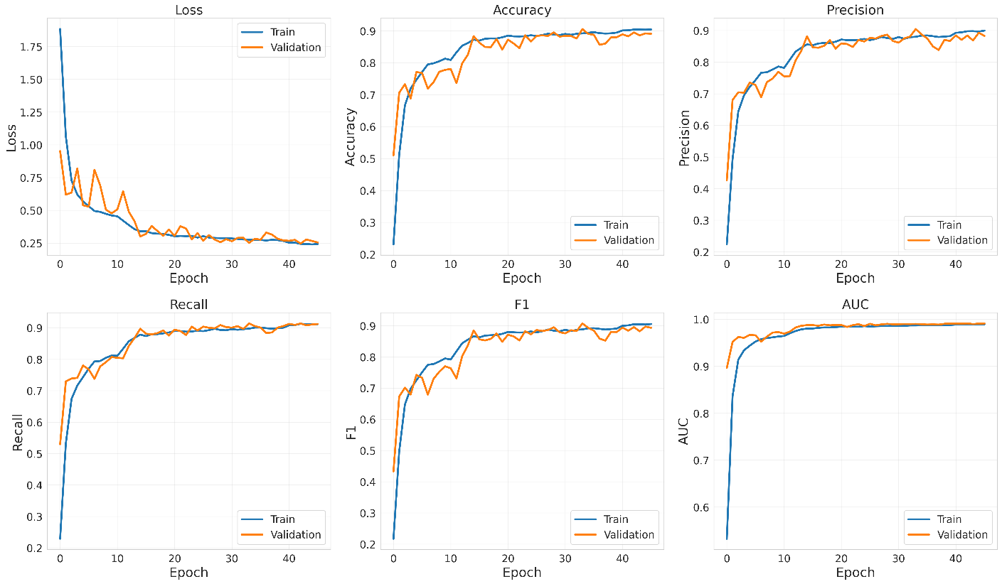

Figure 3. Training and Validation Curves of the Proposed EduFusionFormer
The loss curves demonstrated in Figure 3 depict the convergence properties of the suggested EduFusionFormer model throughout the training process. It should be noted that the fast decrease in the training loss can be seen in the initial epochs, thus, indicating the ability of the network to quickly learn from the heterogeneous multimodal input data provided by the admin, survey, and textual information. The training loss goes down from approximately 1.88 in the first epoch to 0.24 towards the final epochs, whereas the validation loss goes down from approximately 0.94 to 0.25. In the later training epochs, both curves converge to each other without significant differences. Furthermore, the accuracy curves provided in Figure 3 prove the progressive improvement of the framework. The training accuracy increases dramatically from approximately 0.23 in the initial epoch to around 0.91 in the last epoch, whereas the validation accuracy increases considerably from approximately 0.51 to approximately 0.89. Despite the fact that some fluctuations are observable in the validation curve during the middle training epochs, the general tendency is quite stable and positive. Moreover, the small gap between the training and validation accuracy shows that the learned representations can be generalized well enough to the validation dataset.
The similar tendency is visible in the curves depicting the behavior of Macro Precision metric of the framework. The training precision grows from approximately 0.22 in the initial epochs to approximately 0.90 in the latter epochs, whereas the validation precision goes up from approximately 0.43 to 0.89. Despite the oscillations that occur during the validation precision in the intermediate training periods, these oscillations become smaller with the progression of optimization process. Thus, the close convergence of the curves proves that the suggested framework is capable of consistently balancing the ability of correct classifying behavioral classes and preventing false class assignments. The Macro Recall curves demonstrate similar improvements through the training process. The training recall goes up from approximately 0.23 to approximately 0.91, whereas the validation recall goes up from approximately 0.53 to approximately 0.91. The validation recall converges to the relatively stable region after the initial learning process, showing only minor oscillations in the following epochs. Thus, the EduFusionFormer is getting better and better in its ability to detect the samples that belong to the different behavioral classes. The close connection between the training and validation recall indicates that the model cannot lose this ability when used with new validation observations.
The curves demonstrating the behavior of the training and validation Macro F1-score metric can serve as an important indicator of the ability to correctly classify the data while maintaining the balance between precision and recall. Training F1-score goes up rapidly from approximately 0.22 to around 0.90, while validation F1-score goes up from approximately 0.43 to approximately 0.89-0.91. The maximum value of the validation Macro-F1 that was recorded at the selected checkpoint equals 0.9074 and occurs at the 34th epoch as shown in Table 7. The validation curve shows some fluctuations after the sharp increase in the first epochs of optimization, which is normal for multimodal neural architectures. Nevertheless, the general behavior of the curve indicates that the model is progressively learning more discriminative representations while maintaining the strong balance between precision and recall. Finally, the curves of the ROC-AUC metric show the convergence properties of the EduFusionFormer. The training AUC grows from approximately 0.53 in the first epoch to nearly 0.99, while the validation AUC starts from approximately 0.90 and quickly reaches 0.99. The two curves further remain quite close to each other, despite the small fluctuations that occur during the following epochs. Thus, the high AUC values show that the EduFusionFormer becomes quite efficient in its ability to discriminate the five behavioral categories using the predicted class probabilities. The validation AUC of 0.9902 at the selected checkpoint proves the strong discriminative capabilities of the suggested framework.
Thus, as one can see from the presented in Figure 3 analysis of convergence, the proposed EduFusionFormer shows the fast initial learning, stable optimization, and effective generalization. The majority of performance improvements happens in the initial and middle training epochs, after which the accuracy, precision, recall, F1-score, and AUC curves start to converge. Thus, the close relationship between the training and validation curves in the last epochs proves that the model does not show the severe overfitting problem. The chosen checkpoint at the 34th epoch with the validation Macro-F1 of 0.9074 proves to be the most balanced one in terms of validation performance. The convergence of the loss and classification metrics, together with the high validation AUC, proves the efficiency of the suggested combination of dynamic modality weighting, confidence-guided feature refinement, hierarchical cross-modal attention, temporal behavioral memory, consistency learning, and adaptive fusion.

4.5 Confusion Matrix Analysis

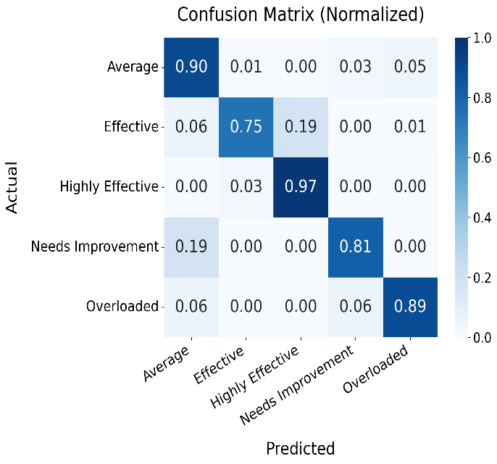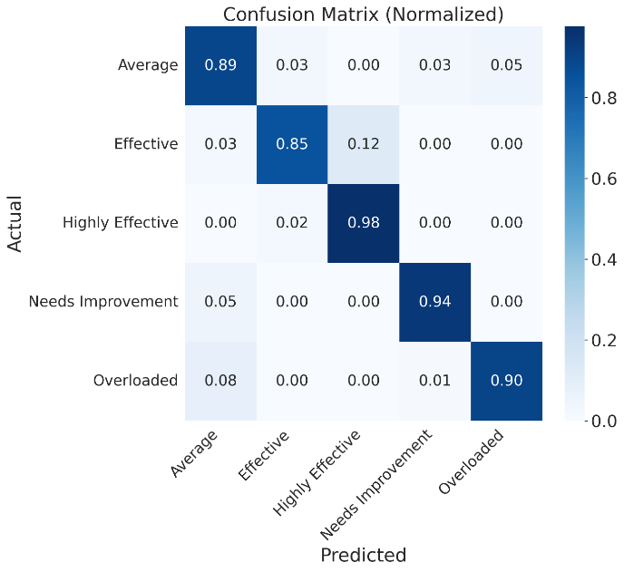

Figure 4. Confusion Matrices of the Baseline BERT+MLP and Proposed EduFusionFormer

Figure 4 shows the confusion matrices normalized from the final test evaluation of Baseline BERT+MLP and EduFusionFormer, allowing a direct comparison of their classification behaviors within the five categories of administrative behaviors. The baseline classifier gets diagonal recognition rates of 0.90, 0.75, 0.97, 0.81, and 0.89 for the Average, Effective, Highly Effective, Needs Improvement, and Overloaded classes, respectively. However, EduFusionFormer increases their recognition to 0.89, 0.85, 0.98, 0.94, and 0.90. As such, EduFusionFormer gives much better classification performance than the baseline model, and its classification performance is more evenly distributed among all behavioral classes. The most notable improvement is seen in the Needs Improvement category where the recognition rate is improved from 0.81 to 0.94, and the Effective category with recognition improvement from 0.75 to 0.85. In addition, the baseline model experiences considerable confusion between Effective and Highly Effective, with 19% of Effective samples confused as Highly Effective; however, the confusion in this case is reduced by EduFusionFormer to only 12%. Finally, EduFusionFormer maintains good recognition of the Highly Effective category with its diagonal recognition rate equal to 0.98.

4.6 Ablation Study

An ablation study was done to assess the impact of each of the important components of the EduFusionFormer in order to measure the effect of adding these components into the basic BERT + MLP model. The BERT+MLP is the basic model in which textual information is used along with the multilayer perceptron for classification. The other models will have each of the proposed components added individually to assess their impact on the overall performance of the model. The configurations considered in the experiment include the basic BERT+MLP model, the addition of Dynamic Modality Importance (DMIL), the Hierarchical Cross-modal Transformer, the Temporal Behavioral Memory model, and the full EduFusionFormer.

Table 9. Ablation Study Results of the Proposed EduFusionFormer
Model | Accuracy ↑ | Precision ↑ | Recall ↑ | Macro-F1 ↑
DMIL (Novelty 1) | 0.8785 | 0.8685 | 0.9047 | 0.8807
Hierarchical (Novelty 2) | 0.8826 | 0.8810 | 0.9083 | 0.8878
Temporal (Novelty 3) | 0.8919 | 0.8957 | 0.9183 | 0.9016
Full EduFusionFormer | 0.8933 | 0.8963 | 0.9192 | 0.9017
From Table 9, it can be seen that the introduction of DMIL into the first ablation setting leads to Accuracy of 87.85% and Macro-F1 of 88.07%, suggesting that the introduction of the dynamic modality weight on its own does not help improve performance when the other components are not present in the proposed architecture. From this, it can be concluded that the effectiveness of DMIL depends on how it interacts with the other multimodal representation learning layers and is not effective on its own. The introduction of the Hierarchical Cross-Modal Transformer layer increases the Macro-F1 performance from 0.8807 to 0.8878 and Recall to 0.9083. This indicates the importance of cross-modal interactions between the different modalities of the educational data in the hierarchical structure. The addition of the temporal behavioral memory layer brings an increase in accuracy to 0.8919, Precision to 0.8957, Recall to 0.9183, and Macro-F1 to 0.9016.
The full version of EduFusionFormer scores an Accuracy of 0.8933, Precision of 0.8963, Recall of 0.9172, and Macro-F1 of 0.9017. While the full model does not outperform the BERT+MLP baseline in all metrics, it is still able to achieve a very competitive Macro-F1 while using the whole multimodal structure. The little gap between the performance of Temporal configuration and that of the full version implies that adding the extra layers of fusion and consistency does not bring any substantial gain in the given experimental conditions. Consequently, the ablation study shows that the temporal behavior modeling and multimodal hierarchy interaction are crucial components of the suggested approach, whereas the contribution of each of its parts has to be considered in relation to others.

4.7 Comparison with State-of-the-Art Models

Table 10. Performance Comparison of the Proposed EduFusionFormer with Baseline Multimodal Models
Model | Accuracy ↑ | Precision ↑ | Recall ↑ | Macro-F1 ↑ | Macro-AUC ↑
BERT + MLP (Late Fusion) [Baseline 1] | 0.8519 | 0.8532 | 0.8651 | 0.8529 | 0.9816
Two-Modal MulT [Baseline 2] | 0.8426 | 0.8151 | 0.8406 | 0.8243 | 0.9638
BERT + GMU [Baseline 3] | 0.8241 | 0.8200 | 0.8497 | 0.8243 | 0.9823
BERT + Perceiver Fusion [Baseline 4] | 0.8463 | 0.8389 | 0.8685 | 0.8472 | 0.9824
EduFusionFormer (Proposed) | 0.9030 | 0.9018 | 0.9192 | 0.9057 | 0.9888
Baseline models follow the similar general evaluation framework with Accuracy, macro Precision, macro Recall, Macro-F1 and multiclass ROC-AUC. Similar approach is used to evaluate the proposed EduFusionFormer against the entire test set with respect to these metrics, where one-vs-rest macro ROC-AUC is included as well. According to the results presented in Table 10, the proposed EduFusionFormer is the best performing model compared to other baselines regarding all presented metrics. It reaches Accuracy 0.9030, Macro Precision 0.9018, Macro Recall 0.9129, Macro-F1 0.9057 and Macro-AUC 0.9888. Thus, the model exhibits good capability of correct classification of administrative behavioral categories with balanced performance across classes. In comparison to the BERT + MLP Late Fusion baseline model, EduFusionFormer shows improvements in Accuracy from 0.8519 to 0.9030, which means absolute improvement by 5.11 percentage points. The Macro-F1 is improved from 0.8529 to 0.9057 while Macro-AUC is improved from 0.9816 to 0.9888. This means that late fusion of textual and tabular representations is not as efficient as proposed architecture’s dynamic multimodal interaction methods. Two-Modal MulT baseline model reaches Accuracy 0.8426 and Macro-F1 0.8243. Despite the fact that MulT baseline model explicitly performs bidirectional cross-modal attention between textual and tabular representations, it still has the limitation in two-modal interaction architecture. The applied MulT model architecture includes text-to-tabular and tabular-to-text cross-modal attention followed by Transformer fusion. The proposed EduFusionFormer model expands this idea through multiple modalities and other dynamic, temporal, consistency and adaptive fusion techniques. Thus, the EduFusionFormer significantly outperforms MulT baseline in terms of classification. BERT + GMU baseline model reaches Accuracy 0.8241 and Macro-F1 0.8243. Despite the fact that GMU gives an explicit method of combining text and tabular representations with the use of gating mechanism, it still doesn’t have hierarchical cross-modal and temporal processing like EduFusionFormer. The gating mechanism used in GMU baseline model combines the projected BERT representation and tabular representation before classification. Better performance of EduFusionFormer proves that learned multimodal interactions need not only single gating mechanism. The BERT + Perceiver Fusion baseline gives the strongest performance among reported baseline models with Accuracy 0.8463, Macro Precision 0.8389, Macro Recall 0.8685, Macro-F1 0.8472 and Macro-AUC 0.9824. However, EduFusionFormer outperforms it by 5.85 percentage points of Macro-F1 and 5.67 percentage points of Accuracy. Thus, the effectiveness of applying multiple complementary learning mechanisms instead of general multimodal fusion architecture is proven.
In summary, the proposed model EduFusionFormer attains superior performance compared to other baseline models in all five criteria for evaluation. This is because the model utilizes the combination of Dynamic Modality Importance Learning, Confidence-Guided Feature Reweighting, Hierarchical Cross-Modal Transformer, Temporal Behavioral Memory, Cross-Modal Consistency Learning, and Adaptive Fusion techniques. This enables the model to dynamically determine the importance of different modalities and captures the interaction between modalities and includes temporal behavior information and adaptive fusion of complementary features. This implies that the proposed model generates a more sophisticated multimodal representation compared to other baseline methods such as BERT fusion, GMU, TabTransformer, MulT, and Perceiver models.

4.8 SHAP-Based Explainability Analysis

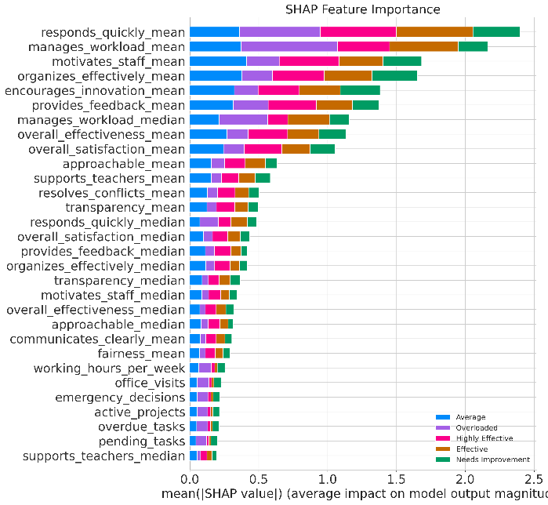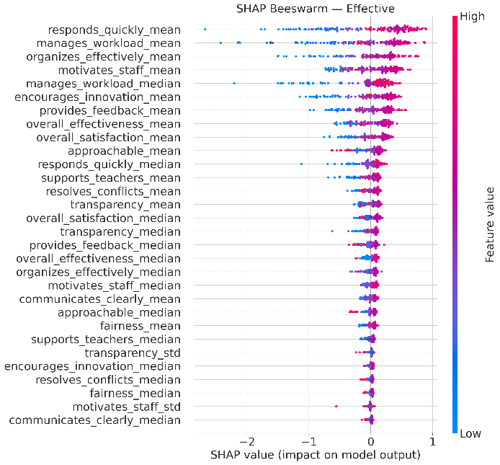
(A) Global SHAP Feature Importance Analysis of the Proposed EduFusionFormer
(B) SHAP-Based Feature Contribution Distribution

Figure 5. SHAP-Based Explainability Analysis of the Proposed EduFusionFormer
In order to increase the interpretability of the proposed EduFusionFormer, the SHAP analysis was used in order to assess the impact of the input features on the model's predictions. Based on the results presented in Figure 5(A), it can be stated that the most influential feature is responds_quickly_mean, followed by manages_workload_mean and organizes_effectively_mean, which implies that the mentioned qualities play a prominent role in influencing the predicted Effective behavioral category. Among other highly influential features are motivates_staff_mean, manages_workload_median, encourages_innovation_mean, and provides_feedback_mean, which illustrates the significance of the mentioned leadership and workload-related features. Additionally, such features as overall_effectiveness_mean and overall_satisfaction_mean make significant contribution to the model's predictions, along with the approachable_mean and supports_teachers_mean features. Moreover, based on the SHAP beeswarm distribution, one can note that high values of the features, which are illustrated with pink points, contribute positively to the predictions of several dominant features. However, lower values of the features can contribute negatively depending on the individual observation. Furthermore, the SHAP importance distribution provided in Figure 5(B) shows that respondents_quickly_mean, manages_workload_mean, motivates_staff_mean, and organizes_effectively_mean features are the most influential features among all evaluated behavioral categories. On the contrary, the contribution of the operational variables, including working_hours_per_week, office_visits, emergency_decisions, active_projects, overdue_tasks, and pending_tasks, is less pronounced compared to the mentioned above features. Overall, based on the results obtained with the SHAP analysis, one can state that the EduFusionFormer model mainly uses responsiveness, workload management, staff motivation, organizational effectiveness, innovation, and feedback-related characteristics in order to identify administrative behavior.

5. Conclusion and Future Work

In our paper, we have introduced EduFusionFormer, a novel multimodal approach to administrational behavioral classification using educational multimodal data including administrational records, survey replies, and textual messages. This approach uses Dynamic Modality Importance Learning, Hierarchical Cross-Modal Transformer, Temporal Behavioral Memory, Cross-Modal Consistency Learning, and Adaptive Fusion to learn complementary behaviors from heterogenous educational data. We have shown experimentally that EduFusionFormer reaches 90.30% Accuracy, 90.18% Macro Precision, 91.29% Macro Recall, and 90.17% Macro-F1, which is high and proves the strong classification capability of the proposed method on all the five behavioral categories. From the confusion matrix, one can see that most samples are classified correctly; from the SHAP analysis, one can understand what factors influence the model prediction, namely responsiveness, workload management, staff motivation, organizational effectiveness, innovation, and feedback. An ablation study also confirmed the contribution of the proposed multimodal and temporal approaches. Thus, EduFusionFormer proved to be an efficient and interpretable approach to the automated analysis of the administrational behaviors and educational decisions. For the future research, one can use other modalities, like audio and video, classroom observations, and even real-time data to receive better behavioral representation. Moreover, one can evaluate the EduFusionFormer on other and larger educational institutions to check its scalability and robustness. Also, one can explore the continual learning and foundation-model-based approaches for administrational behaviors monitoring and explainable decisions making.

6. References

[1] Zheng, Q., Chen, Z., Wang, M., Shi, Y., Chen, S. and Liu, Z., 2024. Automated multimode teaching behavior analysis: A pipeline-based event segmentation and description. IEEE Transactions on Learning Technologies, 17, pp.1677-1693.
[2] Patidar, P., Ngoon, T.J., Vogety, N., Behari, N., Harrison, C., Zimmerman, J., Ogan, A. and Agarwal, Y., 2024. Edulyze: Learning Analytics for Real-World Classrooms at Scale. Journal of Learning Analytics, 11(2), pp.297-313.
[3] Moon, J., Yeo, S., Banihashem, S.K. and Noroozi, O., 2024. Using multimodal learning analytics as a formative assessment tool: Exploring collaborative dynamics in mathematics teacher education. Journal of Computer Assisted Learning, 40(6), pp.2753-2771.

[4] Gong, Y., Wang, F., Zhang, Y. and Geng, J., 2025. RETRACTED: TGEL-transformer: Fusing educational theories with deep learning for interpretable student performance prediction. PloS one, 20(6), p.e0327481.
[5] Sridharan, T.B. and Akilashri, P.S.S., 2025. Multimodal learning analytics for students behavior prediction using multi-scale dilated deep temporal convolution network with improved chameleon Swarm algorithm. Expert Systems with Applications, 286, p.128113.
[6] Ouhaichi, H., Bahtijar, V. and Spikol, D., 2024, July. Exploring design considerations for multimodal learning analytics systems: An interview study. In Frontiers in Education (Vol. 9, p. 1356537). Frontiers Media SA.
[7] Bird, J.J., 2026. What differentiates educational literature? A multimodal fusion approach of transformers and computational linguistics. International Journal of Artificial Intelligence in Education, p.100007.
[8] Sun, C., Huang, S., Sun, B. and Chu, S., 2025. Personalized learning path planning for higher education based on deep generative models and quantum machine learning: a multimodal learning analysis method integrating transformer, adversarial training and quantum state classification. Discover Artificial Intelligence, 5(1), p.29.
[9] Wang, H., 2025. Transformer-based deep learning for adaptive pedagogy under uncertain student preferences. Scientific Reports, 15(1), p.42173.
[10] Boufaida, S.O., Benmachiche, A., Derdour, M., Maatallah, M., Kahil, M.S. and Ghanem, M.C., 2025. TSA-GRU: A novel hybrid deep learning module for learner behavior analytics in MOOCs. Future Internet, 17(8), p.355.
[11] Lin, L., Yang, H., Xu, Q., Xue, Y. and Li, D., 2024. Research on student classroom behavior detection based on the real-time detection transformer algorithm. Applied Sciences, 14(14), p.6153.
[12] Zhou, Y., Wang, J. and Zhang, J., 2024. A Multimodal Image Recognition System for Student Behavior Analysis in Smart Classrooms in Universities. Traitement du Signal, 41(6), p.3285.
[13] Kui, X., Zhang, M., Liu, Q., Wang, Z., Huang, G., Zheng, Z., Xia, J. and Zhang, C., 2024. TSSeer: a visual analytics approach for exploring the correlation between teachers’ multimodal emotions and students’ behaviors in massive open online courses: X. Kui et al. Journal of Visualization, 27(4), pp.749-764.
[14] Lee, G. and Zhai, X., 2025. Realizing visual question answering for education: GPT-4V as a multimodal AI. TechTrends, 69(2), pp.271-287.
[15] Davalos, E., Zhang, Y., Srivastava, N., Salas, J.A., McFadden, S., Cho, S.J., Biswas, G. and Goodwin, A., 2025, July. Llms as educational analysts: Transforming multimodal data traces into actionable reading assessment reports. In International Conference on Artificial Intelligence in Education (pp. 191-204). Cham: Springer Nature Switzerland.
[16] Korban, M., He, C., Youngs, P. and Acton, S.T., 2025, October. Multi-Modal Transformer Network for Classroom Instruction Analysis. In 2025 59th Asilomar Conference on Signals, Systems, and Computers (pp. 969-973). IEEE.
[17] Guo, C., 2025, December. Transformer-based Real-time Teaching Quality Assessment System for Smart Classroom: Multimodal Data Fusion and Behavior Analysis. In 2025 International Conference on Machine Learning, Computational Intelligence and Pattern Recognition (MLCIPR) (pp. 200-204). IEEE.
[18] Kong, Y., Dong, R. and Zhang, H., 2025. Classroom behavior analysis and digital teaching quality evaluation based on spatiotemporal graph neural network. Discover Artificial Intelligence, 5(1), p.404.
[19] Yu, Z., Xie, M., Gao, J., Liu, T. and Fu, Y., 2024, March. From raw video to pedagogical insights: A unified framework for student behavior analysis. In Proceedings of the AAAI Conference on Artificial Intelligence (Vol. 38, No. 21, pp. 23241-23249).
[20] Wang, Z., Wang, M., Zeng, C. and Li, L., 2024. Multi-scale deformable transformers for student learning behavior detection in smart classroom. arXiv preprint arXiv:2410.07834.
[21] Ma, Q., 2024. Utilization of transformer model in multimodal data fusion learning: Cross-modal knowledge transfer in the new generation learning space. Intelligent Decision Technologies, p.18724981251333915.
[22] Cosentino, G., Anton, J., Sharma, K., Gelsomini, M., Giannakos, M. and Abrahamson, D., 2025. Generative AI and multimodal data for educational feedback: Insights from embodied math learning. British Journal of Educational Technology, 56(5), pp.1686-1709.
[23] Chen, Y., Yang, Y., Lan, Z., Chen, X., Zhan, H., Yu, L. and Zhan, Y., 2025. Image Sensor-Supported Multimodal Attention Modeling for Educational Intelligence. Sensors, 25(18), p.5640.
[24] Huang, C., Chen, Y., Zhou, B., Cai, X., Zhai, Z., Zhang, J. and Zhan, Y., 2025. LightEdu-Net: Noise-Resilient Multimodal Edge Intelligence for Student-State Monitoring in Resource-Limited Environments. Sensors, 25(24), p.7529.
[25] Victor, S., Kumar, K.R., Praveen, R.V.S., Aida, R., Kaur, H. and Bhadauria, G.S., 2025, August. GAN and RNN Based Hybrid Model for Consumer Behavior Analysis in E-Commerce. In 2025 2nd International Conference on Intelligent Algorithms for Computational Intelligence Systems (IACIS) (pp. 1-6). IEEE.
[26] Ludwig, T.D. and Laske, M.M., 2026. Organizational behavior management: An enabler of applied behavior analysis. In Clinical and organizational applications of applied behavior analysis (pp. 323-336). Academic Press.
[27] Criado, J.I., Sandoval-Almazán, R. and Gil-Garcia, J.R., 2025. Artificial intelligence and public administration: Understanding actors, governance, and policy from micro, meso, and macro perspectives. Public Policy and Administration, 40(2), pp.173-184.
[28] Zhan, Y. and Kong, X., 2026, April. Performance Evaluation of Administrative Management Using Adaptive Deep Learning Framework. In 2026 2nd International Conference on Intelligent Systems and Computational Networks (ICISCN) (pp. 1-7). IEEE.
[29] Mohammedjany, S., Killi, C.B.R., Rafi, S. and Rizwana, S., 2025. Detecting multimodal cyber-bullying behaviour in social-media using deep learning techniques: S. MohammedJany et al. The Journal of Supercomputing, 81(1), p.284.
[30] Fan, Q., 2025, August. Design and development of university educational administration information management system based on deep learning model. In 2025 Third International Conference on Networks, Multimedia and Information Technology (NMITCON) (pp. 1-7). IEEE.

