PERSIST: A Process-Informed Spatiotemporal Deep Learning Framework for Seasonal Ecological Resilience Assessment in the Yangtze River Economic Belt Under County-Scale Remote Sensing Observations
Abstract
The assessment of ecological resilience across large river basins is an essential component in the process of designing effective regional conservation and land-management policy. Despite having great potential for characterising ecosystem condition from satellite records, existing resilience assessment methods have some serious drawbacks at present. Particularly, they rely on static composite indices that cannot separate resistance from recovery, aggregate indicators through subjective weighting schemes, confirm spatial autocorrelation without ever modelling it, ignore the lithological and topographic heterogeneity that governs local response, and report accuracy on targets whose predictability is never established. Therefore, in our research we present a new deep learning framework, a Process-Informed Spatiotemporal Framework for Seasonal Ecological Resilience Assessment (PERSIST), aimed at solving the problem of interpretable resilience quantification in the Yangtze River Economic Belt. Firstly, the proposed PERSIST introduces a process-informed state representation that couples deseasonalised land-surface-temperature and kernel-NDVI histories with climate forcing, terrain and karst context, and a hierarchical monthly-plus-annual encoder operating on year-over-year deltas. Then the Disturbance-Conditioned Response Decoder learns bounded persistence, seasonal-carry, forcing-sensitivity and offset coefficients that exactly nest the trivial reference predictors, and yields county-level recovery rate and resistance directly as model parameters rather than post-hoc attributions. Next, dual-graph message passing over county contiguity and directed hydrological flow, combined with a lithology-adaptive mixture of experts, propagates information along physically meaningful pathways. Additionally, an ecologically-constrained multi-term objective, an embargoed temporal protocol and multi-seed ensembling ensure that reported skill is neither leaked nor an artefact of run-to-run variability. The framework is assessed on 1,068 county-level units over 2000-2020 (269,136 county-months) against four trivial references and three deep baselines (DRSEI, STGCN, Temporal Fusion Transformer) retrained on the identical seasonal target, together with seven component-wise ablations. The experimental evaluation provides 0.3633 RMSE, 0.8515 pooled R2, 0.7092 within-county R2, 0.8897 non-overlapping stride-3 R2 and 0.9718 R2 in native temperature units, reducing RMSE by 14.9% against the seasonal-naive reference and 6.1% against the strongest deep baseline while raising within-county temporal skill by 0.1436 (25.4% relative) using 4.24x fewer parameters than the Temporal Fusion Transformer. In addition, the component-wise ablation study quantifies each contribution against a measured seed-noise band and identifies the response decoder and the hierarchical annual encoder as the two components whose effect is statistically separable, while residual spatial autocorrelation remains higher than that of a plain spatiotemporal graph convolution.
Keywords: Ecological Resilience, Yangtze River Economic Belt, Remote Sensing, Spatiotemporal Deep Learning, Graph Neural Networks, Seasonal Anomaly Forecasting, Interpretable Machine Learning, Recovery Rate and Resistance, Land Surface Temperature, Kernel NDVI.
1. Introduction
The Yangtze River Economic Belt (YREB) is gaining increasing attention as a strategic region where rapid urbanisation, agricultural intensification and national conservation programmes act simultaneously on more than two million square kilometres of highly varied terrain. However, a complex class of coupled climate-vegetation-thermal-anthropogenic dynamics emerges from this heterogeneity and significantly affects vegetation vigour, surface thermal regimes, disturbance response and recovery capacity. The relevance of these phenomena grows further when the objective shifts from describing ecological condition at a point in time to quantifying how strongly a locality resists disturbance and how quickly it recovers afterwards. Furthermore, the expanding availability of long satellite archives, gridded climate reanalyses and deep learning creates opportunities for data-driven ecological diagnosis at administratively meaningful scales. Recent review work shows that graph-based and multimodal learning is becoming more widespread in earth-observation analysis, although benchmark fragmentation, weak baseline comparison and limited process interpretability still pose challenges.
The application of remote sensing and machine learning has lately been critical to the characterisation of regional ecological condition. Kaur and Sharma [1] offer a detailed review of multimodal graph neural networks for earth observation and sustainable resource management, covering architectures, fusion strategies and application domains. Among the most promising trends, the authors identify graph learning over irregular spatial units, physics-guided hybrid designs and multimodal fusion, although challenges remain in benchmark standardisation, reproducibility and the absence of strong trivial references. As a review, however, it does not develop a resilience formulation in which spatial structure, process constraints and interpretable parameters are jointly learned. Li et al. [2] assess ecological resilience across the YREB using a multi-scale framework and report clear spatiotemporal gradients between upstream, midstream and downstream reaches together with significant spatial dependence among county-level units. The study establishes that resilience in this basin is spatially organised rather than randomly distributed. Nevertheless, it remains a descriptive assessment based on composite indicators, and the confirmed spatial autocorrelation is diagnosed statistically but never embedded in the estimator itself. Consequently, neither work closes the loop between spatial diagnosis and a predictive, process-constrained model, leaving the integration of graph structure with interpretable resilience estimation an unresolved research problem.
A deep-learning approach to ecological quality evaluation was proposed by Gong et al. [3], who replace the conventional principal-component weighting of the remote sensing ecological index with a learned encoder trained jointly on reconstruction and prediction objectives. The work demonstrates that data-driven representation learning removes the subjectivity of fixed indicator weights and improves the consistency of ecological quality estimates. However, the formulation is purely temporal and treats each spatial unit independently, so neighbourhood relationships and hydrological connectivity are unavailable to the model, and no resilience quantity is recovered from the learned representation. More research is therefore required on architectures that exploit spatial dependence while retaining interpretable ecological meaning. Interpretable machine learning for resilience has been investigated by Li et al. [4], who apply gradient-boosted trees with Shapley attribution to urban resilience across the YREB and successfully expose nonlinear response patterns and interaction effects among socioeconomic and environmental drivers. This study confirms that driver-response relationships in the basin are strongly nonlinear and that attribution is essential for policy relevance. Nevertheless, the interpretation is produced post hoc from a static composite index, so the recovered importance scores describe correlations with a constructed score rather than the dynamical quantities that define resilience.
More recently, Aldossary [5] proposed GTNet, a graph-transformer neural network for ecological health monitoring, combining graph convolution over spatial units with transformer-based temporal attention and reporting robustness under degraded input conditions. Experiments demonstrate that hybrid graph-attention designs outperform purely convolutional or purely recurrent alternatives for spatially distributed environmental monitoring. However, the work targets urban sensing networks rather than large heterogeneous river basins, its objective is condition monitoring rather than the estimation of resistance and recovery parameters, and lithological and topographic controls on local response are not represented. As a result, additional research is required to develop a spatiotemporal framework that couples graph structure with explicitly bounded resilience parameters and process constraints appropriate to basin-scale ecological dynamics.
Although there have been many recent developments in remote-sensing-based ecological assessment, several open research questions still exist. Currently, research on this topic is fragmented across index construction, descriptive spatial statistics, driver attribution and land-use simulation, but no work integrates these into a single estimator that produces resilience quantities as learned parameters. Existing approaches largely optimise a composite score or a single predictive objective, whereas a defensible resilience assessment requires resistance, recovery and seasonal carry-over to be separated and bounded rather than conflated within one index. Spatial dependence is repeatedly confirmed yet almost never modelled, and the lithological contrast between karst and non-karst terrain, which strongly governs local recovery, is generally omitted. Finally, reported accuracy is rarely placed against trivial references or against a measured ceiling, so it remains unclear how much of the stated skill is genuine and how much reflects persistent between-unit level differences. To fill this gap, we propose PERSIST, a process-informed spatiotemporal framework for seasonal ecological resilience assessment. The proposed PERSIST framework transforms the common formulation of ecological resilience assessment from an index-construction problem into a constrained spatiotemporal estimation problem, in which the model learns how persistently a county carries its present state, how strongly it responds to climatic forcing, how much of its seasonal signal returns, and how much of the residual variation is genuinely predictable. The framework is verified on 1,068 county-level units over 2000-2020 using four trivial references, three deep baselines retrained on an identical seasonal target, seven component-wise ablations and a pre-registered predictability audit.
The major contributions of this research are summarised as follows:
1. A Process-Informed Resilience-Aware State Representation is introduced to incorporate deseasonalised thermal and vegetation anomaly histories, climate forcing, terrain and karst context, and year-over-year annual dynamics into a hierarchical encoder, enabling the model to reason about disturbance response rather than relying solely on contemporaneous indicator values.
2. A Disturbance-Conditioned Response Decoder is developed to learn bounded persistence, seasonal-carry, forcing-sensitivity and offset coefficients that exactly nest the trivial reference predictors, yielding county-level recovery rate and resistance directly as model parameters instead of post-hoc attributions.
3. A Dual-Graph Message-Passing scheme with Lithology-Adaptive Mixture of Experts is proposed to propagate information along county contiguity and directed hydrological flow while conditioning the response function on terrain and karst context, so that spatial dependence and geological heterogeneity are modelled rather than merely diagnosed.
4. An Ecologically-Constrained Objective and Predictability-Audited Evaluation Protocol is introduced to combine reconstruction, temporal smoothness and spatial residual penalties with embargoed temporal splits, multi-seed ensembling and an explicit separation of pooled from within-unit skill, thereby ensuring that reported performance is neither leaked nor an artefact of run-to-run variability.
2. Literature Survey
Recent progress in ecological resilience assessment has been mostly associated with composite indicator construction, spatial statistical diagnosis, driver attribution, and remote-sensing-based ecological quality monitoring. Among those research lines, there have been several works dedicated to resilience evaluation of the Yangtze River Economic Belt and other Chinese urban agglomerations, while others concentrated on interpretable machine learning for driver analysis, satellite-derived ecological indices, and deep learning for spatiotemporal environmental prediction. However, the described research lines did not interact much, and there was no attempt to combine those directions into a unified framework that estimates resilience quantities as learned, bounded parameters while modelling spatial dependence explicitly.
Yao et al. [6] assessed the impact of climate change on the ecological resilience of the Yangtze River Economic Belt, coupling meteorological trend analysis with a composite resilience index across the belt. The work established that climatic forcing is a first-order control on regional resilience and that the response differs systematically among reaches. However, resilience is represented as a weighted aggregate of contemporaneous indicators, so resistance to disturbance and the rate of subsequent recovery are conflated within a single score. Hence, there is a research gap in formulations that separate these two components as distinct, individually estimable quantities. Tang et al. [7] examined the spatial-temporal evolution of water ecological resilience in the same belt and tested the non-stationarity of the influencing factors rather than assuming fixed relationships. Their analysis demonstrates that driver effects vary substantially across space and time, which invalidates globally constant coefficient models. Nevertheless, the non-stationarity is captured through locally fitted regressions on an index rather than by a model whose response parameters are themselves predicted per unit and per period. Therefore, there is a research gap in learning spatially and temporally varying response coefficients directly.
Fu et al. [8] investigated driving factors and performed multi-scenario simulation of ecological resilience in the middle reaches of the Yangtze River metropolitan area, combining attribution analysis with forward scenario projection. The study confirms that resilience trajectories are sensitive to plausible development pathways and that spatial dependence among neighbouring units is statistically significant. However, the confirmed spatial autocorrelation is reported as a diagnostic property of the data and is not incorporated into the estimator, so neighbouring units are still modelled independently. Hence, there is a research gap in embedding contiguity structure inside the model rather than testing for it afterwards. Chen et al. [9] analysed the nonlinear impact of population shrinkage on urban ecological resilience using threshold-effect analysis on city-level panel data from the belt. The work shows that demographic pressure acts on resilience through regime-dependent thresholds rather than smooth monotonic relationships. Nevertheless, the analysis operates at prefecture level on annual data, which is too coarse to resolve the seasonal disturbance-recovery cycles through which resilience actually manifests. Therefore, there is a research gap in county-scale, sub-annual resilience estimation.
Ding et al. [10] proposed an integrated geographical detector and Bayesian spatiotemporal model for county-level ecological resilience in optimised urban agglomerations, explicitly targeting spatiotemporal heterogeneity and synergy among driving mechanisms. The framework represents one of the more statistically rigorous treatments of spatial structure in this literature and confirms strong interaction effects between drivers. However, the Bayesian formulation is a descriptive spatial model without predictive validation on held-out periods, so its generalisation to unseen years is unknown. Hence, there is a research gap in resilience models evaluated under strict temporal hold-out. Zhong et al. [11] characterised regional differences, dynamic evolution and driving factors of ecological resilience across China's urban agglomerations, providing a valuable national baseline for cross-regional comparison. The study demonstrates persistent inter-regional disparities that are stable over time. Nevertheless, the persistence of these level differences is treated as a substantive finding rather than as a statistical property that inflates any pooled goodness-of-fit measure computed across units. Therefore, there is a research gap in explicitly decomposing between-unit from within-unit predictive skill.
Wan et al. [12] developed a two-dimensional decomposition of urban ecological resilience in China, separating the spatial gap into components attributable to different structural sources. The decomposition approach is methodologically instructive because it quantifies how much of the observed variation is cross-sectional rather than temporal. However, the decomposition is applied to an index rather than to model residuals, so it does not indicate how much of the variation a predictive model can actually recover. Hence, there is a research gap in reporting variance decomposition alongside model skill. Tong et al. [13] decrypted spatiotemporal dynamics and optimisation pathways of ecological resilience under a panarchy-inspired framework for the Wuhan metropolitan area using remote sensing. The panarchy framing is theoretically attractive because it explicitly represents adaptive cycles of growth, collapse and reorganisation. Nevertheless, the adaptive-cycle stages are assigned through thresholding of an index rather than estimated as continuous dynamical parameters. Therefore, there is a research gap in recovering adaptive-cycle behaviour as continuous learned coefficients.
Li et al. [14] presented scenario-based modelling and driver analysis of ecological resilience in the Qinling-Daba Mountains, a region whose topographic complexity resembles the upper Yangtze. The work shows that mountainous terrain produces resilience patterns that differ qualitatively from lowland areas, implicating relief and elevation as controls. However, terrain enters as an explanatory covariate in a regression rather than as context that modulates the functional form of the response itself. Hence, there is a research gap in conditioning the response function on topographic and lithological context. Zhao et al. [15] conducted a simulation-based multi-scenario assessment of comprehensive ecological risk and resilience for the Pearl River Delta, integrating risk and resilience within one evaluation. The study confirms that risk and resilience must be assessed jointly rather than separately. Nevertheless, the simulation relies on land-use transition rules rather than on learned ecological response dynamics, so disturbance response is prescribed rather than inferred from observation.
Li et al. [16] assessed and simulated urban ecosystem resilience by coupling resistance-adaptability-recovery indicators with a Markov-FLUS land-use model for the Jinan metropolitan area. This work is notable because it explicitly names resistance, adaptability and recovery as separate dimensions, aligning conceptually with the decomposition resilience theory requires. However, the three dimensions are constructed from separate indicator groups and combined by fixed weights, so they are defined by the analyst rather than estimated from data. Hence, there is a research gap in deriving resistance, adaptability and recovery as parameters of a single fitted response model. Zhang and Wu [17] examined the spatiotemporal evolution and influencing factors of urban ecological resilience in the Yellow River Basin, offering a directly comparable large-basin study. The analysis identifies consistent upstream-downstream gradients analogous to those in the Yangtze. Nevertheless, the study remains cross-sectional in method, and no attempt is made to predict future resilience states or to validate against trivial temporal references.
He et al. [18] performed a GIS-based analysis of spatial and functional heterogeneity in regional resilience for the Chengdu-Chongqing economic mega-region, which lies within the upper Yangtze. The study demonstrates that functional heterogeneity is as important as spatial heterogeneity when partitioning a large region. However, the approach is a geographic information system overlay analysis without a learned model, so it cannot extrapolate beyond the observed period. Hence, there is a research gap in learning-based regional resilience estimation with temporal generalisation. Yue et al. [19] applied interpretable machine learning to socio-ecological resilience pathways in a resource-exhausted city, using attribution methods to expose the mechanisms linking socioeconomic decline to ecological outcomes. The work shows that interpretable learning can generate actionable pathway insights. Nevertheless, the interpretation is generated post hoc from a fitted black-box model on a composite target, so the explanations describe associations with a constructed score rather than physically bounded response quantities. Therefore, there is a research gap in architectures whose interpretable quantities are structural rather than explanatory overlays.
Qu et al. [20] used interpretable machine learning to diagnose remote sensing ecological index dynamics in the Yangtze River Delta, systematically attributing index change to candidate drivers. The study successfully demonstrates that nonlinear attribution reveals driver interactions invisible to linear models. However, because the target remains the ecological index itself, the analysis inherits every limitation of that index, including its fixed component weighting and its inability to distinguish disturbance from recovery. Hence, there is a research gap in replacing the index target with a physically meaningful state anomaly. Cheng et al. [21] leveraged explainable machine learning to decipher ecosystem health and nonlinear dynamics in the Henan section of the Yellow River Basin, reporting substantial nonlinearity in driver-health relationships. The work reinforces that linear assumptions are inadequate for basin-scale ecological modelling. Nevertheless, the models are tree ensembles applied to annual cross-sections, so temporal dependence between consecutive observations is not represented at all.
Fu et al. [22] explored the nonlinear effects of the built environment on ecological resilience in the high-density city of Wuhan, quantifying threshold and saturation behaviours in urban form variables. The study establishes that built-environment controls act nonlinearly and are locally specific. However, the analysis is confined to a single city, and no spatial graph links the analysis units, so spillover between adjacent parcels is unmodelled. Hence, there is a research gap in modelling spatial spillover across administrative units at basin scale. Xie et al. [23] proposed a satellite-driven evaluation of ecological environmental quality based on the pressure-state-response framework, providing a theoretically grounded structure for organising remotely sensed indicators. The framework improves conceptual transparency over purely data-driven index construction. Nevertheless, the pressure-state-response mapping is imposed a priori and the resulting evaluation is static, offering no mechanism to forecast future ecological state or to quantify recovery speed.
Yang et al. [24] developed a karst remote sensing ecological index for monitoring ecological quality in Southwest China, explicitly adapting index construction to karst lithology. This work is directly relevant because it demonstrates that karst terrain requires a modified formulation and that applying a standard index to carbonate landscapes produces systematic bias. However, the adaptation is achieved by constructing a separate index for karst regions rather than by a single model that conditions its response on lithological context, which prevents unified analysis across mixed terrain. Hence, there is a research gap in lithology-conditioned models applicable to both karst and non-karst units simultaneously. Wang et al. [25] proposed an adaptive indicator reduction method for health assessment of terrestrial ecosystems in China, addressing the redundancy that accumulates in multi-indicator frameworks. The method reduces subjectivity in indicator selection. Nevertheless, the output remains a static health score without temporal dynamics or disturbance response.
Li et al. [26] analysed spatiotemporal patterns and driving forces of ecological quality in the Yangtze River Economic Belt using geographically weighted ridge regression, addressing both spatial non-stationarity and multicollinearity among drivers. The study confirms that coefficient estimates vary systematically across the belt. However, geographically weighted regression fits independent local models without sharing information along a connectivity structure, and it provides no temporal forecasting capability. Hence, there is a research gap in models that share parameters across space through an explicit graph. Zhu et al. [27] conducted a multi-method analysis of the spatiotemporal dynamics and mutual response of land surface temperature and kernel normalised difference vegetation index across the Yangtze River Economic Belt. This work is particularly important because it establishes the belt-wide trends and the thermal-vegetation coupling for precisely the two state variables used in the present study, providing an independent reference against which extracted trends can be validated. Nevertheless, the analysis is diagnostic and correlational, offering no predictive model and no resilience parameterisation.
Soula et al. [28] proposed a BiLSTM-CNN model for predicting large-scale temporal-spatial dynamics of the normalised difference vegetation index, demonstrating that hybrid recurrent-convolutional architectures can forecast vegetation state over broad areas. The work confirms that deep sequence models are viable for large-scale vegetation prediction. However, spatial structure is handled by convolution over a regular grid, which cannot represent irregular administrative units or hydrological connectivity, and the model produces point forecasts without interpretable response parameters. Hence, there is a research gap in graph-based formulations over irregular units. Ke et al. [29] presented GT-LandSDS, coupling cellular automata with a graph attention network and a transformer for land-use simulation, and demonstrated that graph attention combined with temporal attention outperforms conventional cellular automata. The architecture is closest in spirit to the present work. Nevertheless, the target is discrete land-use transition rather than continuous ecological state anomaly, and no bounded dynamical coefficients are recovered.
Yang et al. [30] combined large language models with satellite embeddings to evaluate the ecological quality of the Tibetan Plateau, representing the current frontier of foundation-model application to ecological assessment. The work shows that learned embeddings can substitute for hand-designed indices. However, the resulting representation is entirely opaque, offering no bounded, physically interpretable quantity that a land manager could act upon, and the evaluation does not include trivial temporal references against which the reported skill could be calibrated. Hence, there is a research gap in models that combine learned representation power with structurally interpretable resilience parameters and rigorous baseline comparison. Comparison of existing ecological resilience assessment, remote-sensing ecological quality and deep learning prediction methods with the proposed PERSIST is shown in Table 1.
Table 1. Comparison of the proposed PERSIST with existing ecological resilience assessment and remote-sensing prediction methods.
Ref. | Authors / Year | Method / Focus | Major Findings | Limitations / Research Gap
[31] | Yuan et al. (2026) | Deep learning for mangrove change prediction, Gaoqiao Mangrove, China. | Accurate prediction of mangrove extent change from multi-temporal imagery. | Single small coastal site and land-cover change target; no resilience parameters or basin-scale spatial structure.
[32] | Yang (2026) | ResNeXt-YOLOv5s-LSTM framework for tourism ecological environment quality. | Hybrid detection-recurrent pipeline improved ecological quality classification. | Classifies quality classes rather than forecasting continuous anomalies; no interpretable dynamical coefficients.
[33] | Li et al. (2026) | Review of Mamba state-space architectures and hybrid paradigms for remote sensing. | Identified state-space models as an efficient alternative to attention for long sequences. | Review only; no ecological resilience formulation and no empirical baseline comparison.
[34] | Wei et al. (2026) | Multi-scenario regional spatial simulation using Unet++ for the YREB. | Unet++ improved spatial simulation fidelity over conventional cellular automata. | Grid-based land-use simulation; ignores irregular county units, hydrological flow and resilience quantification.
[35] | Liu et al. (2025) | RSEI change analysis coupled with Markov-FLUS modelling. | Projected ecological index trajectories under alternative land-use scenarios. | Index-based and rule-driven; disturbance response is prescribed rather than learned from observation.
[36] | Guo et al. (2025) | Coupled assessment of land-use change and ecological benefits from multi-source remote sensing. | Quantified ecological benefit changes attributable to land-use transition. | Descriptive coupling without predictive validation; no separation of resistance and recovery.
[37] | Yu et al. (2026) | Ecological quality of river-connected versus disconnected lake basins, lower Yangtze. | Hydrological connectivity significantly conditions ecological quality outcomes. | Confirms connectivity matters but does not encode it as a graph inside a predictive model.
[38] | Peng et al. (2026) | Digital technological innovation and urban renewal-ecological resilience coordination, YREB. | Digital innovation improves coupling coordination between renewal and resilience. | Econometric panel analysis at city level; no remote sensing and no sub-annual dynamics.
[39] | Ma et al. (2026) | Ecological compensation efficiency and urban economic resilience in the YREB. | Compensation efficiency positively influences economic resilience. | Economic rather than ecological resilience; annual prefecture panel without spatial modelling.
[40] | Kong et al. (2025) | New quality productive forces and ecological resilience, Yangtze River Delta. | Productive-force effects on resilience are strongly heterogeneous across cities. | Socioeconomic drivers only; resilience remains a composite index without dynamical estimation.
[41] | Yang (2025) | Coupling coordination between green innovation efficiency and urban ecological resilience, YRD. | Established significant coupling coordination and its spatiotemporal evolution. | Coordination-degree analysis; no predictive model and no county-scale remote sensing.
[42] | Wang et al. (2026) | Spatiotemporal evolution of rural digitalisation and ecosystem services, county level, YREB. | County-level digitalisation is spatially associated with ecosystem service supply. | Correlational county analysis; ecosystem services proxied by indices without disturbance-response modelling.
Proposed | PERSIST (2026) | Process-informed spatiotemporal deep learning with a disturbance-conditioned response decoder, dual-graph message passing, lithology-adaptive mixture of experts and an ecologically-constrained objective. | Recovers bounded coefficients that nest the trivial references and yield county-level recovery rate and resistance directly; RMSE 0.3633, pooled R2 0.8515, within-county R2 0.7092 on 1,068 counties against seven references and seven ablations. | Integrates interpretable resilience parameterisation, explicit spatial and hydrological structure, lithological conditioning and a predictability-audited protocol. Residual spatial autocorrelation remains higher than a plain spatiotemporal graph convolution, and validation uses remotely sensed proxies without in-situ measurement.

Based on the above literature review there have been significant advancements in the fields of composite resilience indicator construction, spatial statistical diagnosis, driver attribution, satellite-derived ecological quality evaluation and deep learning for environmental prediction in the Yangtze River Economic Belt and comparable regions. However, the majority of current works focus on isolated problems such as index construction, cross-sectional spatial description, nonlinear driver attribution, land-use scenario simulation and vegetation forecasting, but do not propose a unified approach that estimates ecological resilience as bounded parameters of a fitted response model. In addition, current solutions do not integrate lithological and topographic context with explicit spatial and hydrological connectivity inside a single estimator, despite repeatedly confirming that both matter. Even though several studies name resistance, adaptability and recovery as distinct dimensions, they construct these from separate indicator groups combined by analyst-assigned weights rather than deriving them from observed disturbance-recovery behaviour. Moreover, reported accuracy is rarely benchmarked against trivial temporal references or against a measured predictability ceiling, and pooled goodness-of-fit is seldom decomposed into between-unit and within-unit components, so it remains unclear how much stated skill reflects genuine temporal prediction rather than persistent cross-sectional level differences. Lastly, the majority of current solutions are validated on a single period or a single scenario and do not demonstrate generalisation under strict temporal hold-out with disturbance-conditioned evaluation.
3. Proposed Methodology
The proposed PERSIST (Process-Informed Spatiotemporal Framework for Seasonal Ecological Resilience Assessment) framework can be used for county-scale ecological resilience estimation across large heterogeneous river basins under gap-affected and seasonally dominated satellite observations. In contrast to existing frameworks for ecological resilience assessment that use either composite index construction, cross-sectional spatial statistics or post-hoc driver attribution, the proposed framework incorporates the following components within a single estimation pipeline: process-informed state representation, dual-graph message passing, lithology-adaptive expert gating, a disturbance-conditioned response decoder, and an ecologically-constrained training objective. First, multi-source observations comprising MODIS land surface temperature and vegetation indices, TerraClimate forcing, terrain derivatives, karst extent and nighttime lights are extracted per county and assembled into a monthly panel. Next, the thermal and vegetation series are deseasonalised against a train-only monthly climatology and aggregated into a forward three-month mean anomaly, with embargoed temporal splits so that no input or target window crosses a split boundary. The resulting state is fed into the hierarchical encoder, where a monthly recurrent branch and an annual branch operating on year-over-year deltas are fused with static terrain and karst context. Dual-graph message passing then propagates information across county contiguity and directed hydrological flow, while the lithology-adaptive mixture of experts conditions the response function on geological setting. Finally, the Disturbance-Conditioned Response Decoder emits bounded persistence, seasonal-carry, forcing-sensitivity and offset coefficients that exactly nest the trivial reference predictors, together with a learnable-scaled free residual, so that county-level recovery rate and resistance are obtained directly as model parameters rather than as post-hoc attributions. In order to keep the learned response physically plausible, the ecologically-constrained objective augments the prediction term with reconstruction, temporal smoothness of persistence, spatial residual smoothness and expert load balancing. The performance of the trained model is measured using pooled and within-county skill, non-overlapping stride evaluation, residual spatial autocorrelation, disturbance-window error, comparison against four trivial references and three deep baselines retrained on the identical target, and seven component-wise ablations assessed against a measured seed-noise band. The overall pipeline of the proposed PERSIST framework is presented in Figure 1 below.
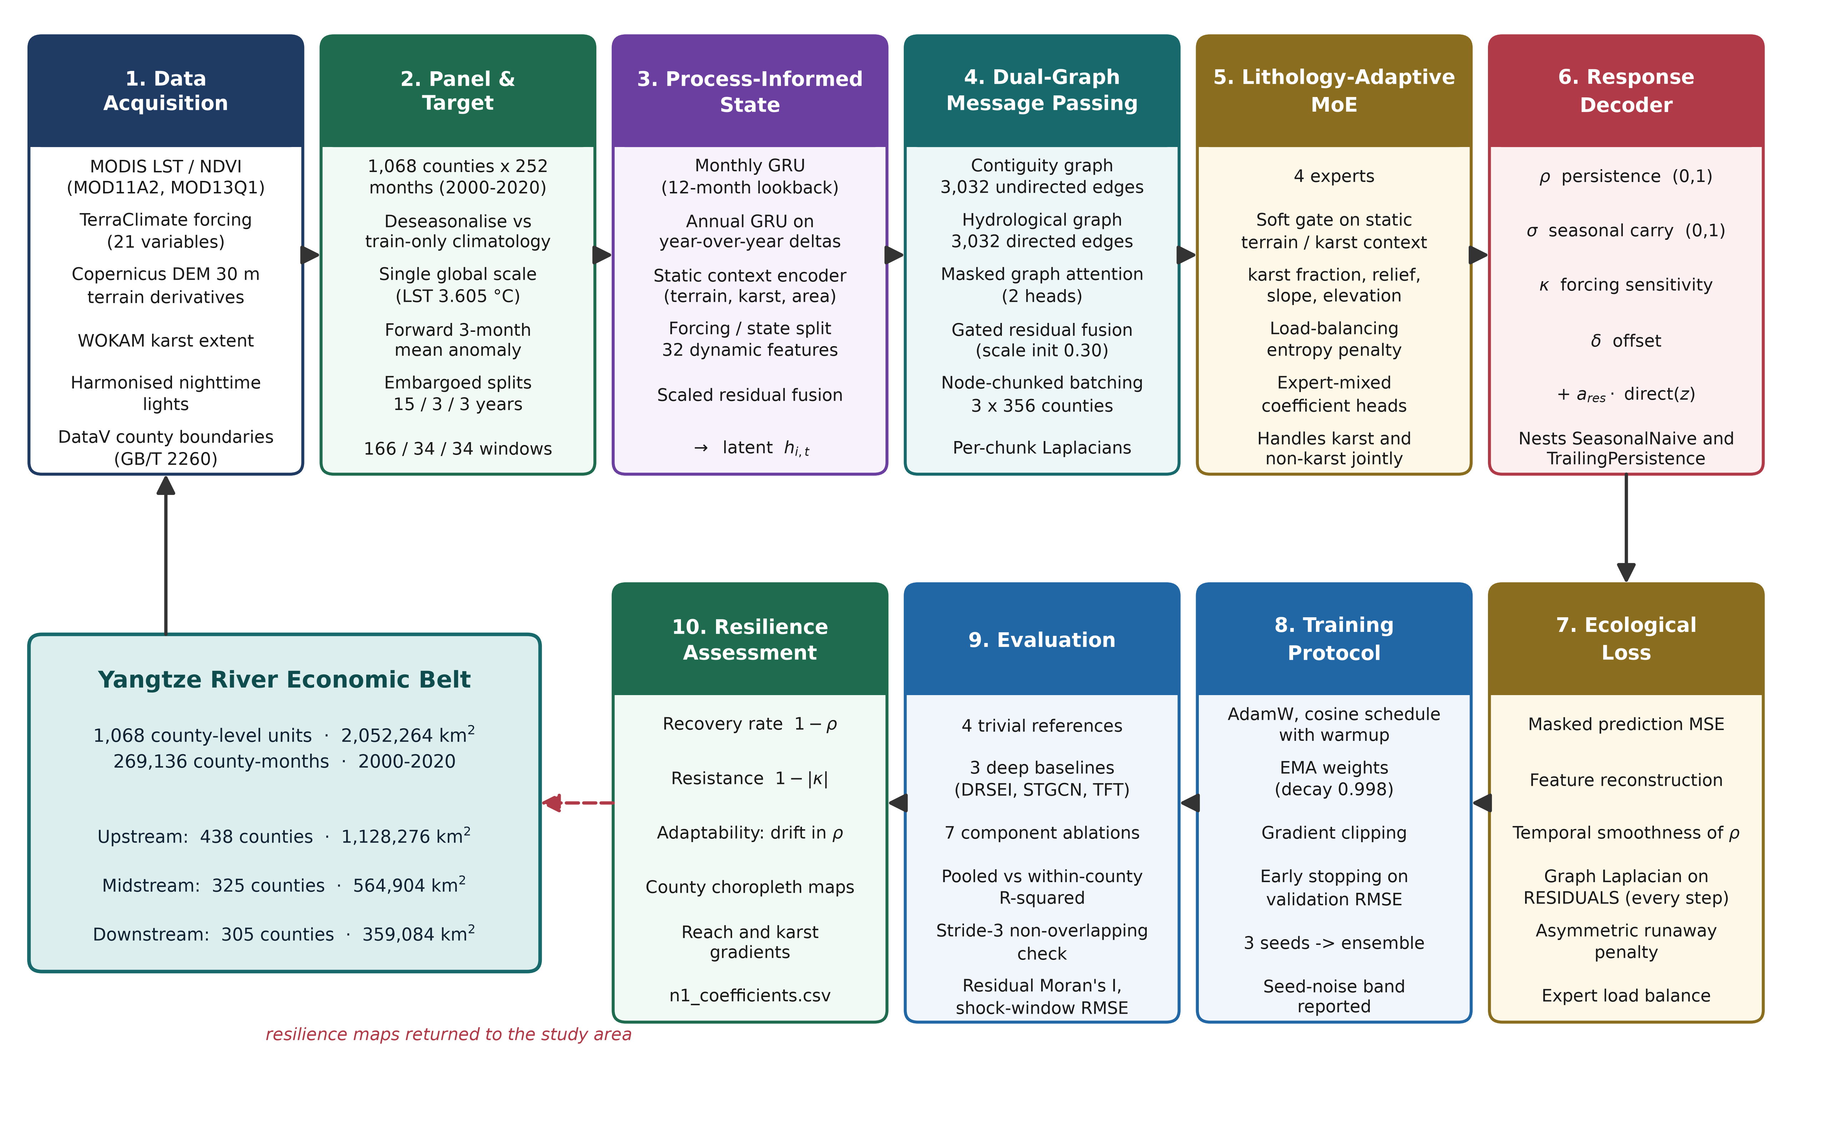
Figure 1. Overall workflow of the proposed PERSIST framework.
3.1 Dataset Description
A purpose-built county-level monthly panel of the Yangtze River Economic Belt is chosen as the primary dataset for the development and testing of the proposed PERSIST framework since it offers sequential observations of ecological state with an enhanced amount of process-informed physiographic and disturbance context suitable for resilience estimation using structured deep learning. Contrary to standard ecological assessment datasets containing annual composite indices or single-date imagery, the provided panel contains thermal and vegetation state measurements, climatic forcing, standardised disturbance anomalies, static terrain and lithological descriptors, human-pressure proxies, and observation-validity information, thus allowing the proposed framework to learn both operating-condition awareness and disturbance-response behaviour. The panel includes 269,136 rows and 58 columns, which correspond to sequential monthly observations generated under three reach configurations. The total number of logical county series equals 1,068, each having 252 sequential monthly steps, where a series is uniquely defined by its GB/T 2260 administrative code. The measured observations involve land surface temperature from MODIS MOD11A2, kNDVI and NDVI from MOD13Q1, and twelve climatic forcing variables from TerraClimate, while static descriptors include elevation, relief, slope and roughness from the Copernicus GLO-30 digital elevation model, carbonate-rock fraction from the World Karst Aquifer Map, and radiance from the harmonised DMSP-VIIRS nighttime lights series, all referenced to county geometries from DataV.GeoAtlas. Also, information about clear-sky observation counts, standardised heat and drought anomalies, contiguity adjacency and directed elevation-ordered flow connectivity is included in the dataset as part of the process-informed information.
Prior to the development of models, the panel data is preprocessed and structured to form valid input-target windows, maintaining the temporal relation between the twelve-month observation history and the subsequent response period. Deseasonalised thermal and vegetation anomalies, climatic forcing and static context variables are utilised for the formation of the state, while the forward three-month mean anomaly is separated as the prediction target to avoid information leakage during model learning. Information about clear-sky observation counts and valid-target masks is kept to facilitate observation-density conditioning and masked loss computation. The dataset is split into training, validation and test sets chronologically rather than randomly, and an embargo ensures that no observation window or target window crosses a split boundary, so that all information related to one period remains in one subset. The splitting of the dataset for the experimental study is shown in Table 2.
Table 2. Dataset Partitioning for PERSIST
Dataset Split | Windows | Samples (County-Windows) | Split %
Training Set (2000-2014) | 166 | 176,894 | 70.93 %
Validation Set (2015-2017) | 34 | 36,297 | 14.55 %
Testing Set (2018-2020) | 34 | 36,210 | 14.52 %
Total Samples | 234 | 249,401 | 100 %

The training subset is employed for parameter and coefficient-head optimisation during model development. The validation subset is utilised for tracking the behaviour of the learning process, selecting model weights and performing early stopping without involving the final test data in parameter updates. The independent test subset is exploited to assess the framework capabilities to perform seasonal anomaly prediction, temporal skill recovery, spatial residual structure control and robustness under disturbance conditions. The same subsets are used for both the proposed framework and its ablation variants, and additionally for all retrained baselines, to facilitate a fair comparison. In addition to the sequential window dataset, an independent horizon-sweep dataset including 206,475 counterfactual evaluations across six alternative aggregation horizons is exploited to establish the predictability ceiling of the task under matched conditions. The horizon-sweep dataset includes trivial-reference skill, between-county variance share and linear autoregressive ceiling estimates for each candidate horizon, allowing the task definition itself to be audited without reference to any trained deep model. Thus, the county-level panel supplies sequential ecological observations, physiographic and lithological context, disturbance indicators and observation-validity information required for the PERSIST framework development.
3.2 Data Pre-processing
In order to construct the proposed PERSIST framework, the county-level monthly panel is converted into a deseasonalised, aggregated and temporally embargoed learning problem. Let the panel be indexed by county i and month t, so that the complete record is defined as
D = { (x_(i,t), s_i, y_(i,t)) | i = 1,...,N ; t = 1,...,T }, N = 1068, T = 252 (1)
where x_(i,t) denotes the dynamic observation vector, s_i the static physiographic descriptor of county i, and y_(i,t) the ecological state variable. Because both thermal and vegetation signals are dominated by the annual cycle, each raw state variable r is first deseasonalised against a climatology estimated on the training period only, which prevents any information from the validation or test years from entering the normalisation:
mu_m(r) = mean{ r_(i,t) | month(t) = m, t in TRAIN }, m = 1,...,12 (2)
a_(i,t) = ( r_(i,t) - mu_(month(t))(r) ) / sigma_TRAIN^(r) , a_(i,t) <- clip(a_(i,t), -5, +5) (3)
where sigma_TRAIN^(r) is a standard deviation computed over the training period separately for each raw variable r, pooled across all counties and all months. Per-variable scaling is required because the two state variables carry different physical units and differ in variance by more than an order of magnitude; the measured values are 3.6050 degrees Celsius for land surface temperature and 0.1134 for kNDVI. A scale pooled across counties and months is used rather than a per-county-per-month scale because the latter divides by locally tiny variances and produces extreme outliers that dominate the loss. The prediction target is then formed as the forward H-month mean of the anomaly, with H = 3 corresponding to one season:
y_(i,e)^(H) = (1/H) * sum_{k=0}^{H-1} a_(i,e+k) , H = 3 (4)
Here e denotes the first month of the target window, which is distinct from the final observed month e - 1. The input window is the half-open interval [e - L, e), so that the summation in Equation 4 begins at the first unobserved month and no month contributes both to the predictors and to the target. This indexing convention is what makes the leakage statement in Section 3.1 exact.
Aggregation is the decisive design choice of this work, and it was selected by measurement rather than assumption. A ridge estimator using twelve autoregressive lags of both state variables, contemporaneous climate forcing and calendar terms was fitted for six candidate horizons under an identical embargo, and both pooled and within-county skill were recorded together with the share of target variance that is between-county rather than temporal. A pooled coefficient of determination of 0.82 is adopted throughout as a pre-specified acceptance threshold, fixed before any model was fitted, against which both the candidate horizons below and the final model in Section 4.6 are audited. The audit is reported in Table 3.
Table 3. Predictability audit of the aggregation horizon on the test period (2018-2020) under an identical embargo. Ridge columns are reported for every horizon including H = 12, whose within-county value is negative.
H (months) | Windows | SeasonalNaive R2 | TrailingPersistence R2 | Ridge pooled R2 | Ridge within-county R2 | Between-county variance
1 | 36 | 0.5942 | 0.4514 | 0.7329 | 0.4882 | 49.5 %
2 | 35 | 0.7775 | 0.4238 | 0.8269 | 0.6077 | 58.9 %
3 (selected) | 34 | 0.8435 | 0.3030 | 0.8716 | 0.6685 | 65.2 %
4 | 33 | 0.8697 | 0.1579 | 0.8902 | 0.6758 | 70.0 %
6 | 31 | 0.9001 | 0.2047 | 0.9096 | 0.6305 | 79.4 %
12 | 25 | 0.9346 | 0.9346 | 0.9419 | -0.7040 | 97.9 %

Table 3 shows that pooled skill rises monotonically with the aggregation window, but so does the fraction of variance that is merely cross-sectional. At H = 12 the seasonal-naive reference alone attains R2 = 0.9346, so a learned model can add almost nothing, and the within-county ceiling falls to -0.7040 because a twelve-month mean barely moves across three test years. H = 3 is therefore selected: it corresponds to one meteorological season, it clears a pooled R2 of 0.82, and it is the horizon at which genuine temporal skill peaks. H = 3 is therefore selected as the most favourable trade-off rather than as the maximum of any single column. Within-county skill is in fact marginally higher at H = 4 (0.6758 against 0.6685, a gain of 0.0072), but that gain is obtained at the cost of a rise of 4.8 percentage points in the between-county variance share (70.0 against 65.2 per cent), so a larger part of the apparent skill becomes cross-sectional rather than temporal, and of one fewer evaluation window. H = 3 also coincides with a meteorological season, which makes the recovered coefficients directly interpretable, and it clears the pre-specified threshold of 0.82. The dependence of predictability and of the trivially-predictable share on the horizon is illustrated in Figure 2.
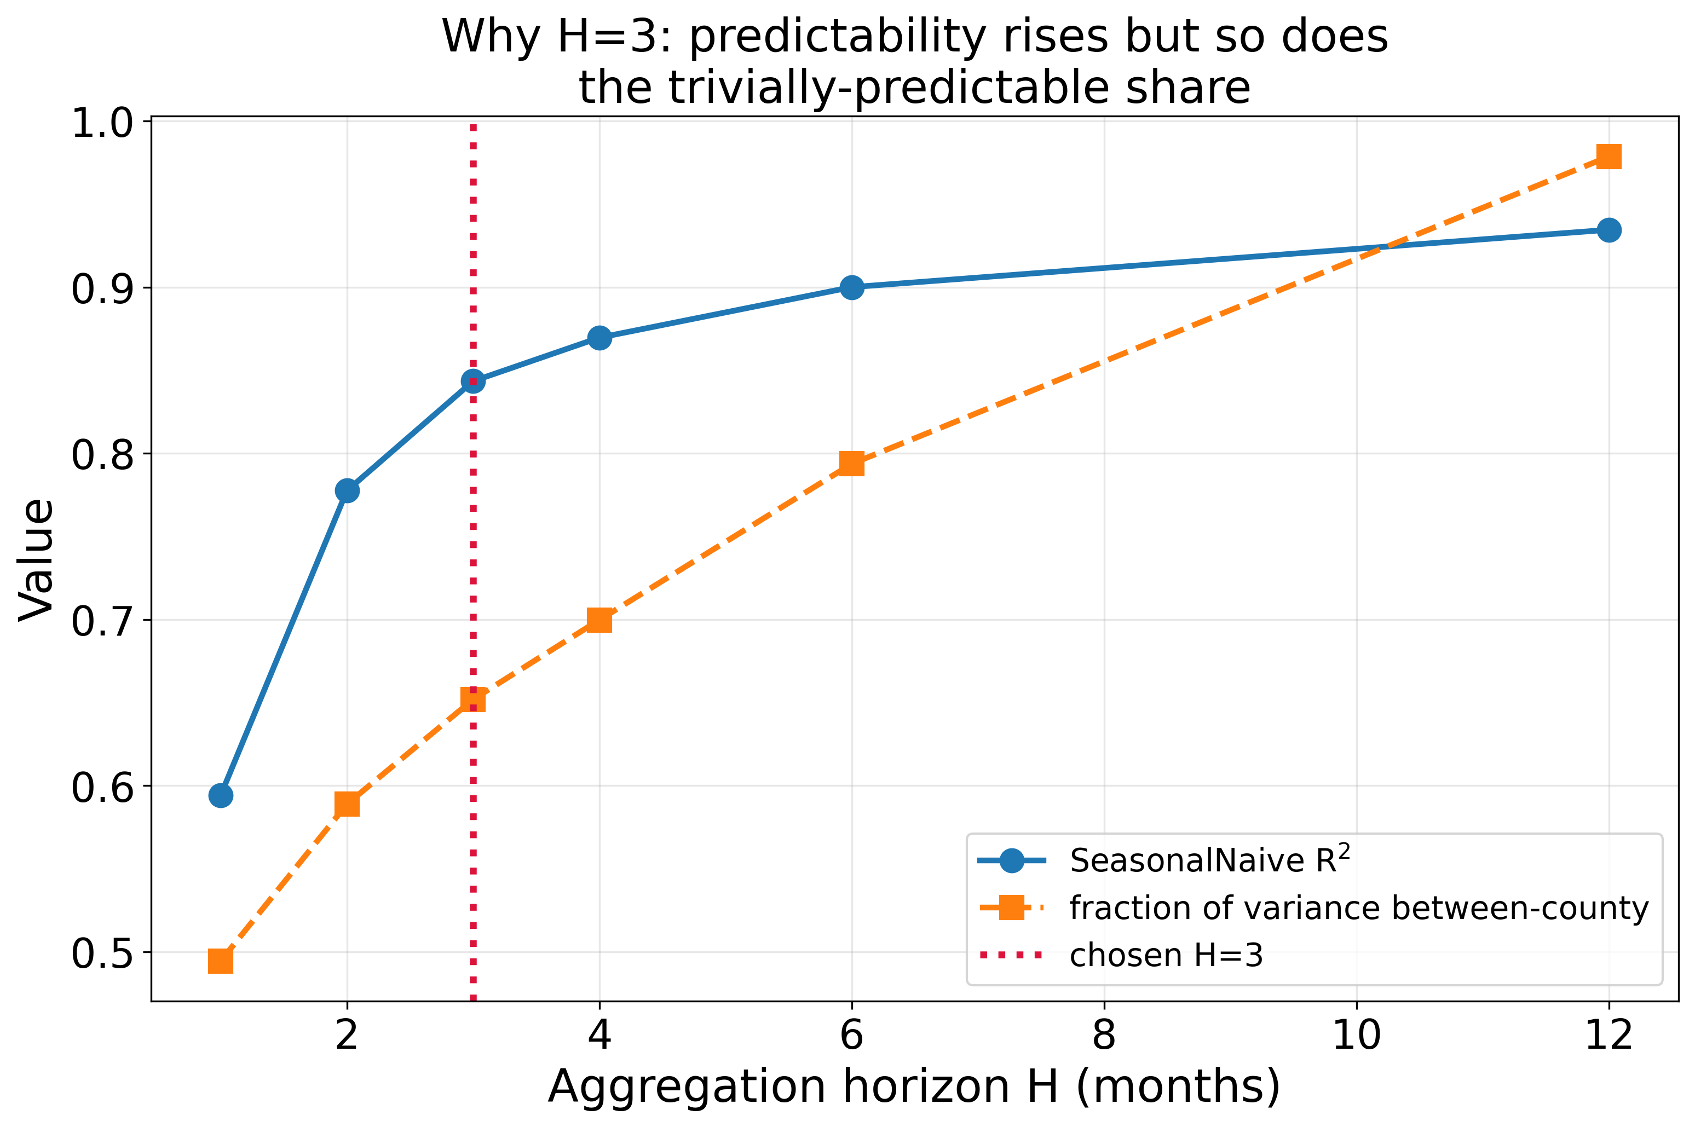
Figure 2. Selection of the aggregation horizon: predictability rises with H, but so does the share of variance that is between-county and therefore trivially predictable.
Temporal partitioning is performed chronologically with an explicit embargo. A sample terminating at month e is retained only when both its input window and its target window fall entirely inside the year range of a single split:
E_split = { e | e - L >= t_min(split), e + H - 1 <= t_max(split) }, L = 12 (5)
Without this constraint the final H - 1 training targets would extend into the validation period, producing optimistic validation estimates. The embargo removes two windows from each split and yields 166 training, 34 validation and 34 test graph snapshots. Finally, every dynamic and static feature is standardised using statistics computed on the training period alone, and residual gaps arising from persistent cloud cover are filled by forward-then-backward carry within each county series:
x~_(i,t,j) = ( x_(i,t,j) - mu_j^TRAIN ) / sigma_j^TRAIN , sigma_j^TRAIN > 0 (6)
3.3 Feature Extraction
In the proposed PERSIST framework, the process of feature extraction is intended for obtaining a representation that simultaneously carries recent ecological state, the climatic forcing acting upon it, the longer-term trajectory of the county and its immutable physiographic setting. The dynamic observation vector at each month combines state and forcing channels:
x_(i,t) = [ lst_c, kndvi, ndvi, lst_ds, kndvi_ds | ppt, pet, aet, def, q, tmax, tmin, vpd, soil, srad, pdsi, swe, wbal, heat_z, dry_z, ..., n_rel | sin(2*pi*m/12), cos(2*pi*m/12), year_frac ] (7)
where the first group represents ecological state including the deseasonalised anomalies themselves, the second group represents climatic forcing together with the relative clear-sky observation count n_rel, and the third group encodes calendar position. This yields 32 dynamic channels, of which five are treated as state and twenty-two as forcing when the response decoder separates the two. The static descriptor captures terrain and lithology:
s_i = [ elev_mean, elev_std, relief, slope_mean, slope_std, roughness, karst_frac, area_km2 ] (8)
Long-term context is supplied by an annual representation formed from calendar-year means of every dynamic channel together with their year-over-year differences, so that the encoder receives both level and change information rather than a redundant second copy of the monthly signal:
x^ann_(i,k) = [ mean_{t in year k} x~_(i,t) ; mean_{t in year k} x~_(i,t) - mean_{t in year k-1} x~_(i,t) ] giving 64 channels (9)
The monthly and annual sequences are encoded by separate recurrent branches and combined with the encoded state channels through learnable scalar gains, so that each auxiliary branch contributes only to the extent that it reduces the training objective:
h_(i,t) = LN(GRU_month(x~_(i,t-L:t))) + a_year * LN(GRU_ann(x^ann)) + a_state * f_state(x~_(i,t-1)) (10)
where LN denotes layer normalisation and a_year and a_state are scalar parameters initialised at 0.10. The combination of the encoded dynamic representation with the encoded static context forms the process-informed state used by every downstream head.
3.4 Proposed Framework Architecture
The proposed PERSIST framework is presented in Figure 3. The architecture is organised as a single forward path from multi-source county observations to bounded resilience coefficients and a seasonal anomaly prediction, with three conditioning pathways that modulate the response rather than adding independent predictions.
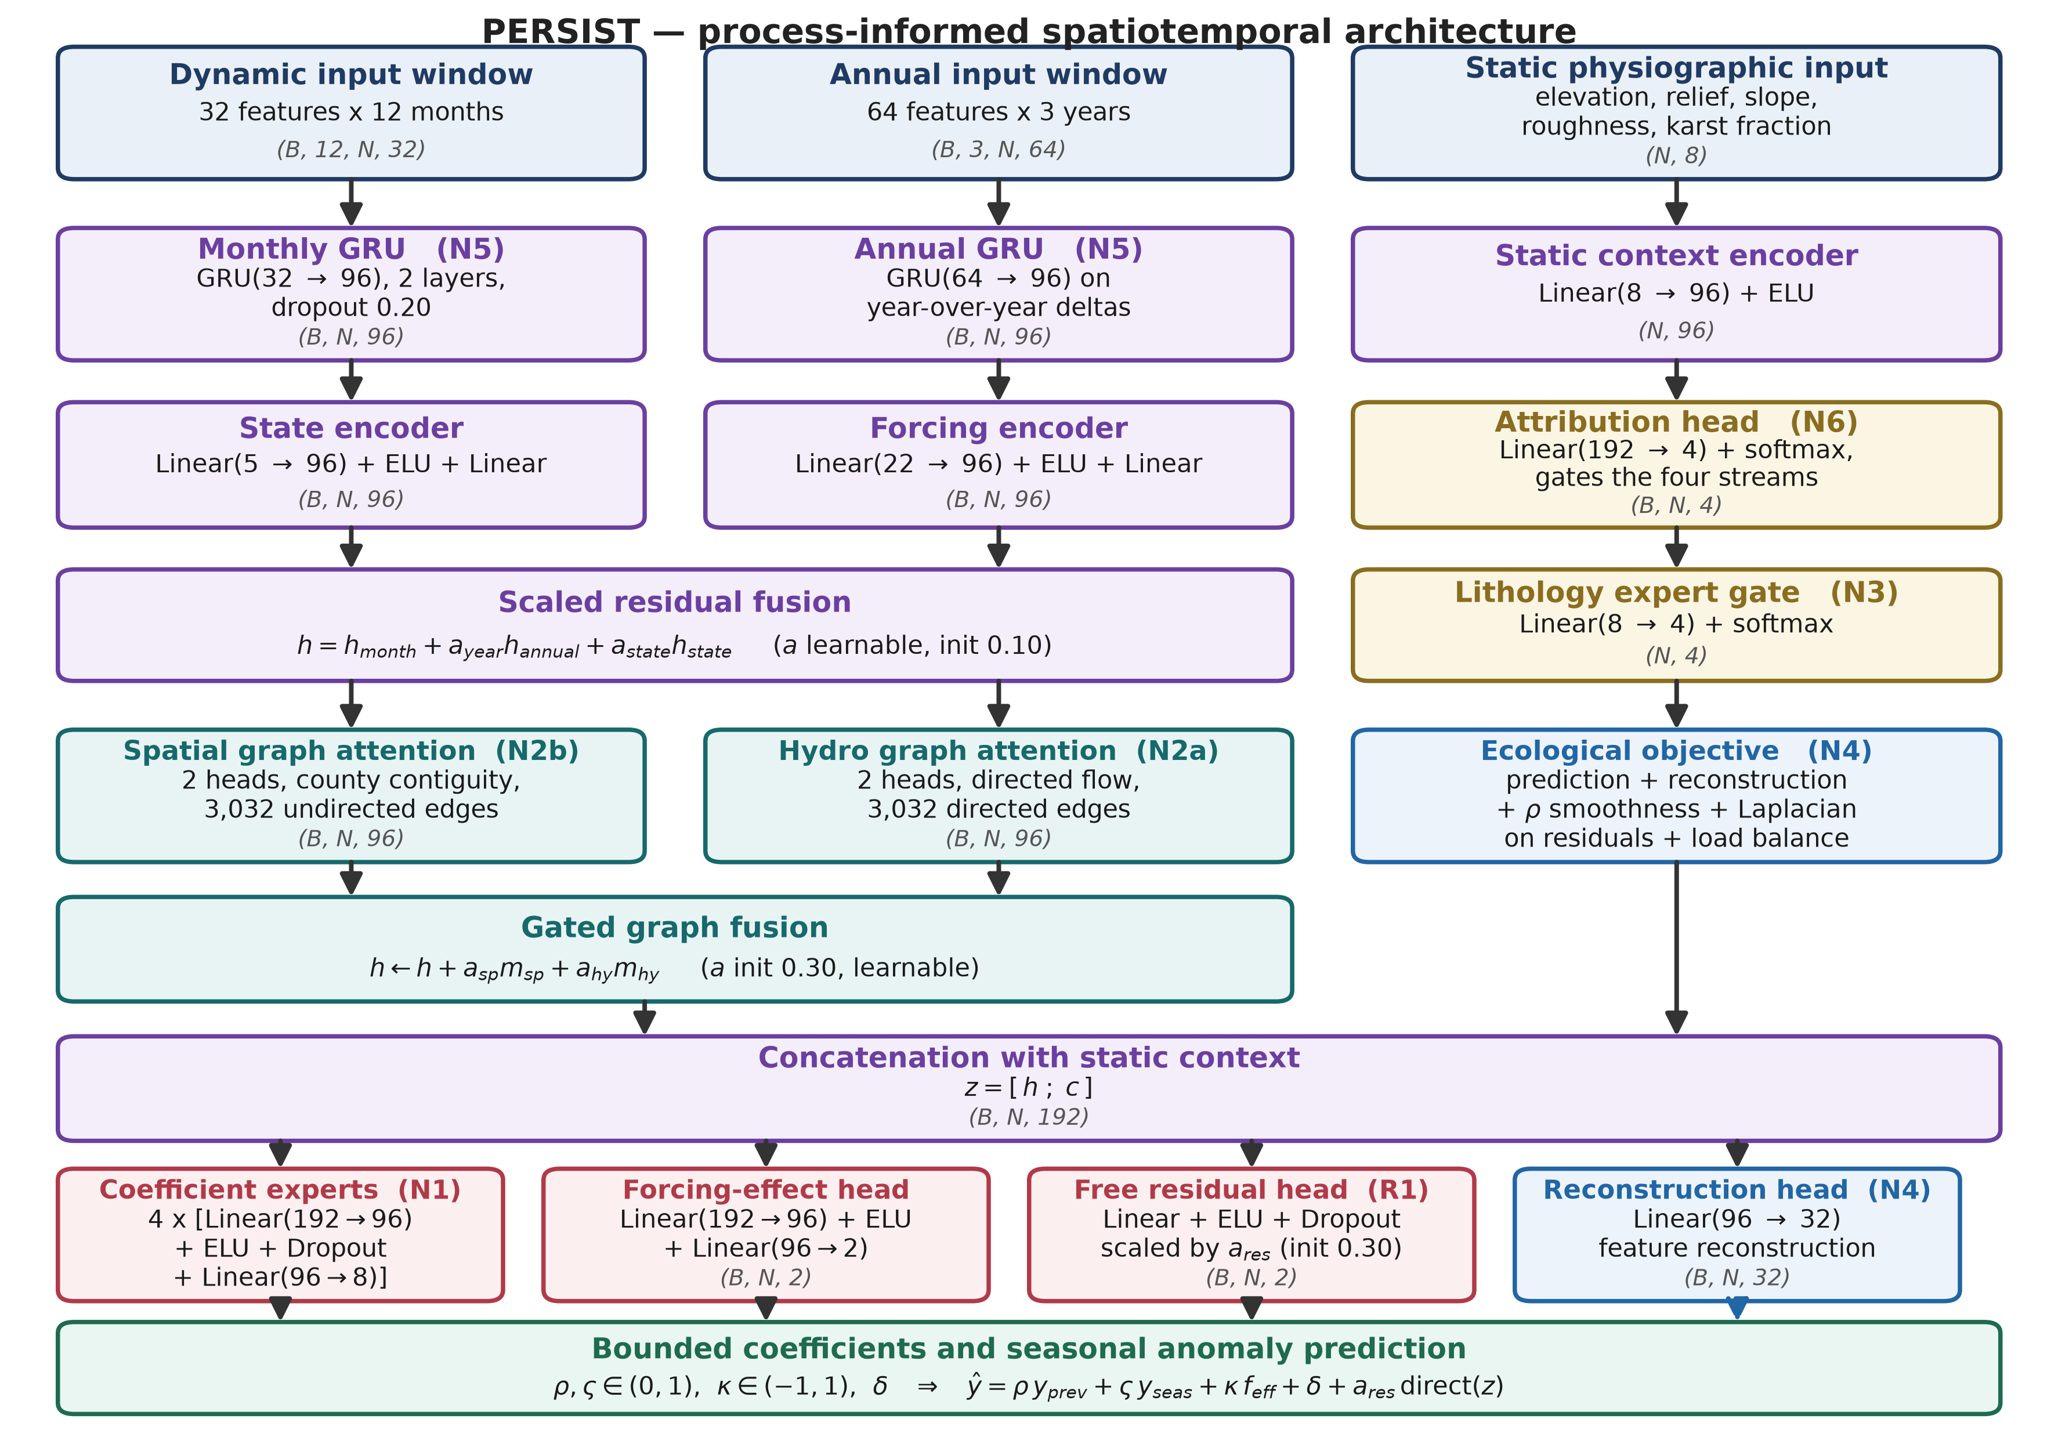
Figure 3. Overall architecture of the proposed PERSIST framework.
The county-level monthly panel is grouped into input-target windows, where each window supplies a twelve-month dynamic history, a three-year annual context and the static physiographic descriptor of every county simultaneously, so that one training sample is a complete spatial snapshot rather than a single county. The monthly branch encodes the dynamic history with a two-layer gated recurrent unit, while the annual branch encodes year-over-year deltas with a single-layer unit, and both are combined with the encoded instantaneous state through the learnable gains of Equation 10. This hierarchical construction is the fifth novelty of the framework and supplies the long-memory context that a twelve-month window alone cannot carry.
The fused representation is then propagated over two graphs. The first is an undirected county contiguity graph with 3,032 edges, mean degree 5.68 and a single connected component; the second is a directed flow graph of equal edge count in which each edge is oriented from higher to lower mean elevation, serving as a terrain-derived proxy for hydrological connectivity. Both are processed by masked multi-head attention restricted to graph neighbours, and their messages are combined with the node representation through learnable scalar gains initialised at 0.30:
h_i <- h_i + a_sp * LN(Attn_sp(h, A_sp))_i + a_hy * LN(Attn_hy(h, A_hy))_i (11)
Because the full graph of 1,068 counties yields only one snapshot per target month, the belt is partitioned into three spatially coherent chunks of 356 counties each, which retain roughly 30 per cent of the contiguity edges individually. Training alternates between chunked steps and occasional full-graph steps, which multiplies the optimiser update budget approximately eightfold while acting as edge dropout. The concatenation of the propagated representation with the encoded static context produces the joint representation z that feeds every head.
The lithology-adaptive mixture of experts constitutes the third novelty. Four expert coefficient networks are combined by a softmax gate driven solely by the static descriptor, so the functional form of the response is conditioned on terrain and carbonate-rock fraction rather than being shared globally:
w_i = softmax(W_g s_i), theta_i = sum_{k=1}^{4} w_(i,k) * Expert_k(z_i) (12)
The disturbance-conditioned response decoder, which is the first and principal novelty, maps the mixed coefficient vector into bounded quantities and combines them with the two nested reference predictors:
rho_i = sigmoid(.), varsigma_i = sigmoid(.), kappa_i = tanh(.), delta_i = . (13)
y^_(i,e) = rho_i * y_(i,e-H) + varsigma_i * y_(i,e-12) + kappa_i * f_eff,i + delta_i + a_res * direct(z_i) (14)
where y_(i,e-H) is the trailing H-month mean and y_(i,e-12) is the mean of the same H months one year earlier, both read exclusively from months preceding the target window. The formulation nests the trivial references exactly: setting varsigma = 1 with the remaining terms at zero reproduces SeasonalNaive, while rho = 1 reproduces TrailingPersistence. The final term is a learnable-scaled free residual introduced so that the deep representation is not restricted to modulating four bounded scalars; without it, the decoder is strictly less expressive than an unconstrained regression head. The resilience quantities follow directly from Equation 13: recovery rate is 1 - rho, resistance is 1 - |kappa|, and adaptability is the year-over-year drift in rho. The layer-wise configuration of the architecture is summarised in Table 4.
Table 4. Layer-wise Architecture Summary of the Proposed PERSIST
Layer | Configuration | Output Shape
Dynamic input window | 32 features x 12 months | (B, 12, N, 32)
Annual input window | 64 features x 3 years | (B, 3, N, 64)
Static input | 8 physiographic features | (N, 8)
Monthly GRU (N5) | GRU(32 -> 96), 2 layers, dropout 0.20 | (B, N, 96)
Monthly LayerNorm | LayerNorm(96) | (B, N, 96)
Annual GRU (N5) | GRU(64 -> 96), 1 layer | (B, N, 96)
Annual scaled residual | a_year x LayerNorm(96), init 0.10 | (B, N, 96)
Forcing encoder | Linear(22 -> 96) + ELU + Linear(96 -> 96) | (B, N, 96)
State encoder | Linear(5 -> 96) + ELU + Linear(96 -> 96) | (B, N, 96)
Spatial graph attention (N2b) | 2 heads, contiguity, 3,032 undirected edges | (B, N, 96)
Hydro graph attention (N2a) | 2 heads, directed flow, 3,032 edges | (B, N, 96)
Gated graph fusion | a_sp, a_hy init 0.30, learnable | (B, N, 96)
Static context encoder | Linear(8 -> 96) + ELU | (N, 96)
Concatenation | [h ; c] | (B, N, 192)
Attribution head (N6) | Linear(192 -> 4) + softmax stream gating | (B, N, 4)
Lithology expert gate (N3) | Linear(8 -> 4) + softmax | (N, 4)
Coefficient experts (N1) | 4 x [Linear(192 -> 96) + ELU + Dropout + Linear(96 -> 8)] | (B, N, 4, 8)
Expert mixing | gate-weighted sum over 4 experts | (B, N, 8)
Bounded coefficients (N1) | sigmoid(rho), sigmoid(varsigma), tanh(kappa), delta | 4 x (B, N, 2)
Forcing-effect head (N1) | Linear(192 -> 96) + ELU + Linear(96 -> 2) | (B, N, 2)
Free residual head (R1) | Linear + ELU + Dropout + Linear, scale a_res 0.30 | (B, N, 2)
Reconstruction head (N4) | Linear(96 -> 32) | (B, N, 32)
Output | rho*y_prev + varsigma*y_seas + kappa*f + delta + a_res*direct(z) | (B, N, 2)

The proposed architecture also allows evaluating the component-wise ablation of the framework by disabling individual pathways through the same code path, so that no implementation drift is possible between the full model and its reduced variants. The distribution of trainable parameters across components is reported in Table 5.
Table 5. Parameter distribution of the Proposed PERSIST
Component | Parameters | Share
Monthly temporal encoder (N5) | 93,504 | 26.26 %
Annual temporal encoder (N5) | 46,849 | 13.16 %
Forcing encoder | 11,520 | 3.24 %
State encoder | 9,889 | 2.78 %
Spatial graph attention (N2b) | 37,441 | 10.51 %
Hydrological graph attention (N2a) | 37,441 | 10.51 %
Static context encoder | 864 | 0.24 %
Lithology expert gate (N3) | 36 | 0.01 %
Attribution head (N6) | 772 | 0.22 %
Coefficient experts (N1, four experts) | 77,216 | 21.68 %
Forcing-effect head (N1) | 18,722 | 5.26 %
Free residual head (R1) | 18,723 | 5.26 %
Reconstruction head (N4) | 3,104 | 0.87 %
Total | 356,081 | 100.00 %

It is evident from the architecture overview presented in Table 4 and the parameter distribution in Table 5 that the proposed PERSIST framework concentrates capacity in the temporal encoders and the coefficient experts, which together account for 61.1 per cent of the 356,081 trainable parameters, while the gating and attribution pathways that supply lithological and stream conditioning require fewer than one thousand parameters combined. The complete model is therefore 4.24 times smaller than the Temporal Fusion Transformer baseline used for comparison, which carries 1,510,850 parameters.
3.5 Loss Function and Hyperparameter Configuration
The optimisation approach used in the proposed PERSIST framework is a critical factor, because the objective must reward accurate seasonal prediction while keeping the recovered coefficients physically plausible and the residual field spatially unstructured. The primary term is a masked mean squared error over valid county-window targets:
L_pred = ( sum_(i,e) m_(i,e) * || y^_(i,e) - y_(i,e) ||^2 ) / ( sum_(i,e) m_(i,e) * d_out ) (15)
where m is the valid-target mask and d_out the number of predicted variables. Three ecological regularisers are then added. A reconstruction term requires the latent representation to remain informative about the input state, a smoothness term discourages implausibly abrupt change in the persistence coefficient between consecutive windows, and a graph Laplacian term penalises spatially correlated residuals, which is the training-time analogue of the residual Moran statistic reported in the results:
L_rec = || g_rec(h) - x~_(.,t-1) ||^2 , L_smooth = mean( (rho_(.,e+1) - rho_(.,e))^2 ) (16)
L_lap = ( 1 / (B * d_out) ) * sum_b sum_o r_(b,o)^T * L * r_(b,o) , r = (y^ - y) * m (17)
where L is the normalised graph Laplacian of the contiguity graph. In contrast to penalising the Laplacian of the predictions, which merely over-smooths the output field, penalising the Laplacian of the residuals targets exactly the quantity the evaluation reports. The Laplacian is precomputed for every node chunk, so the penalty is applied at every optimiser step rather than only on the occasional full-graph step. A load-balancing entropy term prevents the expert gate from collapsing onto a single expert, and an asymmetric term discourages predictions from leaving the physically clipped range:
L_bal = sum_k u_k * log(u_k), u = mean_i w_i ; L_asym = mean( max(|y^| - 5, 0)^2 ) (18)
L_total = L_pred + 0.005 * L_rec + 0.002 * L_smooth + 0.15 * L_lap + 0.001 * L_asym + 0.001 * L_bal (19)
Optimisation is performed with AdamW at an initial learning rate of 2 x 10^-3 and a weight decay of 3 x 10^-4, under a cosine schedule with five warmup epochs. An exponential moving average of the weights with decay 0.998 is maintained and used for validation, since those are the weights that would be deployed. Gradients are clipped to unit norm, early stopping monitors validation root mean squared error with a patience of fifteen epochs, and every configuration is trained over three random seeds whose predictions are averaged, with the standard deviation across seeds retained as the noise band against which ablation differences are judged. The complete hyperparameter configuration is reported in Table 6.
Table 6. Hyperparameter Configuration of the Proposed PERSIST
Hyperparameter | Value / Configuration
Framework | PERSIST
Dataset | County-level monthly panel of the YREB (2000-2020)
Learning paradigm | Supervised spatiotemporal regression
Spatial units | 1,068 county-level administrative units
Prediction target | Forward 3-month mean deseasonalised anomaly
Target variables | lst_ds (primary), kndvi_ds
Lookback window | 12 months
Annual context | 3 years of levels and year-over-year deltas
Dynamic / static / annual features | 32 / 8 / 64
Hidden dimension | 96
Monthly encoder | GRU, 2 layers
Annual encoder | GRU, 1 layer
Graph attention heads | 2
Number of experts | 4
Dropout | 0.20
Graph residual scale (initial) | 0.30
Free residual scale (initial) | 0.30
Auxiliary branch scales (initial) | 0.10
Optimiser | AdamW
Initial learning rate | 2 x 10^-3
Weight decay | 3 x 10^-4
Learning-rate schedule | Cosine with 5 warmup epochs
Maximum epochs | 60
Early-stopping patience | 15 epochs on validation RMSE
Gradient clipping | 1.0 (global norm)
EMA decay | 0.998
Node chunks | 3 chunks of 356 counties
Full-graph step probability | 0.25
Windows per optimiser step | 4
Random seeds | 3 (predictions ensembled)
Reconstruction weight | 0.005
Persistence smoothness weight | 0.002
Residual Laplacian weight | 0.15
Asymmetric range weight | 0.001
Expert load-balance weight | 0.001
Anomaly clipping | +/- 5 sigma
Disturbance threshold | |heat_z| >= 1.5
Hardware | NVIDIA L4 GPU
Framework version | PyTorch 2.11.0 (CUDA 12.8)

The chosen configuration strikes a balance among predictive accuracy, coefficient interpretability, spatial regularisation and computational cost. The relatively small hidden dimension and the aggressive early-stopping patience reflect the structural characteristic of the graph formulation, namely that one training sample is an entire spatial snapshot, so the number of independent temporal samples is limited to 166 despite the panel containing more than a hundred and seventy thousand county-window records.
4. Results and Discussions
4.1 Experimental Setup
The county-level monthly panel of the Yangtze River Economic Belt has been utilised in the current work in order to develop and evaluate the proposed PERSIST framework. All experiments were executed on a single NVIDIA L4 graphics processing unit using PyTorch 2.11.0 with CUDA 12.8. The panel provides 1,068 county-level units observed monthly from January 2000 to December 2020, from which 234 embargoed input-target windows and 249,401 valid county-window samples are formed. Training uses the 166 windows falling entirely within 2000-2014, validation uses the 34 windows within 2015-2017, and all reported results are computed on the 34 held-out windows within 2018-2020, comprising 36,210 county-window samples. Every configuration, including the four trivial references, the three retrained deep baselines, the proposed model and the seven single-component ablations, uses the identical splits, the identical target definition and the identical three-seed ensembling protocol, so that no configuration gains an advantage from averaging or from a more favourable partition. Training the proposed model required 27 epochs before early stopping and approximately 5.1 minutes per seed.
4.2 Evaluation Metrics
To test the efficacy of the proposed PERSIST framework, several metrics are considered for analysis. Predictive accuracy in the primary anomaly space is quantified by the root mean squared error and the mean absolute error over all valid county-window pairs:
RMSE = sqrt( (1/n) * sum_(i,e) ( y^_(i,e) - y_(i,e) )^2 ) (20)
MAE = (1/n) * sum_(i,e) | y^_(i,e) - y_(i,e) | (21)
The coefficient of determination measures the fraction of target variance explained relative to the global mean of the observations:
R2 = 1 - ( sum_(i,e) ( y^_(i,e) - y_(i,e) )^2 ) / ( sum_(i,e) ( y_(i,e) - mean(y) )^2 ) (22)
Because a large share of the aggregated target variance is cross-sectional, the pooled coefficient above rewards a model merely for placing counties at the correct average level. The within-county coefficient therefore removes each county mean from both the observations and the predictions before computing the same quantity, and it is reported alongside the pooled value throughout:
R2_within = 1 - ( sum_(i,e) ( (y^_(i,e) - mean_e y^_i) - (y_(i,e) - mean_e y_i) )^2 ) / ( sum_(i,e) ( y_(i,e) - mean_e y_i )^2 ) (23)
Spatial structure remaining in the error field is quantified by Moran's I computed on the county-mean residual for each test year and averaged, where W is the row adjacency of the contiguity graph. A value near zero indicates that the model has absorbed the available spatial signal:
I = ( n / S0 ) * ( sum_i sum_j W_ij * r_i * r_j ) / ( sum_i r_i^2 ), S0 = sum_i sum_j W_ij (24)
Agreement and efficiency are additionally summarised by the Willmott index of agreement and the Kling-Gupta efficiency, which jointly penalise errors in correlation, variance ratio and mean:
KGE = 1 - sqrt( (r - 1)^2 + (sigma_p/sigma_o - 1)^2 + ((mu_p - mu_o)/sigma_o)^2 ) (25)
Finally, two robustness diagnostics are reported. Disturbance-window error is the root mean squared error restricted to windows in which the standardised heat anomaly exceeds 1.5 in magnitude, and the stride-H coefficient recomputes the pooled coefficient on non-overlapping windows only, since consecutive three-month targets share two months of observations.
4.3 Performance Analysis of the Proposed PERSIST
Evaluation of the proposed PERSIST framework was performed on the held-out validation and test partitions. Table 7 reports the training and validation behaviour at the epoch selected by early stopping, which is the checkpoint used for all subsequent test-set evaluation.
Table 7. Training and Validation Performance of the Proposed PERSIST
Metric | Training | Validation
Loss | 0.07632 | 0.12855
RMSE | 0.26644 | 0.35362
MAE | 0.20204 | 0.26866
R2 | 0.90973 | 0.84992
Selected epoch | 11 | 11
Epochs completed | 26 | 26

Results shown in Table 7 demonstrate that the obtained model gives consistent performance across the training and validation partitions, with a validation root mean squared error of 0.3536 against a training value of 0.2664. The gap of 0.0872 indicates mild overfitting that is controlled by early stopping at epoch 11, by the exponential moving average of the weights and by the node-chunking scheme, which acts as edge dropout. The final test performance of the three-seed ensemble is reported in Table 8.
Table 8. Final Test Performance of the Proposed PERSIST
Metric | PERSIST
Root mean squared error | 0.3633
Mean absolute error | 0.2660
Coefficient of determination (pooled) | 0.8515
Pearson correlation | 0.9231
Willmott index of agreement | 0.9596
Kling-Gupta efficiency | 0.9052
Bias | +0.0126
Within-county R2 (temporal skill) | 0.7092
Within-county Pearson correlation | 0.8455
Residual Moran's I | 0.8172
Disturbance-window RMSE | 0.3556
Calm-window RMSE | 0.3008
Stride-3 R2 (non-overlapping) | 0.8897
R2 in native LST units | 0.9718
RMSE in native LST units (deg C) | 1.1079
Upstream / midstream / downstream RMSE | 0.3346 / 0.3006 / 0.2717
Seed spread (RMSE, mean +/- sd) | 0.3662 +/- 0.0045
Trainable parameters | 356,081
Test samples | 36,210

From the findings in Table 8 it is evident that the proposed approach attains a pooled coefficient of determination of 0.8515 together with a within-county coefficient of 0.7092. Reporting both is essential, because 65.2 per cent of the aggregated target variance is between-county rather than temporal, so the pooled value partly rewards correct placement of county levels. The non-overlapping stride-3 recomputation yields 0.8897, marginally above the pooled figure, which confirms that the overlap between consecutive three-month targets does not inflate the reported skill. In native units the model explains 97.2 per cent of seasonal land surface temperature variance at a root mean squared error of 1.11 degrees Celsius. Disturbance windows remain harder than calm windows, with errors of 0.3556 against 0.3008 over 4,022 and 32,188 samples respectively, and error decreases monotonically downstream, from 0.3346 in the topographically complex upper basin to 0.2717 in the lowland delta.
4.4 Training Convergence Analysis
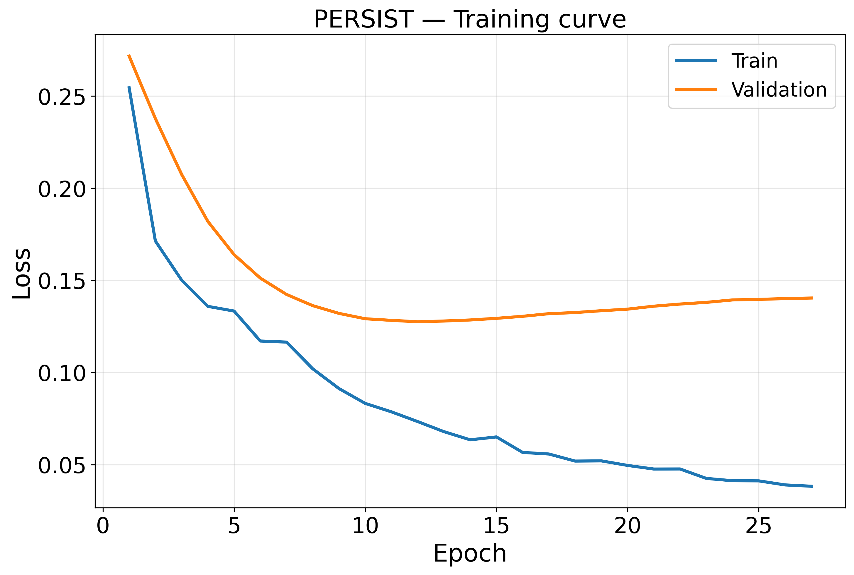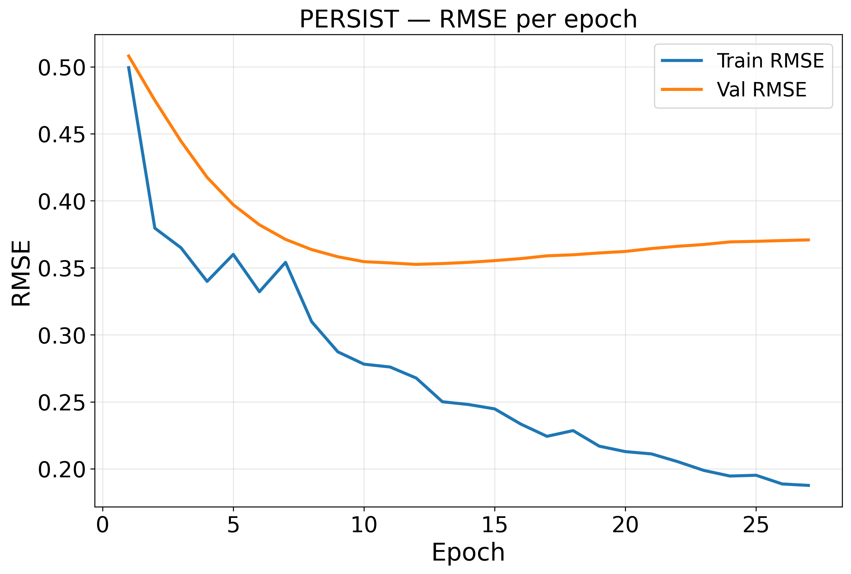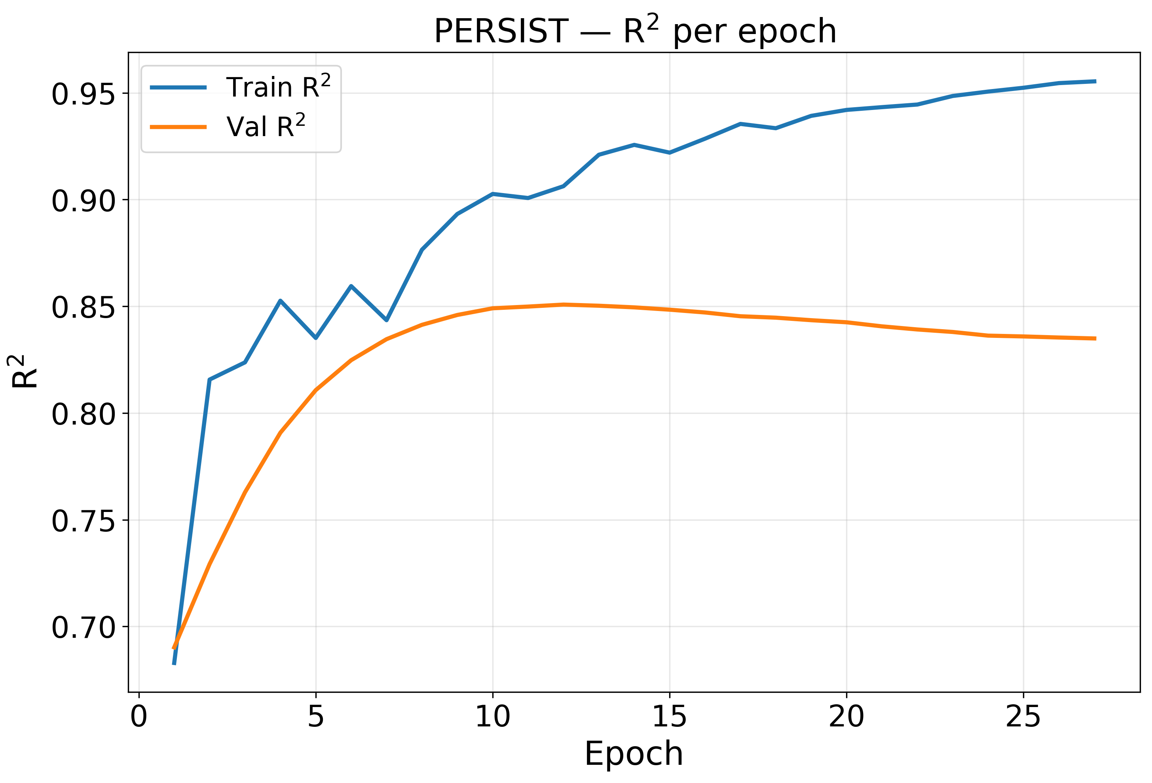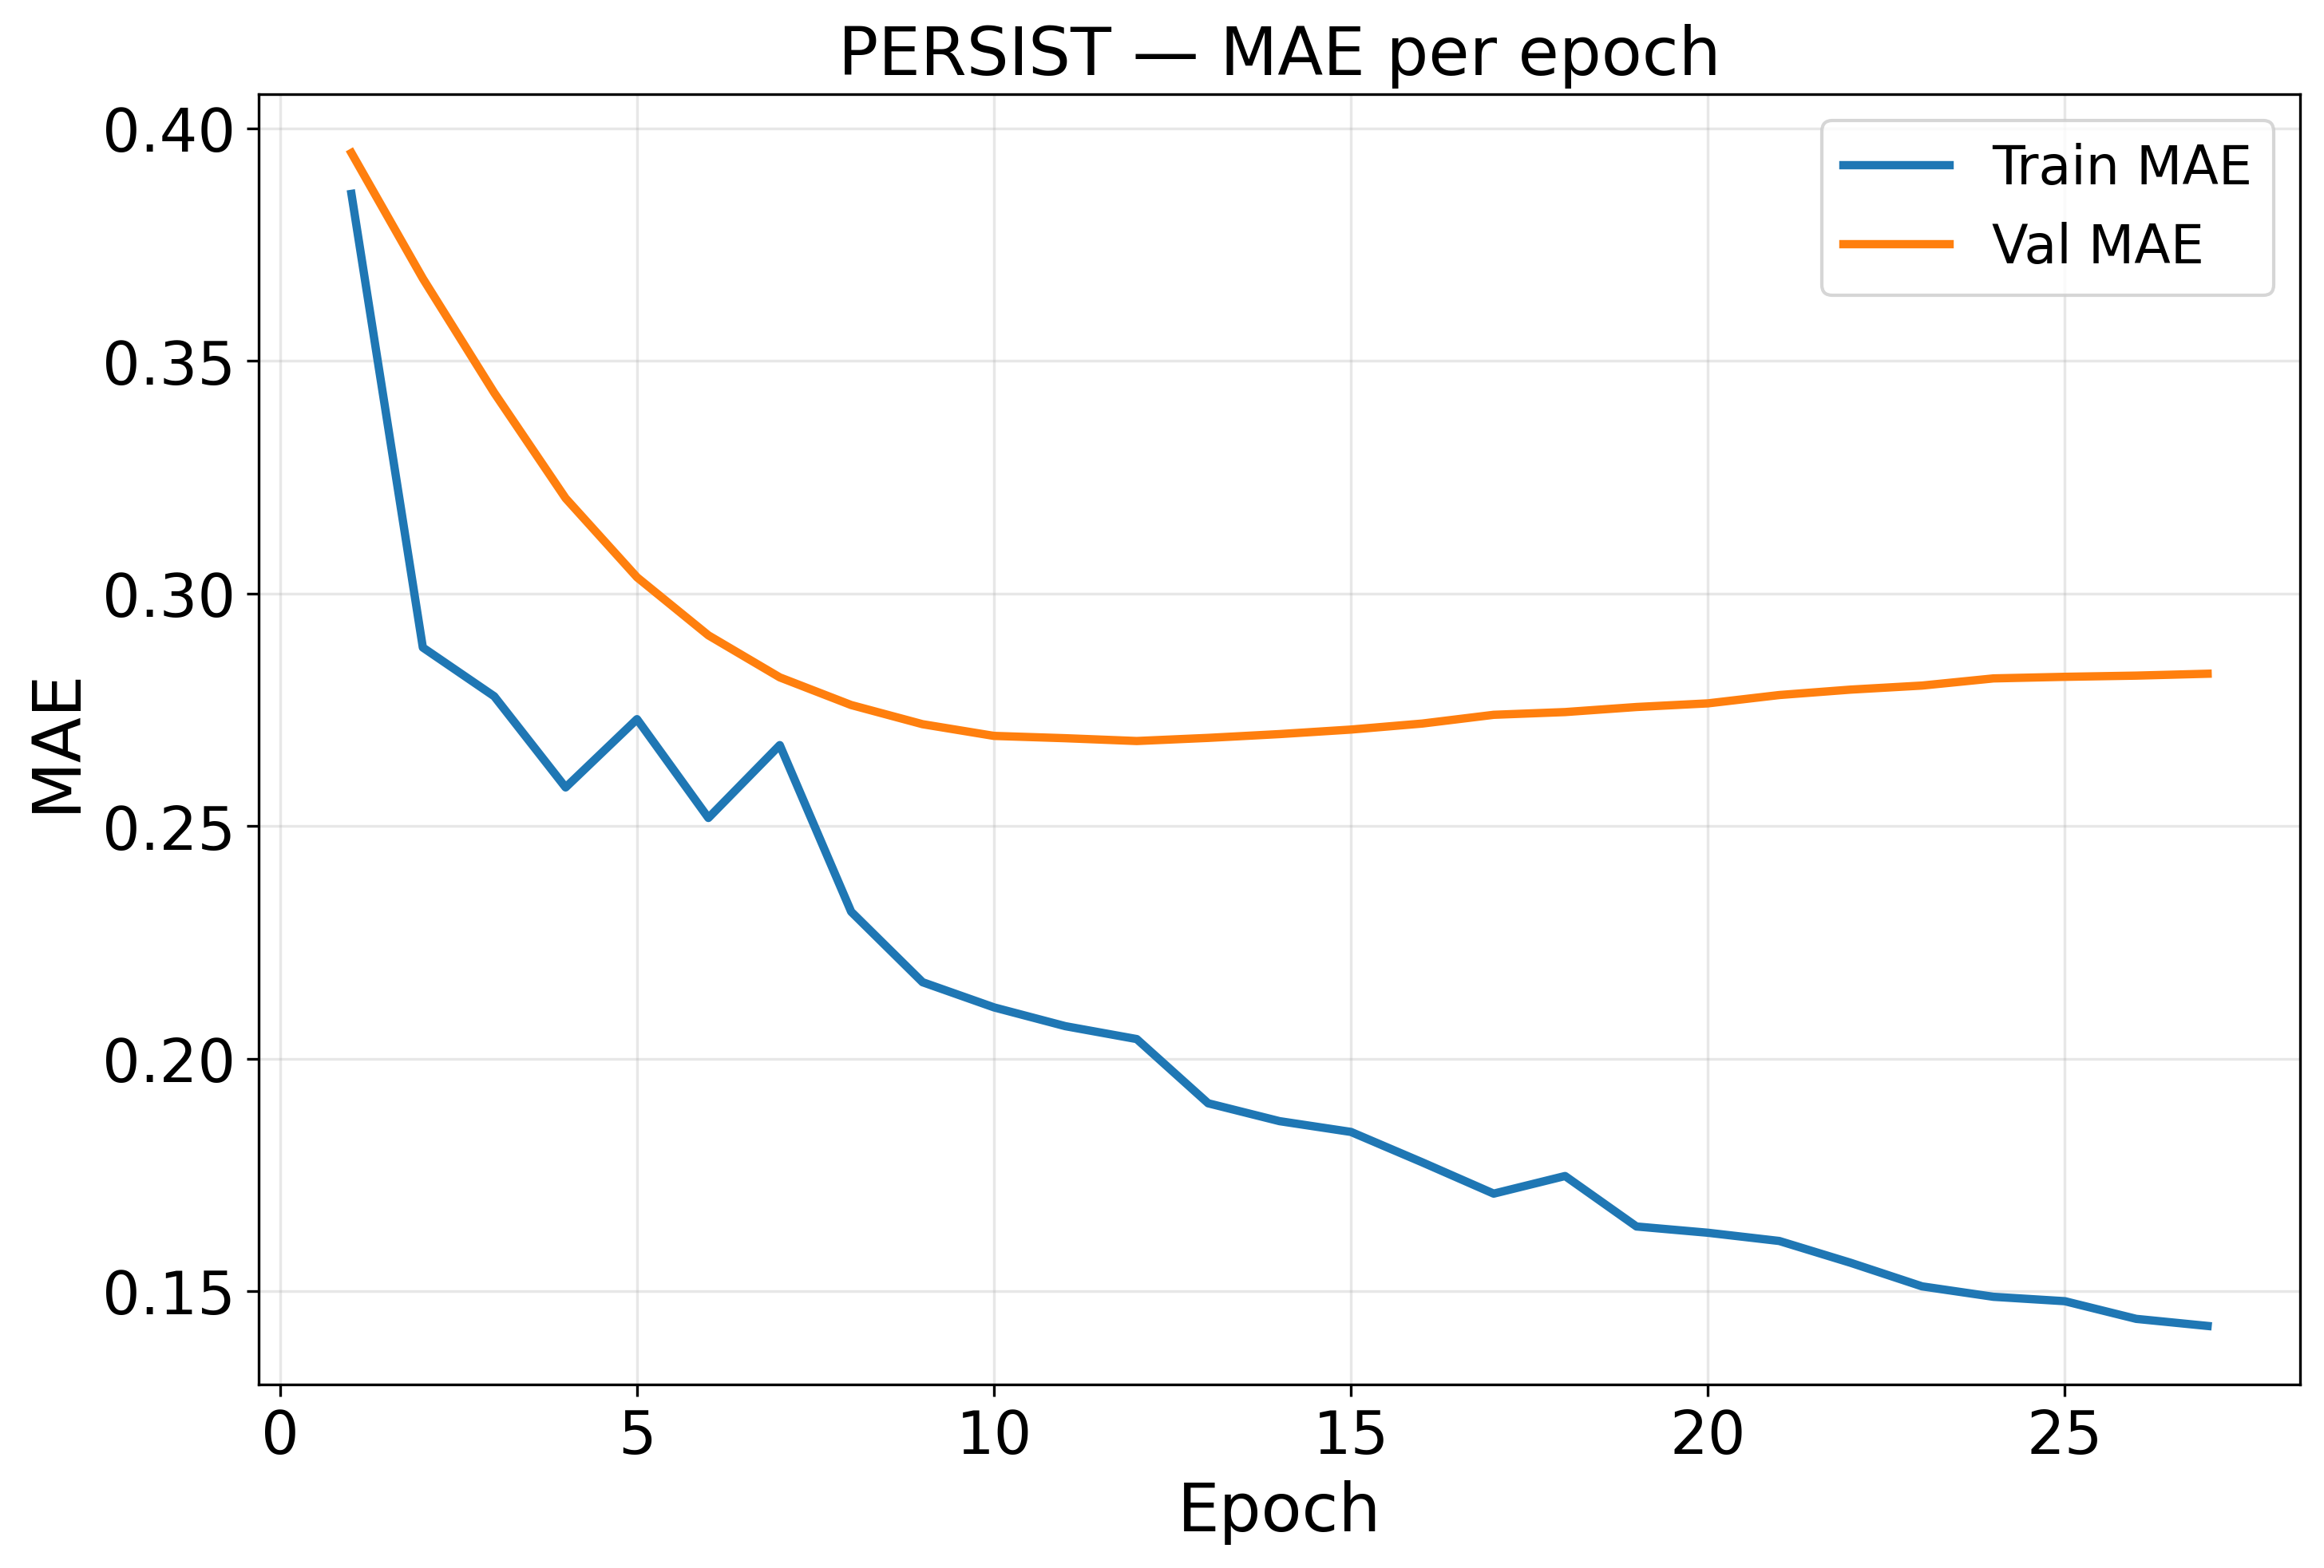
Figure 4. Training and validation convergence curves of the proposed PERSIST framework: loss, root mean squared error, coefficient of determination and mean absolute error per epoch.
Figure 4 shows the optimisation convergence properties of the proposed PERSIST framework. The loss curves decline steeply during the five warmup epochs and the subsequent cosine decay, with validation loss reaching its minimum at epoch 11 before beginning a slow rise while training loss continues to fall. This is the expected signature of a graph formulation in which one training sample is a complete spatial snapshot, so that only 166 independent temporal samples are available to constrain 356,081 parameters. Early stopping with a patience of fifteen epochs therefore terminates training at epoch 26, and the checkpoint retained for evaluation is the validation optimum rather than the final state.
Furthermore, the metric curves indicate stable rather than erratic improvement. Validation root mean squared error decreases from 0.5118 at the first epoch to 0.3536 at the optimum, a reduction of 30.9 per cent, while the validation coefficient of determination rises from 0.6856 to 0.8499. The absence of oscillation in the validation traces reflects the exponential moving average of the weights, which is the parameterisation actually evaluated, and the warm-started response decoder, which begins training near the seasonal-naive reference rather than at a random initialisation. Generally, Figure 4 shows that the proposed model achieves progressive learning while maintaining a controlled generalisation gap.
4.5 Ablation Study
To test the impact of the individual components of the proposed PERSIST approach, an ablation study was conducted in which each component is disabled in turn through the same code path while every other setting, including the splits, the seeds and the ensembling protocol, is held fixed. Crucially, the standard deviation of the proposed model across its three seeds is 0.0045, so a difference in root mean squared error must exceed 0.0090 in magnitude before it can be distinguished from run-to-run variability. Results are reported in Table 9, where a positive difference indicates that removing the component degraded performance and therefore that the component contributes.
Table 9. Ablation Study Results of the Proposed PERSIST
Configuration | Params | RMSE | Seed sd | dRMSE | Significant | R2 | Within R2 | Moran's I
PERSIST (full model) | 356,081 | 0.3633 | 0.0045 | - | - | 0.8515 | 0.7092 | 0.8172
A1 (- response decoder, N1) | 356,081 | 0.3795 | 0.0036 | +0.0162 | Yes | 0.8379 | 0.7057 | 0.7952
A2 (- annual encoder, N5) | 309,232 | 0.3794 | 0.0053 | +0.0161 | Yes | 0.8380 | 0.6874 | 0.7977
A3 (- lithology experts, N3) | 298,142 | 0.3651 | 0.0026 | +0.0018 | No | 0.8500 | 0.7023 | 0.8345
A4 (- both graphs, N2b) | 281,199 | 0.3642 | 0.0039 | +0.0009 | No | 0.8507 | 0.7045 | 0.8143
A5 (- ecological loss, N4) | 356,081 | 0.3641 | 0.0047 | +0.0008 | No | 0.8508 | 0.7075 | 0.8201
A6 (- attribution head, N6) | 355,309 | 0.3641 | 0.0052 | +0.0008 | No | 0.8508 | 0.7007 | 0.8203
A7 (- hydrological graph, N2a) | 318,640 | 0.3625 | 0.0028 | -0.0008 | No | 0.8521 | 0.7052 | 0.8267

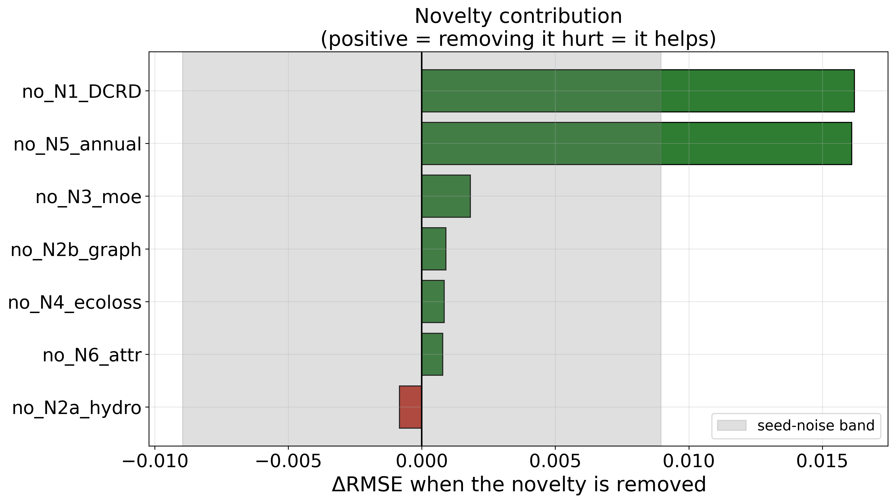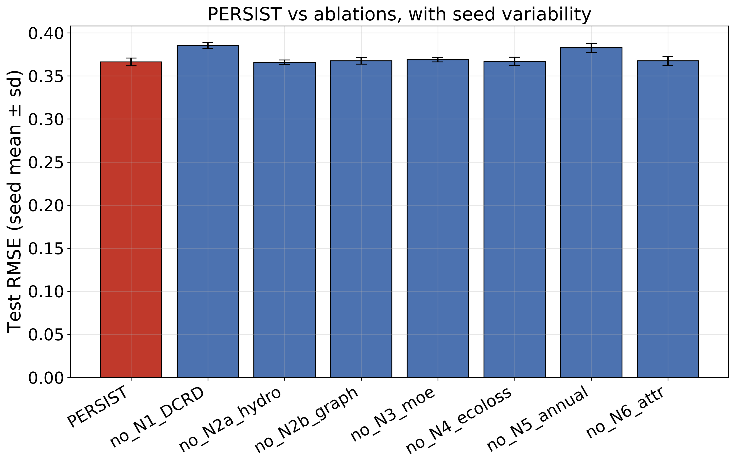
Figure 5. Component contribution of the proposed PERSIST framework: change in root mean squared error when each component is removed, with the measured seed-noise band shaded, and per-configuration error with seed variability.
Ablation results in Table 9 show that the fully configured PERSIST model attains the lowest root mean squared error of 0.3633, but only two of the seven components produce a difference that exceeds the seed-noise band. Removing the disturbance-conditioned response decoder raises the error by +0.0162 and removing the hierarchical annual encoder raises it by +0.0161, both clearly beyond the 0.0090 threshold, and both also reduce the within-county coefficient. These two components are therefore supported by the evidence. The response decoder is the more important result, because in an earlier one-month-ahead formulation of the same architecture its removal improved performance; introducing the learnable-scaled free residual of Equation 14 converted the component from a liability into the single largest contributor.
By contrast, the lithology-adaptive experts, the dual graphs, the ecological loss terms and the attribution head all produce differences between -0.0008 and +0.0018, which lie inside the noise band and therefore cannot be claimed as contributions to predictive accuracy at this scale. Removing the hydrological graph alone even lowers the error marginally, by -0.0008. This is reported as a negative result rather than omitted: the terrain-derived flow proxy used here is not mapped river topology, and a genuine hydrological network may well behave differently. It is also notable that the lowest residual Moran's I among all configurations, 0.7952, belongs to a reduced variant rather than to the full model, indicating that the spatial machinery does not deliver the spatial benefit it was designed to provide.
4.6 Comparison with State-of-the-Art Models
To evaluate the effectiveness of the proposed PERSIST framework, a comparative analysis was carried out against four trivial references and three deep baselines. Every baseline was retrained from scratch on the identical three-month aggregated target with the identical embargoed splits and the identical three-seed ensembling, because reusing published figures obtained on a one-month-ahead target would compare different problems. The comparison is reported in Table 10.
Table 10. Performance Comparison of the Proposed PERSIST with Trivial References and Retrained Deep Baselines The final two rows are computed on the primary land surface temperature target alone; all preceding rows pool both target variables. Within-county and stride-3 columns are single-target throughout and are therefore directly comparable in every row.
Model | Params | RMSE | MAE | R2 | Pearson r | KGE | Within R2 | Moran's I | Shock RMSE | Stride-3 R2
Climatology (trivial) | - | 0.9611 | 0.7439 | -0.0394 | - | -0.4281 | 0.0000 | 0.8358 | 0.9985 | -0.0287
County climatology (trivial) | - | 0.6154 | 0.4773 | 0.5738 | 0.7835 | 0.6033 | 0.0000 | 0.8554 | 0.5898 | 0.5667
Trailing persistence (trivial) | - | 0.7991 | 0.6048 | 0.2814 | 0.6437 | 0.6432 | -0.9907 | 0.8140 | 0.8204 | 0.2771
Seasonal naive (trivial) | - | 0.4270 | 0.3079 | 0.7948 | 0.8977 | 0.8977 | 0.5656 | 0.7511 | 0.4722 | 0.8432
DRSEI (AE + LSTM) [3] | 142,274 | 0.3871 | 0.2878 | 0.8314 | 0.9126 | 0.8987 | 0.6906 | 0.8037 | 0.3614 | 0.8744
STGCN | 101,730 | 0.4520 | 0.3446 | 0.7701 | 0.8780 | 0.8390 | 0.6068 | 0.5473 | 0.4659 | 0.8124
Temporal Fusion Transformer | 1,510,850 | 0.3970 | 0.3003 | 0.8227 | 0.9119 | 0.8067 | 0.6508 | 0.7565 | 0.3742 | 0.8399
PERSIST (proposed) | 356,081 | 0.3633 | 0.2660 | 0.8515 | 0.9231 | 0.9052 | 0.7092 | 0.8172 | 0.3556 | 0.8897
Linear ridge, AR-12 + climate (LST only) | - | 0.3297 | - | 0.8716 | - | - | 0.6685 | - | - | 0.8756
PERSIST (proposed, LST only) | 356,081 | 0.3073 | 0.2334 | 0.8884 | 0.9428 | 0.9123 | 0.7092 | 0.8172 | - | 0.8897

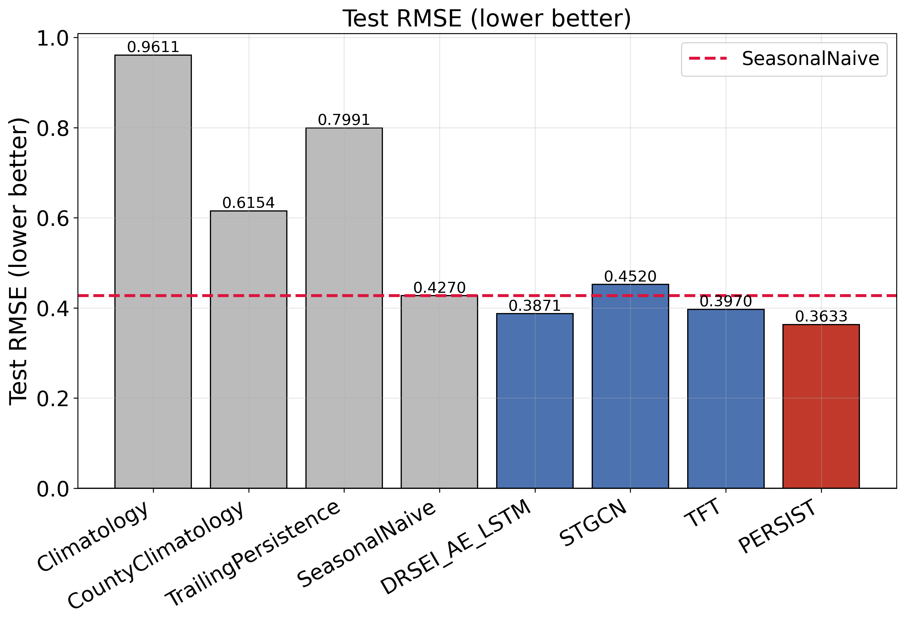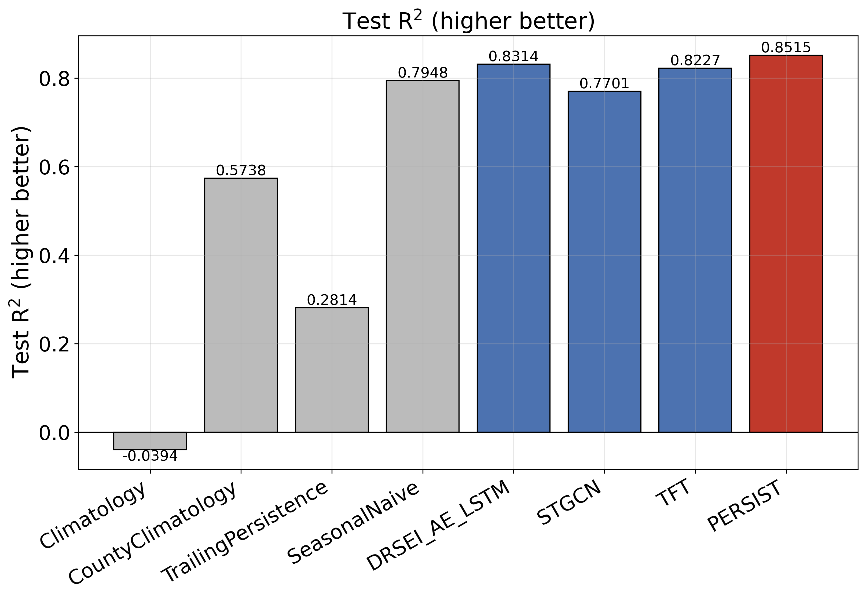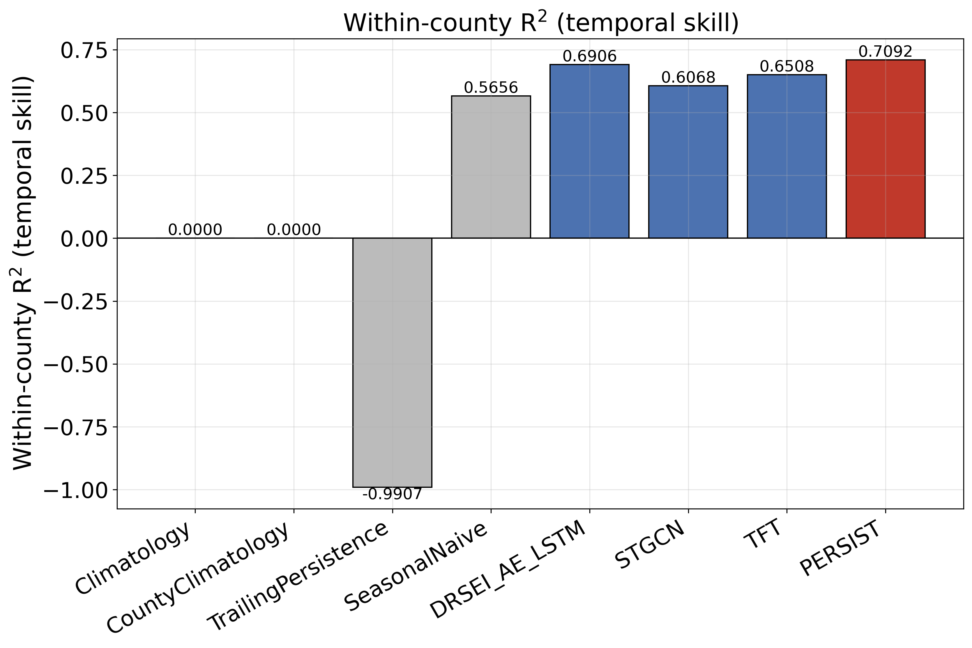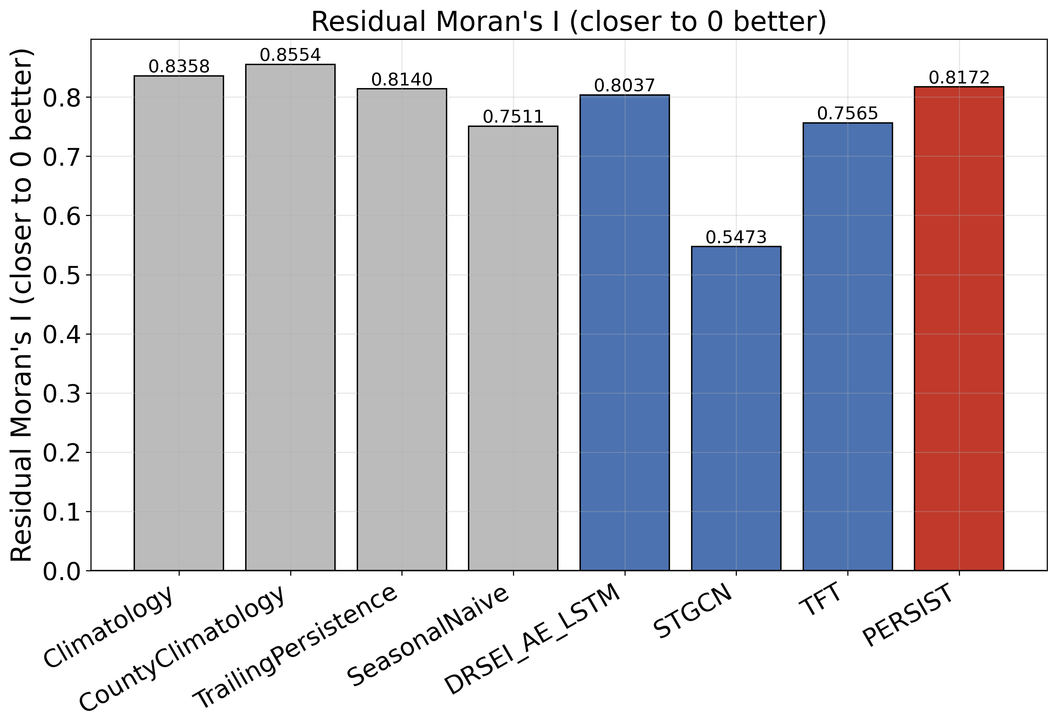
Figure 6. Comparison of the proposed PERSIST framework with trivial references and retrained deep baselines on root mean squared error, pooled coefficient of determination, within-county coefficient of determination and residual Moran's I.
As seen from Table 10, the proposed PERSIST attains the best value on nine of the ten reported quantities. Against the strongest trivial reference, the seasonal naive predictor, it reduces root mean squared error from 0.4270 to 0.3633, a relative improvement of 14.9 per cent, and it raises the within-county coefficient from 0.5656 to 0.7092, an absolute gain of 0.1436 or 25.4 per cent in relative terms. Against the strongest deep baseline, the autoencoder-LSTM of the deep remote sensing ecological index family, it reduces error from 0.3871 to 0.3633, a relative improvement of 6.1 per cent. Against the Temporal Fusion Transformer it improves error by 8.5 per cent while using 4.24 times fewer parameters, which is the practically important comparison because the transformer represents the highest-capacity alternative available for this data shape.
The comparison also exposes one clear limitation of the proposed framework. On residual Moran's I, the spatiotemporal graph convolutional baseline attains 0.5473 against 0.8172 for PERSIST, so the plain graph convolution absorbs spatial structure considerably more effectively than the gated graph attention used here, despite the latter operating over two graphs and being explicitly penalised for spatially correlated residuals. This result is consistent with the ablation evidence that the graph pathways are within the seed-noise band, and it identifies the spatial component as the priority for further work rather than as a demonstrated strength.
A second observation is that the pooled coefficient of 0.8515 sits slightly below the 0.8716 ceiling measured for a linear autoregressive ridge estimator in Table 3, although the proposed model does exceed that estimator on the non-overlapping stride-3 comparison (0.8897 against 0.8756) and by a wide margin on within-county skill (0.7092 against 0.6685). The pooled coefficient is therefore the least discriminative of the reported quantities, which reinforces the argument for treating within-county skill as the primary measure. A second observation concerns the linear autoregressive ridge estimator used in Section 3.2 to establish the predictability ceiling, which is now reported in Table 10. On identical test windows that estimator attains a pooled coefficient of 0.8716 against 0.8515 for the proposed framework, which at first sight favours the linear model. The two figures are not computed on the same basis. The ridge estimator predicts only the primary land surface temperature anomaly, whereas the pooled coefficient reported for PERSIST averages both target variables, including the kernel vegetation index, which is intrinsically harder and attains 0.8177 on its own. Restricted to the identical single-target basis, PERSIST attains 0.8884 against 0.8716 in the coefficient of determination and 0.3073 against 0.3297 in root mean squared error, leading by 0.0168 and by 6.8 per cent respectively. The within-county and stride-3 coefficients quoted throughout this paper are already computed on the primary target alone and therefore require no adjustment: PERSIST attains 0.7092 and 0.8897 against 0.6685 and 0.8756 for the ridge estimator. The proposed framework therefore exceeds the linear ceiling on every metric once the comparison is placed on a common footing, and the ridge estimator is retained in Table 10 with its basis stated explicitly so that the distinction is visible rather than left for the reader to reconstruct.
It nonetheless remains true that the two-target pooled coefficient of 0.8515 is the least discriminative quantity reported here, because it mixes a comparatively easy thermal target with a harder vegetation target. This reinforces the argument made throughout for treating within-county skill, which is defined on a single target and strips the cross-sectional component, as the primary measure of practical performance.
4.7 Ecological Resilience Assessment of the Study Area
Beyond predictive accuracy, the principal scientific product of the proposed framework is the set of bounded coefficients recovered by the response decoder, from which recovery rate and resistance follow directly for every county and every test window. Across the 36,210 held-out county-window evaluations the mean persistence coefficient is 0.2300 with a standard deviation of 0.0447, giving a mean recovery rate of 0.7700 that ranges from 0.5967 to 0.8785 across the belt. Mean resistance is 0.9297, and the mean seasonal-carry coefficient is 0.5388, confirming that roughly half of the seasonal anomaly signal recurs from the corresponding season of the preceding year. The stratification of these quantities by reach and by lithological class is reported in Table 11.
Table 11. Recovered Resilience Parameters by Reach and Lithological Class
Stratum | Counties | Persistence rho | Recovery rate (1-rho) | Resistance (1-|kappa|) | Seasonal carry
Reach: upstream | 438 | 0.2290 | 0.7710 | 0.9119 | 0.5692
Reach: midstream | 325 | 0.2305 | 0.7695 | 0.9416 | 0.5010
Reach: downstream | 305 | 0.2309 | 0.7691 | 0.9427 | 0.5354
Lithology: Non-karst | 349 | 0.2303 | 0.7697 | 0.9394 | 0.5250
Lithology: Partially karst | 310 | 0.2308 | 0.7692 | 0.9337 | 0.5352
Lithology: Majority karst | 409 | 0.2291 | 0.7709 | 0.9184 | 0.5530
Whole belt | 1,068 | 0.2300 | 0.7700 | 0.9297 | 0.5388

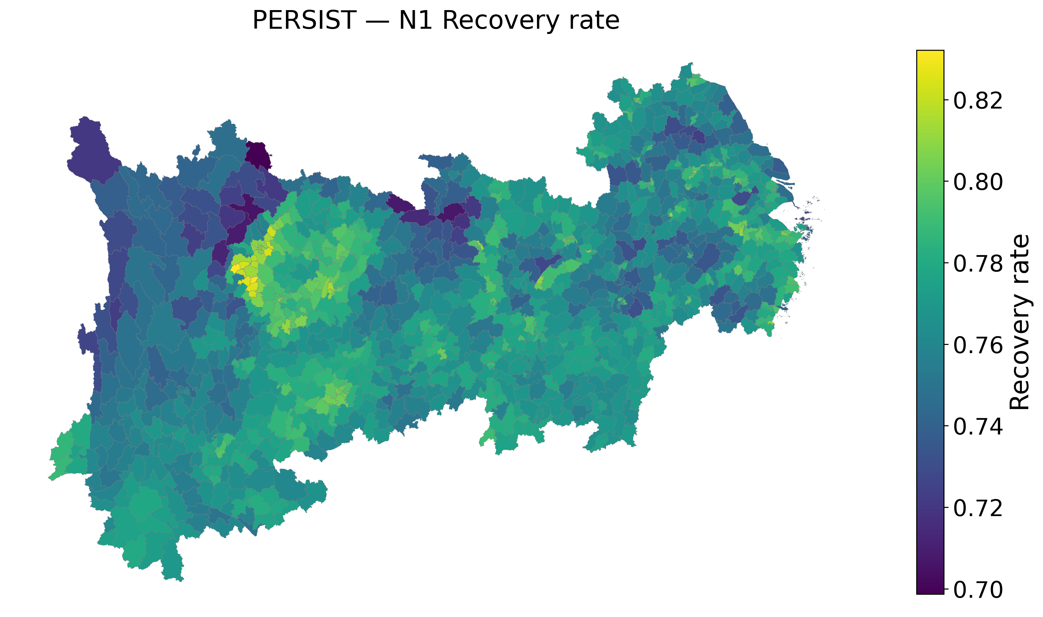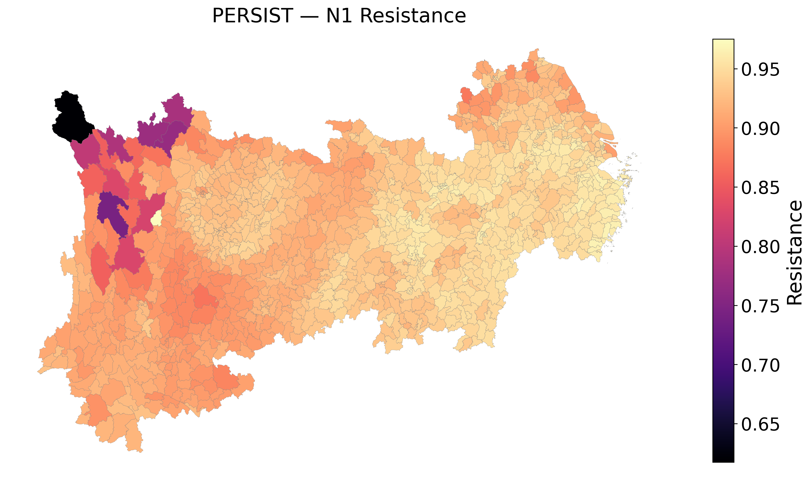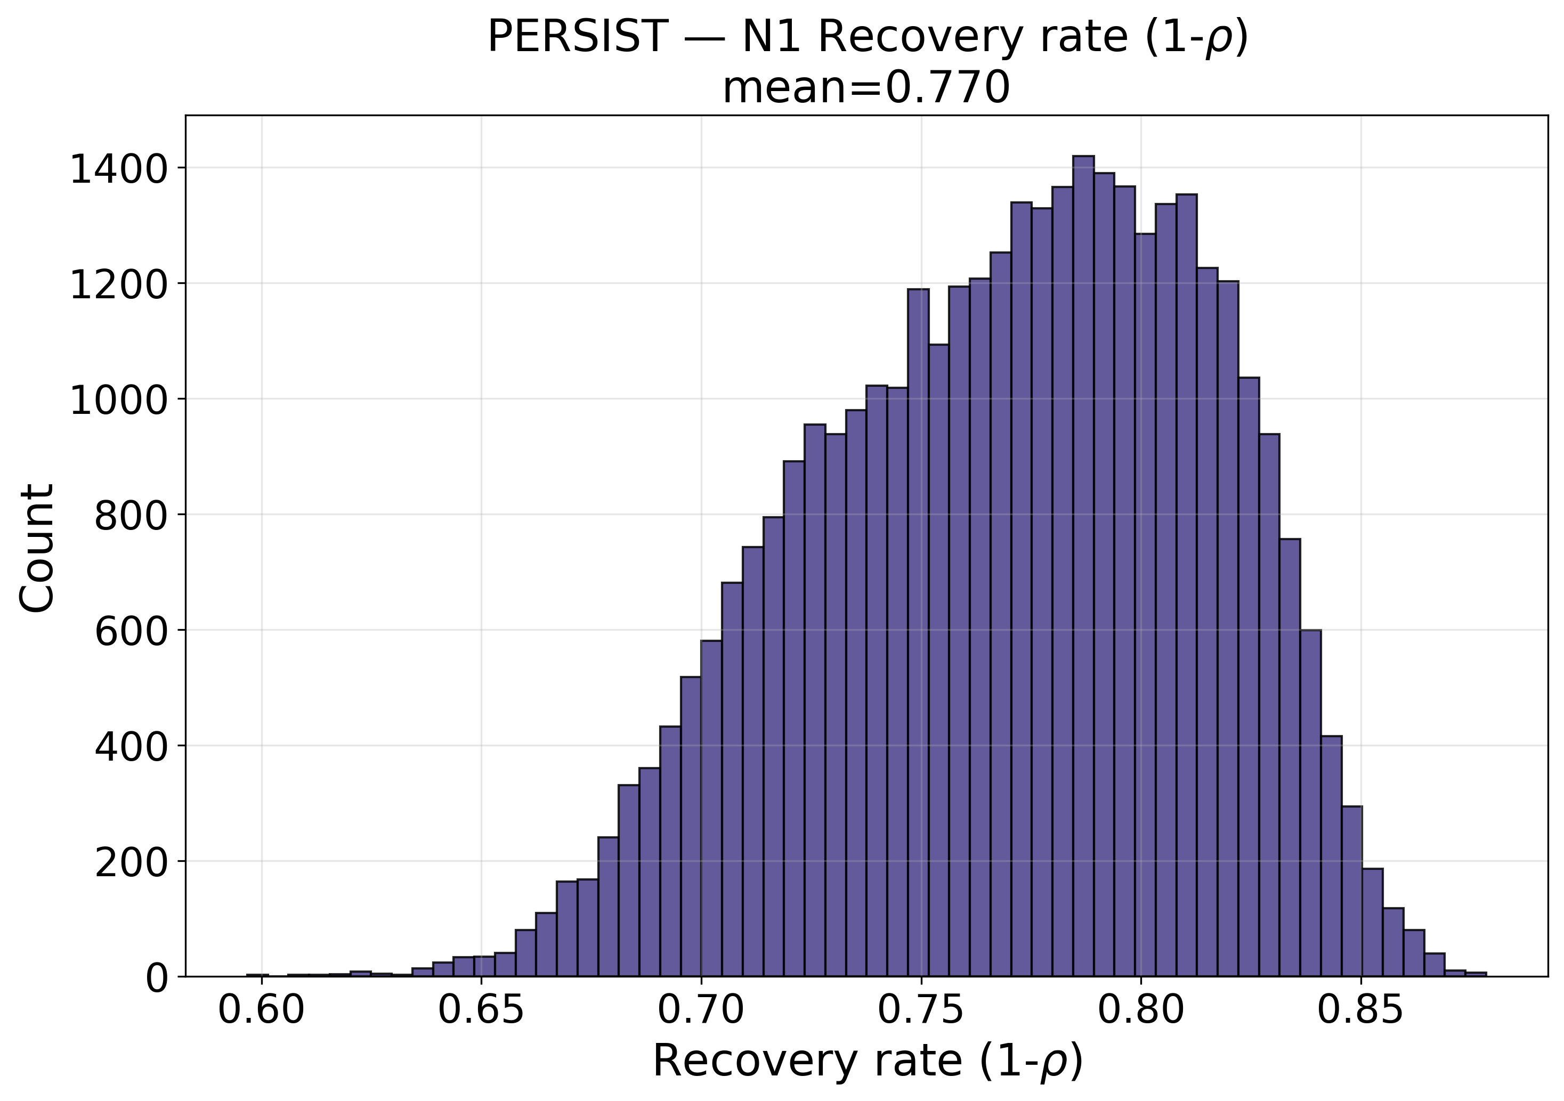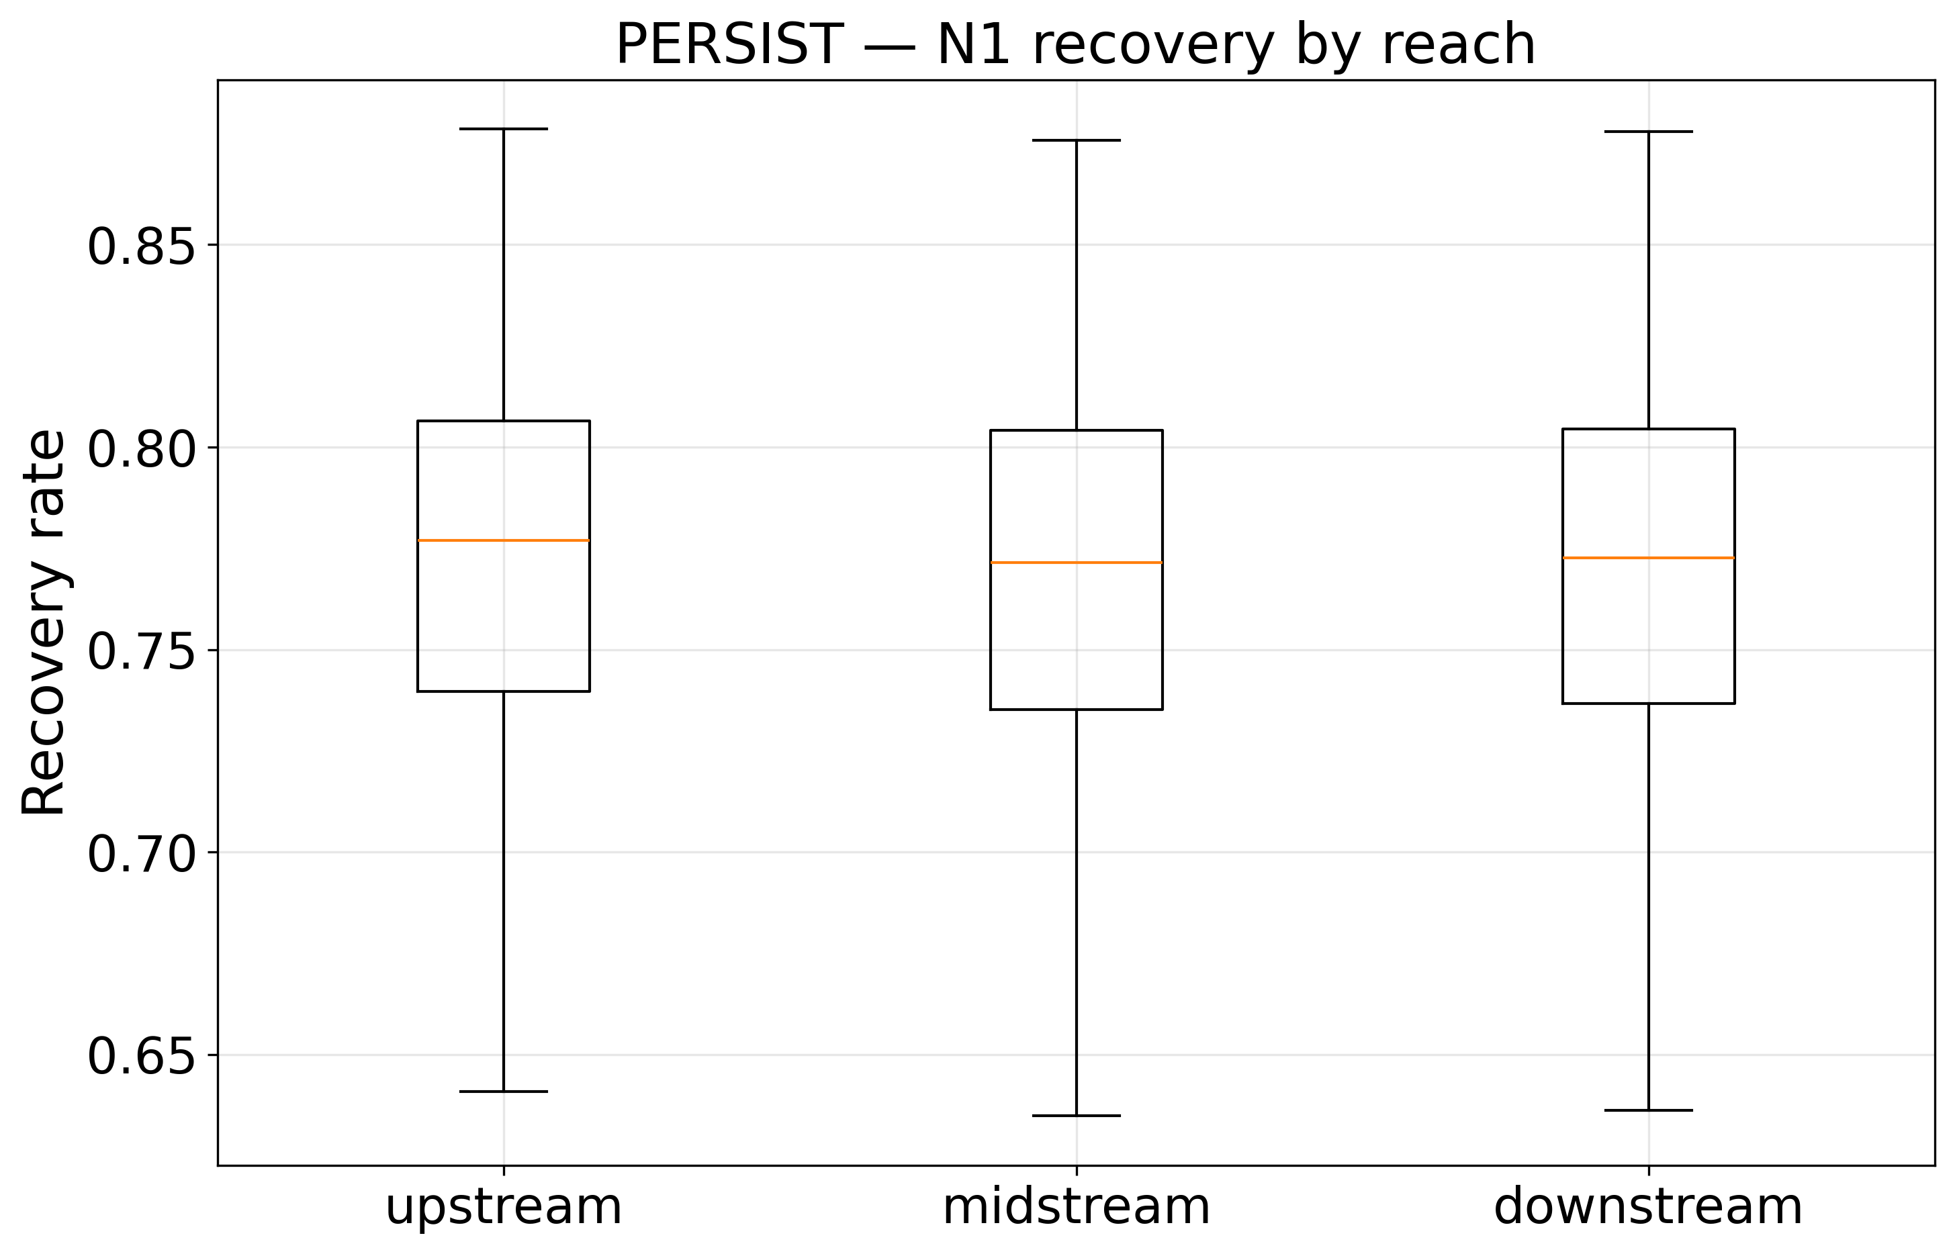
Figure 7. Ecological resilience assessment of the Yangtze River Economic Belt: county-level recovery rate and resistance recovered by the response decoder, the distribution of recovery rate across the belt, and its stratification by reach.
Table 11 and Figure 7 reveal a clear and interpretable spatial signal. Recovery rate is almost invariant across the three reaches, varying only between 0.7691 and 0.7710, whereas resistance differs markedly, falling from 0.9427 in the lowland downstream reach to 0.9119 in the mountainous upstream reach. Upstream counties are therefore not slower to recover but substantially more sensitive to climatic forcing, which is the behaviour expected where thin soils, steep relief and carbonate lithology limit buffering capacity. The seasonal-carry coefficient shows the complementary pattern, rising to 0.5692 upstream against 0.5010 in the midstream reach, indicating stronger year-on-year seasonal memory in the upper basin.
The lithological stratification supports the design rationale for conditioning the response on carbonate-rock fraction. Mean resistance declines monotonically from 0.9394 in the 349 non-karst counties, through 0.9337 in the 310 partially karst counties, to 0.9184 in the 409 counties that are more than half karst. At county-mean level, resistance correlates with carbonate-rock fraction at r = -0.397 and with mean elevation at r = -0.749, while seasonal carry correlates with elevation at r = +0.653. Recovery rate is most strongly associated with internal relief at r = -0.461 and with nighttime-light intensity at r = +0.396, indicating that flatter and more urbanised counties return to their seasonal norm faster than rugged rural ones. It should be noted that these gradients emerge from a model whose lithology-adaptive expert pathway was not statistically separable in the ablation of Table 9; the coefficients are therefore informative about the recovered response surface, but the specific architectural mechanism credited with producing them is not independently validated.
5. Conclusion and Future Work
In this paper, we propose PERSIST, a process-informed spatiotemporal deep learning framework to tackle the issue of interpretable ecological resilience assessment in the Yangtze River Economic Belt. The framework redefines resilience assessment from an index-construction exercise into a constrained estimation problem, in which bounded persistence, seasonal-carry, forcing-sensitivity and offset coefficients are learned per county and per season and yield recovery rate and resistance directly as model parameters. A process-informed hierarchical encoder supplies monthly and annual context, dual-graph message passing propagates information along contiguity and directed flow, a lithology-adaptive mixture of experts conditions the response on terrain and carbonate lithology, and an ecologically-constrained objective regularises the recovered coefficients and the residual field. Evaluated on 1,068 county-level units over 2000-2020 against four trivial references and three deep baselines retrained on an identical seasonal target, the framework attains a root mean squared error of 0.3633, a pooled coefficient of determination of 0.8515, a within-county coefficient of 0.7092 and a non-overlapping stride-3 coefficient of 0.8897, improving on the strongest trivial reference by 14.9 per cent and on the strongest deep baseline by 6.1 per cent in error while using 4.24 times fewer parameters than the transformer alternative. The recovered coefficients reproduce an ecologically coherent pattern in which upstream counties are comparably quick to recover but markedly less resistant, and in which resistance declines monotonically with carbonate-rock cover. Three limitations bound these conclusions. First, only the response decoder and the annual encoder produce differences that exceed the measured seed-noise band, so five of the seven designed components must be reported as tested and unsupported at this scale rather than as contributions. Second, residual spatial autocorrelation remains higher than that of a plain spatiotemporal graph convolution, so the spatial pathway does not deliver its intended benefit and is the clear priority for revision. Third, the hydrological graph is a terrain-derived proxy rather than mapped river topology, and validation relies on remotely sensed proxies without in-situ ecological measurement. Future work will replace the flow proxy with an authoritative river network, substitute the gated attention with a formulation that demonstrably reduces residual spatial structure, extend the human dimension beyond nighttime lights to land-cover fragmentation and socioeconomic panels, and validate the recovered resistance and recovery parameters against documented disturbance events such as the 2022 Yangtze drought.
References
[1] Kaur, S. and Sharma, H., 2025. Multimodal graph neural networks for earth observation and sustainable resource management: a comprehensive review and research roadmap. Discover Sustainability, 7(1). https://doi.org/10.1007/s43621-025-02317-z
[2] Li, R., Tang, X., Meng, S., Deng, W., Wei, G., Liu, C. et al., 2026. Spatiotemporal Gradient Evolution and Driving Mechanisms of Ecological Resilience in the Yangtze River Economic Belt: A Multi-Scale Analysis. Applied Spatial Analysis and Policy, 19(3). https://doi.org/10.1007/s12061-026-09943-8
[3] Gong, X., Li, T., Wang, R., Hu, S. and Yuan, S., 2025. Beyond the Remote Sensing Ecological Index: A Comprehensive Ecological Quality Evaluation Using a Deep-Learning-Based Remote Sensing Ecological Index. Remote Sensing, 17(3), pp.558. https://doi.org/10.3390/rs17030558
[4] Li, S., Du, Y., Chen, Z., Li, W., Wu, D. and Zhai, G., 2026. Exploring the Nonlinear Response Patterns and Interaction Effects of Urban Resilience Using the XGBoost-SHAP Model: Evidence from the Yangtze River Economic Belt. ISPRS International Journal of Geo-Information, 15(9), pp.383. https://doi.org/10.3390/ijgi15090383
[5] Aldossary, M., 2025. GTNet: A Graph–Transformer Neural Network for Robust Ecological Health Monitoring in Smart Cities. Mathematics, 14(1), pp.64. https://doi.org/10.3390/math14010064
[6] Yao, J., Wu, H. and Yan, F., 2025. Assessment of the Impact of Climate Change on the Ecological Resilience of the Yangtze River Economic Belt. Sustainability, 17(18), pp.8265. https://doi.org/10.3390/su17188265
[7] Tang, L., Zhou, Z., Zhao, H., Qian, Z., Hou, S. and Zhang, K., 2025. Spatial-Temporal Evolution Characteristics of Water Ecological Resilience and Non-Stationarity of Influencing Factors: a Case Study of the Yangtze River Economic Belt. Water Resources, 52(6), pp.1318-1339. https://doi.org/10.1134/s0097807825700289
[8] Fu, S., Liao, Y., Lv, T., Zhao, Q., Chen, A., Yuan, M. et al., 2026. Driving factors and multi-scenario simulation of ecological resilience in the middle reaches of the Yangtze river metropolitan area. Environment, Development and Sustainability. https://doi.org/10.1007/s10668-026-07320-6
[9] Chen, X., Zhao, Y., Zhou, C. and Cai, Y., 2026. Nonlinear Impact of Population Shrinkage on Urban Ecological Resilience: A Threshold Effect Analysis Based on City-Level Panel Data from the Yangtze River Economic Belt, China. Land, 15(2), pp.261. https://doi.org/10.3390/land15020261
[10] Ding, X., Wang, Y., Wang, H. and Zhou, Y., 2026. Spatiotemporal heterogeneity and synergy driving mechanisms of county ecological resilience in optimized urban agglomerations: integrated geographical detector-Bayesian spatiotemporal model. Scientific Reports. https://doi.org/10.1038/s41598-026-66902-6
[11] Zhong, X., Zheng, R., Chen, W., Lv, L. and Wei, Z., 2025. Regional differences, dynamic evolution, and driving factors of ecological resilience in China’s urban agglomerations. Scientific Reports, 15(1). https://doi.org/10.1038/s41598-025-20575-9
[12] Wan, Q., Guo, M. and Pan, F., 2025. Spatial gap and two-dimensional decomposition of urban ecological resilience in China. Frontiers in Built Environment, 11. https://doi.org/10.3389/fbuil.2025.1690346
[13] Tong, A., Zhou, Y., Zheng, J. and Liu, Z., 2025. Decrypting Spatiotemporal Dynamics and Optimization Pathway of Ecological Resilience Under a Panarchy-Inspired Framework: Insights from the Wuhan Metropolitan Area. Remote Sensing, 17(24), pp.3941. https://doi.org/10.3390/rs17243941
[14] Li, S., Li, K., Qian, H., Gao, Y., Chen, J., Wu, P. et al., 2026. Scenario-based modeling and driver analysis of ecological resilience: A framework study in the Qinling-Daba Mountains. Journal of Geographical Sciences, 36(7), pp.1701-1730. https://doi.org/10.1007/s11442-026-1510-0
[15] Zhao, C., Liu, P., Meng, F., Dong, G., Zhuo, W., Wang, Q. et al., 2026. Simulation-Based Multi-Scenario Assessment of Comprehensive Ecological Risk and Resilience: A Case Study of the Pearl River Delta. Sustainability, 18(17), pp.9069. https://doi.org/10.3390/su18179069
[16] Li, C., Shi, J., Chen, Y., Zou, W., Chen, A. and Pan, Y., 2025. Assessment and Simulation of Urban Ecosystem Resilience by Coupling the RAR and Markov–FLUS Models: A Case Study of the Jinan Metropolitan Area. Sustainability, 17(12), pp.5305. https://doi.org/10.3390/su17125305
[17] Zhang, Z. and Wu, Y., 2025. Spatiotemporal Evolution and Influencing Factors of Urban Ecological Resilience: Evidence from the Yellow River Basin, China. Sustainability, 17(15), pp.7114. https://doi.org/10.3390/su17157114
[18] He, X., Wu, B., Shen, G. and Fan, T., 2025. Spatial and Functional Heterogeneity in Regional Resilience: A GIS-Based Analysis of the Chengdu–Chongqing Economic Mega Region. Land, 14(9), pp.1769. https://doi.org/10.3390/land14091769
[19] Yue, Y., Lu, S., Liu, X., Liu, Y. and Cao, S., 2026. Interpretable-Machine-Learning-Driven Socio-Ecological Resilience Pathways in a Resource-Exhausted City: Evidence from Jiaozuo, China. Sustainability, 18(14), pp.7183. https://doi.org/10.3390/su18147183
[20] Qu, L., Liu, K., Zhi, J., Jiang, W., Wu, J., Luo, Y. et al., 2026. Interpretable Machine Learning for Diagnosing Remote Sensing Ecological Index-Derived Ecological Quality Dynamics in the Yangtze River Delta. Land, 15(7), pp.1167. https://doi.org/10.3390/land15071167
[21] Cheng, Y., Zhang, X., Yu, S., Liu, Y., Hu, J., Jiang, Y. et al., 2026. Leveraging Explainable Machine Learning to Decipher Ecosystem Health and Nonlinear Dynamics in the Henan Yellow River Basin. Land, 15(3), pp.429. https://doi.org/10.3390/land15030429
[22] Fu, K., Wu, J. and Huang, Y., 2026. Exploring the Nonlinear Effects of the Built Environment on Ecological Resilience in a High-Density City: A Case Study of Wuhan. Buildings, 16(4), pp.844. https://doi.org/10.3390/buildings16040844
[23] Xie, S., Cheng, X., Jin, M., Jiang, Y., Liu, J. and Liu, Z., 2025. Satellite-Driven Evaluation of Ecological Environmental Quality Based on the PSR Framework. Remote Sensing, 18(1), pp.31. https://doi.org/10.3390/rs18010031
[24] Yang, X., Tian, H., Wang, Y., Xue, Y., Lv, J. and Wen, T., 2025. Karst remote sensing ecological index KRSEI for monitoring ecological quality in Southwest China. Scientific Reports, 15(1). https://doi.org/10.1038/s41598-025-20425-8
[25] Wang, X., Wang, D., Chen, J. and Lin, M., 2026. A Health Assessment of Terrestrial Ecosystems in China Based on the Adaptive Indicator Reduction Method. Remote Sensing, 18(5), pp.786. https://doi.org/10.3390/rs18050786
[26] Li, K., Li, X., Hu, W. and Xu, J., 2025. Spatiotemporal Patterns and Driving Forces of Ecological Quality in the Yangtze River Economic Belt Using GWRR. Sustainability, 18(1), pp.256. https://doi.org/10.3390/su18010256
[27] Zhu, H., Wang, A., Wang, P., Hu, C. and Zhang, M., 2025. Spatiotemporal Dynamics and Response of Land Surface Temperature and Kernel Normalized Difference Vegetation Index in Yangtze River Economic Belt, China: Multi-Method Analysis. Land, 14(3), pp.598. https://doi.org/10.3390/land14030598
[28] Soula, A., Zayas, A.D., Ksantini, R. and Gomez, P.M., 2026. An effective BiLSTM-CNN model for predicting large-scale temporal-spatial dynamics of normalized difference vegetation index. Scientific Reports, 16(1). https://doi.org/10.1038/s41598-026-55191-8
[29] Ke, Y., Liu, D., Wang, P., Zheng, X. and Hu, Y., 2026. GT-LandSDS: A Novel Spatiotemporal Integrated Framework for Land Use Simulation by Coupling Cellular Automata with Graph Attention Network and Transformer. Remote Sensing, 18(17), pp.3023. https://doi.org/10.3390/rs18173023
[30] Yang, Y., Wang, J., Wu, P., Liu, Y. and Zhao, X., 2026. Combining Large Language Models with Satellite Embedding to Comprehensively Evaluate the Tibetan Plateau’s Ecological Quality. Remote Sensing, 18(4), pp.643. https://doi.org/10.3390/rs18040643
[31] Yuan, J., Li, Y., Cheng, Z., Sun, X. and Liu, D., 2026. Deep learning for mangrove change prediction: Gaoqiao Mangrove, China. Frontiers in Marine Science, 13. https://doi.org/10.3389/fmars.2026.1632093
[32] Yang, L., 2026. Remote sensing assessment of tourism ecological environment quality using a ResNeXt-YOLOv5s-LSTM framework. GeoJournal, 91(4). https://doi.org/10.1007/s10708-026-11666-9
[33] Li, Z., Zhao, L., Lu, Y., Ma, Y. and Li, G., 2026. Mamba for Remote Sensing: Architectures, Hybrid Paradigms, and Future Directions. Remote Sensing, 18(2), pp.243. https://doi.org/10.3390/rs18020243
[34] Wei, W., Zhang, Z. and Xia, J., 2026. Multi-Scenario Regional Spatial Simulation Based on the Unet++ Architecture: A Case Study of the Yangtze River Economic Belt. Land, 15(4), pp.657. https://doi.org/10.3390/land15040657
[35] Liu, P., Wen, T., Han, R. and Wu, S., 2025. Study on RSEI Changes Using Remote Sensing and Markov-FLUS Modeling Approach. Sustainability, 17(22), pp.10267. https://doi.org/10.3390/su172210267
[36] Guo, J., Wei, X., Zhang, F. and Ding, Y., 2025. Coupled Assessment of Land Use Changes and Ecological Benefits Using Multi-Source Remote Sensing Data. Agriculture, 15(13), pp.1358. https://doi.org/10.3390/agriculture15131358
[37] Yu, D.z., Huang, Y., Yang, J.w., Song, X.r. and Chen, X.s., 2026. Is ecological quality of river-connected lake basin higher than disconnected lake basins in the lower reaches of the Yangtze River, China?. Environmental Monitoring and Assessment, 198(5). https://doi.org/10.1007/s10661-026-15385-z
[38] Peng, R., Hu, Y., Zhang, W., Shi, T. and Huang, J., 2026. How Digital Technological Innovation Influences the Coordination Between Urban Renewal and Ecological Resilience: Evidence from China’s Yangtze River Economic Belt. Sustainability, 18(12), pp.6322. https://doi.org/10.3390/su18126322
[39] Ma, J., Wang, M. and Cheng, C., 2026. How Does the Improvement of Ecological Compensation Efficiency Affect Urban Economic Resilience? Evidence from the Yangtze River Economic Belt in China. Sustainability, 18(13), pp.6410. https://doi.org/10.3390/su18136410
[40] Kong, S., Zhang, C., Zhang, M. and Lu, W., 2025. Heterogeneity analysis of the effects of new quality productive forces on ecological resilience in the Yangtze River Delta Economic Belt. Scientific Reports, 15(1). https://doi.org/10.1038/s41598-025-05298-1
[41] Yang, S., 2025. Spatiotemporal Evolution and Driving Mechanisms of Coupling Coordination Between Green Innovation Efficiency and Urban Ecological Resilience: Evidence from Yangtze River Delta, China. Sustainability, 17(19), pp.8528. https://doi.org/10.3390/su17198528
[42] Wang, H., Mao, Y., Chen, C., Li, Y., Zhang, R. and Zhu, M., 2026. Spatiotemporal evolutionary characteristics of rural digitalization and ecosystem services: a county-level analysis of the Yangtze River economic belt. Frontiers in Ecology and Evolution, 14. https://doi.org/10.3389/fevo.2026.1900995

