PERSIST: A Process-Informed Spatiotemporal Framework for Seasonal Ecological Resilience Assessment in the Yangtze River Economic Belt
Abstract
Ecological resilience assessment in large river basins informs conservation and land-management policy, yet most assessments rely on composite indices with fixed weights that merge resistance and recovery and ignore terrain and lithological controls on local response. This study presents PERSIST (Process-informed Ecological Resilience via Spatiotemporal Inference of Seasonal Trajectories), a framework that estimates resilience parameters directly from satellite and climate records for 1,068 counties in the Yangtze River Economic Belt from 2000 to 2020. Each county is represented by deseasonalised land surface temperature and kNDVI anomalies, TerraClimate forcing, and static terrain and karst descriptors, encoded at monthly and annual scales. A response decoder learns bounded persistence, seasonal-carry, forcing-sensitivity and offset coefficients, from which recovery rate and resistance are derived as model parameters. Information is exchanged along county-contiguity and terrain-derived flow graphs, and a lithology-gated mixture of experts conditions the response on karst cover. Models were trained on embargoed chronological splits and ensembled over three seeds. On the 2018–2020 test period, PERSIST reduced RMSE by 14.9% relative to a seasonal-naive reference and by 6.1% relative to the strongest retrained deep baseline, and raised within-county R² from 0.566 to 0.709 while using 4.24 times fewer parameters than the Temporal Fusion Transformer. Ablation attributed the measurable gain to the response decoder and the annual encoder, the graph and expert components did not exceed seed variability. Upstream and karst-dominated counties showed lower resistance but similar recovery rates.
Keywords: Ecological Resilience; Yangtze River Economic Belt; Remote Sensing; Spatiotemporal Deep Learning; Graph Neural Networks; Seasonal Anomaly Forecasting
1. Introduction
The Yangtze River Economic Belt (YREB) has become a region of strategic national importance. It covers more than two million square kilometres of highly diverse landscape. Across this area, rapid urbanisation, agricultural intensification and national conservation programmes operate at the same time. This heterogeneity produces complex interactions among climate, vegetation, surface temperature and human activity. These interactions strongly affect vegetation vigour, surface thermal regimes and the way ecosystems respond to and recover from disturbance. Their importance grows further when the goal shifts from describing ecological condition to quantifying resistance and recovery speed. At the same time, long satellite archives, gridded climate datasets and advances in deep learning now make data-driven ecological assessment possible at the level of administrative units. Recent reviews show that graph-based and multimodal learning are increasingly used in earth observation. However, these studies often lack standard benchmarks, compare against weak baselines and offer limited process interpretability.
Remote sensing and machine learning have become central to characterising regional ecological condition. Kaur and Sharma (2025) reviewed multimodal graph neural networks for earth observation and sustainable resource management, covering architectures, fusion strategies and application domains. They identified graph learning over irregular spatial units, physics-inspired hybrid designs and multimodal fusion as promising directions. They also noted persistent problems with benchmarks, reproducibility and the absence of strong trivial references. As a review, however, the study does not propose a formulation in which spatial structure, process constraints and interpretable parameters are learned together. Li et al. (2026) assessed ecological resilience in the YREB at multiple scales. They found clear gradients between the upper, middle and lower reaches and significant spatial dependence at the county level. This confirms that resilience in the basin is spatially structured rather than random. However, the assessment is descriptive and based on composite indicators. The spatial autocorrelation is detected statistically but never built into the estimator. Neither study therefore links spatial diagnosis with process-constrained modelling, and incorporating graph structure into an interpretable estimator remains an open problem.
Gong et al. (2025) proposed a deep learning approach to ecological quality assessment. It replaced the principal-component weighting of the remote sensing ecological index with an encoder trained on reconstruction and prediction targets. This reduced weighting subjectivity and improved the consistency of quality estimates. However, the formulation is purely temporal and treats each spatial unit independently. It cannot use neighbourhood relationships or hydrological connectivity, and it recovers no measure of resilience from the learned representation. Li et al. (2026) applied gradient-boosted decision trees with Shapley attribution to urban resilience in the YREB. The results revealed strongly nonlinear responses and interactions among drivers, showing that attribution is needed for practical interpretation. However, the explanations are derived after the fact from a static composite index. The attribution scores therefore describe associations with the index rather than the system dynamics that define resilience.
Aldossary (2025) developed GTNet, a graph-transformer network for ecological health monitoring. It combines temporal attention with graph convolution over spatial units and remains robust when input quality declines. The experiments show that hybrid graph–attention designs outperform purely convolutional or recurrent models for distributed environmental monitoring. However, the work targets urban sensing networks and condition monitoring. It does not account for lithological or topographic controls on local response, nor does it produce bounded resilience measures.
Research is divided among index construction, descriptive spatial statistics, driver attribution and land-use simulation. No existing study combines these into a single estimator that learns resilience properties as model parameters. Current methods optimise a composite score or a single predictive objective. A defensible assessment, however, requires resistance, recovery and seasonal carry-over to be separated and bounded rather than merged into one index. Spatial dependence is repeatedly demonstrated but rarely modelled. The contrast between karst and non-karst terrain, which strongly shapes local recovery, is also largely ignored. Finally, accuracy is seldom compared with trivial references or a measured ceiling. As a result, it is unclear how much reported skill is genuine and how much reflects persistent differences between units.
To address these gaps, we propose PERSIST (Process-informed Ecological Resilience via Spatiotemporal Inference of Seasonal Trajectories). PERSIST reframes resilience assessment as a constrained spatiotemporal estimation problem rather than an index construction task. The model learns how strongly a county retains its current state, how it responds to climatic forcing, how much of its seasonal signal returns and how much residual variability is predictable. We evaluate the framework on 1,068 counties from 2000 to 2020. The evaluation includes four trivial references, three deep baselines retrained on the same seasonal target, seven component-wise ablations and a predictability audit of the forecast horizon.
The main contributions of this study are as follows:
- A hierarchical encoder combines deseasonalised thermal and vegetation anomaly histories, climate forcing, terrain and karst context, and year-over-year annual dynamics. This allows the model to reason about disturbance response rather than rely only on current indicator values.
- The decoder learns bounded persistence, seasonal-carry, forcing-sensitivity and offset coefficients that exactly nest the trivial reference predictors. County-level recovery rate and resistance are obtained directly as model parameters rather than post hoc attributions.
- Information propagates along county contiguity and directed hydrological flow, while the response function is conditioned on terrain and karst context. Spatial dependence and geological heterogeneity are thus modelled rather than only diagnosed.
- The objective combines reconstruction, temporal smoothness and spatial residual penalties. Evaluation uses embargoed temporal splits, multi-seed ensembling and separate reporting of pooled and within-unit skill. These choices are designed to prevent temporal leakage and to separate genuine gains from run-to-run variability.
2. Literature Survey
Ecological resilience is the capacity of an ecosystem to resist disturbance and return to its previous functional state. It has become central to environmental governance in rapidly developing regions. The Yangtze River Economic Belt (YREB) supports more than 40% of China's population and economic output [2], [38]. It spans subtropical lowlands, karst uplands and a dense river network. In this region, resilience assessment directly informs ecological redlining, restoration investment and basin-wide coordination. A reliable assessment must meet three requirements. It must separate resistance from recovery. It must capture the seasonal cycles of disturbance and recovery through which resilience operates. It must also represent the spatial and hydrological pathways along which disturbances spread. Whether current methods meet these requirements decides if resilience estimates can guide future management or only describe past conditions.
Most studies quantify resilience through composite indicator systems. Yao et al. (2025) [6] combined meteorological trend analysis with a composite index. They showed that climate is a primary control on resilience in the YREB and that its effect differs among the upper, middle and lower reaches. Zhang and Wu (2025) [17] found similar upstream–downstream gradients in the Yellow River Basin. This suggests that basin position shapes resilience across large river systems in China. Xie et al. (2025) [23] and Wang et al. (2026) [25] likewise evaluated ecological quality and ecosystem health through satellite-based indicator frameworks. These studies confirm the role of climatic and positional drivers. However, they share a common limitation. Resistance and recovery are merged into a single score. As a result, a county that absorbs shocks cannot be distinguished from one that recovers quickly. Li et al. (2025) [16] partly addressed this problem in the Jinan metropolitan area. They defined separate dimensions for resistance, adaptability and recovery. However, each dimension was built from indicator groups with fixed weights and projected through a Markov–FLUS land-use model. Resilience was therefore set by design rather than estimated from observed ecological response. Zhao et al. (2026) [15] faced the same limitation. Their joint simulation of risk and resilience in the Pearl River Delta relied on land-use transition rules. Overall, these studies show why resilience should be decomposed. However, they provide no way to estimate its components from data.
Tang et al. (2025) [7] showed that the effects of water-related drivers in the YREB vary across space and time. This finding weakens models that assume constant coefficients across the whole basin. Li et al. (2025) [26] reached the same conclusion using geographically weighted ridge regression, which also reduced multicollinearity among drivers. However, both approaches fit separate local models. These models share no information between neighbouring units and cannot make predictions. He et al. (2025) [18] reported comparable spatial and functional heterogeneity in the Chengdu–Chongqing region. Fu et al. (2026) [8] and Ding et al. (2026) [10] went further. They reported strong neighbourhood dependence in the middle Yangtze and interacting drivers at the county level. Ding et al. used a geographical detector combined with a Bayesian spatiotemporal model. Their framework is one of the most rigorous treatments of spatial structure in this field. Even so, a clear inconsistency remains. These studies repeatedly confirm spatial autocorrelation, but they treat it only as a property of the data. They do not use it as structure during estimation. None of them tests performance on held-out years. Zhong et al. (2025) [11] and Wan et al. (2025) [12] further showed that regional differences are persistent and mostly cross-sectional. This finding has an important methodological consequence that is rarely discussed. When differences between units dominate the variance, pooled goodness-of-fit measures overstate how well a model tracks change over time. Yet no study reports between-unit and within-unit skill separately.
Li et al. (2026) [14] showed that resilience in the mountainous Qinling–Daba region behaves differently from that in lowland areas. Yang et al. (2025) [24] found that standard remote sensing ecological indices are systematically biased over carbonate karst landscapes. Together, these findings suggest that terrain and lithology change the form of ecological response, not only its strength. However, Li et al. included terrain only as a covariate in a regression. Yang et al. instead built a separate index for karst areas. Neither approach allows karst and non-karst units to be analysed in one model with a lithology-dependent response. This is an important gap for the YREB, where both landscapes exist side by side.
Temporal resolution is a further limitation. Chen et al. (2026) [9] identified threshold effects of population decline on urban resilience that depend on the prevailing regime. Fu et al. (2026) [22] measured nonlinear effects of the built environment in Wuhan. These findings are useful. However, both studies rely on annual data at the prefecture or city level. Such data hide the seasonal cycles through which vegetation and thermal systems absorb stress and recover. Tong et al. (2025) [13] used the panarchy framework to describe adaptive cycles in the Wuhan metropolitan region. However, the cycle stages were assigned by applying thresholds to an index. They were not inferred as continuous dynamics. Zhu et al. (2025) [27] analysed land surface temperature and kernel NDVI across the YREB and found clear coupled trends. Their analysis, however, remained diagnostic and did not produce a predictive model.
Interpretable machine learning has widened the analysis of resilience drivers. Qu et al. (2026) [20], Cheng et al. (2026) [21] and Yue et al. (2026) [19] used attribution methods to reveal nonlinear interactions that linear models cannot detect. Their results agree that linear assumptions are inadequate. However, the interpretation is applied after fitting black-box models to composite indices. The explanations therefore describe links with constructed targets rather than physical parameters. In addition, tree ensembles fitted to annual cross-sections ignore temporal dependence. Deep learning studies improve prediction but lose interpretability. Soula et al. (2026) [28] used a BiLSTM–CNN to forecast NDVI over a large region. However, grid-based convolution cannot represent irregular administrative units or directed hydrological links. Ke et al. (2026) [29] combined cellular automata, graph attention and transformers in GT-LandSDS. This is the closest architectural precedent for graph-based ecological modelling, but its target was discrete land-use change. Yang et al. (2026) [30] replaced handcrafted indices with satellite embeddings from foundation models. These representations are difficult to interpret. They were also not compared with trivial temporal references, so the reported skill is hard to judge.
Overall, the literature is clearly divided. Indicator-based and statistical studies offer conceptual clarity and spatial diagnosis. However, they do not provide learned, predictive and validated estimates. Deep learning studies offer predictive power. However, they do not produce interpretable resilience measures or physically meaningful spatial structure. Evaluation practice is weak in both groups. Few studies use temporal hold-out validation, compare against persistence or seasonal-naive baselines, or report within-unit skill. Consequently, no existing approach meets the aims of this study. These aims are to estimate resistance and recovery as learned, spatially varying parameters at county and monthly resolution. They also include embedding contiguity and hydrological flow in the model, conditioning the response on lithology and reporting predictive skill that is free of leakage.
The proposed PERSIST framework addresses these gaps directly. Its disturbance-conditioned response decoder learns bounded persistence, seasonal-carry, sensitivity and offset coefficients. These coefficients nest the trivial reference predictors. Recovery rate and resistance are therefore obtained as model parameters rather than index components. Dual-graph message passing over county contiguity and directed hydrological flow makes spatial dependence part of the model structure instead of a post hoc diagnostic. A lithology-dependent mixture of experts allows karst and non-karst counties to be modelled together. Finally, the evaluation combines embargoed training, multi-seed ensembling, trivial reference baselines and separate reporting of pooled and within-county skill. This protocol is rarely applied in the existing literature. Table 1 summarises the research gaps in detail.
Table 1. Comparison of the proposed PERSIST with the methods benchmarked in this study and with the principal methods discussed in Section 2.
Authors / Year | Method | Major Findings | Research Gap
Gong et al. (2025) [3] | Autoencoder + LSTM deep RSEI (DRSEI). Benchmarked in this study. | Learned encoding removes subjective indicator weighting; strongest deep baseline here (RMSE 0.3871, R2 0.8314). | Per-county and purely temporal: no spatial graph, no hydrological connectivity and no resilience parameters recovered.
Yu et al. (2018) [43] | Spatio-temporal graph convolutional network (STGCN). Benchmarked in this study. | Best residual Moran's I of all models (0.5473), so plain graph convolution absorbs spatial structure most effectively. | Generic regression objective; lowest pooled and within-county skill of the three deep baselines and no interpretable coefficients.
Lim et al. (2021) [44] | Temporal Fusion Transformer (TFT). Benchmarked in this study. | Highest-capacity alternative for this data shape (1,510,850 parameters; RMSE 0.3970). | 4.24x more parameters than PERSIST for lower skill on every metric; attention weights are not bounded ecological quantities.
Li et al. (2026) [2] | Multi-scale composite resilience index for the YREB. | Establishes reach-level resilience gradients and significant spatial dependence among counties; independent reference for the present reach contrast. | Descriptive; spatial autocorrelation is diagnosed but never embedded in an estimator, and resistance is not separated from recovery.
Yang et al. (2025) [24] | Karst-specific remote sensing ecological index (KRSEI). | Demonstrates that applying a standard index to carbonate terrain produces systematic bias; motivates the lithology conditioning used here. | Builds a separate index for karst regions rather than one model conditioned on lithology, preventing unified analysis of mixed terrain.
Zhu et al. (2025) [27] | Multi-method analysis of LST and kNDVI dynamics across the YREB. | Provides the belt-wide trends for the two state variables used here and the independent check on the extracted trends. | Diagnostic and correlational; no predictive model and no resilience parameterisation.
Ke et al. (2026) [29] | Cellular automata coupled with graph attention and a transformer. | Confirms that graph attention with temporal attention outperforms conventional cellular automata; closest architecture in spirit to PERSIST. | Target is discrete land-use transition rather than a continuous ecological anomaly; no bounded dynamical coefficients.
Soula et al. (2026) [28] | BiLSTM-CNN for large-scale NDVI prediction. | Shows hybrid recurrent-convolutional models can forecast vegetation state over broad areas. | Convolution over a regular grid cannot represent irregular counties or hydrological flow; point forecasts only.
Ridge, AR-12 + climate (this study) | Linear autoregressive reference fitted for the horizon audit and reported in Tables 3 and 10. | Establishes the predictability ceiling: single-target R2 0.8716, within-county 0.6685, stride-3 0.8756. | Linear and per-county; no spatial structure, no lithological conditioning and no bounded resilience coefficients.
PERSIST (proposed) | Process-informed spatiotemporal decoder with dual-graph message passing and lithology-adaptive experts. | Single-target R2 0.8884 and within-county R2 0.7092, exceeding every reference; recovers bounded recovery rate and resistance per county. | Residual Moran's I (0.8172) worse than STGCN; five of seven components fall within seed noise; hydrological graph is a terrain proxy.

3. Proposed Methodology
PERSIST estimates ecological resilience at the county scale across large and heterogeneous river basins. It is designed for satellite records that are dominated by seasonal cycles and affected by data gaps. Existing approaches usually rely on composite indices, cross-sectional spatial statistics or post hoc driver attribution. PERSIST instead combines five components in one pipeline. These are a process-informed state representation, dual-graph message passing, lithology-adaptive expert gating, a disturbance-conditioned response decoder and an ecologically constrained training objective. We first extract MODIS land surface temperature and vegetation indices, TerraClimate forcing, terrain derivatives, karst presence and nighttime lights for each county. These variables are assembled into a monthly panel. The thermal and vegetation series are deseasonalised using a monthly climatology computed from the training period only. The prediction target is the mean anomaly over the following three months. Temporal splits are embargoed so that no target window crosses a split boundary. The resulting state is passed to a hierarchical encoder. In this encoder, a monthly recurrent branch and an annual branch based on year-over-year differences are fused with static terrain and karst context. Information is then exchanged along two graphs, one for county contiguity and one for hydrological flow. A lithology-adaptive mixture of experts allows the response function to vary between geological settings. Figure 1 illustrates the complete pipeline.

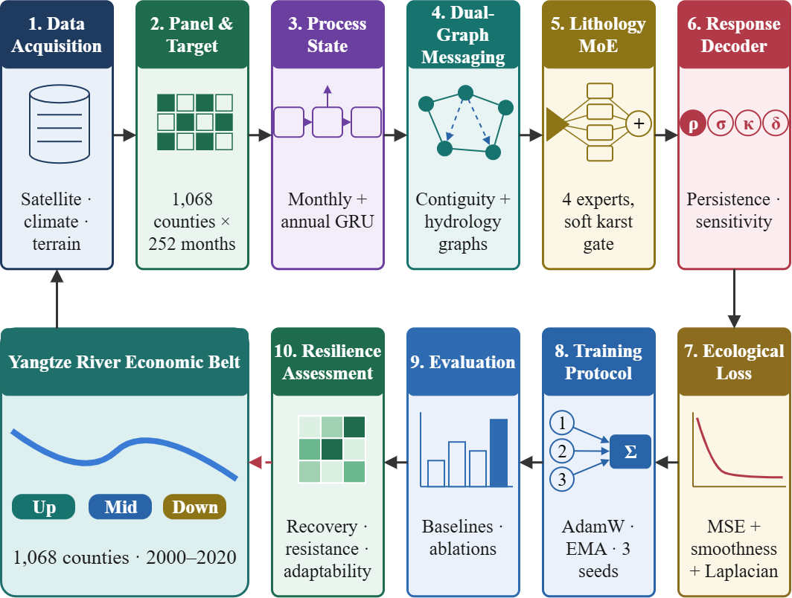
Figure 1. Schematic workflow of the proposed PERSIST framework.
3.1 Dataset Description
This study uses a county-level monthly panel of the Yangtze River Economic Belt as the main dataset for PERSIST, because it allows ecological conditions to be tracked continuously at monthly resolution. Most ecological assessment datasets provide annual composite indices or single-date imagery. This panel instead combines thermal and vegetation states, climate forcing, standardised disturbance anomalies, static terrain and lithology, a human pressure proxy and information on observation validity. This allows the model to learn both the current ecological condition of each county and its response to disturbance.
MOD11A2MOD13Q1TerraClimateCopernicus GLO-30 DEMWorld Karst Aquifer Mapharmonised DMSP–VIIRS seriesDataV.GeoAtlasThe dataset contains 269,136 rows and 58 columns of monthly observations across the upper, middle and lower reaches. It includes 1,068 county time series, each covering 252 consecutive months from January 2000 to December 2020. Each series is identified by its GB/T 2260 administrative code. Land surface temperature is obtained from MOD11A2 [51]. NDVI is obtained from MOD13Q1 [52], and kNDVI is computed from it following Camps-Valls et al. (2021) [46]. Thirteen climate variables are taken from TerraClimate [45], from which a further eight standardised anomalies are derived. Elevation, relief, slope and roughness are derived from the Copernicus GLO-30 DEM [53]. Carbonate-rock fraction is taken from the World Karst Aquifer Map [50]. Nighttime light radiance is obtained from the harmonised DMSP-VIIRS series of Li et al. (2020) [54], using the extended release of that record that covers 2000-2020 [58]; the original publication documents 1992-2018 only. All variables are aggregated to county boundaries from DataV.GeoAtlas [57]. Counties that were merged or renamed during the study period are mapped to their 2020 boundaries, so that each series refers to a consistent spatial unit. The panel also includes clear-sky observation counts, standardised heat and drought anomalies, contiguity adjacency and directed flow links ordered by elevation.
Before modelling, we construct input–target windows that pair a twelve-month history with the response period that follows it. The input state combines deseasonalised thermal and vegetation anomalies, climate forcing and static context. The monthly climatology used for deseasonalisation is computed from the training period only. The target is the mean anomaly over the three months that follow the input window, so no target month overlaps the input history. Clear-sky counts and valid-target masks are retained. This allows the model to account for observation density and to exclude invalid targets from the loss. The data are split chronologically, rather than randomly, into training, validation and test sets. An embargo ensures that no target window crosses a split boundary, so no target month is shared between subsets. Input histories may draw on the months immediately preceding a split; these months are observed before any target in that split and carry no target information. Table 2 summarises the splits.
Table 2. Dataset Partitioning for PERSIST
Dataset Split | Windows | Samples (County-Windows) | Split %
Training Set (2000-2014) | 166 | 176,894 | 70.93 %
Validation Set (2015-2017) | 34 | 36,297 | 14.55 %
Testing Set (2018-2020) | 34 | 36,210 | 14.52 %
Total Samples | 234 | 249,401 | 100 %

The training set is used to optimise the model parameters, including the coefficient heads. The validation set is used to monitor learning, select model weights and apply early stopping. The test set is never used for parameter updates. It is used only to evaluate how well the framework forecasts seasonal anomalies, captures temporal skill, controls spatial residual structure and remains robust under disturbance. The same splits are used for PERSIST, its ablation variants and all retrained baselines, so that the comparisons are consistent. In addition to the sequential window dataset, we use a separate horizon-sweep dataset. It contains 206,475 experiments across six aggregation horizons and is used to establish the predictability ceiling of the task under the same conditions. For each candidate horizon, it records the skill of the trivial references, the share of variance explained by differences between counties and the ceiling achieved by a linear autoregressive model. This allows the task definition itself to be audited independently of any deep learning model. Overall, the county-level panel provides PERSIST with sequential ecological observations, physiographic and lithological context, disturbance indicators and information on observation validity.
3.2 Data Pre-processing
For PERSIST, the county-level monthly panel is converted into a deseasonalised, aggregated and temporally embargoed forecasting problem. Indexing counties by i and months by t, the panel is written as
D=\left\{(\mathbf{x}_{i,t},\mathbf{s}_{i},y_{i,t})\;:\;i=1,\dots,N;\;t=1,\dots,T\right\},\quad N=1068,\;T=252 (1)
where is the dynamic observation vector, is the static physiographic descriptor of county and is the ecological state variable. Thermal and vegetation signals are both dominated by the annual cycle. Each raw state variable is therefore deseasonalised using a climatology estimated from the training period only. This prevents information from the validation or test years from entering the normalisation:
\mu_{m}^{(r)}=\frac{1}{|S_{m}|}\sum_{(i,t)\in S_{m}}r_{i,t},\quad S_{m}=\left\{(i,t):\mathrm{month}(t)=m,\;t\in\mathrm{TRAIN}\right\} (2a)
a_{i,t}^{(r)}=\mathrm{clip}\!\left(\frac{r_{i,t}-\mu_{\mathrm{month}(t)}^{(r)}}{\sigma^{(r)}_{\mathrm{TRAIN}}},\,-5,\,+5\right) (2b)
where is a single global standard deviation of variable over the training period. We use one global scale per variable instead of separate scales for each county and month. County–month scales divide by very small local variances, which produces extreme values that dominate the loss. The resulting scales are 3.6050 °C for land surface temperature and 0.1134 for kNDVI. The prediction target is the mean anomaly over the months that follow the last input month :
y_{i,e}^{(H)}=\frac{1}{H}\sum_{k=0}^{H-1}a_{i,\,e+k}^{(r)},\quad H=3 (3)
A value of corresponds to one climatological season. The choice of horizon is the most important design decision in this study, so we selected it empirically. We fitted a ridge regression for six candidate horizons under the same embargo. The predictors were twelve autoregressive lags of both state variables, concurrent climate forcing and calendar terms. For each horizon, we recorded pooled skill, within-county skill and the share of target variance explained by differences between counties rather than by change over time. Table 3 reports the results.
Table 3. Predictability audit of the aggregation horizon on the test period (2018-2020) under an identical embargo.
H (months) | Windows | SeasonalNaive R2 | TrailingPersistence R2 | Ridge pooled R2 | Ridge within-county R2 | Between-county variance | Ridge stride-H R2
1 | 36 | 0.5942 | 0.4514 | 0.7329 | 0.4882 | 49.5 % | 0.7329
2 | 35 | 0.7775 | 0.4238 | 0.8268 | 0.6077 | 58.9 % | 0.8126
3 (selected) | 34 | 0.8435 | 0.3030 | 0.8715 | 0.6685 | 65.2 % | 0.8756
4 | 33 | 0.8697 | 0.1579 | 0.8901 | 0.6756 | 70.0 % | 0.8785
6 | 31 | 0.9001 | 0.2047 | 0.9094 | 0.6304 | 79.4 % | 0.8950
12 | 25 | 0.9346 | 0.9346 | 0.9419 | -0.7040 | 97.9 % | not estimable

Table 3 shows that pooled skill rises with the horizon, but so does the share of variance that is purely cross-sectional. At H = 12 the seasonal-naive predictor already reaches R2 = 0.9346, and a learned model adds almost nothing. The within-county ceiling at that horizon is strongly negative, -0.7040, because a twelve-month mean barely changes within a three-year test period, so the estimator cannot track the little temporal variation that remains and performs worse than each county's own mean. Within-county skill peaks between H = 3 and H = 4. Moving from H = 3 to H = 4 raises within-county R2 by only 0.007, while the between-county share increases from 65.2% to 70.0%. We therefore selected H = 3. It matches one climatological season and exceeds the pooled threshold of 0.82, which we fixed before model development as the minimum acceptable pooled skill. That threshold is stated here where the audit is introduced and is applied again to the final model in Section 4.6. It also stays close to the maximum temporal skill while limiting the variance that is trivially predictable from county identity. Figure 2 shows how predictability and the trivially predictable component change with the horizon.
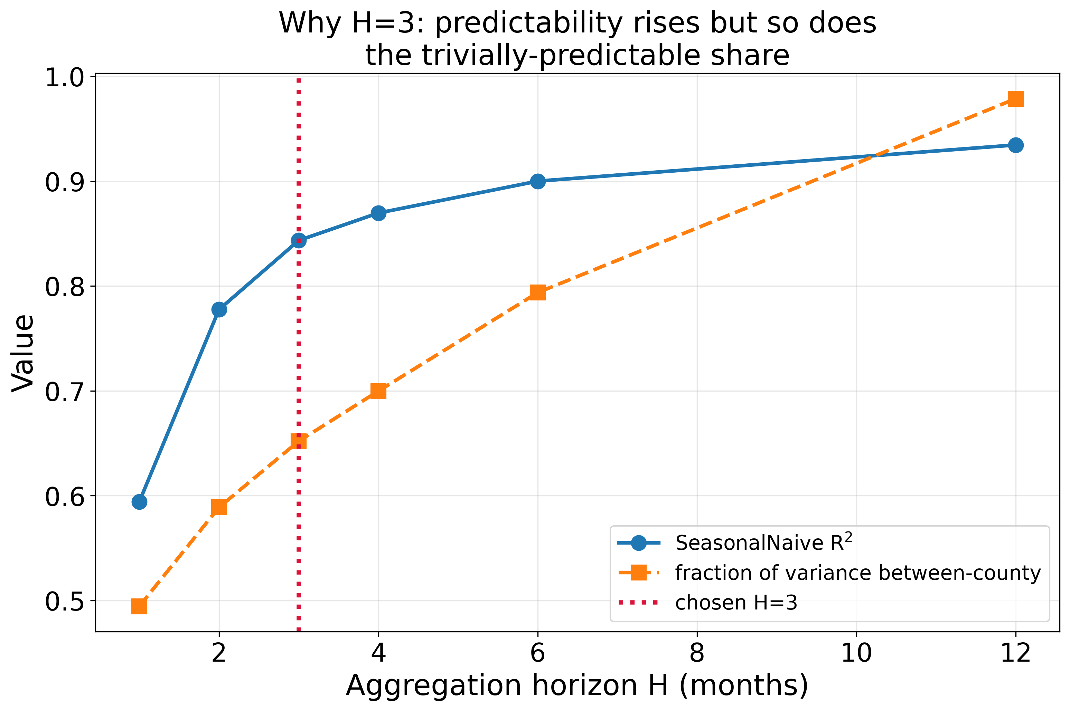

Figure 2. Effect of the aggregation horizon H on seasonal-naive, trailing-persistence and ridge R², and on the between-county share of target variance (test period 2018–2020).
A sample whose target window starts at month e is retained only when the entire target window falls inside the year range of a single split. The twelve-month input window (L = 12) ends at month e − 1 and may extend into the preceding split:
E_{\mathrm{split}}=\left\{e\;:\;e\geq t_{\min}(\mathrm{split}),\;\;e+H-1\leq t_{\max}(\mathrm{split}),\;\;e-L\geq 1\right\},\quad L=12 (4)
Without this constraint, the last H − 1 training targets would extend into the validation period and inflate validation skill. The embargo removes H − 1 = 2 windows at the end of each split, yielding 166 training, 34 validation and 34 test snapshots. Every dynamic and static feature is then standardised with statistics from the training period alone (Equation 5). Residual gaps caused by persistent cloud cover are filled by forward-then-backward carry within each county series:
\tilde{x}_{i,t,j}=\frac{x_{i,t,j}-\mu_{j}^{\mathrm{TRAIN}}}{\sigma_{j}^{\mathrm{TRAIN}}},\quad \sigma_{j}^{\mathrm{TRAIN}}>0 (5)
3.3 Feature Extraction
Feature extraction in PERSIST produces a representation of four kinds of information: the recent ecological state, the climatic forcing acting on it, the longer-term trajectory of the county and its fixed physiographic setting. The monthly dynamic vector combines state, forcing and calendar channels:
\mathbf{x}_{i,t}=\left[\mathbf{x}^{\mathrm{state}}_{i,t}\;\Vert\;\mathbf{x}^{\mathrm{force}}_{i,t}\;\Vert\;\mathbf{x}^{\mathrm{hum}}_{i,t}\;\Vert\;\mathbf{x}^{\mathrm{cal}}_{t}\right]\in\mathbb{R}^{32},\quad 5+22+2+3=32 (6)
where x_(i,t) is the dynamic observation vector of county i in month t and the double bar denotes concatenation. The four blocks sum to the stated 32 channels. The state block holds five channels: the raw land surface temperature, kNDVI and NDVI of the county together with the deseasonalised land-surface-temperature and kNDVI anomalies. The forcing block holds twenty-two channels: thirteen TerraClimate variables (precipitation, reference and actual evapotranspiration, climatic water deficit, runoff, maximum and minimum temperature, vapour pressure deficit, soil moisture, downward shortwave radiation, the Palmer Drought Severity Index, snow water equivalent and climatic water balance), eight standardised anomalies derived from them (the heat and drought anomalies together with the standardised forms of maximum temperature, precipitation, soil moisture, radiation, vapour pressure deficit and drought severity) and the relative clear-sky observation count. The human block holds two channels, the mean and total nighttime-light radiance of the county. The calendar block holds three channels, the sine and cosine of the month index and a linear year fraction, so that December and January remain adjacent. In the response decoder the five state channels are treated as state and the twenty-two forcing channels as forcing.
The static descriptor captures terrain, lithology and county area:
\mathbf{s}_{i}=\left[\mathrm{elev}_{\mu},\,\mathrm{elev}_{\sigma},\,\mathrm{relief},\,\mathrm{slope}_{\mu},\,\mathrm{slope}_{\sigma},\,\mathrm{rough},\,\mathrm{karst},\,\mathrm{area}\right]\in\mathbb{R}^{8} (7)
Long-term context is supplied by an annual representation formed from calendar-year means of every dynamic channel together with their year-over-year differences, so that the encoder receives both level and change information rather than a redundant second copy of the monthly signal:
\mathbf{x}^{\mathrm{ann}}_{i,k}=\left[\bar{\mathbf{x}}_{i,k}\;\Vert\;\bar{\mathbf{x}}_{i,k}-\bar{\mathbf{x}}_{i,k-1}\right]\in\mathbb{R}^{64},\qquad \bar{\mathbf{x}}_{i,k}=\frac{1}{12}\sum_{t\in\mathrm{year}\,k}\tilde{\mathbf{x}}_{i,t} (8)
The monthly and annual sequences are encoded by separate recurrent branches and combined with the encoded state channels through learnable scalar gains, so that each auxiliary branch contributes only to the extent that it reduces the training objective:
\mathbf{h}_{i,e}=\mathrm{LN}\!\left(\mathrm{GRU}_{m}(\tilde{\mathbf{x}}_{i,\,e-L:e-1})\right)+a_{\mathrm{year}}\,\mathrm{LN}\!\left(\mathrm{GRU}_{a}(\mathbf{x}^{\mathrm{ann}}_{i})\right)+a_{\mathrm{state}}\,f_{\mathrm{state}}(\tilde{\mathbf{x}}_{i,\,e-1}) (9)
where LN denotes layer normalization and and are scalar parameters initialized at 0.10. The combination of the encoded dynamic representation with the encoded static context forms the process-informed state used by every downstream head.
3.4 Proposed Framework Architecture
The architecture of PERSIST is shown in Figure 3. Data flow along a single path from multi-source county inputs to bounded resilience coefficients and a seasonal anomaly forecast. Three auxiliary pathways condition the response but do not produce separate forecasts.
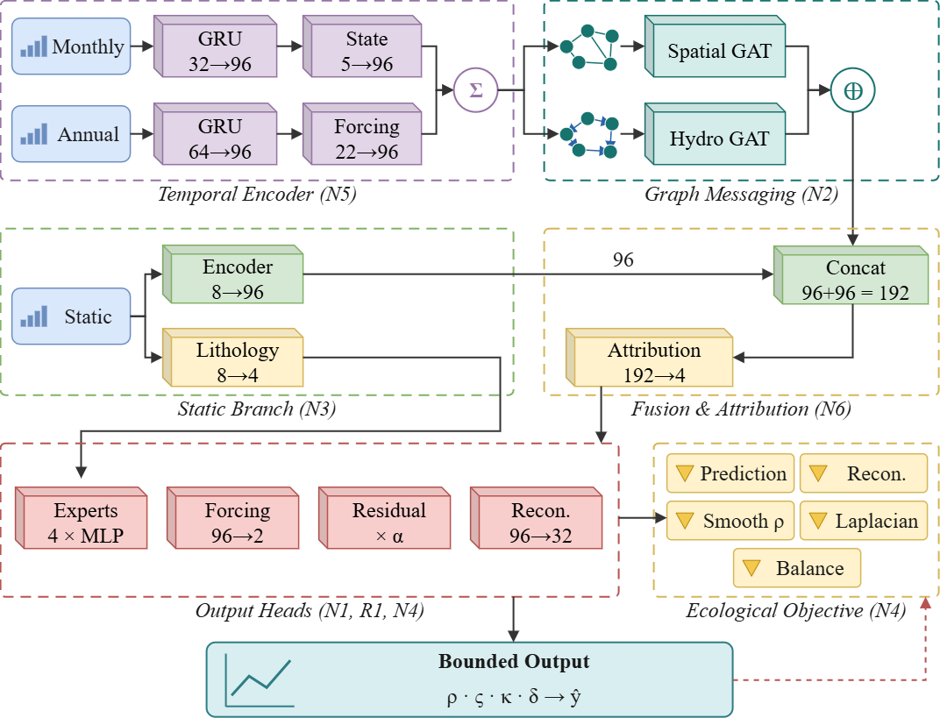
Figure 3. Overall architecture of the proposed PERSIST framework.
The county-level panel is organised into input–target windows. Each window provides a twelve-month dynamic history, a three-year annual context and the static descriptors of all counties together, so each training sample is a complete spatial snapshot rather than a single county. The monthly branch encodes the dynamic history with a two-layer gated recurrent unit (GRU) [56], and the annual branch encodes year-over-year differences with a single-layer GRU. Both are merged with the encoded instantaneous state through the learnable gains in Equation 9. This hierarchical encoder supplies long-memory context that a twelve-month window alone cannot capture.
The resulting representation is then passed over two graphs. The first is the undirected county-contiguity graph, with 3,032 edges, a mean degree of 5.68 and a single connected component. The second is a directed flow graph with the same number of edges, each oriented from the county with higher mean elevation to the county with lower mean elevation as a terrain-based proxy for hydrological connectivity. Each graph is processed by masked multi-head attention restricted to graph neighbours, and the two messages are added to the node representation through learnable scalar gains initialised at 0.30:
\mathbf{h}_{i}\leftarrow\mathbf{h}_{i}+a_{\mathrm{sp}}\,\mathrm{LN}\!\left(\mathrm{Attn}(\mathbf{h},\mathbf{A}_{\mathrm{sp}})\right)_{i}+a_{\mathrm{hy}}\,\mathrm{LN}\!\left(\mathrm{Attn}(\mathbf{h},\mathbf{A}_{\mathrm{hy}})\right)_{i} (10)
Because the full graph of 1,068 counties yields only one sample per target month, the belt is divided into three spatially contiguous partitions of 356 counties each. Each partition retains between 29.9% and 31.3% of the contiguity edges, so any single partition step sees roughly one third of the graph; the 8.0% of edges that join different partitions are absent from every partition step and are seen only on full-graph steps. Training alternates between partition steps and full-graph steps, the latter taken with probability 0.25 after each window batch. With 166 training windows in batches of four, this raises the number of optimiser updates per epoch from 21 under un-chunked training to 136 in expectation, a factor of 6.5, and to 168 in the limiting case where every batch also receives a full-graph step. Partitioning therefore both increases the update budget and acts as a form of edge dropout. The propagated representation is concatenated with the encoded static context to form the joint representation z used by all heads.
The lithology-adaptive mixture of experts combines four coefficient networks through a softmax gate that depends only on the static descriptor:
\mathbf{w}_{i}=\mathrm{softmax}\!\left(\mathbf{W}_{g}\mathbf{s}_{i}\right),\qquad \theta_{i}=\sum_{k=1}^{4}w_{i,k}\,\mathrm{Expert}_{k}(\mathbf{z}_{i}) (11)
The disturbance-conditioned response decoder maps the mixed coefficient vector to bounded quantities and combines them with the two nested reference predictors:
\rho_{i}=\mathrm{sigm}\!\left(\theta^{(1)}_{i}\right),\quad \varsigma_{i}=\mathrm{sigm}\!\left(\theta^{(2)}_{i}\right),\quad \kappa_{i}=\tanh\!\left(\theta^{(3)}_{i}\right),\quad \delta_{i}=\theta^{(4)}_{i} (12a)
\hat{y}_{i,e}=\rho_{i}\,y^{(H)}_{i,\,e-H}+\varsigma_{i}\,y^{(H)}_{i,\,e-12}+\kappa_{i}\,f_{\mathrm{eff},i}+\delta_{i}+a_{\mathrm{res}}\,\mathrm{direct}(\mathbf{z}_{i}) (12b)
where y(H)i,e−H is the mean over the H months before the target window and y(H)i,e−12 is the mean over the same H months one year earlier; both use only months before the target period. Setting ς = 1 and ρ = 0, with all other terms zero, recovers the seasonal-naive predictor, and setting ρ = 1 recovers trailing persistence. The final term is a free residual with a learnable scale. Without it, the decoder would be less expressive than an unrestricted regression head, because the deep representation could act only through four bounded coefficients. The coefficients are estimated for each county, window and target variable, and resilience metrics follow directly from Equation 12: recovery rate is 1 − ρ and resistance is 1 − |κ|. Resistance is defined in this way because κ measures the anomaly response to one standard deviation of effective forcing, so a smaller absolute sensitivity indicates a greater capacity to absorb forcing. Table 4 gives the layer-wise structure of the network.
The coefficient heads are initialised so that training begins from a seasonally-weighted blend rather than from a random mapping: the bias of the seasonal-carry unit is set to 0.8 and that of the persistence unit to 0.0, which after the logistic transform gives an initial seasonal-carry coefficient of 0.69 against a persistence coefficient of 0.50, with the forcing sensitivity and offset initialised at zero. This is an initialisation toward the seasonal-naive solution and not a reproduction of it, since the exact seasonal-naive predictor requires a seasonal-carry coefficient of one and a persistence coefficient of zero. No parameters are transferred from a previously trained model, so the procedure is an initialisation rather than pre-training.
Table 4. Layer-wise Architecture Summary of the Proposed PERSIST
Layer | Configuration | Output Shape
Dynamic input window | 32 features x 12 months | (B, 12, N, 32)
Annual input window | 64 features x 3 years | (B, 3, N, 64)
Static input | 8 physiographic features | (N, 8)
Monthly GRU (N5) | GRU(32 -> 96), 2 layers, dropout 0.20 | (B, N, 96)
Monthly LayerNorm | LayerNorm(96) | (B, N, 96)
Annual GRU (N5) | GRU(64 -> 96), 1 layer | (B, N, 96)
Annual scaled residual | a_year x LayerNorm(96), init 0.10 | (B, N, 96)
Forcing encoder | Linear(22 -> 96) + ELU + Linear(96 -> 96) | (B, N, 96)
State encoder | Linear(5 -> 96) + ELU + Linear(96 -> 96) | (B, N, 96)
Spatial graph attention (N2b) | 2 heads, contiguity, 3,032 undirected edges | (B, N, 96)
Hydro graph attention (N2a) | 2 heads, directed flow, 3,032 edges | (B, N, 96)
Gated graph fusion | a_sp, a_hy init 0.30, learnable | (B, N, 96)
Static context encoder | Linear(8 -> 96) + ELU | (N, 96)
Concatenation | [h ; c] | (B, N, 192)
Attribution head (N6) | Linear(192 -> 4) + softmax stream gating | (B, N, 4)
Lithology expert gate (N3) | Linear(8 -> 4) + softmax | (N, 4)
Coefficient experts (N1) | 4 x [Linear(192 -> 96) + ELU + Dropout + Linear(96 -> 8)] | (B, N, 4, 8)
Expert mixing | gate-weighted sum over 4 experts | (B, N, 8)
Bounded coefficients (N1) | sigmoid(rho), sigmoid(varsigma), tanh(kappa), delta | 4 x (B, N, 2)
Forcing-effect head (N1) | Linear(192 -> 96) + ELU + Linear(96 -> 2) | (B, N, 2)
Free residual head (R1) | Linear + ELU + Dropout + Linear, scale a_res 0.30 | (B, N, 2)
Reconstruction head (N4) | Linear(96 -> 32) | (B, N, 32)
Output | rho*y_prev + varsigma*y_seas + kappa*f + delta + a_res*direct(z) | (B, N, 2)

All ablation variants are produced by disabling individual pathways within the same code path, which avoids implementation drift between the full and ablated models. Table 5 lists the number of trainable parameters per component.
Table 5. Parameter distribution of the Proposed PERSIST and of the retrained deep baselines
Component | Parameters | Share
Monthly temporal encoder (N5) | 93,504 | 26.26 %
Annual temporal encoder (N5) | 46,849 | 13.16 %
Forcing encoder | 11,520 | 3.24 %
State encoder | 9,889 | 2.78 %
Spatial graph attention (N2b) | 37,441 | 10.51 %
Hydrological graph attention (N2a) | 37,441 | 10.51 %
Static context encoder | 864 | 0.24 %
Lithology expert gate (N3) | 36 | 0.01 %
Attribution head (N6) | 772 | 0.22 %
Coefficient experts (N1, four experts) | 77,216 | 21.68 %
Forcing-effect head (N1) | 18,722 | 5.26 %
Free residual head | 18,723 | 5.26 %
Reconstruction head (N4) | 3,104 | 0.87 %
PERSIST total | 356,081 | 100.00 %
Baseline: DRSEI (AE + LSTM) | 142,274 | 0.40x PERSIST
Baseline: STGCN | 101,730 | 0.29x PERSIST
Baseline: Temporal Fusion Transformer | 1,510,850 | 4.24x PERSIST
PERSIST contains 356,081 trainable parameters. The temporal encoders and the coefficient experts together account for 61.1% of them, while the gating and attribution pathways that supply lithological and stream conditioning require fewer than 1,000 parameters combined. The Temporal Fusion Transformer baseline carries 1,510,850 parameters, which is the 4.24x ratio quoted in Section 4.6.
3.5 Loss Function and Hyperparameter Configuration
The training objective must reward seasonal forecasting accuracy while keeping the recovered coefficients physically meaningful and the residual field spatially unstructured. Its main component is a masked mean squared error over county-window targets:
L_{\mathrm{pred}}=\frac{\sum_{i,e}m_{i,e}\left\Vert\hat{\mathbf{y}}_{i,e}-\mathbf{y}_{i,e}\right\Vert^{2}}{d_{\mathrm{out}}\sum_{i,e}m_{i,e}} (13)
where m_{i,e} is the valid-target mask and d_out is the number of predicted variables. Three ecological regularisers are added. The reconstruction loss requires the latent state to retain information about the input state. The smoothness loss discourages abrupt changes in the persistence coefficient between consecutive windows. The graph Laplacian loss penalises spatially correlated residuals and is the training counterpart of the residual Moran's I reported in Section 4:
L_{\mathrm{rec}}=\left\Vert g_{\mathrm{rec}}(\mathbf{h})-\tilde{\mathbf{x}}_{\cdot,\,e-1}\right\Vert^{2},\qquad L_{\mathrm{smooth}}=\mathrm{mean}\!\left[\left(\rho_{\cdot,\,e+1}-\rho_{\cdot,e}\right)^{2}\right] (14a)
L_{\mathrm{lap}}=\frac{1}{B\,d_{\mathrm{out}}}\sum_{b=1}^{B}\sum_{o=1}^{d_{\mathrm{out}}}\mathbf{r}_{b,o}^{\mathsf{T}}\,\mathbf{L}\,\mathbf{r}_{b,o},\qquad \mathbf{r}=\left(\hat{\mathbf{y}}-\mathbf{y}\right)\odot\mathbf{m} (14b)
where L is the normalised graph Laplacian of the contiguity graph. The penalty is applied to the residual field rather than to the predictions, so it does not smooth the forecast itself, and it targets the same quantity that the evaluation reports. The Laplacian is precomputed for each node chunk, so the penalty applies at every optimisation step rather than only at the less frequent full-graph steps. An entropy term prevents the expert gate from collapsing onto a single expert, and an asymmetric term penalises predictions outside the ±5σ range:
L_{\mathrm{bal}}=\sum_{k=1}^{4}u_{k}\log u_{k},\qquad \mathbf{u}=\frac{1}{N}\sum_{i=1}^{N}\mathbf{w}_{i} (15a)
L_{\mathrm{asym}}=\mathrm{mean}\!\left[\max\!\left(\left|\hat{y}\right|-5,\,0\right)^{2}\right] (15b)
L=L_{\mathrm{pred}}+0.005\,L_{\mathrm{rec}}+0.002\,L_{\mathrm{smooth}}+0.15\,L_{\mathrm{lap}}+0.001\,L_{\mathrm{asym}}+0.001\,L_{\mathrm{bal}} (15c)
Optimisation uses AdamW [55] with an initial learning rate of 2 × 10⁻³ and a weight decay of , with a cosine schedule and five warm-up epochs. An exponential moving average (EMA) of the weights with decay 0.998 is maintained, and the EMA weights are used for evaluation. Gradients are clipped to unit global norm, and early stopping monitors validation RMSE with a patience of 15 epochs. Each configuration is trained with three random seeds; the test predictions are averaged, and the standard deviation across seeds defines the noise band used in the ablation study. The full hyperparameter set is provided in Table 6.
Table 6. Hyperparameter Configuration of the Proposed PERSIST
Hyperparameter | Value / Configuration
Framework | PERSIST
Dataset | County-level monthly panel of the YREB (2000-2020)
Learning paradigm | Supervised spatiotemporal regression
Spatial units | 1,068 county-level administrative units
Prediction target | Forward 3-month mean deseasonalised anomaly
Target variables | lst_ds (primary), kndvi_ds
Lookback window | 12 months
Annual context | 3 years of levels and year-over-year deltas
Dynamic / static / annual features | 32 / 8 / 64
Hidden dimension | 96
Monthly encoder | GRU, 2 layers
Annual encoder | GRU, 1 layer
Graph attention heads | 2
Number of experts | 4
Dropout | 0.20
Graph residual scale (initial) | 0.30
Free residual scale (initial) | 0.30
Auxiliary branch scales (initial) | 0.10
Optimiser | AdamW
Initial learning rate | 2 x 10^-3
Weight decay | 3 x 10^-4
Learning-rate schedule | Cosine with 5 warmup epochs
Maximum epochs | 60
Early-stopping patience | 15 epochs on validation RMSE
Gradient clipping | 1.0 (global norm)
EMA decay | 0.998
Node chunks | 3 chunks of 356 counties
Full-graph step probability | 0.25
Windows per optimiser step | 4
Random seeds | 3 (predictions ensembled)
Reconstruction weight | 0.005
Persistence smoothness weight | 0.002
Residual Laplacian weight | 0.15
Asymmetric range weight | 0.001
Expert load-balance weight | 0.001
Anomaly clipping | +/- 5 sigma
Disturbance threshold | |heat_z| >= 1.5
Hardware | NVIDIA L4 GPU
Framework version | PyTorch 2.11.0 (CUDA 12.8)

The configuration balances predictive skill, coefficient interpretability, spatial regularisation and computational cost. The small hidden dimension and long early-stopping patience reflect the snapshot design. Because each training sample is a full spatial snapshot, the model is fitted on only 166 overlapping temporal snapshots, even though the training set contains 176,894 county-window records.
4. Results and Discussions
4.1 Experimental Setup
All experiments used the county-level monthly panel of the YREB and were run on a single NVIDIA L4 GPU with PyTorch 2.11.0 and CUDA 12.8. The panel covers 1,068 counties from January 2000 to December 2020 and yields 234 embargoed windows and 249,401 valid county-window observations. Training uses the 166 windows in 2000–2014 and validation uses the 34 windows in 2015–2017. All reported results are computed on the 34 held-out windows in 2018–2020, which contain 36,210 county-window observations. Every configuration (four trivial references, three retrained deep baselines, the proposed model and seven single-component ablations) uses the same split, target and three-seed ensembling procedure, so no configuration benefits from a different split or from additional averaging. Training of the proposed model stopped early after 26 epochs and took 5.1 min per seed.
4.2 Evaluation Metrics
PERSIST is evaluated with several complementary metrics. Predictive accuracy in the primary anomaly space is quantified by the root mean squared error and the mean absolute error over all valid county-window pairs:
\mathrm{RMSE}=\sqrt{\frac{1}{n}\sum_{i,e}\left(\hat{y}_{i,e}-y_{i,e}\right)^{2}} (16a)
\mathrm{MAE}=\frac{1}{n}\sum_{i,e}\left|\hat{y}_{i,e}-y_{i,e}\right| (16b)
The coefficient of determination measures the fraction of target variance explained relative to the global mean of the observations:
R^{2}=1-\frac{\sum_{i,e}\left(\hat{y}_{i,e}-y_{i,e}\right)^{2}}{\sum_{i,e}\left(y_{i,e}-\bar{y}\right)^{2}} (17)
Because a large share of the aggregated target variance is cross-sectional, pooled R² partly rewards a model for predicting the correct mean level of each county. The within-county coefficient therefore removes each county mean from both observations and predictions before computing the same quantity, and it is reported alongside pooled R² throughout:
R^{2}_{\mathrm{within}}=1-\frac{\sum_{i,e}\left[\left(\hat{y}_{i,e}-\bar{\hat{y}}_{i}\right)-\left(y_{i,e}-\bar{y}_{i}\right)\right]^{2}}{\sum_{i,e}\left(y_{i,e}-\bar{y}_{i}\right)^{2}},\qquad \bar{y}_{i}=\frac{1}{|E|}\sum_{e\in E}y_{i,e} (18)
Spatial structure remaining in the error field is quantified by Moran's I [49] computed on the county-mean residual for each test year and averaged, where W is the row-standardised adjacency matrix of the contiguity graph. A value near zero indicates that the model has absorbed the available spatial signal:
I=\frac{n}{S_{0}}\cdot\frac{\sum_{i}\sum_{j}W_{ij}\,r_{i}\,r_{j}}{\sum_{i}r_{i}^{2}},\qquad S_{0}=\sum_{i}\sum_{j}W_{ij} (19)
Agreement and efficiency are additionally summarised by the Willmott index of agreement [48] and the Kling–Gupta efficiency [47], which jointly penalise errors in correlation, variance ratio and mean:
d=1-\frac{\sum_{i,e}\left(y_{i,e}-\hat{y}_{i,e}\right)^{2}}{\sum_{i,e}\left(\left|\hat{y}_{i,e}-\bar{y}\right|+\left|y_{i,e}-\bar{y}\right|\right)^{2}},\qquad \mathrm{KGE}=1-\sqrt{(r-1)^{2}+\left(\frac{\sigma_{p}}{\sigma_{o}}-1\right)^{2}+\left(\frac{\mu_{p}-\mu_{o}}{\sigma_{o}}\right)^{2}} (20)
Finally, two robustness diagnostics are reported. Disturbance-window error is the root mean squared error restricted to windows in which the standardised heat anomaly exceeds 1.5 in magnitude, and the stride-H coefficient recomputes the pooled coefficient on non-overlapping windows only, since consecutive three-month targets share two months of observations.
4.3 Performance Analysis of the Proposed PERSIST
Table 7 reports training and validation performance at the epoch selected by early stopping, which provides the weights evaluated on the test set.
Table 7. Training and Validation Performance of the Proposed PERSIST
Metric | Training | Validation
Loss | 0.07632 | 0.12855
RMSE | 0.26644 | 0.35362
MAE | 0.20204 | 0.26866
R2 | 0.90973 | 0.84992
Selected epoch | 11 | 11
Epochs completed | 26 | 26

The validation RMSE (0.3536) is higher than the training RMSE (0.2664). This gap of 0.0872 indicates mild overfitting, which is limited by early stopping at epoch 11, EMA weight averaging and node chunking, which acts as edge dropout.
Table 8. Final Test Performance of the Proposed PERSIST
Metric | PERSIST
Root mean squared error | 0.3633
Mean absolute error | 0.2660
Coefficient of determination (pooled) | 0.8515
Pearson correlation | 0.9231
Willmott index of agreement | 0.9596
Kling-Gupta efficiency | 0.9052
Bias | +0.0126
Within-county R2 (temporal skill) | 0.7092
Within-county Pearson correlation | 0.8455
Residual Moran's I | 0.8172
Disturbance-window RMSE | 0.3556
Calm-window RMSE | 0.3008
Stride-3 R2 (non-overlapping) | 0.8897
R2 in native LST units | 0.9718
RMSE in native LST units (deg C) | 1.1079
Upstream / midstream / downstream RMSE | 0.3346 / 0.3006 / 0.2717
Seed spread (RMSE, mean +/- sd) | 0.3662 +/- 0.0045
Trainable parameters | 356,081
Test samples | 36,210
kNDVI RMSE (secondary target) | 0.4117
kNDVI MAE (secondary target) | 0.2986
kNDVI R2 (secondary target) | 0.8177
kNDVI Pearson correlation | 0.9065
kNDVI Willmott index | 0.9506
kNDVI KGE | 0.8867
kNDVI bias | +0.0420
R2 in native kNDVI units | 0.8585
LST-only RMSE / R2 (primary target) | 0.3073 / 0.8884

Table 8 shows a pooled R² of 0.8515 and a within-county R² of 0.7092. Both are reported because 65.2% of the target variance lies between counties rather than within counties over time, so pooled R² partly rewards predicting each county's mean level. Recomputed on non-overlapping windows, the stride-3 R² is 0.8897, slightly higher than the pooled value; the overlap between consecutive three-month targets therefore does not inflate the reported skill. In native units, the model explains 97.2% of the variance in three-month mean land surface temperature with an RMSE of 1.11 °C. This figure includes the seasonal cycle and is not comparable with anomaly-space skill. Disturbance windows remain harder than calm windows (RMSE 0.3556 vs 0.3008; 4,022 vs 32,188 samples). Error decreases monotonically downstream, from 0.3346 in the upper reach to 0.2717 in the lower reach.
Both declared targets are reported. The pooled figures above average the primary land-surface-temperature anomaly and the secondary kNDVI anomaly. Taken separately, the thermal target attains R2 = 0.8884 with an RMSE of 0.3073, whereas the vegetation target attains R2 = 0.8177 with an RMSE of 0.4117. kNDVI is the harder of the two by a clear margin, which is expected because vegetation anomalies respond to management, phenology and land-cover change that the climate forcing does not capture, whereas thermal anomalies track the forcing more directly. In native units the model explains 85.9% of three-month mean kNDVI variance. Because the two targets differ this much, the pooled coefficient sits between them and should not be compared with single-target results from other studies without stating the basis; Section 4.6 returns to this point.

4.4 Training Convergence Analysis
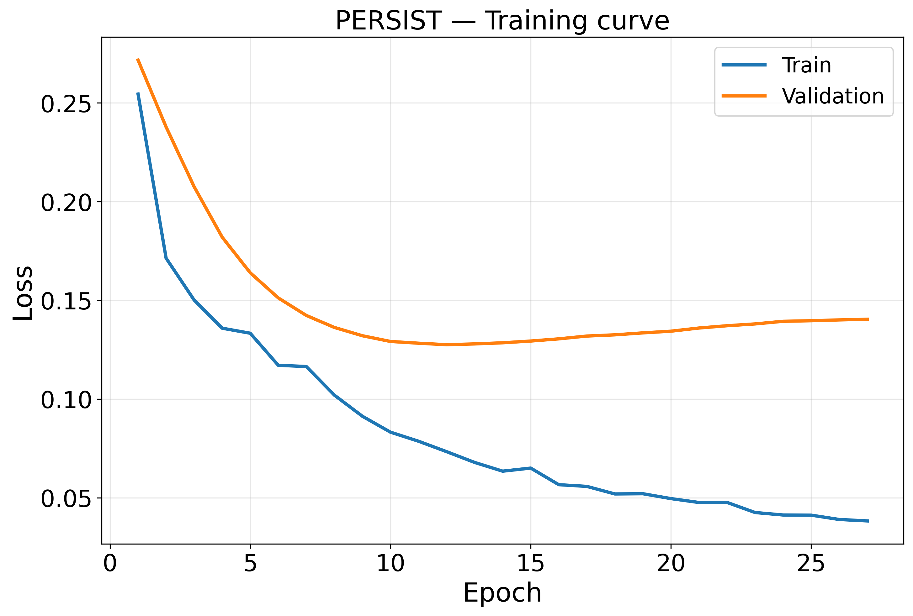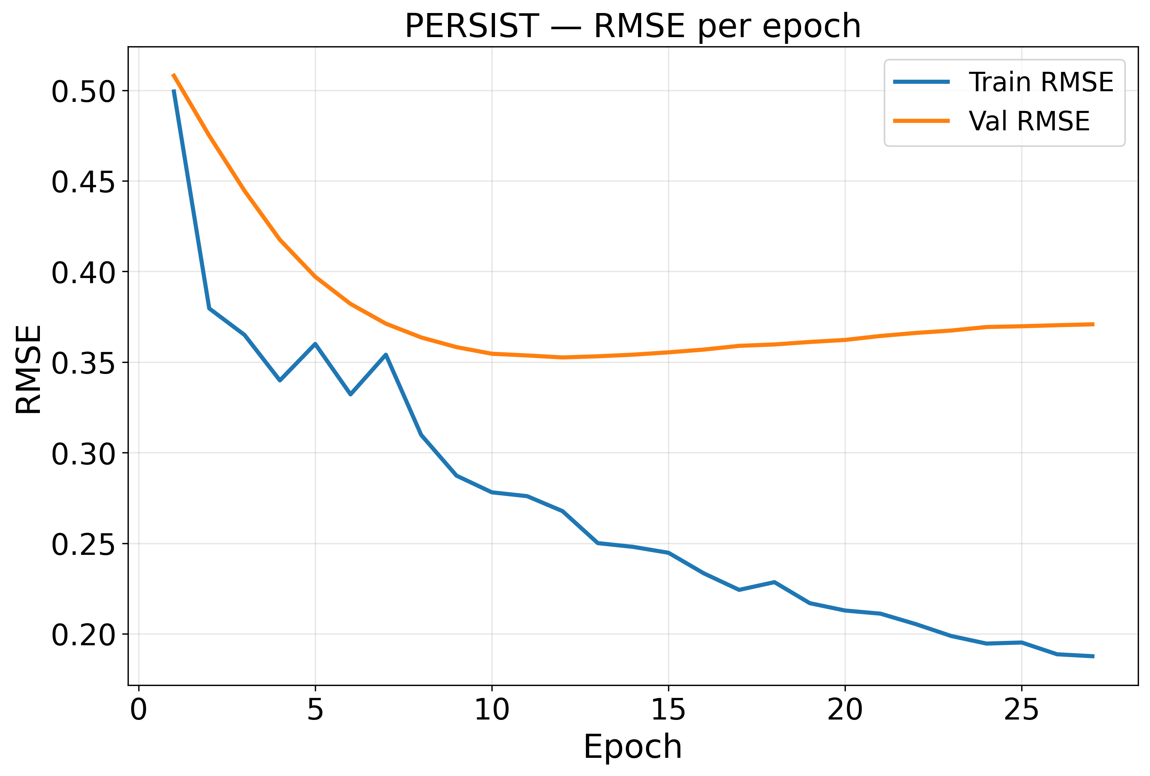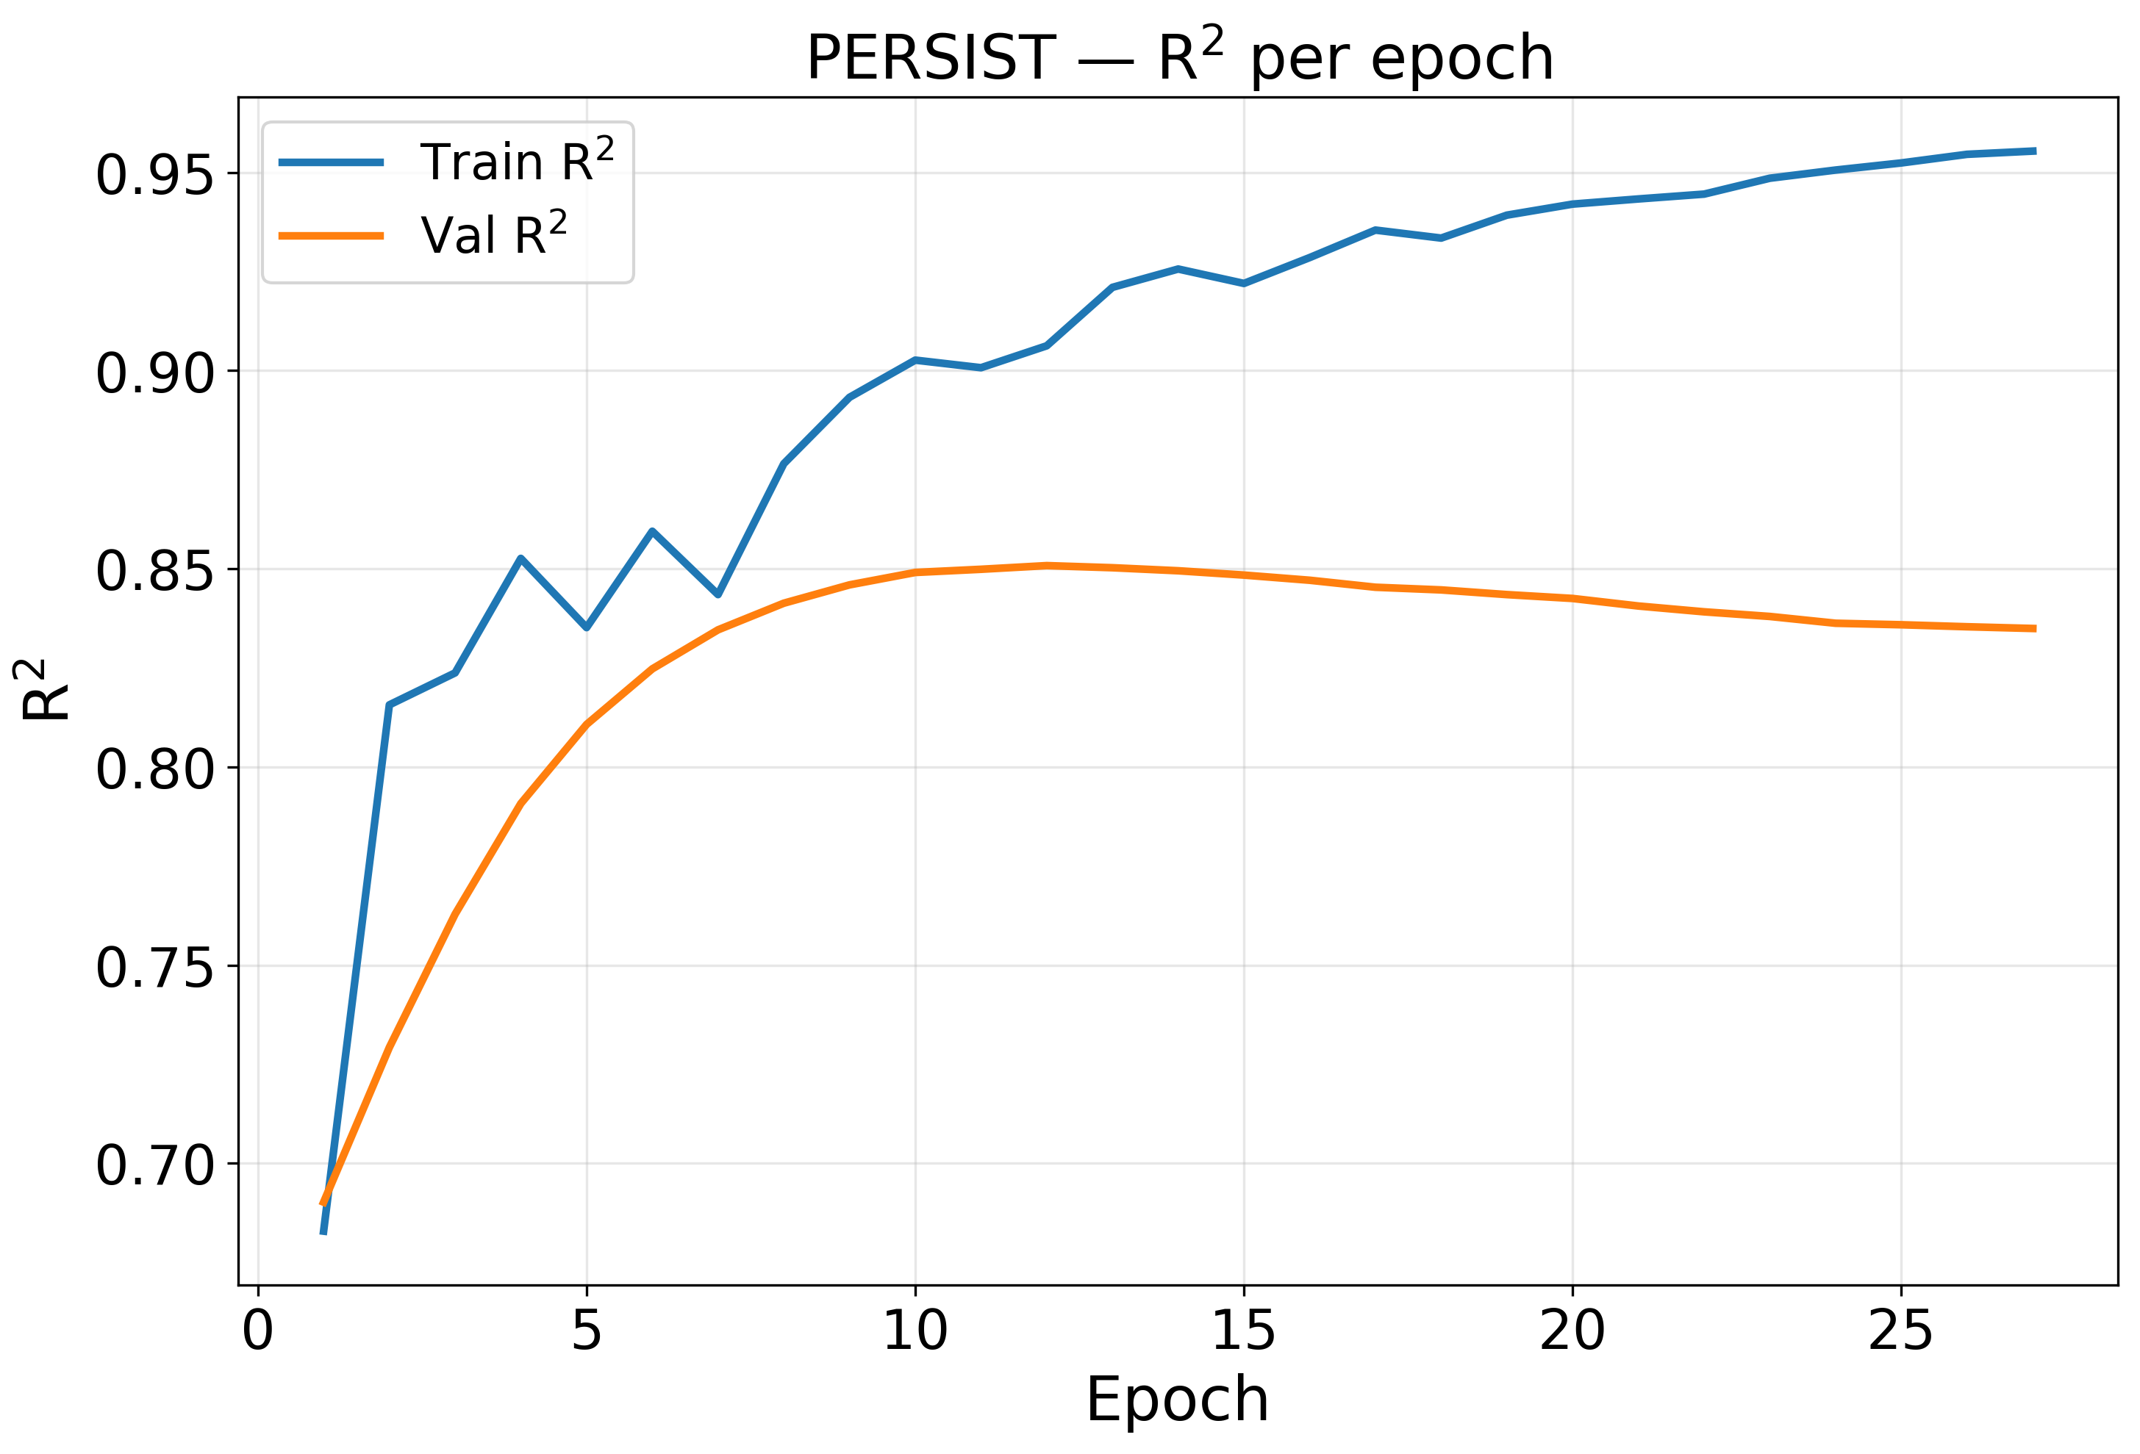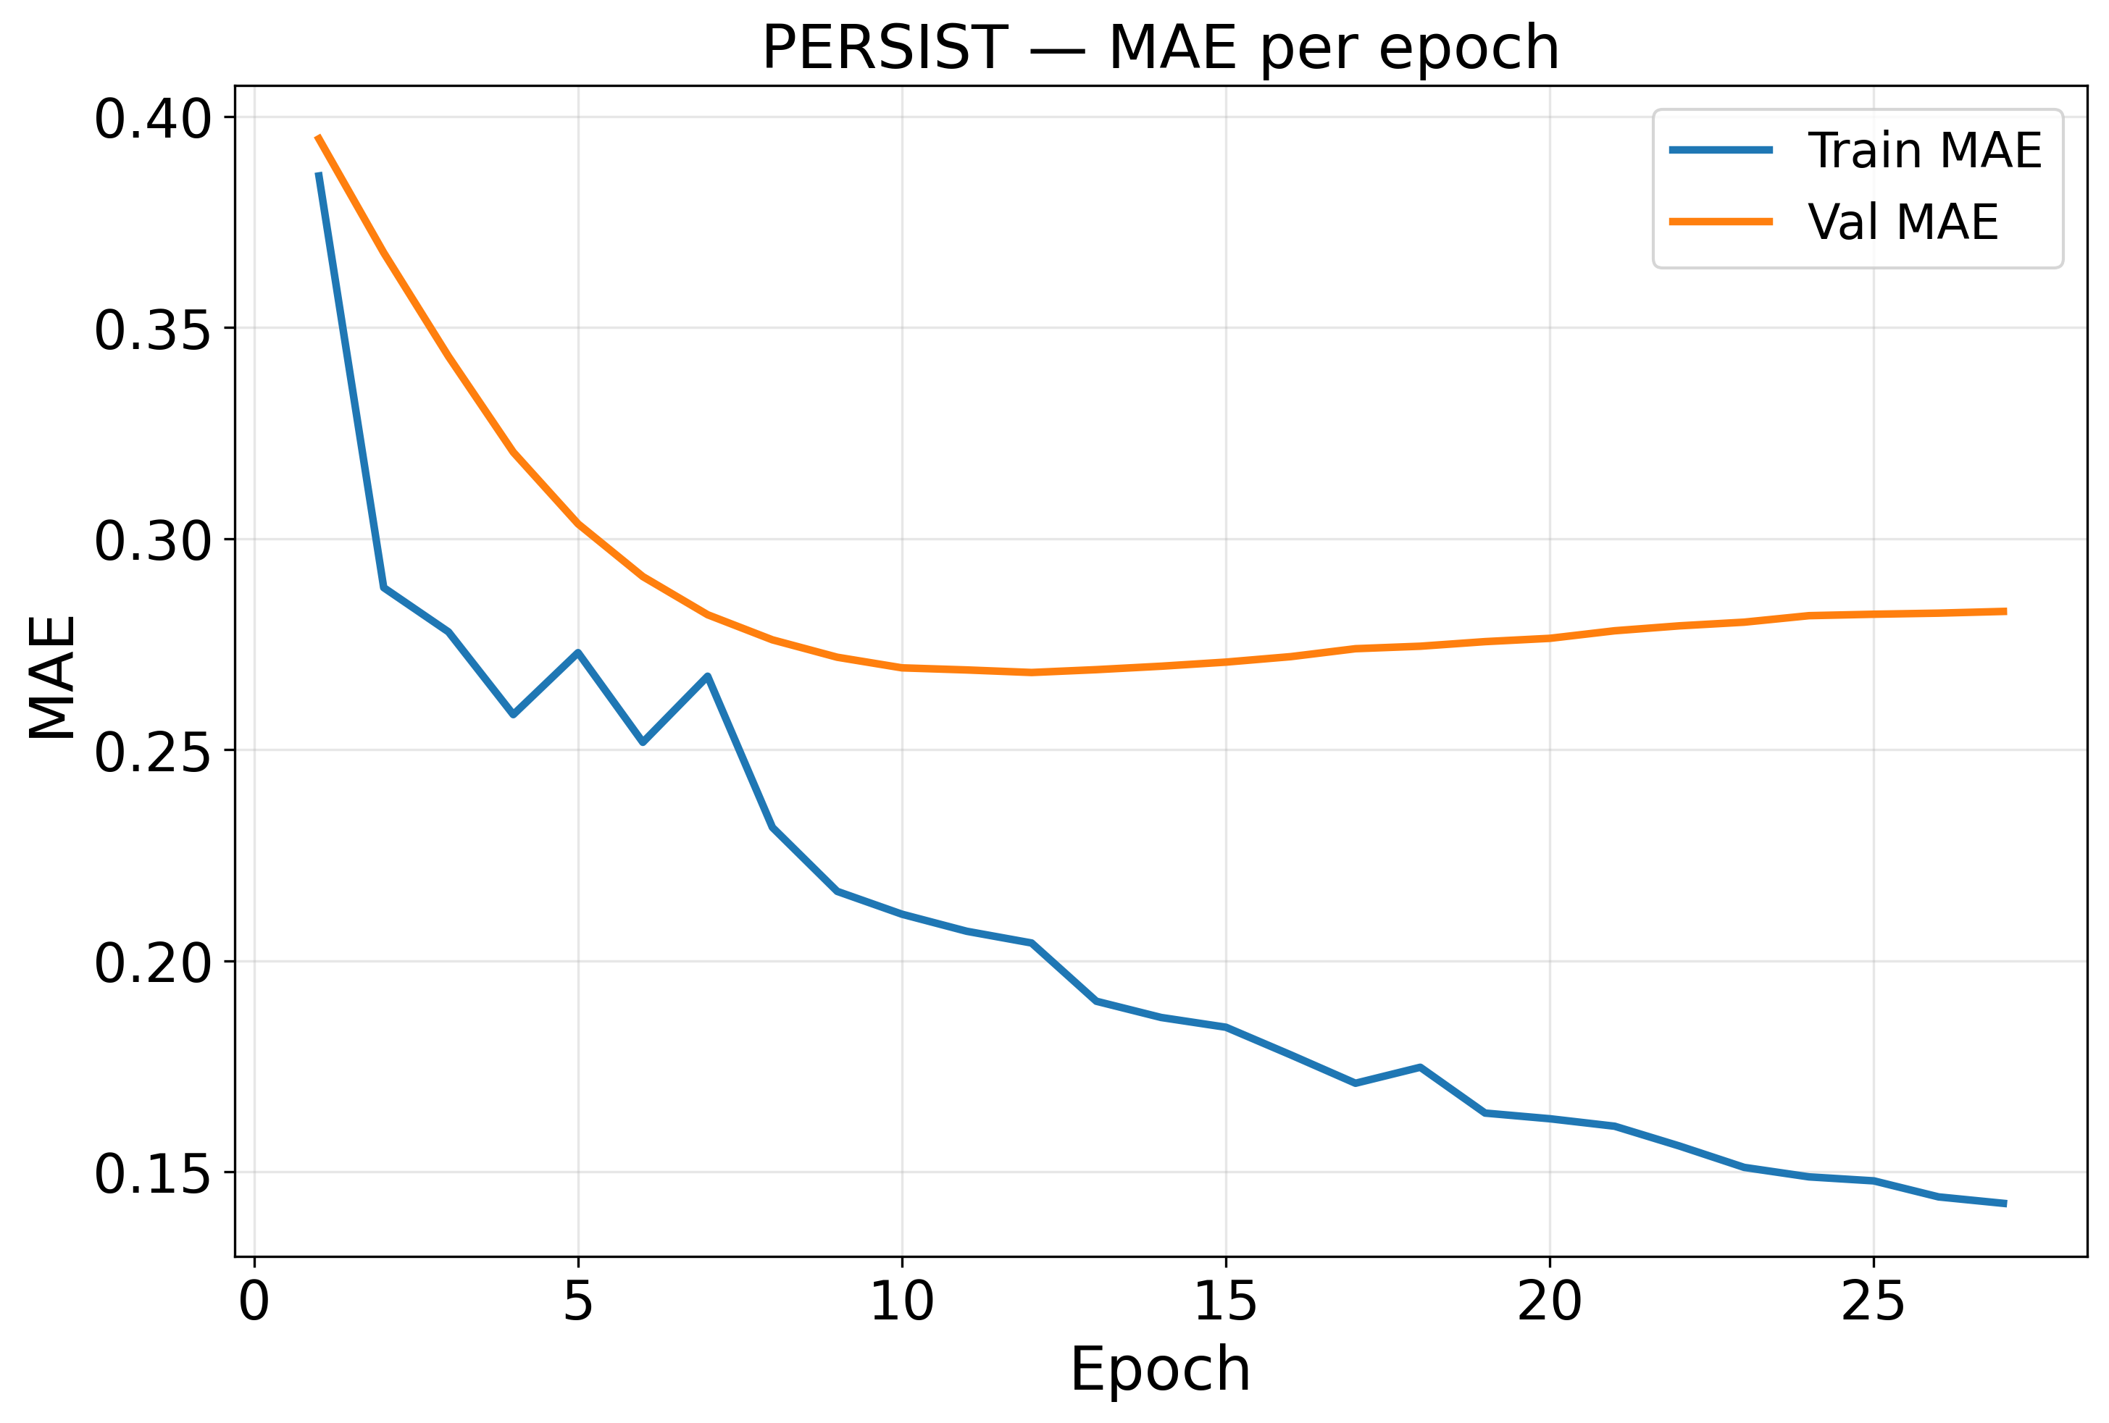
Figure 4. Training and validation convergence of PERSIST: (a) loss, (b) RMSE, (c) R² and (d) MAE per epoch.
Figure 4 shows the optimisation behaviour of PERSIST. Loss falls sharply during the five warm-up epochs and the early cosine-decay phase. Validation loss reaches its minimum at epoch 11, while training loss continues to decline slowly. This pattern is expected in a graph formulation in which each sample is a full spatial snapshot, so that 356,081 parameters are fitted to only 166 overlapping temporal snapshots. Training therefore stopped at epoch 26, after 15 epochs without improvement, and the checkpoint from epoch 11 was retained.
The metric curves improve steadily rather than oscillating. Validation RMSE falls from 0.5118 at epoch 1 to 0.3536 at the optimum, a reduction of 30.9%, and validation R² rises from 0.6856 to 0.8499. We attribute the absence of oscillation to the EMA weights, which form the evaluated parameterisation, and to the initialisation of the response decoder near the seasonal-naive reference rather than at random.
4.5 Ablation Study
To assess the contribution of each component, we disabled one component at a time while keeping all other settings fixed. The seed standard deviation of the full model is 0.0045, so we treat an RMSE difference as meaningful only when it exceeds 0.0090 (two seed standard deviations). This threshold is a heuristic noise band rather than a formal significance test. Table 9 reports the results.
Table 9. Ablation Study Results of the Proposed PERSIST
Configuration | RMSE | Seed sd | Exceeds 2σ band | R2 | Within R2 | Moran's I
A1 (- response decoder, N1) | 0.3795 | 0.0036 | Yes | 0.8379 | 0.7057 | 0.7952
A2 (- annual encoder, N5) | 0.3794 | 0.0053 | Yes | 0.8380 | 0.6874 | 0.7977
A3 (- lithology experts, N3) | 0.3651 | 0.0026 | No | 0.8500 | 0.7023 | 0.8345
A4 (- both graphs, N2a + N2b) | 0.3642 | 0.0039 | No | 0.8507 | 0.7045 | 0.8143
A5 (- ecological loss, N4) | 0.3641 | 0.0047 | No | 0.8508 | 0.7075 | 0.8201
A6 (- attribution head, N6) | 0.3641 | 0.0052 | No | 0.8508 | 0.7007 | 0.8203
A7 (- hydrological graph, N2a) | 0.3625 | 0.0028 | No | 0.8521 | 0.7052 | 0.8267
PERSIST (full model) | 0.3633 | 0.0045 | - | 0.8515 | 0.7092 | 0.8172

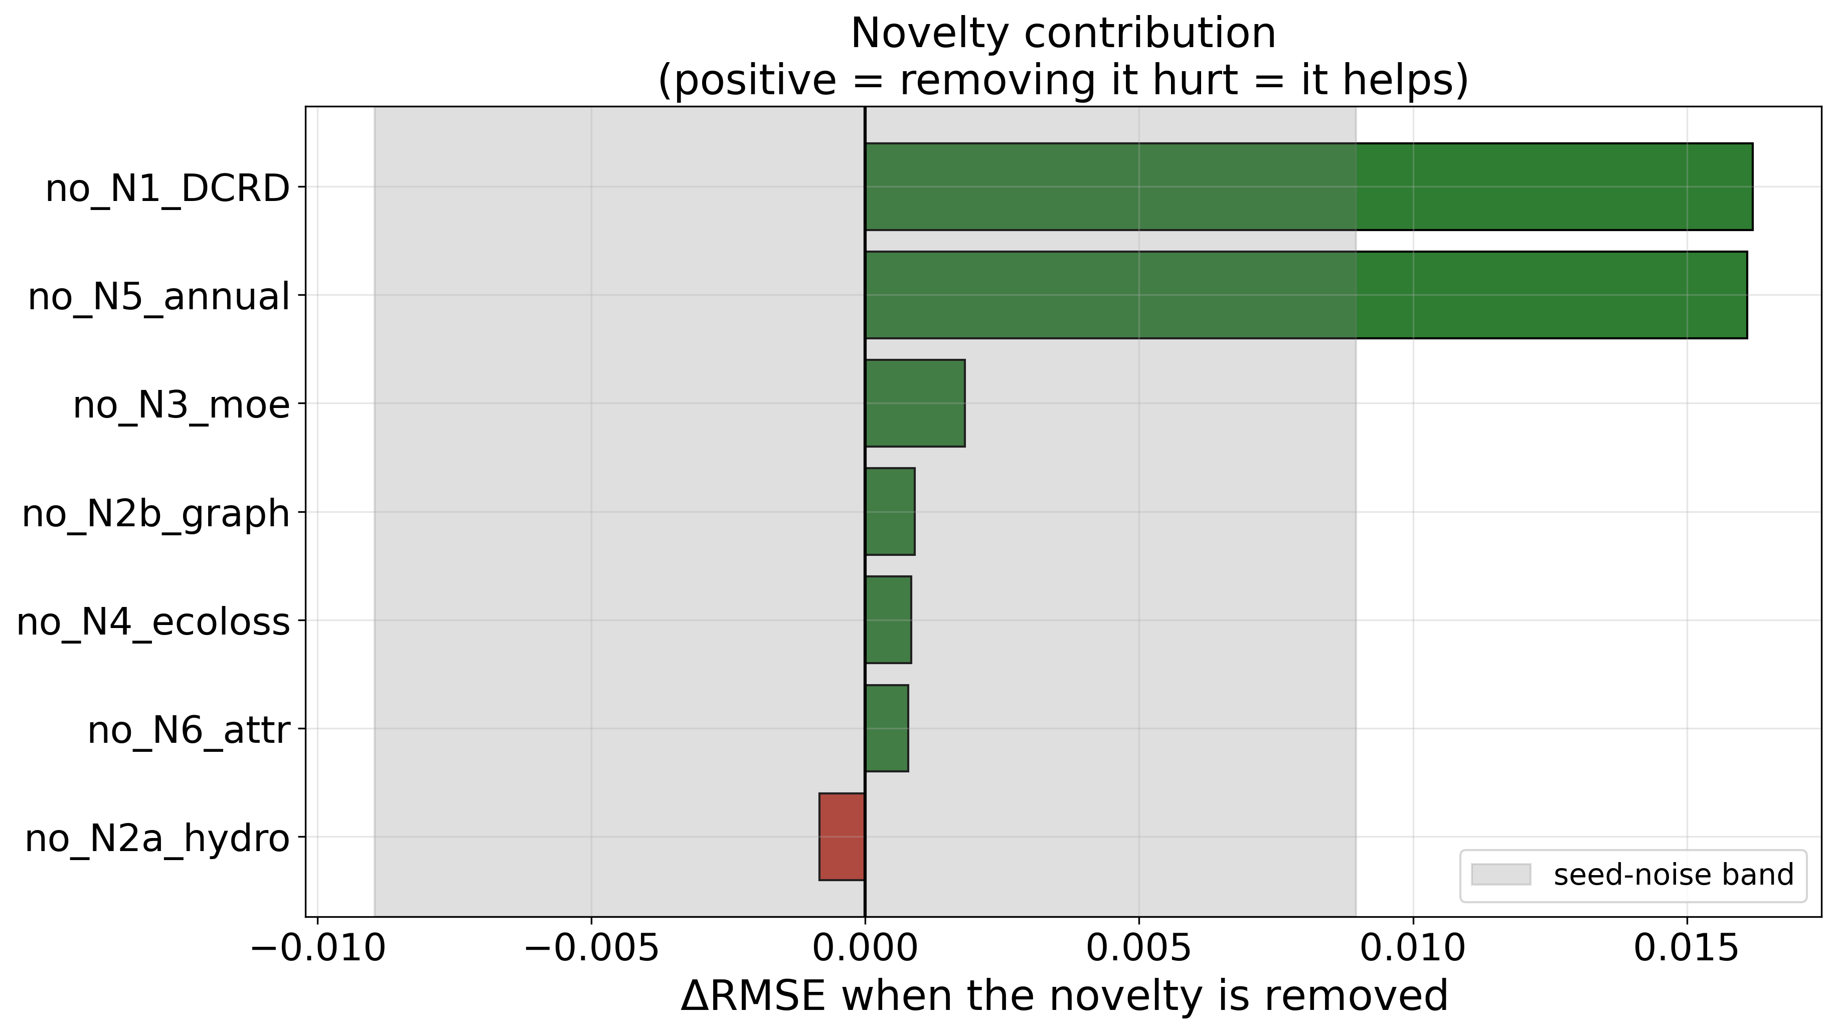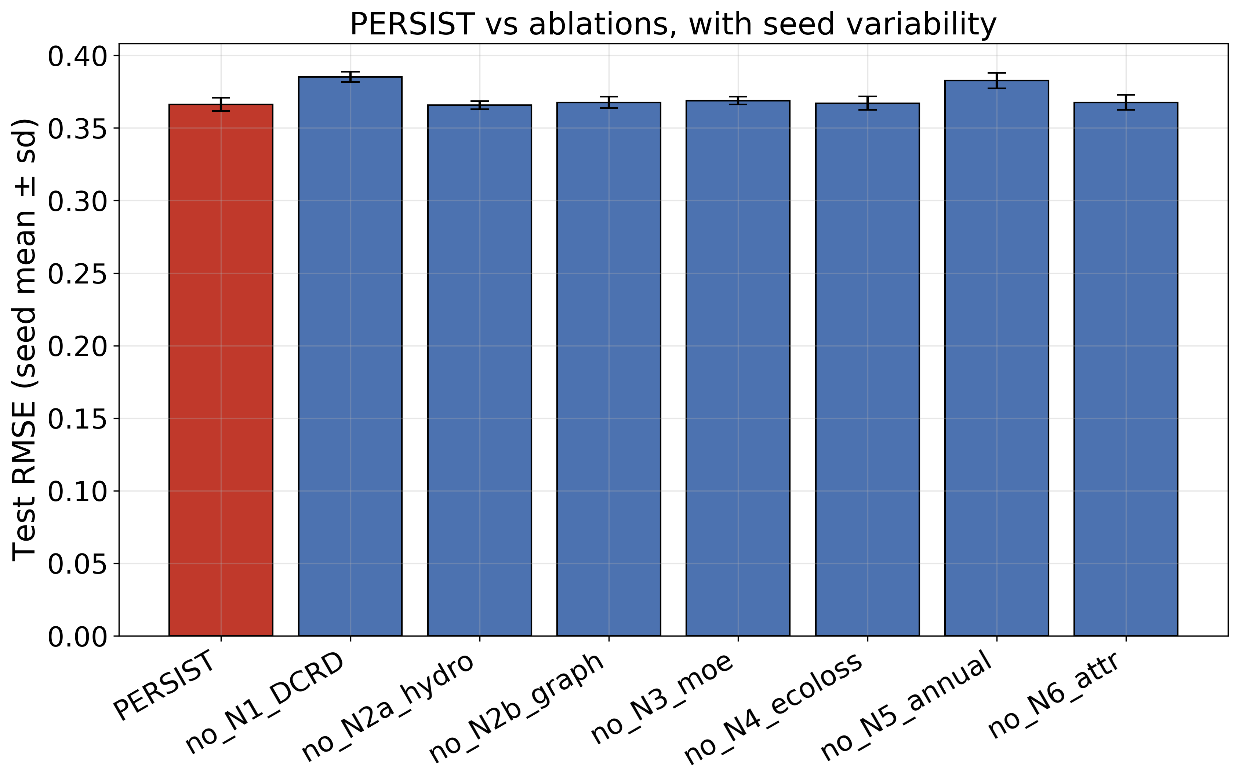
Figure 5. (a) Change in test RMSE relative to the full PERSIST model for each single-component ablation, with the shaded band marking +/-2 seed standard deviations; (b) test RMSE of the full model and of every ablation as seed mean with standard-deviation error bars.
Only two of the seven ablations change RMSE by more than the seed-noise band. Removing the disturbance-conditioned response decoder increases RMSE by 0.0162, and removing the hierarchical annual encoder increases it by 0.0161. Both exceed the 0.0090 threshold, and both removals also reduce within-county R². These two components therefore make a measurable contribution. Figure 5 summarises the effect of each component.
The lithology-adaptive experts, the dual graphs, the ecological loss terms and the attribution head change RMSE by between −0.0008 and +0.0018, which lies within the noise band; at this scale they do not contribute measurably to predictive skill. Removing the hydrological graph reduces RMSE slightly (by 0.0008), so this variant has the lowest RMSE of all configurations (0.3625). We report this as a negative result: the terrain-based flow proxy is not a mapped river network, and a true hydrological network may behave differently. In addition, the lowest residual Moran's I (0.7952) is obtained by the variant without the response decoder, not by the full model.
4.6 Comparison with State-of-the-Art Models
The four trivial references and three deep baselines were all retrained from scratch on the same three-month target, with the same embargoed splits and three-seed ensembling. Published results were not reused, because they were obtained on one-month-ahead targets and therefore describe a different task. The deep baselines are DRSEI [3], STGCN [43] and the Temporal Fusion Transformer (TFT) [44].
Table 10. Performance Comparison of the Proposed PERSIST with Trivial References and Retrained Deep Baselines
Model | RMSE | MAE | R2 | Pearson r | KGE | Within R2 | Moran's I | Shock RMSE | Stride-3 R2
Climatology (trivial) | 0.9611 | 0.7439 | -0.0394 | - | -0.4281 | 0.0000 | 0.8358 | 0.9985 | -0.0287
County climatology (trivial) | 0.6154 | 0.4773 | 0.5738 | 0.7835 | 0.6033 | 0.0000 | 0.8554 | 0.5898 | 0.5667
Trailing persistence (trivial) | 0.7991 | 0.6048 | 0.2814 | 0.6437 | 0.6432 | -0.9907 | 0.8140 | 0.8204 | 0.2771
Seasonal naive (trivial) | 0.4270 | 0.3079 | 0.7948 | 0.8977 | 0.8977 | 0.5656 | 0.7511 | 0.4722 | 0.8432
DRSEI (AE + LSTM) [3] | 0.3871 | 0.2878 | 0.8314 | 0.9126 | 0.8987 | 0.6906 | 0.8037 | 0.3614 | 0.8744
STGCN [43] | 0.4520 | 0.3446 | 0.7701 | 0.8780 | 0.8390 | 0.6068 | 0.5473 | 0.4659 | 0.8124
Temporal Fusion Transformer [44] | 0.3970 | 0.3003 | 0.8227 | 0.9119 | 0.8067 | 0.6508 | 0.7565 | 0.3742 | 0.8399
PERSIST (proposed) | 0.3633 | 0.2660 | 0.8515 | 0.9231 | 0.9052 | 0.7092 | 0.8172 | 0.3556 | 0.8897

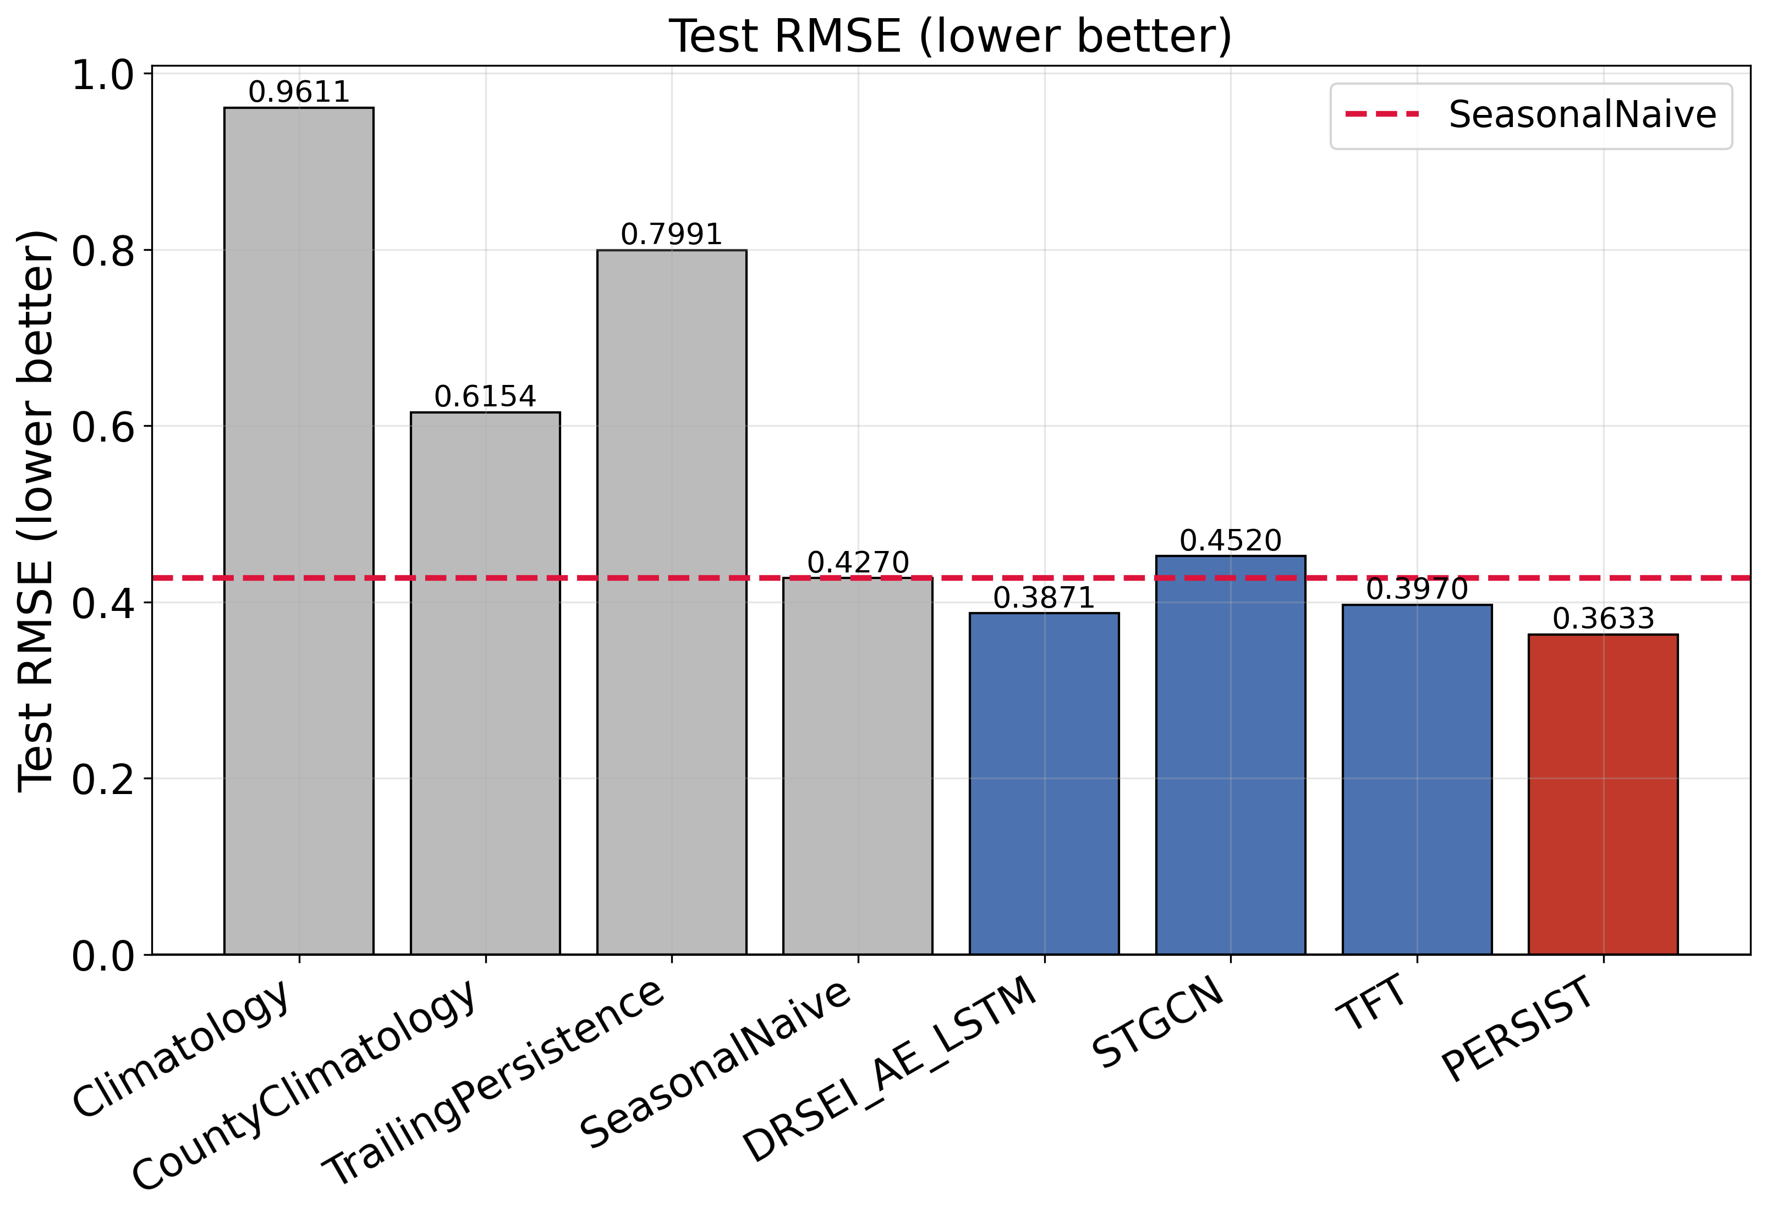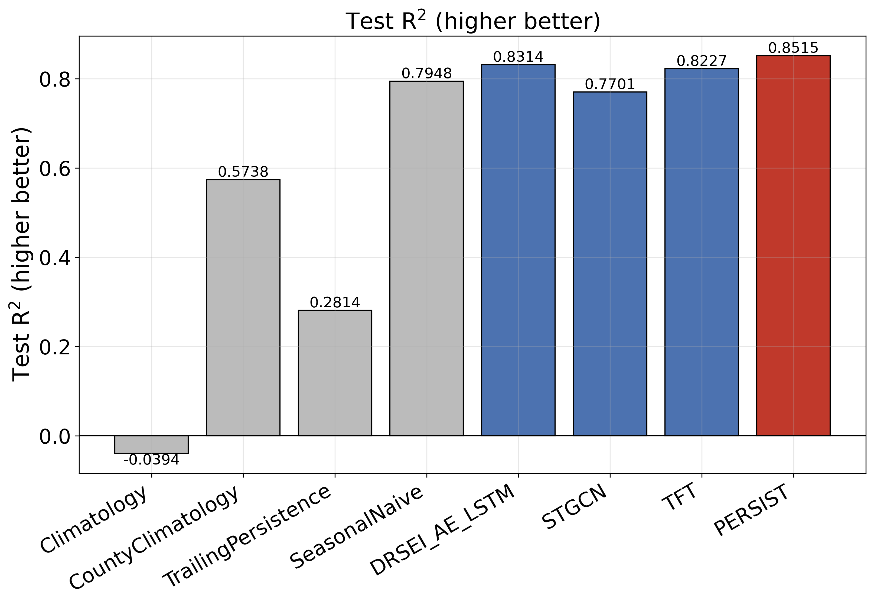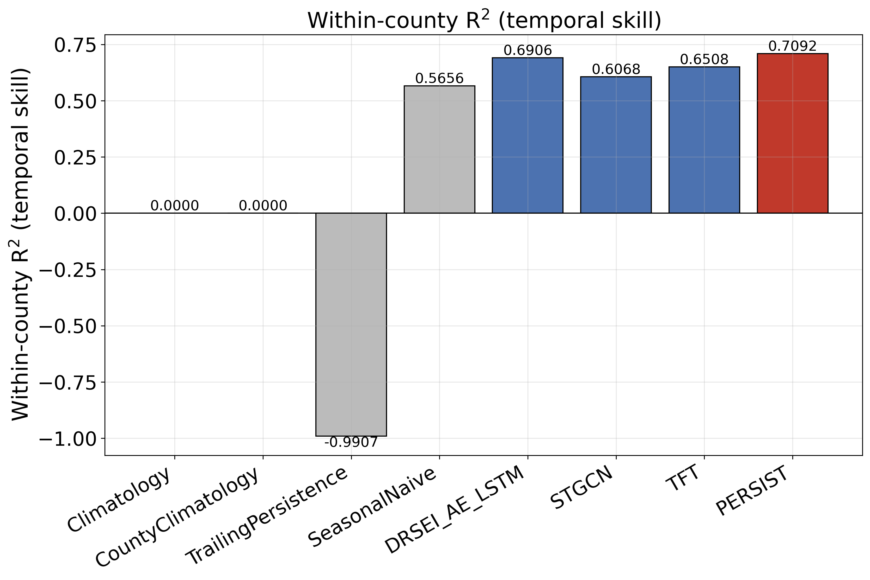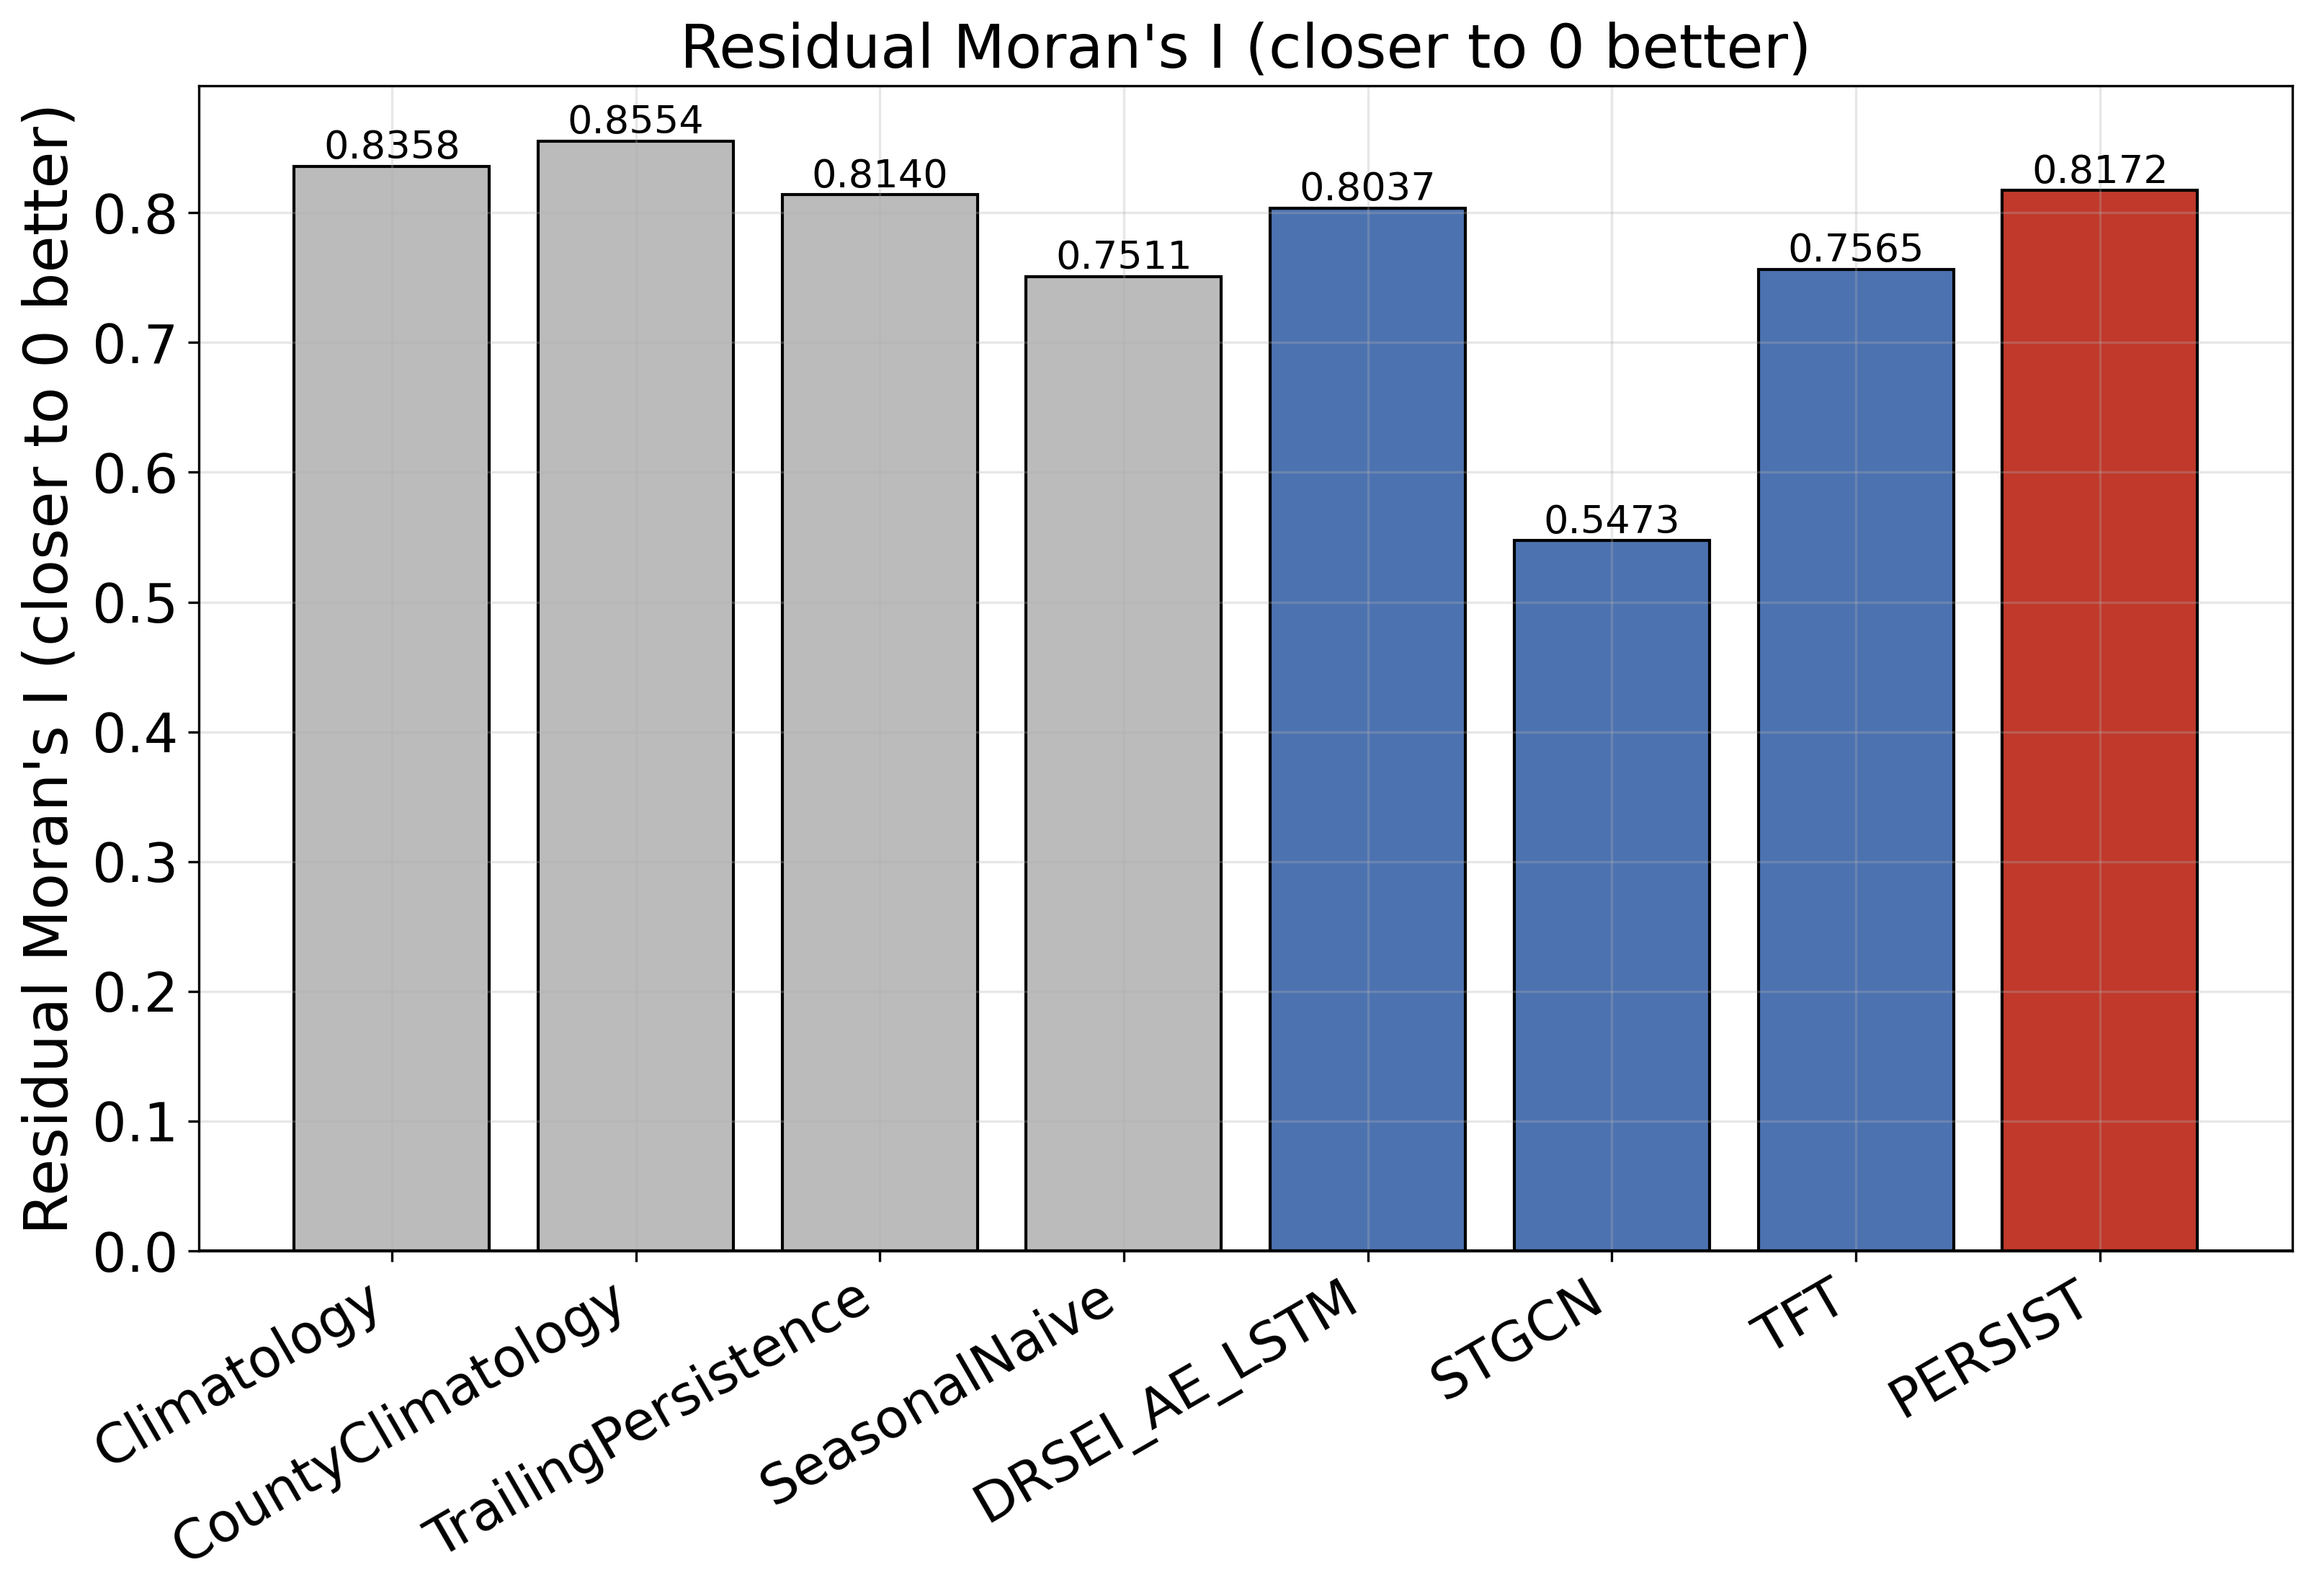
Figure 6. Comparison of PERSIST with the trivial references and retrained deep baselines on (a) RMSE, (b) pooled R², (c) within-county R² and (d) residual Moran's I.
Table 10 shows that PERSIST achieves the best value on eight of the nine reported metrics. Relative to the strongest trivial reference, the seasonal-naive predictor, it reduces RMSE from 0.4270 to 0.3633 (14.9%) and raises within-county R² from 0.5656 to 0.7092, an absolute gain of 0.1436 (25.4% relative). Relative to the strongest deep baseline, DRSEI, it reduces RMSE from 0.3871 to 0.3633 (6.1%). Relative to the TFT, it reduces RMSE by 8.5% with 4.24 times fewer trainable parameters. This last comparison matters in practice because the TFT is the highest-capacity alternative for this data shape.
The comparison also exposes a clear weakness. STGCN reaches a residual Moran's I of 0.5473, compared with 0.8172 for PERSIST. Plain graph convolution therefore absorbs spatial structure better than the gated graph attention used here, even though PERSIST uses two graphs and is explicitly penalised for spatially correlated residuals. Together with the ablation result that the graph pathways fall within seed noise, this indicates that the spatial component of PERSIST needs redesign. A second point concerns the ridge ceiling in Table 3. The pooled R2 of PERSIST (0.8515) is lower than the ridge estimate (0.8716), but the two numbers are not computed on the same basis. The ridge estimator predicts only the primary land-surface-temperature anomaly, whereas the pooled R2 of PERSIST averages both declared targets, including the harder kNDVI anomaly at 0.8177. Restricted to the same single target and the same 34 test windows, PERSIST attains R2 = 0.8884 against 0.8716 and an RMSE of 0.3073 against 0.3297, so it leads the linear ceiling by 0.0168 in R2 and by 6.8% in RMSE. The within-county and stride-3 coefficients quoted throughout are already single-target and need no adjustment: 0.7092 against 0.6685 and 0.8897 against 0.8756, the latter now also reported for every horizon in Table 3. PERSIST therefore exceeds the linear ceiling on every metric once the comparison is placed on a common footing. The two-target pooled coefficient remains the least discriminating quantity reported here because it mixes an easier thermal target with a harder vegetation target, which is why within-county R2 is treated as the primary measure. The final model also clears the pooled acceptance threshold of 0.82 fixed in Section 3.2. Figure 6 compares all models on RMSE, pooled R2, within-county R2 and residual Moran's I.
4.7 Ecological Resilience Assessment of the Study Area
Beyond predictive accuracy, the main scientific output of PERSIST is the set of bounded coefficients from the response decoder, from which recovery rate and resistance are computed for every county and test window. Across the 36,210 held-out county-window pairs, the mean persistence coefficient is 0.2300 (SD 0.0447), giving a mean recovery rate of 0.7700 (range 0.5967–0.8785 across the belt). Mean resistance is 0.9297, and the mean seasonal-carry coefficient is 0.5388, meaning that about 54% of a seasonal anomaly carries over from the same season of the previous year. Table 11 stratifies these quantities by reach and lithological class.
Table 11. Recovered Resilience Parameters by Reach and Lithological Class
Stratum | Counties | Persistence rho | Recovery rate (1-rho) | Resistance (1-|kappa|) | Seasonal carry | Omnibus test vs stratum
Reach: upstream | 438 | 0.2290 | 0.7710 | 0.9119 | 0.5692 | Kruskal-Wallis across reaches: resistance H = 473.5, p < 0.001, eps2 = 0.443
Reach: midstream | 325 | 0.2305 | 0.7695 | 0.9416 | 0.5010 | Kruskal-Wallis across reaches: resistance H = 473.5, p < 0.001, eps2 = 0.443
Reach: downstream | 305 | 0.2309 | 0.7691 | 0.9427 | 0.5354 | Kruskal-Wallis across reaches: resistance H = 473.5, p < 0.001, eps2 = 0.443
Lithology: Non-karst | 349 | 0.2303 | 0.7697 | 0.9394 | 0.5250 | Kruskal-Wallis across lithological classes: resistance H = 257.5, p < 0.001, eps2 = 0.240
Lithology: Partially karst | 310 | 0.2308 | 0.7692 | 0.9337 | 0.5352 | Kruskal-Wallis across lithological classes: resistance H = 257.5, p < 0.001, eps2 = 0.240
Lithology: Majority karst | 409 | 0.2291 | 0.7709 | 0.9184 | 0.5530 | Kruskal-Wallis across lithological classes: resistance H = 257.5, p < 0.001, eps2 = 0.240
Whole belt | 1,068 | 0.2300 | 0.7700 | 0.9297 | 0.5388 | -

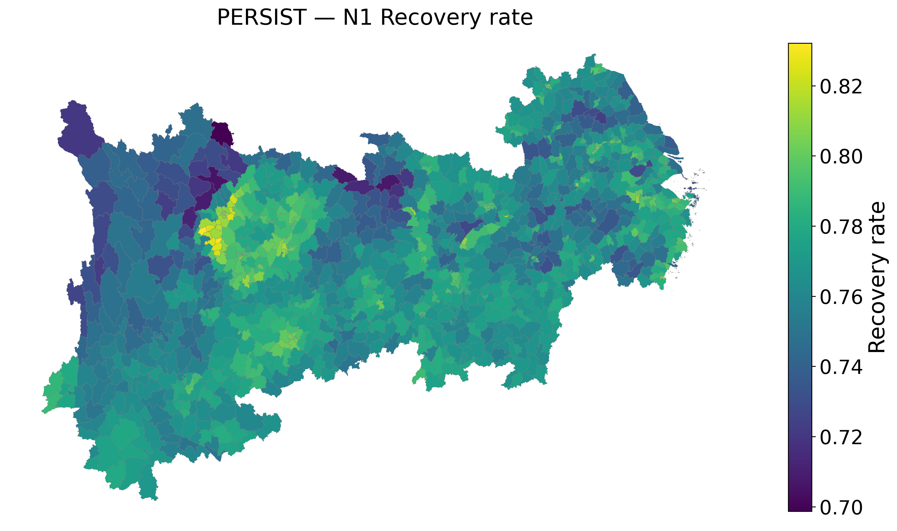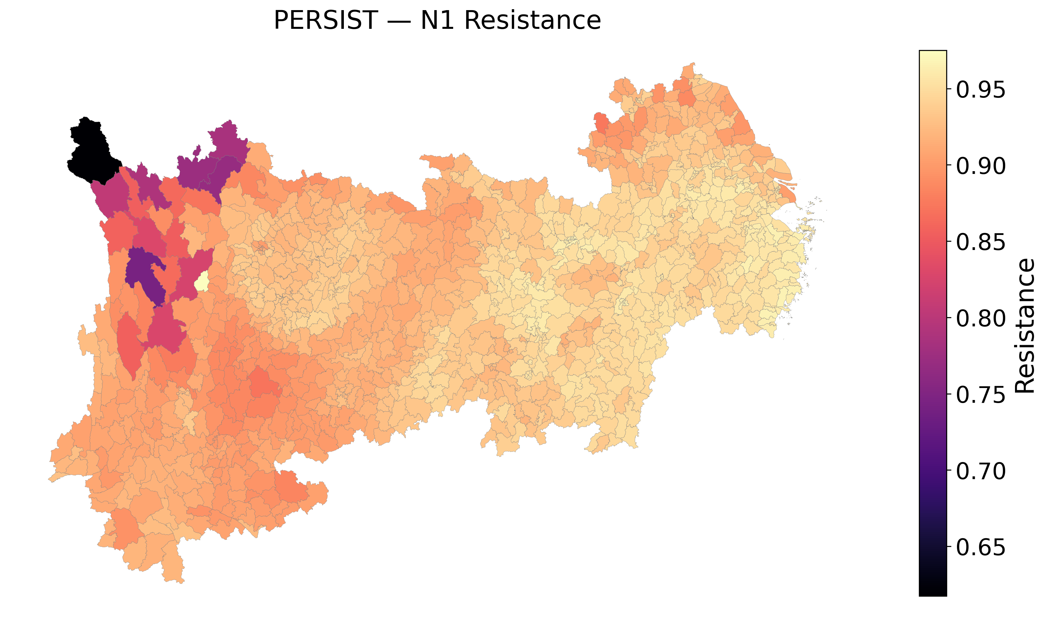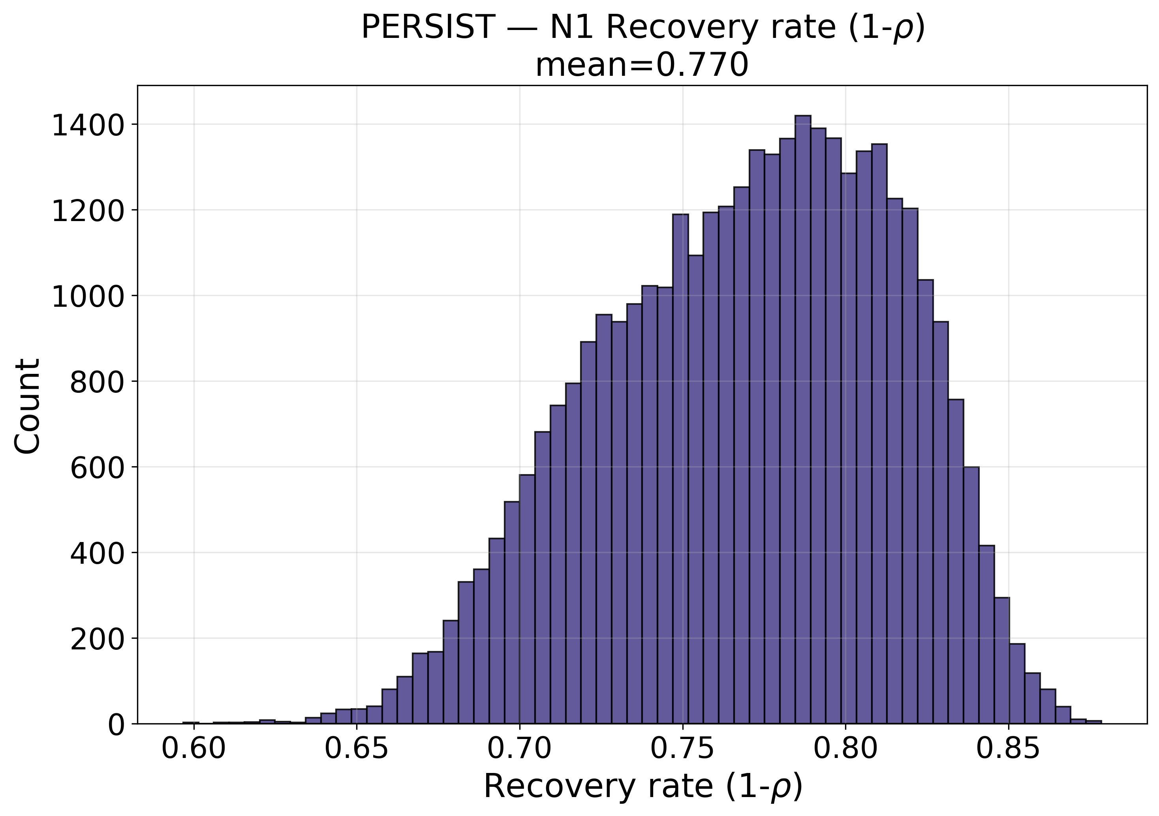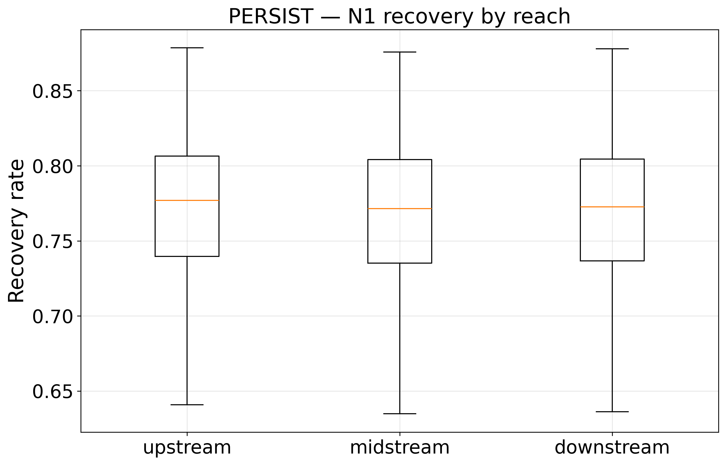
Figure 7. Ecological resilience of the Yangtze River Economic Belt estimated by the response decoder: (a) county-level recovery rate, (b) county-level resistance, (c) distribution of recovery rate across the belt and (d) recovery rate by reach.
Table 11 and Figure 7 show a spatial pattern in resistance but not in recovery. Mean recovery rate is almost identical across the three reaches (0.7691–0.7710), whereas resistance falls from 0.9427 in the lowland downstream reach to 0.9119 in the mountainous upstream reach. Upstream counties therefore do not recover more slowly, but they are less resistant to climatic forcing. This is consistent with thin soils, steep terrain and carbonate geology with limited buffering capacity, although the present data cannot isolate these mechanisms. The seasonal-carry coefficient shows a complementary pattern, rising from 0.5010 in the midstream reach to 0.5692 upstream, which may reflect stronger seasonality of moisture availability in the upper basin. The upstream–downstream contrast agrees with the reach-level resilience gradients reported by Li et al. (2026) [2] and Yao et al. (2025) [6], and the lower resistance of karst counties is consistent with the karst-specific behaviour described by Yang et al. (2025) [24].
The lithological stratification supports conditioning the response on carbonate-rock fraction. Mean resistance declines monotonically from 0.9394 in the 349 non-karst counties to 0.9337 in the 310 partially karst counties and 0.9184 in the 409 majority-karst counties. At the county-mean level, resistance is correlated with carbonate-rock fraction (r = −0.397) and with mean elevation (r = −0.749), and seasonal carry is positively correlated with elevation (r = +0.653). Recovery rate is most strongly correlated with internal relief (r = −0.461) and nighttime light intensity (r = +0.396), so flatter and more brightly lit counties return to their seasonal norm faster. These gradients arise in a model whose lithology-adaptive expert pathway was not distinguishable from noise in the ablation (Table 9). The coefficients therefore describe the recovered response surface, but the mechanism that generates them has not been independently validated.
Table 12. Significance of the reach and lithology contrasts in the recovered resilience parameters. Tests use county-level means (n = 1,068) because county-window pairs are not independent within a county. Pairwise p-values are Holm-corrected [59].
Stratum | Parameter | Kruskal-Wallis H(2) | p | Epsilon-squared | Largest pairwise p (Holm) | Verdict
Reach | Resistance | 473.5 | < 0.001 | 0.443 | 0.016 | significant
Reach | Recovery rate | 1.5 | 0.478 | -0.000 | 0.797 | not significant
Reach | Seasonal carry | 211.7 | < 0.001 | 0.197 | < 0.001 | significant
Lithology | Resistance | 257.5 | < 0.001 | 0.240 | 0.005 | significant
Lithology | Recovery rate | 2.5 | 0.283 | 0.000 | 0.777 | not significant
Lithology | Seasonal carry | 26.3 | < 0.001 | 0.023 | 0.980 | significant
Kruskal-Wallis tests on county-level means confirm the asymmetry described above rather than merely restating it. Resistance differs very strongly across reaches (H = 473.5, p < 0.001, epsilon-squared = 0.443) and across lithological classes (H = 257.5, p < 0.001, epsilon-squared = 0.240), with every pairwise contrast significant after Holm correction; the upstream-versus-downstream contrast in resistance has a Cliff delta of +0.770 and the non-karst-versus-majority-karst contrast +0.618, both large effects. Recovery rate, by contrast, does not differ significantly across reaches (H = 1.48, p = 0.48) or across lithological classes (H = 2.52, p = 0.28), and no pairwise contrast survives correction. Seasonal carry differs significantly in both stratifications (reaches H = 211.7, epsilon-squared = 0.197; lithology H = 26.3, epsilon-squared = 0.023). The claim that the belt shows a spatial pattern in resistance but not in recovery is therefore supported by formal testing and not only by the group means. All correlations reported above are significant at p < 0.001 except carbonate fraction against recovery rate (r = +0.005, p = 0.87), which is consistent with the same conclusion.
5. Conclusion and Future Work
This study introduced PERSIST, a process-informed spatiotemporal framework for interpretable ecological resilience assessment in the Yangtze River Economic Belt. Rather than constructing resilience as a weighted index, PERSIST treats it as a constrained estimation problem in which bounded persistence, seasonal-carry, forcing-sensitivity and offset coefficients are learned for each county and season. Recovery rate and resistance follow directly from these coefficients. The framework combines a hierarchical monthly–annual encoder, dual-graph message passing along contiguity and terrain-derived flow, a lithology-adaptive mixture of experts and an ecologically constrained objective. On 1,068 counties from 2000 to 2020, evaluated against four trivial references and three deep baselines retrained on the same seasonal target, PERSIST reached an RMSE of 0.3633, a pooled R² of 0.8515, a within-county R² of 0.7092 and a stride-3 R² of 0.8897. It reduced RMSE by 14.9% relative to the strongest trivial reference and by 6.1% relative to the strongest deep baseline, with 4.24 times fewer parameters than the TFT. The recovered coefficients form a coherent ecological pattern: upstream counties recover at rates similar to downstream counties but are less resistant, and resistance declines as carbonate-rock cover increases.
Three limitations qualify these results. First, only the response decoder and the annual encoder produced differences larger than seed noise, so only two of the seven designed components can currently be claimed as contributions. Second, residual spatial autocorrelation remains higher than that of a plain STGCN, so the spatial pathway has not delivered its intended benefit. Third, the hydrological graph is derived from terrain rather than mapped river topology, and the model is validated against remote sensing proxies rather than field ecological measurements.
Future work will replace the flow proxy with mapped river-network data, redesign the spatial pathway to reduce residual autocorrelation, add land-use fragmentation and socioeconomic indicators, and validate the recovery and resistance estimates against documented disturbances such as the 2022 Yangtze River drought.
Data Availability: All source datasets are publicly available and are cited as numbered references rather than inline links: MOD11A2 [51], MOD13Q1 [52], TerraClimate [45], Copernicus GLO-30 [53], the World Karst Aquifer Map [50], the harmonised nighttime-light series [54] and its extended release [58], and the DataV.GeoAtlas county boundaries [57]. The derived county panel, the trained model weights, the per-seed metrics and the recovered resilience coefficients are available from the corresponding author on request.
References
[1] Kaur, S. and Sharma, H., 2025. Multimodal graph neural networks for earth observation and sustainable resource management: a comprehensive review and research roadmap. Discover Sustainability, 7(1). https://doi.org/10.1007/s43621-025-02317-z
[2] Li, R., Tang, X., Meng, S., Deng, W., Wei, G., Liu, C. et al., 2026. Spatiotemporal Gradient Evolution and Driving Mechanisms of Ecological Resilience in the Yangtze River Economic Belt: A Multi-Scale Analysis. Applied Spatial Analysis and Policy, 19(3). https://doi.org/10.1007/s12061-026-09943-8
[3] Gong, X., Li, T., Wang, R., Hu, S. and Yuan, S., 2025. Beyond the Remote Sensing Ecological Index: A Comprehensive Ecological Quality Evaluation Using a Deep-Learning-Based Remote Sensing Ecological Index. Remote Sensing, 17(3), pp.558. https://doi.org/10.3390/rs17030558
[4] Li, S., Du, Y., Chen, Z., Li, W., Wu, D. and Zhai, G., 2026. Exploring the Nonlinear Response Patterns and Interaction Effects of Urban Resilience Using the XGBoost-SHAP Model: Evidence from the Yangtze River Economic Belt. ISPRS International Journal of Geo-Information, 15(9), pp.383. https://doi.org/10.3390/ijgi15090383
[5] Aldossary, M., 2025. GTNet: A Graph–Transformer Neural Network for Robust Ecological Health Monitoring in Smart Cities. Mathematics, 14(1), pp.64. https://doi.org/10.3390/math14010064
[6] Yao, J., Wu, H. and Yan, F., 2025. Assessment of the Impact of Climate Change on the Ecological Resilience of the Yangtze River Economic Belt. Sustainability, 17(18), pp.8265. https://doi.org/10.3390/su17188265
[7] Tang, L., Zhou, Z., Zhao, H., Qian, Z., Hou, S. and Zhang, K., 2025. Spatial-Temporal Evolution Characteristics of Water Ecological Resilience and Non-Stationarity of Influencing Factors: a Case Study of the Yangtze River Economic Belt. Water Resources, 52(6), pp.1318-1339. https://doi.org/10.1134/s0097807825700289
[8] Fu, S., Liao, Y., Lv, T., Zhao, Q., Chen, A., Yuan, M. et al., 2026. Driving factors and multi-scenario simulation of ecological resilience in the middle reaches of the Yangtze river metropolitan area. Environment, Development and Sustainability. https://doi.org/10.1007/s10668-026-07320-6
[9] Chen, X., Zhao, Y., Zhou, C. and Cai, Y., 2026. Nonlinear Impact of Population Shrinkage on Urban Ecological Resilience: A Threshold Effect Analysis Based on City-Level Panel Data from the Yangtze River Economic Belt, China. Land, 15(2), pp.261. https://doi.org/10.3390/land15020261
[10] Ding, X., Wang, Y., Wang, H. and Zhou, Y., 2026. Spatiotemporal heterogeneity and synergy driving mechanisms of county ecological resilience in optimized urban agglomerations: integrated geographical detector-Bayesian spatiotemporal model. Scientific Reports. https://doi.org/10.1038/s41598-026-66902-6
[11] Zhong, X., Zheng, R., Chen, W., Lv, L. and Wei, Z., 2025. Regional differences, dynamic evolution, and driving factors of ecological resilience in China’s urban agglomerations. Scientific Reports, 15(1). https://doi.org/10.1038/s41598-025-20575-9
[12] Wan, Q., Guo, M. and Pan, F., 2025. Spatial gap and two-dimensional decomposition of urban ecological resilience in China. Frontiers in Built Environment, 11. https://doi.org/10.3389/fbuil.2025.1690346
[13] Tong, A., Zhou, Y., Zheng, J. and Liu, Z., 2025. Decrypting Spatiotemporal Dynamics and Optimization Pathway of Ecological Resilience Under a Panarchy-Inspired Framework: Insights from the Wuhan Metropolitan Area. Remote Sensing, 17(24), pp.3941. https://doi.org/10.3390/rs17243941
[14] Li, S., Li, K., Qian, H., Gao, Y., Chen, J., Wu, P. et al., 2026. Scenario-based modeling and driver analysis of ecological resilience: A framework study in the Qinling-Daba Mountains. Journal of Geographical Sciences, 36(7), pp.1701-1730. https://doi.org/10.1007/s11442-026-1510-0
[15] Zhao, C., Liu, P., Meng, F., Dong, G., Zhuo, W., Wang, Q. et al., 2026. Simulation-Based Multi-Scenario Assessment of Comprehensive Ecological Risk and Resilience: A Case Study of the Pearl River Delta. Sustainability, 18(17), pp.9069. https://doi.org/10.3390/su18179069
[16] Li, C., Shi, J., Chen, Y., Zou, W., Chen, A. and Pan, Y., 2025. Assessment and Simulation of Urban Ecosystem Resilience by Coupling the RAR and Markov–FLUS Models: A Case Study of the Jinan Metropolitan Area. Sustainability, 17(12), pp.5305. https://doi.org/10.3390/su17125305
[17] Zhang, Z. and Wu, Y., 2025. Spatiotemporal Evolution and Influencing Factors of Urban Ecological Resilience: Evidence from the Yellow River Basin, China. Sustainability, 17(15), pp.7114. https://doi.org/10.3390/su17157114
[18] He, X., Wu, B., Shen, G. and Fan, T., 2025. Spatial and Functional Heterogeneity in Regional Resilience: A GIS-Based Analysis of the Chengdu–Chongqing Economic Mega Region. Land, 14(9), pp.1769. https://doi.org/10.3390/land14091769
[19] Yue, Y., Lu, S., Liu, X., Liu, Y. and Cao, S., 2026. Interpretable-Machine-Learning-Driven Socio-Ecological Resilience Pathways in a Resource-Exhausted City: Evidence from Jiaozuo, China. Sustainability, 18(14), pp.7183. https://doi.org/10.3390/su18147183
[20] Qu, L., Liu, K., Zhi, J., Jiang, W., Wu, J., Luo, Y. et al., 2026. Interpretable Machine Learning for Diagnosing Remote Sensing Ecological Index-Derived Ecological Quality Dynamics in the Yangtze River Delta. Land, 15(7), pp.1167. https://doi.org/10.3390/land15071167
[21] Cheng, Y., Zhang, X., Yu, S., Liu, Y., Hu, J., Jiang, Y. et al., 2026. Leveraging Explainable Machine Learning to Decipher Ecosystem Health and Nonlinear Dynamics in the Henan Yellow River Basin. Land, 15(3), pp.429. https://doi.org/10.3390/land15030429
[22] Fu, K., Wu, J. and Huang, Y., 2026. Exploring the Nonlinear Effects of the Built Environment on Ecological Resilience in a High-Density City: A Case Study of Wuhan. Buildings, 16(4), pp.844. https://doi.org/10.3390/buildings16040844
[23] Xie, S., Cheng, X., Jin, M., Jiang, Y., Liu, J. and Liu, Z., 2025. Satellite-Driven Evaluation of Ecological Environmental Quality Based on the PSR Framework. Remote Sensing, 18(1), pp.31. https://doi.org/10.3390/rs18010031
[24] Yang, X., Tian, H., Wang, Y., Xue, Y., Lv, J. and Wen, T., 2025. Karst remote sensing ecological index KRSEI for monitoring ecological quality in Southwest China. Scientific Reports, 15(1). https://doi.org/10.1038/s41598-025-20425-8
[25] Wang, X., Wang, D., Chen, J. and Lin, M., 2026. A Health Assessment of Terrestrial Ecosystems in China Based on the Adaptive Indicator Reduction Method. Remote Sensing, 18(5), pp.786. https://doi.org/10.3390/rs18050786
[26] Li, K., Li, X., Hu, W. and Xu, J., 2025. Spatiotemporal Patterns and Driving Forces of Ecological Quality in the Yangtze River Economic Belt Using GWRR. Sustainability, 18(1), pp.256. https://doi.org/10.3390/su18010256
[27] Zhu, H., Wang, A., Wang, P., Hu, C. and Zhang, M., 2025. Spatiotemporal Dynamics and Response of Land Surface Temperature and Kernel Normalized Difference Vegetation Index in Yangtze River Economic Belt, China: Multi-Method Analysis. Land, 14(3), pp.598. https://doi.org/10.3390/land14030598
[28] Soula, A., Zayas, A.D., Ksantini, R. and Gomez, P.M., 2026. An effective BiLSTM-CNN model for predicting large-scale temporal-spatial dynamics of normalized difference vegetation index. Scientific Reports, 16(1). https://doi.org/10.1038/s41598-026-55191-8
[29] Ke, Y., Liu, D., Wang, P., Zheng, X. and Hu, Y., 2026. GT-LandSDS: A Novel Spatiotemporal Integrated Framework for Land Use Simulation by Coupling Cellular Automata with Graph Attention Network and Transformer. Remote Sensing, 18(17), pp.3023. https://doi.org/10.3390/rs18173023
[30] Yang, Y., Wang, J., Wu, P., Liu, Y. and Zhao, X., 2026. Combining Large Language Models with Satellite Embedding to Comprehensively Evaluate the Tibetan Plateau’s Ecological Quality. Remote Sensing, 18(4), pp.643. https://doi.org/10.3390/rs18040643
[31] Yuan, J., Li, Y., Cheng, Z., Sun, X. and Liu, D., 2026. Deep learning for mangrove change prediction: Gaoqiao Mangrove, China. Frontiers in Marine Science, 13. https://doi.org/10.3389/fmars.2026.1632093
[32] Yang, L., 2026. Remote sensing assessment of tourism ecological environment quality using a ResNeXt-YOLOv5s-LSTM framework. GeoJournal, 91(4). https://doi.org/10.1007/s10708-026-11666-9
[33] Li, Z., Zhao, L., Lu, Y., Ma, Y. and Li, G., 2026. Mamba for Remote Sensing: Architectures, Hybrid Paradigms, and Future Directions. Remote Sensing, 18(2), pp.243. https://doi.org/10.3390/rs18020243
[34] Wei, W., Zhang, Z. and Xia, J., 2026. Multi-Scenario Regional Spatial Simulation Based on the Unet++ Architecture: A Case Study of the Yangtze River Economic Belt. Land, 15(4), pp.657. https://doi.org/10.3390/land15040657
[35] Liu, P., Wen, T., Han, R. and Wu, S., 2025. Study on RSEI Changes Using Remote Sensing and Markov-FLUS Modeling Approach. Sustainability, 17(22), pp.10267. https://doi.org/10.3390/su172210267
[36] Guo, J., Wei, X., Zhang, F. and Ding, Y., 2025. Coupled Assessment of Land Use Changes and Ecological Benefits Using Multi-Source Remote Sensing Data. Agriculture, 15(13), pp.1358. https://doi.org/10.3390/agriculture15131358
[37] Yu, D.z., Huang, Y., Yang, J.w., Song, X.r. and Chen, X.s., 2026. Is ecological quality of river-connected lake basin higher than disconnected lake basins in the lower reaches of the Yangtze River, China?. Environmental Monitoring and Assessment, 198(5). https://doi.org/10.1007/s10661-026-15385-z
[38] Peng, R., Hu, Y., Zhang, W., Shi, T. and Huang, J., 2026. How Digital Technological Innovation Influences the Coordination Between Urban Renewal and Ecological Resilience: Evidence from China’s Yangtze River Economic Belt. Sustainability, 18(12), pp.6322. https://doi.org/10.3390/su18126322
[39] Ma, J., Wang, M. and Cheng, C., 2026. How Does the Improvement of Ecological Compensation Efficiency Affect Urban Economic Resilience? Evidence from the Yangtze River Economic Belt in China. Sustainability, 18(13), pp.6410. https://doi.org/10.3390/su18136410
[40] Kong, S., Zhang, C., Zhang, M. and Lu, W., 2025. Heterogeneity analysis of the effects of new quality productive forces on ecological resilience in the Yangtze River Delta Economic Belt. Scientific Reports, 15(1). https://doi.org/10.1038/s41598-025-05298-1
[41] Yang, S., 2025. Spatiotemporal Evolution and Driving Mechanisms of Coupling Coordination Between Green Innovation Efficiency and Urban Ecological Resilience: Evidence from Yangtze River Delta, China. Sustainability, 17(19), pp.8528. https://doi.org/10.3390/su17198528
[42] Wang, H., Mao, Y., Chen, C., Li, Y., Zhang, R. and Zhu, M., 2026. Spatiotemporal evolutionary characteristics of rural digitalization and ecosystem services: a county-level analysis of the Yangtze River economic belt. Frontiers in Ecology and Evolution, 14. https://doi.org/10.3389/fevo.2026.1900995
[43] Yu, B., Yin, H. and Zhu, Z., 2018. Spatio-temporal graph convolutional networks: a deep learning framework for traffic forecasting. Proceedings of the 27th International Joint Conference on Artificial Intelligence (IJCAI), pp.3634-3640. https://doi.org/10.24963/ijcai.2018/505
[44] Lim, B., Arık, S.Ö., Loeff, N. and Pfister, T., 2021. Temporal Fusion Transformers for interpretable multi-horizon time series forecasting. International Journal of Forecasting, 37(4), pp.1748-1764. https://doi.org/10.1016/j.ijforecast.2021.03.012
[45] Abatzoglou, J.T., Dobrowski, S.Z., Parks, S.A. and Hegewisch, K.C., 2018. TerraClimate, a high-resolution global dataset of monthly climate and climatic water balance from 1958-2015. Scientific Data, 5, 170191. https://doi.org/10.1038/sdata.2017.191. Accessed via the Microsoft Planetary Computer STAC collection 'terraclimate'.
[46] Camps-Valls, G., Campos-Taberner, M., Moreno-Martínez, Á., Walther, S., Duveiller, G., Cescatti, A. et al., 2021. A unified vegetation index for quantifying the terrestrial biosphere. Science Advances, 7(9), eabc7447. https://doi.org/10.1126/sciadv.abc7447
[47] Gupta, H.V., Kling, H., Yilmaz, K.K. and Martinez, G.F., 2009. Decomposition of the mean squared error and NSE performance criteria: implications for improving hydrological modelling. Journal of Hydrology, 377(1-2), pp.80-91. https://doi.org/10.1016/j.jhydrol.2009.08.003
[48] Willmott, C.J., 1981. On the validation of models. Physical Geography, 2(2), pp.184-194. https://doi.org/10.1080/02723646.1981.10642213
[49] Moran, P.A.P., 1950. Notes on continuous stochastic phenomena. Biometrika, 37(1/2), pp.17-23. https://doi.org/10.2307/2332142
[50] Goldscheider, N., Chen, Z., Auler, A.S., Bakalowicz, M., Broda, S., Drew, D., Hartmann, J., Jiang, G., Moosdorf, N., Stevanovic, Z. and Veni, G., 2020. Global distribution of carbonate rocks and karst water resources. Hydrogeology Journal, 28(5), pp.1661-1677. https://doi.org/10.1007/s10040-020-02139-y. Carbonate-rock polygons taken from the World Karst Aquifer Map (WOKAM), 2017 edition, scale 1:40,000,000, BGR, IAH, KIT and UNESCO, distributed at https://www.bgr.bund.de/whymap/EN/Maps_Data/Wokam/wokam_node_en.html.
[51] LP DAAC, 2022. MOD11A2 v006. MODIS/Terra land surface temperature/emissivity 8-day L3 global 1 km SIN grid. https://planetarycomputer.microsoft.com/dataset/modis-11A2-061
[52] MOD13Q1 MODIS/Terra Vegetation Indices 16-Day L3 Global 250m SIN Grid V006. NASA EOSDIS Land Processes DAAC. https://doi.org/10.5067/MODIS/MOD13Q1.006. https://planetarycomputer.microsoft.com/dataset/modis-13Q1-061
[53] European Space Agency, 2021. Copernicus Global Digital Elevation Model (GLO-30). https://doi.org/10.5270/ESA-c5d3d65. https://planetarycomputer.microsoft.com/dataset/cop-dem-glo-30.
[54] Li, X., Zhou, Y., Zhao, M. and Zhao, X., 2020. A harmonized global nighttime light dataset 1992–2018. Scientific Data, 7, 168. https://doi.org/10.1038/s41597-020-0510-y This publication documents the 1992-2018 record; the 2000-2020 series used here is taken from the extended release of the same repository, cited separately as [58].
[55] Loshchilov, I. and Hutter, F., 2019. Decoupled weight decay regularization. International Conference on Learning Representations (ICLR).
[56] Cho, K., van Merriënboer, B., Gulcehre, C., Bahdanau, D., Bougares, F., Schwenk, H. and Bengio, Y., 2014. Learning phrase representations using RNN encoder–decoder for statistical machine translation. Proceedings of EMNLP, pp.1724-1734. https://doi.org/10.3115/v1/D14-1179.
[57] DataV.GeoAtlas, 2023. China administrative boundary service, county level (GB/T 2260 codes). Alibaba Cloud. https://datav.aliyun.com/portal/school/atlas/area_selector (accessed 2025).
[58] Li, X., Zhou, Y., Zhao, M. and Zhao, X., 2020. A harmonized global nighttime light dataset, extended annual release covering 1992-2021. figshare dataset. https://doi.org/10.6084/m9.figshare.9828827. The 2000-2020 subset of this release is used in the present study.
[59] Holm, S., 1979. A simple sequentially rejective multiple test procedure. Scandinavian Journal of Statistics, 6(2), pp.65-70.

