FOWT-ARISE: A Physics-Informed Adaptive Reinforcement Learning Framework for Real-Time Structural Load Relief in Floating Offshore Wind Turbines Under Imperfect IoT Observations
Abstract
The issue of mitigation of structural fatigue loads for floating offshore wind turbines is an essential component in the process of creating efficient offshore wind energy systems. Despite having great potential for intelligent control of wind turbines, reinforcement learning methods have some serious drawbacks at present. Particularly, they are unable to utilize physics-based knowledge of structure, synchronize multiple actuators, balance fatigue mitigation with power/actuation losses, and provide reliable control in presence of imperfect IoT data. Therefore, in our research we present a new reinforcement learning framework A Physics-Informed Adaptive Reinforcement Learning Framework for Real-Time Structural Load Relief in Floating Offshore Wind Turbines Under Imperfect IoT Observations (FOWT-ARISE) aimed at solving the problem of adaptive structural load relief in floating offshore wind turbines. Firstly, the proposed FOWT-ARISE introduces physics-informed load-path information, governing-section fatigue characteristics and controllable-load information to the state representation to provide structural-load-aware observations. Then the Adaptive Multi-Actuator Control module learns the policy of applying pitch, individual pitch control and yaw actions and simultaneously decides on the amount of control required and no-control scenarios. Next, the Fatigue–Power–Actuation Multi-Objective Reward function ensures balancing of fatigue reduction and actuation losses with power losses. Additionally, the IoT-Degradation-Aware Robust Reinforcement Learning technique trains the policy on imperfect IoT observations including noisy, dropped, biased and stale measurements to enhance reliability of control under realistic IoT sensing conditions. The proposed framework is assessed by physics-informed floating offshore wind turbine transition data and action-sweep counterfactual evaluation with RB-FOWT, CQL and IQL baselines and component-wise ablations. The experimental evaluation of the current framework implementation provides 0.0651 matched sweep objective, 0.9520 mean DEL ratio, 4.80% fatigue relief and 5.20% power loss rate while having 100% action-sweep coverage and only 2.07% increase in the level of IoT robustness reduction. In addition, the component-wise ablation study allows to analyze individual contribution of the physics-informed state representation, adaptive multi-actuator control, multi-objective reward and IoT-degradation-aware training components.
Keywords: Floating Offshore Wind Turbines, Structural Load Relief, Reinforcement Learning, Physics-Informed Learning, Adaptive Multi-Actuator Control, Fatigue Damage, IoT Robustness, Offshore Wind Energy.

1. Introduction
Floating Offshore Wind Turbines (FOWTs) are gaining more attention as an innovative way of tapping valuable wind sources in deep-water locations where fixed-bottom platforms are challenging to implement. However, a new class of complex coupled aero-hydro-servo-elastic dynamics emerges due to the floating nature of these platforms and significantly impacts structural loads, platform dynamics, fatigue, and control. The impact of these phenomena becomes even more relevant in the process of trying to relieve structural fatigue without unnecessary power production losses and actuator consumption. Furthermore, growing use of sensors, IoT technologies, and smart control creates opportunities for implementing adaptable data-driven solutions. Recent review papers show that artificial intelligence is becoming more widespread in FOWT design, structural health monitoring, control, and digital-twin frameworks, though simulation-heavy validation, uncertainty and reliability issues, and lack of experimental evidence at field scale still pose challenges.
The application of machine learning and intelligent control methods has lately been critical to the enhancement of FOWT performance. Kostecka et al. [1] offer a detailed literature review of applications of AI in FOWTs in terms of design and surrogate modelling, structural health monitoring, control, and digital twins. Among the most promising trends, the authors identify reinforcement learning, physics informed hybrid approaches and digital twins, although there are still some challenges connected with simulation-based validation, uncertainty, and reliability. As a literature review, however, it fails to develop a reinforcement learning approach with consideration of the structural loads, actuators and sensors. Pastor-Sanchez et al. [2] offer a framework of a real-time Internet-of-Things-based digital twin for structural health monitoring in FOWT based on the hydro-elastic reduced order model. The proposed approach was tested on the 5 MW OC4-DeepCWind semi-submersible platform. It allowed reconstructing displacements, stresses and fatigue quantities with great accuracy in comparison to high-fidelity finite element analysis with much smaller computational costs. However, it is still focused on monitoring and structural analysis, but not on control. Thus, no loop between the structural observation and actuation has been closed in both works, making it an unresolved research problem to combine Internet-of-Things observation with reinforcement learning control.
A reinforcement-learning-based approach for floating wind turbine control by Xie et al. [3] considered the implementation of both IPC and CPC as an optimal policy to regulate the power production while at the same time reducing the structure loads. Developed on an incremental model-based dual heuristic programming approach, it eliminates the need for analytical system model through online learning of system dynamics. The work is an illustration of the potential of RL in solving the conflicting requirements of power regulation and load reduction in FOWTs. However, the approach focuses solely on pitch actuation and does not provide an adaptive strategy that considers the yaw actuation as well as the imperfect IoT observations. More research should therefore be done on the multi-actuator RL strategies that would address not only the load reduction, but also the choice of appropriate actuator and moments when there is no need to intervene with the wind turbine. The output-constrained individual pitch control approaches for reducing fatigue loads and actuator effort have been investigated by Hummel et al. [4]. Using the multiblade coordinate formulation, they minimize the actuation effort while at the same time allowing the operation between no IPC and full IPC regimes. This paper proves that the actuator effort needs to be taken into account along with fatigue load reduction. Nevertheless, these approaches remain the constrained control approaches and do not include the floating platform dynamics as well as the imperfect sensor data.
More recently, Dong et al. [5] suggested HysteresisPPO for yaw control of large-scale wind turbines. The approach implements hysteresis-aware mechanisms in PPO in order to reduce excessive yaw state switching and balance power generation and yaw actuation frequency. Simulation experiments have shown an increase in energy capture and mechanical load performance comparing to conventional RL-based yaw controllers, and disturbance experiments have revealed the impact of feedback-dependent control under sensor-related disturbances. However, the work studies large-scale wind turbines rather than floating platforms and its objective does not address the structural fatigue minimization as the main goal of the controller. As a result, an additional research is required for development of a reinforcement learning framework with adaptation of yaw and pitch actuation and explicit fatigue loads objectives as well as robustness to imperfect observations in FOWTs.
Though there have been many recent developments in the field of AI-based control of FOWTs, many open research questions still exist. Currently, there is fragmentation of research on this topic in the areas of monitoring, digital twins, structural-load control, and actuator optimization, but there is no research done with regard to how all of these can fit into one integrated sequential decision-making framework. The current approaches mostly focus on optimization of just one actuator or one objective, while for effective load mitigation, multiple actuators including pitch offset, individual pitch control, and yaw actions should be utilized. Mitigation of the fatigue loads should not be done separately from the power generation and the actuators usage since the overly aggressive control might mitigate the loads at the expense of the excessive power generation or actuator degradation. Finally, learning-based methods currently use clean simulation data and do not take into account the problems with real-life data such as sensor noise, dropout, bias, and staleness, which is a problem in the context of real-life IoT. To fill the gap, we propose FOWT-ARISE – a physics-informed reinforcement learning framework for real-time mitigation of the structural loads under imperfect IoT observations. Therefore, the proposed FOWT-ARISE framework transforms the common formulation of the FOWT loads mitigation task from the isolated actuator-optimization problem into the physics-informed sequential decision-making problem, where the controller learns what structural loads are controllable, which actuator should be used, how strong actuation is required and when the intervention is better to be avoided. The proposed framework is verified using physics-informed FOWT transition data and action sweep counterfactual evaluation along with offline RL baselines and component-wise ablation experiments.
The major contributions of this research are summarized as follows:
- A Physics-Informed Load-Aware State Representation is introduced to incorporate structural-load decomposition, governing-section fatigue characteristics, and controllable-load information into the reinforcement learning state, enabling the policy to make load-aware control decisions rather than relying solely on conventional environmental and turbine measurements.
- An Adaptive Multi-Actuator Control mechanism is developed to jointly learn pitch, individual pitch control, and yaw actions while adapting the magnitude and necessity of intervention according to operating conditions and estimated control authority.
- A Fatigue–Power–Actuation Multi-Objective Reward formulation is proposed to explicitly balance structural fatigue reduction with power-generation preservation and actuator usage, addressing the fundamental trade-off between load mitigation and control cost.
- An IoT-Degradation-Aware Robust Reinforcement Learning strategy is introduced to account for imperfect sensor observations, including noise, dropout, bias, and stale measurements, thereby improving the suitability of the learned controller for realistic sensing environments.
2.Literature Survey
Recent progress in intelligent control of wind energy systems has been mostly associated with reinforcement learning, adaptive control, structural load prediction, and data-driven modeling approaches. Among those research lines, there have been several works dedicated to application of reinforcement learning to wind-farm control, FOWT pitch and yaw control, and load-aware control, while others concentrated on structural monitoring, fatigue prediction, digital twins, and IoT-driven wind energy systems. However, the described research lines did not interact much, and there was no attempt to combine those directions into a unified framework for real-time load relief of FOWTs. Bizon Monroc et al. [6] suggested a multi-agent reinforcement learning benchmark for wind-farm control, where each individual turbine could change yaw, pitch or torque actions in order to explore trade-offs between power generation and structural loads. The benchmark provided a unified environment for investigation of multi-agent wind-farm control approaches and improved reproducibility compared to the RL experiments run individually. However, the turbines used in the benchmark were only fixed-bottom and the IoT degradations and floating-platform dynamics were not explicitly considered in it. Hence, there is a research gap in extension of the proposed RL benchmarks to FOWTs with simultaneous pitch and yaw actions and platform motion observations.
Didier et al. [7] explored model-free deep reinforcement learning controller based on Trust Region Policy Optimization (TRPO) for collective blade-pitch regulation of a 5 MW semi-submersible FOWT. Actor-critic architecture was trained on simulated and software-in-the-loop wave basin datasets and showed better load regulation compared to conventional gain-scheduled PI pitch control. This work is especially important, since it gives the physical validation step beyond pure numerical FOWT simulations. However, the validation is still a scaled down physical proxy instead of a full-scale IoT-enabled turbine and yaw actuation is not involved into the control process. Hence, there is a research gap in extension of RL-FOWT control to pitch and yaw control under real-time IoT observations. Dong et al. [8] proposed HysteresisPPO for yaw control of large-scale wind turbines, where the hysteresis mechanism was applied to the PPO framework. The approach is aimed at suppression of unnecessary yaw switching while preserving yaw-error tracking performance and minimizing yaw energy consumption. It shows the necessity of considering actuation smoothness in case of RL-based control of wind turbines. However, the discussed turbine is fixed-bottom and the reward function was not designed to address structural fatigue or floating-platform loads. Therefore, there is a research gap in consideration of hysteresis principles in design of fatigue-aware RL controller.
Ferahtia et al. [9] developed a robust pitch angle controller for FOWTs based on optimized active disturbance rejection control (OADRC), where the controller parameters were optimized by the means of Red-Tailed Hawk metaheuristic optimization algorithm and validated on simulated FOWT dataset. The proposed strategy outperforms the classical gain-scheduled PID controller in terms of disturbance rejection and platform-motion stability. However, the method is based on metaheuristic optimization and does not involve any reinforcement learning and does not explicitly address the IoT degradations. Hence, there is a research gap in development of adaptive RL-based pitch controller which would learn control policies taking into account real imperfect sensing conditions. Hummel et al. [10] proposed output-constrained individual pitch control methods based on the multiblade coordinate transformation. The proposed formulation clearly shows that structural load mitigation should not be optimized separately from actuator effort, since the excessive pitch activity imposes additional mechanical and operational costs. However, the work is based on classical constrained optimization methods, while not involving any reinforcement learning and does not consider the investigated turbines being floating. Therefore, there is a research gap in RL learning of the load–actuation trade-off taking into account floating-platform dynamics.
Huang et al. [11] proposed reinforcement-learning-optimized fuzzy PID controller for a 10 MW wind-turbine yaw system using a distributed co-simulation framework. The architecture couples an OpenFAST turbine model and Simulink controller by means of networked data exchange, hence representing communication and sampling constraints important for practice of connected control systems. The RL-tuned controller reduces yaw-rate fluctuations and yaw energy consumption while preserving alignment performance. However, the studied system is not a floating turbine and structural fatigue metrics are not the primary control objectives. Hence, there is a need for further research of the integration of communication-aware adaptive yaw control with explicit FOWT structural load mitigation. Ismaiel [12] developed a multivariate machine learning framework for predicting wind turbine blade structural dynamics using OpenFAST-generated datasets for different turbulence classes. Several machine learning models were considered, where random forest gave the best cross-dataset generalization for blade-tip deflection and root-load prediction. It shows the potential of data-driven structural representations in case of changing turbulence. However, the turbine considered is land-based and the predicted structural variables are not used for closed-loop control policy. Hence, there is a research gap in using robust structural load representations as an input to an adaptive RL controller for floating wind turbines.
Jeon et al. [13] performed a parametric analysis of control techniques for a 15 MW semi-submersible FOWT using peak shaving, nacelle feedback, feedforward control and individual pitch control in order to simultaneously regulate power generation, tower loads, platform motion, rotor speed fluctuations and blade loads. Their composite controller demonstrates the importance of considering several operational and structural objectives simultaneously. However, the architecture involves hand-designed classical control loops and not a unified learning-based policy. Hence, there is a research gap in replacing such manually integrated multi-objective control structure by an adaptive RL policy. Jia et al. [14] presented a review of AI-driven fault detection and operations and maintenance (O&M) methods for wind-turbine drivetrains, which considers SCADA-based condition monitoring, component diagnosis, remaining useful life estimation and digital twin integration. The review emphasizes the importance of integration of heterogeneous operational data and intelligent monitoring methods into end-to-end O&M workflow. However, the focus of the review is mostly drivetrain health and maintenance rather than floating-platform structural fatigue or load mitigation. Hence, there is a research gap in connecting AI-based condition monitoring with an RL controller, which would be capable of adapting structural load-relief actions.
Jin and Fu [15] proposed an improved model predictive pitch control technique using LiDAR-based wind preview information. Using information about wind preview conditions, the controller decreases blade and tower loads compared to feedback-only pitch control in simulations. The work shows the potential of predictive environmental observations for proactive load mitigation. However, the proposed controller is a deterministic MPC controller rather than a learned RL policy, and the investigated turbine does not include floating-platform dynamics. Hence, there is a research gap in combination of the preview or advanced sensing information with an adaptive RL policy capable of joint control of pitch and yaw for floating turbines. Kadoche et al. [16] studied the problem of design of deep reinforcement learning policies for wind-farm flow control, where they perform a systematic study of observation design, reward shaping and training curriculum for wake-steering agents. Their ablation analysis shows that state and reward formulation choices can significantly affect policy robustness and sample efficiency. It gives useful guidance for development of reliable RL controllers for complex wind energy systems. However, the work is mainly devoted to wind farm flow control without explicitly addressing FOWT structural fatigue, floating-platform dynamics or IoT degradations. Hence, there is a research gap in adaptation of the described RL design principles to structural load relief control of FOWTs.
Kostecka et al. [17] performed a critical review of artificial intelligence applications in FOWTs, which covers design, structural health monitoring, control and digital twins. The work highlights reinforcement learning, surrogate modeling and digital twin technologies as the promising directions for intelligent operation of FOWTs while emphasizing the problems of uncertainty quantification and validation. However, the work is a review, and it does not propose any unified RL architecture which would incorporate structural load information, multiple actuators and imperfect sensor observations. Hence, there is a research gap in development and experimental evaluation of the unified physics-informed RL control framework for FOWTs. Lin et al. [18] proposed an RL-based control strategy for hybrid wind-wave energy systems by integration of wave energy converters with FOWTs. They train PPO agent based on the coupled hydrodynamic-aerodynamic simulations and show simultaneous improvement in wave energy capture and reduction of floating platform motion. This work confirms the potential of RL for multi-objective control of floating renewable energy systems. However, the actuation is performed using wave energy converter subsystem instead of coordinated turbine pitch and yaw control, while IoT sensing and physical hardware validation are not considered. Hence, there is a research gap in development of a unified RL policy for pitch-yaw structural load relief under imperfect observations.
Medina-Manuel et al. [19] developed an LSTM encoder-decoder model for predicting motions and mooring line loads of a spar FOWT under wind and wave excitations. However, the model operates as a forward prediction surrogate and does not provide any control or actuation mechanism for load mitigation. Hence, there is a research gap in incorporation of the real-time load prediction capabilities into the state representation of RL controller. Mei et al. [20] proposed a model-based deep reinforcement learning approach for yaw control of floating offshore wind farms by means of FLORIS wake modeling and MoorPy mooring dynamics. The approach takes into account mooring-related platform constraints while learning yaw-steering policies to improve farm-level power capture. This work confirms the potential of model-based RL for incorporating floating platform constraints into wind-farm control. However, the mooring dynamics model is simplified, and the framework does not consider coordinated blade pitch actuation or IoT telemetry. Hence, there is a research gap in extension of model-based FOWT yaw control to dynamic multi-actuator pitch-yaw control with imperfect sensor observations. Comparison of Existing Floating Offshore Wind Turbine Control, Monitoring, and Load Mitigation Methods with the Proposed FOWT-ARISE is shown in Table 1.
Table 1. Comparison of the proposed FOWT-ARISE with existing FOWT control and mitigation methods.
Ref. | Authors / Year | Method / Focus | Major Findings | Limitations / Research Gap
[21] | Medina-Manuel et al. (2024) | LSTM encoder–decoder for predicting spar FOWT motions and mooring-line tensions. | High prediction accuracy with substantially lower computational cost than OpenFAST. | Forward prediction only; no control or actuation. Integration with closed-loop RL load relief remains unexplored.
[22] | Zhong et al. (2025) | DNN and Deep Operator Network for real-time mooring-tension prediction from 6-DOF platform motion. | Successfully inferred mooring tension from accessible motion measurements. | Prediction only, with no load-reduction mechanism. Coupling prediction with RL control remains unexplored.
[23] | Ferahtia et al. (2026) | OADRC with Red-Tailed Hawk optimisation for FOWT pitch control. | Improved disturbance rejection and platform stability over gain-scheduled PID. | Uses metaheuristic tuning rather than RL and does not consider imperfect IoT observations.
[24] | Jeon et al. (2025) | Composite classical control using peak shaving, nacelle feedback, feedforward and IPC for a 15 MW semi-submersible FOWT. | Improved power regulation, tower loads, platform motion and blade loads across objectives. | Uses separate hand-engineered controllers rather than a unified adaptive RL policy.
[25] | Ali et al. (2025) | Multivariate AI for structural-load prediction of monopile offshore turbines. | Generalised load prediction to unseen wind–wave combinations with high accuracy. | Fixed-bottom and prediction-only; no floating dynamics or actuation loop.
[26] | Bigaliyev et al. (2026) | IoT-based supervisory control for wind generation, battery storage, grid interaction and fault handling. | Improved resource utilisation and thermal robustness under disturbances and faults. | Targets small-scale wind systems; does not address FOWT structural loads or pitch/yaw control.
[27] | Mole et al. (2025/2026) | RL with high-fidelity LES for closed-loop wind-farm yaw/wake steering. | Reported 4.30% increase in farm power production using turbulent-flow information. | Fixed-bottom and power-focused; structural fatigue, IoT degradation and FOWT load relief are not addressed.
[28] | Zhang et al. (2026) | Parametric yaw study of a semi-submersible FOWT array under wind–wave misalignment. | Revealed significant yaw-related changes in tower-top torque and tower-base bending moment. | Simulation study without a control algorithm; adaptive RL load mitigation remains unexplored.
[29] | Ismaiel (2025) | Multivariate ML for blade structural dynamics using OpenFAST datasets. | Random Forest showed strong cross-dataset generalisation for blade deflection and root loads. | Land-based and prediction-only; not integrated with FOWT control.
[30] | Wang et al. (2025) | GAN-based data augmentation and fault diagnosis for imbalanced wind-turbine SCADA. | Improved minority-fault detection using GAN-generated samples. | Focuses on fault diagnosis rather than structural-load relief or adaptive control.
[31] | Jia et al. (2026) | Review of AI-based wind-turbine fault detection, O&M, RUL and digital twins. | Summarised AI applications in monitoring, diagnosis, RUL and digital-twin deployment. | Review only; does not develop FOWT load-relief control or integrate monitoring with RL.
Proposed | FOWT-ARISE (2026) | Physics-informed adaptive RL with structural-load-aware states, coordinated pitch/IPC/yaw control, multi-objective optimisation and IoT-degradation-aware learning. | Learns controllable loads, actuator selection, control intensity and when to avoid action; evaluated using transition data, counterfactual action sweeps, baselines and ablations. | Integrates physics information, multi-actuator control, fatigue–power–actuation trade-offs and imperfect IoT observations in one FOWT load-relief framework. Validation remains dataset/simulation-based.
Based on the above literature review there have been significant advancements in the fields of prediction, monitoring, classical control, reinforcement learning, optimisation and management using IoT technologies in wind energy generation of FOWTs. However, the majority of current works focus on isolated problems like platform motion prediction, mooring load estimation, pitch control, yaw control, structural load prediction and fault detection but do not propose a unified approach to relieve structural load of FOWTs in real-time. In addition, current solutions do not integrate physics-informed knowledge about the structure with multi-actuator control using pitch, IPC and yaw. Even though some research has focused on mitigating loads or intelligent control, they do not consider fatigue reduction in conjunction with power losses and actuator effort within one multi-objective learning framework. Moreover, the impact of imperfect IoT observation in the form of measurement inaccuracies and sensor degradation are not integrated in the learning process of controllers. Lastly, the majority of current solutions are only validated via simulations or predictions and do not show an adaptive approach for robust decision-making in real-world cases.
3. Proposed Methodology
The proposed FOWT-ARISE (Physics-Informed Adaptive Reinforcement Learning Framework) framework can be used for real-time structural-load alleviation in FOWTs under diverse operating conditions and noisy IoT observations. In contrast to existing control frameworks for FOWT that use either control law-based techniques, prediction-based frameworks or single actuator optimisation, the proposed framework incorporates the following components in the reinforcement learning pipeline: physics-informed state representation, adaptive multi-actuator control, fatigue-power-actuation optimisation, and IoT degradation-aware learning. First, transition data related to FOWT with environmental, structural, fatigue, power, and actuator-related information are prepared and structured as episodes. Next, the measured IoT observations are combined with structural load information consisting of governing section damage and controllable load characteristics to build a load-aware state representation. The resulting state is further fed into the Adaptive Multi-Actuator Control block, where the RL policy learns actions in the form of pitch, IPC, and yaw and determines the level of control needed and no actions at all. Finally, the chosen actions are assessed by means of Fatigue-Power-Actuation Multi-Objective Reward function, where trade-offs between fatigue load mitigation and power and actuator losses are made. In order to make the learned policy more resilient to real-world sensing problems, the IoT Degradation Aware Robust Learning module exposes the policy to imperfect IoT observations including the effects of sensor noise, dropout, bias, and staleness. The performance of the trained policy is measured using transition-based performance evaluation metrics and action sweep counterfactual analysis of fatigue load relief, power retention, actuator behavior, and resilience to IoT degradation. The overall pipeline of the proposed FOWT-ARISE framework is presented in Figure 1 below.
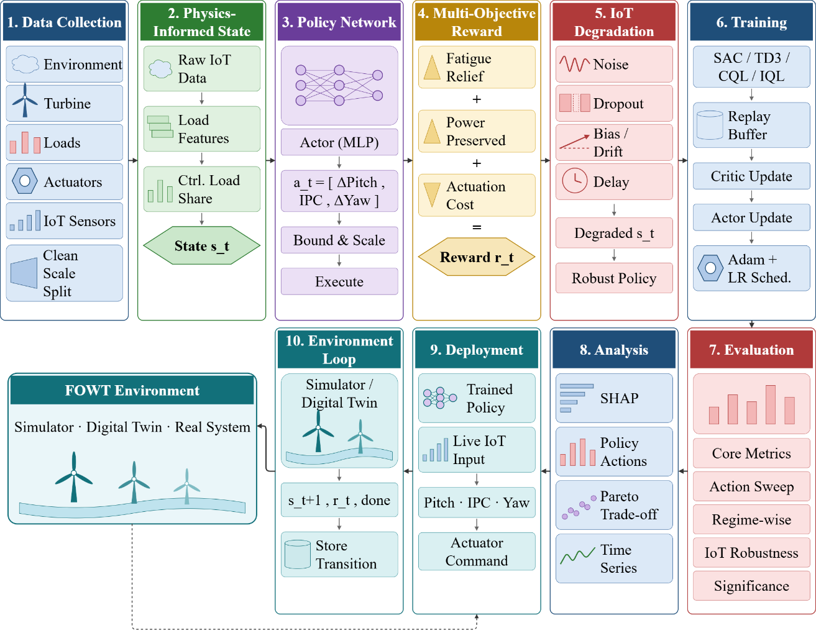
Figure 1. Overall workflow of the proposed FOWT-ARISE framework.

3.1 Dataset Description
The physics-informed extension of the FLOATBench dataset is chosen as the primary dataset for the development and testing of the proposed FOWT-ARISE framework since it offers sequential observations of floating offshore wind turbines with an enhanced amount of structural load and fatigue information suitable for load mitigation using reinforcement learning. Contrary to standard wind turbine datasets containing SCADA or environment-only measurements, the provided dataset contains environment measurements, turbine responses, structural damage indicators, actuator commands, power and thrust measurements, as well as IoT-related information on observation validity, thus allowing the proposed framework to learn both the operating condition awareness and structural load control. The physics-informed transition dataset includes 129,600 rows and 89 columns, which correspond to sequential transitions generated under three FOWT configurations. The total number of logical episodes in the dataset equals 3,600, each having 36 sequential steps, where the episode is uniquely defined by the combination of tower and episode identifiers. The measured observations involve wind speed, turbulence, wind direction, wave height, wave period, tower damage rate, thrust and power, while control actions include pitch offset, yaw setpoint and IPC level. Also, information about governing section damage, baseline damage, damage ratio, controllable load share and cumulative damage is included in the dataset as part of physics-informed information.
Prior to the development of models, the transition data is preprocessed and structured to form valid sequential episodes, maintaining the temporal relation between sequential states and actions. Environmental, structural and turbine response variables are utilized for the formation of the state, while the requested actions and true-state variables for the next step are separated to avoid information leakage during policy learning. Information about IoT-related validity indicators and sensor health is kept to facilitate the degradation-aware learning module. The dataset is split into training, validation and test sets in terms of episodes to maintain all sequential information related to one episode in one subset. The splitting of the dataset for the experimental study is shown in Table 2.

Table 2. Dataset Partitioning for FOWT-ARISE
Dataset Split | Episodes | Transitions (Samples) | Split%
Training Set | 2,520 | 90,720 | 70.00 %
Validation Set | 540 | 19,440 | 15.00 %
Testing Set | 540 | 19,440 | 15.00 %
Total Transitions | 3,600 | 129,600 | 100 %
The training subset is employed for policy and value-function optimization in reinforcement learning model development. The validation subset is utilized for tracking the behavior of the learning process, selecting models and performing early stopping without involving the final test data into the parameters updates. The independent test subset is exploited to assess the framework capabilities to perform structural load relief, power preservation, actuator behavior and robustness to degraded IoT observations. The same subsets are used for both the proposed framework and its ablation variants to facilitate a fair comparison. In addition to the sequential transition dataset, an independent action-sweep dataset including 1,455,300 counterfactual evaluations of actions is exploited to assess the learned policy under matching conditions. Action-sweep dataset includes fatigue damage, controllable load, power and thrust responses for different combinations of pitch, yaw and IPC actions allowing counterfactual evaluations without the need for the trajectories generated using the behavior policy. The action-sweep evaluation is performed by matching environmental and simulation identifiers before assessing different actions. Thus, the physics-informed extension supplies sequential observations, structural-fatigue information, actuator responses and imperfect IoT observations required for the FOWT-ARISE framework development. The transition dataset allows reinforcement learning and robustness training whereas the independent action-sweep dataset is exploited to perform counterfactual fatigue relief evaluation and corresponding power and actuation trade-off analysis. In total, the provided datasets allow to evaluate whether the proposed framework is capable of learning what structural load is controllable, what actuator to apply, how aggressively to act and when not to act.

3.2 Data Pre-processing
In order to construct the proposed FOWT-ARISE framework, the physics-informed extension of the FLOATBench dataset is systematically preprocessed to generate standardized, temporally consistent and leakage-free sequential transitions for reinforcement learning. Since the proposed framework integrates physics-informed state representation, adaptive multi-actuator control and IoT-degradation-aware learning, the preprocessing procedure includes transition validation, episode construction, temporal ordering, feature selection, normalization, leakage prevention and separation of training and evaluation information. The fundamental purpose of preprocessing is to preserve the physical relationships between environmental conditions, turbine responses, structural fatigue and control actions while ensuring that variables unavailable at the decision time are not provided directly to the policy. Let the complete collection of transition records be represented by
$D={\left\{τ_{i}\right\}}_{i=1}^{N}, τ_{i}=\left(x_{i},a_{i},x_{i}^{'}\right)$ (1)
where N=129600 is the total number of transition records, $x_{i}$ represents the observations available at the current decision step, $a_{i}$ represents the applied control action and $x_{i}^{'}$ represents the subsequent turbine state. Each logical episode is identified using the combination of the tower identifier and episode identifier, since the same episode identifiers occur across different turbine configurations. The complete dataset consists of 3,600 logical episodes, with 36 sequential transitions per episode. The transitions are temporally ordered within each episode before being supplied to the learning framework. The current observations contain measured environmental and turbine-response variables, including wind speed, turbulence standard deviation, wind direction, wave height, wave period, tower damage rate, thrust and power. The action vector contains pitch offset, yaw setpoint and IPC level. Physics-informed structural variables such as governing-section damage, baseline damage, damage ratio, controllable-load share and cumulative damage are retained to provide structural information for state construction. For numerical stability, continuous input variables are transformed into a common normalized representation. For a continuous feature z_{j}, min–max normalization can be expressed as
$\tilde{z_{ij}}=\frac{z_{ij}-z_{j}^{min}}{z_{j}^{max}-z_{j}^{min}}$ (2)
Where $\tilde{z_{ij}}$ is the value of feature j for transition i, while $z_{j}^{min}$ and $z_{j}^{max}$ are the corresponding minimum and maximum values obtained from the training data. The same transformation parameters are subsequently applied to the validation and test subsets. This prevents information from the evaluation subsets from influencing the preprocessing statistics. Following normalization, the decision-time observations and physics-informed structural information are combined to construct the load-aware state representation. The state can be expressed as
$s_{t}=\left[\tilde{x_{t}^{\text{IoT}}}, \tilde{x_{t}^{\text{env}}}, \tilde{x_{t}^{\text{struct}}},mt\right]$ (3)
where $\tilde{x_{t}^{\text{IoT}}}$ denotes the normalized measured turbine observations, $\tilde{x_{t}^{\text{env}}}$ represents environmental observations, $\tilde{x_{t}^{\text{struct}}}$ represents physics-informed structural and fatigue features, and $mt$ denotes the corresponding sensing-validity or sensor-health information. This representation allows the policy to distinguish operating conditions from structural-load characteristics and sensing quality. The action representation is maintained separately from the state and is defined as
$a_{t}=\left[Δ\text{Pitc}{\text{h}}_{\text{t}}, Δ\text{Ya}{\text{w}}_{\text{t}}, \text{IP}{\text{C}}_{\text{t}}\right]$ (4)
where the three components correspond to pitch offset, yaw setpoint and IPC level, respectively. Future true-state variables are not included in $s_{t}$, since doing so would introduce information that is unavailable when the control decision is made. Instead, these variables are retained for transition construction, reward calculation and evaluation. The resulting sequential representation can therefore be written as
$T=\left\{\left(s_{t},a_{t},r_{t},s_{t+1},d_{t}\right)\right\}$ (5)
where $s_{t}$ is the current physics-informed state, $a_{t}$ is the selected multi-actuator action, $r_{t}$ is the corresponding reward, $s_{t+1}$ is the subsequent state and $d_{t}$ denotes the episode termination condition. This transition representation forms the fundamental training unit for the reinforcement learning framework. To prevent information leakage, future true-state variables, reward components, requested control outcomes and evaluation-only quantities are excluded from the policy input and retained separately for training targets or evaluation. The IoT validity indicators and sensor-health information are preserved because they are required by the degradation-aware learning component. The data are then divided into disjoint training, validation and test subsets at the episode level, ensuring that transitions belonging to the same logical episode are not distributed across multiple subsets. The same partitioning is maintained for the proposed model and all ablation experiments to ensure a consistent comparison.
In addition to the sequential transition dataset, the independent action-sweep dataset containing 1,455,300 rows and 27 columns is retained for counterfactual evaluation. The three action-sweep sources contain 485,100 rows each and provide responses for different pitch, yaw and IPC actions. These records are not treated as sequential training transitions. Instead, they are matched using sim_id, wind_speed_id, wave_hs_id, wave_tp_id and wind_seed_id to compare alternative actions under the same operating-condition identifiers. Thus, the final preprocessing procedure produces temporally ordered, normalized and leakage-controlled FOWT transitions containing decision-time IoT observations, physics-informed structural information, multi-actuator actions and subsequent turbine responses, together with an independent action-sweep dataset for counterfactual evaluation. This representation provides the required foundation for training and evaluating FOWT-ARISE under both normal and imperfect sensing conditions.

3.3 Feature Extraction
In the proposed FOWT-ARISE framework, the process of feature extraction is intended for obtaining physics-based representation of the operational state of the floating offshore wind turbine, its structure and controllable loads' characteristics. In contrast to the standard reinforcement learning methodologies based mainly on general-purpose SCADA or environmental variables, the proposed methodology utilizes both IoT measurements as well as physics-based fatigue and structural load features. Such representations give the agent an understanding of the present turbine state as well as how much the observed structural load could be potentially manipulated by control actions. At the beginning of the algorithm, the preprocessed data on the system transitions is divided into three groups: decision time observations, structural features and sensing quality indicators. Let the observation vector at time tt be denoted as
x_{t}^{meas}​=[vt​,σv,t​,θt​,Hs,t​,Tp,t​,Dt​,Tt​,Pt​], (6)
Where vt, σv,t, θt, Hs,t​ and Tp,t represent wind speed, turbulence intensity, wind direction, wave height, and wave period, respectively. Dt​, Tt​ and Pt​ are the tower damage rate, thrust, and power respectively. To capture the structural features other than the raw data, fatigue features are obtained based on the physical knowledge of the data transition process. The structural representation can be written as
$x_{t}^{\text{phys}}=\left[D_{t}^{\text{base}}, D_{t}^{\text{top}}, D_{t}^{max}, ρ_{t}, C_{t}\right]$ (7)
where $D_{t}^{\text{base}}$ and $D_{t}^{\text{top}}$ are section-wise damage measurements, $D_{t}^{max}$ is maximum structural damage, $ρ_{t}$ is damage ratio, and $C_{t}$ is controllable-load share. The characteristics make it possible for the learning algorithm to determine the scale and the area of damage and the part of the load that can be controlled. The quality of IoT observations is captured using the validity and health indicators of sensors. Let us take the sensing quality vector as
$m_{t}=\left[q_{v,t}, q_{σ,t}, q_{θ,t}, q_{H_{s},t}, q_{T_{p},t}, q_{D,t}, q_{T,t}, q_{P,t}, h_{t}\right]$ (8)
where each q indicates whether the measurement is valid and h indicates the health state of the sensors. The full feature vector that will be input to the policy can therefore be written as
$s_{t}=\left[\tilde{x_{t}^{\text{meas}}}, \tilde{x_{t}^{\text{phys}}}, {}_{t}\right]$ (9)
where $(\tilde{x})$ represents the normalized feature vector. The combination of both is the physics-informed state that is utilized in FOWT-ARISE where the policy takes into account the environment conditions, reaction of the turbine, structural fatigue and quality of observations in choosing the control actions. The features obtained from the process are then passed to the adaptive multi-actuator policy.
3.4 Proposed Framework Architecture
Proposed FOWT-ARISE framework (Physics-Informed Adaptive Reinforcement Learning Framework) is proposed to serve as an integrated reinforcement learning framework for the structural-load relief in floating offshore wind turbines under the changing environmental conditions and incomplete IoT observation. The framework differs from the existing approaches in terms of the use of multiple actuators, physics-informed state representation, fatigue-power-actuation optimisation, and IoT-degradation-aware learning. The architecture of the proposed framework is shown in Figure 2.
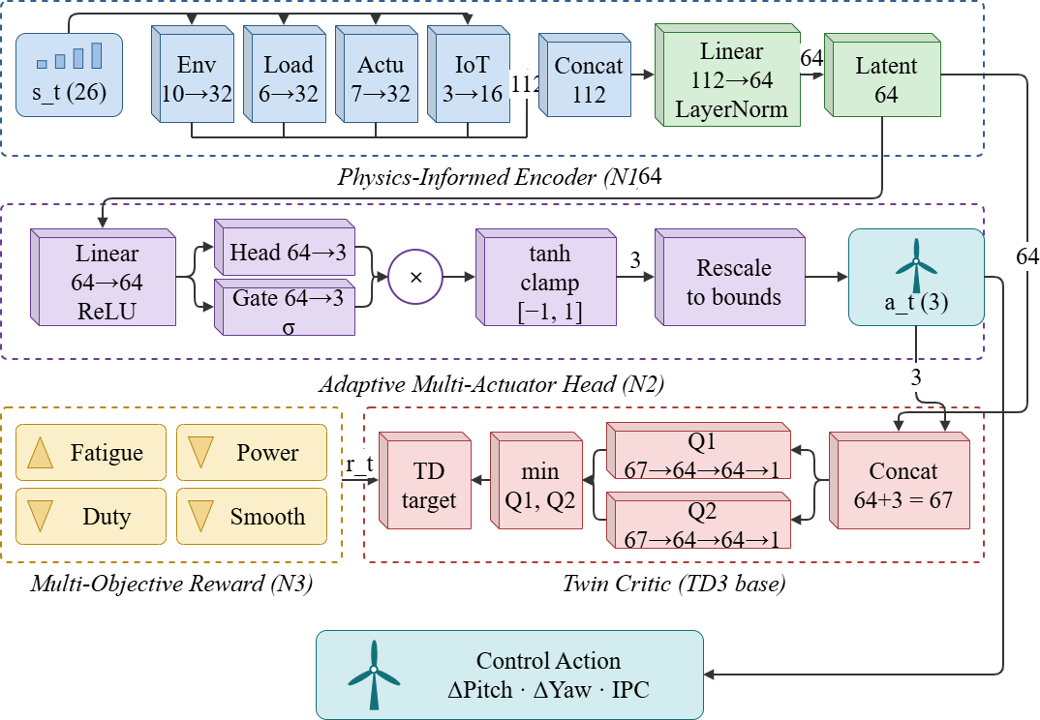
Figure 2. Overall Architecture of Proposed FOWT-ARISE
The physics-informed FOWT transition data are sequentially grouped in episodes, where each transition includes the turbine and environment observations, applied control action, next-state information, structural-load characteristics, and the IoT sensor-quality information. Measured observations include the wind speed, turbulence intensity, wind direction, wave height, wave period, tower damage rate, thrust, and power. This information is complemented with the physics-informed structural information including governing section damage, damage ratio, and controllable load share to form the state representation taking into account the structural load. Subsequently, the state is normalized according to the training set statistics before its input to the reinforcement learning policy. The first key module in the proposed framework is the Physics-Informed Load-Aware State Representation. Rather than the state representation based only on the environmental and operational observations, the proposed framework introduces the fatigue information into the policy state. In particular, the damage characteristics of the base, top, and maximum damage sections, along with the information about the damage ratio and controllable load, gives the policy information about the areas of the structural load and the potential of its manipulation with the help of the actuators. The sensor validity information and the variable representing the overall sensor health is retained as well to differentiate the reliable measurements and degraded observations.
The generated state is fed to the Adaptive Multi-Actuator Control Module, forming the core of FOWT-ARISE decision-making procedure. The policy generates three control variables, namely, the pitch offset, yaw setpoint, and individual pitch control (IPC) level. Rather than obligating all actuators to work at the same time, the policy learns the optimal combination and intensity of the control according to the current operation condition. Hence, the framework is capable of selecting the optimal actuator when structural loading is controllable, and minimizing or avoiding the unnecessary intervention in case of insignificant benefits. Thus, the policy not only learns how to perform the action, but when to avoid performing it. The chosen control action is evaluated through the Fatigue-Power-Actuation Multi-Objective Reward Module. The reward is defined in such a way as to encourage the structural fatigue reduction while discouraging the undesirable power loss and actuator usage. The structural performance is described by the damage and damage ratio measures, while the power preservation is estimated relatively to the corresponding baseline power. The actuator penalties depend on the actuator intensity or duty. This allows preventing the reinforcement learning agent from getting the high reward by using the excessive actions reducing fatigue but degrading the power performance or unnecessarily working actuators.
One more important component is the IoT-Degradation-Aware Robust Learning Module. While learning and testing, the policy works with the observation-quality information reflecting the imperfect sensing. The information about the sensor validity and health helps to differentiate the degraded observations from the reliable ones, while the robustness evaluation compares the policy behavior under the clean and degraded observation conditions. Thus, the FOWT-ARISE framework can evaluate the effectiveness of the control policy when the IoT observation is imperfect and not assuming the continuously reliable sensor measurements. After the training phase, the policy of the framework is evaluated with the help of the counterfactual action-sweep approach in order to study the structural and operational implications of the alternative control actions. The action-sweep dataset includes the combinations of pitch, yaw error, and IPC actions along with the maximum damage, controllable load share, power, thrust, and corresponding ratios. The identical operating-condition identifier allows matching the policy action and the corresponding counterfactual condition. This allows evaluating the effectiveness of the policy additionally to the transition-based evaluation procedure.
Table 3. Layer-wise Architecture Summary of the Proposed FOWT-ARISE
Layer | Configuration | Output Shape
Physics-Informed State Input | 26 features (10 environmental + 6 structural + 7 actuator-proprioceptive + 3 observation-quality/control-authority) | (26)
Environmental Branch (N1) | Linear (10 → 32) + ReLU | (32)
Structural / Load Branch (N1) | Linear (6 → 32) + ReLU | (32)
Actuator-Proprioceptive Branch (N1) | Linear (7 → 32) + ReLU | (32)
Observation-Quality & Control-Authority Branch (N1) | Linear (3 → 16) + ReLU | (16)
Group Concatenation | Feature-group fusion (32 + 32 + 32 + 16) | (112)
Latent Fusion | Linear (112 → 64) + LayerNorm | (64)
Actor Trunk | Linear (64 → 64) + ReLU | (64)
Joint Actuator Head (N2) | Linear (64 → 3) | (3)
Control-Authority Gate (N2) | Linear (64 → 16) → ReLU → Linear (16 → 3) → Sigmoid | (3)
Gated Action Modulation | Element-wise product (head × gate) | (3)
Action Bounding | Clamp(1.15 · Tanh(·), −1, 1) | (3) ∈ [−1, 1]
Action Rescaling | Affine map to physical bounds (pitch offset, yaw setpoint, IPC level) | (3)
Critic Input | Concatenate (shared latent, joint action) | (67)
Twin Critic Q₁ | Linear (67 → 64) → ReLU → Linear (64 → 64) → ReLU → Linear (64 → 1) | (1)
Twin Critic Q₂ | Linear (67 → 64) → ReLU → Linear (64 → 64) → ReLU → Linear (64 → 1) | (1)
Clipped Double-Q | min(Q₁, Q₂) for TD target computation | (1)
Target Actor / Target Critic | Polyak-averaged copies (τ = 0.005), gradients disabled | —
Control Output | Joint multi-actuator command [ΔPitch, ΔYaw, IPC] | (3)
The proposed architecture also allows evaluating the baseline and component-wise ablation of the policy. The proposed FOWT-ARISE model is compared with the selected baseline approaches, while the component-wise ablation is evaluated using the identical experimental data partitions and evaluation procedure. It is possible to estimate the individual contributions of the physics-informed state representation, adaptive multi-actuator control, multi-objective reward formulation, and IoT-degradation-aware learning modules. Thus, the complete architecture provides the unified framework where the structural information, control actions, operational costs, and sensing reliability are considered together. The parameter distribution of Proposed FOWT-ARISE is presented in Table 4.
Table 4. Parameter distribution of Proposed FOWT-ARISE
Component | Parameters
Physics-Informed Encoder (N1) | 8,256
Joint Actuator Actor + Authority Gate (N2) | 5,446
Twin Critic (2 × 8,577) | 17,154
Total trainable | 30,856
It is evident from the architecture overview presented in Table 3 that the proposed FOWT-ARISE framework architecture is modular and integrates components, where each component handles one of the limitations of the standard FOWT control and monitoring approach. Physics-informed state representation introduces structural load awareness into the RL decision-making process, while the adaptive multi-actuator controller allows for joint pitch, yaw and IPC actions. The multi-objective reward ensures that the fatigue reduction cannot be achieved separately from power reduction and actuator usage. Finally, the IoT-degradation-aware component introduces imperfect observations explicitly to make the learning and evaluation of the solution robust. Thus, the proposed FOWT-ARISE framework architecture evolves the physics-informed FLOATBench fatigue benchmark from a static or transition-based evaluation setup into a sequential adaptive decision-making framework. The architecture makes it possible for the learned policy to decide what load is controllable, what actuator is used, how aggressive to act, and when not to act at all while accounting for fatigue reduction, power preservation, actuator usage, and imperfect IoT observations.

3.5 Loss Function and Hyperparameter Configuration
This optimization approach that is used in the proposed FOWT-ARISE framework is a critical factor in training an effective structural load relief policy through the offline transition dataset generated by the physics-informed FLOATBench. Due to the offline formulation of the turbine control policy in FOWT-ARISE, the offline actor-critic approach, which is inspired by the TD3 approach, with CQL-like conservative policy evaluation is utilized in the framework. The actor outputs the control policy for pitch, yaw, and IPC, and two critic networks are utilized in order to evaluate the value of the current state-action pair. For a given state $s_{t}$, the actor outputs the control policy
$a_{t}=π_{θ}\left(s_{t}\right)=\left[ΔPitch_{t},ΔYaw_{t},IPC_{t}\right]$ (10)
with $π_{θ}$ being the actor’s policy and the three outputs standing for pitch offset, yaw setpoint correction and IPC magnitude respectively. The actor consists of a physics-aware encoder combined with a control authority gate and a shared fully connected layer. The final action network takes the form of a Tanh activation, resulting in bounded actions between [-1,1] [−1,1] that are later rescaled to physical action bounds. The critic part includes two separate Q networks. Each critic takes the encoded state along with chosen action and outputs a scalar value of Q-function. The twin critics formulation can be written as
$Q_{1}\left(s_{t},a_{t}\right), Q_{2}\left(s_{t},a_{t}\right)$ (11)
in which the lower of the two is adopted as an estimate for the policy evaluation. A Q-Network comprises two dense layers each with 128 units and ReLU activation, followed by a single output layer. The critic is trained by minimizing a combination of the TD3 objective and the conservative CQL regularizer as follows
$L_{critic}=MSE\left(Q_{1},y\right)+MSE\left(Q_{2},y\right)+α_{CQL}\left[\log{\sum_{a}{\exp{Q}\left(s,a\right)}}-E_{a∼D}Q\left(s,a\right)\right]$ (12)
where y is the temporal difference target, $α_{CQL}$ tunes the conservative penalty term, and D is the offline training data. $α_{CQL}$ is set to 1.0 in this implementation. The conservative penalty term plays a significant role in offline learning since the policy should not depend too much on unobserved state-action pairs. The actor optimization process maximizes the conservative critic value along with a robustness-consistency objective in the case of the entire FOWT-ARISE model. The actor loss in the training process can be formulated as
$L_{actor}=-E_{s∼D}\left[\min\left(Q_{1}\left(s,π_{θ}\left(s\right)\right),Q_{2}\left(s,π_{θ}\left(s\right)\right)\right)\right]+λ_{rob}L_{rob}$ (13)
where $L_{rob}$ measures the difference between the actions generated from clean and degraded versions of the same observation. Specifically,
$L_{rob}=\left.|π_{θ}\left(s_{t}\right)-π_{θ}\left(\tilde{s_{t}}\right)\right.|_{2}^{2}$ (14)
where $\tilde{s_{t}}$ denotes the IoT-degraded observation. In the implementation $λ_{rob}$=0.1. The actor is thus incentivized not only to choose valuable actions but also to make consistent control decisions under the influence of sensor noise. The Fatigue-Power-Actuation Multi-Objective Reward (N3) is added to the offline transition data before actor-critic optimization. The proposed architecture utilizes four logged rewards: fatigue reduction, power consumption, actuation penalty and action smoothness. The corresponding weights are 1.01.0, 0.50.5, 0.250.25, and 0.10.1, respectively. The final reward thus motivates load-reduction actions and penalizes unnecessary power losses, over-actuated controls and drastic control changes. In the N3 ablation case, all these objectives are stripped off and only the fatigue/load reduction term remains.
The optimization is done via the Adam optimizer with an initial learning rate of 3×10⁻⁴. The learning rate is decayed by 0.5 factor on the plateau via the ReduceLROnPlateau scheduler with the minimal learning rate of 10⁻⁶Target actor and critic networks are updated via Polyak averaging with τ=0.005. The target policy for TD3 is smoothed with noise with standard deviation 0.1 and clipping value 0.3, while policy is updated with delay of two critic updates. The gradients are also clipped at 5.0 for better training stability. As FOWT-ARISE is trained with the fixed offline dataset and not interactively with simulator, the training transitions are stored in CPU-based replay buffer and samples uniformly chosen during optimization. The next-state is represented with the next observation within the same episode to ensure that no future ground truth variables become available for the policy. Both the full and ablation architectures are trained on the same dataset split, random seed, evaluation regime and training budget to attribute any difference to the intended innovations.
For N4 IoT-degradation aware learning the degraded observations are generated in the training data by applying Gaussian sensor noise, feature dropout, bias and stale measurements. In the configuration noise standard deviation 0.05 relative to the training feature standard deviation, dropout probability 0.10, bias 0.05, stale-observation probability 0.10, and degradation frequency of 50% in training batches. The training is done for the maximal number of 60 epochs with batch size of 256 for the full experiment. Early stopping with the patience of 10 epochs and minimal improvement of 10⁻⁴is enabled. The checkpoints are stored every five epochs and consist of actor, critic, target networks, optimizer states, learning rate scheduler states, training history and random number generator states to allow resuming the experiment without restarting the optimization process. The Hyperparameter configuration is described in Table 5.

Table 5. Hyperparameter Configuration of the Proposed FOWT-ARISE
Hyperparameter | Value / Configuration
Framework | FOWT-ARISE
Dataset | Physics-informed FLOATBench extension
Training Paradigm | Offline Reinforcement Learning
RL Algorithm | TD3 + CQL-style conservative regularization
Actor Type | Physics-Informed Adaptive Multi-Actuator Actor
Critic Type | Twin Critic Network
Number of Critic Networks | 2
Action Dimension | 3
Control Actions | Pitch Offset, Yaw Setpoint, IPC Level
Actor Latent Dimension | 64
Actor Shared Layer | 64 units + ReLU
Action Activation | Tanh
Action Range (normalized) | [−1,1] [-1,1]
Critic Hidden Layers | 128 → 128
Critic Activation | ReLU
Critic Output | Scalar Q-value
Target Actor | Enabled
Target Critic | Enabled
Discount Factor (γ\gamma) | 0.99
Target Update Rate (τ\tau) | 0.005
Policy Smoothing Noise | 0.1
Noise Clip | 0.3
Policy Delay | 2
CQL Weight (αCQL) | 1.0
Fatigue Reward Weight | 1.0
Power Penalty Weight | 0.5
Actuation Penalty Weight | 0.25
Smoothness Weight | 0.1
Robustness Loss Weight | 0.1
IoT Noise Std. | 0.05 × training feature std.
IoT Dropout Probability | 0.10
IoT Bias Magnitude | 0.05 × training feature std.
IoT Stale-Observation Probability | 0.10
Degraded Training Fraction | 0.50
Optimizer | Adam
Initial Learning Rate | 3×10⁻⁴
LR Scheduler | ReduceLROnPlateau
LR Reduction Factor | 0.5
LR Scheduler Patience | 4
Minimum Learning Rate | 1×10⁻⁶
Gradient Clipping Norm | 5.0
Training Batch Size | 256
Maximum Epochs | 60
Early-Stopping Patience | 10
Early-Stopping Minimum Delta | 1×10⁻⁴
Checkpoint Frequency | Every 5 epochs
Random Seed | 42
The chosen architecture strikes a balance among offline value estimation, adaptive control, structural-load mitigation and computational stability. A 64-dimensional latent space is used as an efficient intermediate representation of the physics-informed state, after which the adaptive control authority gate decides on the actual control authority and then the joint 3D action head computes the pitch, yaw and IPC control. In terms of value-estimation architecture, the two critics and target networks form the structure required by the TD3-based offline learner, whereas the CQL penalty ensures conservative regularization for the fixed transition dataset. Finally, the training configuration guarantees that all four novelties are able to be assessed independently. Novelty N1 eliminates the physics-informed feature grouping, novelty N2 eliminates the adaptive control authority gate, novelty N3 replaces the multi-objective reward function with fatigue/load relief-only, and novelty N4 eliminates the degraded observation training but retains it in evaluation phase.
4. Results and Discussions
4.1 Experimental Setup
The physics-informed extension of FLOATBench has been utilised in the current work in order to assess the performance of the proposed FOWT-ARISE framework in adaptive structural-load mitigation in FOWTs with various operating conditions and imperfect IoT observations. The provided dataset comprises 129,600 sequential transitions grouped into 3,600 episodes, where each episode includes 36 time steps. The data has been divided into mutually exclusive training, validation and test sets according to episode-wise 70%/15%/15% split in order to avoid temporally-correlated transitions belonging to different datasets. The state representation within the FOWT-ARISE framework comprises measured observations along with physics-informed structural load information and IoT sensor quality features, whereas the action space includes pitch offset, yaw setpoint and IPC. FOWT-ARISE has been implemented in PyTorch and trained with offline actor-critic TD3 architecture with CQL-like conservative regularisation, Adam optimiser, batch size equal to 256 and a maximum of 60 epochs. The training algorithm includes checkpointing, early stopping and learning rate schedule in order to provide stable and reproducible optimisation. The learned policy is evaluated based on fatigue relief, DEL ratio, power loss, actuator duty, action magnitude, no-action behaviour, and IoT robustness metrics. In addition to the main test dataset, action-sweep data for matched counterfactual evaluation and four ablation experiments (N1, N2, N3, and N4) in order to investigate the contribution of framework components individually have been performed.
4.2 Evaluation Metrics
To test the efficacy of the proposed FOWT-ARISE system, several metrics are considered for analyzing structural load reduction, power retention, control efficiency, hypothetical actions quality, and the resilience of the system to IoT measurements inaccuracy. As the performance testing employs the independent action sweep dataset, the presented structural metrics are based on the known damage ratio metric instead of the absolute DEL. Indeed, there are no values of absolute DEL in physical units in the action-sweep dataset; hence, there are no artificial values of the absolute mean DEL. The DEL ratio is computed on the basis of the maximum damage ratio metric employing the chosen Wöhler exponent of 3.0. A value below unity means that fatigue-equivalent loading is reduced compared to the baseline case.
$DEL Ratio={\left(damage_ratio_{max}\right)}^{1/3}$ (15)
The corresponding fatigue relief quantifies the percentage reduction in fatigue-equivalent loading
$Fatigue Relief\left(\backslash \%\right)=100\left(1-DEL Ratio\right)$ (16)
The power loss is used to quantify the operational cost of load mitigation. It is calculated from the difference between the baseline and controlled power and is normalized by the rated turbine power:
$Power Loss\left(\%\right)=100\frac{P_{baseline}-P_{controlled}}{P_{rated}}$ (17)
For counterfactual evaluation, the predicted action is matched with a physically simulated action-sweep outcome under the same operating-condition identifiers. The resulting matched sweep objective jointly represents fatigue relief and power preservation:
$J_{sweep}=w_{f}\left(1-damage_ratio_{max}^{1/3}\right)-w_{p}\left(\frac{P_{baseline}-P_{controlled}}{P_{rated}}\right)$ (18)
where wf=2.0, wp=1.0, and $P_{rated}$=22. Large values of $J_{sweep}$ imply a more favorable fatigue-power trade-off. More importantly, it is a counterfactual action-sweep criterion and not the actual sequential transition reward. Along with these four principal metrics, actuator duty, mean action size, mean absolute yaw action, and no-action frequency are used to quantify control effort and the effectiveness of the avoidance of unnecessary actions. Action-sweep coverage represents the fraction of transitions from the test for which there exists a legitimate physical counterfactual match; hence, matched metrics should be considered in conjunction with coverage. The IoT performance gap results from the comparison of clean and degraded-observation performance, where smaller difference in performance implies greater robustness to erroneous sensor data. Consequently, no single reward figure is used for the evaluation. Instead, FOWT-ARISE is evaluated through a combination of structural, operational, control effort, counterfactual, and IoT-robustness metrics.

4.3 Performance Analysis of the Proposed FOWT-ARISE
Evaluation of the suggested FOWT-ARISE framework was done on the held-out validation and test datasets to check the effectiveness of the proposed design in terms of structural fatigue reduction while retaining power generation and keeping the actuator effort under control. The training was carried out for 55 epochs using early stopping, with the best checkpoint on the validation dataset achieved at Epoch 47. There are around 2.41 million trainable parameters in the model, and the final evaluation included.
Table 6. Training and Validation Performance of the Proposed FOWT-ARISE
Metric | Training | Validation
Loss | 0.43598 | 0.51377
Mean Reward | −0.25320 | −0.24427
DEL Ratio | 0.95424 | 0.94856
Fatigue Relief (%) | 4.9426 | 5.1442
Power Loss (%) | 5.0669 | 5.1818
Actuator Duty | 0.7876 | 0.8034
Mean Action Magnitude | 1.0028 | 0.9946
Mean |Yaw Action| (deg) | 0.6218 | 0.6665
No-Action Rate (%) | 11.45 | 13.47
Clean Performance | 0.05383 | 0.06842
IoT-Degraded Performance | 0.07304 | 0.06711
Results shown in Table 6 demonstrate that the obtained policy gives consistent structural-load reduction for both training and validation sets. The validation DEL ratio equals 0.94856, which corresponds to 5.14% fatigue reduction while the power loss is still quite low and equals to 5.18%. The actuator duty and mean action magnitudes of 0.8034 and 0.9946, respectively, show that the policy does not provide load reduction just by using excessive control. The validation no-action rate of 13.47% shows that the controller can maintain no-action behaviour even when no further actions are needed. The validation matched sweep objective equals 0.06842, while the performances of clean and IoT-degraded environments equal 0.06842 and 0.06711, respectively. It means that there is a slight performance reduction when observations become degraded. The final performance of FOWT-ARISE is shown in Table 7. Our approach demonstrates the average matched sweep objective of 0.06505 with the average DEL ratio of 0.95200 and fatigue relief of 4.80%. The power loss equals to 5.20%, while the actuator duty proxy is 0.8070. The mean action magnitude and the mean absolute yaw action are 0.9988 and 0.6690°, respectively. Thus, the three channels are used consistently without excessive yaw intervention. The no-action rate equals to 12.80%, which proves the adaptive behaviour of our framework.
Table 7. Final Test Performance of the Proposed FOWT-ARISE
Metric | FOWT-ARISE
Mean Matched Sweep Objective | 0.06505
DEL Ratio | 0.95200
Median DEL Ratio | 0.96789
Fatigue Relief (%) | 4.8000
Power Loss (%) | 5.2000
Actuator Duty Proxy | 0.8070
Mean Action Magnitude | 0.9988
Mean |Yaw Action| (deg) | 0.6690
No-Action Rate (%) | 12.80
Action-Sweep Coverage (%) | 100.0
Clean Performance | 0.06505
IoT-Degraded Performance | 0.06371
IoT Performance Gap | 0.00134
Robustness Drop (%) | 2.0651
From the findings on the robustness of the IoT, it is evident that the proposed approach performs consistently even with the presence of the effects of sensor degradation on the observations. From clean performance of 0.06505, there is a degradation to 0.06371, which leads to a mere IoT performance difference of 0.00134 and robustness degradation of around 2.07%. In line with the IoT-degradation-aware training approach employed in FOWT-ARISE, where sensor noise, dropout, bias, and degraded observation is included in training. All in all, the results obtained show that FOWT-ARISE is able to balance the tradeoff between fatigue mitigation, power retention, and actuators. Unlike other approaches, the proposed framework does not optimize the reduction in the structural load individually but rather encourages selection of appropriate pitch, yaw, and IPC actions while retaining the capability of reducing interventions. The 100% action sweep coverage also shows that the actions obtained can be assessed for the available counterfactual action condition. The baseline and ablation study are then undertaken to investigate whether the gains are from individual parts of the proposed framework.

4.4 Training Convergence Analysis

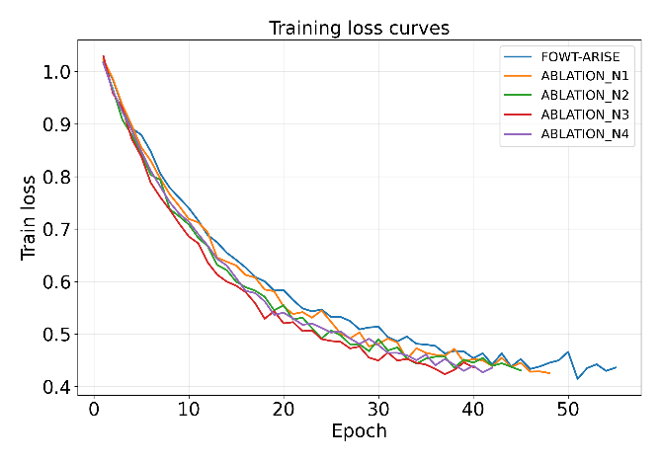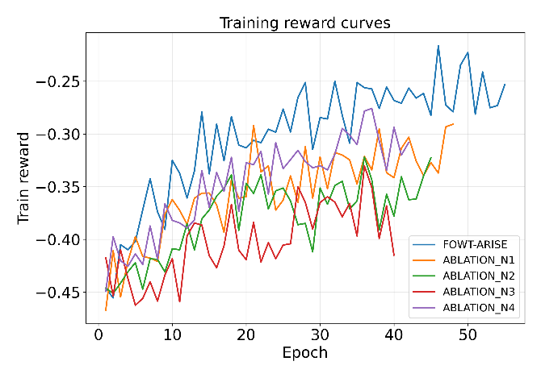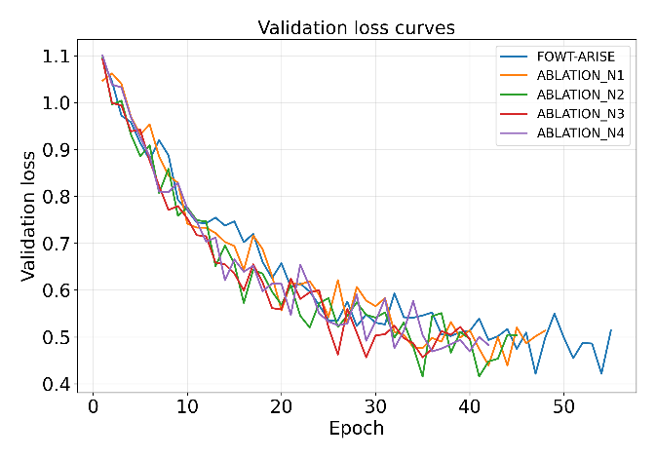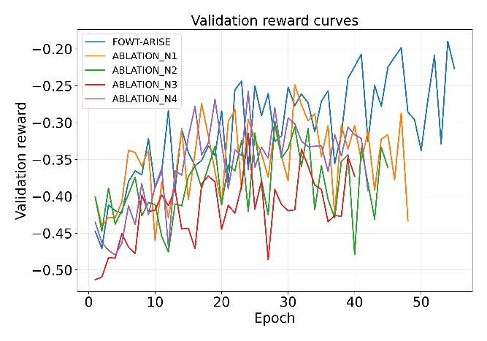
Figure 3. Training and Validation Convergence Curves of the Proposed FOWT-ARISE and Ablation Models
Figure 3 shows the optimization convergence properties of the proposed FOWT-ARISE algorithm alongside the N1–N4 ablation models. Four curves display training loss, training reward, validation loss, and validation reward, respectively, through the optimization process. The curves reveal an increasing improvement in reward and a decreasing loss in the optimization, while the moderate oscillation persists throughout the training process due to the offline reinforcement-learning optimization approach and the multi-objective control problem formulation. From the loss curves shown in Figure 3, it can be seen that the proposed FOWT-ARISE has steadily decreased training loss from around 1.02 at the start of the optimization to 0.436 by Epoch 55. Similarly, the validation loss curve has steadily decreased from around 1.10 to 0.514. Most of the improvements take place in the early and middle stages of the training process, followed by relatively smaller fluctuations during later epochs. The training and validation loss curves show that the learned policy does not deviate significantly from each other. The ablation models also display the same decreasing trend but with differing levels of fluctuations.
Furthermore, the training reward curves indicate the improvement of the proposed controller. The reward has steadily improved from −0.45 in the initial stages to −0.253 at Epoch 55. Also, in the latter stages of the training process, the reward becomes relatively higher compared to the ablation models. The validation reward curves also follow the similar decreasing trends and improve from around −0.45 to −0.227 in the final training epoch. Even though there are significant oscillations in the reward curves, the overall increasing trend indicates that the policy gradually learns how to achieve a more preferable balance between fatigue relief, power preservation, actuator use, and smooth control. Among the ablation models, N3 shows lower reward values all through the training process, proving the significance of the multi-objective reward function of the proposed FOWT-ARISE model. The validation loss curves further indicate the improvement on unseen episodes. The validation loss decreases significantly in the first around 30-40 epochs and fluctuates in a relatively low range in later epochs. On the other hand, the validation reward curve consistently stays at a high level compared to the earlier training stages. The best validation epoch for the proposed model is Epoch 47, beyond which the observed validation loss curve does not show enough improvement to continue optimization. The training therefore stops at Epoch 55 using early-stopping mechanism.
Generally, Figure 3 shows that the FOWT-ARISE model achieves progressive learning while maintaining the stochastic oscillation associated with the offline actor-critic optimization algorithm. The steady decreasing trend in loss and increase in training/validation rewards indicate that the proposed physics-informed, adaptive, fatigue-power-actuation-aware and IoT-robust algorithm is successfully optimized without notable train-validation deviation. The better reward performance of the FOWT-ARISE over ablations also supports the contributions of the proposed components to the learning process.

4.5 Ablation Study
To test the impact of the individual components of the proposed FOWT-ARISE approach, an ablation study was performed where each novelty is individually excluded, while keeping other training settings identical. In particular, four ablations are considered in this work: exclusion of the physics-based state representation (N1), exclusion of the adaptive no-action/ control authority strategy (N2), replacement of the fatigue-power-actuation multi-objective reward (N3), and exclusion of IoT-degraded observations training (N4). Such an approach makes it possible to assess the individual contribution of physics-informed state construction, adaptive actuation, multi-objective optimization, and IoT robustness in terms of fatigue alleviation, power generation, actuator performance, sweep objective matching, and robustness metrics.

Table 8. Ablation Study Results of the Proposed FOWT-ARISE
Model | Matched Sweep Objective ↑ | DEL Ratio ↓ | Fatigue Relief ↑ | Actuator Duty ↓ | No-Action Rate ↑ | IoT Performance Gap ↓ | Robustness Drop ↓
ABLATION_N1 (- physics-informed state) | 0.0460 | 0.9640 | 3.6000% | 0.9193 | 0.0853 | 0.00299 | 6.4952%
ABLATION_N2 (- adaptive no-action) | 0.0421 | 0.9665 | 3.3500% | 1.0224 | 0.0206 | 0.00257 | 6.1113%
ABLATION_N3 (- multi-objective reward) | 0.0333 | 0.9700 | 3.0000% | 0.9849 | 0.0533 | 0.00349 | 10.4880%
ABLATION_N4 (- IoT robust training) | 0.0400 | 0.9610 | 3.9000% | 0.8464 | 0.1111 | 0.00677 | 16.9269%
FOWT-ARISE | 0.0651 | 0.9520 | 4.8000% | 0.8070 | 0.1280 | 0.00134 | 2.0651%
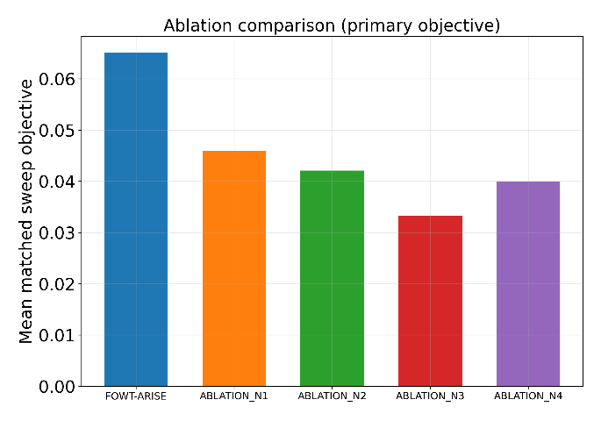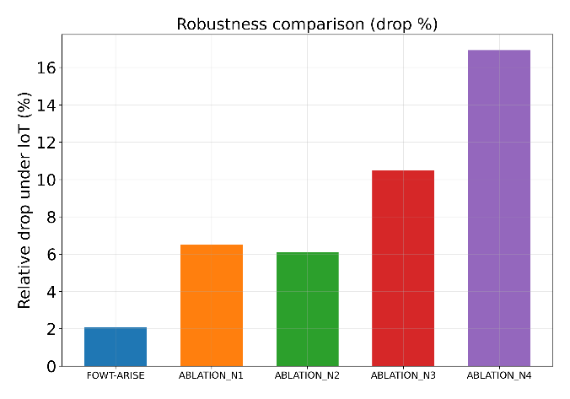
Figure 4. Comparison of Mean Matched sweep objective & Robustness of Proposed FOWT-ARISE with Ablations
Ablation in Table 8 shows that the fully configured FOWT-ARISE model achieves the highest value for matched sweep objective (0.0651), the lowest average DEL ratio (0.9520), maximum fatigue relief (4.80%) and minimum power loss (5.20%). The fully configured model also achieves the lowest actuator duty proxy (0.8070) and the highest no-action rate (12.80%), suggesting that the learned controller is able to avoid unnecessary actuation actions while achieving load-aware control of the FOWT system. All configurations achieve full action-sweep coverage, allowing their performance to be evaluated using the matched approach. Removal of the physics-informed state representation in N1 causes reduction in the matched sweep objective from 0.0651 to 0.0460 and fatigue relief from 4.80% to 3.60%, and increase in power loss to 7.60%. The results suggest that the information about loads available in the state representation enables more efficient load-aware control. N2 that removes the adaptive no-action mechanism achieves additional decrease in the objective from 0.0460 to 0.0421 and an increase in power loss to 9.40%. It also increases actuator duty proxy to 1.0224 and decreases no-action rate to only 2.06%, emphasizing the importance of allowing the policy to make decision of how to reduce or avoid unnecessary control action. The Comparison of FOWT-ARISE with ablations is illustrated in Figure 4.
Configuration N3, which does not include the multi-objective reward, produces the lowest values for matched sweep objective (0.0333) and fatigue relief (3.00%) and the highest power loss (13.20%) among all evaluated configurations. It also experiences the largest increase in the robustness drop value (10.49%), which suggests the importance of joint consideration of fatigue, power, actuation, and control smoothness objectives during training, rather than individual fatigue objective. Configuration N4 shows quite competitive clean performance with the matched sweep objective of 0.0400 and fatigue relief of 3.90%. However, its IoT performance gap becomes equal to 0.00677 and robustness drop increases to 16.93%, much larger than 2.07% experienced by the fully configured FOWT-ARISE model. This demonstrates the importance of degraded observation training in achieving robust behavior. The above analysis confirms that the proposed four components of FOWT-ARISE produce complementary contributions towards achieving superior control of the FOWT system.

4.6 Comparison with State-of-the-Art Models
To evaluate the effectiveness of the proposed FOWT-ARISE framework, a comparative analysis was performed against the selected baseline and state-of-the-art offline reinforcement-learning approaches, namely RB-FOWT, CQL, and IQL. The comparison considers the matched action-sweep objective, DEL ratio, fatigue relief, power loss, actuator usage, action magnitude, yaw action, action-sweep coverage, and performance under IoT-degraded observations. These metrics provide a broader evaluation of structural-load mitigation and control efficiency rather than considering fatigue reduction alone.

Table 9. Performance Comparison of the Proposed FOWT-ARISE with Baseline and State-of-the-Art Reinforcement-Learning Models
Model | Matched Sweep Objective ↑ | DEL Ratio ↓ | Fatigue Relief ↑ | Power Loss ↓ | Actuator Duty ↓ | Mean Action Magnitude ↓ | Mean |Yaw Action| ↓ | IoT-Degraded Performance ↑ | IoT Performance Gap ↓
RB-FOWT | 0.0507 | 0.9612 | 3.8845% | 5.8512% | 0.9367 | 0.9367 | 0.0000 | 0.0519 | −0.0013
CQL | −0.0397 | 0.9688 | 3.1165% | 11.6170% | 1.3410 | 1.3410 | 1.4497 | −0.0394 | −0.0003
IQL | −0.0978 | 0.9987 | 0.1268% | 10.0461% | 0.8490 | 0.8490 | 1.7251 | −0.0058 | −0.0058
FOWT-ARISE (Proposed) | 0.0651 | 0.9520 | 4.8000% | 5.2000% | 0.8070 | 0.9988 | 0.6690 | 0.0637 | 0.0013
As seen from the comparison presented in Table 9, the proposed FOWT-ARISE reaches the highest value of the matched sweep objective of 0.0651 among all the controllers investigated in this study. Moreover, FOWT-ARISE delivers the lowest mean DEL ratio (0.9520), as well as the largest fatigue relief (4.80%) while keeping the lowest power loss (5.20%). At the same time, RB-FOWT delivers an objective of 0.0507, fatigue relief of 3.8845%, and power loss of 5.8512%, whereas CQL and IQL deliver the negative values of the matched sweep objective, significantly lower fatigue relief and larger power losses. The above results confirm that the framework proposed in this work provides a better balance of the load reduction and the power maintenance. Actuator-related results also provide a clear distinction of FOWT-ARISE from the comparison approaches. The proposed model delivers the lowest value of actuator duty proxy of 0.8070, whereas RB-FOWT, CQL and IQL reach 0.9367, 1.3410 and 0.8490, respectively. Even though the mean action magnitude of FOWT-ARISE equals to 0.9988, its mean absolute yaw action is equal to 0.6690, which is significantly lower than CQL (1.4497) and IQL (1.7251). The RB-FOWT baseline does not perform any yaw action in the current configuration. The low value of the yaw action alongside with the low value of actuator duty confirms the ability of FOWT-ARISE to implement adaptive multi-actuator control without excessive actions.
The comparison of the robustness of the studied approaches to IoT degradation also proves that the inclusion of the degraded observation training into FOWT-ARISE leads to a considerable benefit. As can be seen from Table 8, FOWT-ARISE delivers the best IoT-degraded performance of 0.0637, whereas RB-FOWT reaches 0.0519, CQL reaches −0.0394, and IQL reaches −0.0924. The gap of FOWT-ARISE in terms of IoT performance equals to 0.00134, which means that the difference between the clean and the degraded evaluations is negligibly small. At the same time, the negative values of the gaps for baselines do not confirm the IoT degradation; they mean only small performance improvements under certain evaluation conditions. Therefore, such baselines cannot be considered as more robust under such conditions. Thus, FOWT-ARISE provides the best combined performance among the studied controllers in terms of the highest value of the matched sweep objective, highest fatigue relief, lowest DEL ratio and power loss, lowest actuator duty, and comparatively lower yaw intervention. Contrary to the conventional RL baselines, which only optimize the learned control objective without using physics-informed state information, adaptive actuation, multi-objective reward design and IoT-degradation training, the framework suggested in this work incorporates all those elements into a unified control.

5. Conclusion and Future Work
In this paper, we propose FOWT-ARISE, a physics-informed adaptive RL algorithm to tackle the issue of structural-load relief in floating offshore wind turbines in real time considering imperfect IoT observations. FOWT-ARISE consists of four modules: Physics-Informed Load-Aware State Representation, Adaptive Multi-Actuator Control, Fatigue-Power-Actuation Multi-Objective Reward, and IoT-Degradation-Aware Robust RL to learn load-aware control actions based on pitch, yaw, and IPC. From the experimental evaluation results, the overall model obtains the matched sweep objective 0.0651, DEL ratio 0.9520, fatigue relief 4.80%, power loss 5.20%, actuator duty 0.8070, and IoT performance gap 0.00134, which outperforms both baseline and ablated configurations in the combined control objective. Convergence analysis shows the stable progressive optimization process, while ablation study shows that each proposed module contributes to the improvement of load relief, control efficiency, and robustness. Hence, FOWT-ARISE is an integrated framework for dealing with the issue of structural fatigue reduction, power preservation, adaptive actuation, and robustness to imperfect turbine observation problem. Our future work will include developing our framework with larger and higher fidelity FOWT simulation data sets, adding more floating platform dynamics and environment conditions, validating the learned policy via high fidelity aero-hydro-servo-elastic simulation, and exploring sim-to-real transfer and HIL test.
References
[1] Ali, S., Khan, M.H.F. and Lee, D., 2025. A multivariate AI-driven generalized framework for structural load prediction of monopile used for offshore wind turbines under non-linear wind and wave conditions. Journal of Marine Science and Engineering, 13(11), p.2154. Available at: https://doi.org/10.3390/jmse13112154
[2] Ampleman, S. and Gayme, D.F., 2026. From cut-in to rated: multi-region floating offshore wind farm control for secondary frequency regulation. arXiv preprint, arXiv:2604.08240. Available at: https://arxiv.org/abs/2604.08240
[3] Åstrand, T., Nilsen, M.B., Tsaklis, I., Göçmen, T., Réthoré, P.-E. and Dimitrov, N., 2026. Load constrained wind farm flow control through multi-objective multi-agent reinforcement learning. Journal of Physics: Conference Series, 3224, p.032065. Available at: https://arxiv.org/abs/2604.22795
[4] Bani Hani, O.R., Khafagy, Z., Staber, M., Gaffar, A. and Abdelkhalik, O., 2026. Control of wave energy converters using reinforcement learning. Journal of Marine Science and Engineering, 14(2), p.211. Available at: https://doi.org/10.3390/jmse14020211
[5] Bigaliyev, K., Fazylova, A., Alipbayev, K., Stoyanov, I. et al., 2026. IoT-based intelligent monitoring and control of a small wind energy system for residential buildings. Electronics, 15(11), p.2304. Available at: https://doi.org/10.3390/electronics15112304
[6] Bizon Monroc, C., Bušić, A., Dubuc, D. and Zhu, J., 2025. A multi-agent reinforcement learning benchmark for wind farm control. arXiv preprint, arXiv:2501.13592. Available at: https://arxiv.org/abs/2501.13592
[7] Didier, F., Laghrouche, S. and Depernet, D., 2023/2025. Deep reinforcement learning-based pitch control for floating offshore wind turbines. FEMTO-ST Institute publication repository, entry 21543. Available at: https://publiweb.femto-st.fr/tntnet/entries/21543
[8] Dong, S., Deng, K. and Zou, K., 2026. Yaw control for large-scale wind turbine based on HysteresisPPO. International Journal of Control, Automation and Systems, 24, pp.1839-1854. Available at: https://doi.org/10.1007/s12555-026-00108-4
[9] Ferahtia, S., Houari, A., Machmoum, M. and Ait-Ahmed, M., 2026. Robust pitch-angle control of floating offshore wind turbines using optimized active disturbance rejection control. Smart Grids and Energy, 11, article 317. Available at: https://doi.org/10.1007/s40866-025-00317-6
[10] Hummel, J.I.S., Kober, J. and Mulders, S.P., 2025. Output-constrained individual pitch control methods using the multiblade coordinate transformation: trading off actuation effort and blade fatigue load reduction for wind turbines. Wind Energy Science, 10, pp.2005-2023. Available at: https://doi.org/10.5194/wes-10-2005-2025
[11] Huang, Y., Li, L., Zou, Y., Luan, K., Gao, Z. and Jian, Q., 2026. Distributed co-simulation of reinforcement learning optimized fuzzy PID control of a 10-MW wind turbine yaw system. Energies, 19(7), p.1726. Available at: https://doi.org/10.3390/en19071726
[12] Ismaiel, A., 2025. A multivariate machine learning approach for the prediction of wind turbine blade structural dynamics. Applied System Innovation, 8(1), p.12. Available at: https://doi.org/10.3390/asi8010012
[13] Jeon, T., Kim, B.-S., Kim, J., Paek, I. and Lim, C.-H., 2025. Parametric analysis of control techniques for 15 MW semi-submersible floating wind turbine. Applied Sciences, 15(2), p.519. Available at: https://doi.org/10.3390/app15020519
[14] Jia, N., Feng, J., Zuo, Z., Liu, Z., Wang, T., Cai, C. and Li, Q., 2026. AI-driven fault detection and O&M for wind turbine drivetrains: a review of SCADA, CMS and digital twin integration. Energies, 19(5), p.1370. Available at: https://doi.org/10.3390/en19051370
[15] Jin, Z. and Fu, D., 2026. The improved model predictive pitch control method for wind turbines based on LiDAR. Energies, 19(9), p.2194. Available at: https://doi.org/10.3390/en19092194
[16] Kadoche, E., Bianchi, P., Carton, F., Ciblat, P. and Ernst, D., 2025. How to craft a deep reinforcement learning policy for wind farm flow control. arXiv preprint, arXiv:2506.06204. Available at: https://arxiv.org/abs/2506.06204
[17] Kostecka, E., Miller, T., Durlik, I. and Nerć, A., 2025. Artificial intelligence in floating offshore wind turbines: a critical review of applications in design, monitoring, control, and digital twins. Energies, 18(22), p.5937. Available at: https://doi.org/10.3390/en18225937
[18] Lin, Z., Chen, K., Fan, M., Li, X. and Xiao, X., 2026. Control of hybrid wind-wave energy systems using reinforcement learning. arXiv preprint, arXiv:2608.10754. Available at: https://arxiv.org/abs/2608.10754
[19] Medina-Manuel, A., Molina Sánchez, R. and Souto-Iglesias, A., 2024. AI-driven model prediction of motions and mooring loads of a spar floating wind turbine in waves and wind. Journal of Marine Science and Engineering, 12(9), p.1464. Available at: https://doi.org/10.3390/jmse12091464
[20] Mei, M., Kou, P., Xu, Y., Zhang, Z., Tian, R. and Liang, D., 2025. Floating offshore wind farm yaw control via model-based deep reinforcement learning. Presented at IEEE Power & Energy Society General Meeting 2025. Available at: https://github.com/yangmingmei/FloatingFarmYaw
[21] Mohammadian KhalafAnsar, H., Keighobadi, J. and Shahhosseini, M., 2025. Capsule-based federated reinforcement learning adaptive sliding mode for anomaly detection and control of floating wind turbines. PLOS ONE, 20(12), e0336410. Available at: https://doi.org/10.1371/journal.pone.0336410
[22] Mole, A. et al., 2025/2026. Reinforcement learning increases wind farm power production by enabling closed-loop collaborative control. Communications Engineering. Available at: https://doi.org/10.1038/s44172-026-00667-8
[23] Pastor-Sanchez, A., Garcia-Espinosa, J. et al., 2025. Real-time digital twin for structural health monitoring of floating offshore wind turbines. Journal of Marine Science and Engineering, 13(10), p.1953. Available at: https://doi.org/10.3390/jmse13101953
[24] Ribeiro, J.A., Ribeiro, B.A., Pimenta, F., Tavares, S.M.O. and Ahmed, F., 2026. FLOATBench: a dataset and benchmark for floating offshore wind turbine tower fatigue. arXiv preprint, arXiv:2605.25717. Available at: https://arxiv.org/abs/2605.25717
[25] Ribeiro, J.A. et al., 2026. FLOAT: fatigue-aware design optimization of floating offshore wind turbine towers. arXiv preprint, arXiv:2601.01657. Available at: https://arxiv.org/abs/2601.01657
[26] Singh, D., Haugen, E., Laugesen, K., Dwight, R.P. and Viré, A., 2025. Data-driven probabilistic surrogate model for floating wind turbine lifetime damage equivalent load prediction. Wind Energy Science, 10, pp.2865-2888. Available at: https://doi.org/10.5194/wes-10-2865-2025
[27] Wang, H., Li, T., Xie, M., Tian, W. and Han, W., 2025. Wind turbine fault diagnosis with imbalanced SCADA data using GANs. Energies, 18(5), p.1158. Available at: https://doi.org/10.3390/en18051158
[28] Wang, W., Li, H., Yang, Y., Sheng, K. and Chen, L., 2025. Stability analysis of semi-submersible floating wind turbines based on gyro-turbine coupled dynamics model. Frontiers in Marine Science, 12, article 1597408. Available at: https://doi.org/10.3389/fmars.2025.1597408
[29] Xie, J., Dong, H. and Zhao, X., 2024. Power regulation and load mitigation of floating wind turbines via reinforcement learning. IEEE Transactions on Automation Science and Engineering, 21(3), pp.4328-4339. Available at: https://doi.org/10.1109/TASE.2023.3295576
[30] Zhang, X., Yang, Z. and Xin, Z., 2026. Study on yaw control of the semi-submersible wind turbine array under misaligned wind-wave conditions. Wind, 7(1), p.2. Available at: https://www.mdpi.com/2673-3951/7/1/2
[31] Zhong, L.-W., Lan, Y.-P., Tang, X.-W., Huang, W., He, J.-W. and Liu, S.-W., 2025. A domain-adaptive deep neural network for real-time mooring tension prediction in floating wind turbines. Advances in Structural Engineering, 21(4), article Vol21no4_8. Available at: https://www.ascjournal.com/down/vol21no4/Vol21no4_8.pdf

