EBB-Net: Predicting Next-Week Engagement Decline Below Personal Reference Levels with a Context-Adaptive Temporal Network

Abstract
Predicting when a student’s engagement is about to fall rather than only measuring its current level is essential for timely and targeted support in online learning. Existing learning-analytics studies largely classify a student’s current engagement level or predict final outcomes such as pass or fail, dropout and academic risk in the course. Engagement is therefore treated as a static score and no standard operational definition of a substantial engagement decline exists. To address these gaps, this paper proposes EBB-Net, a context-adaptive temporal network that predicts whether a student’s behaviour in the next week will fall below 0.90 of their own personal reference level on an add-one log-ratio scale. The reference level is the median of weekly clicks, active days and unique sites over up to five recent weeks combined as a mean log-ratio. EBB-Net organises 82 weekly features into 14 semantic group tokens contextualised by self-attention, modulates them with static student context through feature-wise linear modulation and models six-week trajectories with a causal temporal convolutional network trained with auxiliary ordinal and change-score heads. Evaluated on the Open University Learning Analytics Dataset with a leakage-audited, enrollment-level split, EBB-Net gives a mean PR-AUC of 0.8105, ROC-AUC of 0.7725, F1-score of 0.7181, Brier score of 0.1916 and ECE of 0.0063 over ten seeds on the held-out test set. A temperature-calibrated ten-seed ensemble with conformal prediction sets is also reported, together with SHAP and LIME explanations of the predictions.

Keywords: Student Engagement Decline, Personal Reference Levels, Deep Learning, Learning Analytics, Probability calibration, Explainable AI

1. Introduction
Student engagement in online courses rarely collapses overnight. It usually weakens over several weeks before a student stops submitting work, fails an assessment or withdraws. Virtual learning environments record this process through weekly clickstream and assessment traces, yet turning these traces into timely warnings remains difficult. Most predictive studies either label how engaged a student currently is or estimate the final course outcome, so the warning arrives after the pattern has formed. What an instructor can act on is whether a student is about to become noticeably less active than that student's own usual behaviour. Forecasting this needs a model that handles noisy weekly records, student context and course timing together and returns probabilities that can be trusted and explained.
Gopinath et al. (2026) [1] proposed RRHEP, an LSTM encoder combined with a Deep Q-Network which classifies the current engagement level of OULAD students as low, moderate or high. However the label is a composite index built from interaction and forum signals that also form the inputs, its weights and cut-offs are not reported and the task is to classify the present level rather than forecast a change. Qin (2025) [2] introduced HTM-MDICE, a transformer-based model that predicts student engagement and ideological understanding in ethical education. While it addresses engagement directly, it estimates the current state rather than how engagement changes between periods. Saleem and Aslam (2025) [3] developed ELCF, a deep learning framework that classifies engagement into five levels from multimodal facial and behavioural observation. However it depends on observation that the authors associate with bias and privacy concerns and classifies present levels instead of forecasting decline from routine platform logs.
Fazil et al. (2024) [4] proposed ASIST, an attention-aware convolutional stacked BiLSTM network using weekly VLE vectors with demographic and assessment information to predict a high, moderate or at-risk performance group. However the target remains the final group, even for the first seven weeks variant. So it shows who may fail but not when behaviour starts to fall and explanation is limited to component-level ablation. Van et al. (2026) [5] fused tabular and weekly time-series data to predict the final grade from weeks 1 to 8. However the experiment is restricted to a single course with 1,043 samples and a final-grade target, leaving short-term behavioural change unexamined.
Objectives
- Define engagement decline relative to each student's own recent levels of weekly clicks, active days and unique sites.
- Group weekly features into semantic groups, adapt them to the student's static context and model a six-week history through a causal temporal network.
- Compare the network with MLP, GRU, TCN, four non-sequential tabular baselines and a five-variant ablation over ten seeds, reporting the mean ± SD over the seeds, a calibrated ensemble and SHAP and LIME explanations.
Aim
The aim of this research is to forecast at the end of each week whether a student's behaviour in the following week will fall below 0.90 of that student's own recent reference level on the add-one log-ratio scale and to return a decline probability with an explanation. Instead of classifying present engagement or predicting the final outcome, the model reads up to six weeks of behaviour organised into 14 feature groups using only information available up to the current week. A context modulation mechanism lets the student's static profile adjust how each group is interpreted.
Novelty
This paper stands out in the sense that it integrates a personal reference level decline target, group-wise token encoding with student-context modulation and a causal temporal network with multi-task heads within a single end-to-end architecture. First, the target compares next week with the median of the student's own recent weeks. Second, the feature-group tokens of every week are modulated by a Feature-wise Linear Modulation (FiLM) layer driven by the student's static context. Third, the binary head gives the decline probability directly while auxiliary ordinal and change-score heads shape the shared representation. Fourth, a ten-seed ensemble is calibrated per history length and given conformal sets. The predictions are explained through SHAP and LIME. A five variant ablation study isolates which components drive the performance.
Contribution
- A context adaptive temporal network (EBB-Net) for next-week engagement decline prediction, evaluated on OULAD using 574,461 weekly windows from 22 module-presentations.
- A personal reference level decline target with a leakage controlled pipeline with enrollment-level splitting before any fitting along with leakage checks.
- Adaptation of group-wise feature tokens, student-context FiLM modulation and a causal TCN to weekly behavioural data with a binary decline head supported by ordinal and change-score auxiliary heads.
- A calibrated and explainable prediction stage combining a ten-seed ensemble, per-history-length temperature scaling, conformal sets and SHAP and LIME validated through a five-variant ablation comparison over ten seeds.
The rest of this paper is organised as follows. Section 2 reviews related work on engagement and performance prediction. Section 3 describes the dataset, the pre-processing pipeline, the decline target and the EBB-Net architecture, together with the loss function and the hyperparameter configuration. Section 4 reports the experimental setup, the training and test results, the calibrated ensemble, the ablation study, the comparison with the baselines, the statistical tests, the cost measurements and the SHAP and LIME explanations, and states the limitations of the study. Section 5 concludes the paper and sets out future work.

2. Literature Survey
Omarbekova et al. (2026) [6] built a Bi-LSTM with temporal attention and an MLP for static traits to predict whether OULAD students pass or fail. The model reached a ROC-AUC of 0.9497 and a weighted F1-score of 0.9008. However the target is the final outcome. Withdrawn students are removed and the calibration of the predicted probabilities is not reported. Muresan et al. (2026) [7] used heterogeneous graph networks with a partial grade feature to predict pass or fail on OULAD at several points of the semester. The validation F1-score rose from 0.6860 at day 20 to 0.8950 near the end of the course. However the graph is built from student and assessment tables without clickstream behaviour. Withdrawn students are merged with failures.
Alnasyan et al. (2025) [8] proposed KANFormer, which joins multi-head self-attention with Kolmogorov-Arnold networks on OULAD to predict student performance. In its ablation study the full model reports an accuracy of 0.9459 and a ROC-AUC of 0.9835. However the authors state that the study is retrospective and that models updated at fixed intervals may miss short-term changes in behaviour. Kalita et al. (2025) [9] used a stack of Bi-LSTM and Bi-GRU layers with SHAP to predict second-term GPA classes from a small set of academic and demographic variables. The accuracy was 0.8823 and the F1-score was 0.9198. However the input has a single time step and the authors list time-series changes as a missing part of the framework.
Sharopov et al. (2026) [10] trained an attention-based Transformer to classify high, moderate and low engagement from learning platform data. The reported accuracy was 0.9580 and the F1-score was 0.9480. However the engagement score is a weighted sum of behaviour features that are also used as inputs. The weights are not given and the dataset is not identified. Subhashini et al. (2024) [11] introduced LearnTrans, which applies Transformer encoder layers to sequences of student interactions from Coursera, Udemy and edX. It reports average accuracy gains of 0.3300 in learning pattern detection and 0.2900 in engagement prediction over baseline methods. However the gains are stated relative to baselines and the task is engagement prediction rather than forecasting a drop in engagement.
Kord et al. (2026) [12] compared eleven machine learning and three deep learning models to predict grades in upcoming courses and to recommend courses. Support Vector Classification gave the highest accuracy of 0.7804 with an F1-score of 0.7537. However the data hold 3,981 records with 11 purely academic features from one faculty. No behaviour logs or weekly sequences are used. Adefemi et al. (2025) [13] combined a CNN with a BiGRU to predict academic performance on three datasets and reported accuracies of 0.9748, 0.9090 and 0.9597. However the datasets are tabular academic records and one of them has only 145 instances. The authors list model interpretability as future work.
Lagares Rodríguez et al. (2025) [14] combined deep learning with AutoML to predict student performance on the xAPI dataset of 480 students. They compared it with a semi-supervised feature selection method. However the authors state that the approach lacks transparency in decision making. Feng (2026) [15] proposed IC-BiSGRU-Net, which uses classroom video, audio and activity logs to classify engagement as active, passive or disengaged in real time. The reported accuracy, precision, recall and F1-score range from 0.9600 to 0.9900. However the model needs video and audio recordings and classifies the present state. The review in the paper lists facial bias and privacy as common limits of such systems.
Table 1. Related works on student engagement prediction
No. | Author Name | Methodology | Advantages | Limitations / Research Gap | Results
[16] | Kumi et al. (2025) | Digital twins of LMS data using CTGAN, TVAE and RealTabFormer. XGBoost trained on the synthetic replica. | Keeps missingness patterns. Tested on real data with complete and incomplete entries. | Predicts the present engagement level, not a future change. Trained on synthetic data. | F1-score above 0.8000.
[17] | Sun and Feng (2026) | Engagement Dynamics Forecaster with a manifold-constrained filter, agent-driven planner and uncertainty regularizer. | Models temporal dependence and uncertainty. | Detects engagement on benchmark datasets (DAiSEE video clips). No forecast of a drop from routine logs. | Accuracy = 0.8593, Macro-F1 = 0.8471 (DAiSEE).
[18] | Hoang et al. (2025) | MobileNetV2 with multi-scale attention-residual block and LSTM on video frames. | Small model of 0.66 M parameters. | Needs video. Classifies the present state. | Accuracy = 0.5749.
[19] | Almasre et al.  (2025) | Bi-LSTM with self-attention on camera, audio, physiological and environmental sensors. WGAN augmentation. | Real-time dashboard with generated feedback. | Needs sensors. Only 36 students. Evaluated on the augmented dataset. | Accuracy = 0.9180.
[20] | Su et al. (2024) | DTransformer with a part-sensitive attention branch and a transformer branch. | Combines facial parts with temporal modelling. | Relies on video datasets (DAiSEE, EmotiW-EP). Present engagement only. | Accuracy = 0.6400 (DAiSEE), MSE = 0.0729 (EmotiW-EP).
[21] | Zhu and Huang (2026) | Graph convolution and transformer on facial landmarks. VAE augmentation. | Handles class imbalance. Small extra computing cost. | Needs webcam video. Uses synthetic samples. Present state only. | F1-score = 0.7289, Accuracy = 0.7125.
[22] | Ferreira et al. (2025) | Two cascaded YOLOv8 models, modified ResNet50 and SVM on face images. | Suited to real-time detection. | Image based. Explainability left to future work. | Precision = 0.9450, Recall = 0.9230, mAP0.5 = 0.9270.
[23] | Mahmood et al. (2024) | CNN and transfer learning (ResNet50, VGG16, InceptionV3) on classroom video of 100 students. | Engagement level metric from behaviour and emotion. | Needs classroom video. Present state only. | Test accuracy = 0.8300 (behaviour), 0.8200 (emotion).
[24] | Sukumaran and Manoharan (2024) | Facial emotion, gaze, head pose and blink rate from camera images. Checked against quiz scores. | Gives teachers an engagement report after each session. | Depends on a camera. Present state only. | Not stated in abstract.
[25] | Li (2026) | Hierarchical multimodal Transformer on sensor, text and video data. | Cross-modal fusion. Predicts a 10-minute window in 0.2 s. | Needs three data types. Built for physical education courses. | F1-score = 0.8100.
[26] | Alharbi et al. (2026) | BEiT vision transformer and graph attention on 468 facial landmarks. Rule-based fusion with gaze and eye aspect ratio. | Interpretable decisions on webcam video. | Engagement comes from fixed rules, not from a trained engagement label. | Emotion accuracy = 0.8800.
[27] | Chen et al. (2026) | Vision Transformer with transfer learning on 71,185 face images of 40 undergraduates. | Links engagement to learning outcomes. Shows a decline after six minutes. | Face images of only 40 students. Present state only. | Accuracy = 0.9380.
[28] | Khaoula  and Soltane (2025) | VGG16 with LSTM on eye-tracking data. | Joins spatial and temporal modelling. | Needs eye-tracking hardware and a custom dataset. | High accuracy reported. Value not stated.
[29] | Aly (2025) | ResNet50 with CBAM and TCN for facial expression recognition. | Real-time progress tracking in online classes. | Trained on facial expression datasets. Needs camera images. | Accuracy = 0.9186 (RAF-DB), 0.9171 (FER2013), 0.9585 (CK+), 0.9708 (KDEF).
[30] | Halawani et al. (2026) | YOLOv5, InceptionResNetV2 features and stacked autoencoder tuned by a quantum-inspired moth flame optimiser. | Tuned classifier for online class engagement. | Image based. Classifies the present state. | Accuracy = 0.9434.
Proposed | EBB-Net (2026) | Feature-group tokens modulated by student context. Causal TCN on six weekly windows. Binary decline head with ordinal and change-score heads. | Forecasts next-week decline from routine VLE logs. Calibrated ensemble with conformal sets. SHAP and LIME explanations. | Addresses present-state labelling and Targets decline below the student’s own baseline using routine logs only. Label uses week t+1 while inputs stop at week t. | PR-AUC = 0.8105, ROC-AUC = 0.7725, F1-score = 0.7181, Brier = 0.1916, ECE = 0.0063.  Mean over ten seeds
On the basis of the literature review above, deep learning has brought clear progress to engagement and performance prediction. Attention, transformer, recurrent and graph models are now common. However most engagement studies label the present level and most performance studies predict the final result. Among the studies reviewed here, we found limited evidence of defining the target as a drop below a student’s own usual level. Many depend on video, sensors or eye tracking. Calibration is judged by error alone or not reported. Explanation is missing or left for future work. Static student context is joined to weekly behaviour by simple concatenation. To address these gaps, EBB-Net forecasts next-week decline against each student’s own baseline using routine VLE logs only. It groups weekly features into semantic tokens, adjusts them with student context and models six weeks with a causal temporal network. It returns decline probabilities, a calibrated ensemble adds conformal sets and SHAP and LIME explain the predictions. The split is at enrollment level with leakage checks.

3. Proposed Methodology
The proposed EBB-Net framework forecasts next-week engagement decline from weekly VLE logs and student context. Each sample is one student at the end of week t. It holds the last six weeks of behaviour and a static student profile. Only information up to week t is used. The target is 1 when behaviour in week t+1 falls below 0.90 of the student’s own baseline on the add-one log-ratio scale. The baseline is the median of the student’s recent weeks. Behaviour combines total clicks, active days and unique sites. Weekly features are split into 14 semantic groups. Each group of each week becomes one token. A small transformer lets the groups interact within a week and a learned attention pools them. Static features pass through a feature tokenizer and two transformer blocks. This gives a context vector. A low-rank FiLM layer turns the context vector into a scale and a shift for every group token. A causal temporal convolution network [33] with LayerNorm then reads the six weeks. Attention pooling over weeks, the last week and the context vector are fused by a small MLP. Three heads sit on top. The binary head gives the decline probability. An ordinal head and a change-score head are auxiliary. They shape the shared representation. The loss is binary cross-entropy plus weighted ordinal and Huber terms. Training uses AdamW with a cosine schedule and EMA weights. Early stopping follows validation PR-AUC. Hyperparameters are tuned by random search. Every model runs on ten seeds and results are reported as mean ± SD. The seeds are also averaged into an ensemble. The ensemble is calibrated by temperature scaling per history length and given conformal sets. SHAP and LIME explain predictions. Metrics are PR-AUC, ROC-AUC, F1, precision, recall, accuracy, Brier score and ECE. The overall pipeline of Proposed EBB-Net is shown in Figure 1.
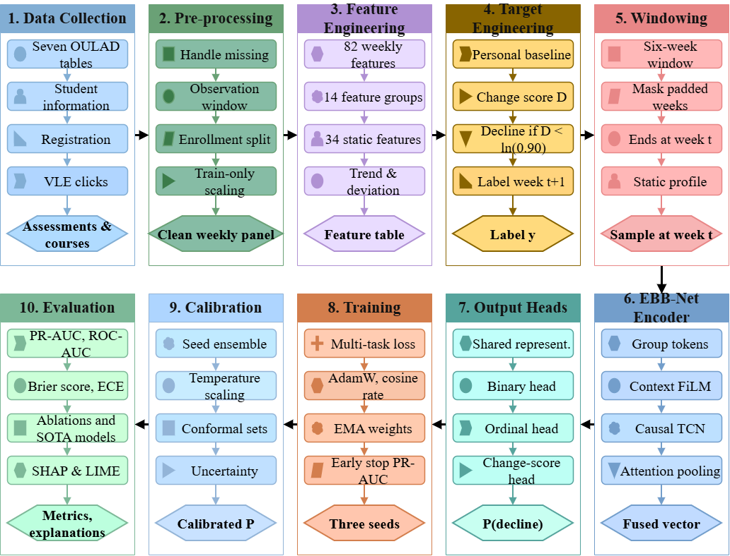Figure 1. Overall workflow of the proposed EBB-Net Framework

3.1 Dataset Description
The Open University Learning Analytics Dataset (OULAD) [31] is the only dataset used to develop and evaluate EBB-Net. It covers seven courses and 22 course presentations. Its tables hold student demographics, registration, course structure, VLE clicks and assessments. The registration table has 32,593 enrollments. An enrollment is one student in one course presentation. One student can have several enrollments. The VLE log has 10,655,280 click rows. Clicks are grouped into weeks with week = floor(day/7) + 1. A week is observed only while the student is registered and the course is running. The withdrawal week and later weeks are not observed. The step into withdrawal gets no label. So withdrawal ends the observation and is not counted as a decline. We removed 45 enrollments with no registration date, 3,362 with no complete observed week and 1,641 with fewer than four observed weeks. This leaves 27,545 enrollments from 24,842 students. The 27,545 enrollments represent the retained cohort before final prediction-window eligibility was applied. A labelled sample required at least three observed historical weeks, a personal baseline meeting the minimum-click rule and an observable next week. Although the initial cohort filter retained enrollments with at least four observed course weeks some of those enrollments did not contribute an eligible prediction window after the remaining conditions were applied. The final dataset therefore contains 574,461 labelled windows from 25,782 enrollments. Each sample holds a window of up to six weeks. Shorter windows are padded and masked. Each week has 82 features in 14 groups. Each student also has 34 static features. The label compares week t+1 with the median of the student’s own recent weeks. It uses total clicks, active days and unique sites. The label is 1 when the combined change score is below log 0.90. This means a combined level below 0.90 of the student’s own baseline on the add-one log-ratio scale. The inputs stop at week t and the label uses week t+1. The input features describe behaviour available through week t, while the target uses the corresponding behavioural observations from week t+1. Historical observations also contribute to the personal baseline used in the target definition. This reuse is intentional because the task measures future behaviour relative to past activity. The next-week component values and the resulting change score are not supplied as model inputs. The temporal separation prevents the future target values from being directly included in the input window. The data are divided by enrollment into 70% training, 15% validation and 15% test. The split is stratified by course presentation and withdrawal status. It has 44 strata and is made before any fitting. Imputation, scaling and the engagement reference use training enrollments only. The training set is used to fit the model. The validation set is used for model selection and tuning. The test set is used only for final evaluation. The partition is shown in Table 2.
Table 2. Dataset Partitioning for EBB-Net
Dataset Split | Students | Enrollments | Rows | Decline (1) | No decline (0)
Training Set | 16,846 | 18,048 | 401,202 | 222,760 | 178,442
Validation Set | 3,813 | 3,859 | 86,973 | 48,051 | 38,922
Testing Set | 3,816 | 3,875 | 86,286 | 47,950 | 38,336
Total | – | 25,782 | 574,461 | 318,761 | 255,700
The decline rate is close to balanced and almost identical in the three splits, at 0.5552 on training, 0.5525 on validation and 0.5557 on test, and 0.5549 over all labelled windows. This prevalence is the chance level for PR-AUC, so a PR-AUC of 0.81 is read against a baseline of about 0.555 and not against 0.5. The date_unregistration field is used only to close the observation window for a withdrawing enrollment and is never a model input. No enrollment appears in two splits. The split unit is the enrollment because the same student takes different courses with different content. The test therefore measures performance on new enrollments and not on new students. Each sample uses only its own enrollment’s history. The classes are fairly balanced.

3.2 Data Pre-processing
The seven OULAD tables are cleaned and joined into one weekly panel. Each row is one student in one course presentation in one week. The tables are linked by module, presentation and student identifiers. In the raw files, missing values are written as the text “?”. These are read as missing. The registration table has 32,593 enrollments. Every one of them has a matching student information row. Some enrollments cannot give a usable history. An enrollment has 33.3 observed weeks on average and at most 39. Clicks are assigned to weeks as
$week\left(d\right)=\left\lfloor d/7\right\rfloor +1$ (1)
where d is the day relative to the course start. A week is observed only while the student is registered and the course is running. The withdrawal week and all later weeks are not observed. The audit found no clicks with a non-positive value and none before registration. It also found no clicks on sites missing from the VLE table. Clicks before the course starts are kept as pre-course activity. Weeks with zero clicks inside the observation window are kept. They count as real inactivity. Count-like features are log-transformed as
$x^{'}=\ln\left(1+x\right)$ (2)
Features that can be negative use a signed version of the same transform. Missing values are replaced with the training median of each feature. Features are then standardised as
$z_{ij}=\frac{x_{ij}-μ_{j}}{σ_{j}}$ (3)
Where $x_{ij}$ is the value of feature $j$ for sample $i$. $μ_{j}$ and $σ_{j}$ are the mean and standard deviation of feature $j$ on the training set. If $σ_{j}$ is almost zero, it is set to 1. Binary features are imputed but not scaled. The weekly features are fitted on training student-weeks. The static features are fitted on training enrollments. The same values are applied unchanged to validation and test. After scaling no missing or infinite values remain. Each sample is then a window of the last six weeks ending at week t. Shorter histories are padded on the left and a mask marks the real weeks. We save the window array, the mask and the static matrix. A flat table of the current-week and static features is also saved for the tabular reference model. Eight automated checks run on the saved data and all pass; they are tabulated in Table 14. They confirm enrollment-level split isolation. They confirm there are no rows before registration, after withdrawal or after the course end.

3.3 Feature and Target Engineering
Feature and target engineering were performed to represent student’s learning behaviour over time and define a measurable next-week engagement decline. Each sample represents a student enrollment in a particular module presentation at week (t). The input contains information available up to that week. The target is derived separately from the student's behaviour in week (t+1). Daily VLE interactions were aggregated into weekly records for each enrollment. The features include total clicks, active days, inactive days, average clicks per active day, maximum daily clicks, unique sites and unique activity types. The dominant activity share and clicks for the six most frequently used activity types were also calculated. The six types were selected using training data only. Clicks from the remaining types were grouped into an other category. Pre-course clicks and active days were included as additional historical information. Assessment features represent submission behaviour and available performance information. These include assessments due, submissions made, late submissions, overdue unsubmitted assessments and submission rate. Score-related features include the latest available score, mean score and the difference between them. Scores were lagged by one week to account for marking delays. Banked assessment results, which OULAD records when a student carries a mark over from an earlier presentation, are excluded from the score features, because the submission did not occur in the observed week and would otherwise create activity that the student did not perform in this presentation. The date_unregistration field is used only to end the observation window and is not a model input. Calendar features represent assessment deadlines known from the published schedule. Static features describe the study context. They include education level, age band, deprivation decile, studied credits, previous attempts, registration timing, gender, region, disability status, module and semester. Categorical information was encoded using numerical or one-hot representations. The final static feature matrix contains 34 features. Additional features were created to describe changes in learning behaviour. These include week-to-week differences, relative changes, three-week rolling means and standard deviations, short-term trends, personal z-scores and ratios to the previous activity peak. Cumulative clicks, active weeks, consecutive inactive weeks and days since the last activity were also included. A peer-relative engagement index was calculated from the percentile ranks of total clicks, active days and unique sites. The reference distributions were estimated from training data for the same module presentation and week. The three percentile ranks were given equal weight.
$E_{i,t}=\frac{P_{\text{clicks}}+P_{\text{active days}}+P_{\text{sites}}}{3}$ (4)
This index’s purpose is to provide context about a student's activity relative to other students at a similar course stage. Personal-baseline features were constructed to represent behaviour relative to each student's own recent history. For each component (c), the baseline is the median of its observed weekly values from week (t-4) through week (t), including the current week. This provides a reference that is less sensitive to an unusually high or low week than a single-week baseline.
$B_{c}\left(t\right)=median_{s∈W_{t}}c\left(s\right)$ (5)
Current deviations from the personal baseline were calculated on a logarithmic scale. The three components were total clicks, active days and unique sites.
$r_{c}\left(t\right)=\ln\left(\frac{1+c\left(t\right)}{1+B_{c}\left(t\right)}\right)$ $D_{\text{cur}}\left(t\right)=\frac{1}{3}\sum_{c∈C}^{ }{r_{c}} \left(t\right)$ (6)
Adding one allows the ratios to be calculated when a component has zero activity. Equal weighting gives the three behavioural components a consistent contribution to the combined score. The target was designed to identify a decline in observed behaviour relative to the student's own recent baseline. For the following week, each component's value was compared with the baseline calculated using information available up to week (t). The three log-ratios were averaged to obtain the next-week change score.
$D\left(t+1\right)=\frac{1}{3}\sum_{c∈C}^{ }{\ln\left(\frac{1+c\left(t+1\right)}{1+B_{c}\left(t\right)}\right)}$ (7)
The binary label is defined as follows
$y=1, D\left(t+1\right)<\ln\left(0.90\right)$ (8)
$y=0, D\left(t+1\right)≥\ln\left(0.90\right)$
A positive label indicates that the geometric mean of the three add-one behavioural ratios for week t+1 is below 0.9000 relative to the corresponding personal baselines calculated using observations through week t. The three components are total clicks, active days and unique sites. The add-one transformation allows zero valued observations to be included in the logarithmic ratio. Consequently, the threshold is defined on the add-one log-ratio scale rather than as a literal percentage reduction in each raw component. The 0.1000 decline fraction is an operational threshold selected for this study. It has not been independently validated as a measure of sustained disengagement or later academic outcomes. The input features describe behaviour and baselines available through week (t), whereas the target uses observations from week (t+1). The next-week change score and its component ratios are stored for label construction and analysis, not included among the model inputs. Samples are also excluded when the next week is not observable, including transitions into the withdrawal week. A sample must have at least three observed weeks and a baseline median of at least one click to be eligible. The data were then organised into six-week sequences ending at week (t), with left-padding and a mask for shorter histories. Each sample contains the 82 dynamic features for the sequence and the 34 static features.

3.4 Proposed Framework Architecture
The proposed EBB-Net is an end-to-end deep learning architecture for forecasting next-week engagement decline. It does not treat the weekly features as one flat vector. It reads each feature group as a token and adapts the tokens to the student's context. A causal temporal encoder then reads the six-week history. The architecture of proposed EBB-Net Framework is shown in Figure 2.
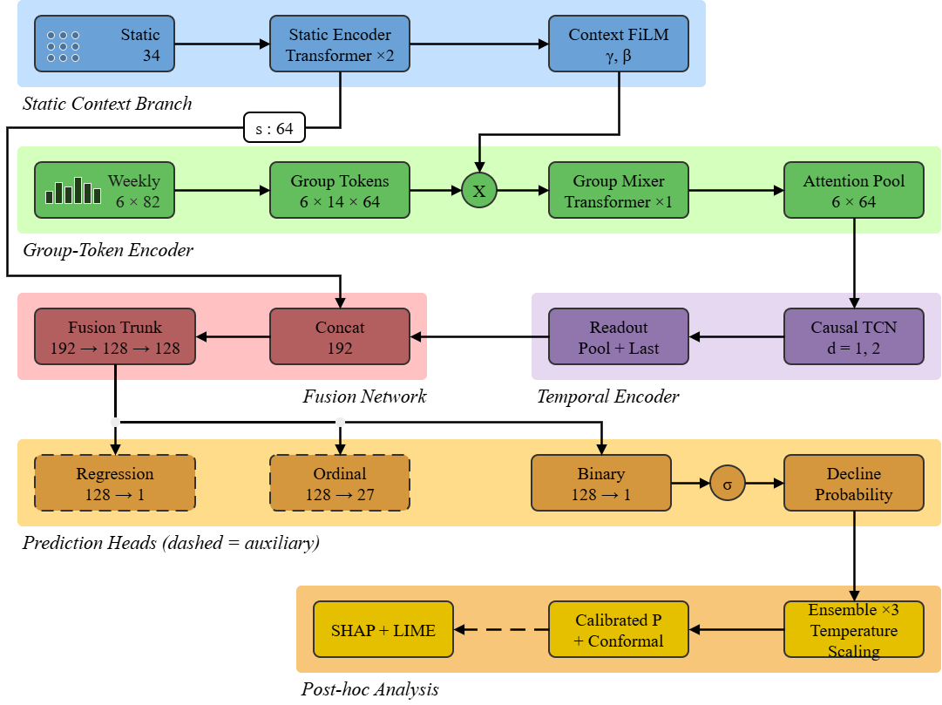
Figure 2. Overall Architecture of Proposed EBB-Net Framework
The input of each sample has two parts. The first is a window of up to six weeks. Each week has 82 features in 14 semantic groups. A mask marks the observed weeks. The second part is a static profile of 34 features. The static encoder is the first module and follows the FT-Transformer design for tabular data [34]. Each static feature becomes one 64-dimensional token. A token is the feature value times a learned weight plus a learned bias. Two transformer blocks with four attention heads let the tokens interact. The tokens are averaged and normalised. This gives one context vector for the student. The second module is the Group-Wise Token Encoder. For each week, every feature group is projected by its own linear layer into a 64-dimensional token. A learned group embedding is added. Features of one group share a meaning. So each group is handled by its own projection. The third module is Context FiLM modulation, which applies feature-wise linear modulation [32] to the group tokens. The context vector passes through a bottleneck of rank 16. A linear layer then gives a scale and a shift for every group token. The tokens are updated as token × (1 + scale) + shift. This layer starts as the identity. It lets the same behaviour be read differently for different students and courses. A transformer layer with four heads then lets the groups interact inside each week. An attention score pools them into one weekly vector. The attention weights over groups are kept for explanation. The fourth module is the Causal Temporal Encoder. The weekly vectors of observed weeks go into a temporal convolution network. It has two residual blocks with kernel size 3 and dilations 1 and 2. Each block has two causal dilated convolutions. A layer normalization over the channels follows each block, separately for every week. Layer normalization is used because it needs no batch statistics. Padded weeks cannot change the statistics. Causal means that week t sees only weeks up to t. Next comes pooling and fusion. A masked attention score pools the weeks. The vector of the last observed week and the context vector are added. The three 64-dimensional vectors are joined into a 192-dimensional vector. Two linear layers of width 128, with layer normalization, GELU and dropout, produce the fused representation. Three heads sit on the fused representation. The binary head is one linear unit. Its sigmoid output is the decline probability. This is the only probability used for prediction. The ordinal head gives cumulative probabilities over thresholds of the change score. There are 27 unique ordered thresholds in the fitted configuration, formed from 24 training-quantile candidates and four exact decline thresholds after duplicates are merged. The logits are kept monotone with softplus increments. The change-score head is a single linear unit. It predicts the scaled change score. Both are auxiliary heads. They only shape the shared representation and do not alter the binary output. The loss has the binary cross-entropy at full weight. It adds the ordinal cross-entropy, an extra term for the four drop thresholds and a Huber loss on the change score. The random search selected a weight of zero for the four-threshold term, so it is inactive in the reported runs. The ordinal output at the 0.90 threshold is trained with the label itself. Here d_t denotes the scaled change score predicted by the regression head, and W_t denotes the set of observed weeks from t-4 to t. The layer-wise Architecture details of proposed EBB-Net is given in Table 3.
Table 3. Layer-wise Architecture Summary of proposed EBB-Net Framework
Layer | Configuration | Output Shape
Weekly Feature Input | 82 dynamic features per week in 14 semantic groups; 6-week window, left-padded, with a validity mask | (6, 82)
Static Context Input | 34 static features (6 numeric, 2 binary flags, 26 one-hot); input-feature dropout 0.10 (training only) | (34)
Static Feature Tokenizer | Per-feature linear embedding x_f·W_f + b_f, one 64-dimensional token per static feature | (34, 64)
Static Context Encoder | 2 pre-norm Transformer encoder layers (4 heads, FFN 128, GELU, dropout 0.05) → mean over tokens → LayerNorm | (64)
Group Projection (14 groups) | Linear(n_g → 64) per group and week, with n_g = 7, 4, 7, 3, 2, 8, 2, 4, 4, 22, 7, 3, 5, 4 | (6, 14, 64)
Group Embedding | Learnable embedding added to each group token | (6, 14, 64)
Context FiLM | Linear(64 → 16) + GELU + Dropout(0.05), then Linear(16 → 2 × 14 × 64) giving a scale γ and a shift β per group token; tokens × (1 + γ) + β; zero-initialised | (6, 14, 64)
Group-Token Mixer | 1 pre-norm Transformer encoder layer over the 14 tokens of each week (4 heads, FFN 128, GELU, dropout 0.05) | (6, 14, 64)
Group Attention Pooling | Linear(64 → 1) token scores, softmax over groups, weighted sum, LayerNorm | (6, 64)
Causal TCN | 2 residual temporal blocks (kernel 3, dilations 1 and 2, two causal convolutions per block, GELU, dropout 0.05, channel-wise LayerNorm, 64 channels), masked input | (6, 64)
Temporal Attention Pooling | Linear(64 → 1) week scores, softmax over valid weeks, weighted sum | (64)
Last-Week Representation | TCN output at the latest valid week | (64)
Concatenation | [temporal pooled vector; last-week vector; static vector] | (192)
Fusion Trunk | Linear(192 → 128) → LayerNorm → GELU → Dropout(0.05) → Linear(128 → 128) → GELU → Dropout(0.05) | (128)
Binary Decline Head | Linear(128 → 1); sigmoid(logit) = decline probability (the only source of the reported probability) | (1) ∈ [0, 1]
Ordinal Head (auxiliary) | Linear(128 → 27) with monotone cumulative logits | (27)
Change-Score Regression Head (auxiliary) | Linear(128 → 1), change score D(t+1) clipped to [−3, 3] and scaled by 3 | (1)
Loss | BCE on the binary logit + 0.50 × BCE (27 ordinal thresholds) + 0.00 × BCE (4 exact decline-fraction thresholds, inactive) + 0.10 × smooth-L1 (change score) | scalar
The proposed architecture also allows evaluating component-wise ablations of the model. EBB-Net is compared with five ablated variants (without group tokens, without context modulation, without the temporal TCN, binary head only, and without change-score regression) are trained with the same enrollment-level partitions, the tuned hyperparameters of the full model, the same seeds and the same evaluation procedure. It is therefore possible to estimate the individual contributions of the group-token encoder, the context modulation, the temporal convolution and the auxiliary heads. The parameter distribution of the proposed EBB-Net model is presented in Table 4.
Table 4. Parameter distribution of Proposed EBB-Net Framework
Component | Parameters
Static Context Encoder | 71,424
Group-Token Encoder (projections, group embedding, mixer, pooling) | 40,705
Context FiLM | 31,504
Causal TCN | 49,664
Temporal Attention Pooling | 65
Fusion Trunk | 41,472
Binary Decline Head | 129
Ordinal Head | 3,483
Change-Score Regression Head | 129
It is evident from the architecture overview presented in Table 3 and the parameter distribution in Table 4 that the proposed EBB-Net architecture is modular and includes components intended to model feature-group relationships, static-context modulation and temporal dependencies. The group-token encoder gives each feature group of each week its own representation and the context FiLM module is designed to let static student context modulate those tokens. The causal TCN with attention pooling models the weekly trajectory instead of a single static score and the binary head is trained against a label defined relative to each student's own personal reference level. So the task is next-week decline rather than present-state classification. The ordinal and change-score heads are auxiliary. They only shape the shared representation and the reported probability comes from the binary head alone. The static context encoder and the causal TCN are the largest components and the three heads together contain only 3,741 parameters. The full model has 238,575 trainable parameters, which is larger than the neural baselines, so parameter count should be kept in mind when interpreting the comparisons. A ten-seed ensemble is also temperature-calibrated per history length and SHAP and LIME provide post-hoc explanations. An enrollment-level split with leakage audit makes the reported performance representative of a genuine forecasting setting. Thus, the proposed EBB-Net architecture reformulates engagement analysis from present-state classification into a structured, context-aware, next-week decline forecasting task.

3.5 Loss Function and Hyperparameters Configuration
The optimisation approach is a critical factor in training an effective engagement-decline forecaster from the leakage-audited, enrollment-level partitioned OULAD feature set. EBB-Net is formulated as a supervised binary classification model with two auxiliary objectives that only shape the shared representation. For a given student-week representation, the binary head produces a single logit z_t, which is converted into a decline probability through the sigmoid function as
$ŷ_{t}=σ\left(z_{t}\right)$ (9)
where σ is the sigmoid activation and $ŷ_{t}$ is the only probability reported by the model. The primary objective is the binary cross-entropy between this probability and the true decline label $y_{t} ,$ computed with BCEWithLogitsLoss directly on the logit for numerical stability as
$L_{BCE}=-\left[y_{t}logŷ_{t}+\left(1-y_{t}\right)\log\left(1-ŷ_{t}\right)\right]$ (10)
The ordinal head predicts the cumulative probabilities $P\left(D<τ_{k}\right)$ at 27 ordered thresholds $τ_{1}<…<τ_{27}$ of the change score D(t+1). These are 24 quantiles of D in the training set between the 0.04 and 0.96 quantiles, together with the four exact thresholds $τ_{δ}=\ln\left(1-δ\right), δ ϵ \left\{0.05,0.10,0.15,0.20\right\}$ with duplicates merged. The head outputs raw values $a_{k}$, which are converted into monotone cumulative logits as
$l_{1}=a_{1}, l_{k}=a_{1}+\sum_{j=2}^{k}{softplus\left(a_{j}-2\right)}$ (11)
so that the predicted cumulative probability never decreases with k. The target of threshold k is $c_{k}=1\left[D\left(t+1\right)<τ_{k}\right]$. At the primary threshold ln(0.90), the target is the decline label $y_{t}$ itself. The ordinal loss is the mean binary cross-entropy over all thresholds, and a second term is computed over the four exact δ thresholds only
$L_{ord}=\frac{1}{27}\sum_{k=1}^{27}{BCE\left(l_{k},c_{k}\right)}$ (12)
$$L_{δ}=\frac{1}{4}\sum_{k∈K_{δ}}^{B}{CE\left(l_{k},c_{k}\right)}$$
The regression head predicts the change score clipped to [−3, 3] and divided by 3, trained with a smooth L1 loss (β = 0.1)
$L_{reg}=SmoothL1\left(\hat{d_{t}},\frac{clip\left(D\left(t+1\right),-3,3\right)}{3}\right)$ (13)
The final objective is
$L=L_{BCE}+λ_{ord}L_{ord}+λ_{δ}L_{δ}+λ_{reg}L_{reg}$ (14)
$$λ_{ord}=0.25, λ_{δ}=0.10, λ_{reg}=0.25$$
The model is trained with AdamW at a base learning rate of $η_{0}=4.9792×{10}^{-4}$ and a weight decay of $λ_{wd}=3.514×{10}^{-4}$ . A linear warm-up over the first $S_{w}=1500$ optimisation steps is combined with cosine decay to ηmin=1×10−5 over the maximum training length. The learning rate at step s is
$η_{s}=\left[η_{min}+\frac{1}{2}\left(η_{0}-η_{min}\right)\left(1+\cos\left(π\min\left(\frac{s}{E_{max}N_{b}},1\right)\right)\right)\right]\min\left(1,\frac{s+1}{S_{w}}\right)$ (15)
where $E_{max}=25$ is the maximum number of epochs and $N_{b}=784$ is the number of batches per epoch. Gradients are clipped at a maximum norm of 1.0. An exponential moving average of the weights with a decay of 0.999 is maintained and all validation, test and checkpoint evaluations use these averaged weights. The model is trained with a batch size of 512 for at most 25 epochs, with early stopping when validation PR-AUC does not improve for 6 consecutive epochs. The classification threshold is not fixed at 0.5. At each epoch, the threshold that maximises validation balanced accuracy is selected through a linear sweep over 181 values between 0.05 and 0.95. The threshold from the epoch with the best validation PR-AUC is retained for test evaluation. The hyperparameters of the full model were selected by random search on validation PR-AUC, using 10 trials with at most 8 epochs per trial, early stopping with a patience of 4. The search covered the learning rate (log-uniform 2.5 × 10⁻⁴ to 8 × 10⁻⁴), weight decay (log-uniform 1 × 10⁻⁴ to 1 × 10⁻²), dropout {0.05, 0.10, 0.15, 0.20}, static-feature dropout {0.05, 0.10, 0.15}, dynamic-feature dropout {0.0, 0.05, 0.10} and the auxiliary loss weights. The selected configuration is a dropout of 0.05, a static-feature dropout of 0.15 and a dynamic-feature dropout of 0.0, with auxiliary loss weights of 0.50 for the cumulative ordinal term, 0.00 for the multi-threshold term and 0.10 for the change-score term, together with the values given above. The search therefore selected a weight of zero for the multi-threshold term, so that term is inactive in every reported run and the trained objective reduces to the binary cross-entropy plus 0.50 times the cumulative ordinal loss plus 0.10 times the smooth L1 loss on the change score. The ablation variants reuse this configuration. The complete hyperparameter configuration is described in Table 5.
Table 5. Hyperparameter configuration of Proposed EBB-Net Framework
Hyperparameter | Value / Configuration
Framework | EBB-Net
Dataset | OULAD
Prediction task | Binary prediction of next-week behavioural engagement decline
Input sequence length | 6 weeks
Dynamic input features | 82 features per week
Static input features | 34 features
Number of dynamic feature groups | 14
Static feature encoder | FT-Transformer-style encoder
Static encoder dimension | 64
Static encoder attention heads | 4
Static encoder blocks | 2
Static encoder feed-forward dimension | 128
Dynamic group encoder | Group-token encoder with multi-head self-attention
Group encoder dimension | 64
Group encoder attention heads | 4
Group encoder feed-forward dimension | 128
Context modulation | Low-rank FiLM with rank 16
Temporal encoder | Causal temporal convolutional network (TCN)
TCN channels | 64
TCN kernel size | 3
TCN dilation rates | 1 and 2
Temporal aggregation | Masked attention pooling and last valid temporal representation
Fusion network | 192 → 128 → 128
Prediction heads | Binary classification, auxiliary ordinal prediction and auxiliary change-score regression
Total trainable parameters | 238,575
Primary learning objective | Binary cross-entropy with logits
Cumulative ordinal loss weight | 0.50
Multi-threshold loss weight | 0.00 (the term is inactive in the selected configuration)
Change-score regression loss weight | 0.10
Change-score regression target | Smooth L1 loss on the change score clipped to the range −3 to 3 and scaled by 3
Optimiser | AdamW
Tuned base learning rate | 0.0004979
Weight decay | 0.0003514
Network dropout rate | 0.05
Static feature dropout | 0.15
Dynamic feature dropout | 0.00
Training batch size | 512
Evaluation batch size | 4096
Learning rate schedule | Step-based warm-up over 1500 steps with cosine decay
Minimum learning rate | 0.00001
Gradient clipping norm | 1.0
Exponential moving average decay | 0.999
Maximum training epochs | 25
Early-stopping patience | 6 epochs
Model selection metric | Validation PR-AUC
Decision-threshold selection metric | Validation balanced accuracy
Hyperparameter tuning | Random search using validation PR-AUC
Tuning configuration | 10 trials including the default configuration, up to 8 epochs per trial and patience of 4 epochs
Main training seeds | 42 to 51
Hyperparameter tuning seed | 1234
Data partitioning | Stratified enrollment-level train, validation and test split
The configuration of EBB-Net separates feature representation, temporal learning and prediction into connected stages. The 64-dimensional representation provides a common feature space for the static context encoder and the weekly dynamic group encoder. The static encoder uses two Transformer blocks with four attention heads. The dynamic encoder represents the 14 feature groups as tokens and uses multi-head attention to learn relationships among them within each week. Low-rank FiLM conditions the dynamic representation on the student's static context. The causal TCN uses a kernel size of 3 and dilation rates of 1 and 2 to process the six-week history. Masked attention pooling summarises the temporal representations, while the last valid temporal representation preserves information from the most recent observed week. These representations are combined with the static context embedding and passed through the fusion network. The binary classification head is the primary prediction head. The cumulative ordinal and change-score regression heads provide auxiliary training signals. Their losses help train the shared representation but are not combined with the binary output to calculate the decline probability. The primary binary probability is obtained by applying the sigmoid function to the binary head's logit. The hyperparameters were selected through random search using validation PR-AUC and a separate tuning seed. The test set was not used for hyperparameter selection. The main experiments used ten seeds, 42 to 51. Checkpoint selection and early stopping used validation PR-AUC, while the decision threshold was selected using validation balanced accuracy. AdamW optimisation, gradient clipping, exponential moving average weights and a warm-up plus cosine learning-rate schedule were used during training. These settings define the configuration evaluated in the experiments rather than establishing that it is optimal for every dataset.

4. Results and Discussions
4.1 Experimental Setup
The Open University Learning Analytics Dataset (OULAD) was used to evaluate the proposed EBB-Net framework for next-week behavioural engagement decline prediction. The prepared dataset contains 574,461 student-enrollment-week prediction samples. Each sample uses a six-week learning history ending at week (t) to predict whether the student's combined behavioural activity in week (t+1) falls below 0.90 of their recent personal baseline on the add-one log-ratio scale. The input representation consists of 82 dynamic features across 14 feature groups and 34 static features. Samples with fewer than three observed weeks, a baseline median below one click or an unavailable next-week observation were excluded. The data were divided into training, validation and test sets. The training set contains 401,202 samples from 18,048 enrollments. The validation set contains 86,973 samples from 3,859 enrollments, while the test set contains 86,286 samples from 3,875 enrollments. The split was performed at the enrollment level using random seed 42. Stratification was applied within module-presentation and withdrawal-status groups to preserve their distribution across partitions. Each enrollment was assigned to one partition. However, the same student may appear in different partitions through separate enrollments. Therefore, the evaluation represents enrollment-level rather than strictly student-disjoint generalisation. EBB-Net was implemented in PyTorch and trained using the AdamW optimiser. The training objective combines binary cross-entropy with auxiliary ordinal and change-score regression losses. Hyperparameters were selected through random search based on validation PR-AUC with a separate tuning seed of 1234. The final experiments used ten random seeds, 42 through 51. All models were trained on a single NVIDIA Tesla T4 GPU (16 GB) with PyTorch 2.11 and CUDA 13.0, on a host with two vCPUs and 13 GB of RAM. Training used a batch size of 512 and a maximum of 25 epochs. Early stopping was applied with a patience of six epochs based on validation PR-AUC. A step-based learning-rate warm-up followed by cosine decay was used along with gradient clipping and exponential moving average weights. The proposed framework was compared with five architectural ablations and three neural baselines (MLP, GRU and TCN) and four tabular baselines (XGBoost, LightGBM, Random Forest and L2-regularised logistic regression). The tuning budget was stated and fixed in advance for every model. EBB-Net was tuned by random search over 10 trials on validation PR-AUC, with up to 8 epochs per trial and a patience of 4. Each of the three neural baselines was tuned by random search over 5 trials on validation PR-AUC, over learning rate, weight decay and dropout. Each of the four tabular baselines was also tuned over 5 trials on validation PR-AUC, over its own tree or regularisation hyperparameters. The budgets are therefore equal across the seven baselines but not between the baselines and EBB-Net, which searched a larger space over 10 trials because it has more hyperparameters, including the auxiliary loss weights. The five ablations were not tuned again and reuse the tuned configuration of the full model. Validation PR-AUC was used for model selection, while the classification threshold was chosen by maximising balanced accuracy on the validation set. The held-out test set was used for final evaluation. The reported metrics include PR-AUC, ROC-AUC, F1-score, precision, recall, accuracy, Brier score, expected calibration error and log-loss. The preprocessing pipeline included checks for enrollment-level split isolation, valid observation windows, causal feature construction, past-only assessment features, independent target reconstruction and exclusion of forbidden input features. Imputation parameters, scaling statistics and the reference distributions used to construct peer-relative engagement features were fitted using training data and then applied to validation and test data. These checks support the intended separation of past inputs from next-week targets.
4.2 Evaluation Metrics
Several metrics are used to test EBB-Net. They cover ranking quality, classification at a fixed threshold and the quality of the predicted probabilities. The task is binary and a decline is the positive class. All metrics are computed on the held-out test set. The threshold-based metrics use one threshold per model. It is chosen on the validation set from a fixed grid between 0.05 and 0.95. The rule maximizes balanced accuracy. The decline rate is above 0.5. Precision shows how many flagged students truly decline
$\text{Pr}{\text{e}}\text{cision}=\frac{TP}{TP+FP}$ (16)
Recall shows how many real declines are found. This matters for an early warning because a missed decline costs more than a false alarm
$\text{Recall}=\frac{TP}{TP+FN}$ (17)
The F1-score balances both Precision and Recall
$F1=\frac{2×\text{Pr}{\text{e}}\text{cision}×\text{Recall}}{\text{Pr}{\text{e}}\text{cision}+\text{Recall}}$ (18)
Here TP, FP and FN are true positives, false positives and false negatives. Accuracy is the share of correct predictions. Two metrics do not depend on the threshold. ROC-AUC measures how well the model ranks declining students above the others. PR-AUC summarises the trade-off between precision and recall. PR-AUC is the primary metric. It selects checkpoints, stops training early and guides tuning. The probabilities are used for early warning, so their quality is also measured. The Brier score is the mean squared difference between the predicted probability and the outcome. Log loss is the binary cross-entropy of the probabilities. The expected calibration error (ECE) compares confidence with the observed decline rate in 15 equal-width bins
$\text{ECE}=\sum_{b=1}^{15}{\frac{n_{b}}{N}\left|\text{ob}{\text{s}}_{\text{b}}-\text{con}{\text{f}}_{\text{b}}\right|}$ (19)
Where $n_{b}$ is the number of samples in bin b and N is the total number of samples. $obs_{b}$ is the observed decline rate and $conf_{b}$ is the mean predicted probability in the bin. Lower values are better for Brier score, log loss and ECE. Every model is run on ten seeds and reported as mean ± standard deviation. The baselines and the ablations are scored in the same way. No single metric judges the model alone. EBB-Net is judged through PR-AUC, ROC-AUC, F1-score, precision, recall, accuracy, Brier score, log loss and ECE.

4.3 Performance Analysis of the Proposed EBB-Net Framework
EBB-Net was evaluated on the validation and test sets. The aim was to check how well it ranks declining weeks and how close its probabilities are to what happens. It also checks how the model behaves on enrollments it has not seen. Training ran for at most 25 epochs with early stopping on validation PR-AUC. Every result is the mean ± standard deviation over ten seeds (42 to 51). Table 6 gives the training and validation results.
Table 6. Training and Validation Performance of the Proposed EBB-Net (mean ± SD over ten seeds)
Metric | Training | Validation
PR-AUC | 0.8241 ± 0.0014 | 0.8047 ± 0.0002
ROC-AUC | 0.7873 ± 0.0015 | 0.7687 ± 0.0002
F1-Score | 0.7280 ± 0.0034 | 0.7157 ± 0.0037
Precision | 0.7519 ± 0.0042 | 0.7351 ± 0.0036
Recall | 0.7057 ± 0.0098 | 0.6974 ± 0.0102
Accuracy | 0.7072 ± 0.0013 | 0.6939 ± 0.0012
Brier Score | 0.1858 ± 0.0006 | 0.1934 ± 0.0001
ECE | 0.0074 ± 0.0003 | 0.0082 ± 0.0011
Log Loss | 0.5457 ± 0.0016 | 0.5653 ± 0.0003
The validation PR-AUC is 0.8047 and the ROC-AUC is 0.7687. The training values are 0.8241 and 0.7873. The gaps are 0.0194 and 0.0186. The F1-score gap is 0.0123. The model has not simply memorised the training windows. The training Brier score of 0.1858 and validation value of 0.1934 also stay close. Precision and recall are near each other on validation at 0.7351 and 0.6974. The threshold is chosen by balanced accuracy, so it does not lean to one class. The ECE is below 0.0100 in both sets, at 0.0074 on training and 0.0082 on validation. The predicted probabilities therefore match the observed decline rate closely. The standard deviation of PR-AUC is only 0.0002 on validation. The ten seeds agree on ranking. F1, precision and recall vary more between seeds. Table 7 gives the test results.
Table 7. Final Test Set Performance of the Proposed EBB-Net (mean ± SD over ten seeds)
Metric | Value
PR-AUC | 0.8105 ± 0.0005
ROC-AUC | 0.7725 ± 0.0004
F1-Score | 0.7181 ± 0.0036
Precision | 0.7409 ± 0.0033
Recall | 0.6969 ± 0.0096
Accuracy | 0.6961 ± 0.0015
Brier Score | 0.1916 ± 0.0002
ECE | 0.0063 ± 0.0012
Log Loss | 0.5607 ± 0.0004
On the test set the PR-AUC is 0.8105 and the ROC-AUC is 0.7725. The test values are close to the validation values. The differences are 0.0058 for PR-AUC and 0.0038 for ROC-AUC. Test is slightly higher than validation. The test set was not used for any choice. It holds different enrollments and small shifts between two such sets are normal. The test accuracy is 0.6961. The test precision is 0.7409 and the recall is 0.6969. So about three of every ten real declines are missed. The F1-score is 0.7181. The test ECE is 0.0063, the Brier score 0.1916 and the log loss 0.5607. The probabilities stay well matched to outcomes on unseen enrollments. The ten seed models were also combined into an ensemble. The test probabilities of the ten seeds were averaged. Temperature scaling [37] was then fitted on the validation set for each history length group. The groups are 3-4, 5-8, 9-16 and 17+ observed weeks. A split conformal step [38] with a miscoverage level of 0.10 was also fitted on the validation set. The decision threshold was chosen on the validation set. Table 8 gives the ensemble results on the test set.
Table 8. Test Set Results of the Calibrated Ten-Seed EBB-Net Ensemble (temperature scaling per history-length group and split conformal sets fitted on the validation set)
Measure | Value
PR-AUC | 0.8132
ROC-AUC | 0.7757
F1-Score | 0.7231
Precision | 0.7419
Recall | 0.7053
Accuracy | 0.6999
PR-AUC 95% CI (student-level bootstrap) | 0.8099 to 0.8166
Brier Score | 0.1904
ECE | 0.0060
Log Loss | 0.5576
Decision threshold | 0.5500
Temperature, 3-4 weeks | 0.9868
Temperature, 5-8 weeks | 1.0636
Temperature, 9-16 weeks | 1.0118
Temperature, 17+ weeks | 1.0118
Conformal quantile | 0.6729
Conformal coverage | 0.9019
Mean conformal set size | 1.4818
The ensemble has a PR-AUC of 0.8132 and a ROC-AUC of 0.7757. The F1-score is 0.7231 with a precision of 0.7419 and a recall of 0.7053. The Brier score is 0.1904, the ECE is 0.0060 and the log loss is 0.5576. The ensemble therefore improves on the single-seed mean on every one of these measures. The 95% confidence interval for the ensemble PR-AUC is 0.8099 to 0.8166. It comes from 500 bootstrap resamples of the test students, so it covers sampling variation in the test students rather than variation between seeds. The temperatures lie between 0.9868 and 1.0636. The averaged probabilities needed only a mild rescaling in every history group. A conformal set is the list of labels the model still allows for a sample. It can be {1}, {0} or {0,1}. The miscoverage level was 0.10, so the target coverage is 0.9000. On the test set the true label was inside the set for 0.9019 of the samples. This meets the target. The mean set size is 1.4818. About 0.5182 of the samples therefore get one label. About 0.4818 get both labels. Both labels are given when the calibrated decline probability lies between 0.3271 and 0.6729. The model cannot separate the two classes with enough confidence for these samples.

4.4 Training Convergence Analysis
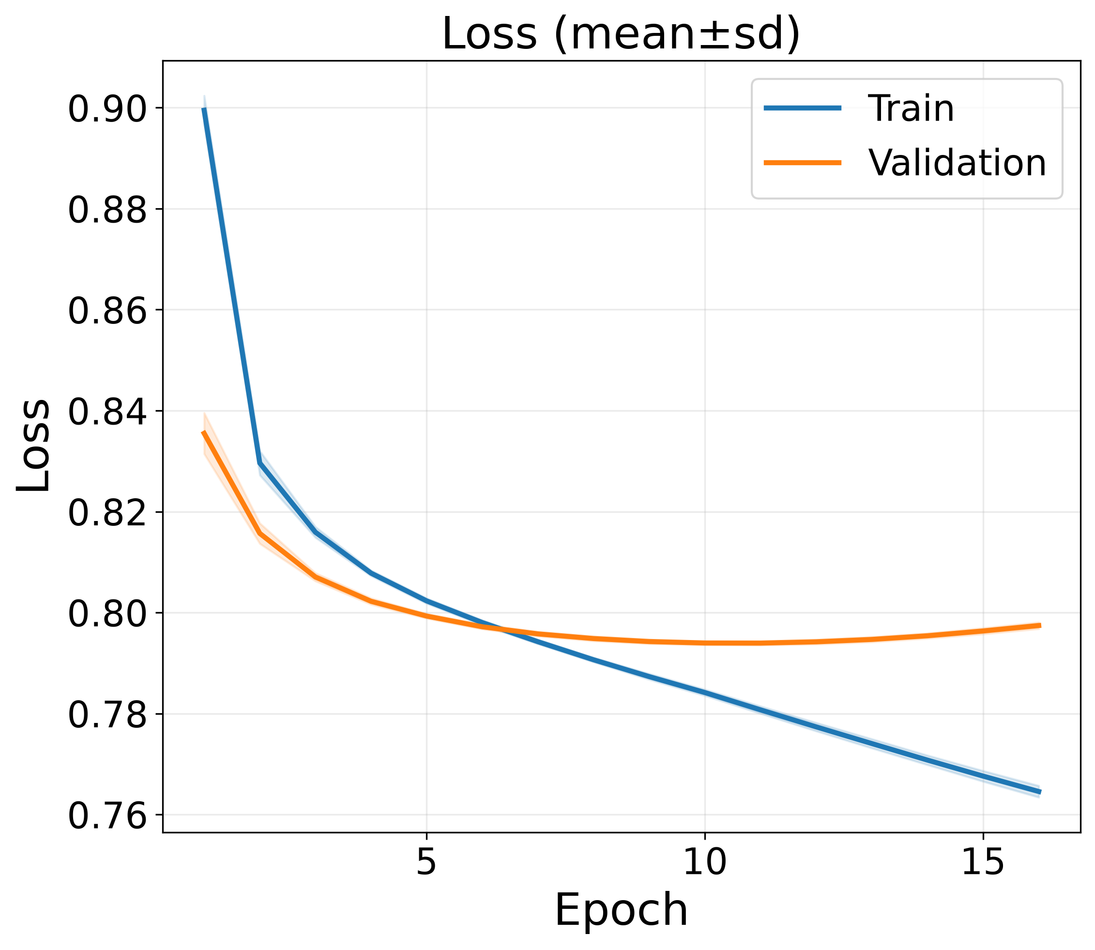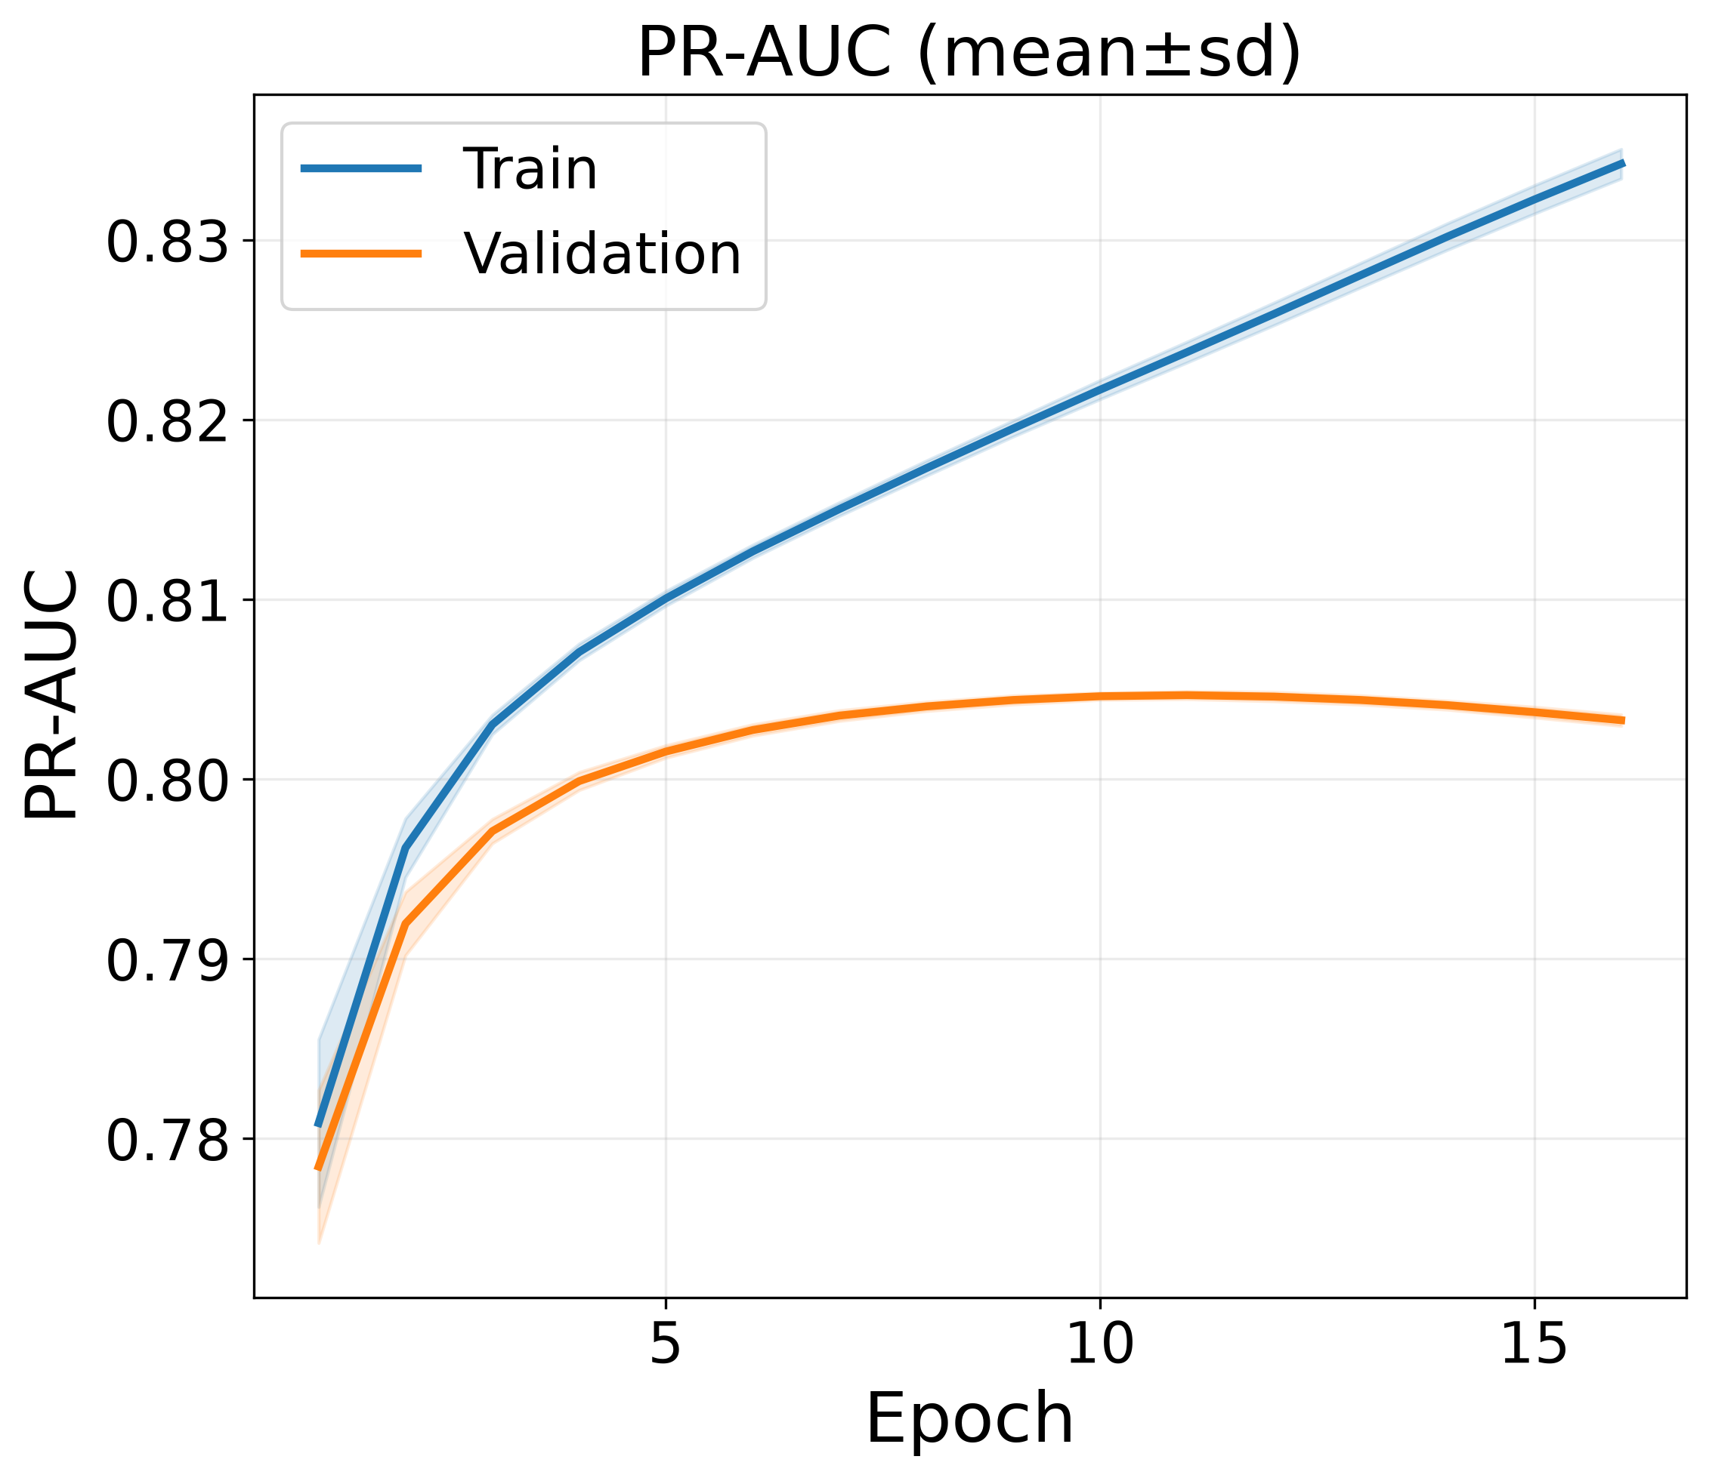
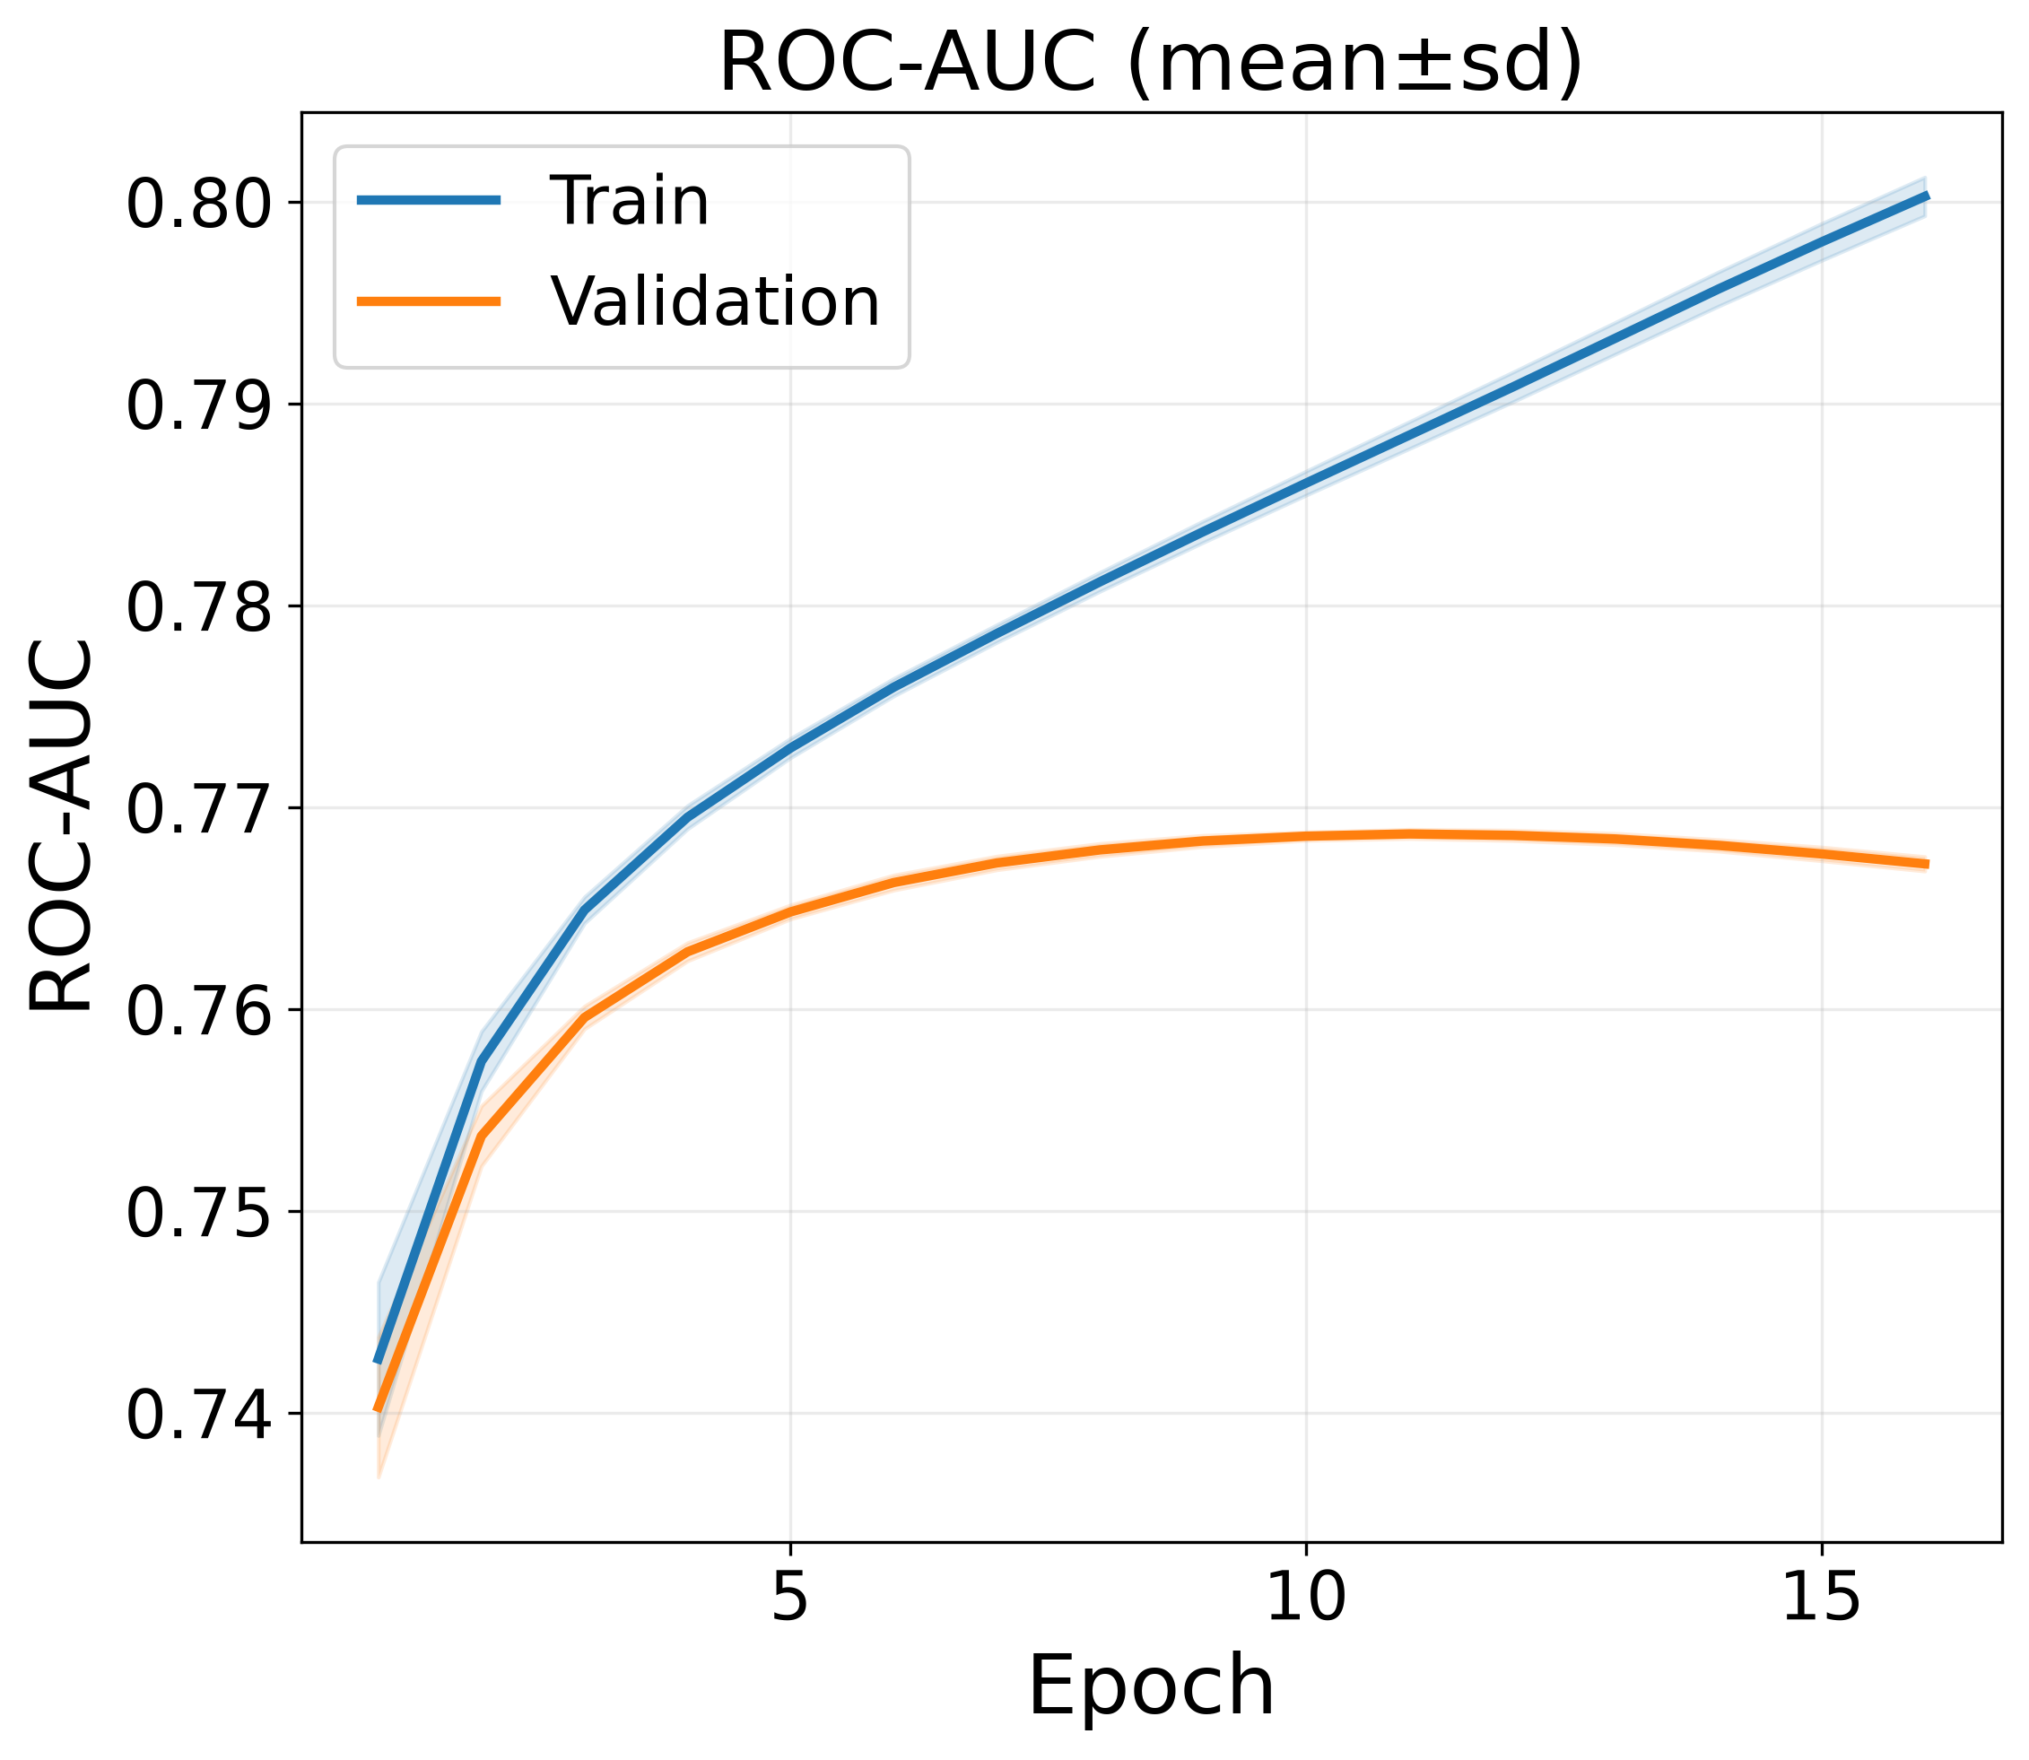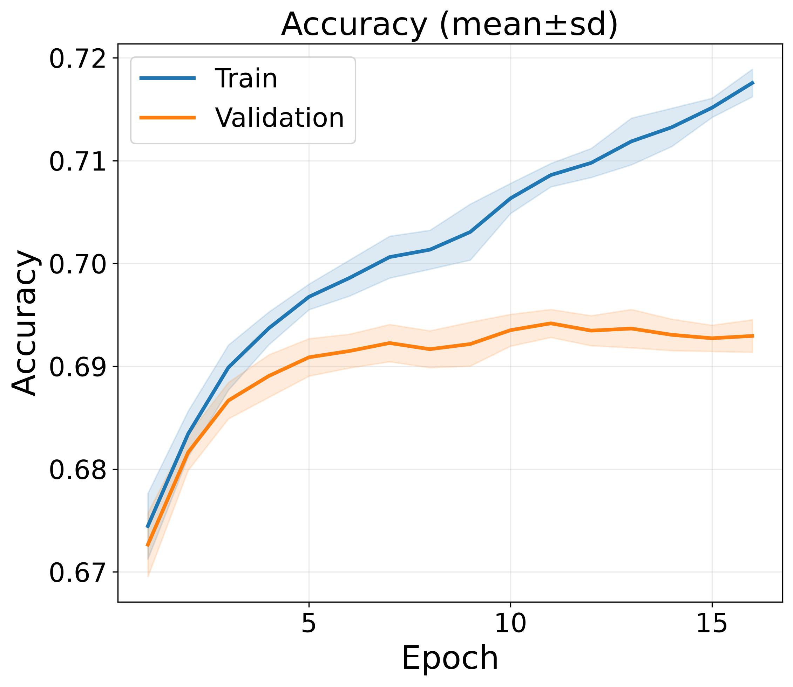
Figure 3. Training and validation convergence curves of the proposed EBB-Net framework (mean ± SD over ten seeds, 42 to 51): (A) loss, (B) PR-AUC, (C) ROC-AUC and (D) accuracy per epoch. The curves are shown for epochs 1 to 16, the range completed by all ten seeds before early stopping.

Figure 3 shows how EBB-Net converged during training. It plots four quantities per epoch. They are the loss, PR-AUC, ROC-AUC and accuracy. Each curve is the mean over the ten seeds (42–51) and the shaded band is the standard deviation. The curves run to epoch 16, which is the last epoch reached by every seed; individual runs stopped between epochs 16 and 18. The loss curves in panel A fall quickly in the first two epochs. The training loss drops from 0.8995 to 0.8296. The validation loss starts lower at 0.8355 and falls to 0.8157. For the first few epochs the validation loss stays below the training loss. The training loss is averaged over the epoch while the weights are still changing and dropout is active, whereas validation uses the averaged weights without dropout. The two curves cross between epochs 6 and 7. After that the training loss keeps falling and reaches 0.7646 at epoch 16. The validation loss reaches its lowest point of 0.7939 at epoch 11 and then rises slightly to 0.7974. The loss here is the training objective, which includes the auxiliary ordinal and change-score terms. Both PR-AUC curves start near 0.78, at 0.7809 on training and 0.7784 on validation. The training PR-AUC rises steadily to 0.8342 at epoch 16. The validation PR-AUC rises quickly and peaks at 0.8047 at epoch 11. It then eases to 0.8033. The gap between the two curves is 0.0024 at epoch 1 and grows to 0.0310 at epoch 16. Most of this growth comes after validation stops improving. The ROC-AUC curves in panel C follow the same shape. The training value rises from 0.7427 to 0.8002. The validation value peaks at 0.7687 at epoch 11 and ends at 0.7672. The accuracy curves in panel D are less smooth. The training accuracy rises from 0.6745 to 0.7176. The validation accuracy rises from 0.6726 to 0.6942 at epoch 11 and then falls to 0.6929. The shaded bands are also wider here than for PR-AUC and ROC-AUC. The three validation metrics and the validation loss therefore all turn at the same epoch, which is epoch 11, and that is the checkpoint selected for every seed. After that the training curves keep improving while the validation curves do not. Early stopping on validation PR-AUC with a patience of six epochs ends each run.

4.5 Ablation Study
An ablation study was run to check what each component of EBB-Net contributes. One component was removed at a time. Five variants were tested. A1 removes the group tokens. A2 removes the context modulation (Context-FiLM). A3 removes the temporal TCN. A4 keeps only the binary head. A5 removes the change-score regression head. Every variant used the same enrollment-level splits and the same seeds as the full model. It also used the tuned hyperparameters of the full model and the same evaluation procedure. The variants were not tuned again. This keeps the comparison on the effect of removing one component. All scores are on the test set and are the mean ± standard deviation over ten seeds. Table 9 gives the test results of Ablations and the EBB-Net
Table 9. Ablation Study Results of the Proposed EBB-Net Framework (mean ± SD over 10 seeds)
Model | PR-AUC ↑ | ROC-AUC ↑ | F1-Score ↑ | Precision ↑ | Recall ↑ | Accuracy ↑ | Brier ↓ | ECE ↓ | Log Loss ↓
EBB-Net (Proposed) | 0.8105 ± 0.0005 | 0.7725 ± 0.0004 | 0.7181 ± 0.0036 | 0.7409 ± 0.0033 | 0.6969 ± 0.0096 | 0.6961 ± 0.0015 | 0.1916 ± 0.0002 | 0.0063 ± 0.0012 | 0.5607 ± 0.0004
A1: w/o Group tokens | 0.8076 ± 0.0004 | 0.7694 ± 0.0003 | 0.7176 ± 0.0071 | 0.7377 ± 0.0064 | 0.6989 ± 0.0189 | 0.6944 ± 0.0024 | 0.1929 ± 0.0001 | 0.0073 ± 0.0012 | 0.5637 ± 0.0003
A2: w/o Context-FiLM | 0.8100 ± 0.0004 | 0.7718 ± 0.0004 | 0.7150 ± 0.0031 | 0.7427 ± 0.0031 | 0.6893 ± 0.0083 | 0.6946 ± 0.0010 | 0.1919 ± 0.0002 | 0.0061 ± 0.0007 | 0.5613 ± 0.0005
A3: w/o Temporal TCN | 0.8099 ± 0.0004 | 0.7717 ± 0.0004 | 0.7148 ± 0.0034 | 0.7425 ± 0.0040 | 0.6891 ± 0.0096 | 0.6944 ± 0.0011 | 0.1920 ± 0.0002 | 0.0065 ± 0.0011 | 0.5614 ± 0.0004
A4: Binary head only | 0.8091 ± 0.0006 | 0.7711 ± 0.0004 | 0.7176 ± 0.0047 | 0.7388 ± 0.0041 | 0.6978 ± 0.0124 | 0.6949 ± 0.0018 | 0.1922 ± 0.0002 | 0.0067 ± 0.0008 | 0.5622 ± 0.0005
A5: w/o Change-score regression | 0.8104 ± 0.0004 | 0.7724 ± 0.0004 | 0.7148 ± 0.0069 | 0.7435 ± 0.0067 | 0.6886 ± 0.0186 | 0.6948 ± 0.0022 | 0.1917 ± 0.0002 | 0.0061 ± 0.0014 | 0.5608 ± 0.0004
Both ranking metrics PR-AUC and ROC-AUC are lower in all five variants compared to full proposed model. The Brier score and log loss of the full model are also the lowest of the six rows.
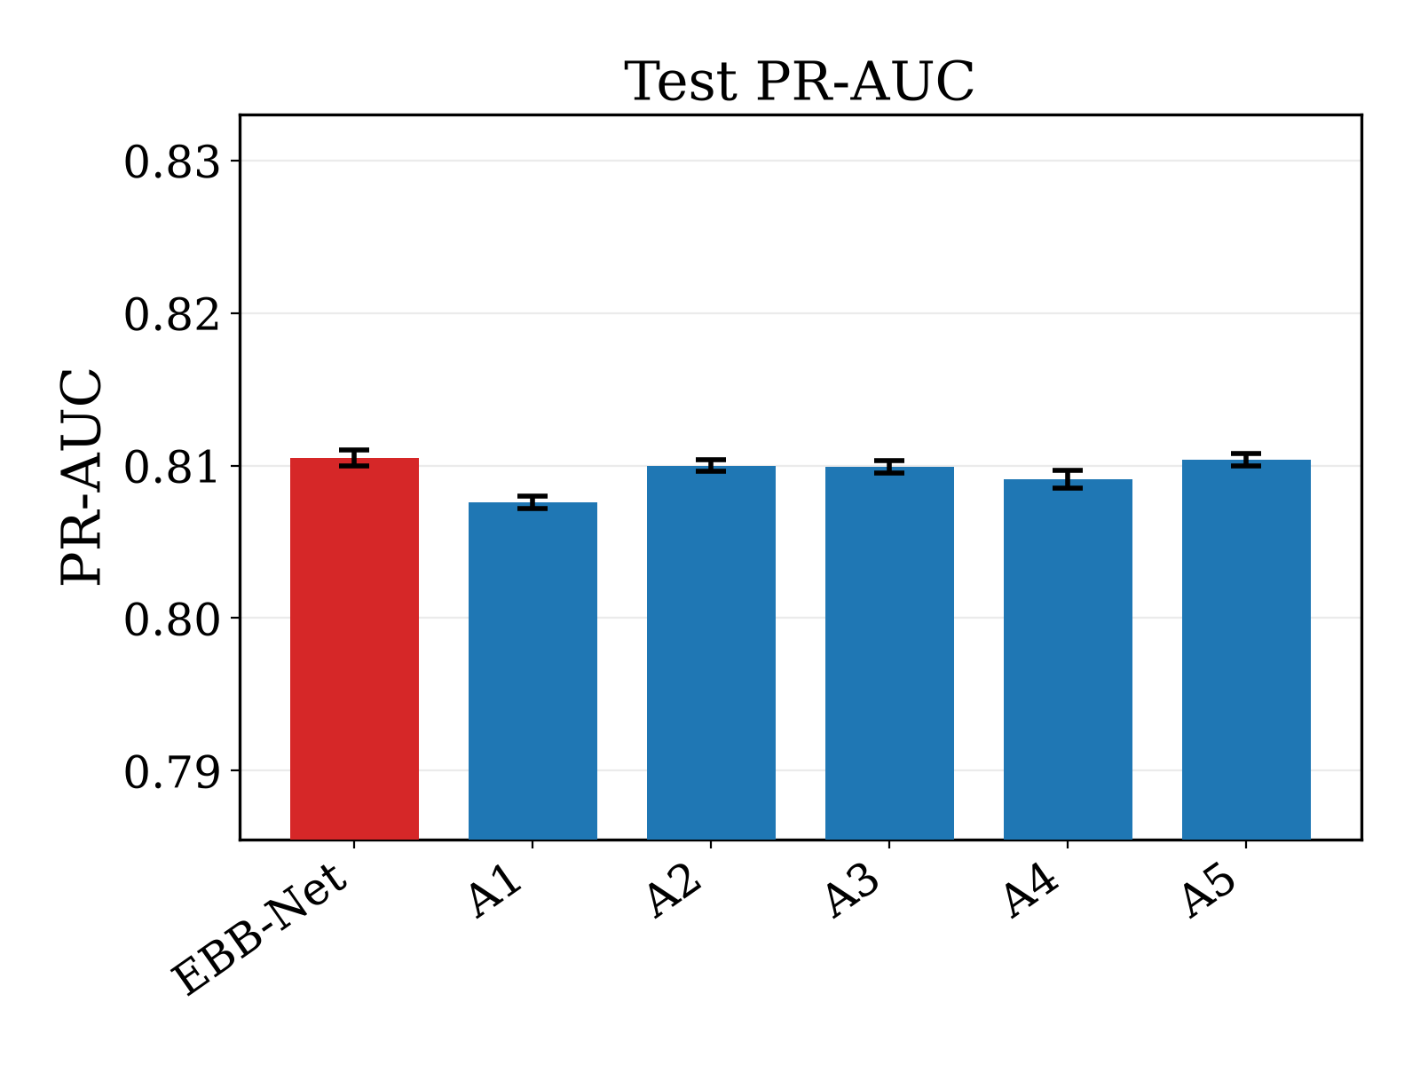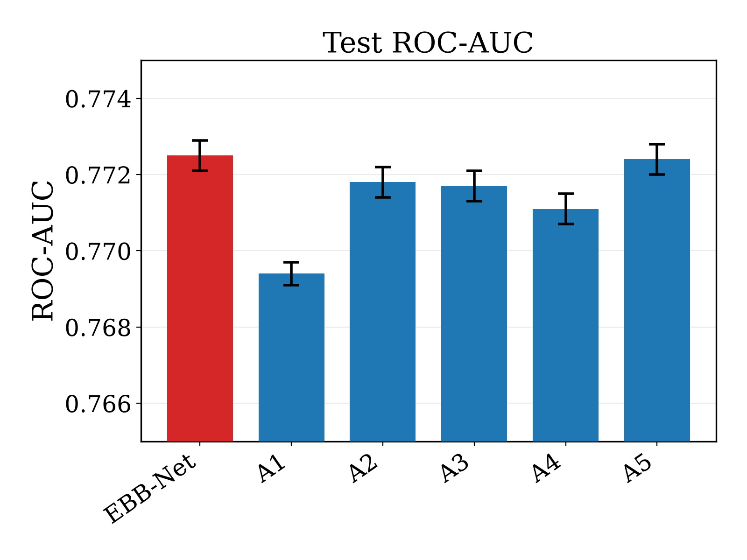
Figure 4. Comparison of the proposed EBB-Net with the five ablation variants on the test set (mean ± SD over ten seeds): (A) PR-AUC and (B) ROC-AUC.
Figure 4 compares the ranking metrics. The vertical axes do not start at zero so that the small gaps are visible. A1 gives the largest drop. Its PR-AUC falls to 0.8076 and its ROC-AUC to 0.7694, which are 0.0029 and 0.0031 below the full model. Its Brier score rises to 0.1929, its ECE to 0.0073 and its log loss to 0.5637. A4 gives the second largest drop, with a PR-AUC of 0.8091 and a ROC-AUC of 0.7711. A2 and A3 lower the PR-AUC by 0.0005 and 0.0006. A3 also shifts the operating point. Its precision is 0.7425 and its recall is 0.6891. A5 gives almost the same result as the full model, with a PR-AUC of 0.8104. The drop for A4 is larger than for A5, which suggests that the ordinal head adds slightly more than the change-score head. The full model has the lowest Brier score and log loss of the six rows. A2 and A5 have a slightly lower ECE of 0.0061.

4.6 Comparison with State-of-the-Art Models
EBB-Net was compared with three models. They are an MLP that uses the last week, a GRU and a TCN. These cover three common ways to handle weekly behaviour. The MLP sees only the last week. The GRU is a recurrent model. The TCN is a temporal convolution model. All three were run on ten seeds and scored on the same test set with the same metrics as EBB-Net. Four non-sequential tabular baselines (XGBoost, LightGBM, Random Forest and L2-regularised logistic regression) were also trained on the identical last-week-plus-static feature set used by the MLP, under the same split and the same ten seeds, and are reported in the same table. Each value is the mean ± standard deviation over the seeds. Table 10 gives the comparison of EBB-Net with State-of-the-Art Models
Table 10. Performance Comparison of the Proposed EBB-Net with State-of-the-Art and Non-Sequential Baseline Models (mean ± SD over 10 seeds)
Model | PR-AUC ↑ | ROC-AUC ↑ | F1-Score ↑ | Precision ↑ | Recall ↑ | Accuracy ↑ | Brier ↓ | ECE ↓ | Log Loss ↓
MLP | 0.7983 ± 0.0005 | 0.7591 ± 0.0005 | 0.7054 ± 0.0060 | 0.7330 ± 0.0052 | 0.6800 ± 0.0154 | 0.6844 ± 0.0020 | 0.1966 ± 0.0002 | 0.0051 ± 0.0008 | 0.5729 ± 0.0005
GRU | 0.8046 ± 0.0005 | 0.7661 ± 0.0006 | 0.7113 ± 0.0044 | 0.7383 ± 0.0041 | 0.6864 ± 0.0116 | 0.6905 ± 0.0016 | 0.1942 ± 0.0002 | 0.0077 ± 0.0014 | 0.5671 ± 0.0006
TCN | 0.8048 ± 0.0004 | 0.7662 ± 0.0004 | 0.7157 ± 0.0054 | 0.7331 ± 0.0052 | 0.6994 ± 0.0149 | 0.6914 ± 0.0017 | 0.1941 ± 0.0002 | 0.0078 ± 0.0011 | 0.5669 ± 0.0004
XGBoost | 0.8058 ± 0.0002 | 0.7662 ± 0.0002 | 0.7101 ± 0.0075 | 0.7400 ± 0.0065 | 0.6829 ± 0.0195 | 0.6903 ± 0.0025 | 0.1942 ± 0.0001 | 0.0061 ± 0.0006 | 0.5668 ± 0.0003
LightGBM | 0.8061 ± 0.0002 | 0.7663 ± 0.0002 | 0.7085 ± 0.0067 | 0.7418 ± 0.0058 | 0.6784 ± 0.0167 | 0.6900 ± 0.0022 | 0.1942 ± 0.0001 | 0.0075 ± 0.0009 | 0.5668 ± 0.0003
Random Forest | 0.7957 ± 0.0002 | 0.7558 ± 0.0002 | 0.7026 ± 0.0061 | 0.7316 ± 0.0053 | 0.6761 ± 0.0159 | 0.6821 ± 0.0019 | 0.1992 ± 0.0001 | 0.0308 ± 0.0006 | 0.5800 ± 0.0002
Ridge (L2 Logistic Regression) | 0.7487 ± 0.0000 | 0.7086 ± 0.0000 | 0.6759 ± 0.0000 | 0.6969 ± 0.0000 | 0.6561 ± 0.0000 | 0.6503 ± 0.0000 | 0.2140 ± 0.0000 | 0.0094 ± 0.0000 | 0.6150 ± 0.0000
EBB-Net (Proposed) | 0.8105 ± 0.0005 | 0.7725 ± 0.0004 | 0.7181 ± 0.0036 | 0.7409 ± 0.0033 | 0.6969 ± 0.0096 | 0.6961 ± 0.0015 | 0.1916 ± 0.0002 | 0.0063 ± 0.0012 | 0.5607 ± 0.0004
EBB-Net has a PR-AUC of 0.8105 and a ROC-AUC of 0.7725. Among the seven comparison models, the two gradient-boosted tree baselines are the strongest: LightGBM reaches a PR-AUC of 0.8061 and XGBoost 0.8058, both ahead of every neural sequence baseline (TCN 0.8048, GRU 0.8046, MLP 0.7983) and both close to but still below EBB-Net. Random Forest (0.7957) and the linear baseline, L2-regularised logistic regression (0.7487), are the weakest, with the linear model trailing EBB-Net by 0.0618 PR-AUC — the largest gap in the table and evidence that the engagement-decline signal is not simply linear in these features. EBB-Net's PR-AUC advantage over the closest baseline, LightGBM, is 0.0044; over the closest neural baseline, TCN, it is 0.0057. The ROC-AUC shows the same pattern: EBB-Net's 0.7725 sits above LightGBM (0.7663), XGBoost (0.7662), TCN (0.7662), GRU (0.7661), MLP (0.7591), Random Forest (0.7558) and Ridge (0.7086). The threshold-based and probability metrics mostly follow the same ordering. EBB-Net's F1-score is 0.7181 against a best-baseline F1 of 0.7157 (TCN); its Brier score (0.1916) and log loss (0.5607) are also the lowest in the table, ahead of the next-best LightGBM/XGBoost/TCN cluster around Brier 0.194 and log loss 0.567. One exception is calibration error (ECE): the Random Forest's probabilities are poorly calibrated out of the box (ECE 0.0308, roughly five times every other model's), while EBB-Net (0.0063), MLP (0.0051) and the tree-based baselines (0.0061–0.0075) are all reasonably well calibrated. Table 11 reports paired, seed-level Wilcoxon tests for these comparisons, with PR-AUC as the prespecified primary metric. EBB-Net has the highest PR-AUC, ROC-AUC and F1-score and the lowest Brier score and log loss among the compared models. It does not lead on every metric: MLP has a lower ECE (0.0051), LightGBM a higher precision (0.7418) and TCN a higher recall (0.6994). The PR-AUC gain over the strongest baseline, LightGBM, is 0.0044, which is small in absolute terms.

4.6.1 Statistical Significance
EBB-Net was compared with the seven baselines (MLP, GRU, TCN, XGBoost, LightGBM, Random Forest and L2-regularised logistic regression) and the five ablations using a paired, exact, two-sided Wilcoxon signed-rank test. The seed is the pairing unit, so n = 10 for every comparison and the exact null distribution is used throughout. PR-AUC was prespecified as the primary metric, and the Holm-Bonferroni correction [39] is applied across the 12 primary comparisons. ROC-AUC and log loss are reported as secondary results, each corrected within its own family of 12 tests. Correcting each metric family separately, rather than pooling all metrics into one family, keeps the primary test from being penalised for the secondary ones. Table 11 reports, for every comparison, the number of paired seeds, the Wilcoxon statistic W, the exact raw p-value, the Holm-adjusted p-value and the matched-pairs rank-biserial correlation r.
Table 11. Statistical significance of EBB-Net against the seven baselines and the five ablations (paired exact two-sided Wilcoxon signed-rank test, pairing unit = seed, n = 10). PR-AUC is the prespecified primary metric, with Holm-Bonferroni correction across the 12 primary comparisons. ROC-AUC and log loss are secondary and are each corrected within their own family of 12 tests. W is the Wilcoxon statistic and r is the matched-pairs rank-biserial correlation.
Model | n | W (PR-AUC) | Raw p (PR-AUC) | Holm p (PR-AUC) | r (PR-AUC) | Holm p (ROC-AUC) | r (ROC-AUC) | Holm p (log loss) | r (log loss)
A1 | 10 | 0.0 | 0.0020 | 0.0234 | 1.00 | 0.0234 | 1.00 | 0.0234 | -1.00
A2 | 10 | 0.0 | 0.0020 | 0.0234 | 1.00 | 0.0234 | 1.00 | 0.0234 | -0.96
A3 | 10 | 2.0 | 0.0059 | 0.0234 | 0.93 | 0.0234 | 1.00 | 0.0234 | -1.00
A4 | 10 | 0.0 | 0.0020 | 0.0234 | 1.00 | 0.0234 | 1.00 | 0.0234 | -1.00
A5 | 10 | 13.0 | 0.1602 | 0.1602 | 0.53 | 0.1309 | 0.56 | 0.0840 | -0.64
MLP | 10 | 0.0 | 0.0020 | 0.0234 | 1.00 | 0.0234 | 1.00 | 0.0234 | -1.00
GRU | 10 | 0.0 | 0.0020 | 0.0234 | 1.00 | 0.0234 | 1.00 | 0.0234 | -1.00
TCN | 10 | 0.0 | 0.0020 | 0.0234 | 1.00 | 0.0234 | 1.00 | 0.0234 | -1.00
XGB | 10 | 0.0 | 0.0020 | 0.0234 | 1.00 | 0.0234 | 1.00 | 0.0234 | -1.00
LGBM | 10 | 0.0 | 0.0020 | 0.0234 | 1.00 | 0.0234 | 1.00 | 0.0234 | -1.00
RF | 10 | 0.0 | 0.0020 | 0.0234 | 1.00 | 0.0234 | 1.00 | 0.0234 | -1.00
Ridge | 10 | 0.0 | 0.0020 | 0.0234 | 1.00 | 0.0234 | 1.00 | 0.0234 | -1.00
At n = 10 the smallest raw p-value the exact two-sided test can return is 0.0020, which corresponds to EBB-Net winning in all ten paired seeds. Across a family of 12 comparisons the corresponding Holm-adjusted value is 0.0234, so significance at the 0.05 level is attainable under this design. EBB-Net wins on PR-AUC in all ten seeds against all seven baselines and against A1, A2 and A4 (W = 0.0, raw p = 0.0020, Holm p = 0.0234, r = 1.00). The comparison with A3 is also significant, with EBB-Net ahead in nine of the ten seeds (W = 2.0, raw p = 0.0059, Holm p = 0.0234, r = 0.93). A5 is the one comparison that does not reach significance (W = 13.0, raw p = 0.1602, Holm p = 0.1602, r = 0.53); EBB-Net is ahead in eight of the ten seeds and the mean PR-AUC difference is only 0.0001, so the change-score head cannot be separated from noise at this sample size. The secondary metrics follow the same pattern: every comparison except A5 reaches a Holm-adjusted p of 0.0234 on both ROC-AUC and log loss. These p-values test whether EBB-Net ranks above each comparison model consistently across seeds. They do not quantify uncertainty from the finite test sample, which is reported separately as the bootstrap interval in Table 8. The effect sizes should be read together with the absolute gaps in Table 10, which are small for the nearest baselines.
4.6.2 Training and Inference Time
Wall-clock training time was logged for every epoch of every run and summed per seed. Table 12 reports the mean and standard deviation, over the same seeds used throughout this paper, of total training time for every model.
Table 12. Training time by model (mean ± SD over the ten seeds; single run on one NVIDIA Tesla T4 GPU with PyTorch 2.11)
Model | Mean train time (s) | SD (s) | Seeds
EBB-Net | 477.7 | 24.4 | 10
A1 | 344.7 | 18.9 | 10
A2 | 472.8 | 15.8 | 10
A3 | 633.9 | 32.3 | 10
A4 | 448.3 | 21.9 | 10
A5 | 470.4 | 25.0 | 10
MLP | 82.8 | 8.6 | 10
GRU | 76.8 | 5.6 | 10
TCN | 109.6 | 8.3 | 10
XGB | 147.9 | 14.2 | 10
LGBM | 157.2 | 18.5 | 10
RF | 1126.8 | 19.1 | 10
Ridge | 18.6 | 0.2 | 10
The gradient-boosted tree baselines (XGBoost, LightGBM) and the linear baseline (Ridge) train in well under three minutes; the neural sequence baselines (MLP, GRU, TCN) train in under two minutes; Random Forest is the slowest baseline at nearly nineteen minutes, driven by its ensemble size. EBB-Net and the five ablations take roughly six to eleven minutes, reflecting the added cost of the temporal TCN, attention pooling and multi-head training objective relative to the single-week MLP baseline. A3 is the slowest of the six EBB-Net variants at 633.9 s, which is longer than the full model at 477.7 s even though it has fewer layers. The reason is the number of epochs rather than the cost of an epoch. Removing the temporal TCN slows convergence, so A3 reaches its best validation PR-AUC around epoch 15 to 19 and runs to the early-stopping limit of 21 to 25 epochs, while the full model peaks at epoch 11 and stops between epochs 16 and 18. The per-epoch cost of A3 is lower, but it runs about eight more epochs.
EBB-Net inference was profiled on the held-out test split using the best single seed checkpoint. A batched pass (batch size 4096) processes the full test set in 1.66 ± 0.007 seconds, i.e. 51,959 rows per second. Single-row (batch size 1) inference, averaged over 500 samples, takes 4.184 ms per enrollment-week. Batch-size independence does not rest on this timing. It follows from the architecture: every operation in EBB-Net acts within one enrollment, the only normalisation is LayerNorm over the channel dimension, and both attention stages are restricted to the groups and weeks of the same sample, so no quantity is computed across the samples of a batch. The prediction for an enrollment-week is therefore the same whether it is scored alone or inside a batch of 4096, up to floating-point summation order.
4.6.3 Performance by Length of Observed History
The model is framed as a weekly early warning, so its accuracy was also measured as a function of how much history a sample carries. The test set was split by the number of observed weeks into the same four groups used for temperature scaling, and the calibrated ten-seed ensemble was scored within each group. Table 13 reports the result.
Table 13. Test performance of the calibrated ten-seed EBB-Net ensemble by length of observed history
Observed weeks | Samples | Decline rate | PR-AUC ↑ | ROC-AUC ↑
3–4 | 7,139 | 0.5700 | 0.7459 | 0.7102
5–8 | 13,232 | 0.5897 | 0.7783 | 0.7233
9–16 | 21,284 | 0.5411 | 0.8012 | 0.7829
17+ | 44,631 | 0.5503 | 0.8328 | 0.7935
All | 86,286 | 0.5557 | 0.8132 | 0.7757
Performance rises monotonically with the length of the observed history. PR-AUC is 0.7459 for samples with only three or four observed weeks and 0.8328 for samples with seventeen or more, a spread of 0.0869. ROC-AUC behaves the same way, from 0.7102 to 0.7935. The decline rate varies much less across the groups, between 0.5411 and 0.5897, so the pattern is not explained by class balance: the chance level for PR-AUC is close to 0.555 in every group, and the margin over chance grows from about 0.176 to about 0.283. Two factors are likely to contribute. A longer history gives the temporal encoder more weeks to read, and it also gives a more stable personal baseline, because the baseline is the median over up to five recent weeks and is noisier when only three are available. The practical consequence is that the earliest warnings, in the first weeks of a presentation, are the least reliable. Users should treat week-3 and week-4 predictions with more caution than the aggregate figures in Table 7 suggest. This analysis is a grouped alternative to a truncation curve. It uses the observed history that each enrollment actually has, rather than truncating every enrollment at a fixed week.
4.7 SHAP Analysis
The SHAP summary plot in Figure 5 shows which inputs drive the decline predictions of EBB-Net. SHAP values [35] were computed with the Gradient SHAP explainer for the best seed model of EBB-Net, chosen by its validation score. The explainer used 200 training samples as background. It explained 300 randomly chosen test samples. The model output is the logit of decline, so SHAP values are in log-odds units. The 20 features with the largest overall contribution are shown. Each point is one sample. A positive SHAP value pushes the prediction toward decline in the next week. A negative value pushes it away from decline. Red points are high feature values and blue points are low feature values. Features are ordered by their mean absolute SHAP value. The labels (t) and (t-1) mark the week the feature comes from.
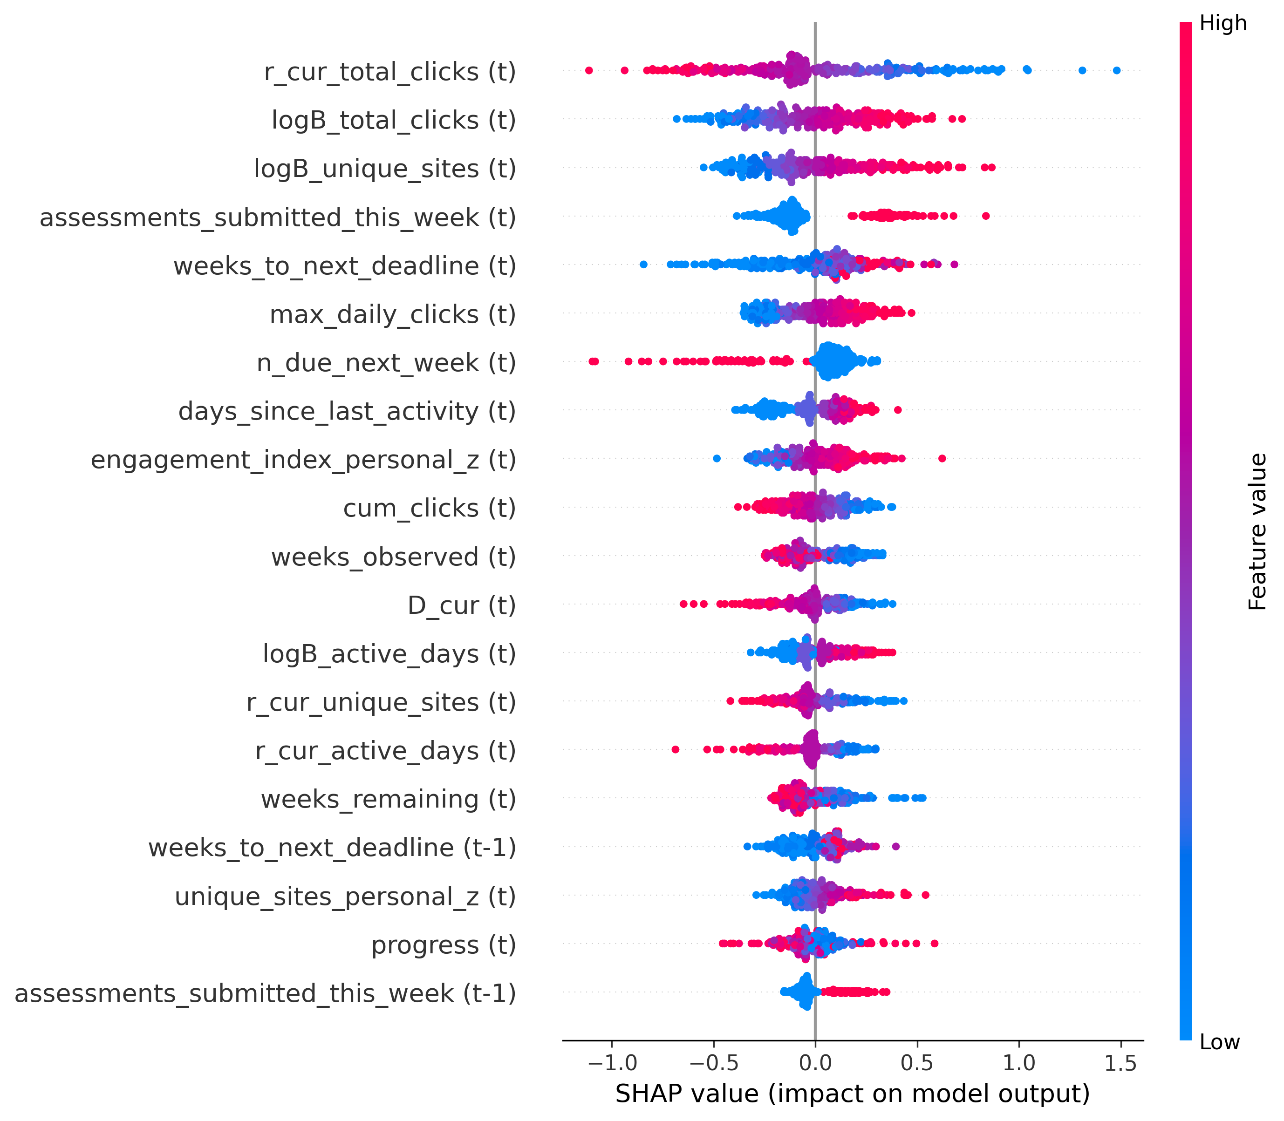
Figure 5. SHAP summary plot of feature contributions for the proposed EBB-Net framework.
The feature with the largest spread is r_cur_total_clicks (t). It is the log ratio of the current week's clicks to the student's personal baseline. High values are mostly negative and low values are mostly positive. The values range from about −1.1 to 1.5. A week with clicks above the personal baseline lowers the predicted decline risk. A week below the baseline raises it. D_cur (t), which averages the three behaviour ratios, shows the same direction. The baseline level itself acts in the opposite direction. High values of logB_total_clicks (t), logB_unique_sites (t) and logB_active_days (t) are mostly positive. A higher usual level raises the predicted risk. The target compares next week with the personal baseline. A student with a higher baseline has more to fall from. A student who is already below the baseline has less room to fall. High values of assessments_submitted_this_week (t) are positive. The same holds for assessments_submitted_this_week (t-1). A larger weeks_to_next_deadline (t) and weeks_to_next_deadline (t-1) push toward decline. A higher n_due_next_week (t) pushes strongly away from decline. Its values reach about −1.1. These patterns suggest that the model links the assessment calendar to the next week's activity. High days_since_last_activity (t) and high max_daily_clicks (t) are positive. High cum_clicks (t) is mostly negative. No demographic or course profile feature appears among the 20 shown. The top features are about current behaviour, personal baselines and assessment timing. SHAP describes how the trained model uses its inputs. It does not show that a feature causes a decline.

4.8 LIME Analysis
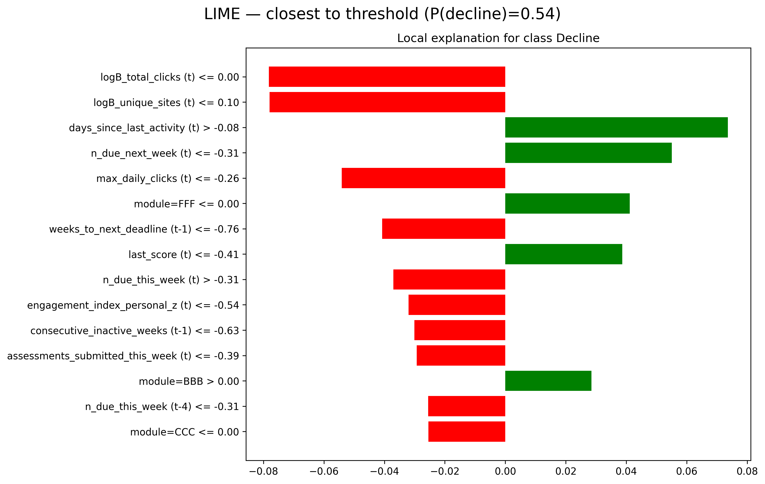
Figure 6. LIME local explanation for the test sample closest to the decision threshold
LIME [36] was used to explain single predictions of EBB-Net. It explains the same best seed model as in the SHAP section. Figure 6 shows the local explanation for one sample. It is the sample whose predicted decline probability is closest to the decision threshold among the 300 test samples explained. The probability is about 0.54. This sample was picked because the model is least decided here. Forces toward and away from decline both show clearly. LIME fitted a local linear model on 3,000 perturbed samples. Continuous features were split into bins using 2,000 training samples. Each condition label shows the bin that holds the value of this sample. The labels are in scaled feature units as described in the pre-processing section. Binary features such as module indicators are not scaled. So “<= 0.00” means the indicator is off and “> 0.00” means it is on. LIME explains the probability of the decline class. Green bars push the prediction toward decline. Red bars push it away from decline. The bar length is the weight in the local model. Five of the 15 listed conditions push toward decline. The largest is days_since_last_activity (t) > −0.08, with a weight of about 0.074. Next is n_due_next_week (t) <= −0.31, with a weight of about 0.055. last_score (t) <= −0.41 adds about 0.039. The module indicators also appear. module=FFF <= 0.00 adds about 0.041 and module=BBB > 0.00 adds about 0.028. So this sample is in module BBB and not in FFF or CCC. Ten conditions push away from decline. The two largest are logB_total_clicks (t) <= 0.00 and logB_unique_sites (t) <= 0.10. Each has a weight of about −0.078. max_daily_clicks (t) <= −0.26 follows at about −0.054. weeks_to_next_deadline (t-1) <= −0.76 is at about −0.041 and n_due_this_week (t) > −0.31 at about −0.037. Smaller weights come from engagement_index_personal_z (t) <= −0.54, consecutive_inactive_weeks (t-1) <= −0.63, assessments_submitted_this_week (t) <= −0.39, n_due_this_week (t-4) <= −0.31 and module=CCC <= 0.00. Each of these is between about −0.025 and −0.032. Eight of the listed features also appear in Figure 5. These are logB_total_clicks (t), logB_unique_sites (t), days_since_last_activity (t), n_due_next_week (t), max_daily_clicks (t), weeks_to_next_deadline (t-1), engagement_index_personal_z (t) and assessments_submitted_this_week (t). For all eight the direction in Figure 6 matches the direction in Figure 5. Low baseline levels and low peak daily clicks push away from decline. A longer time since the last activity pushes toward decline. A low number of items due next week also pushes toward decline.

4.9 Leakage Audit
Eight automated checks run over the prepared arrays every time the pipeline is executed, and all eight pass. They are listed in Table 14 with the outcome of each. The checks cover the split, the observation window, the causality of the derived features, the past-only construction of the assessment features, an independent recomputation of the target, the absence of forbidden inputs, the provenance of the scaler statistics and the absence of any single feature that determines the label. The last check is the most informative for the leakage concern raised in review: the strongest single feature reaches an AUC of 0.622, so no individual input reproduces the label.
Table 14. Automated leakage and causality checks run on the prepared data
# | Check | Outcome
1 | Split isolation at the enrollment level | Pass
2 | No pre-registration, post-withdrawal or post-course rows | Pass
3 | Derived history features unchanged when data after week 18 is removed (47 features) | Pass
4 | Assessment features match a manual past-only recomputation on 400 random rows | Pass
5 | Target recomputed independently on 1,000 random samples | Pass
6 | No forbidden inputs; every window ends at week t | Pass
7 | Scaler statistics and the engagement reference fitted on training data only | Pass
8 | No single feature determines the label (highest single-feature AUC 0.622, weeks_to_next_deadline) | Pass
4.10 Limitations
This study has several limitations. The evaluation split is at enrollment level and is stratified by module presentation and withdrawal status, so it measures generalisation to unseen enrollments and not to a future cohort. A temporal split that trains on the 2013 presentations and tests on the 2014 presentations has not been run. Windows that move into the withdrawal week are excluded, so the most severe form of disengagement never forms a positive label, and this selection narrows the positive class. The threshold of 0.90 is an operational choice on the add-one log-ratio scale and has not been validated against later academic outcomes. Part of the signal may come from regression towards the personal baseline, because the baseline level is both a model input and the reference point of the label. The statistical tests in Table 11 pair models by seed, so they measure how consistently EBB-Net ranks above each comparison model across seeds rather than the uncertainty that comes from the finite test sample; the bootstrap interval in Table 8 covers the latter. The tuning budget is equal across the seven baselines but larger for EBB-Net, which searched ten trials over a wider space, so part of the margin may reflect search effort rather than architecture. The gains over the strongest tabular baseline are small in absolute terms, at 0.0044 PR-AUC. The baselines also see only the last observed week while EBB-Net sees six, so the comparison mixes the effect of architecture with the effect of input history. Finally, only one dataset is used, so the findings are specific to OULAD.

5. Conclusion and Future Work
This paper proposes EBB-Net, a context-adaptive temporal network that forecasts whether a student’s engagement in the next week will fall below 0.90 of the student’s own baseline on the add-one log-ratio scale. EBB-Net groups 82 weekly features into 14 semantic tokens. It adapts them to the student’s context with FiLM and reads six weeks through a causal temporal network. A binary head gives the decline probability. Auxiliary ordinal and change-score heads support the shared representation. On the held-out OULAD test set, EBB-Net reaches a mean PR-AUC of 0.8105, a ROC-AUC of 0.7725, an F1-score of 0.7181, a precision of 0.7409, a Brier score of 0.1916 and an ECE of 0.0063 over ten seeds (42–51). The label uses week t+1 and the inputs stop at week t. EBB-Net had the better mean PR-AUC and ROC-AUC among the compared models. Removing the group tokens gave the largest PR-AUC drop among the ablations. Overall, EBB-Net moves engagement prediction from labelling the present level to forecasting a decline. It adds a calibrated ensemble with conformal sets and SHAP and LIME explanations.
Future work
- The present forecast looks one week ahead. Future work will extend EBB-Net to several weeks ahead. The ordinal head already estimates the chance of drops of 5%, 10%, 15% and 20%. Multi-week horizons would give instructors more lead time and show how a decline develops.
- Future work will test EBB-Net on further courses and learning platforms beyond OULAD. This will show whether the learned group tokens and context adaptation carry over to other institutions and student groups. Data with richer signals, such as forum content, can also be added as a new feature group.
- Future work will connect the calibrated probabilities and conformal sets to an alert pipeline for instructors. A pilot can then measure whether early outreach to flagged students prevents a sustained decline. This would move the work from offline evaluation to real impact.
Data Availability Statement
The Open University Learning Analytics Dataset (OULAD) used in this study is publicly available at https://analyse.kmi.open.ac.uk/open_dataset under a CC-BY 4.0 licence (Kuzilek, Hlosta and Zdrahal, 2017, Scientific Data, 4:170171). The code, configuration files and scripts that reproduce every table and figure in this paper are deposited at [repository URL] (DOI: [DOI]). The deposit includes supplementary file S1, a per-feature dictionary listing the group and transform of all 116 features; S2, the log of the eight automated leakage checks summarised in Table 14; and S3, the hyperparameter search trials for EBB-Net and for each neural baseline.
Ethics Statement
This study uses only publicly available, anonymised data released under a CC-BY 4.0 licence. No personally identifying information was accessed and no ethical approval was required.
Conflict of Interest
The authors declare no conflict of interest.
Funding
[Funding details, or: This research received no external funding.]
References
[1] Gopinath, R., Rajashri, C.K. and Jeyanthi, P., 2026. Predicting Student Motivation and Engagement Using a Hybrid of Recurrent Neural Networks (RNNS) and Reinforcement Learning. International Journal of Artificial Intelligence and Machine Learning, 6(1s), pp.265-275.
[2] Qin, C., 2025. HTM-MDICE: a transformer-based model for predicting student engagement and ideological understanding in ethical education. Frontiers in Psychology, 16, p.1643076.
[3] Saleem, R. and Aslam, M., 2025. A Multi-Faceted deep learning approach for student engagement insights and adaptive content recommendations. IEEE Access, 13, pp.69236-69256.
[4] Fazil, M., Rísquez, A. and Halpin, C., 2024. A novel deep learning model for student performance prediction using engagement data. Journal of Learning Analytics, 11(2), pp.23-41.
[5] Van, U.T., Tieu, B.H. and Tran, D.H., 2026. A multimodal learning analytics model based on deep learning for predicting student performance using tabular and time-series data fusion. Discover Artificial Intelligence, 6(1), p.232.
[6] Omarbekova, A., Ramazan, A., Oralbekova, Z., Lamasheva, Z., Bekmanova, G., Nazyrova, A. and Abuov, A., 2026. A temporal attention-based hybrid deep learning model for student performance and academic risk prediction. Frontiers in Artificial Intelligence, 9, p.1811886.
[7] Muresan, A., Cardei, M. and Cardei, I., 2026. Predicting student success with heterogeneous graph deep learning and machine learning models. arXiv preprint arXiv:2601.06729.
[8] Alnasyan, B., Basheri, M., Alassafi, M. and Alnasyan, K., 2025. KANFormer: an attention-enhanced deep learning model for predicting student performance in virtual learning environments. Social Network Analysis and Mining, 15, p.25.
[9] Kalita, E., Alfarwan, A.M., El Aouifi, H., Kukkar, A., Hussain, S., Ali, T. and Gaftandzhieva, S., 2025, June. Predicting student academic performance using Bi-LSTM: a deep learning framework with SHAP-based interpretability and statistical validation. In Frontiers in Education (Vol. 10, p. 1581247). Frontiers Media SA.
[10] Sharopov, M., Sripada, P.N., Parthasarathy, R., Muzrapova, S. and Uraimov, S., 2026. Student Engagement Prediction in E-Learning Environments Using Attention-Based Transformers. International Journal of Artificial Intelligence and Machine Learning, 6(1s), pp.228-240.
[11] Subhashini, V., Nisha, A.R., Radhalakshmi, V., Madhumita, G., Selvi, K. and Sudharson, K., 2024, April. Detecting learning patterns and student engagement in online courses using deep learning. In 2024 International Conference on Science Technology Engineering and Management (ICSTEM) (pp. 1-7). IEEE.
[12] Kord, A., Aboelfetouh, A. and Shohieb, S.M., 2026. Academic course planning recommendation and students’ performance prediction multi-modal based on educational data mining techniques. Journal of Computing in Higher Education, 38(1), pp.38-76.
[13] Adefemi, K.O., Mutanga, M.B. and Jugoo, V., 2025. Hybrid deep learning models for predicting student academic performance. Mathematical and Computational Applications, 30(3), p.59.
[14] Lagares Rodríguez, J.A., Díaz-Díaz, N. and Barranco González, C.D., 2025. A comparative analysis of student performance prediction: evaluating optimized deep learning ensembles against semi-supervised feature selection-based models. Applied Sciences, 15(9), p.4818.
[15] Feng, F., 2026. Deep learning-based model for analyzing student engagement in activities. Scientific Reports, 16(1), p.2552.
[16] Kumi, S., Lomotey, R.K., Ray, M., Cunningham, E., Milovich, S. and Deters, R., 2025, May. A Data-Driven Digital Twin for Student Engagement Prediction in e-Learning Systems. In 2025 IEEE World AI IoT Congress (AIIoT) (pp. 0560-0566). IEEE.
[17] Sun, M. and Feng, S., 2026. Deep learning for student engagement analysis in educational psychology. Frontiers in Psychology, 17, p.1764399.
[18] Hoang, L., Shorten, G., O'Sullivan, B. and Nguyen, H.D., 2025. A lightweight and reliable framework toward real-time student engagement predictions in learning analytics. In Reliable and Trustworthy Artificial Intelligence 2025, Proceedings of Machine Learning Research, 310, pp.24-33. PMLR.
[19] Almasre, M., Alsaggaf, W., Al-Malki, N. and Brdesee, H., 2025. Emotional Engagement Prediction and LLM Feedback in Smart Learning Environments. International Journal of Artificial Intelligence in Education, 35(5), pp.3429-3458.
[20] Su, R., He, L. and Luo, M., 2024. Leveraging part-and-sensitive attention network and transformer for learner engagement detection. Alexandria Engineering Journal, 107, pp.198-204.
[21] Zhu, X. and Huang, L., 2026. Data augmented hybrid GCN transformer for student engagement recognition in E-learning. Alexandria Engineering Journal, 141, pp.14-23.
[22] Ferreira, F.R.T., do Couto, L.M., de Melo Baptista Domingues, G. and Saporetti, C.M., 2025. Development of a framework using deep learning for the identification and classification of engagement levels in distance learning students. Social Network Analysis and Mining, 15(1), p.37.
[23] Mahmood, N., Bhatti, S.M., Dawood, H., Pradhan, M.R. and Ahmad, H., 2024. Measuring student engagement through behavioral and emotional features using deep-learning models. Algorithms, 17(10), p.458.
[24] Sukumaran, A. and Manoharan, A., 2024. Multimodal engagement recognition from image traits using deep learning techniques. IEEE Access, 12, pp.25228-25244.
[25] Li, J., 2026. Predictive analysis of student engagement in university physical education courses based on a multimodal transformer algorithm. Scientific Reports, 16, p.15123. https://doi.org/10.1038/s41598-026-45928-w
[26] Alharbi, M.H., Alwabel, A.S.A., Alohali, M., Almalki, A.M., Othman, M.F.I. and Ahmad, M.N., 2026. A hierarchical transformer–graph framework for explainable student engagement estimation in E-learning videos. Scientific Reports, 16. https://doi.org/10.1038/s41598-026-52123-4
[27] Chen, G., Han, G., Niu, J. and He, J., 2026. Understanding the impact of emotional engagement on learning outcomes in online education: an automated analysis approach. Scientific Reports, 16(1), p.4825.
[28] Khaoula, T. and Soltane, M., 2025, October. Deep Learning Based Student Engagement Detection Using Eye Tracking. In 2025 IEEE International Multi-Conference on Smart Systems & Green Process (IMC-SSGP) (pp. 1-5). IEEE.
[29] Aly, M., 2025. Revolutionizing online education: Advanced facial expression recognition for real-time student progress tracking via deep learning model. Multimedia Tools and Applications, 84(13), pp.12575-12614.
[30] Halawani, H.T., Alghamdi, S., Aloufi, F.A., Alsolami, M., Alsulaimani, A. and Aljohani, H.M., 2026. Quantum-inspired deep learning optimization for real-time student engagement analysis in virtual classrooms. Alexandria Engineering Journal, 134, pp.375-390.
[31] Kuzilek, J., Hlosta, M. and Zdrahal, Z., 2017. Open University Learning Analytics dataset. Scientific Data, 4, p.170171.
[32] Perez, E., Strub, F., De Vries, H., Dumoulin, V. and Courville, A., 2018. FiLM: Visual reasoning with a general conditioning layer. Proceedings of the AAAI Conference on Artificial Intelligence, 32(1), pp.3942-3951.
[33] Bai, S., Kolter, J.Z. and Koltun, V., 2018. An empirical evaluation of generic convolutional and recurrent networks for sequence modeling. arXiv preprint arXiv:1803.01271.
[34] Gorishniy, Y., Rubachev, I., Khrulkov, V. and Babenko, A., 2021. Revisiting deep learning models for tabular data. Advances in Neural Information Processing Systems, 34, pp.18932-18943.
[35] Lundberg, S.M. and Lee, S.I., 2017. A unified approach to interpreting model predictions. Advances in Neural Information Processing Systems, 30, pp.4765-4774.
[36] Ribeiro, M.T., Singh, S. and Guestrin, C., 2016. "Why should I trust you?": Explaining the predictions of any classifier. In Proceedings of the 22nd ACM SIGKDD International Conference on Knowledge Discovery and Data Mining, pp.1135-1144.
[37] Guo, C., Pleiss, G., Sun, Y. and Weinberger, K.Q., 2017. On calibration of modern neural networks. In Proceedings of the 34th International Conference on Machine Learning, Proceedings of Machine Learning Research, 70, pp.1321-1330.
[38] Lei, J., G'Sell, M., Rinaldo, A., Tibshirani, R.J. and Wasserman, L., 2018. Distribution-free predictive inference for regression. Journal of the American Statistical Association, 113(523), pp.1094-1111.
[39] Holm, S., 1979. A simple sequentially rejective multiple test procedure. Scandinavian Journal of Statistics, 6(2), pp.65-70.

