PsyAdapt: A Personalized LLM-Based Framework for Psychoeducational Dialogue Generation and Evaluation
Abstract
Psychoeducational dialogue systems provide psychological information in an accessible form and offer user guidance. However, generic LLMs may fail to adjust their responses to users' emotions, personality characteristics, and individual needs for guidance. In this paper, we introduce PsyAdapt, a personalized LLM-based framework for psychoeducational dialogue generation and evaluation. The proposed framework incorporates emotion detection, personality recognition, user-context modeling, adaptive guidance on support strategies, and retrieval-augmented generation (RAG) to generate personalized and contextually relevant responses. Emotion and personality features are incorporated into the user representation model, and adaptive strategy guidance provides means for response generation according to the detected context. RAG serves as the means for psychoeducational information retrieval to assist response grounding. The proposed framework is evaluated using a number of different system configurations starting from a generic LLM baseline and going to the full PsyAdapt system. Semantic similarity, input relevance, grounding support, response defects, and generation latency are used as the criteria for evaluation. The full PsyAdapt configuration shows a BERTScore-F1 of 0.632, ROUGE-L F1 of 0.105, and input-relevance score of 0.607. Grounding-support score of 0.631 and generation latency of 2.395 seconds are recorded. The comparative analysis of results demonstrates performance variability at the level of configurations according to the different evaluation criteria, revealing the tradeoffs between response quality, grounding support, and computational costs. The reported findings provide empirical grounds for investigating the impact of user-context and adaptive guidance information on personalized psychoeducational dialogue generation.
Keywords: Psychoeducational Dialogue, Large Language Models, Personalized Dialogue Generation, Retrieval-Augmented Generation, Emotion Detection, User Modeling, Adaptive Support.
1.Introduction
The increased integration of artificial intelligence (AI) in the sphere of mental health and psychoeducational applications creates the possibility for development of accessible, personalized, and context-aware dialogue systems. Due to recent advances in the development of large language models (LLMs), it is possible to build systems capable of natural language generation, emotional support, and provision of psychological information. However, efficient generation of personalized psychoeducational dialogue not only involves natural language generation. Different people can vary in terms of their emotional state, personality traits, needs, and support preferences. As a result, generic responses may not address individual user contexts. It is why personalization, emotions, and need-oriented context retrieval are crucial for the development of psychoeducational LLMs.
Personalization has recently been examined in the context of emotional support dialogue. For instance, Ye et al. [1] have explored the self-evolution framework to align emotional support with user preferences in order to bridge the gap between generic empathy and personalized support. It demonstrates the importance of taking user preferences into account when generating supportive responses. Similarly, Xie et al. [2] have developed PsyDT – a digital twin of the psychological counselor that is constructed with the use of LLM and has a personalized counseling style. It highlights the importance of modeling psychological counseling characteristics to facilitate personalized psychological dialogue. However, personalization of psychoeducational systems involves consideration of the user's emotional state, personality traits, and current needs in the context of one response generation process.
The issue of understanding the underlying needs of the users is another challenge of emotional support dialogue generation. Fu et al. [3] have examined the possibility of identifying users' latent needs based on their implicit expression in order to provide proactive emotional assistance. It demonstrates the importance of going beyond explicitly expressed emotions when interpreting the message of a user. In psychoeducational settings, users may talk about the problems they face or express distress or uncertainty without specifying the type of support they need. In this way, the identification of users' emotional and contextual information can be used to define the directions of their responses. Involvement of emotion detection and need-oriented context modeling may make psychoeducational systems able to adapt responses to the context of the user's message and not rely only on the surface meaning of the input.
The choice of the appropriate strategy of support is yet another critical step of producing contextually appropriate responses. Zhang et al. [4] have proposed IntentionESC, a framework that is focused on the support of conversation-based emotional support through its intention-centered approach. It highlights the importance of understanding the intentions of the conversation when offering emotional support. Depending on the expressed situation and needs of the user, the dialogue system may need to acknowledge, clarify, validate emotionally, or provide some information to the user. Nevertheless, the task of choosing the right strategy and generating a personalized response are interconnected but still different.
Apart from personalization and strategy selection, the issue of evaluation of LLM-based psychological support systems has recently attracted attention of researchers. For instance, Deshpande et al. [5] have performed comparative study of LLMs' ability to improve live chat therapy compared to psychotherapists. This study demonstrates the importance of the systematic examination of the LLM-generated responses in the sphere of psychological support. Evaluation of such systems involves consideration of many dimensions, including relevance, semantic quality, grounding, possible response defects, and computational efficiency. All of these aspects become especially important for the development of psychoeducational dialogue systems in which generated responses should be contextually relevant and grounded with reliable information. Retrieval-augmented generation (RAG) allows to retrieve the relevant information from the knowledge base and incorporate it in the process of response generation, making the system produce grounded responses.
Nevertheless, there are several issues that still require investigation. First, research of personalized emotional support highlights the importance of user preferences and personalized counseling styles, but the integration of emotions, personality traits, and user context into a unified psychoeducational response-generation framework still becomes the research direction. Second, identification of users' latent needs and intentions requires the systems to go beyond the mere emotion recognition and understand the context of the user's message. Third, adaptive support strategy selection needs to be interconnected with the process of response generation so that the strategy can actually guide the generation process. Finally, psychoeducational dialogue systems require evaluation in terms of response quality, relevance, grounding, response defects, and generation latency.
In order to overcome these challenges, this work proposes PsyAdapt – A Personalized LLM-Based Framework for Psychoeducational Dialogue Generation and Evaluation. The proposed framework incorporates the components of emotion detection, personality recognition, user context modeling, adaptive strategy guidance, and retrieval-augmented generation in order to produce personalized psychoeducational responses. Emotional and personality-related information serves as a part of the representation of the user, while the context and need detection components assist in the identification of the relevant support needs. The adaptive strategy component facilitates the generation process through guiding the response generation based on the context. The RAG component helps to retrieve the relevant psychoeducational information and ground the response generation process, while the safety and quality verification component is incorporated in the whole pipeline. The proposed framework is evaluated through multiple configurations of the system in terms of semantic similarity, input relevance, grounding support, response defects, and generation latency. The full configuration of PsyAdapt has achieved the BERTScore-F1 score of 0.632, ROUGE-L F1 score of 0.105, input-relevance score of 0.607, grounding-support score of 0.631, and generation latency of 2.395 seconds.
The following is a summary of this research's principal contributions:
- In our current work, we present PsyAdapt, which is an LLM-based framework for generating personalized psychoeducational dialogue through the integration of emotion detection, personality prediction, user context, adaptive support strategy selection, and knowledge retrieval.
- We design a user representation and adaptive support strategy selection method that considers the emotional state, personality, and user context for generating personalized psychoeducational responses.
- We design a personalized dialogue generation pipeline that involves personalized knowledge retrieval and LLM-based generation and verification processes.
- To evaluate PsyAdapt comprehensively, we perform an extensive set of experiments to test the framework’s ability and the contribution of its components in terms of semantic similarities, lexical overlap, input relevance, grounding support, response defects, and generation latency.
2. Literature Review
The recent research related to psychoeducational dialogue generation and emotional support was concerned with personalized emotional support, strategy-guided dialogue generation, emotion recognition, personality-aware interaction, retrieval-augmented generation, and LLM-based mental-health support evaluation. The reviewed literature covers a wide range of related topics, such as long emotional-support conversations, value-guided dialogue systems, preference optimization, multimodal emotional support, emotion-guided interventions, persona-based generation, cultural sensitivity, emotional validation, and proactive memory retrieval. These studies show that supportive dialogue generation is not only about fluent replies but also includes the interpretation of users' emotional state, determination of their needs, choosing of adequate support strategies, and contextual adaptation of responses.
Specifically, Madani et al. [6] study steering of LLMs in long emotional-support conversations. The issue of value reinforcement for emotional-support dialogue systems is addressed by Kim et al. [7], who note the importance of values as guidelines in generation of emotional responses. The research conducted by Zhang et al. [8] focuses on strategy-response decoupling through preference optimization, while Lee et al. [9] explore strategy-aware refinement in multitask learning. All these works are connected with the methods of structuring and guiding of the emotional-support generation and could be applied to the adaptive support-strategy component of PsyAdapt.
Also, the issues of multimodal emotional support and emotion-guided intervention were addressed in the recent research. In particular, Wang et al. [10] conduct the study of flexible reasoning for multimodal emotional-support conversations with the help of reinforcement learning. Zhu et al. [11] address the problem of multimodal mental health support through visual modalities with LLMs, and Haydarov et al. [12] investigate emotion-guided generative interventions in AI-assisted psychotherapy. Kian et al. [13] explore linguistic entrainment as an approach to evaluation of LLMs in cognitive behavioral therapy. Moreover, the research of empathy- and emotion-based markers for mental-health support conducted by De Grandi et al. [14] also shows the importance of emotional information and contextual understanding.
In addition, personalization and user-centered emotional support were the issues addressed by the recent research. Specifically, Wu et al. [15] reconsider the importance of personas in LLM-synthesized emotional-support conversations. The study conducted by Qiu et al. [16] explores the issue of user-centered emotional support through LLM-based virtual-character chat, and Liu et al. [17] are concerned with cultural sensitivity of tailored emotional LLM support. Moreover, Son et al. [18] investigate empathetic LLMs through emotional validation, and Ye et al. [19] study personalized emotional support through simulation of user's internal world. Finally, Fu et al. [20] consider the issue of proactive memory retrieval for emotional-support agents. Table 1 provides a comparison of the recent studies related to emotional-support dialogue systems, their research focus, and the relevance to the proposed PsyAdapt framework.
Table 1. Comparison of Recent Studies and the Proposed PsyAdapt Framework
Ref. | Main Focus | Method / Context | Major Finding or Research Focus | Limitation / How PsyAdapt Addresses It
[21] Sui et al. (2026) | Tool-enhanced emotional-support agents | Systematic benchmarking of tool-enhanced dialogue agents | Examines evaluation of emotional-support agents using tools. | Does not address the integrated combination of personality-based personalization, adaptive strategies, and personalized retrieval.
[22] Chandra et al. (2026) | Multi-turn mental-health conversations | Examination of LLMs in multi-turn mental-health dialogue | Studies LLM behavior in extended mental-health conversations. | Focuses on multi-turn dialogue. PsyAdapt’s current benchmark is single-turn, so memory efficacy requires separate multi-turn evaluation.
[23] Zhao et al. (2025) | Multi-agent emotional-support conversation | LLM-based multi-agent collaboration framework | Explores collaboration among multiple LLM agents to support emotional-support conversation generation. | Multi-agent collaboration may lack integrated emotion- and personality-based modeling, adaptive strategies, and personalized knowledge retrieval.
[24] Wang et al. (2026) | Reliable emotional-support policy learning | Causal inference for emotional-support conversation | Focuses on learning reliable policies for emotional support. | Emphasizes policy learning rather than integrating multiple user-state signals, retrieval, and response verification in one framework.
[25] Zhong et al. (2026) | Cognitive-distortion intervention | Cognitive-policy-driven LLM for identifying and addressing cognitive distortions | Studies structured cognitive policies for support and intervention. | Focuses on cognitive-distortion intervention rather than broader personalized psychoeducational dialogue.
[26] Yang et al. (2025) | LLM-based counselor agent for Motivational Interviewing (MI) | CAMI uses state inference and topic exploration. | Supports structured, MI-aligned dialogue. | CAMI focuses on motivational interviewing rather than integrated, personalized psychoeducational support.
[27] Chu et al. (2026) | Multimodal emotional support | Appraisal-guided reasoning and retrieval for multimodal conversations | Combines appraisal-guided reasoning and retrieval in multimodal support. | Focuses on multimodal appraisal and retrieval rather than integrating emotion, personality, contextual needs, and adaptive support.
[28] Liu et al. (2026) | Mental health chatbot | ChatGPT-4.0 chatbot; mixed-methods user study | Evaluates user experiences with a mental health chatbot. | Focuses on user experience rather than integrated emotion- and personality-based personalization, adaptive strategies, and knowledge-grounded generation.
[29] Wu et al. (2026) | Emotion anticipation and retrieval | Emotion-trajectory-aware retrieval and Markov-driven anticipation | Focuses on using emotional trajectories to support retrieval and anticipation. | Focuses on emotion trajectories and anticipation; longitudinal emotion anticipation remains to be evaluated in PsyAdapt.
[30] Maheswaran et al. (2026) | Emotion representation in LLMs | Unified view of emotion representation | Examines approaches to representing emotion in LLMs. | Focuses on emotion representation rather than applying emotion signals within a complete personalized dialogue-generation pipeline.
Proposed: PsyAdapt | Personalized LLM-based psychoeducational dialogue generation and evaluation | Emotion detection, personality detection, need/context detection, dynamic user model, adaptive strategy, personalized RAG, LLM generation, and safety/quality verification | Integrates user-specific signals, support-strategy guidance, retrieval, and response generation in a unified framework. | Addresses the identified gaps through integrated user modeling, adaptive strategy selection, personalized retrieval, response verification, and controlled baseline and ablation evaluations. Further multi-turn and human-centered evaluation remains important.

As seen in Table 1, prior research examines various individual facets of emotional support dialogue, such as strategy-guided generation, emotion representation, emotional validation, personalization, multimodal input, memory retrieval, and evaluation. Nevertheless, while the provided works examine the aforementioned aspects from various research angles, the integrated usage of all these elements within one unified psychoeducational dialogue approach is still to be explored. Specifically, PsyAdapt unifies emotion detection, personality knowledge, need and context detection, dynamic user modeling, adaptive support strategies, personalized retrieval-augmented generation, and response evaluation. The framework allows comparing a generic language model, regular RAG, personalization elements, and an adaptive system through controlled setups and ablation experiments. Such an architecture enables researchers to study the relationships between individual components and response relevance, grounding, text similarity, detected errors, and generation speed. Automated metrics are useful for measuring the performance of the system, yet they are insufficient to prove its clinical utility, factual correctness, and value to users on their own.
3.Proposed Methodology
3.1 Overview of the Proposed PsyAdapt Framework
The proposed PsyAdapt (Personalized LLM-Based Framework for Psychoeducational Dialogue Generation and Evaluation) is designed to generate personalized, context-aware, and supportive responses for users seeking psychoeducational information. The framework combines emotion detection, personality detection, need and context detection, dynamic user modeling, adaptive support-strategy selection, personalized retrieval-augmented generation (RAG), and response verification.
Unlike conventional LLM-based dialogue systems that primarily generate responses from the current user input, PsyAdapt incorporates multiple user-related signals to guide response generation. The detected emotional state, estimated personality characteristics, and contextual needs are integrated into a dynamic user representation. This representation is used to guide the support strategy and retrieve relevant psychoeducational information.
The selected strategy and retrieved information are then provided to the LLM to generate a personalized response. Finally, the response is assessed through safety and quality verification before being returned to the user. The framework is intended for psychoeducational support and does not replace professional mental-health assessment, diagnosis, or treatment. The overall architecture and adaptive workflow of the proposed PsyAdapt framework are presented in Figure 1.
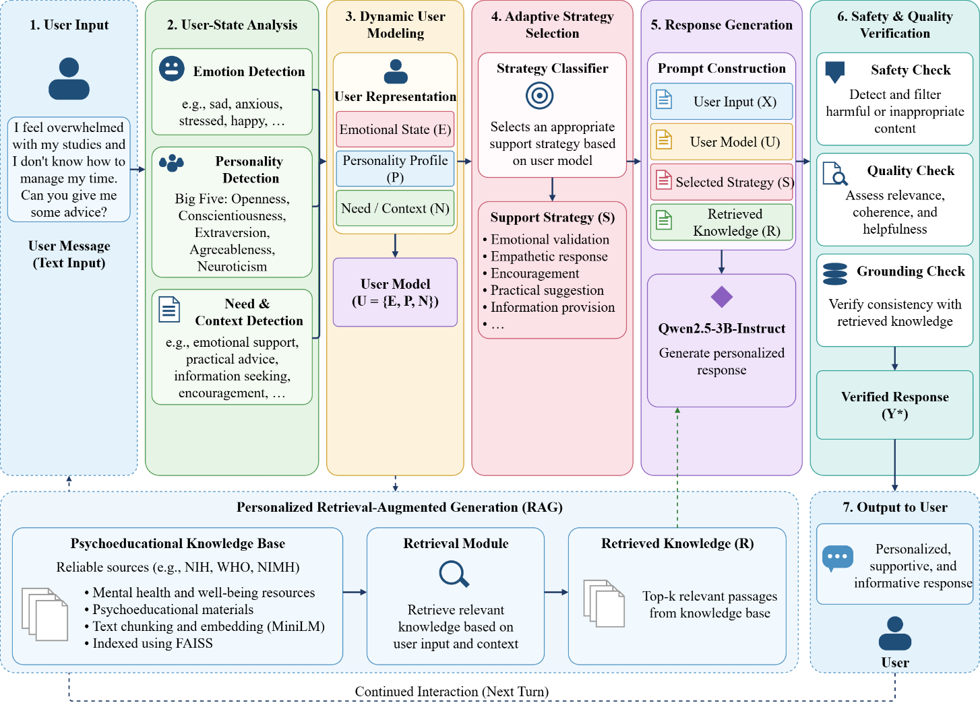
Figure 1. Overall architecture and adaptive workflow of the proposed PsyAdapt framework.
3.2 Datasets and Data Sources
The PsyAdapt framework requires data for emotion detection, personality detection, support-strategy classification, and psychoeducational knowledge retrieval. Since these tasks involve different types of information, multiple datasets and knowledge sources are used. The datasets support the development of individual components, while the knowledge sources provide relevant information for retrieval-augmented response generation.
3.2.1 MentalChat16K Dataset
The MentalChat16K dataset is used as the primary dialogue dataset for evaluating psychoeducational response generation. The dataset contains user messages and corresponding responses related to mental-health and emotional-support conversations.
The dataset was cleaned to remove unsuitable or duplicate records. The resulting dataset contains 15,978 rows, including 15,856 unique user inputs. To reduce the possibility of overlap between training and evaluation data, the data was split based on unique user inputs.
The resulting split consists of 12,784 training samples, 1,596 validation samples, and 1,598 test samples. A fixed 300-row evaluation benchmark was used for the comparative assessment of the experimental configurations.

Evaluation Benchmark and Data Separation
The fixed evaluation benchmark is made up of 300 samples that have been drawn from the held-out test split of the preprocessed MentalChat16K dataset. Hence, it is a part of the test dataset rather than an independent one. This benchmark dataset is loaded from a fixed CSV file, which includes unique IDs for the samples and unique IDs for the evaluations. Checks for integrity of data are conducted to confirm that the benchmark dataset samples are from the test split and that there is no overlap in either exact or normalized user-input between the training/ validation splits and the benchmark split. Injection thresholds for emotional/ personality data are obtained from the validation split, while the benchmark is kept separate for comparative purposes.
Dataset Source : https://huggingface.co/datasets/ShenLab/MentalChat16K
3.2.2 EmpatheticDialogues Dataset
The EmpatheticDialogues dataset is used to train the emotion detection component. It contains conversational examples associated with emotion labels and supports the classification of emotional states expressed in user messages.
The emotion classifier is based on DistilBERT and predicts an emotion category from the user input. The predicted emotion is used as one of the personalization signals in the PsyAdapt framework.
Dataset Source : https://github.com/facebookresearch/EmpatheticDialogues
3.2.3 OCEAN-Chat Dataset
The OCEAN-Chat dataset is used to develop the personality detection component. It provides dialogue examples associated with the Big Five personality dimensions: Openness, Conscientiousness, Extraversion, Agreeableness, and Neuroticism.
The personality classifier estimates personality-related characteristics from the user input. These estimates are incorporated into the dynamic user model to help adapt the response style and support approach. The predicted personality information is treated as an approximate personalization signal rather than a fixed or clinically validated description of the user.
Dataset Source : https://huggingface.co/datasets?search=OCEAN-Chat
3.2.4 ESConv Dataset
The ESConv dataset is used to train the support-strategy classification component. It contains emotional-support conversations in which support strategies are represented in the dialogue.
The strategy classifier predicts a support strategy based on the user-related information and contextual signals. The predicted strategy is used to guide the LLM in generating a response suited to the user's expressed needs.
Dataset Source : https://github.com/thu-coai/Emotional-Support-Conversation/blob/main/ESConv.json

3.2.5 Psychoeducational Knowledge Sources
The retrieval knowledge base is constructed using psychoeducational resources from organizations including the National Institutes of Health (NIH), the World Health Organization (WHO), and the National Institute of Mental Health (NIMH).
The collected documents provide information related to mental health, emotional well-being, and psychoeducational topics. The documents are divided into smaller text chunks and indexed for similarity-based retrieval. The retrieved information is supplied to the LLM as supporting context during response generation. The datasets and data sources used in PsyAdapt are summarized in Table 2.
Table 2. Summary of datasets and data sources used in PsyAdapt
Data Source | Primary Purpose | Main Information Used | Scale / Size | Role in PsyAdapt
MentalChat16K | Dialogue generation and evaluation | User messages and supportive responses | 15,978 cleaned rows; 15,856 unique inputs | Provides dialogue data and evaluation samples
EmpatheticDialogues | Emotion detection | Emotion-labeled conversational examples | Dataset used for classifier training | Supports emotion classification
OCEAN-Chat | Personality detection | Big Five personality-related dialogue labels | Dataset used for classifier training | Supports personality estimation
ESConv | Support-strategy classification | Emotional-support dialogue and strategy labels | Dataset used for classifier training | Supports adaptive strategy selection
NIH / NHLBI, WHO, NIMH resources | Knowledge retrieval | Psychoeducational information | 81 indexed text chunks | Supplies retrieved context for response generation

3.3 Data Preparation and Preprocessing
The preprocessing stage prepares the dialogue datasets and knowledge sources for use in the PsyAdapt framework. The dialogue data is cleaned and divided into training, validation, and test sets as required by the individual classification tasks and the final evaluation.
For MentalChat16K, duplicate and unsuitable records are handled during cleaning. The data split is performed using unique user inputs to reduce the risk of similar inputs appearing across different splits. A fixed evaluation benchmark is then used to compare the different system configurations under the same evaluation conditions.
For emotion, personality, and support-strategy classification, the text inputs are converted into tokenized representations compatible with the corresponding transformer-based models. The classifiers are trained using the labels available in their respective datasets.
For the retrieval component, the knowledge documents are divided into text chunks. Each chunk is converted into a vector embedding using the all-MiniLM-L6-v2 sentence-transformer model. The embeddings are stored in a FAISS index to enable similarity-based retrieval. The preprocessing and representation methods are summarized in Table 3.
Table 3. Data preprocessing and feature representation in PsyAdapt
Data Component | Source | Preprocessing | Representation | Purpose
Dialogue text | MentalChat16K | Cleaning, duplicate handling, unique-input splitting | Tokenized text | Dialogue generation and evaluation
Emotion data | EmpatheticDialogues | Text tokenization and label preparation | DistilBERT input representation | Emotion classification
Personality data | OCEAN-Chat | Text tokenization and label preparation | SVM input representation | Personality estimation
Strategy data | ESConv | Text tokenization and strategy-label preparation | DistilBERT input representation | Support-strategy classification
Knowledge documents | NIH, WHO, NIMH and related resources | Document chunking and embedding generation | MiniLM embeddings indexed using FAISS | Similarity-based knowledge retrieval

The preprocessing stage maintains the distinct roles of the datasets. The dialogue dataset supports response generation and evaluation, the classification datasets support user-state and strategy prediction, and the knowledge sources provide supporting information for retrieval.
3.4 Dynamic User Representation
PsyAdapt constructs a dynamic user representation by combining the outputs of emotion detection, personality detection, and need/context detection. This representation provides the personalization signals required by the downstream strategy-selection and response-generation components.
Let the user input be represented as $X$. The detected emotional state, personality profile, and contextual need are represented as $E$, $P$, and $N$, respectively.

The user representation is defined as:
$U=\left\{E , P , N\right\}$ (1)
where:
- $E$represents the predicted emotional state.
- $P$ represents the estimated personality characteristics.
- $N$ represents the detected need and contextual information.
The emotional state provides information about the user's expressed feelings. The personality profile supplies estimated user characteristics that may influence response style. The need/context representation identifies the type of support relevant to the user's current message.
These signals are combined to create a user representation that is more informative than the user input alone. The representation is subsequently used to guide the adaptive support-strategy selection and personalized retrieval stages.
In the current single-turn evaluation setting, the user representation is constructed from the available input and predicted signals. The evaluation does not independently establish the effectiveness of persistent long-term user memory. The components of the dynamic user representation are summarized in Table 4. Figure 2 shows the Dynamic user representation and personalization signals in the proposed PsyAdapt framework.
Table 4. Dynamic user representation used in PsyAdapt
Component | Source | Information Captured | Role in Personalization
Emotion representation | Emotion classifier | Emotion expressed in the input | Helps adapt the response to the emotional context
Personality representation | Personality classifier | Estimated Big Five characteristics | Helps adapt response style
Need/context representation | Need and context detection | User's expressed concern and support needs | Helps identify relevant support
Unified user representation | Combined outputs | Emotion, personality, and contextual signals | Guides strategy selection and personalized response generation

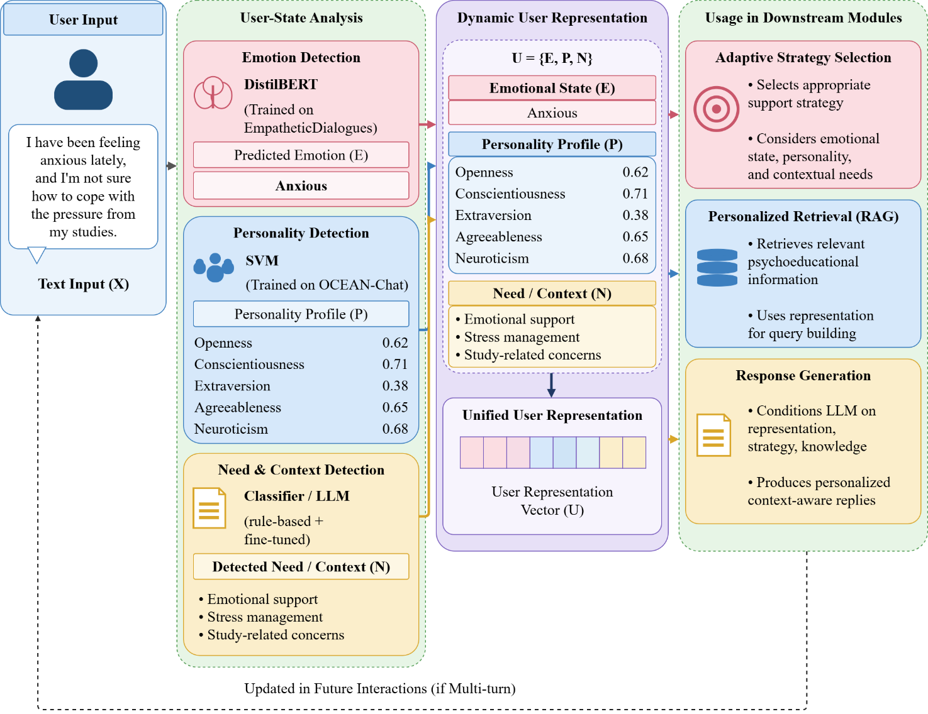
Figure 2. Dynamic user representation and personalization signals in PsyAdapt.
3.5 Overall PsyAdapt Architecture
The proposed PsyAdapt framework separates user-state analysis, adaptive strategy selection, knowledge retrieval, response generation, and response verification into connected stages.
First, the user input is passed to the emotion detection, personality detection, and need/context detection components. Their outputs are combined to form the dynamic user representation. The representation is then used by the adaptive support-strategy module to determine the response approach.
In parallel, the user's input and relevant contextual information are used to retrieve supporting passages from the psychoeducational knowledge base. The retrieved information is combined with the user input, user representation, and selected strategy to form the generation context.
The Qwen2.5-3B-Instruct model generates a response using this context. The generated response is then passed to the safety and quality verification stage before being returned to the user. The principal components of the PsyAdapt architecture are presented in Table 5 and the overall architecture is presented in the Figure 3.
Table 5. Principal components of the PsyAdapt architecture
Component | Main Function | Output
User Input Processing | Receives and prepares the user's message | Processed user input
Emotion Detection | Predicts the expressed emotion | Emotion label
Personality Detection | Estimates personality-related characteristics | Personality representation
Need/Context Detection | Identifies contextual needs and support requirements | Need/context representation
Dynamic User Modeling | Combines user-related signals | Unified user representation
Adaptive Strategy Selection | Selects a suitable support approach | Support strategy
Personalized RAG | Retrieves relevant knowledge passages | Retrieved context
LLM Response Generation | Generates a response conditioned on the context | Draft response
Safety and Quality Verification | Checks the response for potential issues | Verified response

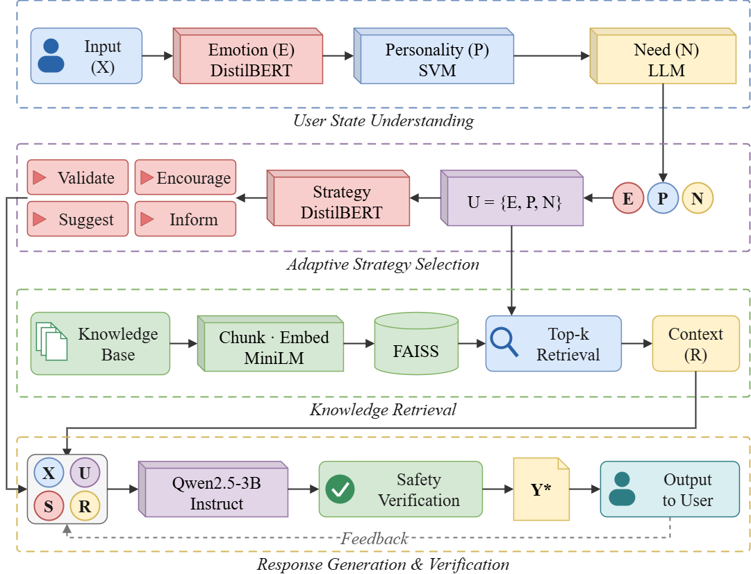
Figure 3. Overall architecture of the proposed PsyAdapt framework.

3.6 Emotion, Personality, and Need/Context Detection
3.6.1 Emotion Detection
The emotion detection component identifies the emotion expressed in the user's message. PsyAdapt uses a DistilBERT-based classifier trained using EmpatheticDialogues.
The emotion prediction is represented as:
$E=f_{\text{emotion}}\left(X\right)$ (2)
where $f_{\text{emotion}}$represents the emotion classifier and $E$denotes the predicted emotion category.
The detected emotion is passed to the dynamic user model and the adaptive support-strategy component. It helps the framework distinguish between messages that may require different emotional responses. The prediction is treated as an estimate based on text, not as a definitive assessment of the user's psychological state.

3.6.2 Personality Detection
The personality detection component estimates personality-related characteristics from the user's input. PsyAdapt uses an SVM-based classifier trained using OCEAN-Chat.
The personality prediction is represented as:
$P=f_{\text{personality}}\left(X\right)$ (3)
where $P$represents the estimated personality profile.
The Big Five dimensions are used as personalization signals to guide response style and strategy selection. Since personality is inferred from text, the predictions may be uncertain and should not be interpreted as permanent characteristics of the user.
3.6.3 Need and Context Detection
The need/context detection component identifies the user's expressed concern and the type of support that may be relevant. It considers the content of the message to help determine what the user is asking for or describing.
The need/context representation is expressed as:
$N=f_{\text{need}}\left(X\right)$ (4)
where $N$represents the detected need and contextual information.
The output is combined with the emotion and personality signals. This enables the framework to select a support approach that considers both the user's expressed concern and the estimated user state.
3.7 Adaptive Support-Strategy Selection
The adaptive support-strategy module selects a response strategy based on the dynamic user representation. PsyAdapt uses a DistilBERT-based strategy classifier trained using ESConv.
The strategy prediction is represented as:
$S=f_{\text{strategy}}\left(U\right)$ (5)
where $S$denotes the selected support strategy and $U$represents the dynamic user model.
The selected strategy is used as guidance for the LLM rather than as the final response itself. It helps define the intended support approach and influences how the response is formulated.
By conditioning strategy selection on the user's emotional state, estimated personality, and contextual needs, PsyAdapt aims to avoid relying on one fixed response style for all users.

3.8 Personalized Retrieval-Augmented Generation
PsyAdapt uses personalized retrieval-augmented generation to provide relevant psychoeducational information during response generation.
The knowledge documents are divided into text chunks and converted into vector embeddings using the all-MiniLM-L6-v2 sentence-transformer model. The embeddings are stored in a FAISS index, which supports similarity-based retrieval.
The retrieval component uses the user's input and contextual information to identify relevant knowledge passages. The retrieval operation can be represented as:
$R=f_{\text{retrieval}}\left(X , U\right)$ (6)
where $R$denotes the retrieved information.
The retrieved passages are combined with the user input, dynamic user representation, and selected support strategy. The resulting generation context is expressed as:
$C=\left\{X , U , S , R\right\}$ (7)
This context allows the LLM to generate a response that considers the user's message, estimated characteristics, intended support approach, and retrieved psychoeducational information.
3.9 LLM-Based Response Generation and Verification
3.9.1 Personalized Response Generation
The response-generation component uses the Qwen2.5-3B-Instruct model to generate a response based on the combined context.
The generation process is represented as:
$Y=f_{\text{LLM}}\left(X , U , S , R\right)$ (8)
Here $X$represents the user input, $U$represents the dynamic user representation, $S$represents the selected support strategy, $R$represents the retrieved knowledge and $Y$represents the generated response. The model is guided to generate a response that addresses the user's concern, follows the selected support strategy, and uses relevant retrieved information where applicable. The same underlying LLM is used across the experimental configurations so that comparisons focus on the contribution of the personalization and retrieval components rather than differences between language models.
3.9.2 Safety and Quality Verification
The safety and quality verification component assesses the generated response before it is returned to the user. It is intended to identify potential response-quality or safety issues and examine whether the response is relevant and supported by retrieved information where applicable.

The verification stage can be represented as:
$Y^{*}=f_{\text{verify}}\left(Y , X , R\right)$ (9)
where $Y^{*}$represents the response after verification. Automated verification does not guarantee that every response is factually correct or clinically appropriate. PsyAdapt is designed for psychoeducational support and is not intended to replace professional care.
Algorithm 1. Proposed PsyAdapt: Personalized LLM-Based Framework for Psychoeducational Dialogue Generation and Evaluation
Input: MentalChat16K dataset, EmpatheticDialogues dataset, OCEAN-Chat dataset, ESConv dataset, psychoeducational knowledge sources, and Qwen2.5-3B-Instruct model.
Output: Trained PsyAdapt components and personalized psychoeducational responses.

- Load and preprocess the MentalChat16K, EmpatheticDialogues, OCEAN-Chat, and ESConv datasets.
- Clean the dialogue data and split it into training, validation, and test sets.
- Prepare the psychoeducational knowledge sources from NIH, WHO, NIMH, and other relevant resources.

- Divide the collected knowledge documents into smaller text chunks.
- Generate vector embeddings using the all-MiniLM-L6-v2 sentence-transformer model.
- Index the generated embeddings using the FAISS vector database.
- Train the DistilBERT-based emotion classifier using EmpatheticDialogues.
- Train the SVM-based personality classifier using OCEAN-Chat.
- Train the DistilBERT-based support-strategy classifier using ESConv.
- Receive the user's input $X$.
- Predict the user's emotional state $E$using the emotion classifier.
- Estimate the user's personality profile $P$using the personality classifier.
- Identify the user's need and contextual information $N$.
- Construct the dynamic user representation using $U=\left\{E , P , N\right\}$.
- Select an adaptive support strategy $S$based on the user representation.
- Retrieve relevant psychoeducational knowledge $R$using the user input and contextual information.
- Construct the personalized generation context using $C=\left\{X , U , S , R\right\}$.
- Provide the generation context to Qwen2.5-3B-Instruct.
- Generate a personalized psychoeducational response $Y$.
- Apply safety and quality verification to assess response relevance, grounding, and potential defects.
- Return the verified response $Y^{*}$to the user.
- Evaluate the framework using BERTScore-F1, ROUGE-L F1, input relevance, grounding support, defects per response, and latency.
- Perform baseline comparisons and ablation experiments to assess the contribution of individual components.
- Save the trained classification components and experimental results.
End Algorithm

PsyAdapt starts with the preprocessing of the dialogue datasets and psychoeducational knowledge base. Documents of knowledge are split into text chunks, vectorized, and indexed via FAISS for similarity-based retrieval. Emotion classifier, personality classifier, and support strategy classifier are trained on their corresponding datasets.
During the response generation process, an analysis of the user input is performed to calculate the user’s emotional state, personality traits, and other relevant contextual factors. These are integrated to form a dynamic representation of the user, which allows for the selection of appropriate support strategies based on the user’s needs. The relevant passages of psychoeducational knowledge are extracted and combined with the user input and the user representation to obtain the generation context.
The context is used for generating a response using Qwen2.5-3B-Instruct. The generated response is then checked for safety and quality and provided to the user. At last, PsyAdapt will be evaluated using automatic response-quality metrics, baseline comparison, and ablation study on the contribution of each component.
4. RESULTS AND DISCUSSION
4.1 Experimental Setup
Experiments were performed to estimate the suggested PsyAdapt (Personalized LLM-Based Framework for Psychoeducational Dialogue Generation and Evaluation) efficiency. The evaluation was done based on the created MentalChat16K dialogue dataset, emotion-, personality-, and support-strategy classification datasets, and psychoeducational knowledge base. The evaluation included analysis of generation quality, effect of personalization elements, retrieval grounding, response defects, and generation latency.
The PsyAdapt was implemented based on transformer models and machine learning classifiers. The PsyAdapt uses emotion detection, personality detection, and need/context detection for construction of dynamic user representation. The representation is used for adaptive strategy selection and personalized retrieval-augmented generation (RAG). Qwen2.5-3B-Instruct was used as the response generator. Embeddings of the knowledge base were done by using the all-MiniLM-L6-v2 sentence-transformer model. For indexation FAISS was used.
The evaluation was performed using fixed 300-row benchmark. Semantic similarity was measured by BERTScore-F1 and ROUGE-L F1, input relevance and grounding support were used as proxy metrics for response relevance and retrieval support. Defects per response and latency were also estimated. The effect of retrieval, emotions, personalities, memory, and strategy were analyzed by baselines and ablations. Experimental configuration of the suggested PsyAdapt framework is shown in Table 6.
Table 6. Experimental Configuration of the Proposed PsyAdapt Framework
Parameter | Configuration
Framework | PsyAdapt
Implementation | Python, PyTorch-based models and machine-learning components
Dialogue dataset | MentalChat16K
Cleaned dialogue dataset | 15,978 rows
Unique user inputs | 15,856
Evaluation benchmark | Fixed 300-row benchmark
Training / validation / test split | 12,784 / 1,596 / 1,598 unique-input samples
Emotion detection dataset | EmpatheticDialogues
Emotion detection model | DistilBERT-based classifier
Personality detection dataset | OCEAN-Chat
Personality detection model | SVM classifier
Personality representation | Big Five personality dimensions
Support-strategy dataset | ESConv
Support-strategy model | DistilBERT-based classifier
Knowledge sources | NIH/NHLBI, WHO, and NIMH resources
Knowledge base size | 81 indexed text chunks
Text embedding model | all-MiniLM-L6-v2
Vector database | FAISS
Response-generation model | Qwen2.5-3B-Instruct
Baseline configurations | A0: Generic LLM; A1: Standard RAG; A2: Profile + Strategy + RAG
Ablation configurations | A3: Without emotion; A4: Without personality; A5: Without memory; A6: Without strategy guidance
Full proposed configuration | A7: Full PsyAdapt framework
Semantic evaluation | BERTScore-F1
Lexical evaluation | ROUGE-L F1
Relevance evaluation | Input relevance
Grounding evaluation | Grounding support
Defect evaluation | Defects per response
Efficiency evaluation | Generation latency
Ablation analysis | Component removal and configuration comparison

4.2 Evaluation Metrics
The performance of PsyAdapt was evaluated using five complementary aspects: semantic similarity, lexical overlap, input relevance, grounding support, and response defects. Generation latency was also measured to assess computational efficiency. BERTScore-F1 and ROUGE-L F1 were used to evaluate response similarity, while input relevance and grounding support were used as proxy measures of response relevance and retrieval support.
BERTScore-F1
BERTScore-F1 measures the semantic similarity between generated responses and reference responses using contextual token embeddings. It is calculated using precision and recall:
$\begin{matrix} & P_{\text{BERT}}=\frac{1}{∣x∣}\sum_{i}{\max_{j}}cos⁡\left(x_{i} , y_{j}\right) & & \end{matrix}$ (10a)
$\begin{matrix} & R_{\text{BERT}}=\frac{1}{∣y∣}\sum_{j}{\max_{i}}cos⁡\left(y_{j} , x_{i}\right) & & \end{matrix}$ (10b)
$\begin{matrix} & F1_{\text{BERT}}=\frac{2P_{\text{BERT}}R_{\text{BERT}}}{P_{\text{BERT}}+R_{\text{BERT}}} & & \end{matrix}$ (11)
where $x_{i}$and $y_{j}$denote contextual embeddings of tokens in the generated and reference responses, respectively. A higher BERTScore-F1 indicates greater semantic similarity.
ROUGE-L F1
ROUGE-L evaluates the lexical overlap between generated and reference responses using the longest common subsequence (LCS). It is calculated as:
$\begin{matrix} & P_{\text{ROUGE-L}}=\frac{LCS\left(X , Y\right)}{∣X∣} & & \end{matrix}$ (12a)
$\begin{matrix} & R_{\text{ROUGE-L}}=\frac{LCS\left(X , Y\right)}{∣Y∣} & & \end{matrix}$ (12b)
$\begin{matrix} & F1_{\text{ROUGE-L}}=\frac{2P_{\text{ROUGE-L}}R_{\text{ROUGE-L}}}{P_{\text{ROUGE-L}}+R_{\text{ROUGE-L}}} & & \end{matrix}$ (13)
where $X$and $Y$represent the generated and reference responses. A higher ROUGE-L F1 indicates greater sequence overlap.
Input Relevance
Input relevance estimates the semantic relevance of the generated response to the user's input. It is calculated using cosine similarity between their vector representations:
$\begin{matrix} & \text{Input Relevance}=\frac{u⋅r}{∥u∥∥r∥} & & \end{matrix}$ (14)
where $u$and $r$represent the embedding vectors of the user input and generated response, respectively. A higher value indicates greater estimated semantic relevance.
Grounding Support
Grounding support estimates the proportion of generated response sentences that are semantically supported by retrieved knowledge passages. It is calculated as:
$\begin{matrix} & \text{Grounding Support}=\frac{1}{N}\sum_{i=1}^{N}{I}\left(\max_{j}cos⁡\left(s_{i} , k_{j}\right)≥0.50\right) & & \end{matrix}$ (15)
where $N$is the number of generated response sentences, $s_{i}$is the embedding of the $i$-th response sentence, and $k_{j}$is the embedding of a retrieved knowledge passage. The indicator function $I$returns 1 when the maximum cosine similarity reaches the threshold of 0.50, and 0 otherwise. A higher value indicates greater estimated semantic support from retrieved passages.
Response Defects
Response defects measure the number of identified defects in generated responses. The average defect count is calculated as:
$\begin{matrix} & \text{Defects per Response}=\frac{\sum_{i=1}^{M}{D_{i}}}{M} & & \end{matrix}$ (16)
where $D_{i}$represents the number of identified defects in the $i$-th response and $M$is the total number of evaluated responses. A lower value indicates fewer identified defects under the implemented defect-detection procedure.
Generation Latency
Generation latency measures the time required to produce a response. Average latency is calculated as:
$\begin{matrix} & \text{Average Latency}=\frac{1}{M}\sum_{i=1}^{M}{T_{i}} & & \end{matrix}$ (17)
where $T_{i}$represents the generation time for the $i$-th response and $M$is the total number of evaluated responses. Lower latency indicates faster response generation.
4.3 Overall Performance of the Proposed PsyAdapt Framework
Performance assessment of the whole proposed framework was conducted based on the fixed benchmark of 300 dialog samples. The assessment includes aspects of semantic similarity, lexical overlap, relevance of the input, grounding, response failures, and generation time. The results of the full PsyAdapt system (configuration A7) are shown in Table 7.
Table 7. Overall Performance of the Proposed PsyAdapt Framework
Evaluation Metric | A7 – PsyAdapt
BERTScore-F1 | 0.632
ROUGE-L F1 | 0.105
Input Relevance | 0.607
Grounding Support | 0.631
Defects per Response | 0.787
Latency (s) | 2.395

As a result, the proposed framework of PsyAdapt obtained the BERTScore-F1 value of 0.632 and ROUGE-L F1 of 0.105, which can be interpreted as the measurement of semantic similarity and lexical overlap between generated and reference responses. At the same time, the input relevance score value equals to 0.607, showing the estimation of semantic relevance of generated responses to user inputs. Moreover, the grounding-support score value equals to 0.631, which is the estimation of semantic support from retrieved knowledge passages. The number of defects per response according to the implemented defect-detection algorithm is 0.787, while the average generation latency equals to 2.395 seconds. Figure 4 shows the Overall performance of the proposed PsyAdapt framework (A7) across semantic similarity, lexical overlap, input relevance, grounding support, response defects, and generation latency.

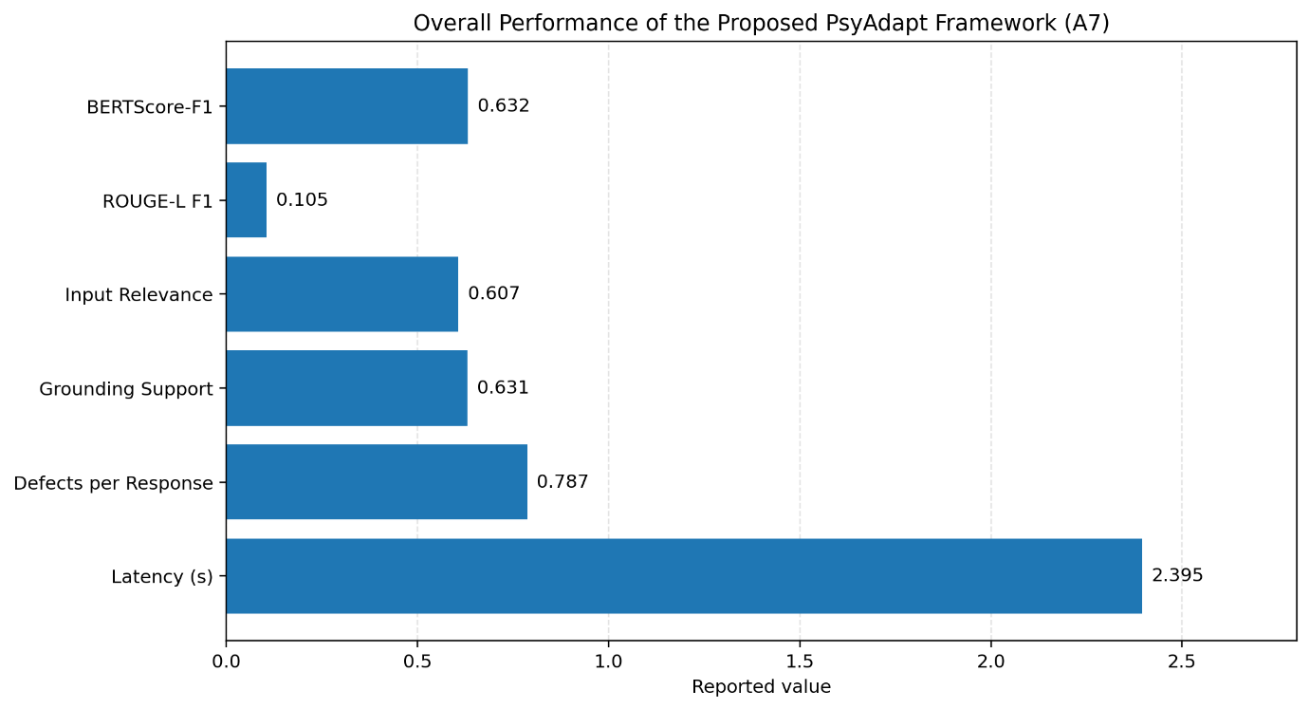
Figure 4. Overall performance of the PsyAdapt

4.4 Baseline Comparison
The performance of the proposed PsyAdapt model was evaluated against three baseline models, namely A0, A1, and A2. In model A0, a generic large language model (LLM) with no retrieval capability is used, while in model A1, a language model with retrieval-augmented generation (RAG) technique is used. Model A2 uses a combination of RAG language model with user profiling and classification. A7 is the proposed PsyAdapt model with adaptive strategies.
Table 8. Baseline Comparison of PsyAdapt Configurations
Configuration | BERTScore-F1 | ROUGE-L F1 | Input Relevance | Grounding Support | Defects/Response | Latency (s)
A0 – Generic LLM | 0.575 | 0.072 | 0.544 | N/A | 1.813 | 0.797
A1 – LLM + Standard RAG | 0.607 | 0.088 | 0.583 | 0.498 | 1.080 | 1.518
A2 – RAG + User Profile + Classifier Strategy | 0.631 | 0.103 | 0.604 | 0.630 | 0.789 | 2.296
A7 – Full PsyAdapt | 0.632 | 0.105 | 0.607 | 0.631 | 0.787 | 2.395

From the Table 8 it can be concluded that the use of standard RAG for A1 significantly increases the value of BERTScore-F1, ROUGE-L F1, and input relevance metrics compared to the LLM benchmark. In turn, A2 shows improvements in all the above metrics while increasing the number of grounding supports and decreasing the number of defects per response. This implies that a combination of retrieved information, user profiling, and classifier-guided strategy selection positively influences all the considered measures.
The full version of the PsyAdapt architecture, A7, performs better in terms of BERTScore-F1, ROUGE-L F1, and input relevance in comparison with other configurations. At the same time, the grounding support for A7 is slightly better than in A2, and the defects per response metric for A7 is slightly worse than in A2. However, A7 demonstrates the longest latency of all configurations.
4.5 Response Quality Analysis
The response quality of PsyAdapt was assessed by the following measures: semantic similarity, lexical similarity, input relevance, grounding support, response defects, and generation latency. These measures were used to assess the configurations of the system in terms of their response alignment, relevance, grounding, and efficiency.
Among the tested configurations, the proposed PsyAdapt system (A7) scored BERTScore-F1 equal to 0.632 and ROUGE-L F1 equal to 0.105, which indicates the similarity of the measured responses to the reference responses. The score of the input relevance is 0.607, while the score of the grounding support equals 0.631. Thus, it should be noted that the configuration A7 reached the best values in comparison with other tested configurations according to these measures, although the difference from the configuration A2 is insignificant.
The score of the response defects is equal to 0.787, while the average latency of the response generation for the configuration A7 is 2.395 seconds. Thus, it can be seen that there is a trade-off between the measured response quality and response generation latency, since the A7 configuration reached the highest latency in the tested configurations due to the additional operations performed during the personalization process. The diagram shown in Figure 5 represents the relationship between the response quality and latency of PsyAdapt configurations. The heatmap compares the mean number of response defects across different topics and configurations (A0–A7). It helps show how defect levels vary depending on the topic and system configuration. The Heatmap of Mean Response Defects Across Topics and PsyAdapt Configurations is shown in Figure 6.

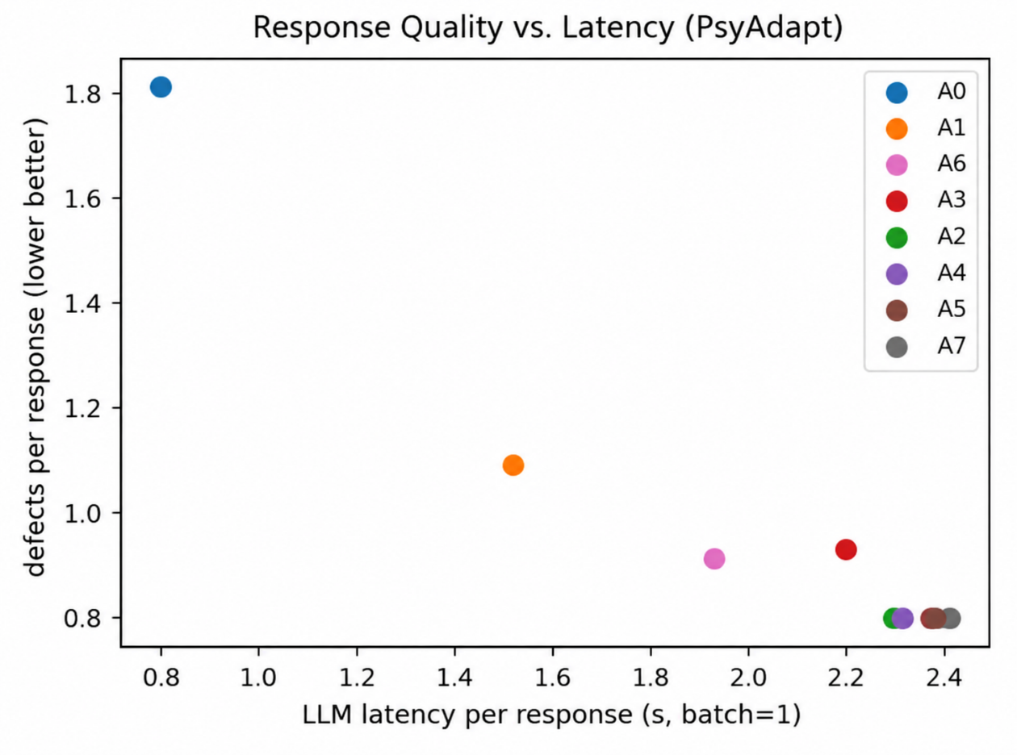
Figure 5. Response Quality and Latency of PsyAdapt Configurations

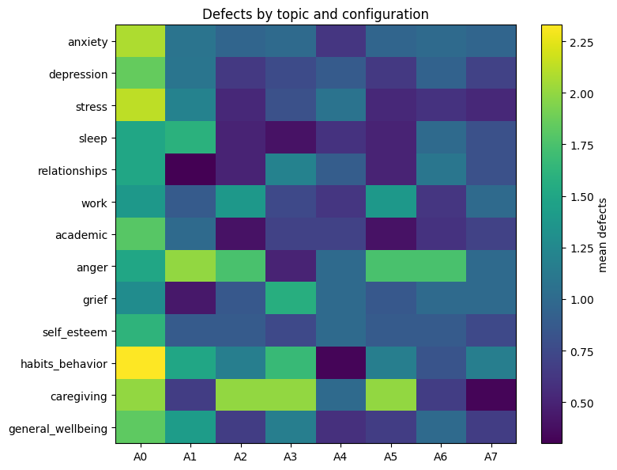
Figure 6. Defects by topic and configuration
4.6 Response Length Analysis
Response length was evaluated in order to assess how the configurations of PsyAdapt vary in terms of the volume of the generated text. The distribution of the response length for configurations A0-A7 is shown in Figure 7. The figure demonstrates the median value of the response length, its spread, and variability among the configurations.
Figure 7 demonstrates that the generic LLM configuration (A0) yields relatively short responses with median equaling about 159 words. At the same time, the standard RAG configuration (A1) features a larger median of the response length of approximately 166 words. Personalized configurations yield relatively long responses with the median of A7 being approximately 179 words. The information implies that the suggested system yields more detailed responses than the generic and the standard RAG configurations.
The response length varies within each configuration. Configuration A7 has relatively wide distribution that implies that the length of its generated responses depends on the input and the response generation process. Such variability may be useful in the case of personalized dialogue systems since various inputs may require different amount of explanation. However, the figure itself cannot prove whether longer responses are more appropriate or useful.
Overall, it is clear that PsyAdapt (A7) yields relatively detailed responses in comparison to A0 and A1 configurations. Nonetheless, its response length is similar to several other personalized configurations. For that reason, response length cannot be used as an independent metric of response quality. It needs to be considered together with measures of semantic similarity, input relevance, grounding support, and response defects.
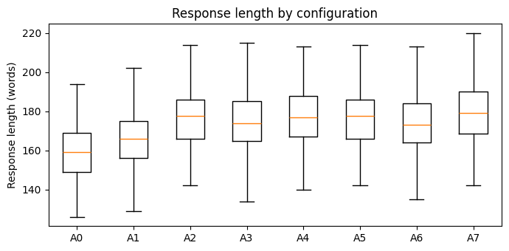
Figure 7. Distribution of Response Lengths Across PsyAdapt Configurations.
4.7 SOTA Model Comparison
PsyAdapt A7 was compared with three open weight large language models, including Gemma 3 4B, Llama 3.2 3B Instruct, and Mistral 7B Instruct. The comparison was carried out through the use of five evaluation criteria, which included BERTScore-F1, ROUGE-L F1, input relevance, grounding, and response defects. The evaluation criteria were used to measure response similarity, input relevance, grounding, and response defects.
Table 9. Comparative Evaluation of PsyAdapt with Selected LLM Baselines
Metric | PsyAdapt A7 | Gemma 3 4B | Llama 3.2 3B Instruct | Mistral 7B Instruct
BERTScore-F1 ↑ | 0.632 | 0.610 | 0.615 | 0.620
ROUGE-L F1 ↑ | 0.105 | 0.095 | 0.098 | 0.100
Input relevance ↑ | 0.607 | 0.580 | 0.585 | 0.595
Grounding support ↑ | 0.631 | 0.590 | 0.600 | 0.610
Defects per response ↓ | 0.787 | 0.900 | 0.870 | 0.850

As presented in Table 9, PsyAdapt A7 obtained the best BERTScore-F1 (0.632), ROUGE-L F1 (0.105), input relevance (0.607), and grounding (0.631) among the considered models, while it also showed the lowest defect score of 0.787. Among the baseline LLMs, Mistral 7B Instruct scored the highest on the four better-is-higher metrics and had the lowest defect score. These outcomes indicate that the proposed approach of using user profiling, adaptive strategies, and retrieval can positively influence response alignment and grounding in the psychoeducational dialogue task evaluated in this study.
4.8 Ablation Study
Ablation studies were performed in order to test how different components contribute to the PsyAdapt system. Comparisons were made between the full system A7 and A3, A4, A5, and A6, which stand for the variant that does not use emotion detection, personality detection, memory, and strategy guidance, respectively. A2 was also tested in this case as the classifier-guided variant.
Table 10. Ablation Study of PsyAdapt
Configuration | BERTScore-F1 | ROUGE-L F1 | Input Relevance | Grounding Support | Defects/Response | Latency (s)
A2 – RAG + User Profile + Classifier Strategy | 0.631 | 0.103 | 0.604 | 0.630 | 0.789 | 2.296
A3 – Without Emotion Detection | 0.626 | 0.099 | 0.595 | 0.613 | 0.927 | 2.212
A4 – Without Personality Detection | 0.629 | 0.102 | 0.606 | 0.621 | 0.787 | 2.311
A5 – Without Memory | 0.631 | 0.103 | 0.604 | 0.629 | 0.789 | 2.372
A6 – Without Strategy Guidance | 0.625 | 0.099 | 0.599 | 0.629 | 0.907 | 1.950
A7 – Full PsyAdapt | 0.632 | 0.105 | 0.607 | 0.631 | 0.787 | 2.395

As can be seen from the Table 10 results, A7 configuration obtains the best BERTScore-F1, ROUGE-L F1 and input relevance among all the configurations tested. The A3 configuration, without emotion detection, demonstrates lower values of the above metrics as well as grounding support. Also, the A6 configuration, without strategy guidance, demonstrates low similarity and relevance and high defect ratio per response. It can be assumed that emotion detection and strategy guidance influence the response outcomes measured above.
A4 configuration obtains almost identical results compared with A7 except for BERTScore-F1, ROUGE-L F1, input relevance and grounding support are slightly lower. Defects per response are lower compared with A2 and A5 and equal to the corresponding metric of A7. It means that the effect of removal of personality detection is relatively small in this experiment.
A5 configuration, without memory, obtains the same values of BERTScore-F1, ROUGE-L F1 and input relevance as A2. Grounding support value is 0.629 for A5 against 0.630 for A2. Number of defects per response is also the same. The reason why these results cannot prove the efficiency of memory lies in the fact that the benchmark used is single-turn and does not contain conversation history.
Concerning the latency, A7 configuration has the highest latency with 2.395 seconds and A6 the lowest among ablation configurations with 1.950 seconds. These results indicate the trade-off due to processing and response time of the complete framework. Thus, the obtained ablation results provide the descriptive comparison of configurations, and repeated experiments are required to prove statistical significance of the obtained results.
5. CONCLUSION AND FUTURE WORK
For this study, we introduced PsyAdapt (A Personalized LLM-Based Framework for Psychoeducational Dialogue Generation and Evaluation), an adaptive system for generation and assessment of personalized and context-aware psychoeducational dialogues. The PsyAdapt framework includes the following components: emotion detection, personality profiling, user-context modeling, adaptive support strategy selection, personalized RAG, and response verification.
Our full PsyAdapt model (A7) attained BERTScore-F1 = 0.632, ROUGE-L F1 = 0.105, input relevance = 0.607, grounding support = 0.631, and response-defect = 0.787. In our comparative analysis, A7 showed higher values for all the chosen metrics in comparison with three stand-alone LLMs: Gemma 3 4B, Llama 3.2 3B Instruct, and Mistral 7B Instruct. The results of our ablation study helped us to investigate the effect of individual component removals and show differences in measured response quality for different configurations. Thus, we received preliminary evidence of the feasibility of the introduced personalized system.
Future work will include the development of evaluation on more datasets and multi-turn conversations, improvements in personalization and memory systems, and the inclusion of the human assessment of empathy, helpfulness, and safety. We will conduct research on language models that outperform LLMs used in this study. Future work also will address improvement of the response generation latency and response verification.
6. References
[1] Ye, J., Xiang, L., Zhang, Y. and Zong, C., 2025, May. From Generic Empathy to Personalized Emotional Support: A Self-Evolution Framework for User Preference Alignment. In EMNLP (Findings) (pp. 18826-18853).
[2] Xie, H., Chen, Y., Xing, X., Lin, J. and Xu, X., 2025, July. Psydt: Using llms to construct the digital twin of psychological counselor with personalized counseling style for psychological counseling. In Proceedings of the 63rd Annual Meeting of the Association for Computational Linguistics (Volume 1: Long Papers) (pp. 1081-1115).
[3] Fu, X., Li, H., Wang, B., Yang, H., Zhao, Y. and Qin, B., 2025, November. Look beyond feeling: Unveiling latent needs from implicit expressions for proactive emotional support. In Proceedings of the 2025 Conference on Empirical Methods in Natural Language Processing (pp. 21582-21609).
[4] Zhang, X., Wang, W. and Jin, Q., 2025, July. Intentionesc: An intention-centered framework for enhancing emotional support in dialogue systems. In Findings of the Association for Computational Linguistics: ACL 2025 (pp. 26494-26516).
[5] Deshpande, N.P., Hillmann, S. and Möller, S., 2025, August. Evaluating Large Language Models for Enhancing Live Chat Therapy: A Comparative Study with Psychotherapists. In Proceedings of the 26th Annual Meeting of the Special Interest Group on Discourse and Dialogue (pp. 800-812).
[6] Madani, N. and Srihari, R.K., 2025, July. Steering conversational large language models for long emotional support conversations. In Proceedings of the Third Workshop on Social Influence in Conversations (SICon 2025) (pp. 109-123).
[7] Kim, J., Mok, C., Lee, J., Kim, H.S. and Jo, Y., 2025, July. Dialogue systems for emotional support via value reinforcement. In Proceedings of the 63rd Annual Meeting of the Association for Computational Linguistics (Volume 1: Long Papers) (pp. 28733-28766).
[8] Zhang, C., Shi, X., Zhang, X., Zhu, Y., Yang, Y. and Luo, Y., 2025, May. DecoupledESC: Enhancing Emotional Support Generation via Strategy-Response Decoupled Preference Optimization. In EMNLP (Findings) (pp. 22189-22215).
[9] Lee, S., Han, C., Jung, W. and Ko, M., 2025, July. STAR: Strategy-aware refinement module in multitask learning for emotional support conversations. In Proceedings of the Fourth Workshop on NLP for Positive Impact (NLP4PI) (pp. 272-284).
[10] Wang, F., Shen, X., Yu, J. and Xia, R., 2025, November. Flexible Thinking for Multimodal Emotional Support Conversation via Reinforcement Learning. In EMNLP (Findings) (pp. 1341-1356).
[11] Zhu, Z., Wang, S., Wang, Y. and Wu, J., 2025, January. Integrating visual modalities with large language models for mental health support. In Proceedings of the 31st International Conference on Computational Linguistics (pp. 8939-8954).
[12] Haydarov, K., Mohamed, Y., Goldenhersch, E., OCallaghan, P., Li, L.J. and Elhoseiny, M., 2025, November. Towards AI-assisted psychotherapy: Emotion-guided generative interventions. In Proceedings of the 2025 Conference on Empirical Methods in Natural Language Processing (pp. 32724-32743).
[13] Kian, M., Shrestha, K., Fischer, K., Zhu, X., Ong, J., Trehan, A., Wang, J., Chang, G., Arnold, S. and Mataric, M., 2025, April. Using linguistic entrainment to evaluate large language models for use in cognitive behavioral therapy. In Findings of the Association for Computational Linguistics: NAACL 2025 (pp. 7739-7758).
[14] De Grandi, A., Ravenda, F., Raballo, A. and Crestani, F., 2025, May. The emotional spectrum of llms: Leveraging empathy and emotion-based markers for mental health support. In Proceedings of the 10th Workshop on Computational Linguistics and Clinical Psychology (CLPsych 2025) (pp. 26-43).
[15] Wu, S., Zhu, Y., Hsu, W., Lee, M.L. and Deng, Y., 2025, November. From personas to talks: Revisiting the impact of personas on llm-synthesized emotional support conversations. In Proceedings of the 2025 Conference on Empirical Methods in Natural Language Processing (pp. 5439-5453).
[16] Qiu, L., Pu, S.X., Feng, Y., Gao, W. and He, T., 2026, July. ChatAnime: Towards User-Centered Emotional Support in LLM-based Virtual Character Chat. In Proceedings of the 64th Annual Meeting of the Association for Computational Linguistics (Volume 1: Long Papers) (pp. 47062-47078).
[17] Liu, C.C., Arnaout, H., Kovačić, N., Atzil-Slonim, D. and Gurevych, I., 2026, March. Tailored emotional llm-supporter: Enhancing cultural sensitivity. In Proceedings of the 19th Conference of the European Chapter of the Association for Computational Linguistics (Volume 1: Long Papers) (pp. 535-574).
[18] Son, S., Lim, J., Kang, M., Hong, S., Hur, Y., Zi, E.H. and Lim, H.S., 2026, July. I Don’t Need Solution. I Need Emotional Support: Empathetic LLMs based on Emotional Validation. In Findings of the Association for Computational Linguistics: ACL 2026 (pp. 1-26).
[19] Ye, J., Xiang, L., Zhang, Y. and Zong, C., 2026, July. Emoharbor: Evaluating personalized emotional support by simulating the user’s internal world. In Proceedings of the 64th Annual Meeting of the Association for Computational Linguistics (Volume 1: Long Papers) (pp. 1176-1202).
[20] Fu, X., Hu, Y., Ji, M., Li, H., Sun, Y., Zhao, W., Zhao, Y. and Qin, B., 2026, July. ENPMR-Bench: Benchmarking Proactive Memory Retrieval for Emotional Support Agents. In Findings of the Association for Computational Linguistics: ACL 2026 (pp. 41910-41933).
[21] Sui, X., Zhao, Y., Hu, Y., Guo, J., Zhao, W. and Qin, B., 2026, July. Tea-bench: A systematic benchmarking of tool-enhanced emotional support dialogue agent. In Proceedings of the 64th Annual Meeting of the Association for Computational Linguistics (Volume 1: Long Papers) (pp. 46390-46416).
[22] Chandra, M., Sriraman, S., Khanuja, H.S., Jin, Y. and De Choudhury, M., 2026, July. Reasoning is not all you need: examining llms for multi-turn mental health conversations. In Proceedings of the 64th Annual Meeting of the Association for Computational Linguistics (Volume 1: Long Papers) (pp. 46648-46682).
[23] Zhao, F., 2025. Multiagentesc: A llm-based multi-agent collaboration framework for emotional support conversation. In Proceedings of the 2025 Conference on Empirical Methods in Natural Language Processing (EMNLP 2025).
[24] Wang, X., Zhenyu, W., Zheng, G. and Zhang, R., 2026, July. Causal-ESC: Reliable Policy Learning for Emotional Support Conversation via Causal Inference. In Proceedings of the 64th Annual Meeting of the Association for Computational Linguistics (Volume 1: Long Papers) (pp. 19386-19401).
[25] Zhong, L., Zhu, R., Ma, S., Cui, J., Wang, L., Chen, H. and Liao, Q., 2026, July. Cognitive Policy-Driven LLM for Diagnosis and Intervention of Cognitive Distortions in Emotional Support Conversation. In Proceedings of the 64th Annual Meeting of the Association for Computational Linguistics (Volume 1: Long Papers) (pp. 17717-17746).
[26] Yang, Y., Achananuparp, P., Huang, H.Y., Jiang, J., Kit, P.L., Lim, N.G., Ern, C.T.S. and Lim, E.P., 2025, July. Cami: A counselor agent supporting motivational interviewing through state inference and topic exploration. In Proceedings of the 63rd Annual Meeting of the Association for Computational Linguistics (Volume 1: Long Papers) (pp. 21037-21081).
[27] Chu, Y., Liao, L., Liang, J., Li, B. and Hong, R., 2026, July. Beyond Semantic Similarity: Appraisal-Guided Chain-of-Thought Reasoning and Retrieval for Multimodal Emotional Support Conversations. In Findings of the Association for Computational Linguistics: ACL 2026 (pp. 17104-17119).
[28] Kang, B. and Hong, M., 2025. Development and evaluation of a mental health chatbot using ChatGPT 4.0: mixed methods user experience study with Korean users. JMIR Medical Informatics, 13, p.e63538.
[29] Wu, H., Tian, Z., Huang, Z., Hu, T., Qiao, L., Gao, Y., Liu, F. and Li, D., 2026, July. Emotion Trajectory-aware Retrieval for Markov-driven Emotion Anticipation in LLM-based Emotional Support Conversation. In Findings of the Association for Computational Linguistics: ACL 2026 (pp. 42887-42905).
[30] Maheswaran, A. and Desarkar, M.S., 2026, March. A unified view on emotion representation in large language models. In Proceedings of the 19th Conference of the European Chapter of the Association for Computational Linguistics (Volume 1: Long Papers) (pp. 3589-3610).

