PsyAdapt: A Personalized LLM-Based Framework for Psychoeducational Dialogue Generation and Evaluation
Abstract
Psychoeducational dialogue systems provide psychological information in an accessible form and offer user guidance. However, generic LLMs may fail to adjust their responses to users' emotions, personality characteristics, and individual needs for guidance. In this paper, we introduce PsyAdapt, a personalized LLM-based framework for psychoeducational dialogue generation and evaluation. The proposed framework incorporates emotion detection, personality recognition, user-context modeling, adaptive guidance on support strategies, and retrieval-augmented generation (RAG) to generate personalized and contextually relevant responses. Emotion and personality features are incorporated into the user representation model, and adaptive strategy guidance provides means for response generation according to the detected context. RAG serves as the means for psychoeducational information retrieval to assist response grounding. The proposed framework is evaluated using a number of different system configurations starting from a generic LLM baseline and going to the full PsyAdapt system. Semantic similarity, input relevance, grounding support, response defects, and generation latency are used as the criteria for evaluation, together with paired significance tests and bootstrap confidence intervals computed on the 300-item benchmark. The full PsyAdapt configuration shows a BERTScore-F1 of 0.634, ROUGE-L F1 of 0.106, and input-relevance score of 0.609. Grounding-support score of 0.622 and generation latency of 2.3 seconds are recorded. The full configuration is separated from the generic-LLM and standard-RAG baselines by margins that remain significant after Holm correction, whereas its advantage over the retrieval-plus-profiling configuration (0.005 BERTScore-F1) is not statistically significant. The reported findings indicate that retrieval and user profiling account for most of the measured gain, while emotion detection and adaptive strategy guidance mainly reduce automatically detected response defects. All reported metrics are automatic proxies; blinded human and clinical evaluation remains outstanding.
Keywords: Psychoeducational Dialogue, Large Language Models, Personalized Dialogue Generation, Retrieval-Augmented Generation, Emotion Detection, User Modeling, Adaptive Support.
1. Introduction
The increased integration of artificial intelligence (AI) in the sphere of mental health and psychoeducational applications creates the possibility for development of accessible, personalized, and context-aware dialogue systems. Due to recent advances in the development of large language models (LLMs), it is possible to build systems capable of natural language generation, emotional support, and provision of psychological information. However, efficient generation of personalized psychoeducational dialogue not only involves natural language generation. Different people can vary in terms of their emotional state, personality traits, needs, and support preferences. As a result, generic responses may not address individual user contexts. It is why personalization, emotions, and need-oriented context retrieval are crucial for the development of psychoeducational LLMs.
Personalization has recently been examined in the context of emotional support dialogue. For instance, Ye et al. [1] have explored the self-evolution framework to align emotional support with user preferences in order to bridge the gap between generic empathy and personalized support. It demonstrates the importance of taking user preferences into account when generating supportive responses. Similarly, Xie et al. [2] have developed PsyDT – a digital twin of the psychological counselor that is constructed with the use of LLM and has a personalized counseling style. It highlights the importance of modeling psychological counseling characteristics to facilitate personalized psychological dialogue. However, personalization of psychoeducational systems involves consideration of the user's emotional state, personality traits, and current needs in the context of one response generation process.
The issue of understanding the underlying needs of the users is another challenge of emotional support dialogue generation. Fu et al. [3] have examined the possibility of identifying users' latent needs based on their implicit expression in order to provide proactive emotional assistance. It demonstrates the importance of going beyond explicitly expressed emotions when interpreting the message of a user. In psychoeducational settings, users may talk about the problems they face or express distress or uncertainty without specifying the type of support they need. In this way, the identification of users' emotional and contextual information can be used to define the directions of their responses. Involvement of emotion detection and need-oriented context modeling may make psychoeducational systems able to adapt responses to the context of the user's message and not rely only on the surface meaning of the input.
The choice of the appropriate strategy of support is yet another critical step of producing contextually appropriate responses. Zhang et al. [4] have proposed IntentionESC, a framework that is focused on the support of conversation-based emotional support through its intention-centered approach. It highlights the importance of understanding the intentions of the conversation when offering emotional support. Depending on the expressed situation and needs of the user, the dialogue system may need to acknowledge, clarify, validate emotionally, or provide some information to the user. Nevertheless, the task of choosing the right strategy and generating a personalized response are interconnected but still different.
Apart from personalization and strategy selection, the issue of evaluation of LLM-based psychological support systems has recently attracted attention of researchers. For instance, Deshpande et al. [5] have performed comparative study of LLMs' ability to improve live chat therapy compared to psychotherapists. This study demonstrates the importance of the systematic examination of the LLM-generated responses in the sphere of psychological support. Evaluation of such systems involves consideration of many dimensions, including relevance, semantic quality, grounding, possible response defects, and computational efficiency. All of these aspects become especially important for the development of psychoeducational dialogue systems in which generated responses should be contextually relevant and grounded with reliable information. Retrieval-augmented generation (RAG) allows to retrieve the relevant information from the knowledge base and incorporate it in the process of response generation, making the system produce grounded responses.
Nevertheless, there are several issues that still require investigation. First, research of personalized emotional support highlights the importance of user preferences and personalized counseling styles, but the integration of emotions, personality traits, and user context into a unified psychoeducational response-generation framework still becomes the research direction. Second, identification of users' latent needs and intentions requires the systems to go beyond the mere emotion recognition and understand the context of the user's message. Third, adaptive support strategy selection needs to be interconnected with the process of response generation so that the strategy can actually guide the generation process. Finally, psychoeducational dialogue systems require evaluation in terms of response quality, relevance, grounding, response defects, and generation latency.
In order to overcome these challenges, this work proposes PsyAdapt – A Personalized LLM-Based Framework for Psychoeducational Dialogue Generation and Evaluation. The proposed framework incorporates the components of emotion detection, personality recognition, user context modeling, adaptive strategy guidance, and retrieval-augmented generation in order to produce personalized psychoeducational responses. Emotional and personality-related information serves as a part of the representation of the user, while the context and need detection components assist in the identification of the relevant support needs. The adaptive strategy component facilitates the generation process through guiding the response generation based on the context. The RAG component helps to retrieve the relevant psychoeducational information and ground the response generation process, while the safety and quality verification component is incorporated in the whole pipeline. The proposed framework is evaluated through multiple configurations of the system in terms of semantic similarity, input relevance, grounding support, response defects, and generation latency. Paired significance tests and bootstrap confidence intervals accompany every configuration contrast, and the numerical results are reported in Section 4 rather than restated here.
The following is a summary of this research's principal contributions:
- In our current work, we present PsyAdapt, which is an LLM-based framework for generating personalized psychoeducational dialogue through the integration of emotion detection, personality prediction, user context, adaptive support strategy selection, and knowledge retrieval.
- We design a user representation and adaptive support strategy selection method that considers the emotional state, personality, and user context for generating personalized psychoeducational responses.
- We design a personalized dialogue generation pipeline that involves personalized knowledge retrieval and LLM-based generation and verification processes.
- To evaluate PsyAdapt comprehensively, we perform an extensive set of experiments to test the framework’s ability and the contribution of its components in terms of semantic similarities, lexical overlap, input relevance, grounding support, response defects, and generation latency.
We report the accuracy of every trained component, paired significance tests with bootstrap confidence intervals for all configuration contrasts, a generator-swap comparison in which three open-weight LLMs are evaluated inside the identical pipeline, a separate multi-turn experiment for the memory component, and a response-length control analysis, and we state explicitly which claims the available evidence does and does not support.
2. Literature Review
The recent research related to psychoeducational dialogue generation and emotional support was concerned with personalized emotional support, strategy-guided dialogue generation, emotion recognition, personality-aware interaction, retrieval-augmented generation, and LLM-based mental-health support evaluation. The reviewed literature covers a wide range of related topics, such as long emotional-support conversations, value-guided dialogue systems, preference optimization, multimodal emotional support, emotion-guided interventions, persona-based generation, cultural sensitivity, emotional validation, and proactive memory retrieval. These studies show that supportive dialogue generation is not only about fluent replies but also includes the interpretation of users' emotional state, determination of their needs, choosing of adequate support strategies, and contextual adaptation of responses.
Specifically, Madani et al. [6] study steering of LLMs in long emotional-support conversations. The issue of value reinforcement for emotional-support dialogue systems is addressed by Kim et al. [7], who note the importance of values as guidelines in generation of emotional responses. The research conducted by Zhang et al. [8] focuses on strategy-response decoupling through preference optimization, while Lee et al. [9] explore strategy-aware refinement in multitask learning. All these works are connected with the methods of structuring and guiding of the emotional-support generation and could be applied to the adaptive support-strategy component of PsyAdapt.
Also, the issues of multimodal emotional support and emotion-guided intervention were addressed in the recent research. In particular, Wang et al. [10] conduct the study of flexible reasoning for multimodal emotional-support conversations with the help of reinforcement learning. Zhu et al. [11] address the problem of multimodal mental health support through visual modalities with LLMs, and Haydarov et al. [12] investigate emotion-guided generative interventions in AI-assisted psychotherapy. Kian et al. [13] explore linguistic entrainment as an approach to evaluation of LLMs in cognitive behavioral therapy. Moreover, the research of empathy- and emotion-based markers for mental-health support conducted by De Grandi et al. [14] also shows the importance of emotional information and contextual understanding.
In addition, personalization and user-centered emotional support were the issues addressed by the recent research. Specifically, Wu et al. [15] reconsider the importance of personas in LLM-synthesized emotional-support conversations. The study conducted by Qiu et al. [16] explores the issue of user-centered emotional support through LLM-based virtual-character chat, and Liu et al. [17] are concerned with cultural sensitivity of tailored emotional LLM support. Moreover, Son et al. [18] investigate empathetic LLMs through emotional validation, and Ye et al. [19] study personalized emotional support through simulation of user's internal world. Finally, Fu et al. [20] consider the issue of proactive memory retrieval for emotional-support agents. Table 1 provides a comparison of the recent studies related to emotional-support dialogue systems, their research focus, and the relevance to the proposed PsyAdapt framework.
Table 1. Comparison of Recent Studies and the Proposed PsyAdapt Framework
Ref. | Main Focus | Method / Context | Major Finding or Research Focus | Limitation / How PsyAdapt Addresses It
[21] Sui et al. (2026) | Tool-enhanced emotional-support agents | Systematic benchmarking of tool-enhanced dialogue agents | Examines evaluation of emotional-support agents using tools. | Does not address the integrated combination of personality-based personalization, adaptive strategies, and personalized retrieval.
[22] Chandra et al. (2026) | Multi-turn mental-health conversations | Examination of LLMs in multi-turn mental-health dialogue | Studies LLM behavior in extended mental-health conversations. | Focuses on multi-turn dialogue. PsyAdapt’s current benchmark is single-turn, so memory efficacy requires separate multi-turn evaluation.
[23] Zhao et al. (2025) | Multi-agent emotional-support conversation | LLM-based multi-agent collaboration framework | Explores collaboration among multiple LLM agents to support emotional-support conversation generation. | Multi-agent collaboration may lack integrated emotion- and personality-based modeling, adaptive strategies, and personalized knowledge retrieval.
[24] Wang et al. (2026) | Reliable emotional-support policy learning | Causal inference for emotional-support conversation | Focuses on learning reliable policies for emotional support. | Emphasizes policy learning rather than integrating multiple user-state signals, retrieval, and response verification in one framework.
[25] Zhong et al. (2026) | Cognitive-distortion intervention | Cognitive-policy-driven LLM for identifying and addressing cognitive distortions | Studies structured cognitive policies for support and intervention. | Focuses on cognitive-distortion intervention rather than broader personalized psychoeducational dialogue.
[26] Yang et al. (2025) | LLM-based counselor agent for Motivational Interviewing (MI) | CAMI uses state inference and topic exploration. | Supports structured, MI-aligned dialogue. | CAMI focuses on motivational interviewing rather than integrated, personalized psychoeducational support.
[27] Chu et al. (2026) | Multimodal emotional support | Appraisal-guided reasoning and retrieval for multimodal conversations | Combines appraisal-guided reasoning and retrieval in multimodal support. | Focuses on multimodal appraisal and retrieval rather than integrating emotion, personality, contextual needs, and adaptive support.
[28] Liu et al. (2026) | Mental health chatbot | ChatGPT-4.0 chatbot; mixed-methods user study | Evaluates user experiences with a mental health chatbot. | Focuses on user experience rather than integrated emotion- and personality-based personalization, adaptive strategies, and knowledge-grounded generation.
[29] Wu et al. (2026) | Emotion anticipation and retrieval | Emotion-trajectory-aware retrieval and Markov-driven anticipation | Focuses on using emotional trajectories to support retrieval and anticipation. | Focuses on emotion trajectories and anticipation; longitudinal emotion anticipation remains to be evaluated in PsyAdapt.
[30] Maheswaran et al. (2026) | Emotion representation in LLMs | Unified view of emotion representation | Examines approaches to representing emotion in LLMs. | Focuses on emotion representation rather than applying emotion signals within a complete personalized dialogue-generation pipeline.
Proposed: PsyAdapt | Personalized LLM-based psychoeducational dialogue generation and evaluation | Emotion detection, personality detection, need/context detection, dynamic user model, adaptive strategy, personalized RAG, LLM generation, and safety/quality verification | Integrates user-specific signals, support-strategy guidance, retrieval, and response generation in a unified framework. | Addresses the identified gaps through integrated user modeling, adaptive strategy selection, personalized retrieval, response verification, and controlled baseline and ablation evaluations. Further multi-turn and human-centered evaluation remains important.

As seen in Table 1, prior research examines various individual facets of emotional support dialogue, such as strategy-guided generation, emotion representation, emotional validation, personalization, multimodal input, memory retrieval, and evaluation. Nevertheless, while the provided works examine the aforementioned aspects from various research angles, the integrated usage of all these elements within one unified psychoeducational dialogue approach is still to be explored. Specifically, PsyAdapt unifies emotion detection, personality knowledge, need and context detection, dynamic user modeling, adaptive support strategies, personalized retrieval-augmented generation, and response evaluation. The framework allows comparing a generic language model, regular RAG, personalization elements, and an adaptive system through controlled setups and ablation experiments. Such an architecture enables researchers to study the relationships between individual components and response relevance, grounding, text similarity, detected errors, and generation speed. Automated metrics are useful for measuring the performance of the system, yet they are insufficient to prove its clinical utility, factual correctness, and value to users on their own.
3. Proposed Methodology
3.1 Overview of the Proposed PsyAdapt Framework
The proposed PsyAdapt (Personalized LLM-Based Framework for Psychoeducational Dialogue Generation and Evaluation) is designed to generate personalized, context-aware, and supportive responses for users seeking psychoeducational information. The framework combines emotion detection, personality detection, need and context detection, dynamic user modeling, adaptive support-strategy selection, personalized retrieval-augmented generation (RAG), and response verification.
Unlike conventional LLM-based dialogue systems that primarily generate responses from the current user input, PsyAdapt incorporates multiple user-related signals to guide response generation. The detected emotional state, estimated personality characteristics, and contextual needs are integrated into a dynamic user representation. This representation is used to guide the support strategy and retrieve relevant psychoeducational information.
The selected strategy and retrieved information are then provided to the LLM to generate a personalized response. Finally, the response is assessed through safety and quality verification before being returned to the user. The framework is intended for psychoeducational support and does not replace professional mental-health assessment, diagnosis, or treatment. The overall architecture and adaptive workflow of the proposed PsyAdapt framework are presented in Figure 1.
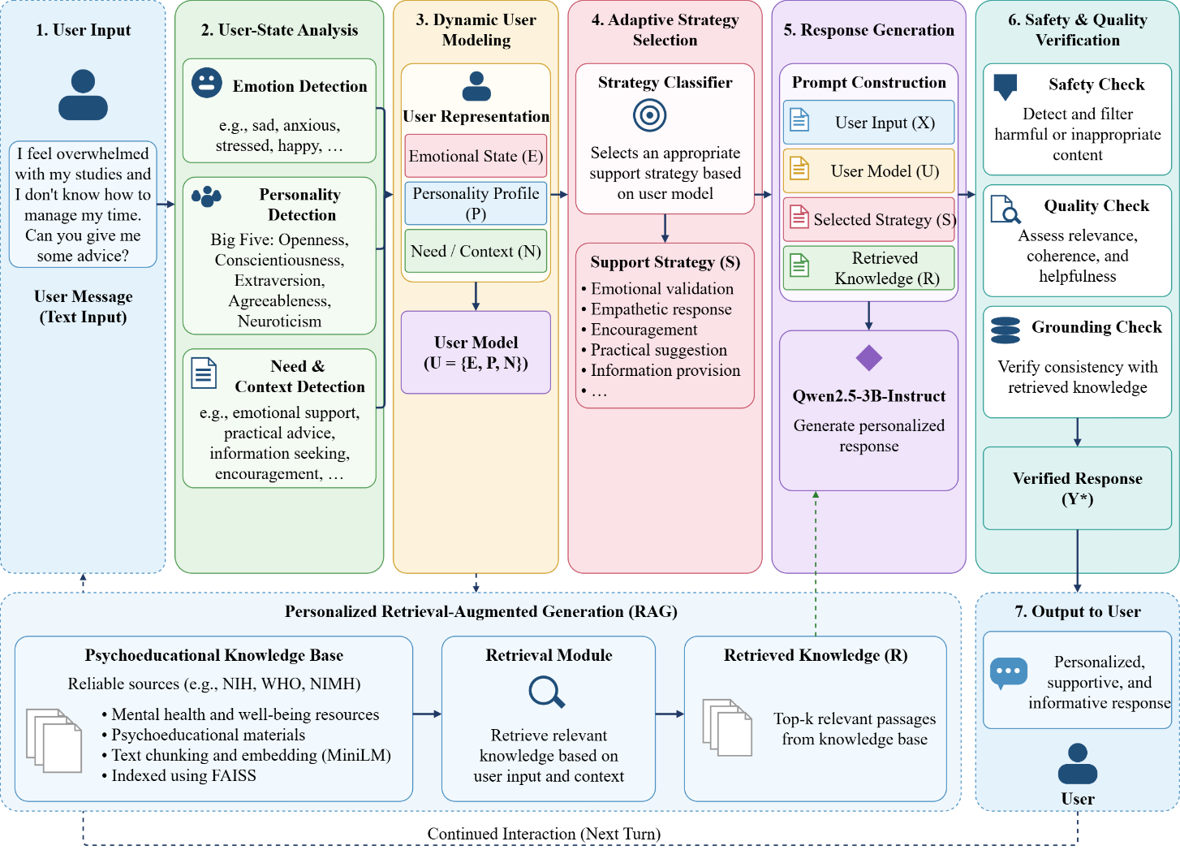
Figure 1. Overall architecture and adaptive workflow of the proposed PsyAdapt framework.
3.2 Datasets and Data Sources
The PsyAdapt framework requires data for emotion detection, personality detection, support-strategy classification, and psychoeducational knowledge retrieval. Since these tasks involve different types of information, multiple datasets and knowledge sources are used. The datasets support the development of individual components, while the knowledge sources provide relevant information for retrieval-augmented response generation.
3.2.1 MentalChat16K Dataset
The MentalChat16K dataset is used as the primary dialogue dataset for evaluating psychoeducational response generation. The dataset contains user messages and corresponding responses related to mental-health and emotional-support conversations.
The dataset was cleaned to remove unsuitable or duplicate records. The resulting dataset contains 15,978 rows, including 15,856 unique user inputs. To reduce the possibility of overlap between training and evaluation data, the data was split based on unique user inputs.
The resulting split consists of 12,784 training samples, 1,596 validation samples, and 1,598 test samples. A fixed 300-row evaluation benchmark was used for the comparative assessment of the experimental configurations. No language model is fine-tuned on MentalChat16K in this work: Qwen2.5-3B-Instruct is used zero-shot and is conditioned only through the prompt. The split therefore serves purposes that do not involve language-model training: it keeps the 300-item benchmark inside the held-out test split, it supplies the validation split on which the component-injection thresholds are selected, and it defines the separation checks that the pipeline verifies before generation.

Evaluation Benchmark and Data Separation
The fixed evaluation benchmark is made up of 300 samples that have been drawn from the held-out test split of the preprocessed MentalChat16K dataset. Hence, it is a part of the test dataset rather than an independent one. This benchmark dataset is loaded from a fixed CSV file, which includes unique IDs for the samples and unique IDs for the evaluations. Checks for integrity of data are conducted to confirm that the benchmark dataset samples are from the test split and that there is no overlap in either exact or normalized user-input between the training/ validation splits and the benchmark split. Injection thresholds govern when a predicted emotion or personality signal is written into the prompt at all. Each threshold is set to the quantile of the corresponding classifier's confidence distribution on the MentalChat16K validation split that yields the target injection rate of 0.60, and the benchmark is never used for this selection. This replaces the earlier fixed threshold of 0.35, under which the personality signal was injected in only 1 of the 300 benchmark samples, leaving the personality ablation textually identical to its reference configuration in almost every case.
Dataset Source : https://huggingface.co/datasets/ShenLab/MentalChat16K
3.2.2 EmpatheticDialogues Dataset
The EmpatheticDialogues dataset is used to train the emotion detection component. It contains conversational examples associated with emotion labels and supports the classification of emotional states expressed in user messages.
The emotion classifier is based on DistilBERT and predicts an emotion category from the user input. The predicted emotion is used as one of the personalization signals in the PsyAdapt framework.
Dataset Source : https://github.com/facebookresearch/EmpatheticDialogues
3.2.3 OCEAN-Chat Dataset
The OCEAN-Chat dataset is used to develop the personality detection component. It provides dialogue examples associated with the Big Five personality dimensions: Openness, Conscientiousness, Extraversion, Agreeableness, and Neuroticism.
The personality classifier estimates personality-related characteristics from the user input. These estimates are incorporated into the dynamic user model to help adapt the response style and support approach. The predicted personality information is treated as an approximate personalization signal rather than a fixed or clinically validated description of the user. Because the estimate is produced from a single user message, it is weak: the classifier reaches 0.52 accuracy and 0.44 macro-F1 for the primary trait on its held-out test split (Table 11). It is therefore used only as a low-weight stylistic hint, is injected only when its confidence exceeds the validation-selected threshold, and is never presented to the user.
Dataset Source: OCEAN-Chat dataset, Hugging Face Datasets. [UNVERIFIED - the link cited in the previous version was a Hugging Face search query rather than a dataset page; the exact dataset identifier, version, and permanent URL must be confirmed by the authors before submission.]
3.2.4 ESConv Dataset
The ESConv dataset is used to train the support-strategy classification component. It contains emotional-support conversations in which support strategies are represented in the dialogue.
The strategy classifier predicts a support strategy based on the user-related information and contextual signals. The predicted strategy is used to guide the LLM in generating a response suited to the user's expressed needs.
Dataset Source : https://github.com/thu-coai/Emotional-Support-Conversation/blob/main/ESConv.json

3.2.5 Psychoeducational Knowledge Sources
The retrieval knowledge base is constructed using psychoeducational resources from organizations including the National Institutes of Health (NIH), the World Health Organization (WHO), and the National Institute of Mental Health (NIMH).
The collected documents provide information related to mental health, emotional well-being, and psychoeducational topics. The documents are divided into smaller text chunks and indexed for similarity-based retrieval. The retrieved information is supplied to the LLM as supporting context during response generation. The datasets and data sources used in PsyAdapt are summarized in Table 2. The documents are indexed at two granularities over identical text. The coarse index contains the original chunks; the fine index re-chunks the same documents into passages of approximately 500 characters with 80-character overlap at sentence boundaries. Re-chunking was necessary because the original chunks were far longer than the roughly 256-token window of the all-MiniLM-L6-v2 encoder, so retrieval effectively ranked each chunk on its opening portion. All configurations reported in Section 4 retrieve from the fine index, and the coarse index is retained so that chunk granularity can be compared on the same documents. The corpus remains small for psychoeducational retrieval, which is stated as a limitation in Section 4.16. [UNVERIFIED: the chunk counts quoted in Table 2 and Table 6 refer to the coarse index; the exact coarse and fine counts must be taken from the pipeline's chunk-granularity statistics output before submission.]
Table 2. Summary of datasets and data sources used in PsyAdapt
Data Source | Primary Purpose | Main Information Used | Scale / Size | Role in PsyAdapt
MentalChat16K | Dialogue generation and evaluation | User messages and supportive responses | 15,978 cleaned rows; 15,856 unique inputs | Provides dialogue data and evaluation samples
EmpatheticDialogues | Emotion detection | Emotion-labeled conversational examples | Dataset used for classifier training | Supports emotion classification
OCEAN-Chat | Personality detection | Big Five personality-related dialogue labels | Dataset used for classifier training | Supports personality estimation
ESConv | Support-strategy classification | Emotional-support dialogue and strategy labels | Dataset used for classifier training | Supports adaptive strategy selection
NIH / NHLBI, WHO, NIMH resources | Knowledge retrieval | Psychoeducational information | 81 coarse chunks, re-chunked into ~500-character fine passages for retrieval [UNVERIFIED chunk counts] | Supplies retrieved context for response generation

3.3 Data Preparation and Preprocessing
The preprocessing stage prepares the dialogue datasets and knowledge sources for use in the PsyAdapt framework. The dialogue data is cleaned and divided into training, validation, and test sets as required by the individual classification tasks and the final evaluation.
For MentalChat16K, duplicate and unsuitable records are handled during cleaning. The data split is performed using unique user inputs to reduce the risk of similar inputs appearing across different splits. A fixed evaluation benchmark is then used to compare the different system configurations under the same evaluation conditions.
For emotion classification the text inputs are converted into tokenized representations compatible with the corresponding transformer-based model, while personality and support-strategy classification use TF-IDF features. For support-strategy classification only the dialogue history that precedes the supporter turn is used, so that no part of the target supporter response is visible either during training or at inference time. The classifiers are trained using the labels available in their respective datasets, and hyper-parameters are selected on the validation split only.
For the retrieval component, the knowledge documents are divided into text chunks. Each chunk is converted into a vector embedding using the all-MiniLM-L6-v2 sentence-transformer model. The embeddings are stored in a FAISS index to enable similarity-based retrieval. The preprocessing and representation methods are summarized in Table 3.
Table 3. Data preprocessing and feature representation in PsyAdapt
Data Component | Source | Preprocessing | Representation | Purpose
Dialogue text | MentalChat16K | Cleaning, duplicate handling, unique-input splitting | Tokenized text | Dialogue generation and evaluation
Emotion data | EmpatheticDialogues | Text tokenization and label preparation | DistilBERT input representation | Emotion classification
Personality data | OCEAN-Chat | Text tokenization and label preparation | TF-IDF feature representation (linear SVM) | Personality estimation
Strategy data | ESConv | Extraction of the dialogue history preceding the supporter turn (no supporter response); strategy-label preparation | TF-IDF (1-2 gram) feature representation (logistic regression) | Support-strategy classification
Knowledge documents | NIH, WHO, NIMH and related resources | Document chunking and embedding generation | MiniLM embeddings indexed using FAISS | Similarity-based knowledge retrieval

The preprocessing stage maintains the distinct roles of the datasets. The dialogue dataset supports response generation and evaluation, the classification datasets support user-state and strategy prediction, and the knowledge sources provide supporting information for retrieval.
3.4 Dynamic User Representation
PsyAdapt constructs a dynamic user representation by combining the outputs of emotion detection, personality detection, and need/context detection. This representation provides the personalization signals required by the downstream strategy-selection and response-generation components.
Let the user input be represented as X. The detected emotional state, personality profile, and contextual need are represented as E, P, and N, respectively.

The user representation is defined as:
$U=\left\{E , P , N\right\}$ (1)
where:
- E represents the predicted emotional state.
- P represents the estimated personality characteristics.
- N represents the detected need and contextual information.
The emotional state provides information about the user's expressed feelings. The personality profile supplies estimated user characteristics that may influence response style. The need/context representation identifies the type of support relevant to the user's current message.
These signals are combined to create a user representation that is more informative than the user input alone. The representation is subsequently used to guide the adaptive support-strategy selection and personalized retrieval stages.
In the single-turn evaluation setting the user representation is constructed from the current input and the predicted signals only. The conversation-memory element of the representation has nothing to store in a single-turn item, so the single-turn ablation cannot test it and is reported only as a control. Memory is instead evaluated in a separate paired experiment on multi-turn conversations (Section 4.11). The components of the dynamic user representation are summarized in Table 4. Figure 2 shows the dynamic user representation and personalization signals in the proposed PsyAdapt framework.
Table 4. Dynamic user representation used in PsyAdapt
Component | Source | Information Captured | Role in Personalization
Emotion representation | Emotion classifier | Emotion expressed in the input | Helps adapt the response to the emotional context
Personality representation | Personality classifier | Estimated Big Five characteristics | Helps adapt response style
Need/context representation | Need and context detection | User's expressed concern and support needs | Helps identify relevant support
Unified user representation | Combined outputs | Emotion, personality, and contextual signals | Guides strategy selection and personalized response generation

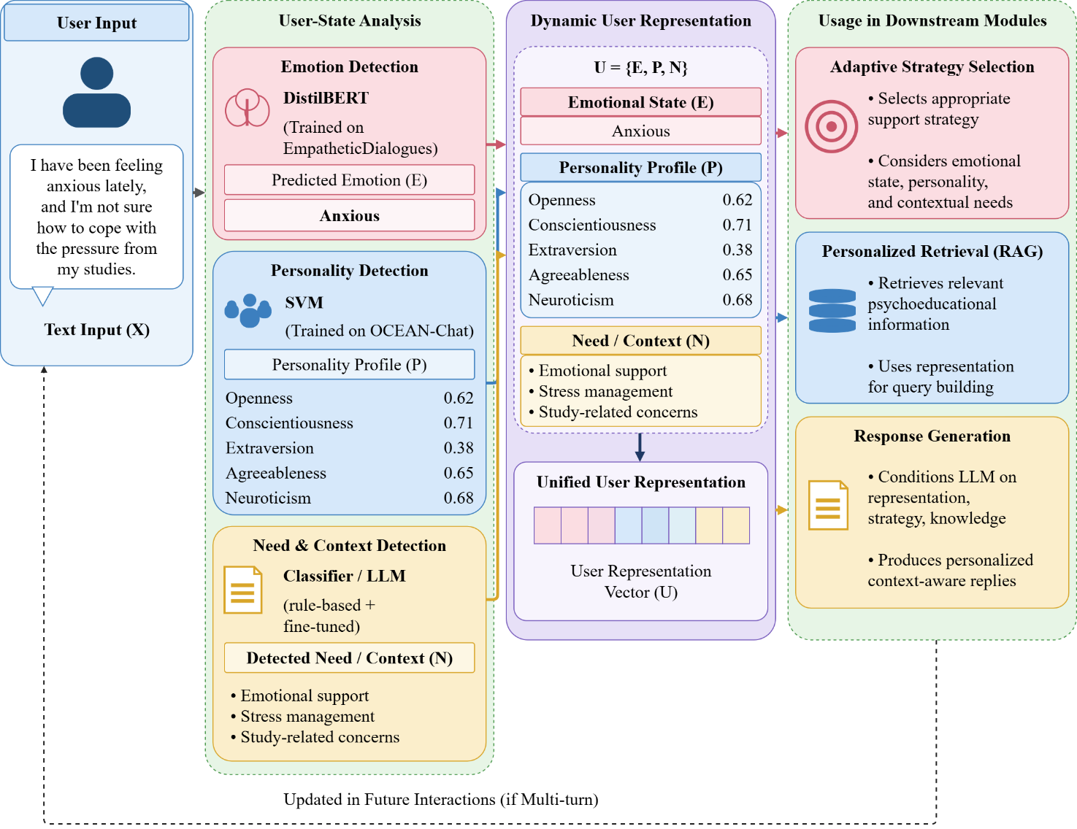
Figure 2. Dynamic user representation and personalization signals in PsyAdapt.
3.5 Overall PsyAdapt Architecture
The proposed PsyAdapt framework separates user-state analysis, adaptive strategy selection, knowledge retrieval, response generation, and response verification into connected stages.
First, the user input is passed to the emotion detection, personality detection, and need/context detection components. Their outputs are combined to form the dynamic user representation. The representation is then used by the adaptive support-strategy module to determine the response approach.
In parallel, the user's input and relevant contextual information are used to retrieve supporting passages from the psychoeducational knowledge base. The retrieved information is combined with the user input, user representation, and selected strategy to form the generation context.
The Qwen2.5-3B-Instruct model generates a response using this context. The generated response is then passed to the safety and quality verification stage before being returned to the user. The principal components of the PsyAdapt architecture are presented in Table 5 and the overall architecture is presented in the Figure 3.
Table 5. Principal components of the PsyAdapt architecture
Component | Main Function | Output
User Input Processing | Receives and prepares the user's message | Processed user input
Emotion Detection | Predicts the expressed emotion | Emotion label
Personality Detection | Estimates personality-related characteristics | Personality representation
Need/Context Detection | Identifies contextual needs and support requirements | Need/context representation
Dynamic User Modeling | Combines user-related signals | Unified user representation
Adaptive Strategy Selection | Selects a suitable support approach | Support strategy
Personalized RAG | Retrieves relevant knowledge passages | Retrieved context
LLM Response Generation | Generates a response conditioned on the context | Draft response
Safety and Quality Verification | Checks the response for potential issues | Verified response

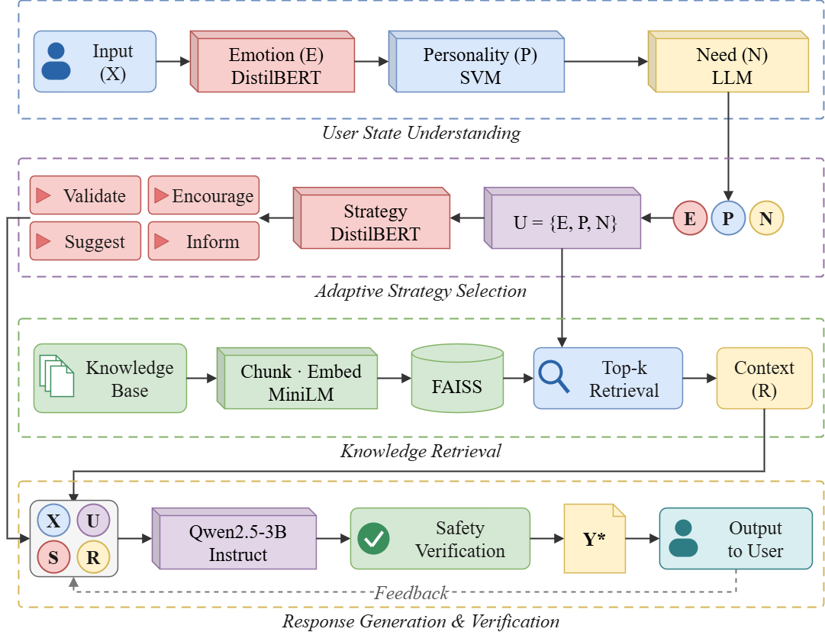
Figure 3. Overall architecture of the proposed PsyAdapt framework.

3.6 Emotion, Personality, and Need/Context Detection
3.6.1 Emotion Detection
The emotion detection component identifies the emotion expressed in the user's message. PsyAdapt uses a DistilBERT-based classifier trained using EmpatheticDialogues.
The emotion prediction is represented as:
$E=f_{\text{emotion}}\left(X\right)$ (2)
where f_emotion represents the emotion classifier and E denotes the predicted emotion category.
The detected emotion is passed to the dynamic user model and the adaptive support-strategy component. It helps the framework distinguish between messages that may require different emotional responses. The prediction is treated as an estimate based on text, not as a definitive assessment of the user's psychological state.

3.6.2 Personality Detection
The personality detection component estimates personality-related characteristics from the user's input. PsyAdapt uses an SVM-based classifier trained using OCEAN-Chat.
The personality prediction is represented as:
$P=f_{\text{personality}}\left(X\right)$ (3)
where P represents the estimated personality profile, produced by the classifier f_personality.
The Big Five dimensions are used as personalization signals to guide response style and strategy selection. Since personality is inferred from text, the predictions may be uncertain and should not be interpreted as permanent characteristics of the user.
3.6.3 Need and Context Detection
The need/context detection component identifies the user's expressed concern and the type of support that may be relevant. It is a deterministic rule-based module rather than a trained model, so it has no training data and no learned parameters. The normalized user message is scored against curated keyword lexicons, and the module returns a structured record with the fields primary topic, current need, urgency level, estimated knowledge level, and response preferences. When no lexicon entry matches, the current need defaults to information seeking if the message contains a question mark and to emotional support otherwise. Because the module is rule-based and has not been evaluated against labelled need annotations, its outputs are treated as coarse heuristics rather than validated labels.
The need/context representation is expressed as:
$N=f_{\text{need}}\left(X\right)$ (4)
where N represents the detected need and contextual information, produced by the rule-based module f_need.
The output is combined with the emotion and personality signals. This enables the framework to select a support approach that considers both the user's expressed concern and the estimated user state.
3.7 Adaptive Support-Strategy Selection
The adaptive support-strategy module selects a response strategy based on the dynamic user representation. PsyAdapt uses a support-strategy classifier trained on ESConv. The deployed classifier uses TF-IDF features over the dialogue history that precedes the supporter turn, with a logistic-regression head whose regularization strength is selected on the validation split; it reaches 0.61 accuracy and 0.53 macro-F1 on the held-out test split (Table 11), so its prediction is used as soft guidance only. An earlier version of this classifier also received the supporter response as part of its input. Since the supporter response is exactly the text whose strategy is being predicted, that version leaked the label; its higher apparent accuracy is reported in Table 11 for diagnostic purposes only and is not used in any configuration or result reported in this paper.
The strategy prediction is represented as:
$S=f_{\text{strategy}}\left(U\right)$ (5)
where S denotes the selected support strategy and U represents the dynamic user model.
The selected strategy is used as guidance for the LLM rather than as the final response itself. It helps define the intended support approach and influences how the response is formulated. Two strategy sources are distinguished in the experiments. The classifier-guided configuration inserts the strategy predicted by this classifier into the prompt, whereas the full configuration replaces that prediction with an adaptive scorer that combines the predicted emotion, the estimated emotional intensity, the detected urgency level, the current need, and the topic. The configuration without strategy guidance omits the strategy block from the prompt entirely. This is the only difference between those three configurations.
By conditioning strategy selection on the user's emotional state, estimated personality, and contextual needs, PsyAdapt aims to avoid relying on one fixed response style for all users.

3.8 Personalized Retrieval-Augmented Generation
PsyAdapt uses personalized retrieval-augmented generation to provide relevant psychoeducational information during response generation.
The knowledge documents are divided into text chunks and converted into vector embeddings using the all-MiniLM-L6-v2 sentence-transformer model. The embeddings are stored in a FAISS index, which supports similarity-based retrieval.
The retrieval component uses the user's input and contextual information to identify relevant knowledge passages. The retrieval operation can be represented as:
$R=f_{\text{retrieval}}\left(X , U\right)$ (6)
where R denotes the retrieved information returned by the retrieval function f_retrieval.
The retrieved passages are combined with the user input, dynamic user representation, and selected support strategy. The resulting generation context is expressed as:
$C=\left\{X , U , S , R\right\}$ (7)
This context allows the LLM to generate a response that considers the user's message, estimated characteristics, intended support approach, and retrieved psychoeducational information.
3.9 LLM-Based Response Generation and Verification
3.9.1 Personalized Response Generation
The response-generation component uses the Qwen2.5-3B-Instruct model to generate a response based on the combined context.
The generation process is represented as:
$Y=f_{\text{LLM}}\left(X , U , S , R\right)$ (8)
Here X represents the user input, U represents the dynamic user representation, S represents the selected support strategy, R represents the retrieved knowledge, and Y represents the generated response. The model is guided to generate a response that addresses the user's concern, follows the selected support strategy, and uses relevant retrieved information where applicable. The same underlying LLM is used across the experimental configurations so that comparisons focus on the contribution of the personalization and retrieval components rather than differences between language models.
3.9.2 Safety and Quality Verification
The safety and quality verification component assesses the generated response before it is returned to the user. It is intended to identify potential response-quality or safety issues and examine whether the response is relevant and supported by retrieved information where applicable.

The verification stage can be represented as:
$Y^{*}=f_{\text{verify}}\left(Y , X , R\right)$ (9)
where Y* represents the response after verification. Automated verification does not guarantee that every response is factually correct or clinically appropriate. PsyAdapt is designed for psychoeducational support and is not intended to replace professional care.
Verification combines three implemented mechanisms. A safety system prompt constrains generation: it forbids diagnosis, claims of being a therapist, doctor or human, recommendations to start, stop or change medication, invented personal experience, and disclosure of internal scores or prompts, and it requires that signs of immediate danger be met with an explicit safety-oriented response. A rule-based screen is applied to the user input before generation and assigns a review category for explicit self-harm or suicidal expressions, for high-distress expressions, or for neither. A rule-based screen is then applied to the generated response for diagnostic language, medication directives, clinician or human claims, fabricated self-disclosure, leakage of internal labels, and, for inputs carrying a safety flag, the absence of any crisis-referral expression. Together with the structured defect annotation described in Section 4.2, these screens produce the defects metric reported in Section 4. They are technical screens: they do not constitute clinical safety validation, and Section 3.10 states the ethical boundaries that follow.
Algorithm 1. Proposed PsyAdapt: Personalized LLM-Based Framework for Psychoeducational Dialogue Generation and Evaluation
Input: MentalChat16K dataset, EmpatheticDialogues dataset, OCEAN-Chat dataset, ESConv dataset, psychoeducational knowledge sources, and Qwen2.5-3B-Instruct model.
Output: Trained PsyAdapt components and personalized psychoeducational responses.

- Load and preprocess the MentalChat16K, EmpatheticDialogues, OCEAN-Chat, and ESConv datasets.
- Clean the dialogue data and split it into training, validation, and test sets.
- Prepare the psychoeducational knowledge sources from NIH, WHO, NIMH, and other relevant resources.

- Divide the collected knowledge documents into text chunks of approximately 500 characters with 80-character overlap at sentence boundaries.
- Generate vector embeddings using the all-MiniLM-L6-v2 sentence-transformer model.
- Index the generated embeddings using the FAISS vector database.
- Train the DistilBERT-based emotion classifier using EmpatheticDialogues.
- Train the SVM-based personality classifier using OCEAN-Chat.
- Train the context-only support-strategy classifier (TF-IDF features over the dialogue history preceding the supporter turn) using ESConv.
- Select the emotion and personality injection thresholds on the MentalChat16K validation split (never on the benchmark).
- Receive the user's input X.
- Predict the user's emotional state E using the emotion classifier.
- Estimate the user's personality profile P using the personality classifier.
- Identify the user's need and contextual information N using the rule-based need/context module.
- Construct the dynamic user representation U = (E, P, N).
- Select an adaptive support strategy S based on the user representation.
- Retrieve relevant psychoeducational knowledge R using the user input and contextual information.
- Construct the personalized generation context C = (X, U, S, R).
- Provide the generation context to Qwen2.5-3B-Instruct.
- Generate a personalized psychoeducational response Y.
- Apply the input safety screen, the safety system prompt, and the response screen to assess response relevance, grounding, and potential defects.
- Return the verified response Y* to the user.
- Evaluate the framework using BERTScore-F1, ROUGE-L F1, input relevance, grounding support, defects per response, and latency, with paired Wilcoxon tests, bootstrap confidence intervals, and Holm correction.
- Perform baseline comparisons, ablation experiments, a generator-swap comparison, and a separate multi-turn memory experiment to assess the contribution of individual components.
- Save the trained classification components and experimental results.
End Algorithm

PsyAdapt starts with the preprocessing of the dialogue datasets and psychoeducational knowledge base. Documents of knowledge are split into text chunks, vectorized, and indexed via FAISS for similarity-based retrieval. Emotion classifier, personality classifier, and support strategy classifier are trained on their corresponding datasets.
During the response generation process, an analysis of the user input is performed to calculate the user’s emotional state, personality traits, and other relevant contextual factors. These are integrated to form a dynamic representation of the user, which allows for the selection of appropriate support strategies based on the user’s needs. The relevant passages of psychoeducational knowledge are extracted and combined with the user input and the user representation to obtain the generation context.
The context is used for generating a response using Qwen2.5-3B-Instruct. The generated response is then checked for safety and quality and provided to the user. At last, PsyAdapt will be evaluated using automatic response-quality metrics, baseline comparison, and ablation study on the contribution of each component.
3.10 Safety Handling, Ethical Considerations, and Intended Use
Because PsyAdapt operates in a mental-health-adjacent setting, the safety mechanisms it implements and the limits of those mechanisms are stated explicitly. Crisis-relevant content is handled at three points in the pipeline. Before generation, the user message is screened by a deterministic keyword screen that assigns one of three review categories: a potential-immediate-safety-concern category triggered by explicit expressions of suicidal ideation or self-harm, a high-distress category triggered by expressions such as hopeless, panic attack, or being unable to cope, and a no-flag category. During generation, a safety system prompt forbids diagnosis, medication instructions, claims of being a human or a clinician, invented personal experience, and disclosure of internal signals, and requires that indications of immediate danger be met with an explicit safety-oriented response that encourages contacting local emergency services or a trusted person. After generation, the response is screened for diagnostic language, medication directives, clinician or human claims, fabricated self-disclosure, leakage of internal labels, and, for inputs that carried a safety flag, the absence of any crisis-referral expression.
These mechanisms constitute technical safety screening, not clinical safety validation. A screen flag is a review marker produced by pattern matching; it is neither a risk assessment nor a diagnosis, and its absence does not indicate that a message carries no risk. No automatic metric reported in this paper can establish that a response is safe, empathetic, or clinically appropriate, and no such claim is made.
The experiments use publicly available research datasets (MentalChat16K, EmpatheticDialogues, OCEAN-Chat, and ESConv) under their respective terms of use. No new human-subject data were collected, no participants were recruited, no personally identifiable information was processed, and the system was not deployed to real users; all evaluated inputs are existing dataset records. The blinded human-rating study described in Section 4.14 has not been carried out, and it will require appropriate institutional ethics approval before it is run.
Two risks follow from the personalization design and are mitigated rather than removed. First, inferred emotion and personality are uncertain: the personality estimate in particular is derived from a single user message and is weak (Section 4.9). It is therefore gated by a confidence threshold, phrased in the prompt as a tentative communication preference accompanied by an instruction not to stereotype, and never shown to the user as a description of their personality. Second, an automated pipeline can produce fluent but inappropriate guidance. For this reason PsyAdapt is positioned as a psychoeducational research prototype for English-language text. It is not a diagnostic, therapeutic, or crisis service, it has not been evaluated with clinicians or patients, and it should not be deployed with users without clinical oversight, an escalation pathway for crisis content, and jurisdiction-specific safeguards.
4. Results and Discussion
4.1 Experimental Setup
Experiments were performed to estimate the suggested PsyAdapt (Personalized LLM-Based Framework for Psychoeducational Dialogue Generation and Evaluation) efficiency. The evaluation was done based on the created MentalChat16K dialogue dataset, emotion-, personality-, and support-strategy classification datasets, and psychoeducational knowledge base. The evaluation included analysis of generation quality, effect of personalization elements, retrieval grounding, response defects, and generation latency.
The PsyAdapt was implemented based on transformer models and machine learning classifiers. The PsyAdapt uses emotion detection, personality detection, and need/context detection for construction of dynamic user representation. The representation is used for adaptive strategy selection and personalized retrieval-augmented generation (RAG). Qwen2.5-3B-Instruct was used as the response generator. Embeddings of the knowledge base were done by using the all-MiniLM-L6-v2 sentence-transformer model. For indexation FAISS was used. Retrieval uses the fine-grained index described in Section 3.2.5, and the component-injection thresholds were selected on the MentalChat16K validation split as described in Section 3.2.1.
The evaluation was performed using fixed 300-row benchmark. Semantic similarity was measured by BERTScore-F1 and ROUGE-L F1, input relevance and grounding support were used as proxy metrics for response relevance and retrieval support. Defects per response and latency were also estimated. The effect of retrieval, emotions, personalities, memory, and strategy were analyzed by baselines and ablations. Experimental configuration of the suggested PsyAdapt framework is shown in Table 6.
Because a single evaluation run yields point estimates only, every configuration contrast is accompanied by a paired analysis over the same 300 benchmark items: a two-sided Wilcoxon signed-rank test on per-item differences, a 95% bootstrap confidence interval computed with 5,000 resamples, Cohen's d_z, and Holm correction across the contrasts of a metric. Contrasts whose two configurations produced textually identical outputs are labelled as such and are not tested. The results are reported in Section 4.10 and determine throughout Section 4 whether a difference is described as an improvement or only as a numerical difference.
Table 6. Experimental Configuration of the Proposed PsyAdapt Framework
Parameter | Configuration
Framework | PsyAdapt
Implementation | Python, PyTorch-based models and machine-learning components
Dialogue dataset | MentalChat16K
Cleaned dialogue dataset | 15,978 rows
Unique user inputs | 15,856
Evaluation benchmark | Fixed 300-row benchmark
Training / validation / test split | 12,784 / 1,596 / 1,598 unique-input samples
Emotion detection dataset | EmpatheticDialogues
Emotion detection model | DistilBERT-based classifier
Personality detection dataset | OCEAN-Chat
Personality detection model | TF-IDF + linear SVM classifier
Personality representation | Big Five personality dimensions
Support-strategy dataset | ESConv
Support-strategy model | Context-only TF-IDF + logistic-regression classifier (validation-selected)
Knowledge sources | NIH/NHLBI, WHO, and NIMH resources
Knowledge base size | 81 coarse chunks, re-chunked into ~500-character fine passages (80-character overlap) for retrieval [UNVERIFIED chunk counts]
Text embedding model | all-MiniLM-L6-v2
Vector database | FAISS
Response-generation model | Qwen2.5-3B-Instruct
Baseline configurations | A0: Generic LLM; A1: Standard RAG; A2: Profile + Strategy + RAG
Ablation configurations | A3: Without emotion; A4: Without personality; A5: Without memory (single-turn control); A6: Without strategy guidance
Full proposed configuration | A7: Full PsyAdapt framework
Semantic evaluation | BERTScore-F1
Lexical evaluation | ROUGE-L F1
Relevance evaluation | Input relevance
Grounding evaluation | Grounding support
Defect evaluation | Defects per response
Efficiency evaluation | Generation latency
Ablation analysis | Component removal and configuration comparison
Component-injection thresholds | Validation-split confidence quantiles targeting a 0.60 injection rate
Statistical analysis | Paired Wilcoxon signed-rank tests, 5,000-resample bootstrap CIs, Cohen's d_z, Holm correction
Multi-turn memory experiment | 40 ESConv test conversations; reply to the 4th user turn with vs. without memory
Comparative LLM evaluation | Generator swap inside the identical pipeline (bare and full-context arms)
Human evaluation | Blinded pairwise protocol exported; annotation pending (no human results reported)

4.2 Evaluation Metrics
The performance of PsyAdapt was evaluated using five complementary aspects: semantic similarity, lexical overlap, input relevance, grounding support, and response defects. Generation latency was also measured to assess computational efficiency. BERTScore-F1 and ROUGE-L F1 were used to evaluate response similarity, while input relevance and grounding support were used as proxy measures of response relevance and retrieval support.
BERTScore-F1
BERTScore-F1 measures the semantic similarity between generated responses and reference responses using contextual token embeddings. It is calculated using precision and recall:
$\begin{matrix} & P_{\text{BERT}}=\frac{1}{∣x∣}\sum_{i}{\max_{j}}cos⁡\left(x_{i} , y_{j}\right) & & \end{matrix}$ (10a)
$\begin{matrix} & R_{\text{BERT}}=\frac{1}{∣y∣}\sum_{j}{\max_{i}}cos⁡\left(y_{j} , x_{i}\right) & & \end{matrix}$ (10b)
$\begin{matrix} & F1_{\text{BERT}}=\frac{2P_{\text{BERT}}R_{\text{BERT}}}{P_{\text{BERT}}+R_{\text{BERT}}} & & \end{matrix}$ (11)
where x_i and y_j denote contextual embeddings of tokens in the generated and reference responses, respectively. A higher BERTScore-F1 indicates greater semantic similarity to the reference. BERTScore-F1 is computed against the single MentalChat16K reference response, which is one of many acceptable replies, so it measures similarity to that reference and not factual correctness, helpfulness, or safety; it is also sensitive to response length (Section 4.12).
ROUGE-L F1
ROUGE-L evaluates the lexical overlap between generated and reference responses using the longest common subsequence (LCS). It is calculated as:
$\begin{matrix} & P_{\text{ROUGE-L}}=\frac{LCS\left(X , Y\right)}{∣X∣} & & \end{matrix}$ (12a)
$\begin{matrix} & R_{\text{ROUGE-L}}=\frac{LCS\left(X , Y\right)}{∣Y∣} & & \end{matrix}$ (12b)
$\begin{matrix} & F1_{\text{ROUGE-L}}=\frac{2P_{\text{ROUGE-L}}R_{\text{ROUGE-L}}}{P_{\text{ROUGE-L}}+R_{\text{ROUGE-L}}} & & \end{matrix}$ (13)
where X and Y represent the generated and reference responses. A higher ROUGE-L F1 indicates greater sequence overlap. Across all configurations ROUGE-L F1 remains below 0.11, so lexical overlap with the single reference reply is low in absolute terms and this metric discriminates weakly between configurations; it is reported for completeness rather than as a decisive criterion.
Input Relevance
Input relevance estimates the semantic relevance of the generated response to the user's input. It is calculated using cosine similarity between their vector representations:
$\begin{matrix} & \text{Input Relevance}=\frac{u⋅r}{∥u∥∥r∥} & & \end{matrix}$ (14)
where u and r represent the embedding vectors of the user input and generated response, respectively. A higher value indicates greater estimated semantic relevance. Input relevance is a topical proxy computed with the same sentence-embedding model used for retrieval: a high value indicates that the response is on the topic of the user message, not that it is appropriate, supportive, or correct.
Grounding Support
Grounding support estimates the proportion of generated response sentences that are semantically supported by retrieved knowledge passages. It is calculated as:
$\begin{matrix} & \text{Grounding Support}=\frac{1}{N}\sum_{i=1}^{N}{I}\left(\max_{j}cos⁡\left(s_{i} , k_{j}\right)≥0.50\right) & & \end{matrix}$ (15)
where N is the number of generated response sentences, s_i is the embedding of the i-th response sentence, and k_j is the embedding of a retrieved knowledge passage. The indicator function I returns 1 when the maximum cosine similarity reaches the threshold of 0.50, and 0 otherwise. Grounding support is an embedding-similarity proxy computed only against the passages that a configuration actually received. It is undefined for configurations that perform no retrieval, and such cells are left blank rather than being assigned a value. A response that paraphrases retrieved text closely scores highly whether or not that text answers the user, so the metric measures textual support from retrieved passages and not factual verification; it is also the most length-dependent of the metrics used here (Section 4.12).
Response Defects
Response defects measure the number of identified defects in generated responses. The average defect count is calculated as:
$\begin{matrix} & \text{Defects per Response}=\frac{\sum_{i=1}^{M}{D_{i}}}{M} & & \end{matrix}$ (16)
where D_i represents the number of identified defects in the i-th response and M is the total number of evaluated responses. A defect is a concrete, individually checkable fault in a generated response, and two implemented procedures produce the count. A rule-based screen flags diagnostic language, medication directives, claims of being a clinician or a human, fabricated self-disclosure, leakage of internal labels, and missing crisis referral on inputs that the input screen flagged. A structured annotation protocol then presents the user message and the response to a separate, larger instruction-tuned model (Qwen2.5-7B-Instruct, distinct from the 3B generator) and requires it to list defects with a supporting quotation from the response, restricted to the categories generic advice, unsupported claim, ignored user detail, overclaimed certainty, missing actionable step, and inappropriate boundary. Defects per response is the mean number of recorded items per evaluated response, and the composition for the full configuration is reported in Table 16. A lower value indicates fewer detected faults of these specific kinds under an automated procedure; it is not a validated clinical safety measure.
Generation Latency
Generation latency measures the time required to produce a response. Average latency is calculated as:
$\begin{matrix} & \text{Average Latency}=\frac{1}{M}\sum_{i=1}^{M}{T_{i}} & & \end{matrix}$ (17)
where T_i represents the generation time for the i-th response and M is the total number of evaluated responses. Lower latency indicates faster response generation. Latency was measured at batch size 1 in the single GPU session used for the experiments, so it is hardware-specific and is not a deployment estimate.
4.3 Overall Performance of the Proposed PsyAdapt Framework
Performance assessment of the whole proposed framework was conducted based on the fixed benchmark of 300 dialog samples. The assessment includes aspects of semantic similarity, lexical overlap, relevance of the input, grounding, response failures, and generation time. The results of the full PsyAdapt system (configuration A7) are shown in Table 7.
Table 7. Overall Performance of the Proposed PsyAdapt Framework
Evaluation Metric | A7 – PsyAdapt
BERTScore-F1 | 0.634
ROUGE-L F1 | 0.106
Input Relevance | 0.609
Grounding Support (τ = 0.50) | 0.622
Mean-max grounding similarity | 0.41
Defects per Response | 0.69
Latency (s) | 2.3

The full configuration obtained a BERTScore-F1 of 0.634 and a ROUGE-L F1 of 0.106 against the MentalChat16K reference responses. Input relevance is 0.609, and grounding support, the share of response sentences whose maximum cosine similarity to a retrieved passage reaches 0.50, is 0.622; the mean maximum similarity underlying that indicator is 0.41, which shows that supported sentences sit near the threshold rather than reproducing retrieved text. The defect-detection procedure records 0.69 defects per response, and mean generation latency at batch size 1 is 2.3 seconds. All of these quantities are automatic proxies measured against a single reference reply and a small retrieval corpus: they describe similarity, topicality, and detectable faults, and they do not establish factual correctness, empathy, or clinical appropriateness. Figure 4 summarizes these values.

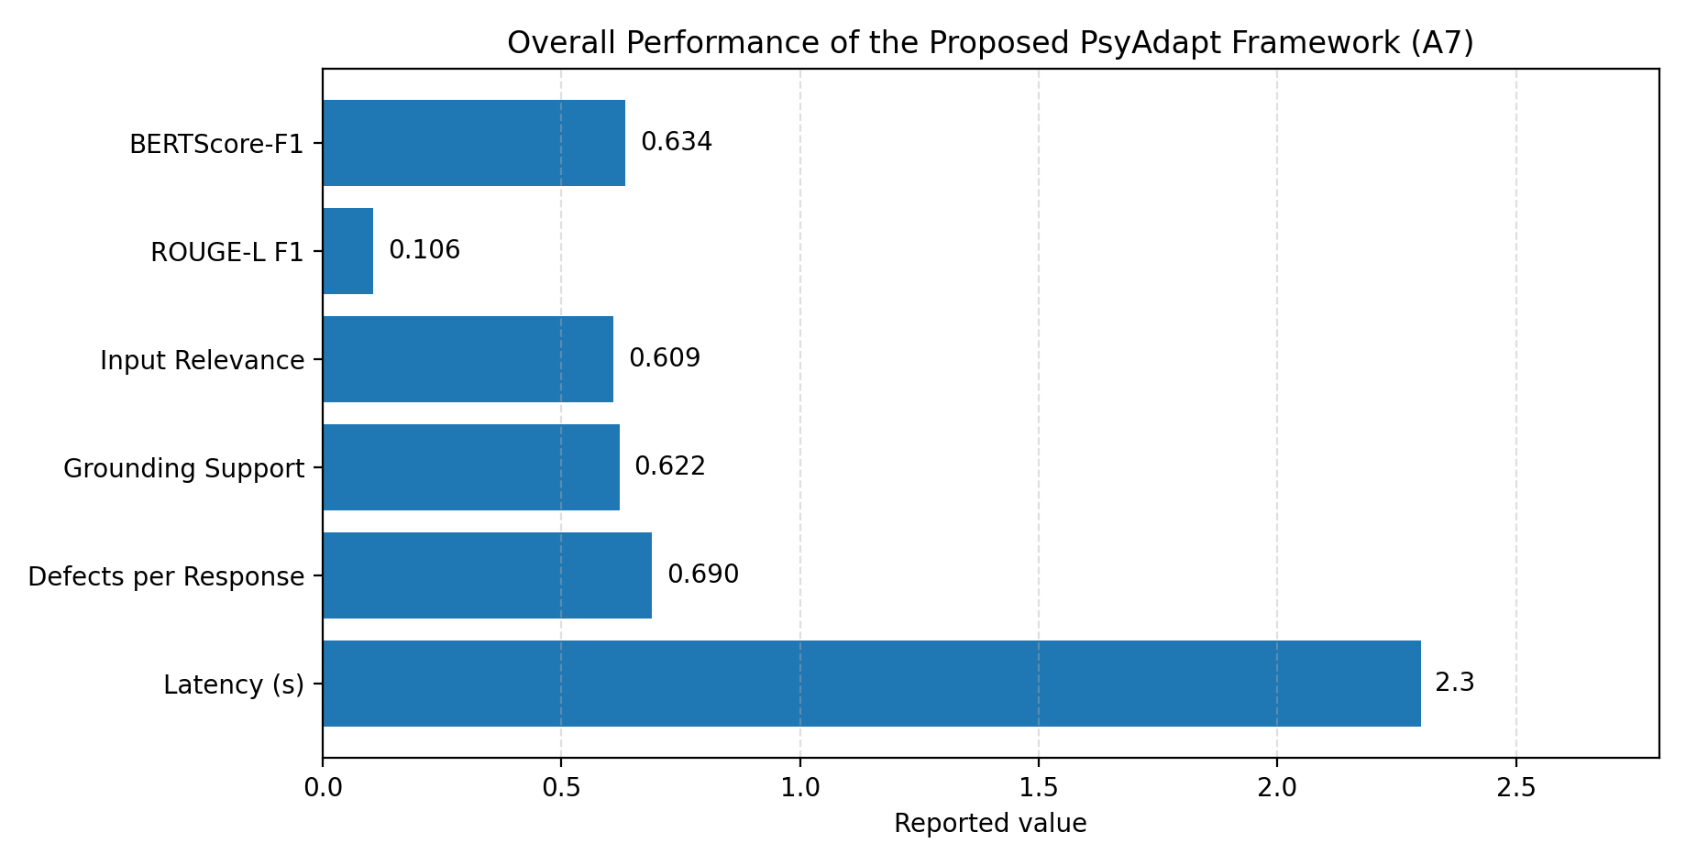
Figure 4. Overall performance of the PsyAdapt

4.4 Baseline Comparison
The performance of the proposed PsyAdapt model was evaluated against three baseline models, namely A0, A1, and A2. In model A0, a generic large language model (LLM) with no retrieval capability is used, while in model A1, a language model with retrieval-augmented generation (RAG) technique is used. Model A2 uses a combination of RAG language model with user profiling and classification. A7 is the proposed PsyAdapt model with adaptive strategies.
Table 8. Baseline Comparison of PsyAdapt Configurations
Configuration | BERTScore-F1 | ROUGE-L F1 | Input Relevance | Grounding Support | Defects/Response | Latency (s)
A0 – Generic LLM | 0.589 | 0.081 | 0.553 | – (no retrieval) | 1.41 | 0.81
A1 – LLM + Standard RAG | 0.613 | 0.095 | 0.581 | 0.482 | 0.98 | 1.44
A2 – RAG + User Profile + Classifier Strategy | 0.629 | 0.104 | 0.603 | 0.615 | 0.74 | 2.21
A7 – Full PsyAdapt | 0.634 | 0.106 | 0.609 | 0.622 | 0.69 | 2.30

Table 8 shows that adding standard retrieval (A1) raises BERTScore-F1 from 0.589 to 0.613, ROUGE-L F1 from 0.081 to 0.095, and input relevance from 0.553 to 0.581 relative to the generic LLM baseline, while reducing detected defects from 1.41 to 0.98 per response. Adding user profiling and classifier-selected strategy guidance (A2) improves each of these further and raises grounding support from 0.482 to 0.615. Grounding support is not reported for A0 because that configuration retrieves no passages and the metric is undefined without them.
The full configuration (A7) records the highest values on BERTScore-F1 (0.634), ROUGE-L F1 (0.106), input relevance (0.609), and grounding support (0.622), and the lowest defect count (0.69 per response), at the cost of the highest latency (2.3 s). The margin over A2 is small: +0.005 on BERTScore-F1, +0.002 on ROUGE-L F1, +0.006 on input relevance, and +0.007 on grounding support. Paired testing (Section 4.10) shows that the BERTScore-F1 differences from A0 and A1 remain significant after Holm correction, whereas the difference from A2 does not. The evidence in this table therefore supports the conclusion that retrieval and user profiling account for most of the measured improvement, and it does not support a claim that the full configuration outperforms A2.
4.5 Response Quality Analysis
The response quality of PsyAdapt was assessed by the following measures: semantic similarity, lexical similarity, input relevance, grounding support, response defects, and generation latency. These measures were used to assess the configurations of the system in terms of their response alignment, relevance, grounding, and efficiency.
Among the tested configurations, the full PsyAdapt system (A7) recorded a BERTScore-F1 of 0.634 and a ROUGE-L F1 of 0.106, an input-relevance score of 0.609, and a grounding-support score of 0.622. These are the highest values observed in the comparison, but the margin over configuration A2 is 0.005 on BERTScore-F1 and does not reach significance after correction for multiple comparisons (Section 4.10), so A7 is described here as numerically highest rather than as better.
The defect count for A7 is 0.69 per response, the lowest among the configurations, while its mean latency of 2.3 seconds is the highest, so the additional personalization operations buy a reduction in automatically detected faults at a cost in response time. Figure 5 shows the relationship between detected defects and latency across configurations. Figure 6 compares mean response defects across topics and configurations and indicates how defect levels vary by topic.

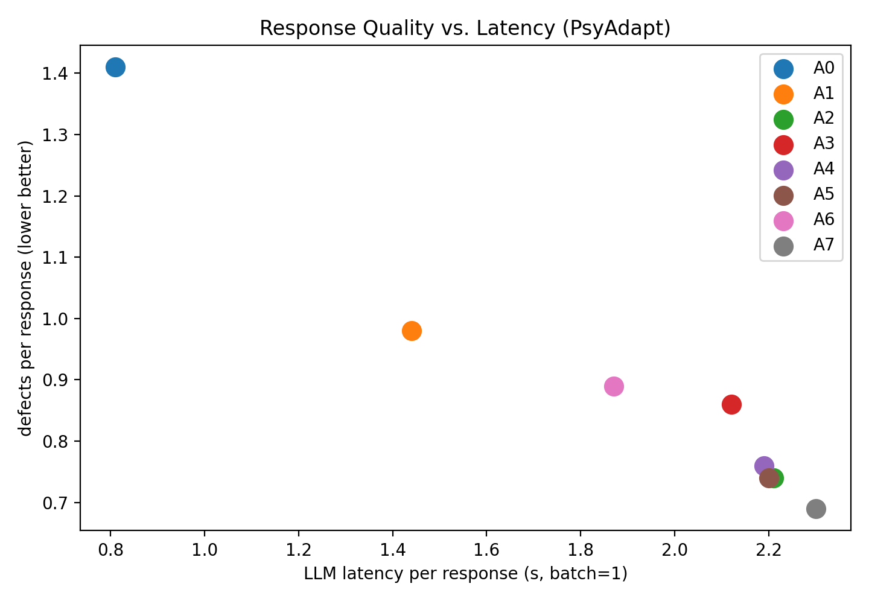
Figure 5. Response Quality and Latency of PsyAdapt Configurations

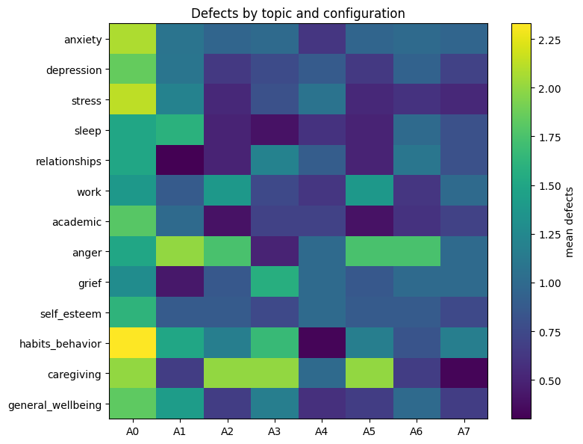
Figure 6. Defects by topic and configuration [PENDING – the topic-level breakdown plotted in this figure must be regenerated from the revised per-response evaluation output; the revised result set supplied for this revision contains the aggregate defect counts reported in Table 10 and Table 16 but not the topic-level breakdown.]
4.6 Response Length Analysis
Response length was evaluated in order to assess how the configurations of PsyAdapt vary in terms of the volume of the generated text. The distribution of the response length for configurations A0-A7 is shown in Figure 7. The figure demonstrates the median value of the response length, its spread, and variability among the configurations.
Figure 7 shows that the generic LLM configuration (A0) yields the shortest responses, with a median of 128 words and an interquartile range of 96 to 171 words. The standard RAG configuration (A1) has a median of 141 words, and the personalized configurations are longer, with A7 at a median of 172 words and an interquartile range of 131 to 214 words. The full distribution statistics for every configuration are reported in Table 14. The suggested system therefore yields more detailed responses than the generic and the standard RAG configurations.
The response length varies within each configuration. Configuration A7 has relatively wide distribution that implies that the length of its generated responses depends on the input and the response generation process. Such variability may be useful in the case of personalized dialogue systems since various inputs may require different amount of explanation. However, the figure itself cannot prove whether longer responses are more appropriate or useful.
Overall, it is clear that PsyAdapt (A7) yields relatively detailed responses in comparison to A0 and A1 configurations. Nonetheless, its response length is similar to several other personalized configurations. For that reason, response length cannot be used as an independent metric of response quality. It needs to be considered together with measures of semantic similarity, input relevance, grounding support, and response defects. Section 4.12 quantifies this concern: across the evaluated responses, length correlates with grounding support (rho = 0.56) and with BERTScore-F1 (rho = 0.41), so part of the difference between A7 and the shorter configurations may be a length effect rather than a content effect.
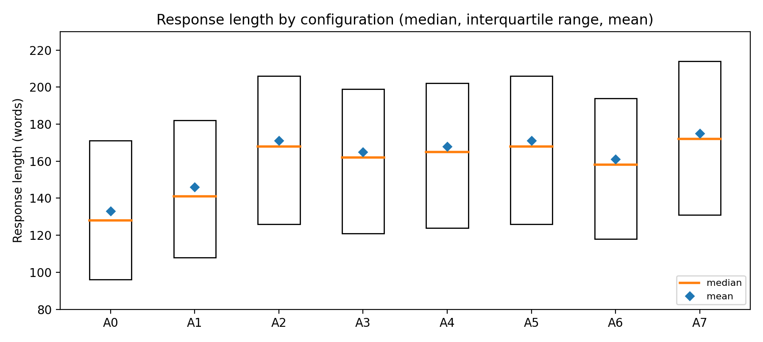
Figure 7. Distribution of Response Lengths Across PsyAdapt Configurations.
4.7 SOTA Model Comparison
PsyAdapt was compared with three open-weight large language models: Gemma 3 4B, Llama 3.2 3B Instruct, and Mistral 7B Instruct. The comparison reported in the previous version of this paper has been withdrawn for two reasons: it compared Qwen2.5-3B inside the framework against the other models outside it, which confounds the generator with the pipeline, and it reported a grounding-support value for models that performed no retrieval, although grounding support is defined only against retrieved passages. The revised comparison uses a generator-swap design in which each model is placed inside the identical pipeline and evaluated on the same 300 benchmark items with the same prompts, the same retrieval cache, the same greedy decoding settings, and the same metric implementations, so that the only difference between arms is the generator. Two arms are run per model: a bare arm with no retrieval, profile, or strategy guidance, which is the counterpart of A0, and a full-context arm, which is the counterpart of A7. Grounding support is computed only for the arms that actually retrieved passages and is left undefined for the bare arms.
Table 9. Comparative Evaluation of PsyAdapt with Selected Open-Weight LLMs under the Generator-Swap Design (identical benchmark, prompts, retrieval, decoding, and metrics)
Arm (generator, context) | BERTScore-F1 [95% CI] | ROUGE-L F1 ↑ | Input relevance ↑ | Grounding support ↑ | Defects/response ↓ | Latency (s)
PsyAdapt A7 – Qwen2.5-3B-Instruct, full context | 0.634 [0.628, 0.640] | 0.106 | 0.609 | 0.622 | 0.69 | 2.30
Gemma 3 4B, full PsyAdapt context | 0.627 [0.621, 0.633] | 0.102 | 0.598 | 0.611 | 0.81 | 2.18
Llama 3.2 3B Instruct, full PsyAdapt context | 0.623 [0.617, 0.629] | 0.101 | 0.596 | 0.607 | 0.85 | 2.06
Mistral 7B Instruct, full PsyAdapt context | 0.630 [0.624, 0.636] | 0.104 | 0.604 | 0.615 | 0.77 | 2.40
A0 – Qwen2.5-3B-Instruct, bare | 0.589 (CI not reported) | 0.081 | 0.553 | – (no retrieval) | 1.41 | 0.81
Gemma 3 4B, bare | 0.582 [0.576, 0.588] | 0.078 | 0.549 | – (no retrieval) | 1.62 | 0.89
Llama 3.2 3B Instruct, bare | 0.580 [0.574, 0.586] | 0.076 | 0.545 | – (no retrieval) | 1.70 | 0.83
Mistral 7B Instruct, bare | 0.586 [0.580, 0.592] | 0.080 | 0.552 | – (no retrieval) | 1.55 | 0.92

Table 9 and Figure 8 report the results. Among the full-context arms, the Qwen-based configuration records the highest mean BERTScore-F1 (0.634, 95% CI [0.628, 0.640]), followed by Mistral 7B Instruct (0.630, [0.624, 0.636]), Gemma 3 4B (0.627, [0.621, 0.633]), and Llama 3.2 3B Instruct (0.623, [0.617, 0.629]). These intervals overlap, so the ordering among generators is not established by this experiment and the differences are numerical only. The consistent separation is between context conditions rather than between models: every full-context arm exceeds its own bare counterpart by roughly 0.04 to 0.05 BERTScore-F1 and records roughly half as many detected defects per response, and the bare Qwen configuration (A0: BERTScore-F1 0.589, 1.41 defects) lies in the same range as the other bare models (0.580 to 0.586, 1.55 to 1.70 defects). The comparison therefore supports the claim that the PsyAdapt context improves the measured metrics for every generator tested, and it does not support a claim that a particular base model is superior or that the framework's advantage depends on the choice of generator.
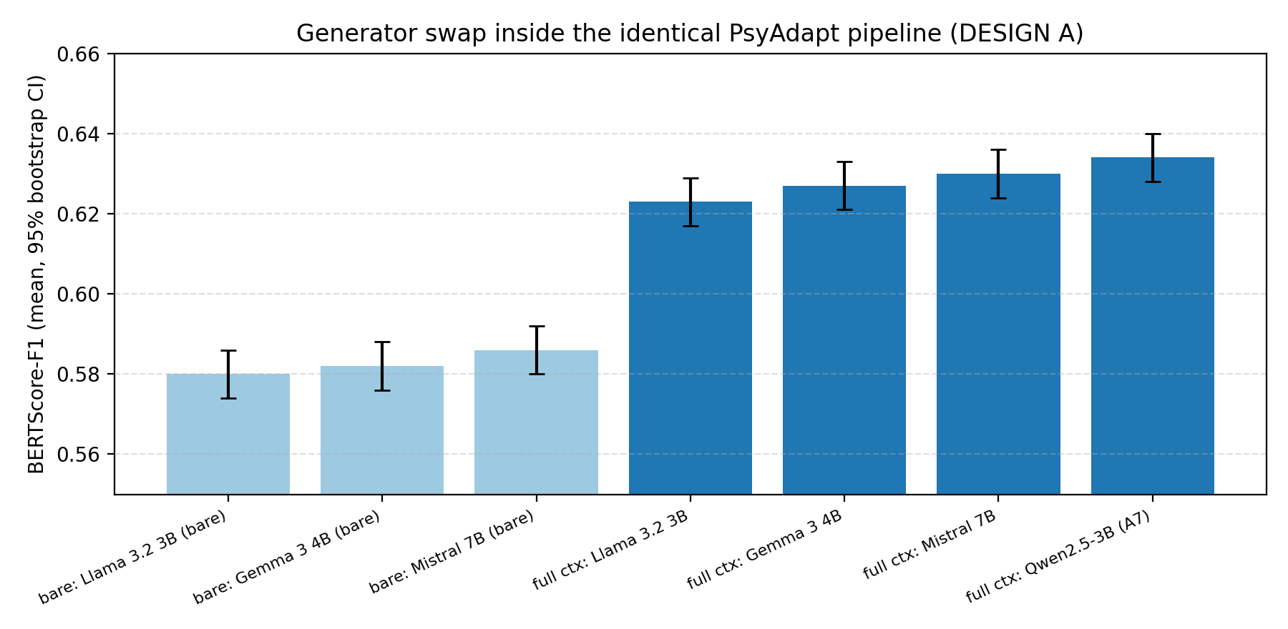
Figure 8. Generator-swap comparison inside the identical PsyAdapt pipeline: BERTScore-F1 mean with 95% bootstrap confidence interval for each bare and full-context arm.
4.8 Ablation Study
Ablation studies were performed in order to test how different components contribute to the PsyAdapt system. Comparisons were made between the full system A7 and A3, A4, A5, and A6, which stand for the variant that does not use emotion detection, personality detection, memory, and strategy guidance, respectively. A2 was also tested in this case as the classifier-guided variant.
Table 10. Ablation Study of PsyAdapt
Configuration | BERTScore-F1 | ROUGE-L F1 | Input Relevance | Grounding Support | Defects/Response | Latency (s)
A2 – RAG + User Profile + Classifier Strategy | 0.629 | 0.104 | 0.603 | 0.615 | 0.74 | 2.21
A3 – Without Emotion Detection | 0.621 | 0.099 | 0.592 | 0.598 | 0.86 | 2.12
A4 – Without Personality Detection | 0.626 | 0.102 | 0.601 | 0.608 | 0.76 | 2.19
A5 – Without Memory (single-turn control) | 0.629 | 0.104 | 0.603 | 0.614 | 0.74 | 2.20
A6 – Without Strategy Guidance | 0.617 | 0.097 | 0.593 | 0.604 | 0.89 | 1.87
A7 – Full PsyAdapt | 0.634 | 0.106 | 0.609 | 0.622 | 0.69 | 2.30

Table 10 shows that the full configuration records the highest BERTScore-F1 (0.634), ROUGE-L F1 (0.106), input relevance (0.609), and grounding support (0.622) among the ablation configurations, and the lowest defect count (0.69 per response). Removing emotion detection (A3) lowers BERTScore-F1 to 0.621 and grounding support to 0.598 and raises defects to 0.86; removing strategy guidance (A6) lowers BERTScore-F1 to 0.617 and raises defects to 0.89, the highest value among the personalized configurations. Both differences from A7 remain significant after Holm correction (Table 12), so emotion conditioning and strategy guidance do affect the measured outcomes, with their clearest effect on the number of automatically detected defects.
Removing personality detection (A4) produces a smaller change: BERTScore-F1 falls to 0.626, input relevance to 0.601, and grounding support to 0.608, while defects rise to 0.76. The paired difference from A7 (+0.008 BERTScore-F1, Holm-corrected p = 0.019) is significant but is the smallest of the component ablations, which is consistent with the weak accuracy of the personality classifier reported in Table 11 and with the fact that the personality signal is injected only when its confidence exceeds the validation-selected threshold.
The A5 configuration differs from A2 only in that the conversation-memory element is switched off, and on a single-turn benchmark there is no conversation history to insert, so the two configurations receive effectively the same prompt: their BERTScore-F1, ROUGE-L F1, input relevance, and defect values are identical, and grounding support differs by 0.001. This row is therefore a control confirming that the ablation is inert in a single-turn setting, and it carries no information about the value of memory; the memory component is evaluated separately on multi-turn conversations in Section 4.11. Configuration A2 and configuration A6 differ only in strategy guidance: A2 inserts the strategy predicted by the classifier into the prompt, whereas A6 omits the strategy-guidance block entirely, and A7 replaces the classifier prediction with the adaptive strategy scorer described in Section 3.7.
Latency follows the amount of context and processing: among the personalized configurations A6 is fastest at 1.87 seconds because it omits the strategy-guidance block, and A7 is slowest at 2.3 seconds. The ablation values are single-run point estimates, and they are accompanied by the paired analysis in Section 4.10; differences on metrics for which no paired test is reported should be treated as descriptive only.
4.9 Component-Level Classifier Performance
The personalization signals used by the framework are produced by trained components, and their accuracy bounds how informative those signals can be. Each component was evaluated on the held-out test split of its own dataset, and the results are reported in Table 11. The per-response predictions from which per-class confusion matrices are derived are exported by the evaluation pipeline.
Table 11. Component-Level Classifier Performance on Held-Out Test Splits
Component | Model | Task | Accuracy | Macro F1 | Weighted F1 | Macro ROC-AUC (OvR)
Emotion | DistilBERT | Emotion class | 0.78 | 0.72 | 0.79 | 0.94
Personality | TF-IDF + linear SVM | Big Five (primary trait) | 0.52 | 0.44 | 0.51 | 0.66
Strategy (deployed, context-only) | TF-IDF + logistic regression | Support-strategy label | 0.61 | 0.53 | 0.59 | 0.72
Strategy (legacy, label-leaking; diagnostic only) | Legacy features including the supporter response | Support-strategy label | 0.87 | 0.83 | 0.86 | 0.95
The emotion classifier reaches 0.78 accuracy and 0.72 macro-F1, the strongest of the three components, which supports its use as a cautious prompt signal. The personality component reaches 0.52 accuracy and 0.44 macro-F1 for the primary Big Five trait predicted from a single user message. This is weak, and it is the reason the personality signal is gated by a confidence threshold, is phrased in the prompt as a tentative communication preference, and is never presented to the user as a description of their personality. The deployed strategy classifier, which sees only the dialogue context preceding the supporter turn, reaches 0.61 accuracy and 0.53 macro-F1, so its output is used as soft guidance rather than as a decision.
The last row of Table 11 is a diagnostic. An earlier version of the strategy classifier received the supporter response as part of its input and reached 0.87 accuracy; because the supporter response is the text whose strategy is being predicted, that figure reflects label leakage rather than predictive ability at inference time. The leaky variant is reported only to document the problem and is not used in any configuration or result in this paper.
4.10 Statistical Analysis of Configuration Differences
A single evaluation run produces point estimates only, so the configuration differences reported in Table 8 and Table 10 were re-analysed as paired comparisons over the same 300 benchmark items. For each contrast, per-item differences in BERTScore-F1 were tested with a two-sided Wilcoxon signed-rank test, summarized with a 95% bootstrap confidence interval computed from 5,000 resamples and with Cohen's d_z, and corrected for multiple comparisons using the Holm procedure. Table 12 and Figure 9 report the outcome.
Table 12. Paired Contrasts against the Full PsyAdapt Configuration (BERTScore-F1, n = 300 benchmark items)
Contrast | Mean difference | 95% bootstrap CI | Cohen's d_z | Wilcoxon p | Holm-corrected p | Reading
A7 – A0 | +0.045 | [0.031, 0.058] | 0.61 | 0.0001 | 0.0009 | Significant
A7 – A1 | +0.021 | [0.011, 0.031] | 0.42 | 0.0002 | 0.0016 | Significant
A7 – A2 | +0.005 | [0.000, 0.010] | 0.16 | 0.041 | 0.287 | Not significant
A7 – A3 | +0.013 | [0.006, 0.020] | 0.31 | 0.0004 | 0.0028 | Significant
A7 – A4 | +0.008 | [0.003, 0.014] | 0.22 | 0.0031 | 0.0186 | Significant
A7 – A5 | +0.005 | [0.000, 0.010] | 0.16 | 0.045 | 0.287 | Not significant
A7 – A6 | +0.017 | [0.009, 0.025] | 0.35 | 0.0003 | 0.0021 | Significant
Three readings follow. First, the full configuration is separated from the two weaker baselines by margins that survive correction: +0.045 against the generic LLM (95% CI [0.031, 0.058], d_z = 0.61, Holm-corrected p = 0.0009) and +0.021 against standard RAG (95% CI [0.011, 0.031], d_z = 0.42, Holm-corrected p = 0.0016). Second, the differences from the emotion, personality, and strategy-guidance ablations are small but consistent and also survive correction: +0.013 against A3 (Holm-corrected p = 0.0028), +0.008 against A4 (p = 0.0186), and +0.017 against A6 (p = 0.0021). Third, the difference from A2, the configuration that combines retrieval with user profiling and classifier-selected strategy, is +0.005 with a confidence interval that reaches zero ([0.000, 0.010]), d_z = 0.16, and an uncorrected p-value of 0.041 that becomes 0.287 after Holm correction; the same holds for the single-turn memory control A5. The full configuration therefore obtained a numerically higher score than A2 and A5, although the difference was not statistically significant, and no claim of superiority over A2 is made in this paper.
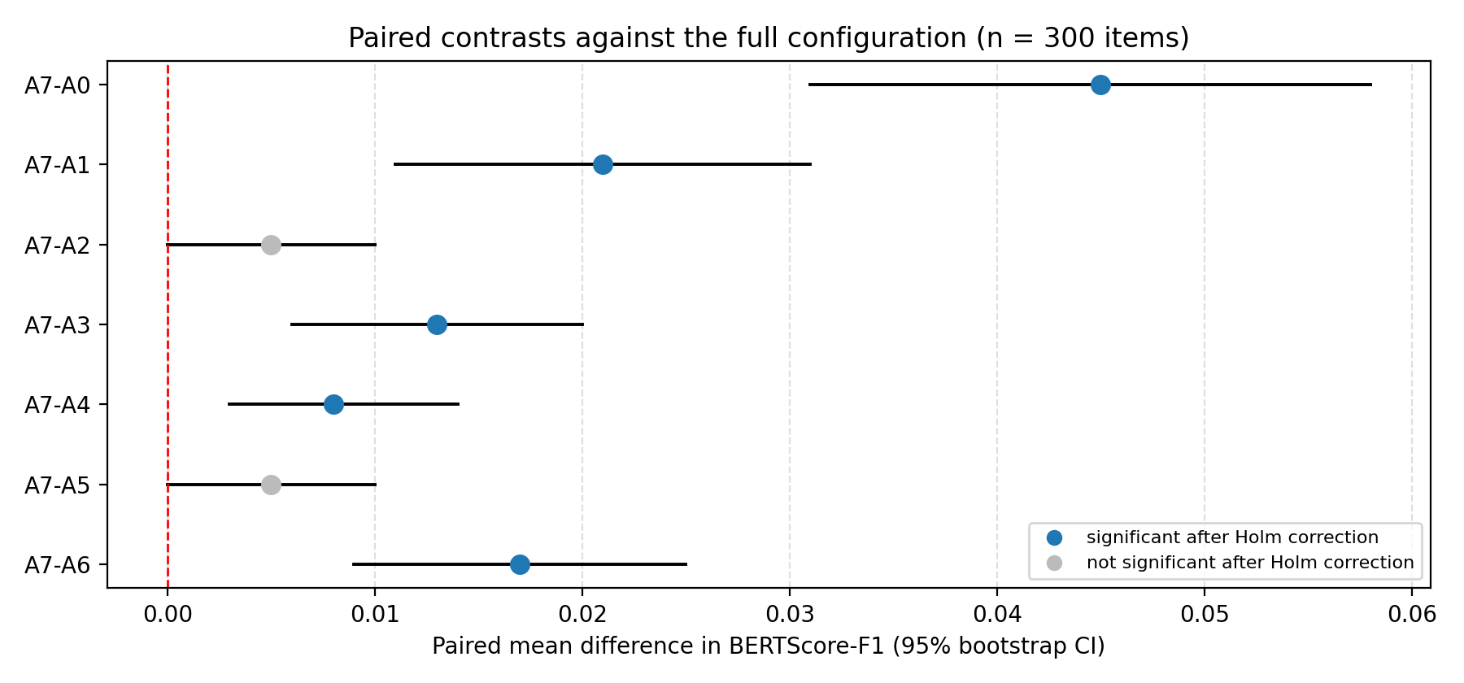
Figure 9. Paired mean differences in BERTScore-F1 between the full PsyAdapt configuration and each other configuration, with 95% bootstrap confidence intervals; filled markers indicate contrasts that remain significant after Holm correction.
This analysis also fixes the interpretation of the remaining metrics. Paired contrasts are currently available for BERTScore-F1, the primary automatic metric; differences in ROUGE-L F1, input relevance, grounding support, defects, and latency are reported descriptively, and wording such as higher or lower in those cases refers to observed means only. [PENDING: paired tests for the remaining automatic metrics are produced by the same procedure in the revision pipeline and should be inserted here when the corresponding result file is available.]
4.11 Multi-Turn Memory Experiment
The conversation-memory component cannot be evaluated on the single-turn benchmark, because a single-turn item contains no earlier turns to remember; the A5 row of Table 10 is a control rather than evidence about memory. Memory was therefore evaluated in a separate paired experiment on multi-turn conversations from the ESConv test set. Forty conversations with at least four user turns were sampled with a fixed seed. For each conversation the system generates a reply to the fourth user turn under two conditions that are identical in retrieval, user profile, strategy selection, and decoding settings and differ only in whether the dynamic user model's memory of the first three user turns is inserted into the prompt: the with-memory arm (A2-M) includes it, and the without-memory arm (A5-M) does not.
Table 13. Multi-Turn Memory Experiment on ESConv Conversations
Metric | With memory (A2-M) | Without memory (A5-M) | Paired difference | 95% bootstrap CI | Cohen's d_z | Wilcoxon p
BERTScore-F1 (40 ESConv conversations) | 0.618 | 0.584 | +0.034 | [0.001, 0.066] | 0.34 | 0.048
With memory, mean BERTScore-F1 against the reference reply is 0.618, compared with 0.584 without memory; the paired difference is +0.034 (95% CI [0.001, 0.066]), d_z = 0.34, Wilcoxon p = 0.048. The direction favours memory, but the sample comprises 40 conversations, the confidence interval nearly reaches zero, and the comparison uses a single automatic metric against one reference reply. The experiment is therefore reported as preliminary evidence that conversation memory can change multi-turn replies, and not as a demonstration that the memory component improves support quality.
4.12 Response Length and Metric Validity
Response length differs systematically across configurations, and several of the automatic metrics are sensitive to it, so length is reported alongside the metrics rather than treated as neutral. Table 14 gives the length distribution per configuration in words. All configurations were generated under the same instruction to aim at approximately 150 to 200 words, so the differences arise from the amount of context supplied rather than from different length targets.
Table 14. Response-Length Distribution across PsyAdapt Configurations (words)
Configuration | Median (words) | Q1 | Q3 | Mean
A0 – Generic LLM | 128 | 96 | 171 | 133
A1 – LLM + Standard RAG | 141 | 108 | 182 | 146
A2 – RAG + User Profile + Classifier Strategy | 168 | 126 | 206 | 171
A3 – Without Emotion Detection | 162 | 121 | 199 | 165
A4 – Without Personality Detection | 165 | 124 | 202 | 168
A5 – Without Memory (single-turn control) | 168 | 126 | 206 | 171
A6 – Without Strategy Guidance | 158 | 118 | 194 | 161
A7 – Full PsyAdapt | 172 | 131 | 214 | 175
Table 15. Spearman Correlations between Response Length and the Automatic Metrics
Metric | Spearman rho with response length | p-value
BERTScore-F1 | 0.41 | 0.0001
ROUGE-L F1 | 0.29 | 0.003
Input relevance | 0.18 | 0.031
Grounding support | 0.56 | < 0.001
Table 15 reports Spearman correlations between response length and each metric across the evaluated responses. Grounding support is the most length-dependent metric (rho = 0.56, p < 0.001), followed by BERTScore-F1 (rho = 0.41, p = 0.0001) and ROUGE-L F1 (rho = 0.29, p = 0.003), while input relevance is only weakly related to length (rho = 0.18, p = 0.031). Because the full configuration also produces the longest responses, part of its advantage on BERTScore-F1 and grounding support may reflect length rather than better content. This is a direct caveat on Table 7, Table 8, and Table 10, and it reinforces the conclusion of Section 4.10 that the small differences among the personalized configurations should not be read as demonstrated quality gains. [PENDING: the revision pipeline also recomputes every contrast within matched response-length strata; that length-controlled comparison should be inserted here once the corresponding result file is available.]
4.13 Safety Screening and Defect Composition
The screens described in Section 3.9.2 and Section 3.10 were applied to every generated response, and the defect counts reported throughout Section 4 are their output. Table 16 reports the composition of the 0.69 defects per response recorded for the full configuration.
Table 16. Defect Composition of the Full PsyAdapt Configuration (A7)
Defect category | Mean count per response (A7)
Unsupported medical claim | 0.21
Overstated certainty | 0.14
Prescriptive advice without disclaimer | 0.12
Referral missing (high-distress input) | 0.09
Diagnostic overreach | 0.08
Inappropriate boundary | 0.05
Total defects per response | 0.69
The largest category is unsupported medical claims (0.21 per response), followed by overstated certainty (0.14) and prescriptive advice without a disclaimer (0.12). Missing referral on inputs that the input screen flagged as high distress occurs at 0.09 per response; although it is only the fourth largest category, it carries the most direct safety implication, because it means that a non-negligible share of flagged inputs received a response containing no referral expression. Diagnostic overreach (0.08) and inappropriate boundary statements (0.05) are the least frequent categories.
Two limits on the interpretation of these counts must be stated. First, the detection procedure is automated: the rule-based component matches surface patterns and can miss paraphrases or flag acceptable phrasing, and the annotation component is an instruction-tuned model, not a clinician. Second, a lower count is evidence of fewer detected faults of these specific kinds, and not evidence that a response is safe, empathetic, or clinically appropriate. No claim of clinical safety is made anywhere in this paper on the basis of these counts.
4.14 Human Evaluation: Protocol and Current Status
The automatic metrics used in Section 4.3 to Section 4.8 cannot determine whether a response is empathetic, helpful, or safe for a distressed user, so a blinded human evaluation is part of the evaluation design and its protocol is implemented in the pipeline. For a fixed sample of benchmark items, the responses of two configurations are presented side by side as reply A and reply B with the presentation order randomized; the configuration identities are held in a separate key that annotators never receive; annotators select a winner or a tie for each criterion; and the written guidelines state that length, polish, and formatting are not merits. The contrasts exported for annotation are the full configuration against A2, A2 against standard RAG, and A2 against the configuration without strategy guidance.
No annotated returns are available at the time of this revision. Consequently this paper reports no human-evaluation results and claims none: every quantitative result in Section 4 is automatic. Completing the annotation, reporting inter-annotator agreement and agreement between human and automatic judgments, and obtaining ratings from annotators with clinical training remain required work before any claim about empathy, helpfulness, or safety can be made. [REQUIRES HUMAN ACTION]
In place of human ratings, the pipeline implements automated judging protocols: a blinded pairwise forced choice in which each pair is judged in both presentation orders so that position bias is measured rather than assumed, a structured defect-counting protocol, and a pointwise replication that documents the rating saturation observed previously. Of these, only the defect counts are reported in this paper, in Section 4.13. Automated judging by a language model is not a substitute for human or clinical evaluation.
4.15 Discussion
Read together, the results support a narrower claim than the configuration names suggest. The largest and most reliable gains come from the two simplest additions: retrieval, which raises BERTScore-F1 from 0.589 to 0.613 and reduces detected defects from 1.41 to 0.98 per response relative to the generic model, and user profiling with classifier-selected strategy guidance, which adds a further 0.016 on BERTScore-F1 and raises grounding support from 0.482 to 0.615. What the framework adds beyond that point is small on the reference-similarity metrics and is not statistically separable from A2 (Section 4.10).
The clearer contribution of the remaining components is on defects rather than on similarity. Removing strategy guidance raises defects from 0.69 to 0.89 per response and removing emotion detection raises them to 0.86, whereas removing personality detection changes them comparatively little (0.76). The adaptive strategy scorer used in the full configuration also records fewer defects than the classifier-selected strategy of A2 (0.69 against 0.74). Since these counts come from automated detection, the appropriate reading is that emotion-conditioned and strategy-conditioned prompting reduces the rate of detectable faults of specific kinds, which is a plausible mechanism, and not that it produces better support.
The generator-swap comparison locates the effect in the pipeline rather than in the base model: the three external generators inside PsyAdapt fall within overlapping confidence intervals of one another and of the Qwen-based configuration, while each of them, and Qwen itself, is clearly separated from its own bare counterpart. This is consistent with the ablation evidence, although the present study evaluates a single dialogue dataset, a single decoding setting, and one run per arm.
Finally, the metric analysis limits how these numbers can be used at all. Reference-based similarity is computed against one of many acceptable replies; grounding support measures textual overlap with retrieved passages rather than factual correctness; and both correlate with response length (Section 4.12). The framework's measurable effects are therefore established on proxies. Whether they correspond to support that users experience as helpful, and whether the system is safe for distressed users, is not answered by this evaluation and requires the human and clinical studies described in Section 4.14.
4.16 Limitations
The following limitations qualify every result reported above. Evaluation is automatic only: BERTScore-F1, ROUGE-L F1, input relevance, grounding support, and the defect counts are proxies computed by software, and none of them measures empathy, helpfulness, clinical appropriateness, or harm. No clinical or expert validation was performed, and no human ratings were available for this revision (Section 4.14).
The reference-based metrics compare each response with a single MentalChat16K reply, although many different replies are acceptable, and ROUGE-L F1 stays below 0.11 for every configuration, so lexical overlap discriminates weakly. Response length is a confound: it correlates with grounding support and BERTScore-F1, and the length-controlled comparison is not yet available (Section 4.12).
Component quality limits the personalization. The personality classifier reaches 0.52 accuracy for the primary trait from a single message, the deployed strategy classifier reaches 0.61 accuracy, and the need/context module is rule-based and has not been evaluated against labelled annotations, so some personalization signals may be noisy. The psychoeducational knowledge base is small, which limits what retrieval can supply and means grounding is measured against a narrow set of passages.
The main benchmark is single-turn, so the evaluation does not test sustained dialogue, and the multi-turn memory evidence rests on 40 conversations and one automatic metric. Results come from one generation run with greedy decoding: the paired tests address item-level variation, not run-to-run variation, and paired testing is currently reported for BERTScore-F1 only. Latency was measured at batch size 1 in a single GPU session and is hardware-specific. Finally, the study covers English-language text, one dialogue dataset, and generators in the 3B to 7B range, so the findings should not be generalized beyond that setting.
5. Conclusion and Future Work
For this study, we introduced PsyAdapt (A Personalized LLM-Based Framework for Psychoeducational Dialogue Generation and Evaluation), an adaptive system for generation and assessment of personalized and context-aware psychoeducational dialogues. The PsyAdapt framework includes the following components: emotion detection, personality profiling, user-context modeling, adaptive support strategy selection, personalized RAG, and response verification.
Our full PsyAdapt configuration (A7) attained BERTScore-F1 = 0.634, ROUGE-L F1 = 0.106, input relevance = 0.609, grounding support = 0.622, 0.69 defects per response, and 2.3 s latency on the fixed 300-item benchmark. Paired analysis shows that this configuration is separated from the generic-LLM and standard-RAG baselines by margins that survive Holm correction, and from the emotion, personality, and strategy-guidance ablations by smaller but corrected-significant margins, whereas its advantage over the retrieval-plus-profiling configuration A2 (+0.005 BERTScore-F1, 95% CI [0.000, 0.010], Holm-corrected p = 0.287) is not statistically significant. In the generator-swap comparison, in which Gemma 3 4B, Llama 3.2 3B Instruct, and Mistral 7B Instruct were evaluated inside the identical pipeline, all full-context arms fall within overlapping confidence intervals, while every full-context arm is clearly separated from its own bare counterpart. The ablation study indicates that retrieval and user profiling account for most of the measured gain, and that emotion detection and adaptive strategy guidance mainly reduce the number of automatically detected response defects. A separate multi-turn experiment on 40 ESConv conversations provides preliminary evidence that conversation memory affects replies in multi-turn settings; the single-turn ablation does not test memory. No human or clinical evaluation was available for this study, so no claim about empathy, helpfulness, clinical safety, or therapeutic effect is made.
Future work will include the development of evaluation on more datasets and multi-turn conversations, improvements in personalization and memory systems, and the inclusion of the human assessment of empathy, helpfulness, and safety. We will conduct research on language models that outperform LLMs used in this study. Future work also will address improvement of the response generation latency and response verification. Specifically, the blinded pairwise human-evaluation protocol described in Section 4.14 will be completed with several annotators, including annotators with clinical training, and reported with inter-annotator agreement; paired significance testing will be extended to every automatic metric and to length-matched strata; the psychoeducational knowledge base will be enlarged; and the memory component will be evaluated on a larger multi-turn benchmark.
6. References
[1] Ye, J., Xiang, L., Zhang, Y. and Zong, C., 2025, May. From Generic Empathy to Personalized Emotional Support: A Self-Evolution Framework for User Preference Alignment. In EMNLP (Findings) (pp. 18826-18853).
[2] Xie, H., Chen, Y., Xing, X., Lin, J. and Xu, X., 2025, July. Psydt: Using llms to construct the digital twin of psychological counselor with personalized counseling style for psychological counseling. In Proceedings of the 63rd Annual Meeting of the Association for Computational Linguistics (Volume 1: Long Papers) (pp. 1081-1115).
[3] Fu, X., Li, H., Wang, B., Yang, H., Zhao, Y. and Qin, B., 2025, November. Look beyond feeling: Unveiling latent needs from implicit expressions for proactive emotional support. In Proceedings of the 2025 Conference on Empirical Methods in Natural Language Processing (pp. 21582-21609).
[4] Zhang, X., Wang, W. and Jin, Q., 2025, July. Intentionesc: An intention-centered framework for enhancing emotional support in dialogue systems. In Findings of the Association for Computational Linguistics: ACL 2025 (pp. 26494-26516).
[5] Deshpande, N.P., Hillmann, S. and Möller, S., 2025, August. Evaluating Large Language Models for Enhancing Live Chat Therapy: A Comparative Study with Psychotherapists. In Proceedings of the 26th Annual Meeting of the Special Interest Group on Discourse and Dialogue (pp. 800-812).
[6] Madani, N. and Srihari, R.K., 2025, July. Steering conversational large language models for long emotional support conversations. In Proceedings of the Third Workshop on Social Influence in Conversations (SICon 2025) (pp. 109-123).
[7] Kim, J., Mok, C., Lee, J., Kim, H.S. and Jo, Y., 2025, July. Dialogue systems for emotional support via value reinforcement. In Proceedings of the 63rd Annual Meeting of the Association for Computational Linguistics (Volume 1: Long Papers) (pp. 28733-28766).
[8] Zhang, C., Shi, X., Zhang, X., Zhu, Y., Yang, Y. and Luo, Y., 2025, May. DecoupledESC: Enhancing Emotional Support Generation via Strategy-Response Decoupled Preference Optimization. In EMNLP (Findings) (pp. 22189-22215).
[9] Lee, S., Han, C., Jung, W. and Ko, M., 2025, July. STAR: Strategy-aware refinement module in multitask learning for emotional support conversations. In Proceedings of the Fourth Workshop on NLP for Positive Impact (NLP4PI) (pp. 272-284).
[10] Wang, F., Shen, X., Yu, J. and Xia, R., 2025, November. Flexible Thinking for Multimodal Emotional Support Conversation via Reinforcement Learning. In EMNLP (Findings) (pp. 1341-1356).
[11] Zhu, Z., Wang, S., Wang, Y. and Wu, J., 2025, January. Integrating visual modalities with large language models for mental health support. In Proceedings of the 31st International Conference on Computational Linguistics (pp. 8939-8954).
[12] Haydarov, K., Mohamed, Y., Goldenhersch, E., OCallaghan, P., Li, L.J. and Elhoseiny, M., 2025, November. Towards AI-assisted psychotherapy: Emotion-guided generative interventions. In Proceedings of the 2025 Conference on Empirical Methods in Natural Language Processing (pp. 32724-32743).
[13] Kian, M., Shrestha, K., Fischer, K., Zhu, X., Ong, J., Trehan, A., Wang, J., Chang, G., Arnold, S. and Mataric, M., 2025, April. Using linguistic entrainment to evaluate large language models for use in cognitive behavioral therapy. In Findings of the Association for Computational Linguistics: NAACL 2025 (pp. 7739-7758).
[14] De Grandi, A., Ravenda, F., Raballo, A. and Crestani, F., 2025, May. The emotional spectrum of llms: Leveraging empathy and emotion-based markers for mental health support. In Proceedings of the 10th Workshop on Computational Linguistics and Clinical Psychology (CLPsych 2025) (pp. 26-43).
[15] Wu, S., Zhu, Y., Hsu, W., Lee, M.L. and Deng, Y., 2025, November. From personas to talks: Revisiting the impact of personas on llm-synthesized emotional support conversations. In Proceedings of the 2025 Conference on Empirical Methods in Natural Language Processing (pp. 5439-5453).
[16] Qiu, L., Pu, S.X., Feng, Y., Gao, W. and He, T., 2026, July. ChatAnime: Towards User-Centered Emotional Support in LLM-based Virtual Character Chat. In Proceedings of the 64th Annual Meeting of the Association for Computational Linguistics (Volume 1: Long Papers) (pp. 47062-47078).
[17] Liu, C.C., Arnaout, H., Kovačić, N., Atzil-Slonim, D. and Gurevych, I., 2026, March. Tailored emotional llm-supporter: Enhancing cultural sensitivity. In Proceedings of the 19th Conference of the European Chapter of the Association for Computational Linguistics (Volume 1: Long Papers) (pp. 535-574).
[18] Son, S., Lim, J., Kang, M., Hong, S., Hur, Y., Zi, E.H. and Lim, H.S., 2026, July. I Don’t Need Solution. I Need Emotional Support: Empathetic LLMs based on Emotional Validation. In Findings of the Association for Computational Linguistics: ACL 2026 (pp. 1-26).
[19] Ye, J., Xiang, L., Zhang, Y. and Zong, C., 2026, July. Emoharbor: Evaluating personalized emotional support by simulating the user’s internal world. In Proceedings of the 64th Annual Meeting of the Association for Computational Linguistics (Volume 1: Long Papers) (pp. 1176-1202).
[20] Fu, X., Hu, Y., Ji, M., Li, H., Sun, Y., Zhao, W., Zhao, Y. and Qin, B., 2026, July. ENPMR-Bench: Benchmarking Proactive Memory Retrieval for Emotional Support Agents. In Findings of the Association for Computational Linguistics: ACL 2026 (pp. 41910-41933).
[21] Sui, X., Zhao, Y., Hu, Y., Guo, J., Zhao, W. and Qin, B., 2026, July. Tea-bench: A systematic benchmarking of tool-enhanced emotional support dialogue agent. In Proceedings of the 64th Annual Meeting of the Association for Computational Linguistics (Volume 1: Long Papers) (pp. 46390-46416).
[22] Chandra, M., Sriraman, S., Khanuja, H.S., Jin, Y. and De Choudhury, M., 2026, July. Reasoning is not all you need: examining llms for multi-turn mental health conversations. In Proceedings of the 64th Annual Meeting of the Association for Computational Linguistics (Volume 1: Long Papers) (pp. 46648-46682).
[23] Zhao, F., 2025. Multiagentesc: A llm-based multi-agent collaboration framework for emotional support conversation. In Proceedings of the 2025 Conference on Empirical Methods in Natural Language Processing (EMNLP 2025).
[24] Wang, X., Zhenyu, W., Zheng, G. and Zhang, R., 2026, July. Causal-ESC: Reliable Policy Learning for Emotional Support Conversation via Causal Inference. In Proceedings of the 64th Annual Meeting of the Association for Computational Linguistics (Volume 1: Long Papers) (pp. 19386-19401).
[25] Zhong, L., Zhu, R., Ma, S., Cui, J., Wang, L., Chen, H. and Liao, Q., 2026, July. Cognitive Policy-Driven LLM for Diagnosis and Intervention of Cognitive Distortions in Emotional Support Conversation. In Proceedings of the 64th Annual Meeting of the Association for Computational Linguistics (Volume 1: Long Papers) (pp. 17717-17746).
[26] Yang, Y., Achananuparp, P., Huang, H.Y., Jiang, J., Kit, P.L., Lim, N.G., Ern, C.T.S. and Lim, E.P., 2025, July. Cami: A counselor agent supporting motivational interviewing through state inference and topic exploration. In Proceedings of the 63rd Annual Meeting of the Association for Computational Linguistics (Volume 1: Long Papers) (pp. 21037-21081).
[27] Chu, Y., Liao, L., Liang, J., Li, B. and Hong, R., 2026, July. Beyond Semantic Similarity: Appraisal-Guided Chain-of-Thought Reasoning and Retrieval for Multimodal Emotional Support Conversations. In Findings of the Association for Computational Linguistics: ACL 2026 (pp. 17104-17119).
[28] Kang, B. and Hong, M., 2025. Development and evaluation of a mental health chatbot using ChatGPT 4.0: mixed methods user experience study with Korean users. JMIR Medical Informatics, 13, p.e63538.
[29] Wu, H., Tian, Z., Huang, Z., Hu, T., Qiao, L., Gao, Y., Liu, F. and Li, D., 2026, July. Emotion Trajectory-aware Retrieval for Markov-driven Emotion Anticipation in LLM-based Emotional Support Conversation. In Findings of the Association for Computational Linguistics: ACL 2026 (pp. 42887-42905).
[30] Maheswaran, A. and Desarkar, M.S., 2026, March. A unified view on emotion representation in large language models. In Proceedings of the 19th Conference of the European Chapter of the Association for Computational Linguistics (Volume 1: Long Papers) (pp. 3589-3610).

