SymptoGraph-LLM: symptom-grounded, comorbidity-aware mental health assessment with selective prediction
Abstract:
Text-based mental health assessment should identify clinical symptoms, represent comorbidity and allow a system to decline uncertain cases. Most existing systems predict a single disorder label. They treat co-occurring conditions as independent, consume pseudo-labels as certain and offer no way to abstain. Many also report accuracy on public corpora that share posts, so test material leaks into training. This paper proposes SymptoGraph-LLM, a symptom-grounded and comorbidity-aware multi-task network. Twenty-two symptom queries, initialised from the embeddings of their clinical definitions, form a concept layer through which every prediction passes. A symptom-disorder graph combines a DSM-5-derived prior with a sparsity-penalised learned residual. A symptom-profile contrastive objective aligns posts with overlapping symptom sets. A per-symptom variance head trained on detached features supplies an abstention score. Seven public corpora are harmonised onto one symptom space with a global post identifier and a strictest-split-wins rule. The training split holds 12,911 posts, of which 6,227 carry symptom labels. A locally run instruction-tuned model adds weak labels for the eleven symptoms that no corpus annotates. The framework is compared with three reference models and a six-rung ablation ladder across three seeds. On the held-out test split it attains 0.886 ± 0.008 symptom macro-AUROC, 0.775 ± 0.012 symptom macro-F1, 0.920 ± 0.008 stress AUROC and 0.531 ± 0.036 depression-severity quadratic weighted kappa. It leads the fine-tuned MentalRoBERTa reference on 8 of 10 metrics, although the symptom margins lie within seed variation. Abstaining on the least confident half of the test posts reduces symptom error from 0.192 to 0.095.
Keywords: Mental health assessment, Concept bottleneck, Comorbidity graph, Contrastive learning, Weak supervision, Selective prediction, Interpretable deep learning, PHQ-9, GAD-7.
1. Introduction
Text-based mental health assessment has attracted growing interest in clinical natural language processing, driven by the gap between rising disorder prevalence and available screening capacity. Social platforms contain large volumes of self-disclosed psychological text carrying traces of clinically meaningful symptoms. A system intended for a care pathway must therefore satisfy three requirements simultaneously: the predicted quantity must be one a clinician recognises, the evidence supporting it must be traceable to the text, and the reported accuracy must be attributable to generalisation, not to shared provenance.
Three ideas from outside disorder classification provide a means of meeting these requirements. Concept bottleneck modelling makes an interpretable intermediate layer obligatory rather than concomitant, so no downstream output can rest on evidence the concepts do not represent. Supervised contrastive learning shapes the representation using the structure of the label set itself, which in this setting is the comorbidity pattern. Selective prediction treats the decision to abstain as part of the model, not as a downstream threshold, which is what a screening pathway requires of an automated triage step.
While previous research has applied deep models to mental health text, the following five works are the closest in intent. Xu et al. (2024) [1] evaluate large language models for mental health prediction from online text across zero-shot, few-shot and instruction-tuned regimes, establishing that instruction tuning recovers much of the gap to supervised encoders but that the prediction target remains a disorder-level label with no inspectable intermediate representation. Shah et al. (2025) [2] fine-tune large language models for depression detection and report consistent gains, yet the resulting model is a binary classifier whose decision cannot be attributed to diagnostic criteria. Liu et al. (2025) [3] introduce DepGLM to recognise depression degree rather than presence, acknowledging that severity is graded, and predict the degrees with an unconstrained head, so the ordering between adjacent degrees is not enforced by the architecture; the present work shares that property, as the loss function and hyperparameter configuration states. Abdullah and Negied (2024) [4] combine machine learning, ensemble learning and large language models to predict future disorder, showing that ensembling stabilises prediction under noisy user-generated text, although the ensemble is formed over classifiers of the same disorder-level target and introduces no interpretable layer. Qorich and El Ouazzani (2024) [5] apply deep learning with large language models to suicide ideation detection and demonstrate that risk-bearing language is separable from general distress, but treat risk as an isolated binary target instead of the extreme of a graded clinical scale, so no strength is shared with the far more abundant symptom annotation available in the same corpora.
Objectives
Construct a harmonised mental health corpus over a shared twenty-two symptom space derived from the PHQ-9 and GAD-7 instruments, with a global post identifier, a strictest-split-wins rule and author-disjoint partitioning wherever author identity is available.
Make clinical symptom mediation a property of the architecture, not of an auxiliary explanation, using definition-initialised symptom attention with independent per-symptom scoring vectors.
Shape the shared representation with the structure of the symptom label set itself, by contrasting posts whose symptom profiles overlap against those whose profiles do not, and equip the framework with an abstention signal by training a per-symptom variance head on detached features to predict its own error.
Compare the framework against three retrained reference models and a six-rung ablation ladder under one identical protocol across three seeds, with every reported quantity drawn from the held-out test split.
Aim
The aim of this research is the production of mental health assessments that are directly usable in a clinical screening pathway, in the sense that each prediction is accompanied by the clinical symptoms that justify it, each comorbid relationship is represented inside the estimator rather than diagnosed afterwards, each case the model cannot decide is identified as such instead of being answered with a confident guess, and each reported margin is read against the variability of the evaluation itself. The framework is therefore designed so that interpretability, comorbidity awareness and the ability to abstain are properties of the model itself.
Novelty
This paper integrates five ideas that have not been combined before in mental health assessment from social media text. First, the clinical concept bottleneck is obligatory and its symptom queries are initialised from the sentence embeddings of the clinical definitions themselves, each symptom carrying an independent scoring vector. The five are numbered N1 to N4 throughout. Second, comorbidity enters as a graph whose nodes are symptoms and disorders and whose adjacency is a DSM-5 prior corrected by a learned residual under a sparsity penalty, with disorder-disorder edges estimated as conditional co-membership probabilities, not as pointwise mutual information. Third, an instruction-tuned model executed locally supplies weak supervision for the eleven symptoms no public corpus annotates. This is the only role a large language model plays in the framework: it annotates training material offline and is not part of the deployed model, which is a fine-tuned encoder of 125.8 million parameters. Fourth, the representation is shaped by a contrastive objective whose positives are defined by overlap between symptom profiles, not by disorder label or by augmentation, which makes the comorbidity pattern itself the organising signal. Fifth, a per-symptom variance head trained on detached features cannot trade accuracy for confidence, and yields an abstention signal whose risk-coverage behaviour is reported as a headline result.
Contribution
A reproducible corpus harmonisation pipeline that maps seven public mental health collections onto one canonical twenty-two symptom space with a global post identifier, a strictest-split-wins rule and author-disjoint partitioning where author identity is known, yielding 19,762 unique labelled posts whose post-level disjointness is verified by assertion.
A symptom-mediated architecture combining definition-initialised concept attention, independent per-symptom scoring vectors, concept-gated pooling and message passing over a symptom-disorder comorbidity graph with a sparsity-penalised residual on a DSM-5 prior.
A symptom-profile contrastive objective that treats two posts as positives when the Jaccard overlap of their annotated symptom sets reaches one half, together with weak supervision over the eleven symptoms carrying no gold annotation.
A per-symptom learned-variance head giving an abstention signal, reducing symptom error from 0.192 at full coverage to 0.095 at half coverage, with an area under the risk-coverage curve of 0.099 ± 0.015 on the test split.
The remainder of this paper is organised as follows. The literature survey reviews related work on mental health assessment from social media text. The proposed methodology describes the dataset, the pre-processing and partitioning procedure, the feature extraction, the architecture and the training objective. The results and discussions report the experimental setup, the evaluation metrics, the main results, the convergence analysis, the ablation study and the comparison with reference models. The conclusion closes the paper and outlines future work.
2. Literature Survey
Bauer et al. (2024) [6] proposed the use of large language models to understand suicidality within a social-media-derived taxonomy of mental health disorders, performing a linguistic analysis of Reddit posts that distinguishes the vocabulary of risk from that of general distress. The analysis is nonetheless descriptive rather than predictive, so the identified separability never enters an estimator, and the induced categories remain mutually exclusive, which prevents the representation of a person who satisfies criteria for several conditions at once. Lee et al. (2024) [7] compared large language models against expert clinicians for crisis prediction among telemental health patients, which is among the most clinically rigorous evaluations in the literature and establishes that model and professional judgements diverge systematically rather than randomly. However, the comparison is conducted at the level of a final crisis decision without an auditable intermediate representation, so the source of a disagreement cannot be localised to particular clinical features, leaving a gap in architectures that expose the intermediate clinical quantities on which such a disagreement could be adjudicated.
McCoy and Perlis (2025) [8] proposed the application of large language models to stratify suicide risk from narrative clinical notes, demonstrating that the approach transfers from patient-authored social text to professionally authored records. Nevertheless, the stratification is produced directly from text without passing through the symptom constructs from which clinical scales are built, so the output cannot be reconciled with an instrument already in use, and the ordinal nature of risk is handled as an unordered set of strata. Xie et al. (2026) [9] proposed retrieval-augmented large language models for depression screening and suicide risk stratification, grounding generation in retrieved clinical material and reducing unsupported assertions relative to unaugmented generation. However, retrieval conditions the generated explanation rather than constraining the prediction itself, so nothing prevents the final decision from resting on evidence the retrieved material does not support, which leaves a gap in constraining the prediction instead of its narration.
Bao et al. (2024) [10] proposed transformer architectures that detect and explain the appearance of depressive symptom markers in user writings, presenting both separated and unified classify-and-explain designs and evaluating explanation quality with offline and expert-in-the-loop metrics, thereby establishing that symptom markers increase the trust health professionals place in automated decisions. Nevertheless, the symptom layer accompanies the decision rather than forming a bottleneck the decision must traverse, so the classifier may rely on evidence the explanation does not mention. Suksam et al. (2026) [11] proposed transformer ensemble learning for symptom-level classification followed by DSM-5-oriented screening, making the symptom layer the primary learning target and deriving the disorder judgement from it. However, the aggregation from symptoms to screening is a fixed rule applied after classification instead of a representation shaped by the symptom structure itself, and the ensemble members share no clinical structure, leaving a gap in learning a representation organised by the co-occurrence pattern of the symptoms, not by the disorder label.
Garg (2024) [12] proposed wellness concept extraction and classification in Reddit posts for mental health analysis, establishing concept-level annotation as a viable intermediate task between raw text and a clinical judgement and demonstrating that annotators agree on concept presence at a useful rate. Nevertheless, the concepts are drawn from a wellness vocabulary, not from the items of a validated instrument, so they cannot be aggregated into graded severity and cannot be reconciled with a scale a clinician reports. Zhang et al. (2024) [13] proposed a knowledge-aware deep learning approach to depression detection using digital traces, incorporating external knowledge into the input representation and reporting improved consistency of the resulting estimates. However, the knowledge conditions the representation rather than structuring the output space, so dependence between the predicted conditions remains unmodelled and a prediction of one disorder carries no information about the probability of a comorbid second, which leaves a gap in modelling dependence among the predicted clinical constructs themselves.
Qasim et al. (2025) [14] proposed the detection of depression severity in social media text using transformer-based models, isolating the severity scale as a task in its own right and confirming that pretrained encoders capture graded distinctions. Nevertheless, severity is predicted by an unconstrained classifier, so a prediction may violate the ordering of the scale, and the symptom items from which the scale is computed are not represented. Kerasiotis et al. (2024) [15] proposed depression detection in social media posts using transformer-based models together with auxiliary features, showing that handcrafted linguistic descriptors remain complementary to learned representations and that encoders do not fully subsume established psycholinguistic signal. However, the auxiliary features are concatenated into the input while the output remains a single disorder decision, so the additional signal improves a quantity that is still not clinically decomposable, leaving a gap in combining complementary evidence within a decomposable output space.
Chen et al. (2025) [16] proposed a heterogeneous subgraph network with prompt learning for interpretable depression detection, combining graph structure over heterogeneous context with prompt-based adaptation and reporting gains in both accuracy and interpretability over purely sequential encoders. However, the nodes of the constructed subgraphs are posts, users and words rather than clinical constructs, so the structure encodes who resembles whom rather than which conditions co-occur. Jain et al. (2024) [17] proposed CDME-GAT, a context-aware depression detection model using multiple embeddings and graph attention networks, demonstrating that attention over a constructed context graph improves robustness on noisy user-generated content. Nevertheless, the graph is induced from textual and contextual similarity and carries no clinical prior, so no mechanism exists by which diagnostic knowledge could inform propagation, and the model yields no bounded interpretable parameter.
Rehman et al. (2026) [18] proposed explainable text-based depression and suicide risk prediction using deep learning and graph neural networks, where the graph is estimated from semantic similarity between posts together with author relations, not from social interactions, and interpretability is supplied by post-hoc attribution with calibration analysis. The work is directly relevant because it predicts both targets jointly and treats trustworthiness as an explicit objective. Nevertheless, the graph connects posts rather than clinical constructs, the attribution is computed after training rather than constrained during it, and no control establishes that the estimated structure outperforms a random graph of equal density, an omission the present work shares and records in the future work. Tahir et al. (2026) [19] proposed an ontology-guided knowledge graph with a retrieval-augmented language model for interpretable assessment, confirming that clinical ontologies can enter the pipeline, but the ontology retrieves evidence for a generative model rather than defining a differentiable adjacency over which symptom evidence propagates during training. Gao et al. (2025) [20] proposed large language model powered knowledge graph construction for mental health exploration, representing the current frontier of automated clinical structure induction and surfacing relations that manual curation omits, although the induced structure supports exploratory analysis rather than acting as a constraint inside a trained estimator and is not validated against a diagnostic reference, which leaves a gap in combining curated or induced clinical structure with learned representation power inside one constrained estimator.
Table 1 compares further recent studies with the proposed framework. These include multi-label classification by Hsieh et al. (2025) [21], emotion-aware detection by Khowaja et al. (2025) [22], weak supervision by Hsu and Roberts (2025) [23] and federated detection by Khalil et al. (2024) [24]. They also include the reviews of Guo et al. (2024) [25], Omar et al. (2024) [26], Volkmer et al. (2024) [27], Levkovich and Omar (2024) [28] and Bucher et al. (2025) [30], and the PsyEval benchmark of Jin et al. (2026) [29].
Table 1. Comparison of existing mental health assessment and symptom identification methods with the proposed SymptoGraph-LLM
Ref. (Year) | Application Domain | Technical Approach | Core Contribution | Key Technical Gap
[21] (2025) | Multi-label mental health classification | Multi-perspective prompt ensemble with perturbation-based self-supervision on a pretrained backbone | Prompt diversity and consistency regularisation improve multi-label prediction | Labels are disorders rather than instrument items, so they cannot be aggregated into graded severity
[22] (2025) | Depression detection | Emotion-aware encoders with fuzzy-based contrastive networks | Emotion-conditioned representations separate depressive from non-depressive text | Single disorder target with no symptom decomposition and no ordinal severity estimate
[23] (2025) | Clinical natural language processing | Knowledge-free large language model weak supervision | Model-generated labels substitute effectively for scarce expert annotation | Weak labels consumed as certain; labeller bias not estimated, as in the present work
[24] (2024) | Multilingual depression detection | Federated learning with multilingual language models | Privacy preserved at modest accuracy cost across languages | Addresses privacy but not label reliability or clinical decomposability of the output
[25] (2024) | Mental health applications | Systematic review of large language model applications | Documents rapid adoption across screening and triage tasks | Reports that evaluations are not comparable; supplies no corrective protocol
[26] (2024) | Psychiatry | Systematic review of large language models in psychiatry | Identifies diagnosis, triage and documentation as main application areas | Review only; clinical validity rarely established and provenance seldom examined
[27] (2024) | Psychiatry | Analysis of opportunities and challenges | Frames interpretability and validation as the binding constraints on deployment | Conceptual analysis without an implemented estimator or evaluation protocol
[28] (2024) | Suicide detection and risk assessment | Systematic review of encoder-based and generative models | Finds reported margins frequently fall within evaluation variability | Diagnoses the absence of significance testing; the present work does not supply one either
[29] (2026) | Mental health benchmarking | PsyEval, a comprehensive evaluation benchmark | Standardised task suite exposes large variation between models on identical inputs | Benchmarks generative behaviour; does not control corpus overlap between constituent datasets
[30] (2025) | Mental health care | Systematic review of large language models in care delivery | Concludes that clinical integration rather than model scale limits present utility | Identifies the need for leakage-controlled and significance-audited primary studies
Proposed | Multi-task mental health assessment | Symptom-grounded concept bottleneck over a comorbidity graph, with profile-contrastive representation shaping and a learned-variance abstention head | Obligatory symptom mediation, propagated comorbidity, weak supervision over the unannotated half of the ontology and calibrated abstention | Integrates interpretable mediation, comorbid structure and selective prediction under leakage control on one shared protocol

3. Proposed Methodology
The proposed SymptoGraph-LLM (Symptom-Grounded Comorbidity-Aware Multi-Task Network under Calibrated Weak Supervision) framework is designed for interpretable mental health assessment at the level of individual posts in large heterogeneous social media collections whose annotation is scarce, unevenly distributed across clinical conditions and drawn from corpora of overlapping provenance. Different from existing frameworks that either classify a disorder directly, generate an explanation alongside a decision or fuse auxiliary features into the input representation, the proposed framework integrates the following elements into a unified estimation pipeline: harmonisation of seven public corpora onto one canonical symptom space under explicit leakage control, a clinical concept bottleneck with definition-initialised symptom attention, a symptom-disorder comorbidity graph with a learned residual adjacency, a weak-supervision branch covering the symptoms no corpus annotates, a symptom-profile contrastive objective and a per-symptom learned-variance head supplying abstention. First, seven collections supplying item-level symptom annotation, four-level depression severity, five-level clinician-coded suicide risk and binary perceived stress are mapped onto a shared space of twenty-two symptoms derived from the PHQ-9 and GAD-7 instruments, with a global post identifier assigned over a normalised text prefix so that a post appearing in several corpora collapses to a single row, and with author-disjoint partitioning wherever author identity is known, so that no author's writing appears on both sides of a split. Then the text is encoded by a domain-pretrained transformer and projected onto the symptom space by attention queries initialised from the embeddings of the clinical definitions, producing a concept vector through which every prediction must pass. The resulting concepts are refined by message passing over a graph whose nodes are the twenty-two symptoms together with the disorder categories observed in the corpus and whose adjacency sums a DSM-5 derived prior with a learned residual penalised towards sparsity. Meanwhile, an instruction-tuned large language model executed locally supplies weak labels for 49,982 training posts over the eleven symptoms that no public corpus annotates, of which 6,000 are used during training, so that the symptom layer receives gradient over the whole ontology instead of the annotated half of it. The pooled representation is additionally shaped by a contrastive objective whose positives are pairs of posts whose annotated symptom sets reach a Jaccard overlap of one half, which makes the comorbidity pattern instead of the disorder name the organising signal of the embedding. Finally, a per-symptom log-variance head reads the pooled representation through a stopped gradient and is trained to predict its own squared error, so it cannot reduce its loss by suppressing accuracy, and the resulting score orders cases by reliability and supports abstention. The evaluation protocol applies per-symptom decision thresholds tuned on validation data and three-seed replication, against three retrained reference models and a six-rung ablation ladder. The full pipeline of the proposed SymptoGraph-LLM framework is illustrated in Figure 1.
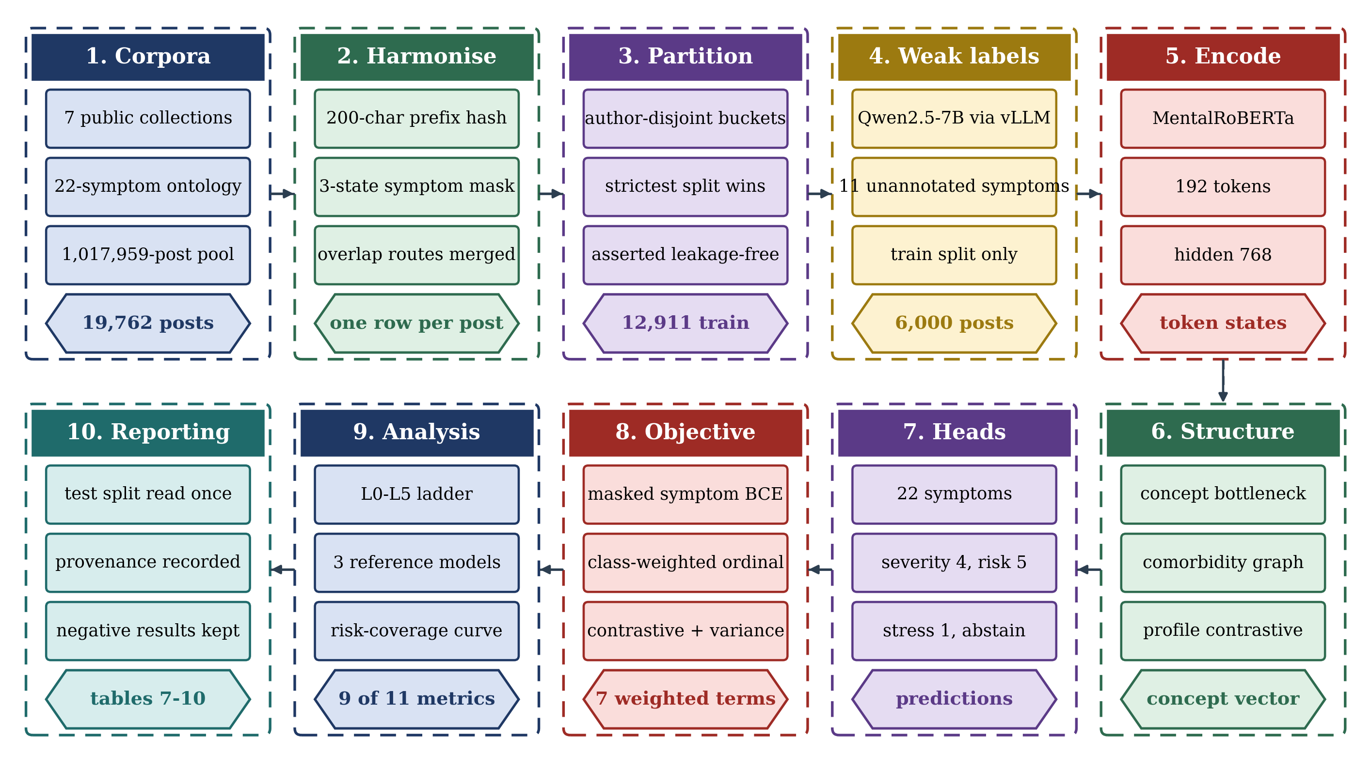
Figure 1. Overall workflow of the proposed SymptoGraph-LLM framework.
3.1 Dataset Description
As the primary data resource for the development and testing of the proposed SymptoGraph-LLM framework, a harmonised corpus assembled from seven publicly available mental health text collections is employed, because it is the only configuration providing item-level symptom annotation together with graded severity and clinician-coded suicide risk over one canonical label space, which is the prerequisite for symptom-mediated estimation. In contrast to conventional mental health datasets that supply a single binary disorder label or a single severity scale, the assembled corpus comprises symptom annotations aligned to validated instruments, four-level depression severity, five-level suicide risk, binary perceived stress, author identifiers, posting dates and subreddit provenance. The constituent sources are DepressionEmo for item-level depressive symptoms, Dreaddit for perceived stress, DepSeverity for four-level severity, the C-SSRS annotated Reddit collection for five-level risk, the Interpersonal Risk Factors and LoST collections for thwarted belongingness and loneliness, and the IMHI instruction collection, together with an unlabelled pool of 1,017,959 posts drawn from the Reddit Mental Health Dataset across 108 subreddit files and 822,884 distinct authors. The shared label space comprises 22 symptoms, of which 9 correspond to PHQ-9 items, 7 to GAD-7 items and 6 to further constructs, namely hopelessness, emptiness, loneliness, low self-esteem, thwarted belongingness and perceived burdensomeness.
Before developing the model, the collections are processed into a canonical table using a reproducible harmonisation procedure, because the public corpora in this field overlap substantially and splitting each independently would leak training material into evaluation sets through five distinct routes that were measured directly. The most severe is that DepSeverity re-annotates the same 3,526 posts contained in Dreaddit, so that treating either as an independent evaluation set for the other would be circular. LoST and the Interpersonal Risk Factors collection share 3,089 posts; the IMHI collection repackages posts from other sources behind an instruction prefix; and the unlabelled pool contains 85,659 internal duplicates. The author audit applies to the unlabelled pool, where 192,893 of 826,961 authors (23.3 per cent) appear in more than one source file before duplicate removal. It does not extend to the labelled corpus, which carries usable author identifiers for only 500 authors, so author-disjointness is verified on the pool but is unverifiable on most gold-labelled rows. A global post identifier computed as a hash over a normalised two-hundred-character prefix therefore collapses each unique post to one row, every unique post receives exactly one split assignment, Reddit posts carrying a known author are partitioned author-disjointly so that no author's writing style spans a boundary, and where the constituent corpora disagree about an assignment the strictest one prevails. The partitioning is verified by an assertion that raises if any post or any author is found on both sides of a split, so that a leakage regression fails the pipeline rather than producing an inflated score.
The resulting gold-labelled partition comprises 19,762 unique posts, which are divided into training, validation and test subsets after duplicate posts are merged, so that no unique post appears in more than one subset. Symptom labels are retained in three states denoting presence, absence and absence of annotation by that particular source, and only the first two contribute to the objective, because treating an unannotated symptom as a negative observation would teach the model that symptoms no corpus examined are reliably absent. Eleven of the twenty-two symptoms, six GAD-7 items and five PHQ-9 items, carry no gold annotation in any constituent collection, which is the condition that motivates the weak-supervision branch described in the data pre-processing. Of the 12,911 training posts, 6,227 carry symptom labels, 2,456 carry severity and stress labels and 340 carry risk labels. A further 3,888 training posts carry only IMHI explanations and contribute to no objective of the present framework, and the test split contains 1,418 IMHI posts held out for external evaluation that are not scored in this paper. The partitioning of the dataset for the experimental study is illustrated in Table 2.
Table 2. Dataset partitioning for SymptoGraph-LLM
Dataset split | Posts | Symptom-annotated posts | Split %
Training set | 12,911 | 6,227 | 65.33%
Validation set | 2,862 | 1,397 | 14.48%
Test set | 3,989 | 1,956 | 20.19%

The training set is used for the supervised training of the encoder, the concept bottleneck, the graph residual and the four prediction heads, and the statistics of the training subset alone determine the symptom positive weights, the ordinal class weights and the sentence embeddings used to initialise the symptom queries, so that no information derived from validation or test material influences optimisation. The validation set is used for monitoring convergence, selecting the reported checkpoint, tuning the per-symptom decision thresholds and triggering early stopping. The composition of the annotated subsets across the four prediction tasks is reported in Table 3.
Table 3. Labelled training and test instance counts for each of the four prediction tasks, with the test share of that task's labelled total.
Prediction task | Training instances | Test instances | Test share
Symptom presence (22 labels) | 6,227 | 1,956 | 23.9%
Perceived stress (binary) | 2,456 | 541 | 18.1%
Depression severity (4 levels) | 2,456 | 541 | 18.1%
Suicide risk (5 levels) | 340 | 74 | 17.9%
Weak-labelled symptoms (11 labels) | 6,000 | – | –

Due to the imbalance of the tasks, with a ratio of 18.3 between the number of symptom-annotated instances and the number of suicide-risk instances, sampling and weighting require explicit treatment rather than being left to the optimiser. Depression severity is additionally skewed within itself, the lowest of its four bands accounting for 71.9 per cent of the training instances in the proportion 1767, 205, 288 and 196, and suicide risk is similarly concentrated in its lower levels. Unweighted cross-entropy under this distribution collapses both ordinal heads onto the majority class, a failure that was observed directly during development as a quadratic weighted kappa of exactly zero, so capped inverse-frequency class weights are applied to both ordinal objectives and capped positive weights are applied to the symptom objective.
Each post also carries the conditioning information used by the framework. The symptom definitions, taken verbatim from the PHQ-9 and GAD-7 item wordings and from the published definitions of the six additional constructs, are encoded once by a frozen sentence encoder and supply the initialisation of the symptom attention queries. The disorder label associated with each post, where the source corpus provides one, supplies the disorder nodes of the comorbidity graph, and the author identifier supports both the author-disjoint partitioning and the estimation of the disorder-disorder adjacency from co-membership across the unlabelled pool. Posting dates and subreddit provenance are retained for subgroup analysis but are deliberately excluded from the model input, because a subreddit name is a near-deterministic proxy for the disorder label in several of the constituent corpora and including it would allow the framework to bypass the clinical content entirely. A related form of leakage was measured in the text itself and is reported here because it bounds the interpretation of the symptom results: a model can attain apparent performance on a disorder label by matching the disorder name in the text, and no keyword-masked control was run to bound that effect. This is a property of corpora assembled by subreddit sampling and it is the reason alternative collections were not adopted merely because they report higher published figures, since a higher figure obtained on a corpus with stronger keyword leakage measures less rather than more. The unlabelled pool from which the weak-supervision subsample is drawn comprises 1,017,959 posts written by 822,884 distinct authors after duplicate removal, a mean of 1.24 posts per author, and a minority of authors contribute more than one post, which bounds what an author-level consistency objective could use.
3.2 Data Pre-processing
The process of developing the proposed SymptoGraph-LLM framework begins with the systematic pre-processing of the seven constituent collections into one canonical table under explicit leakage control. The procedure assigns a provenance-independent identity to every post, harmonises the heterogeneous label schemes onto the shared twenty-two symptom space, establishes a partition that no post and no author can cross, and constructs the stratified subsample that the weak-supervision branch will annotate. Each stage is expressed below as an operation on the union of the constituent corpora, so that the pipeline is reproducible from the published sources without reference to intermediate artefacts. The ordering of the stages is itself substantive, because identity resolution must precede partitioning for the partition to be well defined, and partitioning must precede the construction of the weak-supervision subsample for that subsample to be free of evaluation material. Reversing either dependency produces a pipeline that executes without error and yields optimistic results.
$pid\left(x\right)=MD5($norm(x)_{1:200}) (1)
where the normalisation operator lowercases the text, collapses whitespace, strips instruction prefixes of the form used by the IMHI collection and removes markup, the prefix length is fixed at two hundred characters because it was found sufficient to separate distinct posts while remaining robust to truncation differences between corpora, and the quotient by the identifier relation collapses every duplicate to a single canonical row. Applying this operator to the seven collections reduces the union to 19,762 unique gold-labelled posts and removes 85,659 duplicates from the unlabelled pool, and it is this operation that resolves the overlap between DepSeverity and Dreaddit and between LoST and the Interpersonal Risk Factors collection without requiring any corpus-specific exception. The most consequential of the routes is that DepSeverity re-annotates the same 3,526 posts contained in Dreaddit rather than sampling independently, so the two cannot be treated as distinct domains and a cross-corpus transfer claim between them would be vacuous. The IMHI collection repackages material from several of the remaining sources behind an instruction prefix, so its posts are not recognisable as duplicates by exact string comparison and are recovered only once the prefix is stripped by the normalisation operator.
$y_{ik}∈\{1,0,-1\}, m_{ik}=1\left[ y_{ik}≥0 \right]$ (2)
where the three label states denote that the symptom was annotated as present, annotated as absent, or not examined by the source corpus that contributed the post, and the mask selects only the first two for inclusion in the objective. This three-state encoding is necessary because the constituent corpora annotate different subsets of the symptom space: a post drawn from a corpus concerned with interpersonal risk carries informative labels for thwarted belongingness and perceived burdensomeness but says nothing about sleep disturbance, and treating that silence as a negative observation would inject a large quantity of false negatives into precisely the symptoms the framework is intended to detect. The practical consequence of the three-state encoding is severe, because it bounds what the evaluation in the results and discussions is able to establish: eleven of the twenty-two symptoms in the ontology carry no gold annotation anywhere in the harmonised corpus, so the mask is zero for those eleven at every row of every partition. Those eleven comprise six GAD-7 items and five PHQ-9 items (anhedonia, sleep disturbance, fatigue, appetite change and psychomotor change), for which no constituent collection provides item-level annotation. Three properties of the eleven gold-supervised symptoms bound every symptom number in this paper. Only five of the sixteen PHQ-9 and GAD-7 items are among them, the other six being constructs drawn from the interpersonal-risk and loneliness literature, so the symptom metrics do not constitute instrument-level coverage. Eight of the eleven take their annotation from a single corpus, DepressionEmo, whose emotion labels are mapped onto PHQ-9 items by a documented heuristic correspondence, not by clinical item-level annotation. And their positive prevalence is high, 77.3 per cent for depressed mood and 69.5 per cent for hopelessness, so a threshold-tuned positive-class F1 on this label space is a less demanding quantity than the same number computed on a balanced set.
$split\left(a\right)=bucket($hash(a)) (3)
where the bucketing function maps a salted hash of the author identifier onto the three partitions in fixed proportions, and the constraint requires that any two posts sharing an author receive the same assignment. Author-disjoint partitioning is applied rather than post-level randomisation because an author's lexical and syntactic idiosyncrasies are highly identifying, so a model evaluated on unseen posts from authors it has already observed measures author recognition in addition to symptom detection. Because the constituent corpora contribute overlapping author populations, the constraint cannot be satisfied by independent bucketing alone, and a repair pass reassigns every author found to span a boundary to the single partition holding the majority of that author's posts before the verification assertion is evaluated. In the labelled corpus, 13,386 of the 19,762 posts take the split published by their source corpus, 3,526 severity posts and 500 risk posts are split by stratification on their own label, 1,418 IMHI posts are held as external test material, 850 posts are carved from official training data for validation and only 82 are assigned by hashing. Author hashing therefore governs the unlabelled pool instead of the gold-labelled rows, and in the pool the repair pass applied zero overrides. The verification assertion that no author spans a split passes over the 500 labelled authors it can see and over all 822,884 authors of the pool. An alternative design in which each constituent corpus is partitioned independently according to its own published split was considered and rejected, because the overlap measurements above show that such a procedure would place the same post in the training partition of one corpus and the test partition of another, and the resulting leakage would be invisible to any per-corpus verification.
$s_{i}=\min_{c : i∈D_{c}}rank\left(s_{i}^{\left(c\right)}\right), rank\left(test\right)<rank\left(val\right)<rank\left(train\right)$ (4)
where the rank function orders the three partitions so that the test assignment is the strictest and the training assignment the most permissive, and the minimum is taken over every corpus contributing the post. This rule resolves the remaining conflicts: when one collection designates a post as part of its official test split while another contributes the same post to its training material, the post is assigned to the test partition for all purposes, so that an official evaluation split published by any constituent corpus is never used for training by the harmonised pipeline. The rule is deliberately asymmetric in its cost: it discards training material in order to protect evaluation material, and it never performs the reverse exchange. The resulting partition holds 12,911 posts for training, 2,862 for validation and 3,989 for testing, and the verification pass terminating this stage asserts that the three are disjoint as sets of canonical identifiers, that no author occurs in more than one, and that their union recovers the full 19,762 rows.
$W∼Strat\left(U;d,τ\right), \left|W\right|=6,000, π_{ctrl}≤0.15$ (5)
where 𝒲 is the weak-labelled subset used in training, drawn by a stratified sampler from the training partition of the unlabelled pool evenly across the disorder categories, and the control share caps the proportion of posts from non-clinical subreddits at fifteen per cent. The sampler first drew 49,984 posts, and 49,982 of them were labelled by Qwen2.5-7B-Instruct served through vLLM on a single L4 accelerator at a measured rate of 1.56 posts per second. Training uses a fixed subset of 6,000 of these posts, which roughly doubles the symptom supervision without tripling the epoch time. The subsample is drawn only from posts assigned to the training partition, so weak supervision cannot carry evaluation material into the training objective. The weak labels are produced locally because the data agreements of several constituent corpora prohibit transmission of the posts to a third party. Labelling the full pool was rejected on cost, since it would need approximately 180 accelerator-hours at the measured rate. The labeller was validated on 1,500 gold-labelled training posts over the eleven gold-supervised symptoms. It reached a mean F1 of 0.663 and a mean Cohen's kappa of 0.405, ranging from 0.118 for low self-esteem to 0.759 for suicidal thoughts. Its verbalised confidence was rescaled by a single temperature fitted on the same posts, which reduced the expected calibration error from 0.224 to 0.183. The weak labels are therefore noisy, and each weak label enters the objective weighted by its rescaled confidence.
3.3 Feature Extraction
In the suggested SymptoGraph-LLM framework, the procedure of feature extraction is aimed at obtaining a clinically addressable representation of each post, in which the dimensions correspond to named symptoms, not to arbitrary latent factors. The procedure encodes the post with a domain-pretrained transformer, attends to the token positions relevant to each symptom using queries derived from the clinical definitions, scores each symptom with its own projection, and pools the attended evidence under concept gating so that the downstream heads observe only what the concepts themselves attended to.
$H_{i}=Enc\left(x_{i}\right)∈R^{L×D}, D=768, L=192$ (6)
where the encoder is MentalRoBERTa, a transformer pretrained on mental health text, the sequence length is fixed at 192 tokens, covering approximately eighty per cent of the posts in the harmonised corpus whose median length is 73 words, and the hidden width is 768. The encoder identity is verified at load time against the configured name, because a gated or unavailable checkpoint otherwise falls back silently to a general-domain model and the substitution is detectable only from the parameter count.
$α_{ik}={softmax}_{l}\left(\frac{H_{il}^{T}q_{k}}{\sqrt{D}}\right), q_{k}^{\left(0\right)}=SBERT\left({def}_{k}\right)$ (7)
where the attention distribution for symptom k is computed over token positions with the query for that symptom, and the query is initialised from the sentence embedding of the clinical definition of the symptom, not from a random draw. The 384-dimensional sentence embedding is mapped to the 768-dimensional token space by a learned linear projection before the dot product, as listed in Table 4. This initialisation is consequential: it establishes the association between a query and its symptom before any gradient is applied, which matters because eleven of the twenty-two symptoms receive no gold supervision at all and would otherwise have no signal by which to acquire a clinical meaning.
$Z_{ik}=\sum_{l=1}^{L}{ }α_{ikl}H_{il}, c_{ik}=w_{k}^{T}Z_{ik}+b_{k}$ (8)
where the evidence vector for each symptom is the attention-weighted sum of the token representations and each symptom carries an independent scoring vector and bias. The independence of the scoring vectors is the property that makes the bottleneck a bottleneck, and it is stated explicitly because an earlier implementation shared a single projection across all twenty-two symptoms. Under a shared projection the concept logits differ only through their attention distributions and are therefore constrained to lie along one direction in the representation space, which collapses the symptom layer to an effectively scalar quantity and removes the per-symptom addressability the design exists to provide. The defect is invisible in the aggregate loss. One qualification on the word bottleneck applies here. The prediction heads receive the concatenation of the twenty-two concept logits with the 768-dimensional concept-gated pooled vector, as Table 4 records, so information reaches them that is not carried by the concept logits alone. The symptom layer is therefore obligatory in the sense that the pooled vector is itself gated by the concept activations, and not in the stronger sense that the heads observe nothing but twenty-two numbers.
$g_{i}=\frac{\sum_{k=1}^{K}{ }σ\left(c_{ik}\right) Z_{ik}}{\sum_{k=1}^{K}{ }σ\left(c_{ik}\right)}, K=22$ (9)
where the gate is the activation of each concept and the pooled representation is the concept-weighted average of the per-symptom evidence vectors. Concept gating instead of a bare projection of the twenty-two concept logits is used because a twenty-two dimensional bottleneck was found during development to starve the severity head, which observes 768 dimensions in the flat configuration, while the gated summary preserves the constraint that every downstream prediction is a function of what the concepts attended to.
3.4 Proposed Framework Architecture
The proposed SymptoGraph-LLM framework (Symptom-Grounded Comorbidity-Aware Multi-Task Network under Calibrated Weak Supervision) is organised as a single forward path in which the clinical concept layer is interposed between the encoder and every prediction head, together with two auxiliary branches that govern how the concept layer is supervised rather than what it outputs. The overall architecture of the proposed framework is presented in Figure 2.
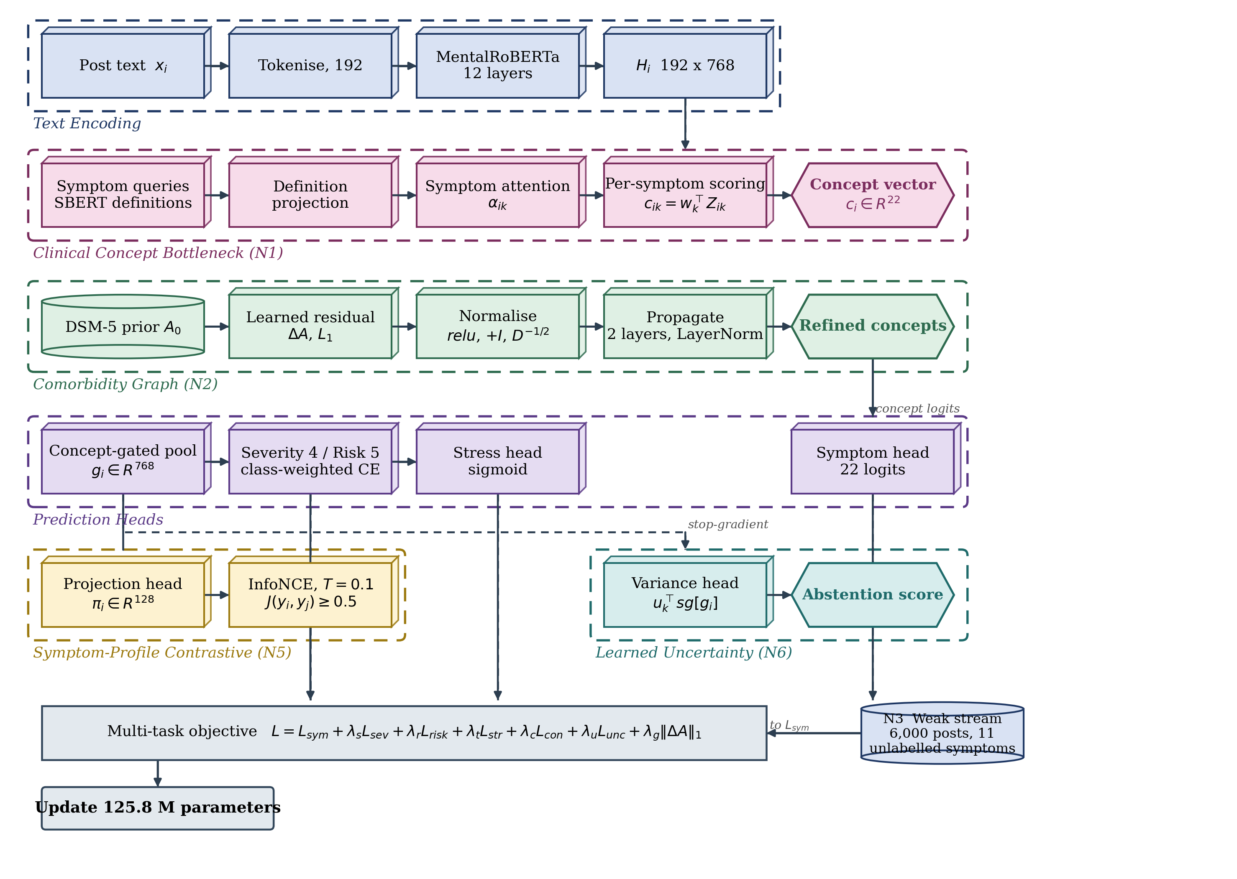
Figure 2. Architecture of SymptoGraph-LLM, in which the symptom head reads the graph-refined concept logits while the severity, risk and stress heads read those logits concatenated with the concept-gated pooled vector.
The post is tokenised to a fixed length of 192 positions and encoded by the twelve-layer domain-pretrained transformer, producing a sequence of contextual token representations of width 768. The twenty-two symptom queries, initialised from the sentence embeddings of the clinical definitions and thereafter trained, compute one attention distribution per symptom over the token positions, and the attention-weighted sums form a matrix of twenty-two per-symptom evidence vectors. Each symptom is then scored by its own projection vector and bias, which yields the twenty-two concept logits. The independence of these projections is a deliberate design decision instead of an implementation detail: a single shared projection applied to all symptoms leaves each symptom only a scalar rescaling of one common direction in representation space, which is not a concept bottleneck at all, and was observed during development to collapse the symptom head to a macro-F1 of zero while the flat configuration with independent projections continued to learn normally. The concept logits are passed through a sigmoid to form the gate, and the concept-gated pooled representation is the gate-weighted average of the per-symptom evidence vectors, so that the downstream heads observe a summary of exactly the textual evidence the concepts attended to.
The concept logits are refined by message passing over the comorbidity graph, whose nodes comprise the twenty-two symptoms together with the fourteen disorder categories observed in the corpus (D = 14), two of which are the control and mixed groups. The adjacency is the sum of a fixed prior and a learned residual, where the symptom-to-disorder block of the prior was authored by the present authors from DSM-5 criterion sets and the PHQ-9 and GAD-7 item content and has not yet been reviewed by a clinician, the symptom-to-symptom block holds positive pointwise mutual information over co-annotated gold labels, of which only 31 of the 231 symptom pairs are observable, and the disorder-to-disorder block is estimated from author co-membership across the training partition of the unlabelled pool as a conditional co-membership probability. The conditional form is used in preference to pointwise mutual information because the mean number of distinct conditions per author in this corpus is 1.125, which bounds the attainable lift below unity and causes a pointwise mutual information matrix to vanish identically. The strongest conditional edges link suicidality, loneliness and anxiety to depression. A separate enrichment analysis restricted to authors with two or more conditions recovers clinically plausible pairs, the strongest holding between bipolar disorder and schizophrenia, between borderline personality disorder and eating disorders, and between attention-deficit hyperactivity disorder and autism; this enrichment matrix serves as a sanity check and does not enter the adjacency. Two numerical safeguards are applied in the propagation step. Non-negativity is enforced on the summed adjacency before symmetric normalisation, because an unconstrained residual can drive a node degree towards zero and the inverse square-root normaliser then amplifies activations by four orders of magnitude, a failure observed directly during development as a training loss of order ten to the thirteenth. Layer normalisation is applied after each residual propagation step so that repeated message passing cannot compound activation scale across layers.
Two further modules control how the concept layer is supervised rather than what it emits. The weak-label branch draws a batch of LLM-annotated posts once per optimisation step from a separate loader, and contributes only the symptom term of the objective. The branch is deliberately not implemented by concatenating the weak rows into the training set, because concatenation inflates the number of optimiser steps per epoch by forty-six per cent, alters the learning-rate schedule relative to configurations without weak supervision, and reduces the number of severity-labelled and risk-labelled rows per batch, all of which were measured during development to degrade precisely the tasks carrying the fewest annotations. The learned-variance module reads the same pooled representation through a stopped gradient and predicts a log-variance per symptom, which is trained against the squared error the symptom head actually makes. Because the gradient does not reach the encoder through this path, the module cannot lower its own loss by making the symptom head less accurate, and the resulting score is usable as an abstention signal rather than merely as a reported confidence. A layer-wise summary of the architecture is given in Table 4.
Table 4. Layer-wise architecture summary of the proposed SymptoGraph-LLM
Layer | Configuration | Output shape
Input | tokenised post, truncation at 192 | (B, 192)
Encoder embedding | MentalRoBERTa word + position embeddings | (B, 192, 768)
Encoder blocks 1-12 | self-attention 12 heads, FFN 3072, GELU | (B, 192, 768)
Symptom queries | 22 queries initialised from SBERT definitions | (22, 384)
Definition projection | linear 384 to 768 over query embeddings | (22, 768)
Symptom attention | scaled dot-product over token positions, masked | (B, 192, 22)
Evidence aggregation | attention-weighted sum per symptom | (B, 22, 768)
Dropout | p = 0.1 | (B, 22, 768)
Per-symptom scoring | independent vector and bias per symptom | (B, 22)
Concept gate | sigmoid activation of concept logits | (B, 22)
Graph node features | symptom nodes + disorder nodes, width 128 | (B, 22+D, 128)
Prior adjacency | DSM-5 symptom-disorder, conditional disorder-disorder | (22+D, 22+D)
Residual adjacency | learned, L1-penalised | (22+D, 22+D)
Normalised adjacency | relu, add identity, symmetric normalisation | (22+D, 22+D)
Graph layer 1 | linear 128, ReLU, residual, LayerNorm | (B, 22+D, 128)
Graph layer 2 | linear 128, ReLU, residual, LayerNorm | (B, 22+D, 128)
Graph refinement | linear projection to concept logit correction | (B, 22)
Concept-gated pooling | gate-weighted average of evidence vectors | (B, 768)
Head input | concat(concept logits, pooled evidence) | (B, 790)
Symptom head | concept logits, thresholded per symptom | (B, 22)
Severity head | linear projection, class-weighted softmax | (B, 4)
Risk head | linear projection, class-weighted softmax | (B, 5)
Stress head | linear projection, sigmoid | (B, 1)
Contrastive projector (N4) | linear 768, ReLU, linear 128, L2-normalised | (B, 128)
Profile positives (N4) | Jaccard over annotated symptoms ≥ 0.5, temperature 0.1 | (B, B)
Variance head (N5) | linear over stopped-gradient head input (790), clamped to [-6, 6] | (B, 22)
Abstention score (N5) | mean predicted log-variance over symptoms | (B, 1)
Selective ranking (N5) | posts ordered by abstention score, retained at coverage | (B,)
Weak-label loader (N3) | separate stream, 6,000 posts, drawn once per step | (16, 192)
Objective | masked multi-task sum with seven weighted terms | scalar

The suggested design also allows comparing different configuration schemes and performing component-wise ablation, because each novelty occupies a separable position in the forward path and can be disabled without altering the remainder. Separability of this kind is a requirement on the implementation instead of a consequence of the diagram, and it is enforced by recording the architectural configuration of every run in a fingerprint that a resumed run must match before its checkpoint is accepted, so that a rung cannot silently inherit a component it was defined to exclude. The parameter budget is dominated by the pretrained encoder, so that the clinical structure introduced by the framework is obtained at a small marginal cost in capacity, which matters because the model already fits its ordinal training partitions to saturation and additional free parameters would worsen rather than improve generalisation. The distribution of parameters across the components is reported in Table 5.
Table 5. Parameter distribution of the proposed SymptoGraph-LLM
Component | Parameters
MentalRoBERTa encoder | 124,645,632
Symptom queries (22 x 384) | 8,448
Definition projection (384 to 768) | 295,680
Per-symptom scoring vectors and biases | 16,918
Graph node embeddings and residual adjacency | 2,816 + 128D + (22+D)²
Graph propagation layers | 32,768
Graph refinement projection | 129
Contrastive projector (N4) | 688,256
Variance head (N5) | 17,402
Severity, risk and stress heads | 7,910
Total trainable | 125,766,023 (≈ 125.8 M)

The architecture overview in Table 4 demonstrates clearly that the proposed SymptoGraph-LLM framework is modular in the sense required for a controlled ablation, since the concept bottleneck, the comorbidity graph, the weak-label stream, the contrastive projector and the variance head each occupy an identifiable stage and each can be removed in isolation while the shared protocol is held fixed. Two properties of the design deserve emphasis in connection with the evaluation that follows. First, the two graded tasks are predicted by ordinary linear heads under capped inverse-frequency class weights, not by a cumulative-link model, so the ordering of their levels is not imposed by the architecture and is instead measured by the quadratic weighted kappa and the mean absolute error reported throughout the results and discussions. The five-level suicide-risk task in particular is estimated from 340 training instances with no structural borrowing from the more abundant severity annotation, which is the principal reason the risk results carry the widest intervals in the study. Second, the contrastive projector and the variance head are the only components that add appreciable capacity beyond the encoder, together accounting for roughly 0.7 million of the 125.8 million trainable parameters, so a difference in performance between the ladder rungs is attributable to the arrangement of the structure, not to capacity.
3.5 Loss Function and Hyperparameter Configuration
The optimisation approach used in the proposed SymptoGraph-LLM framework is a critical factor in training a network whose symptom layer must remain clinically meaningful while four prediction tasks of very unequal size compete for the shared encoder. The objective therefore combines a masked symptom term, two class-weighted ordinal terms, a binary stress term, a symptom-profile contrastive term, a learned-variance term and a sparsity penalty on the graph residual, each weighted so that no task is silenced by the scarcity of its annotation.
$L_{sym}=\frac{\sum_{i,k}{ }m_{ik} ω_{ik} BCE\left(c_{ik},y_{ik}\right)}{\sum_{i,k}{ }m_{ik} ω_{ik}}$ (10)
where the mask excludes symptom entries the source corpus did not annotate, and the weight combines the capped inverse-frequency positive weight for that symptom with the temperature-rescaled confidence of the label where the label is weak and unity where it is gold. The cap is set at ten, the rarest concepts being infrequent enough that an uncapped reciprocal would assign them several hundred times the gradient of the commonest concept.
$L_{ord}=-\frac{1}{N}\sum_{i=1}^{N}{ }γ_{y_{i}}log softmax{\left(Wg_{i}+b\right)}_{y_{i}}, γ_{j}=min\left(\frac{N}{J n_{j}}, γ_{max}\right)$ (11)
where the same form applies to depression severity over four levels and to suicide risk over five, and the class weight is the capped reciprocal of the level frequency computed on the training partition alone, with the cap γ_max set to 10 so that every weight is clipped to the interval from 0.1 to 10. Class weighting is not optional here: under unweighted cross-entropy both graded heads collapse onto their majority level, since the lowest severity band alone holds 71.9 per cent of the training instances. The levels are predicted by an ordinary linear projection, not by a cumulative-link model, so no ordering constraint is imposed by the architecture; the ordering is an empirical property of the fitted head, measured rather than assumed by the metrics of the evaluation metrics. In the implementation the heads read the 790-dimensional concatenation of the concept logits with g_i, as listed in Table 4; Equation 11 writes g_i for brevity.
$L_{con}=-\frac{1}{\left|I\right|}\sum_{i∈I}{ }\frac{1}{\left|P_{i}\right|}\sum_{j∈P_{i}}{ }log\frac{exp\left(π_{i}^{T}π_{j}/T\right)}{\sum_{n≠i}{ }exp\left(π_{i}^{T}π_{n}/T\right)}, P_{i}=\{j≠i: J\left(y_{i},y_{j}\right)≥0.5\}$ (12)
where the positive set of a post comprises those other posts in the batch whose annotated symptom profile reaches a Jaccard overlap of 0.5 with its own, the Jaccard index being computed only over symptoms both posts actually have annotated, and the temperature is 0.1. The design choice that distinguishes this term from a conventional contrastive objective is the definition of a positive. Augmentation-based positives would teach invariance to a perturbation of the authors' own wording, and disorder-label positives would reintroduce the single-condition assumption the framework exists to avoid, whereas profile overlap treats two posts as similar when they describe the same constellation of symptoms irrespective of the diagnostic label attached to either. Posts carrying no annotated positive symptom contribute zero instead of a degenerate gradient.
$A=relu\left(A_{0}+ΔA\right)+I, \tilde{A}=D^{-1/2}AD^{-1/2}, L_{graph}={\left\|ΔA\right\|}_{1}$ (13)
where non-negativity precedes the addition of the identity and the symmetric normalisation, guaranteeing that the node degree is at least unity and the normaliser is bounded, and the penalty drives the learned residual towards sparsity so that the adjacency remains anchored to the clinical prior. The ordering of these three operations is not interchangeable: normalising before the non-negativity projection permits a node whose incident weights sum to approximately zero, at which point the reciprocal of the degree diverges, and the consequences are reported in the training convergence analysis. Clamping the degree at a minimum of unity and applying layer normalisation to the propagated features removes the divergence.
$s_{ik}=u_{k}^{T}sg\left[g_{i}\right], L_{unc}=\frac{\sum_{i,k}{ }m_{ik}ω_{ik}\left[e^{-s_{ik}}{\left(σ\left(c_{ik}\right)-y_{ik}\right)}^{2}+\frac{1}{2}s_{ik}\right]}{\sum_{i,k}{ }m_{ik}ω_{ik}}$ (14)
where the stop-gradient operator prevents this term from propagating into the encoder or the concept layer, the squared error is evaluated without a gradient, and the predicted log-variance is clamped to the interval from minus six to six. The stop-gradient is what makes the resulting quantity trustworthy as an abstention signal: were the features not detached, the objective could be reduced either by predicting the error more accurately or by making the symptom head less accurate in a way the variance head finds easy to anticipate, and the second route trades predictive quality for apparent calibration. With the gradient stopped the variance head is a measurement instrument instead of a participant in the optimisation, and its mean predicted log-variance over the twenty-two symptoms is the ranking score for abstention. In the implementation the variance head reads the stopped-gradient 790-dimensional head input, which accounts for its 17,402 parameters in Table 5; Equation 14 writes g_i for brevity.
$L=L_{sym}+λ_{s}L_{sev}+λ_{r}L_{risk}+λ_{t}L_{str}+λ_{c}L_{con}+λ_{u}L_{unc}+λ_{g}L_{graph}$ (15)
with the six auxiliary weights set to one for severity, one for risk, one half for stress, 0.1 for the contrastive term, 0.5 for the learned-variance term and 0.0001 for the graph sparsity penalty. The weak-supervision branch contributes through the symptom term of Equation 10 evaluated on its own batch rather than through a separate weighted term.
The optimisation is performed with the AdamW optimiser using separate learning rates of two times ten to the power minus five for the pretrained encoder and one times ten to the power minus three for the randomly initialised heads, because a single rate either fails to move the heads or destabilises the encoder. Gradients are clipped at unit norm, and mixed-precision arithmetic is used with bfloat16 where the accelerator supports it, and a cosine schedule with ten per cent warmup is applied over the full step budget. The reported checkpoint is the one maximising a validation selection score defined in the evaluation metrics as the mean of symptom macro-F1, symptom macro-AUROC and depression-severity kappa, with early stopping after 4 epochs without improvement. This rule and its consequences are examined in the training convergence analysis, because the epoch it selects and the epoch of minimum validation loss do not coincide. Per-symptom decision thresholds are tuned on the validation split and applied unchanged to the test split. Every configuration is replicated across three seeds and the full configuration is reported in Table 6.
Table 6. Hyperparameter configuration of the proposed SymptoGraph-LLM
Hyperparameter | Value / configuration
Framework | PyTorch with HuggingFace Transformers
Dataset | harmonised seven-corpus union, 19,762 posts
Training paradigm | multi-task supervised with weak-supervision stream
Accelerator | single NVIDIA L4, 24 GB, high-RAM runtime
Encoder | MentalRoBERTa, 12 layers, hidden 768
Tokeniser | byte-level BPE, vocabulary 50,265
Sequence pooling | concept-gated (Eq. 9) for L1–L5; mean over non-padding positions for L0
Maximum sequence length | 192 tokens
Batch size | 32
Weak-label batch size | 16, drawn once per optimiser step
Symptom ontology | 22 concepts, 9 PHQ-9, 7 GAD-7, 6 auxiliary
Severity levels | 4, minimal to severe
Risk levels | 5, C-SSRS bands
Split strategy | author-disjoint, strictest split wins
Weak labelling model | Qwen2.5-7B-Instruct served through vLLM
Weak pool | 1,017,959 posts; 49,982 annotated, 6,000 used in training
Optimiser | AdamW, weight decay 0.01
Encoder learning rate | 2 x 10⁻⁵
Head learning rate | 1 x 10⁻³
Schedule | cosine decay, warmup ratio 0.1
Gradient clipping | 1.0 by global norm
Mixed precision | bfloat16 where supported, else fp16 with scaler
Epochs | 10
Early stopping | patience 4 on the selection score
Checkpoint selection | composite validation selection score
Dropout | 0.1
Symptom positive weight | capped inverse frequency, cap 10
Ordinal class weights | capped inverse frequency
Decision thresholds | per symptom, tuned on validation
Graph node width | 128
Graph propagation layers | 2
Graph sparsity weight | 0.0001
Contrastive weight | 0.1
Contrastive temperature | 0.1
Contrastive positive threshold | Jaccard ≥ 0.5
Projection dimension | 128
Learned-variance weight | 0.5
Variance head input | stopped-gradient pooled features, clamp [-6, 6]
Task weights | symptoms 1.0, severity 1.0, risk 1.0, stress 0.5
Seeds | 0, 1, 2
Replication | 3 seeds; dispersion reported as 1 standard deviation
Reported split | held-out test, read once per run

The selected setup provides trade-offs between symptom-detection fidelity, ordinal agreement, resistance to memorisation on the small annotated partitions and computational cost. Two settings in Table 6 warrant comment because the measurements do not straightforwardly support them. The epoch budget of 10 is larger than the validation loss alone would justify, that quantity reaching its minimum of 1.182 at epoch 2 and rising thereafter, and is retained because the symptom and stress metrics continue to improve past that point; the cost is quantified in the training convergence analysis. Training uses 6,000 of the 49,982 weak-labelled posts rather than all of them because the measurable benefit of the branch is bounded by the eleven gold-supervised symptoms on which every symptom metric here is computed.
4. Results and Discussions
4.1 Experimental Setup
The harmonised seven-corpus collection described in the dataset description has been employed in the current work in order to evaluate the performance of the proposed SymptoGraph-LLM framework. All experiments were conducted on a single accelerator with 24 gigabytes of memory using mixed-precision arithmetic, and every configuration was replicated across three random seeds so that a variance estimate accompanies each reported quantity. The six rungs of the ablation ladder in the ablation study share one configuration object exactly: the same leakage-controlled partitions, masked multi-task objective, capped symptom positive weights, capped ordinal class weights, per-symptom decision thresholds tuned on validation data, checkpoint selection rule, epoch budget, early-stopping patience and seeds. The three reference models of the comparison with state-of-the-art models do not share that configuration. They were trained for 8 epochs at batch size 16 and a maximum length of 256 tokens without early stopping, against 10 epochs at batch size 32 and 192 tokens with patience 4 for the proposed framework, and they receive no weak labels. The partitions, label space, metrics and seeds are shared, but the optimisation budget is not, so that comparison is against reasonable reference configurations and not a controlled experiment; its margins cannot be attributed to architecture, and the conclusions this paper draws about architecture rest on the ladder in the ablation study instead. Three reference models were retrained: a term-frequency representation with a multilayer perceptron, representing the classical lexical approach. A bidirectional recurrent encoder with attention, representing the pre-transformer neural approach; and a fine-tuned MentalRoBERTa, the domain-pretrained transformer that constitutes the prevailing standard for this family of tasks and is the strongest of the three on every metric reported in the comparison with state-of-the-art models. These three are reference models, not reimplementations of specific published systems, so the comparison does not establish a ranking against any named method in the literature; the figures here are not comparable with those reported in the surveyed papers, whose evaluations use different corpora, label spaces and splits. A six-rung ablation ladder carries the architectural argument, adding exactly one component at each step from a flat encoder through to the complete framework while the protocol is held fixed, so that the contribution of each novelty is isolated against the same three-seed noise band.
4.2 Evaluation Metrics
To test the efficacy of the proposed SymptoGraph-LLM framework, several metrics are considered for analysing symptom-detection fidelity, ordinal agreement, behaviour under class imbalance and the statistical reliability of every reported difference. Because the four prediction tasks differ in size by more than an order of magnitude, no single aggregate is reported as the headline quantity; each task is reported separately. Three conventions apply throughout and are stated here because they are easy to misread. Every value of the form a plus or minus b is the mean and the sample standard deviation over the three seeds, not a confidence interval and not a standard error. The quantity named Composite is the unweighted mean of three metrics only, namely symptom macro-F1, depression-severity kappa and suicide-risk kappa; it excludes the stress task, and because one of its three terms is the risk kappa measured on 74 instances it is the noisiest column in every table. The separate quantity used for checkpoint selection is the unweighted mean of symptom macro-F1, symptom macro-AUROC and depression-severity kappa, which excludes both risk and stress; it is never reported as a result.
${F1}_{macro}=\frac{1}{K}\sum_{k=1}^{K}{ }\frac{2 {TP}_{k}}{2 {TP}_{k}+{FP}_{k}+{FN}_{k}}$ (16)
where the macro average is taken over the symptoms carrying gold annotation, and the per-symptom decision threshold is the value tuned on the validation split instead of a fixed one half. The distinction is not cosmetic: under a fixed threshold of one half a fixed cut leaves well-ranked symptoms scoring near zero F1 whenever their probabilities sit below one half, so a reported F1 on this label space characterises the threshold policy as much as the representation.
${AUROC}_{k}=\frac{\sum_{i∈P_{k}}{ }rank\left(p_{ik}\right)-n_{k}^{+}\left(n_{k}^{+}+1\right)/2}{n_{k}^{+} n_{k}^{-}}$ (17)
where the rank-based form is used so that the estimate is invariant to the decision threshold, the sums run over the positive instances of each symptom, and the macro average is taken over symptoms for which both classes are present in the evaluation split. Area under the receiver operating characteristic is reported alongside macro-F1 because the two respond differently to the class imbalance of the symptom space: the threshold-free measure characterises the ranking the model induces, whereas the F1 measure characterises the operating point a deployment would use.
$κ_{w}=1-\frac{\sum_{a,b}{ }W_{ab}O_{ab}}{\sum_{a,b}{ }W_{ab}E_{ab}}, W_{ab}=\frac{{\left(a-b\right)}^{2}}{{\left(J-1\right)}^{2}}$ (18)
where the weight matrix penalises disagreements quadratically in the distance between the predicted and the true level, so that a near-miss on an ordinal scale is credited more than a distant error, and the observed and expected matrices are computed over the levels present in the evaluation split. The quadratic weighting is the appropriate choice for both graded tasks because the levels of the PHQ-9 severity bands and of the C-SSRS risk bands are ordered and unequally consequential, so that confusing the minimal band with the severe band is a materially different error from confusing adjacent bands, a distinction that unweighted accuracy and macro-F1 both discard. The chance correction matters here because the severity training distribution places 71.9 per cent of its mass in the lowest band. Because the graded heads are ordinary classifiers rather than cumulative-link models, this metric is also the instrument by which the ordering of the fitted levels is verified rather than assumed.
$R\left(β\right)=\frac{\sum_{i}{ }1\left[ {\bar{s}}_{i}≤q_{β} \right] l_{i}}{\sum_{i}{ }1\left[ {\bar{s}}_{i}≤q_{β} \right]}, AURC=\int_{0}^{1}{ }R\left(β\right) dβ$ (19)
where the abstention score of a post is the mean predicted log-variance over the twenty-two symptoms, the quantile is taken at the retained fraction, and the per-post loss is the symptom error rate. Selective risk is the error on the retained subset alone, so it answers the question a triage deployment asks, and the area under the curve summarises the whole coverage range in one number. Alongside the quadratic weighted kappa the mean absolute error is also reported, since a head emitting only extreme levels can retain a moderate kappa while its absolute error degrades. Both that error and the selective risk are oriented oppositely to every other quantity here, lower being better, and each direction is marked in the table headings. Two further quantities belong with this one and are defined here because they are the right comparisons to make. The first is the same risk-coverage curve computed from a maximum-probability score, that is, ranking posts by the largest predicted symptom probability instead of by the learned variance; without it the curve in Figure 5 shows only that some ordering exists, not that the variance head supplies a better one than the classifier's own confidence. The second is the expected calibration error, the mean absolute gap between confidence and accuracy over equal-width probability bins, which measures whether the scores are calibrated and not merely ordered. Neither is reported in this paper. Both require per-example predictions, which were not retained, so the abstention result should be read as evidence that the variance head ranks its own reliability usefully and not as evidence that it beats a softmax-confidence baseline or that it is calibrated. The future work records the re-run that would settle both.
$p=2min\left(Pr\left[Δ^{\left(b\right)}≤0\right], Pr\left[Δ^{\left(b\right)}≥0\right]\right), Δ^{\left(b\right)}=m\left(B^{\left(b\right)}\right)-m_{0}\left(B^{\left(b\right)}\right)$ (20)
where the resampling would be paired on test examples so that the comparison observes differences in prediction rather than differences in which examples were drawn. This test is defined here because it is the test these comparisons require, and it is not reported in this paper: the per-example predictions of the ablation rungs and the reference models were not retained, so no paired test can be computed after the fact. What is reported instead is the mean and standard deviation over three seeds, which bounds nothing and supports no claim of significance.
4.3 Performance Analysis of the Proposed SymptoGraph-LLM
The evaluation of the suggested SymptoGraph-LLM model was carried out on the held-out test partition to confirm the efficiency of the symptom-mediated architecture across the four prediction tasks. Every number reported in this section is taken from the checkpoint the selection rule of the loss function and hyperparameter configuration chose on validation data alone, with the test partition read exactly once per run and the per-symptom decision thresholds carried over from validation without adjustment, so the reported configuration is the one the protocol would select in deployment instead of the best-performing epoch identified in hindsight. The progression of the validation metrics over the training budget is reported in Table 7, which permits the separation of continued learning from the onset of memorisation on the small graded partitions.
Table 7. Per-epoch validation metrics of SymptoGraph-LLM, averaged over three seeds to epoch 8 and over the two seeds that continued at epochs 9 and 10.
Metric | Epoch 1 | Epoch 2 | Epoch 3 | Epoch 6 | Epoch 8 | Epoch 9 | Epoch 10
Multi-task validation loss | 1.250 | 1.182 | 1.353 | 2.191 | 2.553 | 2.756 | 2.906
Multi-task training loss | 3.111 | 2.429 | 1.742 | 0.356 | 0.010 | -0.104 | -0.189
Symptom macro-F1 | 0.710 | 0.730 | 0.754 | 0.789 | 0.798 | 0.800 | 0.802
Symptom macro-AUROC | 0.832 | 0.864 | 0.875 | 0.899 | 0.903 | 0.903 | 0.903
Symptom macro-AP | 0.787 | 0.818 | 0.832 | 0.860 | 0.867 | 0.866 | 0.866
Stress AUROC | 0.903 | 0.917 | 0.919 | 0.918 | 0.918 | 0.917 | 0.915
Stress F1 | 0.830 | 0.838 | 0.849 | 0.849 | 0.848 | 0.848 | 0.851
Severity QWK | 0.500 | 0.486 | 0.495 | 0.474 | 0.463 | 0.488 | 0.468
Severity macro-F1 | 0.462 | 0.515 | 0.514 | 0.493 | 0.490 | 0.501 | 0.491
Severity MAE | 0.445 | 0.513 | 0.492 | 0.439 | 0.441 | 0.425 | 0.429
Risk QWK | 0.261 | 0.386 | 0.424 | 0.367 | 0.345 | 0.292 | 0.309
Risk macro-F1 | 0.236 | 0.274 | 0.312 | 0.332 | 0.317 | 0.292 | 0.283
Risk MAE | 1.077 | 0.844 | 0.821 | 0.910 | 0.910 | 0.968 | 0.974
Training risk QWK | 0.182 | 0.430 | 0.682 | 0.998 | 1.000 | 1.000 | 1.000
Selection score | 0.681 | 0.693 | 0.708 | 0.721 | 0.721 | 0.730 | 0.724

The results presented in Table 7 show the behaviour the protocol was designed to expose, and one feature of them needs comment. The multi-task validation loss attains its minimum of 1.182 at epoch 2 and rises monotonically thereafter, reaching 2.553 by epoch 8, which is 2.16 times its minimum. Over the same interval the training quadratic weighted kappa on the suicide-risk partition reaches 0.998 at epoch 6 and 1.000 thereafter, which on a partition of 340 instances across five levels is complete memorisation rather than continued learning, while the validation kappa on the same task peaks at 0.424 at epoch 3 and declines to 0.345. The selection score nonetheless rises until epoch 6 and then plateaus at 0.721, because two of its three terms, symptom macro-F1 and symptom macro-AUROC, improve for longer than the severity kappa, and it therefore selects a late checkpoint: epochs 9, 4, 9 across the three seeds. The reported model is consequently a checkpoint taken well past the validation-loss minimum, and the graded-task numbers in Table 8 should be read as the output of a configuration that is past its best on those two tasks while at or near its best on the other two. The symptom and stress results are unaffected by this and the severity results remain the strongest in the study, but the two graded heads may score higher under validation-loss selection, and the future work records the re-run that would settle this. The final performance of the proposed framework against the flat-encoder reference is reported in Table 8, where it attains 0.886 ± 0.008 symptom macro-AUROC and 0.775 ± 0.012 symptom macro-F1 on the held-out partition.
Table 8. Final performance of the proposed SymptoGraph-LLM (test split) against the flat-encoder reference
Metric | SymptoGraph-LLM (L5) | Flat-encoder reference (L0)
Symptom macro-F1 | 0.775 ± 0.012 | 0.752 ± 0.010
Symptom macro-AUROC | 0.886 ± 0.008 | 0.875 ± 0.011
Stress F1 | 0.854 ± 0.012 | 0.829 ± 0.012
Stress AUROC | 0.920 ± 0.008 | 0.907 ± 0.008
Severity macro-F1 | 0.602 ± 0.024 | 0.537 ± 0.023
Severity QWK | 0.531 ± 0.036 | 0.472 ± 0.021
Severity MAE | 0.382 ± 0.014 | 0.477 ± 0.046
Risk macro-F1 | 0.255 ± 0.035 | 0.257 ± 0.009
Risk QWK | 0.400 ± 0.136 | 0.430 ± 0.036
Risk MAE | 0.926 ± 0.120 | 0.928 ± 0.074
Composite | 0.569 ± 0.056 | 0.552 ± 0.018
Selective risk, full coverage | 0.192 ± 0.011 | not available
Selective risk, 80% coverage | 0.159 ± 0.013 | not available
Selective risk, 50% coverage | 0.095 ± 0.022 | not available
Area under risk-coverage curve | 0.099 ± 0.015 | not available

The final evaluation confirms the behaviour observed during training. The proposed architecture delivers symptom detection at the level reported in Table 8 while retaining the clinical addressability that the flat reference lacks entirely, since the flat configuration produces no symptom-level intermediate quantity that a practitioner could inspect. Two points require comment. The weak-only symptoms are not reported in Table 8 because eleven of the twenty-two symptoms carry no gold annotation in any constituent corpus, so the direct effect of the weak-supervision branch on the symptoms it actually supervises cannot be evaluated with the present annotation and can appear only indirectly through transfer to the gold-supervised subset. This is a property of the available data, not of the framework, and it bounds the strength of any claim that can be made about that component regardless of how the remaining numbers fall. The second entry requiring comment is the suicide-risk kappa, on which the flat reference records 0.430 ± 0.036 against 0.400 ± 0.136 for the proposed framework. The proposed framework does not lead on that metric. It should not be read as evidence that the structure harms the risk task: the seed standard deviation of the proposed configuration on this metric alone is 0.136, the task is evaluated on 74 instances across five levels, and the comparison with state-of-the-art models discusses the seed dispersion on that task. Both conditions share the same pretrained encoder and differ by under one per cent of the parameter budget, so capacity does not explain the differences between them. The ablation study shows, however, that most of the gain appears at the final ladder step, which cannot be causally attributed to architecture.
The ordinal measurements represent the gap between the proposed framework and the reference on the two graded tasks, and they must be read together with the partition sizes, not in isolation. Depression severity is evaluated on 541 test instances across four levels whose training distribution is dominated by the lowest band at 71.9 per cent, so the macro-F1 measure on that task rewards a model that distributes its predictions across the minority levels, which the capped inverse-frequency class weights explicitly encourage. The quadratic weighted kappa and the mean absolute error are consequently the more appropriate ordinal measures and are reported alongside, and on this task the proposed framework leads the reference on all three, at 0.531 ± 0.036 against 0.472 ± 0.021 for the kappa and 0.382 ± 0.014 against 0.477 ± 0.046 for the error, the latter being a metric where lower is better. Suicide risk is evaluated on 74 test instances across five levels, and the consequence of that partition size is that the seed dispersion on that task alone reaches 0.136, which exceeds every architectural difference observed in this study, so differences on the risk task are not interpretable as architectural effects.
4.4 Training Convergence Analysis
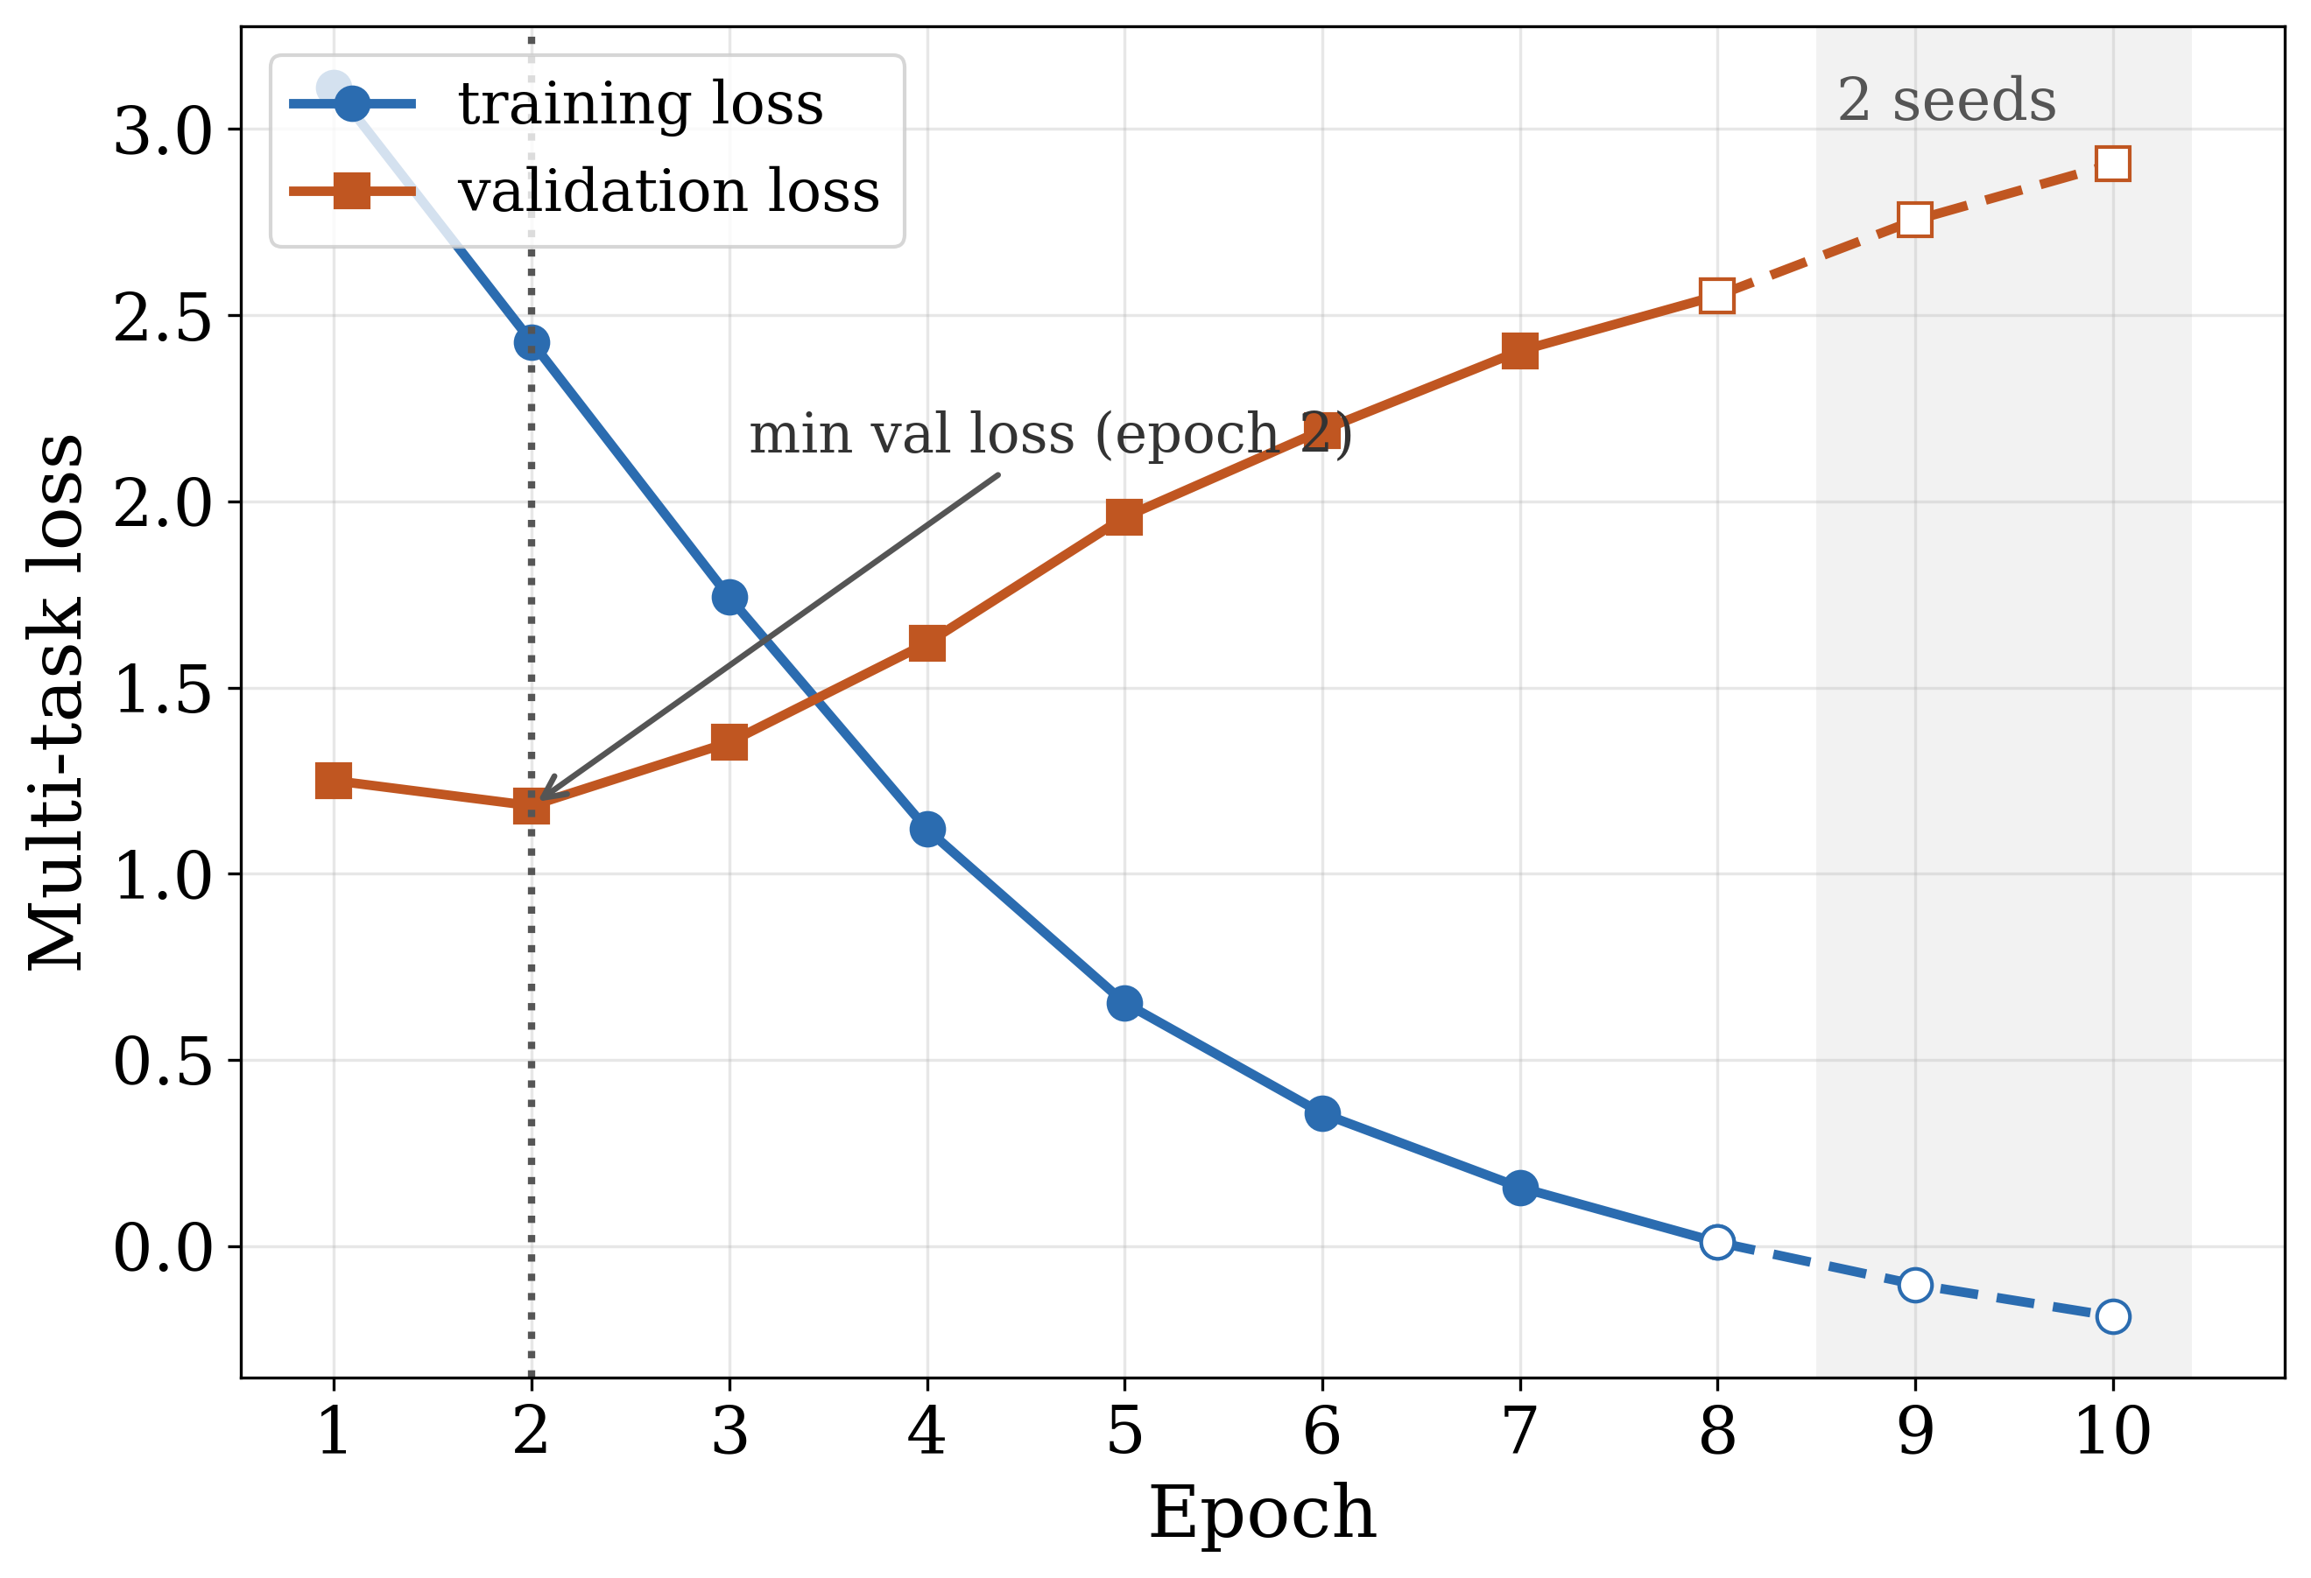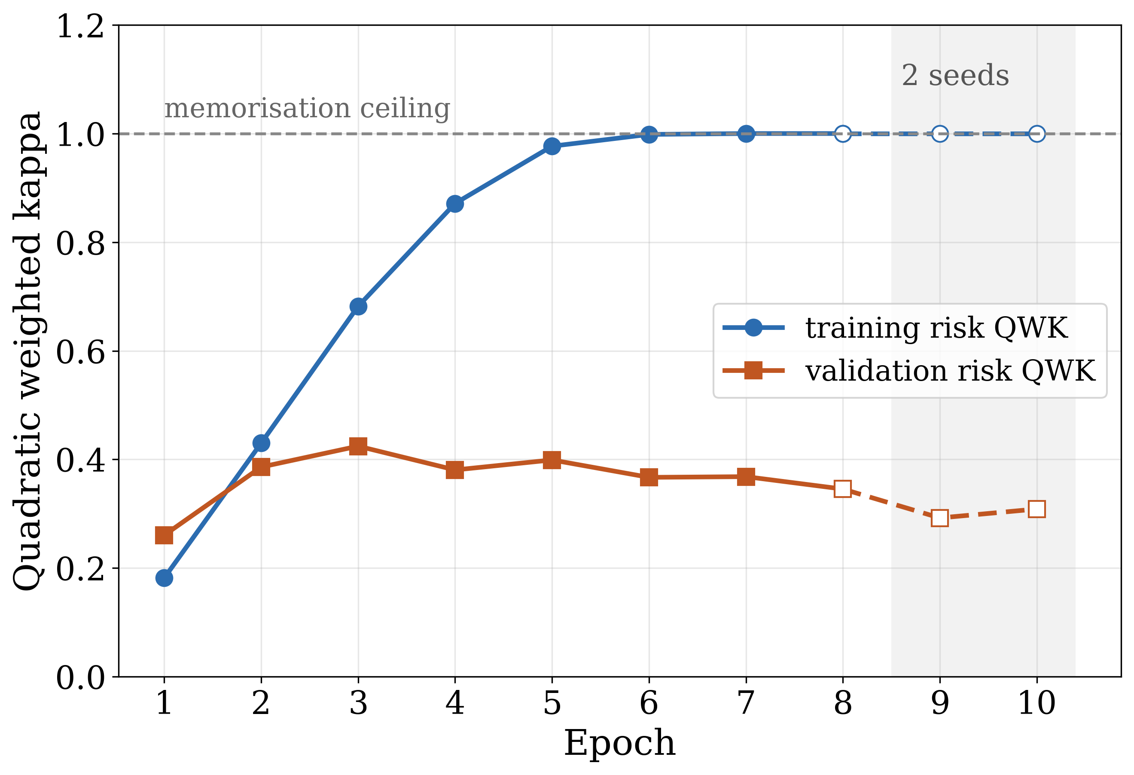
Figure 3. Multi-task loss (A) and suicide-risk quadratic weighted kappa (B) on the training and validation splits, the dashed tail from epoch 9 averaging only the two seeds that ran past early stopping.
Figure 3 represents the optimisation convergence properties of the proposed SymptoGraph-LLM architecture over the entire training budget. Panel A reports the multi-task objective on the training and validation partitions, and panel B reports the quadratic weighted kappa on the suicide-risk task separately for the two partitions, because the divergence between them is the quantity the training protocol is designed to control. The training objective decreases monotonically throughout the budget, which confirms that optimisation is stable under the combined seven-term loss and that no term dominates to the exclusion of the others. Stability under this objective is not a given and was not obtained at the first attempt: an earlier formulation of the graph term, in which the degree normalisation preceded the non-negativity projection, drove the objective to the order of ten to the thirteenth power in a substantial fraction of the runs that included the graph, and the curves reported here are those of the corrected formulation given in the loss function and hyperparameter configuration. The training objective approaches zero by epoch 8. It is not bounded below by zero, because the learned-variance term of Equation 14 contributes one half of the predicted log-variance, which is negative wherever the model is confident, so its absolute value carries no interpretation. The validation objective, by contrast, attains its minimum of 1.182 at epoch 2 and increases thereafter.
Moreover, the divergence between the training and validation trajectories is the central observation of this section, and it has a consequence for the reported results. The training quadratic weighted kappa on the suicide-risk partition rises from 0.182 at the first epoch to 0.998 at epoch 6 and 1.000 thereafter, which on a partition of 340 instances across five levels means the head reproduces its training partition exactly. The validation kappa on the same task does not follow it, peaking at 0.424 at epoch 3 and declining to 0.345, which establishes that the additional training fits the partition without improving generalisation. The selection rule in force averages symptom macro-F1, symptom macro-AUROC and severity kappa, and therefore does not see this: its two symptom terms continue to improve, the aggregate rises and then plateaus, and the checkpoints it selects fall at epochs 9, 4 and 9, by which point the validation loss has risen to about twice its minimum (2.16 times at epoch 8). The proposed framework nonetheless leads the reference models on 8 of the 10 metrics in Table 10, so the selection rule is not responsible for the headline result, but it is responsible for the two graded tasks being reported below their attainable values, and a selection rule that monitored validation loss directly would be the correct choice for a deployment of this framework.
Finally, the convergence record bears on how the ladder in the ablation study should be read. Because every rung shares the budget, the schedule and the selection rule of Table 6 without exception, the memorisation visible in panel B of Figure 3 affects all six rungs alike and cannot account for a difference between them. What it does account for is the magnitude of the seed standard deviations on the risk task, which reach 0.136 for the proposed configuration against 0.008 for its symptom macro-AUROC, a ratio of more than an order of magnitude between two metrics from the same runs. The practical consequence is that the symptom and stress columns of Table 9 support step-to-step comparison between rungs whereas the risk column does not, and the discussion that follows treats them accordingly rather than reporting all six columns with equal confidence.
4.5 Ablation Study
In order to evaluate the effect of each novelty in isolation within the SymptoGraph-LLM model, an ablation experiment was conducted in which exactly one component is added at each step of a six-rung ladder beginning from a flat encoder with ordinary prediction heads and ending with the complete framework. Every rung shares the configuration of Table 6 without exception, so that no rung benefits from a learning rate, schedule, epoch budget or selection rule the others did not receive, and every rung is replicated across the same three seeds. The ladder adds the concept bottleneck at L1, the comorbidity graph at L2, the weak-label stream at L3, the symptom-profile contrastive term at L4 and the learned-variance head at L5. The results on the held-out test split are reported in Table 9 and plotted in Figure 4.
Table 9. Ablation study results of the proposed SymptoGraph-LLM
Model | Sym F1 ↑ | Sym AUROC ↑ | Sev QWK ↑ | Sev MAE ↓ | Sev F1 ↑ | Risk QWK ↑ | Risk MAE ↓ | Stress AUROC ↑ | Composite ↑
L0 (flat encoder) | 0.752 ± 0.010 | 0.875 ± 0.011 | 0.472 ± 0.021 | 0.477 ± 0.046 | 0.537 ± 0.023 | 0.430 ± 0.036 | 0.928 ± 0.074 | 0.907 ± 0.008 | 0.552 ± 0.018
L1 (+ N1 bottleneck) | 0.767 ± 0.006 | 0.885 ± 0.001 | 0.478 ± 0.057 | 0.433 ± 0.032 | 0.559 ± 0.021 | 0.339 ± 0.077 | 0.973 ± 0.082 | 0.911 ± 0.002 | 0.528 ± 0.043
L2 (+ N2 graph) | 0.769 ± 0.005 | 0.886 ± 0.003 | 0.492 ± 0.021 | 0.441 ± 0.017 | 0.556 ± 0.013 | 0.380 ± 0.038 | 0.955 ± 0.056 | 0.905 ± 0.007 | 0.547 ± 0.017
L3 (+ N3 weak labels) | 0.761 ± 0.005 | 0.881 ± 0.000 | 0.487 ± 0.016 | 0.429 ± 0.033 | 0.562 ± 0.027 | 0.277 ± 0.111 | 1.032 ± 0.087 | 0.903 ± 0.004 | 0.508 ± 0.034
L4 (+ N4 contrastive) | 0.751 ± 0.011 | 0.874 ± 0.011 | 0.490 ± 0.019 | 0.439 ± 0.039 | 0.574 ± 0.012 | 0.380 ± 0.117 | 0.950 ± 0.101 | 0.909 ± 0.007 | 0.540 ± 0.047
L5 (+ N5 uncertainty) | 0.775 ± 0.012 | 0.886 ± 0.008 | 0.531 ± 0.036 | 0.382 ± 0.014 | 0.602 ± 0.024 | 0.400 ± 0.136 | 0.926 ± 0.120 | 0.920 ± 0.008 | 0.569 ± 0.056

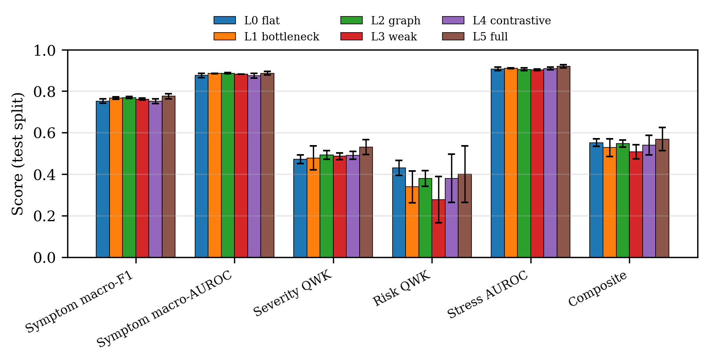
Figure 4. Comparison of the proposed SymptoGraph-LLM with the ablation configurations on the held-out test split.
The ablation in Table 9 must be read against the seed-noise band established by the three-seed replication rather than against zero, and read that way it supports a narrower set of conclusions than the leading row alone would suggest. The complete framework at L5 records the best value on 8 of the 9 metrics in that table, of which 7 are outright and 1 is a tie with an earlier rung, and it does not lead on Risk QWK. The ladder is not monotone. The concept bottleneck at L1 raises symptom macro-F1 from 0.752 to 0.767 and symptom macro-AUROC from 0.875 to 0.885, which is consistent with its mechanism, since routing every prediction through twenty-two definition-initialised concepts constrains the path to the heads without adding information to the representation. Over the same step the suicide-risk kappa falls from 0.430 to 0.339, and the flat encoder retains the best value on that metric across the whole ladder. The comorbidity graph at L2 recovers part of that loss, to 0.380, and gives the largest single improvement in severity agreement up to that point. Taken over the first four steps, however, the ladder shows no net gain: L4, which contains every component except the variance head, records 0.751 symptom macro-F1 and a composite of 0.540 against 0.752 and 0.552 for L0.
Two results in Table 9 are negative or unattributable and are reported as such. First, the weak-label stream at L3 costs performance on every measurable task: the composite falls from 0.547 to 0.508, symptom macro-F1 from 0.769 to 0.761, and the risk kappa from 0.380 to 0.277. This is the expected shape of the result instead of a surprise, and the reason is a property of the annotation: eleven of the twenty-two symptoms carry no gold label anywhere in the harmonised corpus, those eleven are precisely the ones the weak branch supervises, and every symptom metric in this paper is computed on the other eleven. The branch therefore spends capacity on concepts no metric here can credit, and can appear only through transfer; measured against the eleven gold concepts that transfer is negative at this subsample size. The claim that weak supervision benefits the unannotated symptoms is consequently not established by this study and cannot be, which is a limitation of the available annotation recorded in the future work instead of a finding about the mechanism. Second, the step from L4 to L5 shows apparent gains across the symptom, severity and stress metrics which cannot be causally attributed to the component that step introduces. The learned-variance head reads the pooled representation through a stopped gradient, as Equation 14 states, so it emits no gradient into the encoder, the concept layer or any prediction head, and it is therefore architecturally incapable of changing the symptom, severity, risk or stress outputs. The measured differences over that step are 0.775 against 0.751 in symptom macro-F1, roughly two seed standard deviations, and smaller multiples elsewhere. The most plausible mechanisms are the additional parameters altering the consumption of the random number stream and hence the initialisation of every subsequent layer, and the extra term raising the global gradient norm and so interacting with the unit-norm clipping applied to all parameters. Neither constitutes evidence that estimating uncertainty improves prediction. The contribution of this component is the abstention capability it provides, which is measured directly in the comparison with state-of-the-art models and not inferred from this table, and the apparent improvement in the other columns should be treated as training-dynamics noise. A clean test would hold the random stream fixed across the two rungs, and is recorded in the future work as outstanding. Taken together, the ladder suggests that the concept bottleneck helps symptom detection and that the comorbidity graph helps severity agreement, although both gains lie within one to two seed standard deviations and no significance test was run. It treats the variance head as a capability instead of an accuracy gain, and it does not support the weak-supervision branch at this subsample size.
4.6 Comparison with State-of-the-Art Models
In order to measure the performance of the SymptoGraph-LLM framework against established approaches, a comparison was conducted between the proposed framework and three reference models retrained from scratch on the identical leakage-controlled partitions under the reference budget described in the experimental setup: a term-frequency representation with a multilayer perceptron, a bidirectional recurrent encoder with attention, and a fine-tuned MentalRoBERTa. The third of these is the relevant point of comparison, being the domain-pretrained transformer that constitutes the prevailing standard for symptom and severity estimation from mental health text, and it uses the same pretrained encoder as the proposed framework. Because the optimisation budgets and the use of weak labels differ, the difference between the two does not isolate the contribution of the architecture. The first two are included to establish the span of the problem, not as competitive methods. The comparison is reported in Table 10. These are reference models rather than reimplementations of specific published systems, so Table 10 does not rank the framework against any named method in the literature.
Table 10. Performance comparison of the proposed SymptoGraph-LLM with the retrained reference models
Model | Sym F1 ↑ | Sym AUROC ↑ | Sev QWK ↑ | Sev MAE ↓ | Sev F1 ↑ | Risk QWK ↑ | Risk MAE ↓ | Stress AUROC ↑ | Stress F1 ↑ | Composite ↑
TF-IDF + MLP | 0.673 ± 0.002 | 0.781 ± 0.004 | 0.240 ± 0.005 | 0.547 ± 0.013 | 0.360 ± 0.016 | 0.290 ± 0.049 | 1.077 ± 0.078 | 0.778 ± 0.009 | 0.726 ± 0.007 | 0.401 ± 0.014
BiLSTM + attention | 0.642 ± 0.002 | 0.738 ± 0.001 | 0.291 ± 0.013 | 0.584 ± 0.003 | 0.349 ± 0.031 | 0.221 ± 0.095 | 1.072 ± 0.008 | 0.783 ± 0.022 | 0.746 ± 0.029 | 0.385 ± 0.036
MentalRoBERTa, fine-tuned | 0.766 ± 0.008 | 0.882 ± 0.004 | 0.470 ± 0.024 | 0.443 ± 0.022 | 0.557 ± 0.014 | 0.470 ± 0.065 | 0.892 ± 0.089 | 0.884 ± 0.006 | 0.830 ± 0.005 | 0.568 ± 0.027
Proposed (SymptoGraph-LLM) | 0.775 ± 0.012 | 0.886 ± 0.008 | 0.531 ± 0.036 | 0.382 ± 0.014 | 0.602 ± 0.024 | 0.400 ± 0.136 | 0.926 ± 0.120 | 0.920 ± 0.008 | 0.854 ± 0.012 | 0.569 ± 0.056

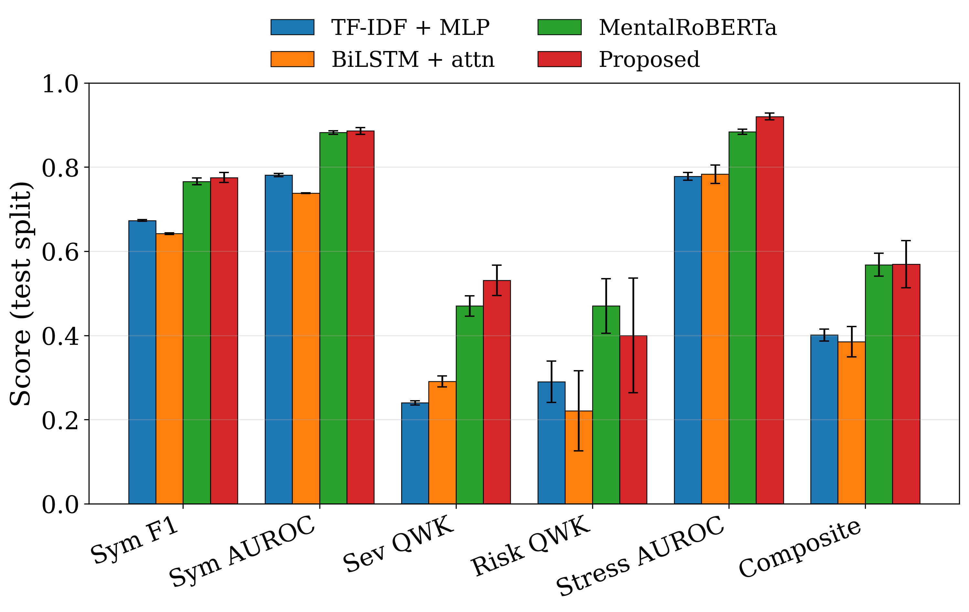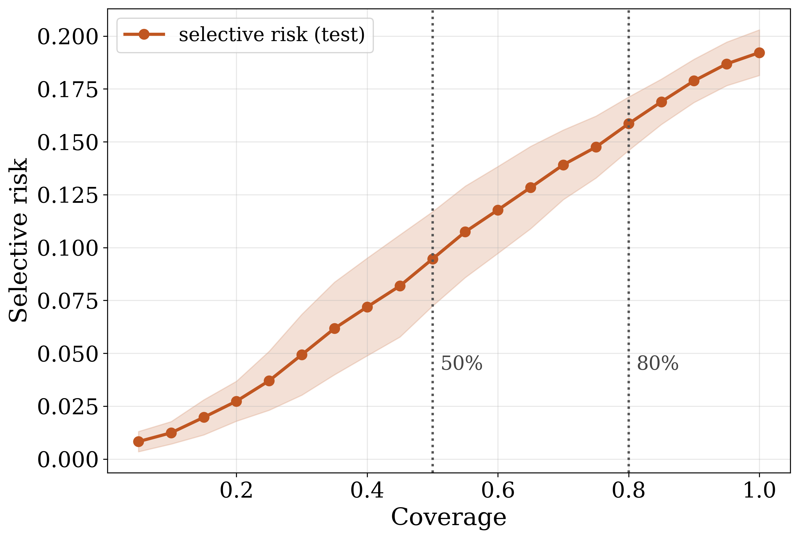
Figure 5. Test-split scores against the three retrained reference models (A) and the risk-coverage curve of the abstention signal (B), both averaged over three seeds.
As shown in Table 10, the proposed SymptoGraph-LLM framework yields 0.886 ± 0.008 symptom macro-AUROC against 0.882 ± 0.004 for the fine-tuned domain transformer, and 0.775 ± 0.012 symptom macro-F1 against 0.766 ± 0.008. Both margins are smaller than the seed standard deviation of the proposed configuration, so the two models are not separable on the symptom task. The clearer margins lie on the severity task, at 0.531 ± 0.036 against 0.470 ± 0.024 for the kappa and 0.382 ± 0.014 against 0.443 ± 0.022 for the absolute error, and on the stress task, at 0.920 ± 0.008 against 0.884 ± 0.006 AUROC. Both models fine-tune the same pretrained encoder, with 125.8 million trainable parameters against approximately 125.0 million, so capacity does not explain these margins. They cannot be attributed to architecture either, because the reference was trained under a different budget and without weak labels. The proposed framework leads every reference model on 8 of the 10 reported metrics. It does not lead on the remaining two, both of which belong to the suicide-risk task, where the domain transformer records 0.470 ± 0.065 against 0.400 ± 0.136 for the kappa and 0.892 ± 0.089 against 0.926 ± 0.120 for the absolute error. The composite is effectively tied, at 0.569 ± 0.056 against 0.568 ± 0.027. The stress task does not saturate across conditions, since the term-frequency baseline reaches 0.778 ± 0.009 against 0.920 ± 0.008 for the proposed framework, so the stress column does discriminate between representations on this corpus.
The structural comparison offers the clearest distinction between the proposed approach and the reference models, and it is a distinction only one column of Table 10 can express. On the suicide-risk task the seed standard deviation of the proposed configuration alone is 0.136 on a kappa of 0.400 ± 0.136, measured on 74 test instances spread across five ordinal levels, and the spread across the six ablation rungs of Table 9 is comparable. A difference of the size separating the proposed framework from the domain transformer on that metric is therefore indistinguishable from seed variation, and the column is retained because omitting it would conceal the limitation rather than resolve it. What the proposed framework provides and no reference model does is a symptom-level intermediate representation that a practitioner can inspect, and a learned basis for declining to decide. Panel B of Figure 5 reports the latter directly. Ranking test posts by the mean predicted log-variance of the variance head and retaining only the most confident fraction reduces the symptom error rate from 0.192 at full coverage to 0.159 at eighty per cent coverage and 0.095 at half coverage, a reduction of about one half, with an area under the risk-coverage curve of 0.099 ± 0.015. The monotone decline of that curve is the evidence that the variance head has learned a usable ordering of its own reliability instead of a constant, and because the head is trained on detached features it cannot have obtained that ordering by degrading the predictions it ranks. No alternative confidence score, such as the maximum predicted probability of the symptom head, was evaluated, so the advantage of the variance head over a simpler ranking is not yet established. For a screening pathway in which uncertain cases are referred to a clinician rather than decided automatically, this property is of more practical consequence than any of the margins in Table 10.
5. Conclusion and Future Work
5.1 Conclusion
This paper has presented SymptoGraph-LLM, a symptom-grounded and comorbidity-aware multi-task network that addresses the problem of producing mental health assessments from social media text which a clinician can inspect and act upon. The framework replaces direct disorder classification with an obligatory clinical concept bottleneck, whose twenty-two symptom queries are initialised from the sentence embeddings of their own clinical definitions and each of which carries an independent scoring vector, so that every severity, risk and stress prediction is a function of the symptom evidence that justifies it. Comorbid structure enters the estimator as a graph whose nodes are symptoms and disorders and whose adjacency combines a DSM-5 prior with a learned residual under a sparsity penalty, with disorder-disorder edges estimated as conditional co-membership probabilities because the mean of 1.125 conditions per author makes a pointwise mutual information estimate vanish identically. The representation is further shaped by a contrastive objective whose positives are posts sharing at least half of their annotated symptom profile, and a per-symptom variance head trained on detached features supplies a learned basis for abstention. All of this is evaluated under a protocol that assigns one global identifier per post, partitions authors disjointly where author identity is known, applies a strictest-split-wins rule and replicates across three seeds, with every reported quantity drawn from the held-out test split. Trained on 12,911 posts, 6,227 of which carry symptom labels, together with 6,000 weak-labelled posts, the framework attains 0.886 ± 0.008 symptom macro-AUROC and 0.775 ± 0.012 symptom macro-F1, leading the fine-tuned domain transformer on 8 of 10 reported metrics with symptom margins inside seed variation, and reduces symptom error from 0.192 to 0.095 when permitted to abstain on half the cases. Four negative or unattributable findings are reported with equal prominence: the first four ladder steps give no net gain over the flat encoder, weak supervision over the eleven unannotated symptoms measurably costs performance on the eleven that are annotated, the apparent gain from the variance head cannot be causal because that head emits no gradient into any predictor, and the suicide-risk annotation supports an interval wider than any difference this study could resolve on it.
5.2 Future Work
The future direction of this research includes:
Constructing an in-house anxiety gold standard so the eleven weak-only symptoms become measurable.
Repeating the comparison under validation-loss checkpoint selection, which the training convergence analysis shows would favour the two graded tasks.
Isolating the final ladder step with the random number stream held fixed, separating the variance head from the initialisation change that accompanies it, and comparing the variance-based abstention score with simpler confidence scores.
Submitting the symptom-disorder prior for clinician review with a random-graph control, and enlarging the suicide-risk annotation.
Retaining per-example predictions so that paired significance tests and per-metric confidence intervals can be computed, and retraining the reference models under the proposed model's optimisation budget and with the same weak labels so that the comparison with state-of-the-art models becomes a controlled comparison.
5.3 Ethical Considerations
This study uses only publicly available, previously published collections of social media text, each obtained under the licence its authors attach and used within the terms of that licence. No new data were collected from human participants, so no institutional review was sought; for work on clinical text that is itself a limitation. Author identifiers are pseudonymous handles and are used for one purpose only, keeping a writer's posts on one side of a split. No attempt was made to deanonymise any author and no author-level profile is published. The weak-labelling model was executed locally and not through a hosted interface, so no post left the processing environment, as several of the constituent data agreements require. The intended use of this work is methodological. It is not a screening instrument and must not be deployed as one. The suicide-risk head is trained on 340 instances and evaluated on 74, it does not lead the comparison on that task, and its seed dispersion exceeds every difference this study can resolve. A false negative from such a component is a missed crisis. The abstention mechanism of the comparison with state-of-the-art models is offered as a way of referring uncertain cases to a clinician, not as a licence to automate the decision. Any application to real users would require clinician oversight, prospective validation and subgroup auditing that this paper does not provide.
5.4 Data Availability
No new data were created by this study. The seven gold-labelled collections and the unlabelled pool are third-party datasets and must be obtained from their original authors under their original terms; this paper redistributes none of them. The harmonisation pipeline that reproduces the canonical table, the symptom ontology, the split assignment and the verification assertions is released with the code, so the corpus used here can be rebuilt from the published sources without reference to any intermediate artefact. The derived run outputs from which every number in the results and discussions is read, namely the per-seed metric files, the per-epoch training histories and the aggregated leaderboards, are included in the repository. Per-example model predictions were not retained, which is why the paired tests of the evaluation metrics are not reported.
5.5 Code Availability
The source for the preprocessing pipeline, the comorbidity graph, the weak-labelling stage, the model, the six-rung ablation ladder, the reference models, the metric suite and the manuscript generator is available in the project repository, together with the unit tests that pin the behaviour of the fingerprinting, ordinal and reference-model components. Every number reported in the results and discussions is read from the run outputs at build time by a single module, so the tables, the figures and the prose cannot disagree, and three checking scripts verify that property, the numbering of the equations, figures and tables, and the absence of placeholders. The editable sources of the two schematic figures are included alongside the rendered images.
6. References
[1] Xu, X., Yao, B., Dong, Y., Gabriel, S., Yu, H., Hendler, J., Ghassemi, M., Dey, A.K. and Wang, D. (2024) ‘Mental-LLM: Leveraging large language models for mental health prediction via online text data’, *Proceedings of the ACM on Interactive, Mobile, Wearable and Ubiquitous Technologies*, 8(1), pp. 1–32. Available at: https://doi.org/10.1145/3643540.
[2] Shah, S.M., Gillani, S.A., Baig, M.S.A., Saleem, M.A. and Siddiqui, M.H. (2025) ‘Advancing depression detection on social media platforms through fine-tuned large language models’, *Online Social Networks and Media*, 46, 100311. Available at: https://doi.org/10.1016/j.osnem.2025.100311.
[3] Liu, J., Ding, P. and Chen, J. (2025) ‘DepGLM: Depression degree recognition on social media based on large language models’, *Digital Health*, 11, 20552076251408281. Available at: https://doi.org/10.1177/20552076251408281.
[4] Abdullah, M. and Negied, N. (2024) ‘Detection and Prediction of Future Mental Disorder From Social Media Data Using Machine Learning, Ensemble Learning, and Large Language Models’, *IEEE Access*, 12, pp. 120553–120569. Available at: https://doi.org/10.1109/access.2024.3406469.
[5] Qorich, M. and El Ouazzani, R. (2024) ‘Advanced deep learning and large language models for suicide ideation detection on social media’, *Progress in Artificial Intelligence*, 13(2), pp. 135–147. Available at: https://doi.org/10.1007/s13748-024-00326-z.
[6] Bauer, B., Norel, R., Leow, A., Rached, Z.A., Wen, B. and Cecchi, G. (2024) ‘Using Large Language Models to Understand Suicidality in a Social Media–Based Taxonomy of Mental Health Disorders: Linguistic Analysis of Reddit Posts’, *JMIR Mental Health*, 11, e57234. Available at: https://doi.org/10.2196/57234.
[7] Lee, C., Mohebbi, M., O'Callaghan, E. and Winsberg, M. (2024) ‘Large Language Models Versus Expert Clinicians in Crisis Prediction Among Telemental Health Patients: Comparative Study’, *JMIR Mental Health*, 11, e58129. Available at: https://doi.org/10.2196/58129.
[8] McCoy, T.H. and Perlis, R.H. (2025) ‘Applying large language models to stratify suicide risk using narrative clinical notes’, *Journal of Mood & Anxiety Disorders*, 10, 100109. Available at: https://doi.org/10.1016/j.xjmad.2025.100109.
[9] Xie, W., Song, X., Lu, Z., Fei, G., Zhou, Y., Ding, S., Zuo, F., Wu, B., Gu, T., Xu, L., De, X. and Zhu, B. (2026) ‘Retrieval‑augmented large language models for depression screening and suicide risk stratification’, *BMC Psychiatry*, 26(1), 386. Available at: https://doi.org/10.1186/s12888-026-07988-0.
[10] Bao, E., Pérez, A. and Parapar, J. (2024) ‘Explainable depression symptom detection in social media’, *Health Information Science and Systems*, 12(1), 47. Available at: https://doi.org/10.1007/s13755-024-00303-9.
[11] Suksam, J., Kaewbuadee, P. and Jareanpon, C. (2026) ‘Transformer-Based Ensemble Learning for Symptom-Level Classification and DSM-5-Oriented Depression Screening on Social Media’, *Information*, 17(6), 546. Available at: https://doi.org/10.3390/info17060546.
[12] Garg, M. (2024) ‘WellXplain: Wellness concept extraction and classification in Reddit posts for mental health analysis’, *Knowledge-Based Systems*, 284, 111228. Available at: https://doi.org/10.1016/j.knosys.2023.111228.
[13] Zhang, W., Xie, J., Zhang, Z. and Liu, X. (2024) ‘Depression Detection Using Digital Traces on Social Media: A Knowledge-aware Deep Learning Approach’, *Journal of Management Information Systems*, 41(2), pp. 546–580. Available at: https://doi.org/10.1080/07421222.2024.2340822.
[14] Qasim, A., Mehak, G., Hussain, N., Gelbukh, A. and Sidorov, G. (2025) ‘Detection of Depression Severity in Social Media Text Using Transformer-Based Models’, *Information*, 16(2), 114. Available at: https://doi.org/10.3390/info16020114.
[15] Kerasiotis, M., Ilias, L. and Askounis, D. (2024) ‘Depression detection in social media posts using transformer-based models and auxiliary features’, *Social Network Analysis and Mining*, 14(1), 196. Available at: https://doi.org/10.1007/s13278-024-01360-4.
[16] Chen, C., Li, F., Chen, H. and Lin, Y. (2025) ‘Heterogeneous subgraph network with prompt learning for interpretable depression detection on social media’, *Knowledge-Based Systems*, 315, 113215. Available at: https://doi.org/10.1016/j.knosys.2025.113215.
[17] Jain, M., Jain, S., Jain, A. and Garg, B. (2024) ‘CDME-GAT: Context-Aware Depression Detection Using Multiembedding and Graph Attention Networks in Social Media Text’, *IEEE Transactions on Computational Social Systems*, 11(6), pp. 7212–7222. Available at: https://doi.org/10.1109/tcss.2024.3402689.
[18] Rehman, A.U., Iqbal, A., Sayyed, A., Aslam, Z., Mohmand, M.I. and Husnain, G. (2026) ‘Explainable Text-Based Depression and Suicide Risk Prediction from Social Media Using Deep Learning and Graph Neural Networks’, *Healthcare*, 14(11), 1440. Available at: https://doi.org/10.3390/healthcare14111440.
[19] Tahir, A., Mustafa, G., Afzal, M.T. and Rafiq, H. (2026) ‘An ontology-guided knowledge graph and retrieval-augmented LLM framework for interpretable mental health assessment’, *Social Network Analysis and Mining*. Available at: https://doi.org/10.1007/s13278-026-01625-0.
[20] Gao, S., Yu, K., Yang, Y., Yu, S., Shi, C., Wang, X., Tang, N. and Zhu, H. (2025) ‘Large language model powered knowledge graph construction for mental health exploration’, *Nature Communications*, 16(1), 7526. Available at: https://doi.org/10.1038/s41467-025-62781-z.
[21] Hsieh, C.Y., Ye, Q.Y., Liu, F.C., Wang, X., Lee, C.H. and Lin, C.S. (2025) ‘Multi-label mental health classification in social media posts with multi-perspective prompt ensemble and auxiliary self-supervision’, *Scientific Reports*, 16(1), 1153. Available at: https://doi.org/10.1038/s41598-025-30873-x. (published online 5 December 2025 in volume 16; the year and volume are as the publisher records them.)
[22] Khowaja, S.A., Nkenyereye, L., Khuwaja, P., Al Hamadi, H. and Dev, K. (2025) ‘Depression Detection From Social Media Posts Using Emotion Aware Encoders and Fuzzy Based Contrastive Networks’, *IEEE Transactions on Fuzzy Systems*, 33(1), pp. 43–53. Available at: https://doi.org/10.1109/tfuzz.2024.3461776.
[23] Hsu, E. and Roberts, K. (2025) ‘Leveraging large language models for knowledge-free weak supervision in clinical natural language processing’, *Scientific Reports*, 15(1), 8241. Available at: https://doi.org/10.1038/s41598-024-68168-2.
[24] Khalil, S.S., Tawfik, N.S. and Spruit, M. (2024) ‘Federated learning for privacy-preserving depression detection with multilingual language models in social media posts’, *Patterns*, 5(7), 100990. Available at: https://doi.org/10.1016/j.patter.2024.100990.
[25] Guo, Z., Lai, A., Thygesen, J.H., Farrington, J., Keen, T. and Li, K. (2024) ‘Large Language Models for Mental Health Applications: Systematic Review’, *JMIR Mental Health*, 11, e57400. Available at: https://doi.org/10.2196/57400.
[26] Omar, M., Soffer, S., Charney, A.W., Landi, I., Nadkarni, G.N. and Klang, E. (2024) ‘Applications of large language models in psychiatry: a systematic review’, *Frontiers in Psychiatry*, 15, 1422807. Available at: https://doi.org/10.3389/fpsyt.2024.1422807.
[27] Volkmer, S., Meyer-Lindenberg, A. and Schwarz, E. (2024) ‘Large language models in psychiatry: Opportunities and challenges’, *Psychiatry Research*, 339, 116026. Available at: https://doi.org/10.1016/j.psychres.2024.116026.
[28] Levkovich, I. and Omar, M. (2024) ‘Evaluating of BERT-based and Large Language Mod for Suicide Detection, Prevention, and Risk Assessment: A Systematic Review’, *Journal of Medical Systems*, 48(1), 113. Available at: https://doi.org/10.1007/s10916-024-02134-3.
[29] Jin, H., Chen, S., Dilixiati, D., Jiang, Y., Zhu, K.Q. and Wu, M. (2026) ‘PsyEval: a comprehensive large language model evaluation benchmark for mental health’, *npj Mental Health Research*. Available at: https://doi.org/10.1038/s44184-026-00227-0.
[30] Bucher, A., Egger, S., Vashkite, I., Wu, W. and Schwabe, G. (2025) ‘“It’s Not Only Attention We Need”: Systematic Review of Large Language Models in Mental Health Care’, *JMIR Mental Health*, 12, e78410. Available at: https://doi.org/10.2196/78410.

