**OJT / Field Report**

1. Introduction : My name is siddhi Jitendra khopade . I am currently pursuing Msc data science degree from B.N. Bandodkar college of science , thane.

This report documents the On-the-Job Training (OJT) experience in the field of data analysis. The internship involved analyzing data from an Excel file and creating a pivot table to discern differences and patterns.

1. Project Overview

Title: Data science

Date: [Date of Report]

Location: Ifuture Technology private limited ,thane. this is a IT Training Company & with more than 15 years of Goodwill & Trust

Team Members: single

Objectives :

* To gain practical experience in data analysis techniques.
* To apply theoretical knowledge in a real-world setting.
* To enhance skills in Excel and data manipulation.

Theoretical framework :

The project is grounded in principles of data analysis, including data cleaning, manipulation, and visualization. The scope of work encompasses analyzing a dataset provided by the organization and presenting insights through graphical representations.

Scope of Work :

The scope of this study involves examining sales data from 2011 and 2012 to understand the performance of various book categories. It includes assessing category-wise sales revenue, identifying trends, and exploring potential implications for the publishing industry.

1. Methodology:

The methodology involved importing the dataset into Excel, cleaning the data, performing data analysis using pivot tables, and visualizing the findings through graphs and chart

1. Process :

The process began with understanding the dataset structure and variables. Data cleaning techniques were then applied to address any inconsistencies or missing values. Next, pivot tables were created to summarize and analyze the data. Finally, various graphs and charts were generated to visualize the insights.

1. Observations and Findings

1.The total sales revenue in 2011 and 2012 varied significantly across different book categories.

2.The category "Comics" generated the highest sales revenue in both 2011 and 2012, with a total of $1,705 in both years.

3.The category "Dictionary" saw a substantial increase in sales revenue from 2011 to 2012, jumping from $1,430 to $9,000.

4."Education" books experienced a decrease in sales revenue from 2011 to 2012, dropping from $1,300 to $225.

Similarly, the "Novels" category also witnessed a decline in sales revenue from $1,275 in 2011 to $2,625 in 2012.

2 Specific Findings

Category-wise Sales Comparison:

Comics: The consistent sales revenue suggests a stable demand for comic books over the years.

Dictionary: The dramatic increase in sales revenue from 2011 to 2012 indicates a significant shift in consumer behavior towards dictionary books.

Education: Despite a decrease in sales revenue, the education category still contributes substantially to overall sales.

Novels: The decline in sales revenue highlights a potential need for reevaluation of marketing strategies or product offerings within the novels category.

1. Data Analysis :

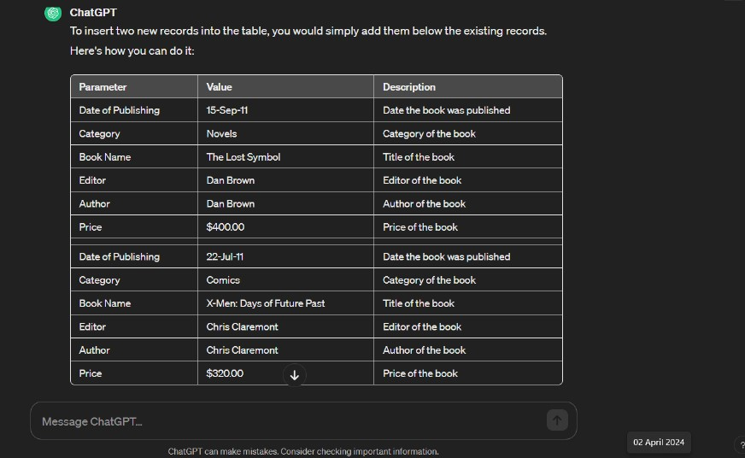

2. Graphs and Charts :

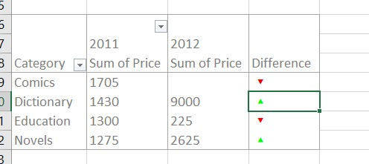

1. The output / application of the project developed (for development project):

The project provides insights for publishers to optimize marketing strategies and product offerings based on category-wise sales performance.

1. Conclusions:

Comic books show consistent demand, while dictionaries saw a significant revenue increase. Fluctuations in education and novels categories suggest areas for further investigation.

1. Recommendations / Future Scope :

Expand comic book titles, analyze factors driving dictionary sales, investigate reasons behind sales fluctuations in education/novels, and adapt strategies based on market trends.

1. References :

Data sources used for analysis.

The code should not be included in the main project.