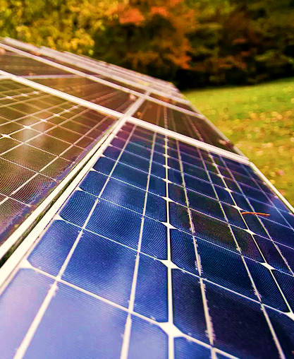

“The Future of Solar Energy is Bright.”

Made with respect to the syllabus taught during training at the centre

MADE WITH ♥️ BY THE STUDENTS OF ALIAH UNIVERSITY

DEPT. ELECTRICAL ENGINEERING

ALIAH UNIVERSITY

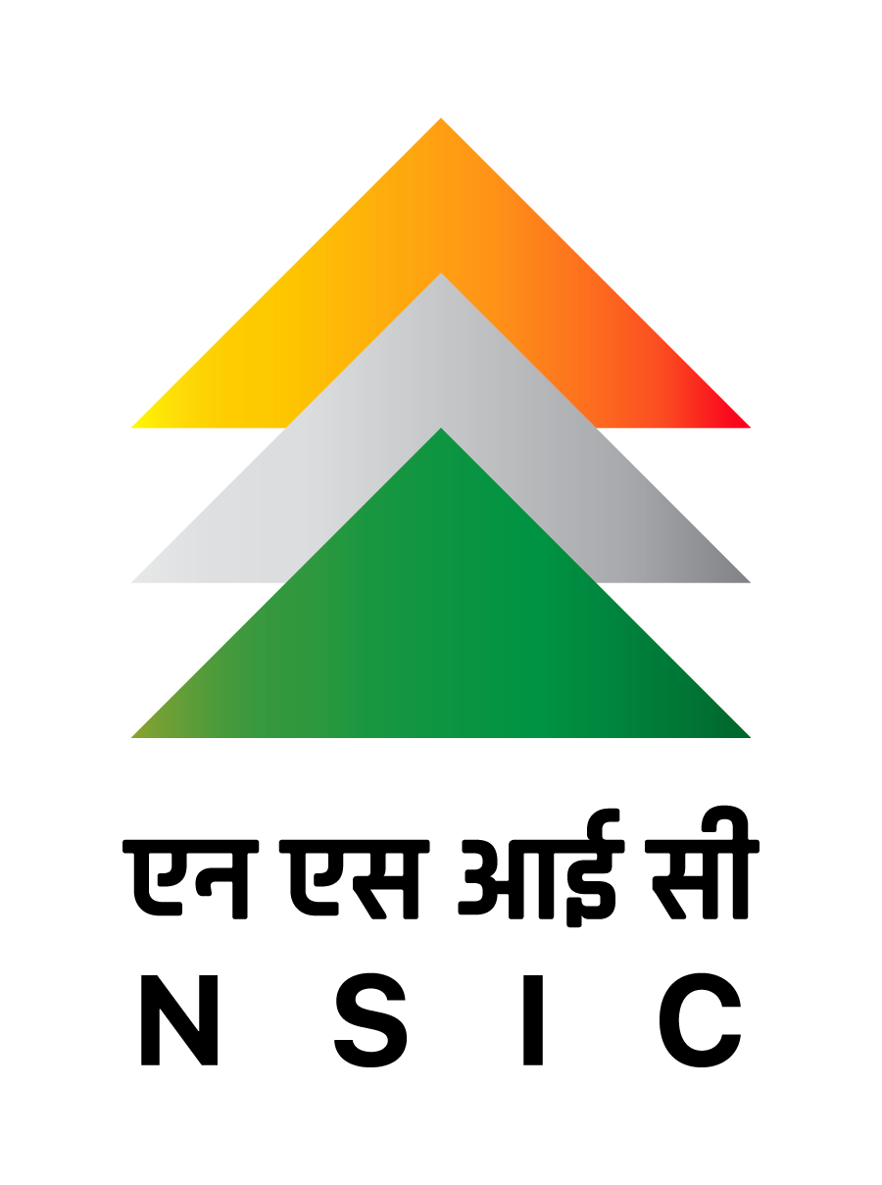

A REPORT ON

SOLAR

TECHNOLOGY

NATIONAL

SMALL

INDUSTRIES

CORPORATION

HOWRAH