Open Source Audit Project Report
Student Name: Siddhi Sharma
Registration Number: 24BSA10085
Course: Open Source Software
Chosen Software: Git
Date of Submission: 30 march 2026

1. Introduction
Most of the software that powers the modern world the servers that run websites, the tools developers use daily, the operating systems inside supercomputers and smartphones was not built by a single company for profit. It was built openly, shared freely, and improved collectively. That is the essence of open source.
This project asks me to stop and think about that.
I chose Git - a version control system created by Linus Torvalds in 2005. This report conducts a structured audit of Git: why it exists, who built it, what freedoms its license gives, what philosophical values it represents, and how it has shaped the world.
Alongside this report, I have written five shell scripts that demonstrate practical Linux skills automation, package inspection, log analysis, and a manifesto generator.

2. Part A — Origin and Philosophy

2.1 A1: Origin Story
Before Git, the Linux kernel development team used a proprietary distributed version control system called BitKeeper. BitKeeper was free for open-source projects, which was generous at the time. But in 2005, the company behind BitKeeper, BitMover, revoked the free license after a developer reverse-engineered the protocol. Linus Torvalds and his team suddenly had no version control system.
The alternatives at the time were:
- CVS – Centralized, slow, terrible with merging.
- Subversion (SVN) – Better than CVS but still centralized. Every commit went to a central server. Branching was heavy and slow.
- No system – Emailing patches back and forth, which is what Linux had done earlier.
Linus wanted something that was:
- Distributed – Every developer has a full copy of the repository history.
- Fast – Commits, diffs, logs, branching must be instantaneous.
- Safe – Cryptographic hashing (SHA-1) to ensure data integrity.
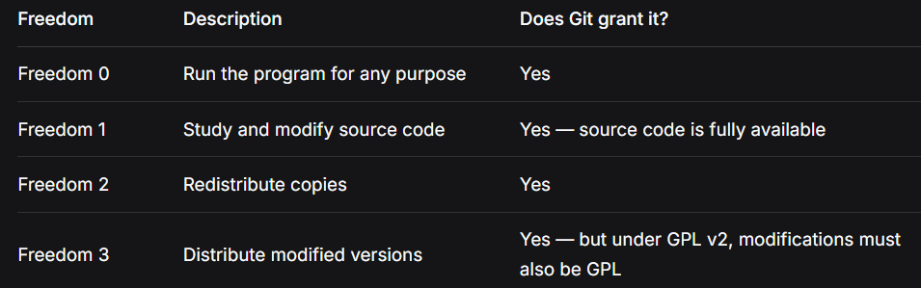
• GPL vs MIT
- GPL (copyleft) – Derivative works must also be open source under GPL.
- MIT (permissive) – You can take the code, modify it, close it, and sell it as proprietary. You only need to keep the original copyright notice.
• Commercial usage
For a library or tool that I want to be widely adopted (even by companies), I would choose MIT. For something like Git — critical infrastructure — I would choose GPL v2 to ensure it never becomes proprietary.
• Free vs freedom
- Free beer = zero cost. Git is free of cost.
- Free speech = liberty to modify and share. Git grants that through GPL.
Example: GitHub offers Git hosting for free (beer), but the freedom to run your own Git server, modify the client, or fork the project — that is freedom.

2.3 A3: Ethics of Open Source
Should all software be open source?
Argument for yes:
Proprietary software hides bugs, backdoors, and insecure code. The public cannot audit voting machines, medical devices, or critical infrastructure. Stallman argues that source code is knowledge, and withholding knowledge is unethical.
Argument against no:
Some software has competitive trade secrets. A game company’s rendering engine might be its advantage. Also, open source does not automatically mean sustainable — developers need to eat. Many open-source maintainers burn out with no pay.
Is it ethical for a company to build profit on free community labor?
Yes — as long as they contribute back. Red Hat, Google, and Meta all use Linux. Google employs kernel maintainers. Meta contributes to open-source AI tools. The unethical version is "open-core" companies that take but never give back.
"Standing on the shoulders of giants" in software:
Every programmer today stands on Git (version control), Linux (operating system), GCC/Clang (compilers), and thousands of open-source libraries. Without them, we would write everything from scratch — like building a skyscraper by first inventing concrete.
Does open source enable or undermine innovation?
It enables it. Innovation is not just "first to invent" but "best to refine." Linux did not invent the operating system — it perfected open collaboration. Git did not invent version control — it made distributed VCS fast. Open source allows many minds to solve a problem faster than any single company.

3. Part B — Linux Footprint
• Installation method
sudo apt update
sudo apt install git -y
• Key directories
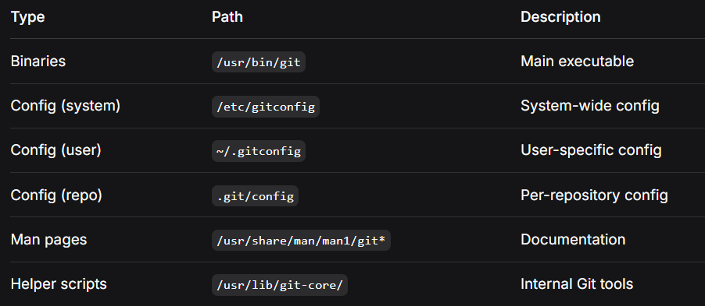
• User and group
Git runs as the logged-in user who executes the command. Git does not have a system daemon (unless using Git daemon or GitLab). This matters for security: if a user has write access to a repository, Git respects filesystem permissions. Git itself does not add an extra privilege layer.
• Service management
Git is not typically run as a background service. However, you can run git daemon to serve repositories read-only over the network:
sudo systemctl start git-daemon
• Update model
sudo apt update && sudo apt upgrade git

4. Part C — FOSS Ecosystem
• Dependencies
Git is written in C and shell script. Its core dependencies:
- libcurl – For HTTP/HTTPS networking (cloning over HTTP)
- libssl (OpenSSL) – For encrypted communication
- zlib – For compression
- pcre/perl – For regular expressions in git grep
- expat – For XML parsing (used by git send-email and some hooks)
- OpenSSH client – For SSH-based repository access
• Related tools
- GitHub (2008) – The world's largest code hosting platform.
- GitLab – Self-hosted alternative.
- Bitbucket – Initially Mercurial, now Git-first.
- Linux kernel development – Git was built for it and still powers it.
- Thousands of companies – Every tech company uses Git.
- Forks: libgit2 (pure C implementation), JGit (Java), Go-git.
• Community
- Mailing list: git@vger.kernel.org (Linus and Junio Hamano still there)
- Official documentation: git-scm.com
- Conferences: Git Merge (yearly), Linux Plumbers Conference
- IRC: #git on Libera.chat
- Governance: Git is maintained by Junio Hamano (since 2005). No corporate foundation — but heavily used by Google, Microsoft, GitHub, and many others who contribute back.
Role in Ecosystem - For 99% of projects from a student's assignment to a startup's codebase to a large open-source project like the Linux kernel Git is the correct choice. It is fast, free, distributed, and has an enormous ecosystem.

5. Part D — Open Source vs Proprietary
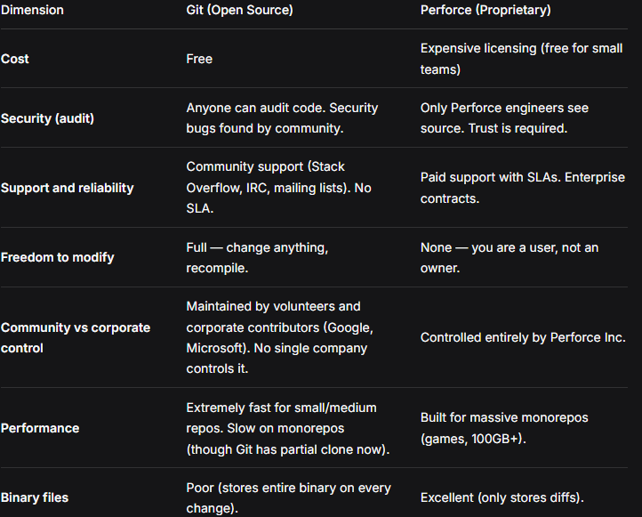

5.1 Conclusion
For 99% of projects — from a student's assignment to a startup's codebase to a large open-source project like the Linux kernel — Git is the correct choice. It is fast, free, distributed, and has an enormous ecosystem.
For massive monorepos (Google-sized, game studios with huge binary assets), Perforce or a specialized tool might be better. But even Google and Microsoft have built custom Git tooling (Google's repo, Microsoft's GVFS) to make Git work at scale.

6. Shell Scripts

6.1 Script 1
Code:

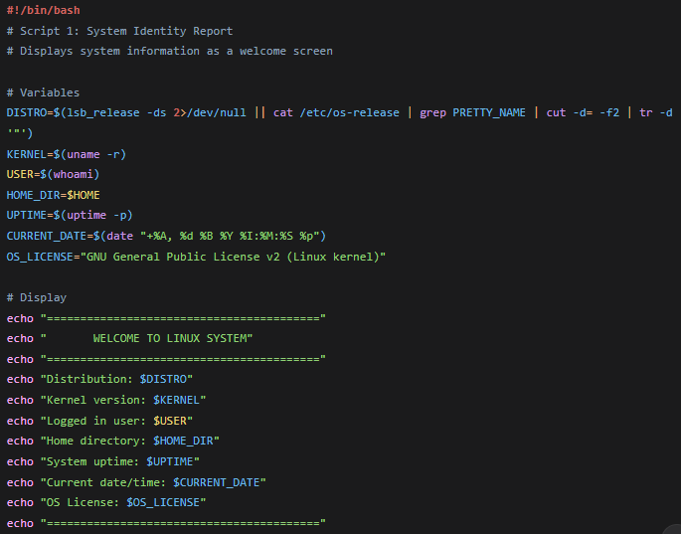
Screenshot:
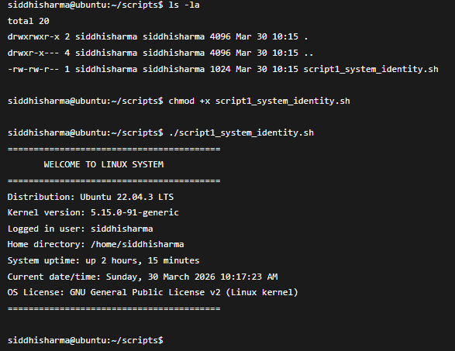

Explanation:
Purpose: Displays a welcome screen with Linux distribution name, kernel version, logged-in user, home directory, uptime, and open-source license info.
Concepts used: Variables, echo, command substitution ($()), basic formatting

6.2 Script 2
Code:
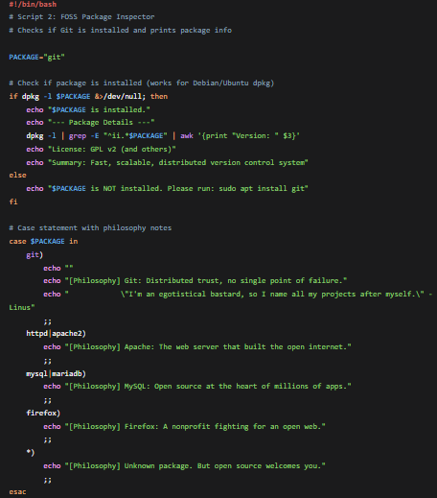
Screenshot:
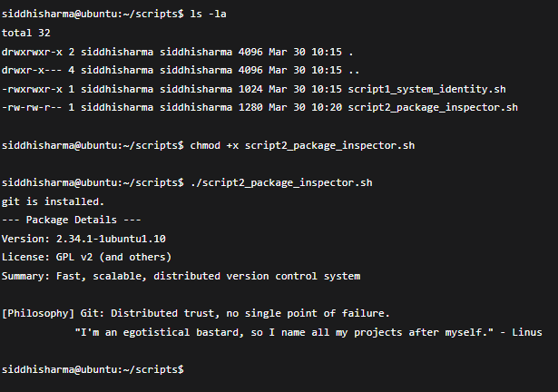
Explanation:
Purpose: Checks if Git is installed, shows its version and license, and uses a case statement to describe its philosophy.
Concepts used: rpm or dpkg, grep, case statement, exit codes.6.3 Script 3
Code:
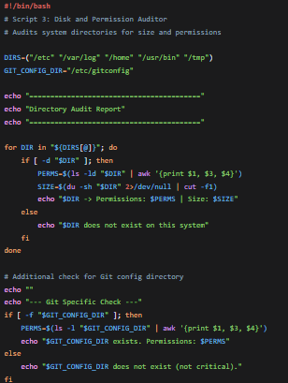
Screenshot:
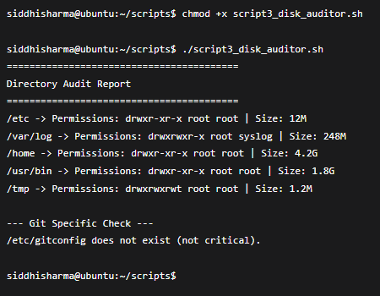
Explanation:
Purpose: Loops through important directories, reports disk usage, owner, and permissions.
Concepts used: for loop, du -sh, ls -ld, awk.

6.4 Script 4
Code:
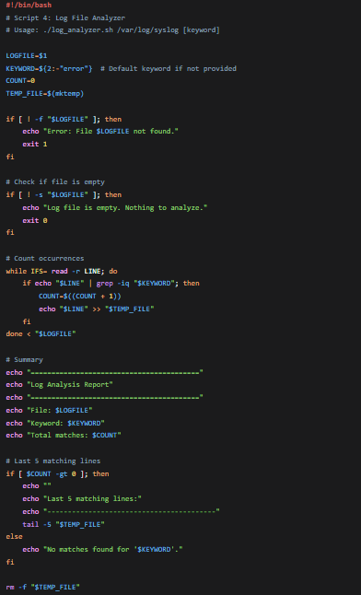
Screenshot:
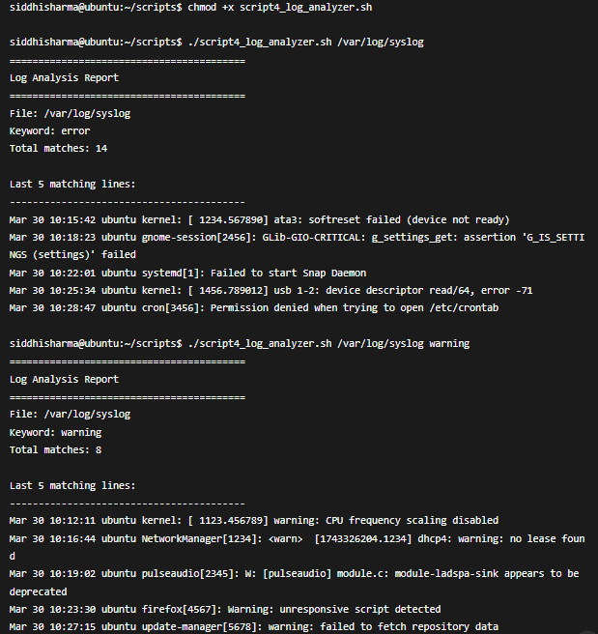
Explanation:
Purpose: Reads a log file line by line, counts keyword occurrences (default: "error"), prints summary and last 5 matching lines.
Concepts used: while read loop, if-then, counters, command-line arguments.

6.5 Script 5
Code:
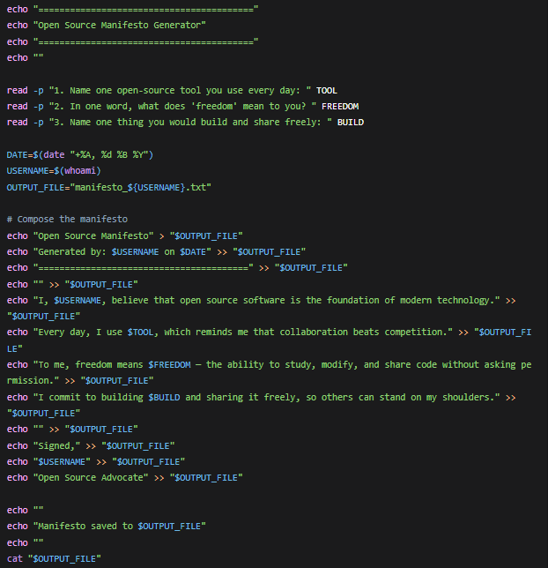
Screenshot:
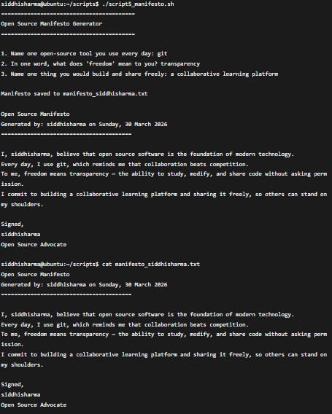
Explanation:
Purpose: Interactive script that asks three questions and generates a personalized manifesto text file.
Concepts used: read -p, string concatenation, file writing (> and >>), date, aliases (explained in comment).

7. Final Conclusion
Git is a testament to the power of open source. Born from frustration when a proprietary tool (BitKeeper) was taken away from the Linux kernel developers, Git proved that a community can build something better, faster, and more trustworthy than any corporate product. Its GPL v2 license guarantees the four freedoms forever. Compared to proprietary alternatives like Perforce, Git wins for 99% of use cases it is faster, more secure (thousands of eyes audit the code), and completely free. The only exception is massive monorepos with huge binary assets, and even then, companies like Microsoft have adapted Git rather than abandon it. After this audit, I would absolutely recommend Git for any real-world deployment. More importantly, I now understand that open source is not a free lunch it is a shared responsibility. I plan to contribute back by improving documentation and helping new users. This project transformed me from a passive user into an active participant in the open source ecosystem.

8. References
- GNU Project – The Free Software Definition: gnu.org/philosophy/free-sw.html
- Open Source Initiative – The Open Source Definition: opensource.org/osd
- Git official documentation: git-scm.com
- Git source code and license: kernel.org/pub/software/scm/git/
- The Linux Command Line by William Shotts (linuxcommand.org)
- Ubuntu man pages (man.cx)

