GENERATIVE AI
23CSE475

Team 31:
SIDHARTH S NAIR : CB.SC.U4CSE23443

Title:
Dress and Accessory Generator Using GANs and VAEs

Architecture Design

- System Architecture
The proposed Dress and Accessory Generator uses a hybrid VAE-GAN architecture that combines the structured latent space representation of VAEs with the high-quality image generation capabilities of GANs. This approach addresses the individual limitations of each model while amplifying their respective strengths. The architecture consists of three primary components working in concert:
- Encoder Network (VAE component): Compresses input images into a probabilistic latent space representation
- Decoder/Generator Network: Functions as both the VAE decoder and GAN generator, creating images from latent vectors
- Discriminator Network (GAN component): Evaluates image authenticity and provides adversarial feedback to the generator
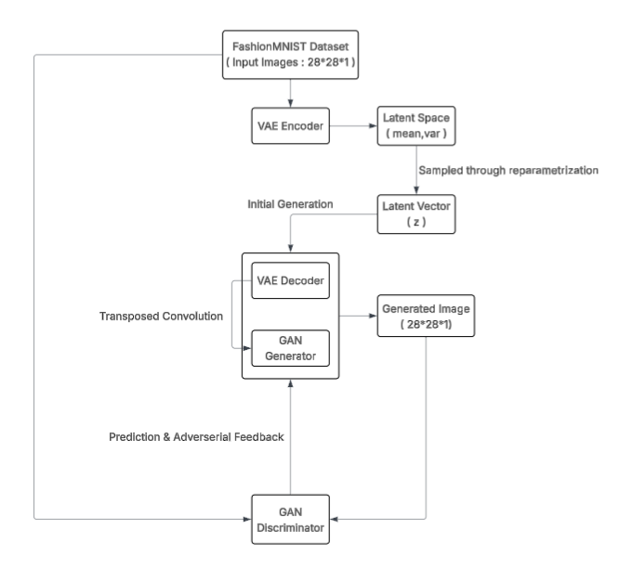

- Component Architecture

- VAE Encoder -
Purpose: Compress training images to latent distribution
Input: 28*28*1 (greyscale image)
Output: μ (128-dim), logσ² (128-dim)

- Latent Space -
Dimensionality: 128
Distribution: Gaussian N(μ, σ²)
Prior: Standard Normal N(0, 1)

- VAE Decoder / GAN Generator -
Purpose: Generate 28×28 images from latent vectors
Input: 128-dim latent vector (z)
Output: 28 × 28 × 1 (grayscale image)

- GAN Discriminator -
Purpose: Distinguish real from generated images
Input: 28 × 28 × 1 (grayscale image)
Output: Single probability [0, 1] (1 = real, 0 = fake)

- Modules

- Module 1: The Data Loading & Preprocessing Module
This module handles all data preparation tasks before model training. It loads raw Fashion-MNIST images, filters them for relevant categories (dresses and accessories), and prepares them for the neural networks.
Components:
  - Dataset Loader: Fetches Fashion-MNIST from torchvision/tensorflow datasets
  - Label Filter: Extracts classes
  - Normalization Pipeline: Converts pixel values from [0,255] to [-1,1] for optimal GAN training
  - Data Augmenter: Applies horizontal flips and small rotations to increase dataset diversity
  - Batch Generator: Creates mini-batches of 128 images for stable training
  - Output: Preprocessed image tensors of shape (batch_size, 1, 28, 28) with values in range [-1, 1]

- Module 2: Training Module
This is the core training architecture showing the parallel operation of VAE and GAN components with their respective loss functions feeding into a hybrid optimization strategy.
Components:
  - Encoder: Compresses 28×28 images into probabilistic latent space (μ, σ²) of dimension 128
  - Latent Space: Structured 128-dimensional space where each point represents a fashion design
  - Decoder: Reconstructs images from latent vectors, ensuring structural coherence
  - Loss Components: KL Divergence (for latent regularization) + Reconstruction Loss (L1/MAE for pixel accuracy)
  - Generator: Shares weights with VAE decoder, synthesizes images from latent vectors
  - Discriminator: Binary classifier distinguishing real vs. generated images
  - Adversarial Feedback: Gradients from discriminator guide generator toward photorealism
  - Output: Trained model weights capturing both structural understanding and realistic generation capabilities

- Module 3: Latent Control Module
This module maps the learned latent space into controllable dimensions that enable interactive manipulation of generated designs.
Components:
  - Latent Space Analyzer: Performs PCA/t-SNE to identify meaningful latent dimensions
  - Disentanglement Mapper: Identifies which latent dimensions control specific attributes (sleeve length, silhouette, neckline, bag shape, handle style)
  - Interpolation Engine: Enables smooth transitions between different designs via linear interpolation in latent space
  - Style Vector Generator: Creates latent vectors corresponding to specific style preferences
  - Output: Controllable latent vectors that can be manipulated via user inputs to generate desired fashion designs

- Module 4: Generation & Enhancement Module
This module handles the actual generation of new fashion designs and post-processing for visualization.
Components:
  - Trained Decoder/Generator: Takes latent vectors and produces 28×28 grayscale images
  - Style Mixer: Combines attributes from different latent vectors to create hybrid designs
  - Batch Generator: Produces multiple design variations simultaneously for comparison
  - Visualization Engine: Arranges generated images in grid format for display
  - Output: Generated dress and accessory images ready for visualization

Experiment Design

  - Technology Stack
Component | Technology | Version | Purpose
Deep Learning Framework | PyTorch | 2.0+ | Model implementation, training, and inference
GPU Acceleration | CUDA | 11.7+ | Parallel computation for faster training
GPU Optimization | cuDNN | 8.5+ | Optimized deep learning primitives
Data Processing | NumPy | 1.24+ | Array operations and manipulations
 | torchvision | 0.15+ | Dataset loading and basic transforms
Visualization | Matplotlib | 3.7+ | Plotting and image display
 | TensorBoard | 2.13+ | Training monitoring and metric logging
 | Seaborn | 0.12+ | Statistical visualizations
Model Persistence | pickle | - | Checkpoint saving
 | torch.save | - | Model weight serialization
Evaluation | scikit-learn | 1.3+ | Metrics computation
 | SciPy | 1.10+ | Statistical calculations
Development | Jupyter Notebook | - | Interactive experimentation
 | Python | 3.9+ | Primary programming language
Environment | Anaconda | - | Package and environment management

  - Experiments

- Experiment 1:
Purpose: To validate that filtering Fashion-MNIST for only dress and bag categories improves generation quality and reduces mode collapse on irrelevant clothing types.
Problem Being Solved: When trained on all 10 Fashion-MNIST classes, the model divides its capacity across too many categories, resulting in lower quality generations for target classes (dresses and accessories). The model may also confuse features between categories (e.g., generating dress-like trousers).
Baseline Approach: Train VAE-GAN on full Fashion-MNIST dataset (all 10 classes, 60,000 images)
Experimental Approach: Train identical VAE-GAN architecture on filtered dataset (only classes 3 and 8, approximately 12,000 images)
Control Variables: Same model architecture, hyperparameters, and training duration
Training Duration: 100 epochs for both approaches

- Experiment 2:
Purpose: To evaluate the hybrid VAE-GAN architecture's ability to generate high-fidelity fashion images that are both structurally coherent (correct dress/bag shapes) and visually realistic (sharp details, textures).
Problem Being Solved: Pure VAEs produce blurry images lacking fine details, while pure GANs often generate unrealistic structures or collapse to limited modes. The hybrid approach aims to combine structural understanding (from VAE) with photorealistic details (from GAN).
Baseline 1 (VAE only): Train only encoder-decoder with KL + reconstruction loss (no adversarial component)
Baseline 2 (GAN only): Train only generator + discriminator with random noise input (no encoder)
Experimental (VAE-GAN): Train full hybrid architecture with all loss components
Training Configuration: All models trained on filtered dress+bag dataset for 100 epochs
Latent Dimension: 128 for all models (GAN uses 128-dim random noise)

- Experiment 3:
Purpose: To systematically evaluate the contribution of each loss component to the final generation quality and determine optimal weighting.
Problem Being Solved: The hybrid loss function has three components (KL, reconstruction, adversarial) with weighting factors α, β, γ. The optimal balance between structure preservation and visual realism needs to be empirically determined.
Variant 1: α=0, β=10, γ=1 (No KL regularization - removes latent structure)
Variant 2: α=1, β=0, γ=1 (No reconstruction - removes pixel accuracy)
Variant 3: α=1, β=10, γ=0 (No adversarial - removes realism, pure VAE)
Variant 4-9: Vary γ from 0.1 to 10.0 while keeping α=1, β=10 constant
Variant 10-12: Vary β from 1 to 50 while keeping α=1, γ=1 constant

