

**Team 14**

**User Manual**

**Team Members:**

Andrew Veldhuis

Hashim Vekar

Melissa Tran

Sidhant Vashist

Queenie Wang

**Table of Contents**

1. **PURPOSE OF DECISION SUPPORT TOOL ……………………………….….2**
2. **DISCLAIMER…………………………………………………………………….….2**
3. **Assumptions………………………………………………………………..2**
4. **Device………………………………………………………………………..2**
5. **SETUP………………………………………………………………………………..3**
6. **KEY DETAILS……………………………………………………………………….3**
7. **Worksheet #1: Welcome…………………………………………………..3**
8. **Worksheet #2: Planner…………………………………………………….4**
9. **Worksheet #3: Team……………………………………………………….5**
10. **Worksheet #4: Progress…………………………………………………..6**
11. **Worksheet #5: Communication………………………………………….6**
12. **DEVELOPER……………………………………...…………………………………7**
13. **SUPPORT……………………………………………………………………………8**
14. **RESOURCES………………………………………………………………………..8**
15. **PURPOSE OF DECISION SUPPORT TOOL**

P.O.D.M.S. (Project Organization & Decision Making System) is a decision support tool that was created to help individuals solve their packing dilemmas. This decision support tool was created to help plan and execute projects in a efficiently and effectively. P.O.D.M.S is a system that includes all functions one will need during a project laid out in a simple and easy-to-use manner. The goal of this decision support tool is to achieve three main team dynamics; planning, organizing and communication.

1. **DISCLAIMER**
2. **Assumptions**
3. Conflicts

Internal team conflicts is often a leading factor to tasks not being completed close to the due date indicated in the program, it will be clear that something is wrong and it will be up to the project managers to locate and help resolve the issue.

1. Individual Team Dynamic

If a team consist of dominating and reluctant members, there will be an imbalance in the team. The effects of this problem may become the incompletion of tasks and decrease of the project quality. It is important for group members to trust each other rather than doing other people’s work themselves. A balanced group dynamic is a goal for any project to be done well.

1. **Device**

Due to the difference in operating systems on Mac and Windows, there are two versions of P.O.D.M.S. Please download the corresponding program to the corresponding device.

1. **SETUP**
2. Download Microsoft Excel



1. Download the P.O.D.M.S. decision support tool that is appropriate for your device.
2. Launch it as an Excel File (Enable Macros). Upon first boot of PODMS you may have to click the “Enable Editing” and “Enable Content” Buttons that appear at the top.

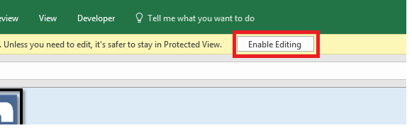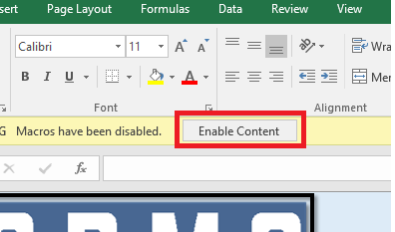

1. Decisions can be altered at the discretion of the user.
2. **KEY DETAILS**
3. **Worksheet #1: Welcome**

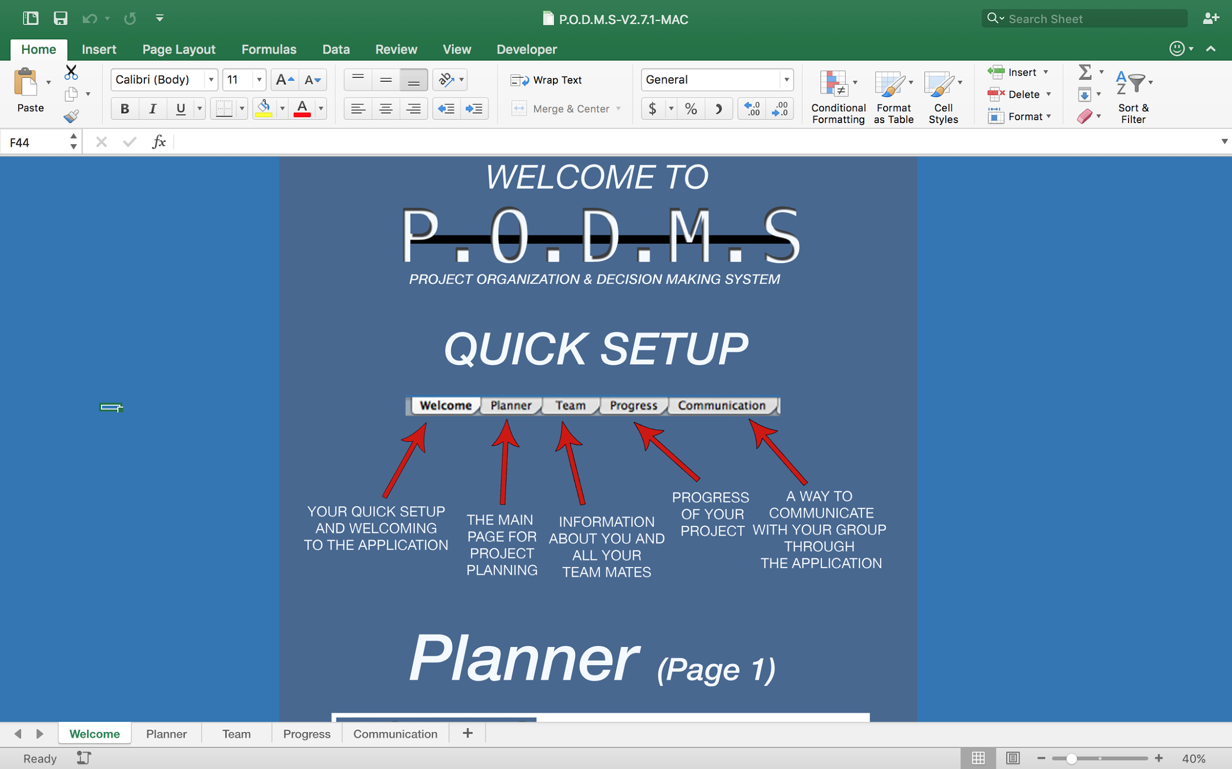

This page provides users with a brief setup guide of each worksheet within P.O.D.M.S. without looking into this user guide.

1. **Worksheet #2: Planner**

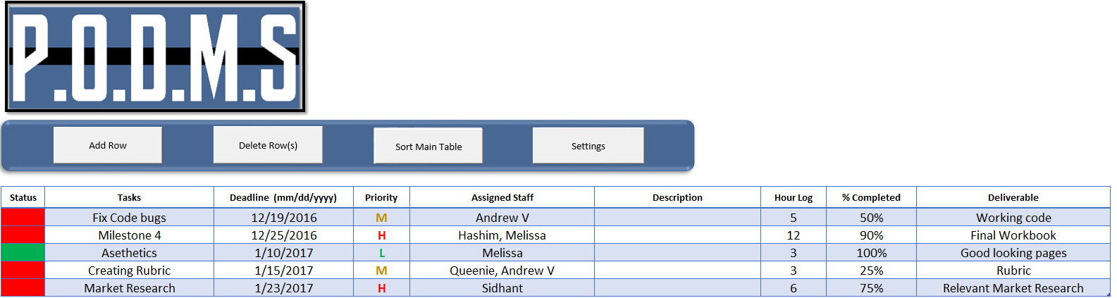

1. There are four buttons at the top of this page (Add row, Delete Row(s), Sort Main Table, and Settings).
2. The “Add Row” button will allow users to add another row to the table. All the rows will automatically correspond to the functions of other worksheets. When adding a row a medium priority will automatically be assigned to that new task.
3. The “Delete Row(s)” button will allow users to remove the last row inserted or remove a selected row.
4. The “Sort Main Table” button will allow users to sort the table in alphabetical order, by date, by priority, or by completion depending the needs of the users.
5. The “Settings” button will allow users to change the weight of each priority, as well as insert the project start date. For example if you want high priority to be the only one taken into account set high priority to 1 and the others to 0. If a start date is set, the user will be unable to set deadlines prior to the start date.
6. The status on the left side will turn green upon a task being marked at 100% complete.
7. Other fields in the table is dependent upon the user to input themselves, and the information will affect data on other worksheets.
8. It is important the %Complete entries are entered as a percent, otherwise you risk setting a complete value outside of 0-100%.

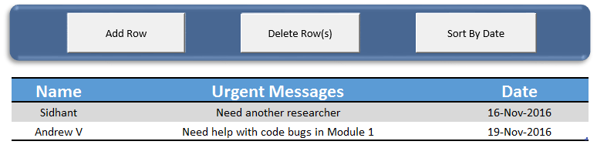

1. The “Add Row” button inserts a new row in the table. When a row is added the current date is automatically entered into the date column.
2. The “Delete Row(s) button allows users to remove the last inserted row, or a selected row.
3. The “Sort By Date” button will sort the messages into chronological order.
4. **Worksheet #3: Team**

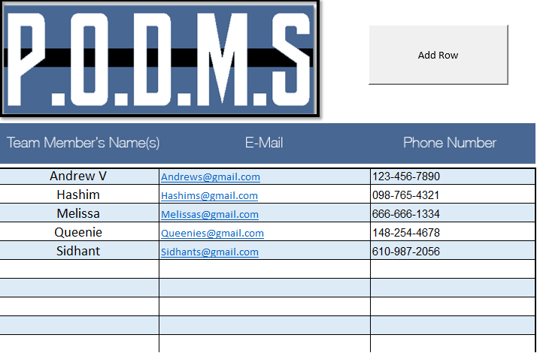

1. This page allows users to find information regarding other team members.
2. Information in this table is to be filled out by the user.
3. The “Add Row” button allows the users to insert a new row into the table.
4. When a new name is entered the program will automatically sort the names by alphabetical order.
5. For PODMS to function optimally, don’t insert duplicate names. If two team members have the same name have the same, indicate of difference by last name initial.
6. **Worksheet #4: Progress**

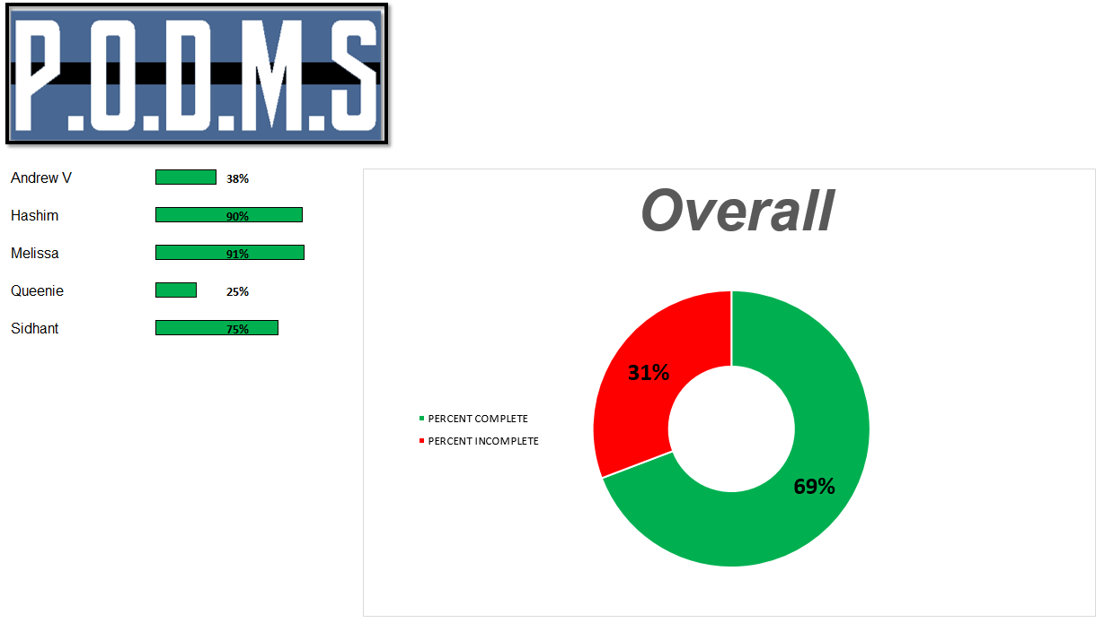

1. On the left are individual progress bars, calculated from the planner page.
2. The graph represents the overall percentage of complete or incomplete tasks for the entire project. The graph is adjusted in conjunction with the overall progress changes on the main table in the planner worksheet.
3. Everything on this sheet is automatically calculated and set. There is no need to edit anything on this page it is purely to present information in a clear helpful form.
4. **Worksheet #5: Communication**

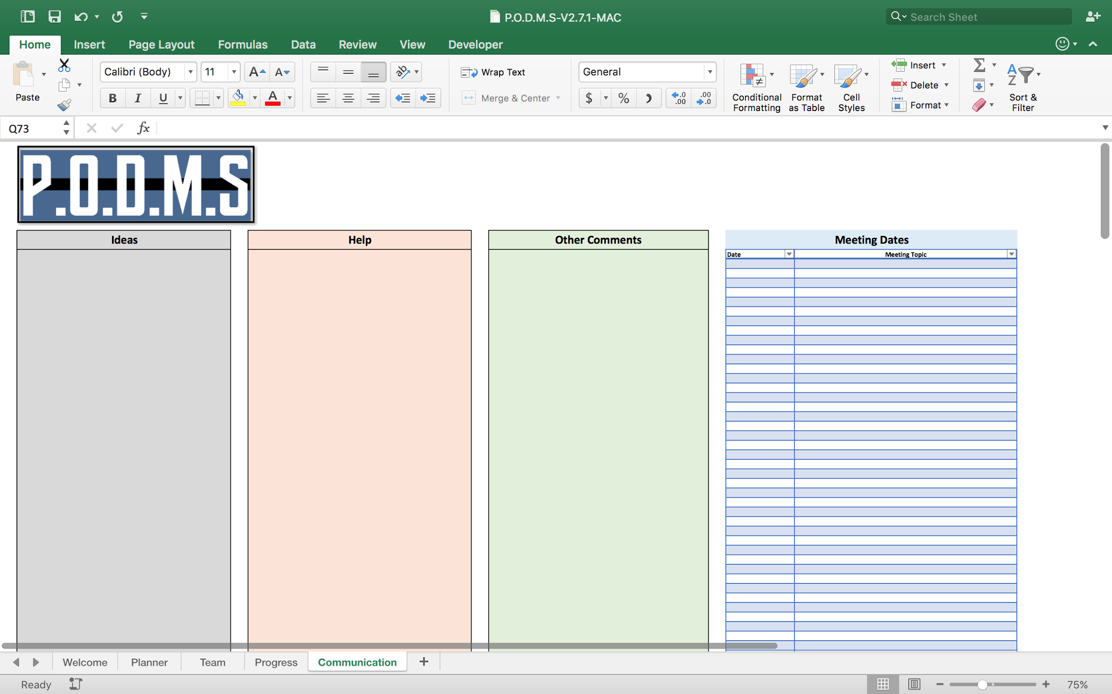

1. This worksheet allows users to communicate between each other.
2. Each table has a specific category which include, ideas, help, other comments and meeting dates.
3. These tables are to be used at the discretion of the users.
4. **Developer**
5. **Adjust Column width on the “Planner” table.**

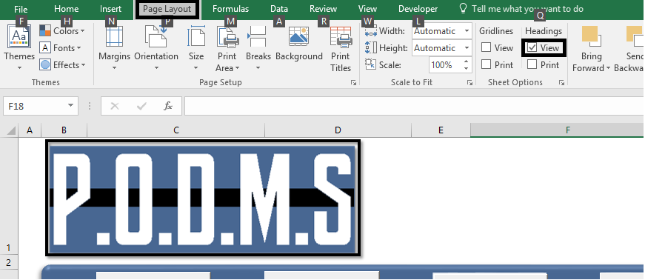

If you require wider columns for the main table, go to “Page Layout” and make sure the “View” box under “Headings” is checked. If so, the column letters will appear and you can then drag them left or right to make them smaller or bigger. This is necessary if the boxes are too small to write all the information needed.

**2. Change the date format in planner table**

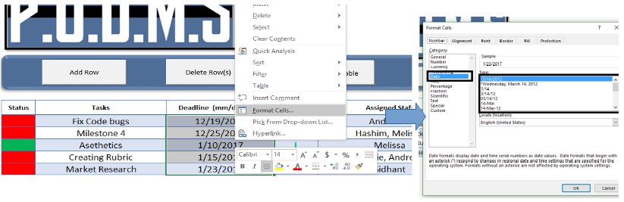

If you wish to have a different date format, select all the dates in the deadline column, right click and select format cells. You will then see what is on the right side of the image. In box indicated, select a date format and then press OK.

**3. Move buttons around**

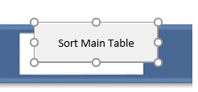

To do this simply right click on a button and left click on it again. You should be able to then click and draw the button around, even resize it if needed by clicking and dragging the circles along the edge of the button.

1. **SUPPORT**

For support, contact [yowaterloo@gmail.com](mailto:yowaterloo@gmail.com)

1. **RESOURCES**
2. "How to Create Drop down List with Multiple Selections or Values in Excel?" How to Create Drop down List with Multiple Selections or Values in Excel? ExtendOffice, n.d. Web. 5 Nov. 2016. <<https://www.extendoffice.com/documents/excel/2448-excel-drop-down-list-multiple-selection.html>>