# Intermediate report CIT

# 2019 Week 14

* Strategies that improved the tests:
  + Better data sampling, e.g. to reduce skewness of data
  + Ignored bad data entries, such as data acquired form retracting the drill bit, which should not be considered during training
  + Script for automatic labeling of the drilling data based on the depth map of the block.
* Results from improved strategies:
  + A material detection algorithm with good accuracy based on the data from AD10.

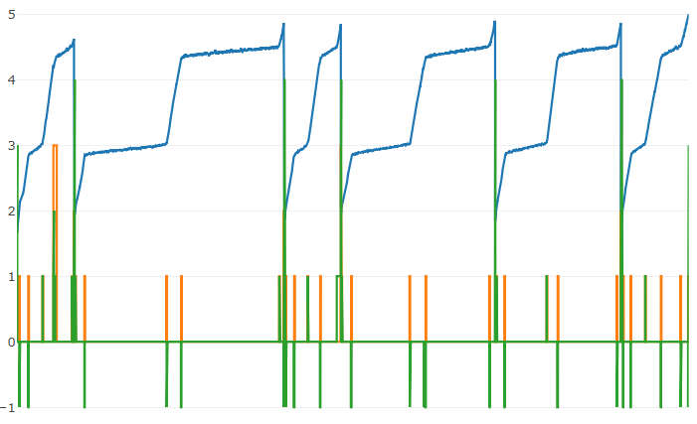

Figure 1 Result of the material classifier. The green line shows the correctness of the result, a zero means correct results. The green line is correct except where the orange is nonzero, indicating pars not usable for material classification.

* In-progress for this week and next week:
  + Checking the convergence of different supervised learning algorithms
  + Starting to build Reinforcement learning framework based the result from convergence test with supervised learning.
  + Build environment for drilling (reward function, terminal states, transitions etc.)
  + Build loss function based on the paper [DQfD](https://arxiv.org/pdf/1704.03732.pdf) to initially train on the expert demonstration data and then continue training on the drill setup.
  + Implement a prioritized sampler based on the importance sampling weights and priorities ([prioritized experience replay](https://arxiv.org/pdf/1511.05952.pdf) based on expert demonstrations).