Abstract
The accuracy and efficiency of the Video Semantic Recognition can be improved by performing feature selection on the features that has been extracted from the video. A subset of features has been selected. The feature set is highly dimensional because a video is generally very rich in semantic. Feature selection is done for a better, compact and accurate representation of the video. Since it is difficult and time consuming to compute all the labelled videos and do a classification, the number of labelled videos is small. Nowadays, most of the applications have a large amount of unlabelled videos. And supervised feature selection will fail to realise the important features since the labelled videos are less and therefore it is difficult to do a classification to target classes. So this gives an intuition to use a mixture of labelled and unlabelled videos and apply semi supervised algorithms to select relevant features from the video such that they are discriminative to respective target classes by using effectively the inofrmation associated with the large amount of unlabeled videos. In this project, we will provide a comparative study of which algorithm has the most efficieny and accuracy under the given assumptions. Following are the three semi supervised algorithms that we will be approaching for the study – Spline Regression, Graph Based Semi Supervised Algorithm and Adaboost. In the experiments to come, a comparative study will be provided on the three typical tasks of video semantic recognition, namely – Video Concept Detection, Video Classification and Human Action Recognition.

Introduction
Most of the applications of video semantic recognition has data represented by high dimensional feature vectors. It has been observed that one can extract high dimensional visual features which are heterogeneous from a given video frame. Features such as global like direction of edges, gabor, and color moment and some local features such as space time interest points. In this high dimensional space of observed features, it is difficult to classify video samples of different classes and is called as “curse of dimensionality” problem. And since it is known that more the number of irrelevant features, the degree of polynomial tends to increase and thus the process of training used for classification tends to be overfitting. So, this issue has to be resolved.
One solution to this issue is dimensionality reduction. The original high dimensional feature space is reduced onto a new reduced dimensionlaity feature space and the video samples are being represented in that new space. The two basic methods of mapping in dimensionality reduction or the other way round is done either by constructing new features or by keeping a subset of the features that has been obtained from the original space. For the former mapping, two major strands are PCA( The Principal Component Analysis ) and the Isometric Mapping of data manifolds. PCA uses the linear subspace learning and the latter uses the nonlinear manifold learning methods. In this project, the dimensionality reduction approach has been explored, making a subset of the features from the original space, and its possible applications to the video semantic recognition.
The common approach of dimensionality reduction, feature selection, has an important role in improving the accuracy and efficieny of analysis of the video samples. Firstly, the computations has been redduced as the new dimension of the feature subset is very low. And then the noisy ones are being removed for a efficient representation of the video samples, thus making a better classification result.
Algorithms to perform feature selection can be basically classified into the following groups, supervised feature selection and the unsupervised feature selection. In supervised features selection, the algorithm computes the relevance of the feature by evaluating the correlation of that feature with the target classes. Pastly, Fischer score, robust regression and regression algorithms like sparse multi output regression has been used to select the features based on the labels on the training data. Since the discriminative information is there enclosed with the labels, the supervised feature selection algorithm is able to select the discriminative features from the training data. The unsupervised feature selection algorithm uses the separability and the variance among the data to evaluate feature relevance where there are no labels in the training data. The usual practice criteria that has been observed is to select some of the features that preserve the distribution of the data and structure of the data set from the entire feature set efficiently. But the difficulty here is that the label information sometimes is not directly available and therefore the unsupervised feature selection algorithm has more problems in selecting the disriminative features using the distribution and the structure of the data.
It has been observed that the amount of unlabeled videos are huge and getting large amount of high quality labelled videos is very difficult. Since the amount of labelled videos is fairly small, supervised feature selection algorithm will fail to find out the features that are relevant enough to discrimate them to respective target classes. Therefore a need for semi supervised feature selection algorithm approach could be used to identify the most relevant features that are discriminative enough to target classes. In order to make use of the labelled and the unlabelled video samples, the semi superised feature selection algorithm makes use of the distribution and the structure of the data to evaluate the relevance of the features. Several semi supervised feature selection algorithms based on the spectral assumption, the geometry of distribution of data, and others.
So, in this project, we propose a comparative study for semi supervised feature selection via the following semi supervised algorithms like the Spline regression, the graph based semi supervised algorithm and the adaboost algorithm.
In the experiments to come, standard benchmark video samples as training data sets are used to provide a comparative study on the performance of video semantic recognition by semi supervised feature selection algorithms which basically corresponds to the three important video semantic recognition taks. A comparative study on the performance of video semantic recognition using the semi supervised feature selection algorithms will be provided.

Graph based Semi Supervised Feature Selection Algorithm
In this algorithm, the idea is to efficiently search for the optimal sub graph features containing both the labeled and the un labeled graphs. This algorithm is different from the existing feature selection processes in vector spaces which has the assumption that the feature set is given, but this algorithm has the semi supervised feature selection being performed on graph data in a proceeding way together with the sub graph feature mining process. Also we develop a feature evaluation criteria in order to estimate the usefulness of subgraph features based upon both the labeled graphs and the unlabeled graphs. Then we need to develop an algorithm to efficiently search for optimal subgraph features by judiciously pruning/cutting the sub graph feature space.
One of the major difficulty associated with the graph classification is in the structure of graph which gets complex at times and there will be lack of vector representations. So, selecting a proper set of features for data in graph is an important for graph classification process. As it is known that generating large amount of labeled data is really expensive and difficult to obtain. At the same time there is tremendous large amount of un labeled data available. Thus it is very much desirable that the large amounts of un labeled graphs can be used to have a better feature selection for graphs, and imporve the graph classification performances.
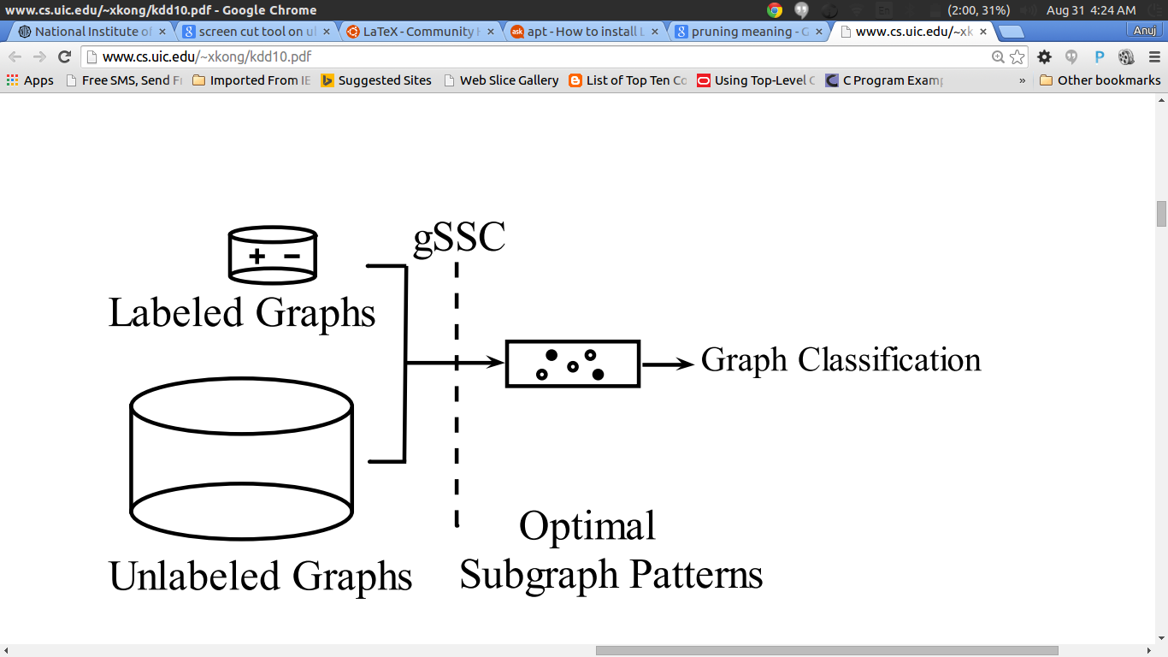
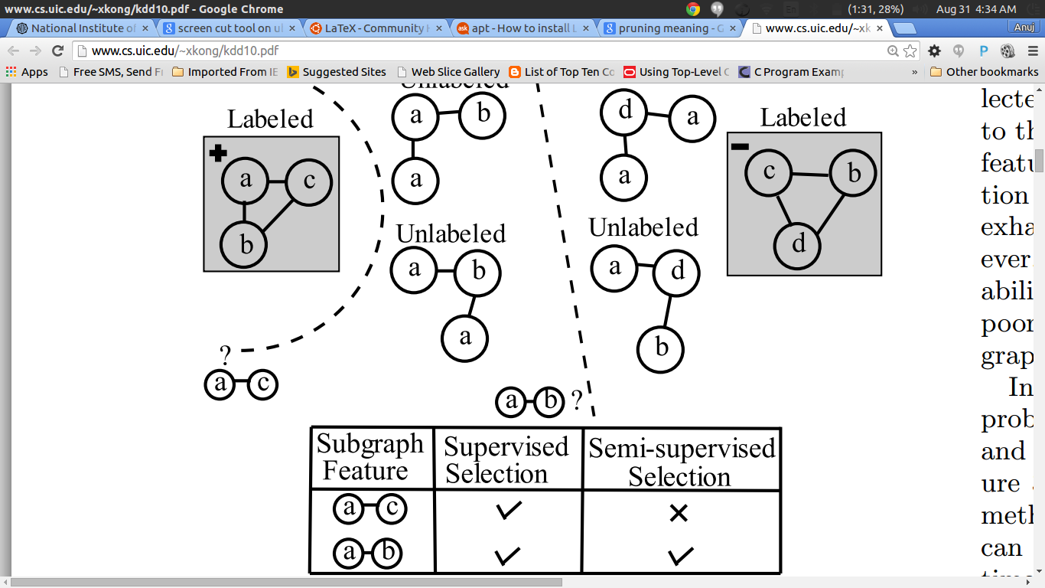
Consider this example for the graph based semi supervised feature selection algorithm
Let us consider a dataset with four un labeled graphs and two labeled graphs. Now in the two labeled graphs one can observe that the two discriminative features are “a-b” and “a-c”. It is very clear that the subgraph feature “a-b” is more useful than “a-c” in order to separate the unlabeled graphs. This happens because the un labeled graphs are not at all separable on the basis of “a-c”.

Spline regression for semi supervised feature selection

Splines

A spline curve is a mathematical representation which allow a user to design and control the shape of complex curves and surfaces. The user enters a sequence of points, and a curve is constructed whose shape closely follows this sequence.The points are called control points. A curve that actually passes through each control point is called an interpolating curve and a curve that passes near to the
control points but not necessarily through them is called an approximating curve.

Cubic Splines are used for the following reasons
1. it is the lowest degree polynomial that can support an inflection
2. it is very well behaved numerically – that means that the curves will
usually be smooth and not jumpy

To make more complex curves we used the concepts of piecewise curve fitting and parameterization. The conditions for piece wise curve fitting are as follows:

1. We require that each curve segment pass through its control points. Thus,
fi(xi) = yi, and fi(xi+1) = yi+1. This enforces C0 continuity – that is,where the curves join they meet each other.
2. We require that the curve segments have the same slope where they join
together. Thus, f'i(xi+1) = f'i+1(xi+1). This enforces C1 continuity –that is that slopes match where the curves join.
3. The curve segments have the same curvature where they join together. Thus, f''i(xi+1) = f''i+1(xi+1).
This enforces C2 continuity – that curvatures match at the join.

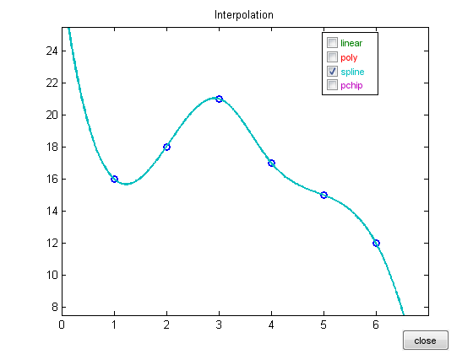
Semi Supervised Feature Selection using Spline Regression – Methodology

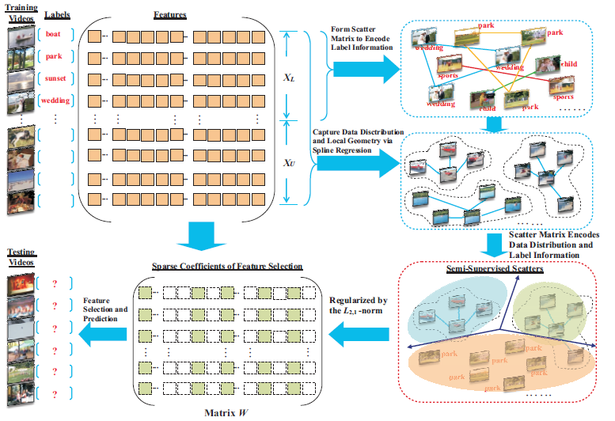

Given a large data set of labelled and unlabelled videos, where the size of unlabelled>>size of labelled, we employ semi supervised feature selection using spline regression in the following manner :

1) We create a feature matrix with the entire data set.
2) We create a scatter matrix with only the labelled set to encode label information
3) With the unlabelled set,we apply spline regression to capture data distribution and local geometry
4) We create a scatter matrix with the same and we end up with semi supervised scatters in the process
5) After regularization via the L21 norm, the new matrix W will be sparse in rows which makes it ideal for feature selection
6)The top features are taken into consideration and is used to classify the test videos

Some of the challenges that spline regression faces is that there is a tendency to overfit and how these control points are determined. Fortunately, many programming language implementations of this automatically assign these control points in such a way that piecewise smooth curves are generated which follow the aformentioned three conditions. The resultant curve generated out of this process is made to best fit the data without overfitting the data.

