**System Design:**

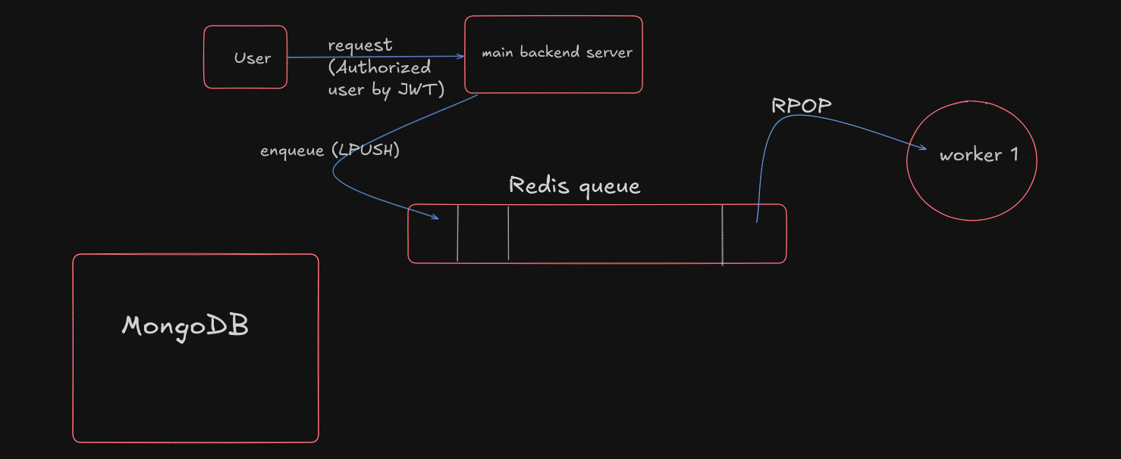

## Client-Server Model

The system implements a traditional client-server architecture with the following components:

* User Client: Initiates requests to the main backend server
* Main Backend Server: Handles incoming client requests and authentication
* Redis Queue: Acts as the message broker between server and workers
* Worker Process: Processes requests from the queue

## Queue Management

The system utilizes Redis as the queue management system with the following workflow:

* Queue Operations:
  + LPUSH: Server enqueues requests to Redis queue
  + RPOP: Worker dequeues requests for processing
* Request Flow:
  + Requests are stored in Redis in FIFO (First-In-First-Out) order
  + Each request maintains its order of arrival
  + Workers process requests sequentially to ensure ordered execution

## Worker Architecture

The worker implementation follows these principles:

* Single Worker Model: Dedicated worker process that continuously polls the Redis queue
* Sequential Processing: Requests are processed one at a time in the order they were received
* Asynchronous Operation: Worker operates independently of the main server
* Reliable Processing: Uses RPOP to ensure each request is processed exactly once

This architecture provides:

* Scalability through decoupled components
* Reliability through persistent queue storage
* Ordered processing of requests
* Efficient resource utilization
* Easy monitoring and maintenance

The system can be extended by adding more workers or implementing additional queue features as needed.

## Backend Tech Stack

* TypeScript: Used as the primary programming language, providing type safety and better development experience
* Node.js: Runtime environment for executing JavaScript/TypeScript code
* Express: Web framework for handling HTTP requests, routing, and middleware implementation
* MongoDB: Primary database for storing user information, connected via db.ts
* Redis: Implements message queue functionality for request processing
  + Uses LPUSH for enqueueing requests from main server
  + Uses RPOP for dequeuing requests by worker process

## Authentication & Security

* bcrypt: Implements password hashing in passwordHashing.ts for secure user credential storage
* JWT: Handles user authentication tokens in jwtAuth.ts middleware
* Zod: Implements request validation schemas in userSchema.ts for input validation

## Containerization & Services

* Docker: Containerizes different components of the application:
  + Main backend server
  + Redis queue
  + Worker process
  + Prometheus
  + Grafana

## Monitoring & Metrics

* Prometheus: Collects metrics from the application:
  + Active requests tracking
  + Request count monitoring
  + Request time measurements
* Grafana: Visualizes metrics collected by Prometheus

## Project Structure

* /src: Contains main application code
* /middlewares: Authentication and validation middleware
* /monitoring: Prometheus metrics configuration
* /routes: API endpoint definitions
* /schemas: Data validation schemas
* /tests: Unit and integration tests

## Systems monitoring and logging

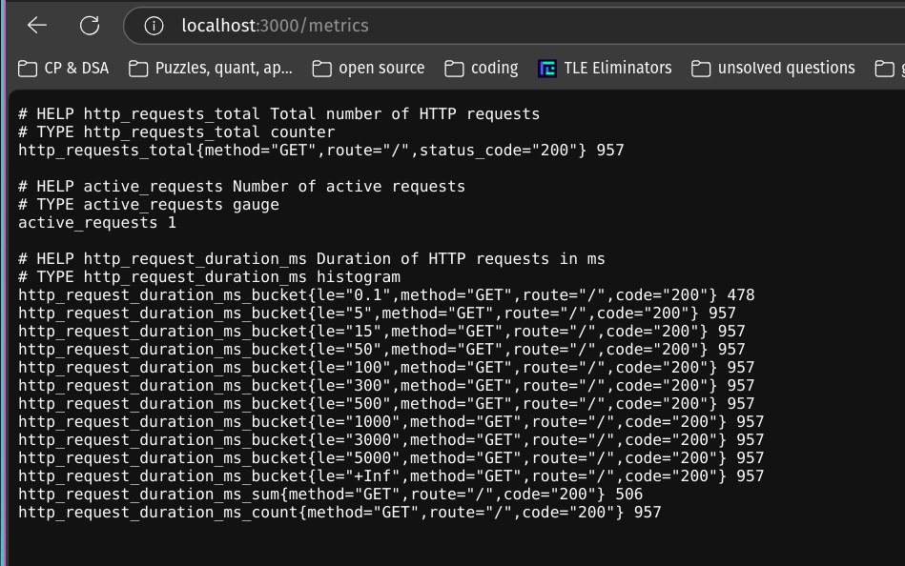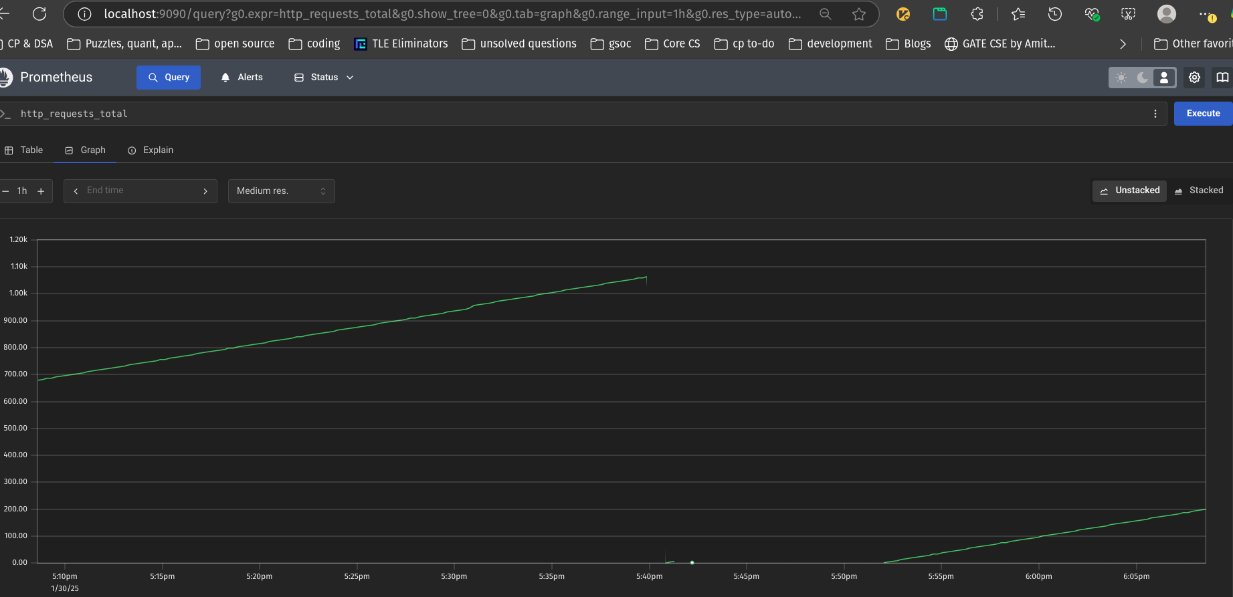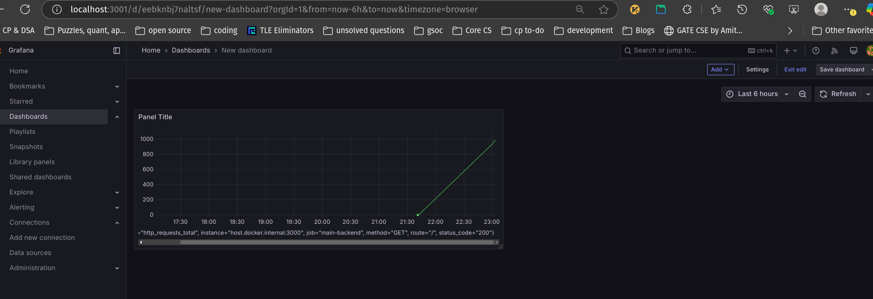

## Project Setup Guide

## 1. Redis Setup

Start Redis container:

bash

docker run --name my_redis -d -p 6379:6379 redis

## 2. Main Backend Setup

Navigate to main backend directory and install dependencies:

bash

cd main-backend

npm install

Run unit tests:

bash

npm test

Start the main backend server:

bash

npm run start

## 3. Worker Setup

Navigate to worker directory and install dependencies:

bash

cd workers

npm install

Start the worker:

bash

npm run start

## 4. Prometheus Setup

Start Prometheus container with host access:

bash

docker run -p 9090:9090 \

-v $(pwd)/prometheus.yml:/etc/prometheus/prometheus.yml \

--add-host=host.docker.internal:host-gateway \

prom/prometheus

## 5. Grafana Setup

Start Grafana container:

bash

docker run -d -p 3001:3000 --add-host=host.docker.internal:host-gateway --name=grafana grafana/grafana:latest

## 6. Grafana Configuration

1. Access Grafana at [http://localhost:3001](http://localhost:3001/)
2. Login with credentials:
   * Username: admin
   * Password: admin
3. Add Prometheus data source:
   * Navigate to Configuration → Data Sources
   * Add new data source
   * Select Prometheus
   * Set URL to: [http://host.docker.internal:9090](http://host.docker.internal:9090/)
   * Save & Test