# **PYTHON ASSIGNMENT**

**About Us**

We are motivated individuals who specialize in providing IT and software development services to clients worldwide. We have been in this industry for the last 4 years. If you like to work in a fast-paced environment with a multitude of technologies, Ignis Tech Solutions is the best place for you.

**Assignment Requirements**

Here’s a short and simple assignment to be completed before you join us!

The assignment goal is to Write a script (**main.py**) which will scrape all the required data from the website <https://www.pagesjaunes.fr/> and store it in a csv file.

**Process**

1. Go to <https://www.pagesjaunes.fr/annuaire/alsace>. For each alphabet, you go to the “see all cities” page.

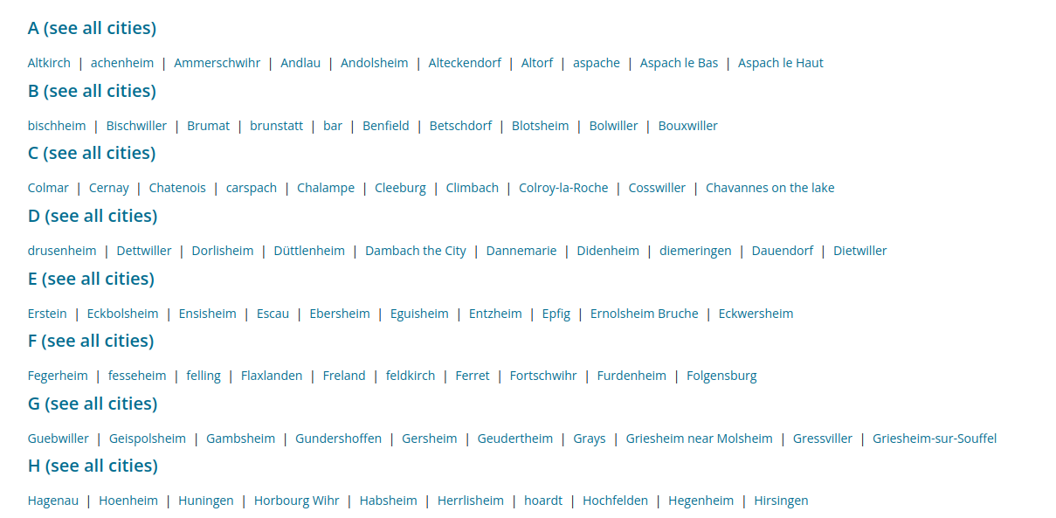

1. For that alphabet, get all the city links. (Note: if you click “see all cities” for A, it’ll show for B, C, D etc on the same page, so make sure not to get redundant urls)

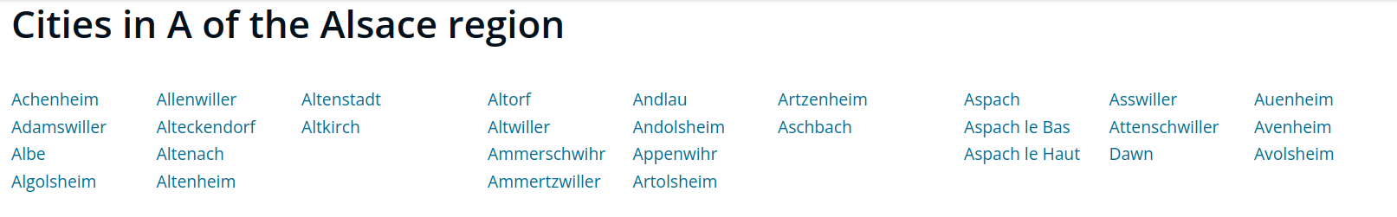

1. For each city link, go to this url - <city-link>/professionels   
   (eg-> [pagesjaunes.fr/annuaire/altkirch-68/professionnels](https://www.pagesjaunes.fr/annuaire/altkirch-68/professionnels))
2. **You’ve to scrape all the business links for all the pages in each city of Alsace region**

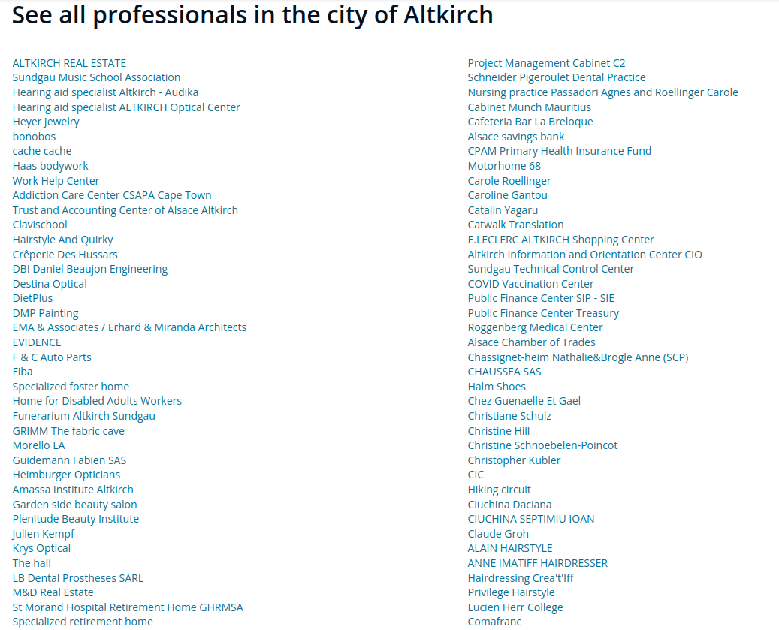

1. The scraped data must be stored in a CSV file that has the following 3 columns:  
    Business Link City Link City Name

**NOTE:** You need to use Python’s *requests* module for the task. (Selenium is NOT allowed)

You need to create a **class** with the functions for making requests, scraping data, processing data, and writing to a CSV file(you can add any other function if needed). Submissions without proper OOPS concepts will not be preferred.

**IMPORTANT DETAILS**

DEADLINE: 11:55 PM, 6th November, 2022

* The assignment has to be submitted at: <https://forms.gle/aNrixuzGMPyuCLeX8>

NOTE: Early submission will give you an advantage.

* It should be a single main.py file and output csv file all pushed on a **private** github repo. Add **ignis-tech-solutions** as a collaborator to your repository. Do test/verify your code before submitting it.
* Make sure the code is neat and readable.
* For any doubts, feel free to drop a mail at [devgods99@gmail.com](mailto:devgods99@gmail.com) We’ll try to respond asap!
* In case you’re not able to complete within the deadline, do submit the code even if a part or it completely doesn’t work. Because the work you put in and skills you possess are reflected by your code.
* Only Requests and Beautiful Soup modules can be used. **DO NOT** use Selenium, Pandas or Urllib2.