San Jose State University
Fall 2017


Project Abstract

LAB 3 –Dropbox Application

CMPE 273

SUBMITTED BY –

SUBMITTED TO-

Siddharth Suthar(011439636)

Prof. Simon Shim

Enterprise Distributed System Lab 3 Report

Introduction

Goal :

The Goal of the Assignment is to understand the concepts of the SpringBoot and React. And to understand the cross platform origin problems , and how to solve that and to implement the business logic of Dropbox like application in React and springboot.

Purpose :

To develop a Dropbox like application that performs the basic functionalities of the Dropbox application like File Upload , File Download, File Share , User Creation , Group Creation Displaying user Info , user logs , maintaining the state , and encryption of Password using salt and hash. The idea is to understand and implement the concepts and architecture of the application in ReactJs , Redux , NodeJs, Kafka queue , and Mongodb. Kafka Queue is used to make the system distributed and allow it to be horizontally scalable.

System Design

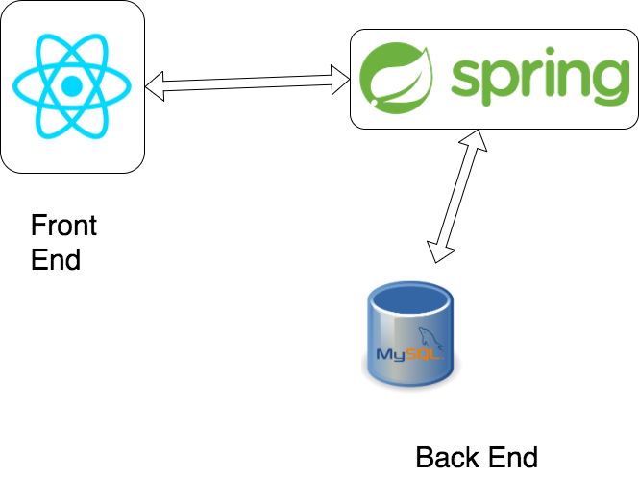

As mentioned in the architecture , the front end part of the application is implemented in ReactJs and the back end part of the application is implemented in Spring Boot

API’s Created :

Method : POST

- Localhost:3001/users/login

- Localhost:3001/users/doLogout

- Localhost:3001/users/doRegister

- Localhost:3001/users/validateUser

- Localhost:3001/files/share

- Localhost:3001/files/upload

- Localhost:3001/files/delete

- Localhost:3001/files/uploadFolder

- Localhost:3001/files/deleteFolder

- Localhost:3001/users/createGroup

- Localhost:3001/users/addMember

Method : GET

- Localhost:3001/users/getFiles

- Localhost:3001/users/groups

Screen Shots :

- Sign In and Sign Up Page : User can Login or Sign Up on this page
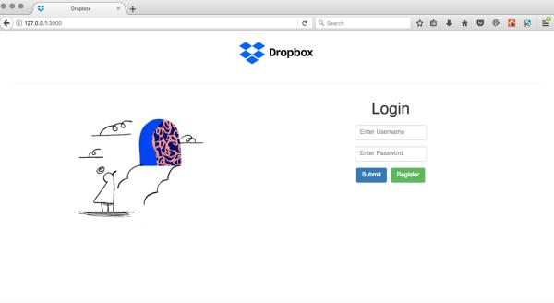
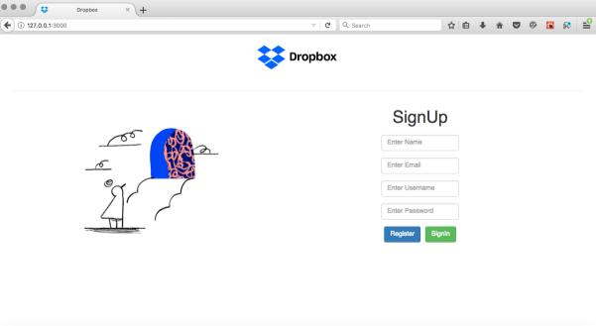

- Dashboard : This is the dashboard of the application where the user can create new folders, upload files and share files. And mark his files as Starred or not.
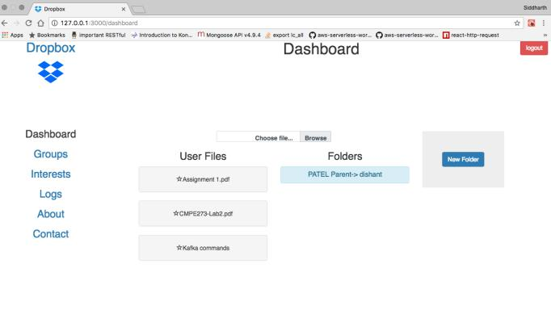

Starred Files-
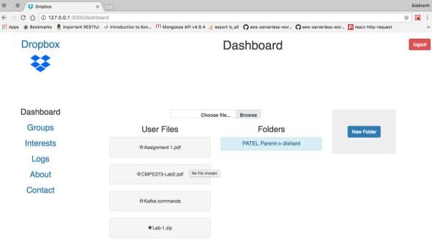

File Share , Download , Delete Functionalities-

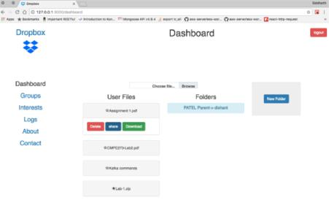

Folder Share, Create, Add Files and Delete Functionality-
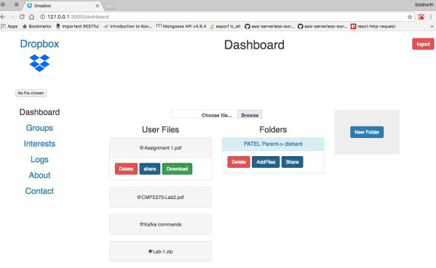

Groups Page :

Creating a group (Owner is by default member of the Group) –
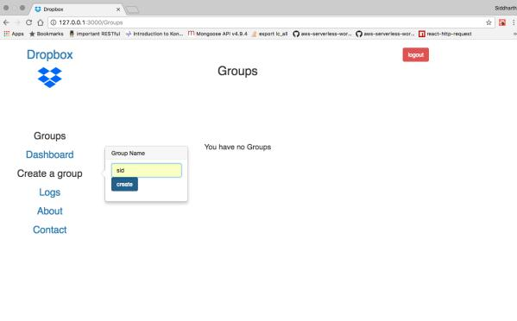

Group with owner as a default member –
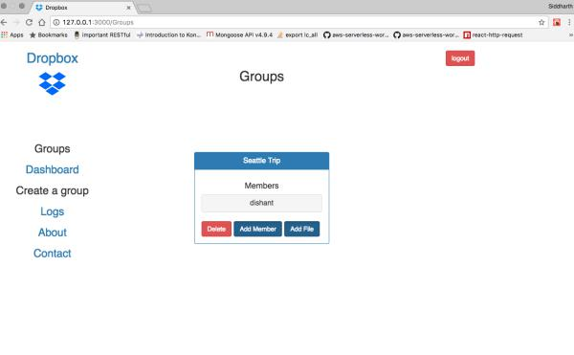

Adding a new member and checking in that member’s groups page-

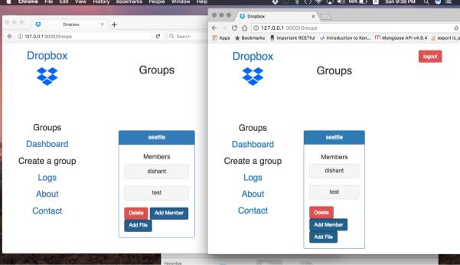

About Page –
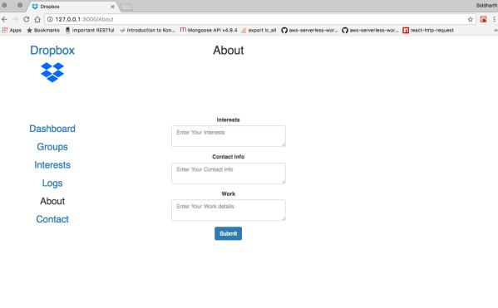

Junit :

Performance :

The performance of the system has been measured using Apache Jmeter.

- For 100 concurrent users –

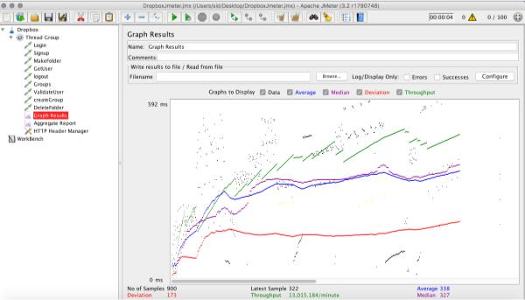

- For 200 Concurrent Users :

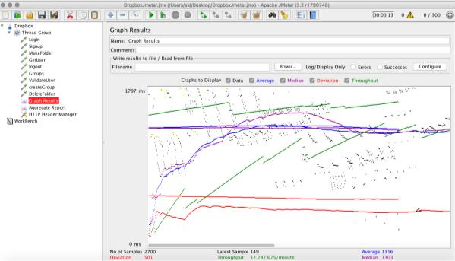

- For 300 concurrent users :

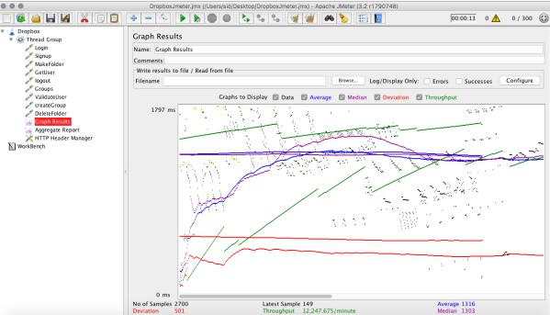

- For 400 Concurrent Users :

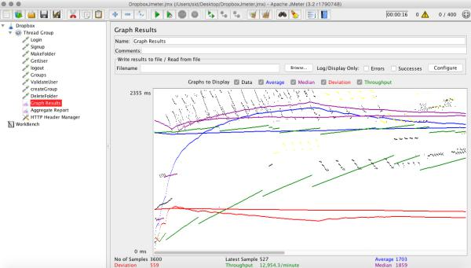

- For 500 concurrent Users :

