**WEEK-2**

**Logging using SLF4J**

NAME : SIDHARTH K

SUPERSET ID : 6430194

**Exercise 1: Logging Error Messages and Warning Levels**

**Main.java**

package com.example;  
  
import org.slf4j.Logger;  
import org.slf4j.LoggerFactory;  
  
public class Main{  
 private static final Logger *logger* = LoggerFactory.*getLogger*(Main.class);  
  
 public static void main(String[] args) {  
 *logger*.error("This is an error message");  
 *logger*.warn("This is a warning message");  
 }  
}

**Output:**

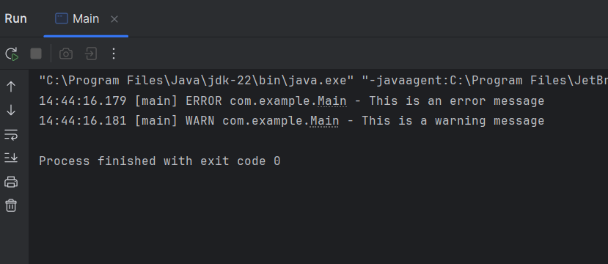

**Exercise 2: Parameterized Logging**

**Main.java**

package com.example;  
  
import org.slf4j.Logger;  
import org.slf4j.LoggerFactory;  
  
public class Main {  
  
 private static final Logger *logger* = LoggerFactory.*getLogger*(Main.class);  
  
 public static void main(String[] args) {  
 String user = "Sid";  
 int age = 20;  
 *logger*.info("User {} has logged in.", user);  
 *logger*.warn("User {} is {} years old - verify age!", user, age);  
 *logger*.error("Login attempt failed for user: {}", user);  
 }  
}

**Output:**

**Exercise 3: Using Different Appenders**

**Main.java**

package com.example;  
  
import org.slf4j.Logger;  
import org.slf4j.LoggerFactory;  
  
public class Main {  
  
 private static final Logger *logger* = LoggerFactory.*getLogger*(Main.class);  
  
 public static void main(String[] args) {  
 *logger*.debug("Debugging application startup");  
 *logger*.info("App started successfully");  
 *logger*.warn("Disk space is running low");  
 *logger*.error("Unhandled exception occurred");  
 }  
}

**Output:**

