**Week 2**

**PLSQL Exercises**

NAME : SIDHARTH K

SUPERSET ID : 6430194

**Exercise 1: Control Structures:**

**Scenario 1:**

BEGIN

    FOR cus IN (

        SELECT CUSTOMERID, DOB

        FROM CUSTOMERS

    ) LOOP

        IF Months_Between(SYSDATE, cus.DOB)/12 < 60 THEN

            UPDATE LOANS

            SET INTERESTRATE = INTERESTRATE - 1

            WHERE CUSTOMERID = cus.CUSTOMERID;

            DBMS_OUTPUT.PUT_LINE('Updated interest rate for Customer ID: ' || cus.CustomerID);

        END IF;

    END LOOP;

END;

/

**Output:**

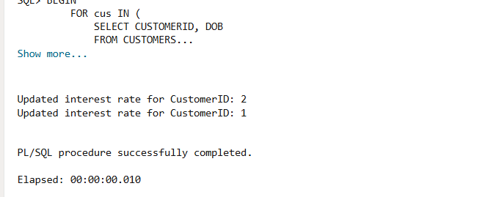

**Scenario 2:**

BEGIN

   FOR rec IN (SELECT CustomerID, Balance FROM Customers)

   LOOP

      IF rec.Balance > 10000 THEN

         UPDATE Customers

         SET IsVIP = 'TRUE'

         WHERE CustomerID = rec.CustomerID;

         DBMS_OUTPUT.PUT_LINE('CustomerID ' || rec.CustomerID || ' promoted to VIP.');

      END IF;

   END LOOP;

   COMMIT;

END;

/

**Output:**

**Scenario 1:**

BEGIN

   FOR rec IN (

      SELECT LoanID, CustomerID, EndDate

      FROM Loans

      WHERE EndDate BETWEEN SYSDATE AND SYSDATE + 30

   ) LOOP

      DBMS_OUTPUT.PUT_LINE(

         'Reminder: Loan ID ' || rec.LoanID ||

         ' for Customer ID ' || rec.CustomerID ||

         ' is due on ' || TO_CHAR(rec.EndDate, 'DD-MON-YYYY')

      );

   END LOOP;

END;

/

**Output:**

**Exercise 2: Error Handling:**

**Scenario 1:**

CREATE OR REPLACE PROCEDURE SafeTransferFunds(

p_from_account_id IN NUMBER,

p_to_account_id IN NUMBER,

p_amount IN NUMBER

)

IS v_balance NUMBER;

BEGIN

SELECT Balance INTO v_balance FROM Accounts

WHERE AccountID = p_from_account_id

FOR UPDATE;

IF v_balance < p_amount THEN

RAISE_APPLICATION_ERROR(-20001, 'Insufficient funds.');

END IF;

UPDATE Accounts

SET Balance = Balance - p_amount

WHERE AccountID = p_from_account_id;

UPDATE Accounts

SET Balance = Balance + p_amount

WHERE AccountID = p_to_account_id;

COMMIT;

DBMS_OUTPUT.PUT_LINE('Transfer completed successfully.');

EXCEPTION

WHEN OTHERS THEN

ROLLBACK;

DBMS_OUTPUT.PUT_LINE('Error during transfer: ' || SQLERRM);

END;

/

**Output:**

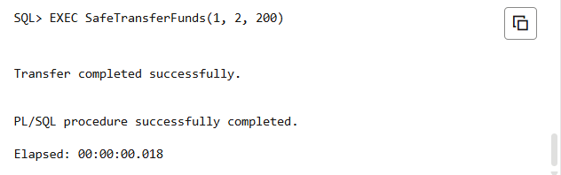

**Scenario 2:**

CREATE OR REPLACE PROCEDURE UpdateSalary(

    p_employee_id IN NUMBER,

    p_percentage  IN NUMBER

)

IS

BEGIN

    UPDATE Employees

    SET Salary = Salary + (Salary * p_percentage / 100)

    WHERE EmployeeID = p_employee_id;

IF SQL%ROWCOUNT = 0 THEN

        RAISE_APPLICATION_ERROR(-20002, 'Employee ID does not exist.');

    END IF;

    COMMIT;

    DBMS_OUTPUT.PUT_LINE('Salary updated successfully.');

EXCEPTION WHEN OTHERS THEN

        ROLLBACK;

        DBMS_OUTPUT.PUT_LINE('Error updating salary: ' || SQLERRM);

END;

/

**Output:**

**Scenario 3:**

CREATE OR REPLACE PROCEDURE AddNewCustomer(

p_customer_id IN NUMBER,

p_name IN VARCHAR2,

p_dob IN DATE,

p_balance IN NUMBER

)

IS

BEGIN

INSERT INTO Customers (CustomerID, Name, DOB, Balance, LastModified)

VALUES (p_customer_id, p_name, p_dob, p_balance, SYSDATE);

COMMIT;

DBMS_OUTPUT.PUT_LINE('New customer added successfully.');

EXCEPTION

WHEN DUP_VAL_ON_INDEX THEN

DBMS_OUTPUT.PUT_LINE('Error: Customer ID already exists.');

WHEN OTHERS THEN

DBMS_OUTPUT.PUT_LINE('Unexpected error: ' || SQLERRM);

END;

/

**Output:**

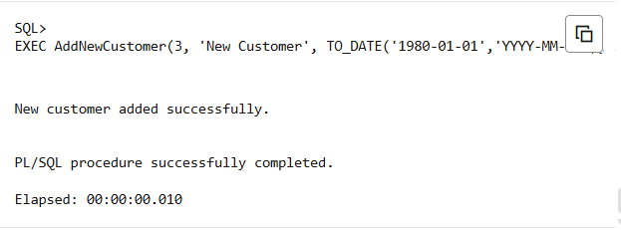

**Exercise 3: Stored Procedures:**

**Scenario 1:**

CREATE OR REPLACE PROCEDURE ProcessMonthlyInterest

IS

BEGIN

UPDATE Accounts

SET Balance = Balance + (Balance * 0.01)

WHERE AccountType = 'Savings';

COMMIT;

DBMS_OUTPUT.PUT_LINE('Monthly interest applied to all Savings accounts.');

END;

/

EXEC ProcessMonthlyInterest;

**Output:**

**Scenario 2:**

CREATE OR REPLACE PROCEDURE UpdateEmployeeBonus(p_department IN VARCHAR2, p_bonus_pct  IN NUMBER)

IS

BEGIN

   UPDATE

   Employees

   SET Salary = Salary + (Salary * p_bonus_pct / 100)

   WHERE Department = p_department;

   IF SQL%ROWCOUNT > 0 THEN

      DBMS_OUTPUT.PUT_LINE('Salaries updated for department: ' || p_department);

   ELSE

      DBMS_OUTPUT.PUT_LINE('No employees found in department: ' || p_department);

   END IF;

   COMMIT;

END;

/

EXEC UpdateEmployeeBonus('IT', 5);

**Output:**

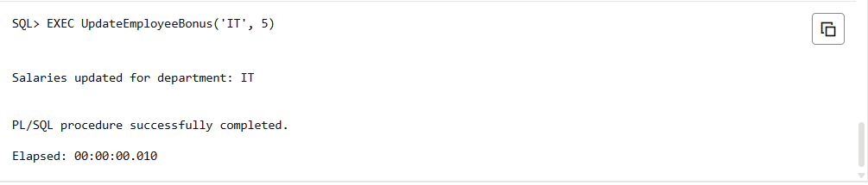

**Scenario 3:**

CREATE OR REPLACE PROCEDURE TransferFunds(p_from_account IN NUMBER,p_to_account   IN NUMBER,p_amount IN NUMBER)

IS

    v_balance NUMBER;

BEGIN

   SELECT Balance INTO v_balance

   FROM Accounts

   WHERE AccountID = p_from_account

   FOR UPDATE;

   IF v_balance < p_amount THEN

      RAISE_APPLICATION_ERROR(-20001, 'Insufficient funds in source account.');

   END IF;

   UPDATE Accounts

   SET Balance = Balance - p_amount

   WHERE AccountID = p_from_account;

   UPDATE Accounts

   SET Balance = Balance + p_amount

   WHERE AccountID = p_to_account;

   COMMIT;

   DBMS_OUTPUT.PUT_LINE('Funds transferred successfully.');

EXCEPTION

   WHEN OTHERS THEN

      ROLLBACK;

      DBMS_OUTPUT.PUT_LINE('Error transferring funds: ' || SQLERRM);

END;

/

EXEC TransferFunds(1, 2, 300);

**Output:**

**Exercise 4: Functions:**

**Scenario 1:**

CREATE OR REPLACE FUNCTION CalculateAge(p_dob IN DATE) RETURN NUMBER

IS

    v_age NUMBER;

BEGIN

    v_age := TRUNC(MONTHS_BETWEEN(SYSDATE, p_dob) / 12);

    RETURN v_age;

END;

/

SELECT CalculateAge(TO_DATE('1975-08-11','YYYY-MM-DD')) AS Age FROM dual;

**Output:**

**Scenario 2:**

CREATE OR REPLACE FUNCTION CalculateMonthlyInstallment(

    p_loan_amount   IN NUMBER,

    p_interest_rate IN NUMBER,

    p_years         IN NUMBER

) RETURN NUMBER

IS

    v_monthly_rate NUMBER;

    v_months       NUMBER;

    v_installment  NUMBER;

BEGIN

    v_monthly_rate := p_interest_rate / (12 * 100);

    v_months := p_years * 12;

    v_installment := p_loan_amount * v_monthly_rate / (1 - POWER(1 + v_monthly_rate, -v_months));

    RETURN v_installment;

END;

/

SELECT CalculateMonthlyInstallment(7000, 8, 3) AS Installment FROM dual;

**Output:**



**Scenario 3:**

CREATE OR REPLACE FUNCTION HasSufficientBalance(

    p_account_id IN NUMBER,

    p_amount     IN NUMBER

) RETURN BOOLEAN

IS

    v_balance NUMBER;

BEGIN

    SELECT Balance INTO v_balance

    FROM Accounts

    WHERE AccountID = p_account_id;

    IF v_balance >= p_amount THEN

        RETURN TRUE;

    ELSE

        RETURN FALSE;

    END IF;

END;

/

DECLARE

    v_result BOOLEAN;

BEGIN

    v_result := HasSufficientBalance(1, 500);

    IF v_result THEN

        DBMS_OUTPUT.PUT_LINE('Sufficient balance.');

    ELSE

        DBMS_OUTPUT.PUT_LINE('Insufficient balance.');

    END IF;

END;

/

**Output:**

**Exercise 5: Triggers:**

**Scenario 1:**

CREATE OR REPLACE TRIGGER UpdateCustomerLastModified

BEFORE UPDATE ON Customers

FOR EACH ROW

BEGIN

   :NEW.LastModified := SYSDATE;

END;

/

**Output:**

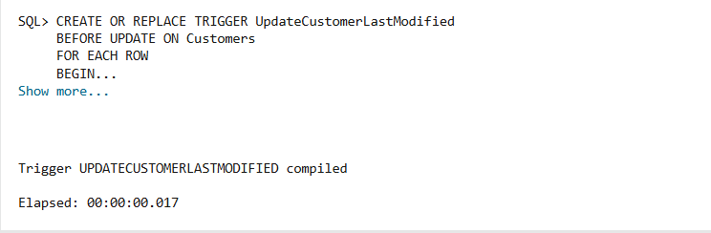

**Scenario 2:**

CREATE TABLE AuditLog (

    AuditID NUMBER GENERATED ALWAYS AS IDENTITY PRIMARY KEY,

    TransactionID NUMBER,

    AccountID NUMBER,

    Amount NUMBER,

    TransactionType VARCHAR2(10),

    TransactionDate DATE

);

CREATE OR REPLACE TRIGGER LogTransaction

AFTER INSERT ON Transactions

FOR EACH ROW

BEGIN

   INSERT INTO AuditLog (TransactionID,AccountID,Amount,TransactionType,TransactionDate)

   VALUES (:NEW.TransactionID,:NEW.AccountID,:NEW.Amount,:NEW.TransactionType,:NEW.TransactionDate);

END;

/

**Output:**

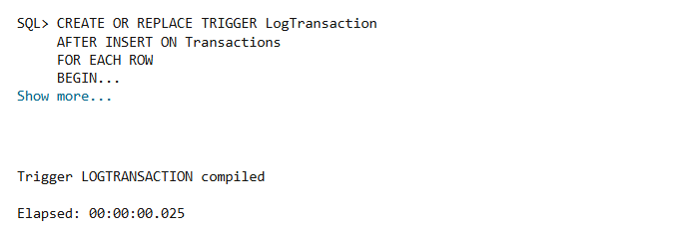

**Scenario 3:**

CREATE OR REPLACE TRIGGER CheckTransactionRules

BEFORE INSERT ON Transactions

FOR EACH ROW

DECLARE

   v_balance NUMBER;

BEGIN

   SELECT Balance INTO v_balance

   FROM Accounts

   WHERE AccountID = :NEW.AccountID

   FOR UPDATE;

   IF :NEW.TransactionType = 'Withdrawal' THEN

      IF :NEW.Amount > v_balance THEN

         RAISE_APPLICATION_ERROR(-20001, 'Withdrawal exceeds available balance.');

      END IF;

   ELSIF :NEW.TransactionType = 'Deposit' THEN

      IF :NEW.Amount <= 0 THEN

         RAISE_APPLICATION_ERROR(-20002, 'Deposit amount must be positive.');

      END IF;

   END IF;

END;

/

**Output:**

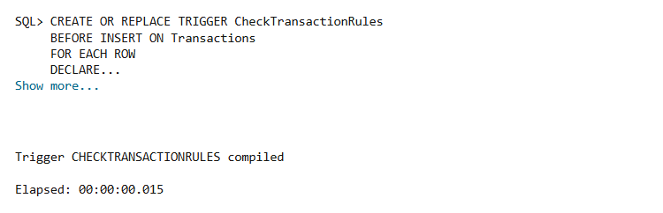

**Exercise 6: Cursors:**

**Scenario 1:**

DECLARE

   CURSOR c_monthly_txns IS

      SELECT t.TransactionID,t.AccountID,t.TransactionDate,t.Amount,t.TransactionType,a.CustomerID

      FROM Transactions t

      JOIN Accounts a ON t.AccountID = a.AccountID

      WHERE TRUNC(t.TransactionDate, 'MM') = TRUNC(SYSDATE, 'MM');

BEGIN

   FOR rec IN c_monthly_txns LOOP

      DBMS_OUTPUT.PUT_LINE(

         'CustomerID: ' || rec.CustomerID ||

         ', AccountID: ' || rec.AccountID ||

         ', TransactionID: ' || rec.TransactionID ||

         ', Date: ' || TO_CHAR(rec.TransactionDate, 'DD-MON-YYYY') ||

         ', Type: ' || rec.TransactionType ||

         ', Amount: ' || rec.Amount

      );

   END LOOP;

END;

/

**Output:**

**Scenario 2:**

DECLARE

   CURSOR c_accounts IS

      SELECT AccountID, Balance

      FROM Accounts;

BEGIN

   FOR rec IN c_accounts LOOP

      UPDATE Accounts

      SET Balance = Balance - 50

      WHERE AccountID = rec.AccountID;

      DBMS_OUTPUT.PUT_LINE('Annual fee deducted from AccountID: ' || rec.AccountID ||'. New Balance: ' || (rec.Balance - 50));

   END LOOP;

   COMMIT;

END;

/

**Output:**

**Scenario 3:**

DECLARE

   CURSOR c_loans IS

      SELECT LoanID, InterestRate

      FROM Loans;

   v_new_rate NUMBER;

BEGIN

   FOR rec IN c_loans LOOP

      IF rec.InterestRate < 5 THEN

         v_new_rate := rec.InterestRate + 1;

      ELSE

         v_new_rate := rec.InterestRate - 0.5;

      END IF;

      UPDATE Loans

      SET InterestRate = v_new_rate

      WHERE LoanID = rec.LoanID;

      DBMS_OUTPUT.PUT_LINE('LoanID: ' || rec.LoanID || ', Old Rate: ' || rec.InterestRate || ', New Rate: ' || v_new_rate );

   END LOOP;

   COMMIT;

END;

/

**Output:**

**Exercise 7: Packages:**

**Scenario 1:**

CREATE OR REPLACE PACKAGE CustomerManagement IS

   PROCEDURE AddCustomer(p_customer_id NUMBER, p_name VARCHAR2,p_dob DATE, p_balance  NUMBER);

   PROCEDURE UpdateCustomer(p_customer_id NUMBER, p_name VARCHAR2,p_balance NUMBER );

   FUNCTION GetBalance(p_customer_id NUMBER ) RETURN NUMBER;

END CustomerManagement;

/

BEGIN

   CustomerManagement.AddCustomer(10, 'New Customer', TO_DATE('1973-11-21','YYYY-MM-DD'), 2000);

   CustomerManagement.UpdateCustomer(10, 'Updated Name', 3000);

   DBMS_OUTPUT.PUT_LINE('Balance: ' || CustomerManagement.GetBalance(10));

END;

/

**Output:**

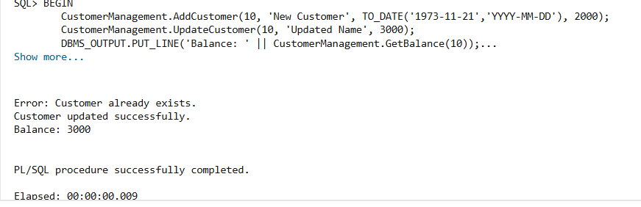

**Scenario 2:**

CREATE OR REPLACE PACKAGE EmployeeManagement IS

   PROCEDURE HireEmployee(p_employee_id NUMBER,p_name VARCHAR2,p_position VARCHAR2,p_salary NUMBER,p_department VARCHAR2,p_hiredate DATE);

   PROCEDURE UpdateEmployee(p_employee_id NUMBER,p_salary NUMBER,p_department VARCHAR2);

   FUNCTION AnnualSalary(

       p_employee_id NUMBER

   ) RETURN NUMBER;

END EmployeeManagement;

/

CREATE OR REPLACE PACKAGE BODY EmployeeManagement IS

   PROCEDURE HireEmployee(

       p_employee_id NUMBER,

       p_name        VARCHAR2,

       p_position    VARCHAR2,

       p_salary      NUMBER,

       p_department  VARCHAR2,

       p_hiredate    DATE

   ) IS

   BEGIN

       INSERT INTO Employees (

           EmployeeID, Name, Position, Salary, Department, HireDate

       )

       VALUES (

           p_employee_id, p_name, p_position, p_salary, p_department, p_hiredate

       );

       COMMIT;

       DBMS_OUTPUT.PUT_LINE('Employee hired successfully.');

   EXCEPTION

       WHEN DUP_VAL_ON_INDEX THEN

           DBMS_OUTPUT.PUT_LINE('Error: Employee already exists.');

   END HireEmployee;

   PROCEDURE UpdateEmployee(

       p_employee_id NUMBER,

       p_salary      NUMBER,

       p_department  VARCHAR2

   ) IS

   BEGIN

       UPDATE Employees

       SET Salary = p_salary,

           Department = p_department

       WHERE EmployeeID = p_employee_id;

       IF SQL%ROWCOUNT = 0 THEN

           DBMS_OUTPUT.PUT_LINE('Employee not found.');

       ELSE

           DBMS_OUTPUT.PUT_LINE('Employee updated successfully.');

       END IF;

       COMMIT;

   END UpdateEmployee;

   FUNCTION AnnualSalary(

       p_employee_id NUMBER

   ) RETURN NUMBER IS

       v_salary NUMBER;

   BEGIN

       SELECT Salary INTO v_salary

       FROM Employees

       WHERE EmployeeID = p_employee_id;

       RETURN v_salary * 12;

   EXCEPTION

       WHEN NO_DATA_FOUND THEN

           RETURN NULL;

   END AnnualSalary;

END EmployeeManagement;

/

BEGIN

   EmployeeManagement.HireEmployee(10, 'Sam Smith', 'Analyst', 5000, 'Finance', SYSDATE);

   EmployeeManagement.UpdateEmployee(10, 6000, 'Finance');

   DBMS_OUTPUT.PUT_LINE('Annual Salary: ' || EmployeeManagement.AnnualSalary(10));

END;

/

**Output:**

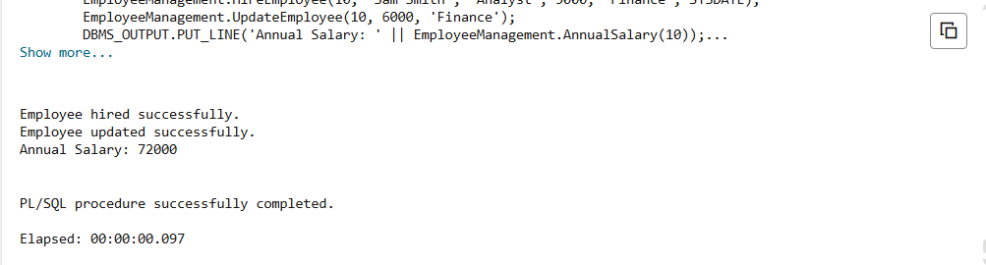

**Scenario 3:**

CREATE OR REPLACE PACKAGE BODY AccountOperations IS

   PROCEDURE OpenAccount(

       p_account_id   NUMBER,

       p_customer_id  NUMBER,

       p_type         VARCHAR2,

       p_balance      NUMBER

   ) IS

   BEGIN

       INSERT INTO Accounts (

           AccountID, CustomerID, AccountType, Balance, LastModified

       )

       VALUES (

           p_account_id, p_customer_id, p_type, p_balance, SYSDATE

       );

       COMMIT;

       DBMS_OUTPUT.PUT_LINE('Account opened successfully.');

   EXCEPTION

       WHEN DUP_VAL_ON_INDEX THEN

           DBMS_OUTPUT.PUT_LINE('Error: Account already exists.');

   END OpenAccount;

   PROCEDURE CloseAccount(

       p_account_id NUMBER

   ) IS

   BEGIN

       DELETE FROM Accounts

       WHERE AccountID = p_account_id;

       IF SQL%ROWCOUNT = 0 THEN

           DBMS_OUTPUT.PUT_LINE('Account not found.');

       ELSE

           DBMS_OUTPUT.PUT_LINE('Account closed successfully.');

       END IF;

       COMMIT;

   END CloseAccount;

   FUNCTION GetTotalBalance(

       p_customer_id NUMBER

   ) RETURN NUMBER IS

       v_total NUMBER;

   BEGIN

       SELECT SUM(Balance)

       INTO v_total

       FROM Accounts

       WHERE CustomerID = p_customer_id;

       RETURN NVL(v_total,0);

   END GetTotalBalance;

END AccountOperations;

/

BEGIN

   AccountOperations.OpenAccount(20, 1, 'Savings', 1000);

   AccountOperations.CloseAccount(20);

   DBMS_OUTPUT.PUT_LINE('Total Balance: ' || AccountOperations.GetTotalBalance(1));

END;

/

**Output:**

