**WEEK-4**

**SPRING REST**

NAME : SIDHARTH K

SUPERSET ID : 6430194

**Exercise 1: Create a Spring Web Project using Maven:**

**CODE:**

**EmployeeManagementSystemApplication.java:**

package com.cognizant.spring_learn;

import org.springframework.boot.SpringApplication;

import org.springframework.boot.autoconfigure.SpringBootApplication;

@SpringBootApplication

public class SpringLearnApplication {

    public static void main(String[] args) {

        SpringApplication.run(SpringLearnApplication.class, args);

    }

}

**Output:**

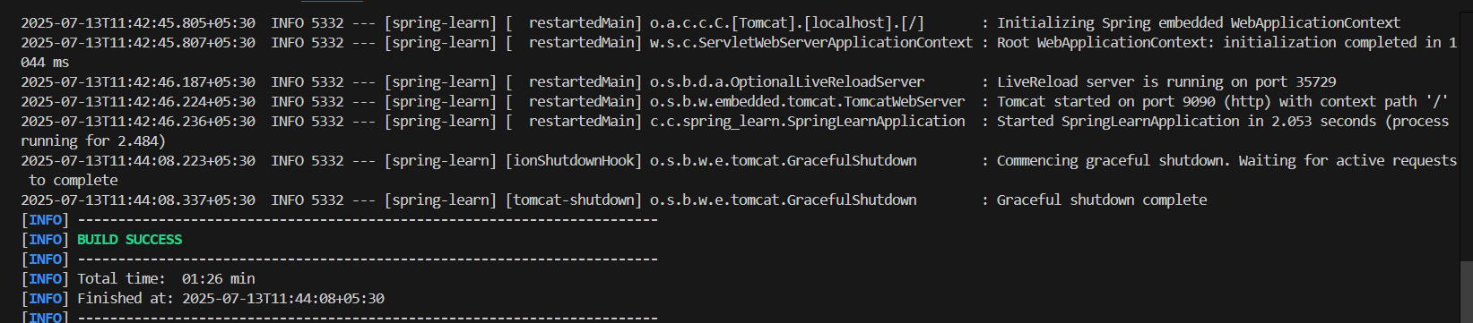

**Exercise 4: Spring Core – Load Country from Spring Configuration XML:**

**CODE:**

**Country.java:**

package com.cognizant.spring_learn;

import org.slf4j.Logger;

import org.slf4j.LoggerFactory;

public class Country {

    private static final Logger LOGGER = LoggerFactory.getLogger(Country.class);

    private String code;

    private String name;

    public Country() {

        LOGGER.debug("Inside Country Constructor.");

    }

    public String getCode() {

        LOGGER.debug("Inside getCode.");

        return code;

    }

    public void setCode(String code) {

        LOGGER.debug("Inside setCode.");

        this.code = code;

    }

    public String getName() {

        LOGGER.debug("Inside getName.");

        return name;

    }

    public void setName(String name) {

        LOGGER.debug("Inside setName.");

        this.name = name;

    }

    @Override

    public String toString() {

        return "Country [code=" + code + ", name=" + name + "]";

    }

}

**SpringLearnApplication.java:**

package com.cognizant.spring_learn;

import org.slf4j.Logger;

import org.slf4j.LoggerFactory;

import org.springframework.boot.SpringApplication;

import org.springframework.boot.autoconfigure.SpringBootApplication;

import org.springframework.context.support.ClassPathXmlApplicationContext;

@SpringBootApplication

public class SpringLearnApplication {

    private static final Logger LOGGER = LoggerFactory.getLogger(SpringLearnApplication.class);

    public static void main(String[] args) {

        SpringApplication.run(SpringLearnApplication.class, args);

        displayCountry();

    }

    public static void displayCountry() {

        LOGGER.info("START");

        try (ClassPathXmlApplicationContext context = new ClassPathXmlApplicationContext("country.xml")) {

            Country country = context.getBean("country", Country.class);

            LOGGER.debug("Country : {}", country.toString());

        }

        LOGGER.info("END");

    }

}

**Country.xml:**

<?xml version="1.0" encoding="UTF-8"?>

<beans xmlns="http://www.springframework.org/schema/beans"

       xmlns:xsi="http://www.w3.org/2001/XMLSchema-instance"

       xsi:schemaLocation="http://www.springframework.org/schema/beans

        https://www.springframework.org/schema/beans/spring-beans.xsd">

    <bean id="country" class="com.cognizant.spring_learn.Country">

        <property name="code" value="IN" />

        <property name="name" value="India" />

    </bean>

</beans>

**application.properties:**

spring.application.name=spring-learn

server.port=9090

logging.level.org.springframework=info

logging.level.com.cognizant.spring_learn=debug

**Output:**

