**HW3 – SLAM Solvers**

1. **Linear model**
2. Default: Time to solve: 0.029s

Fig 1: 2d_linear.npz with default solver

1. Pseudo Inverse: Time to solve: 2.07s

Fig 2: 2d_linear.npz with pinv

1. LU: Time to solve: 0.019s

Fig 3. U (upper triangular) Matrix from LU decomposition

Fig 4: 2d_linear.npz with LU

1. LU-COLAMD: time to solve: 0.032s

Fig 5: U (Upper triangular matrix)

Fig 6: 2d_linear_npz with LU + COLAMD

e) QR: Time to solve: 0.39s

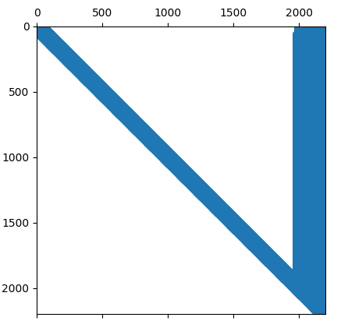

Fig 7. R matrix from QR factorization

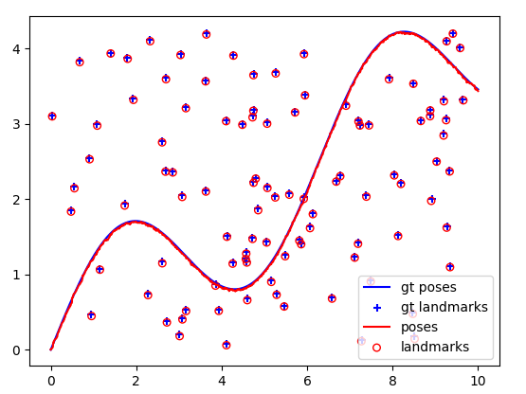

Fig 8. 2d_linear_npz with QR factorization

d) QR with COLAMD: Time to solve: 0.33 s

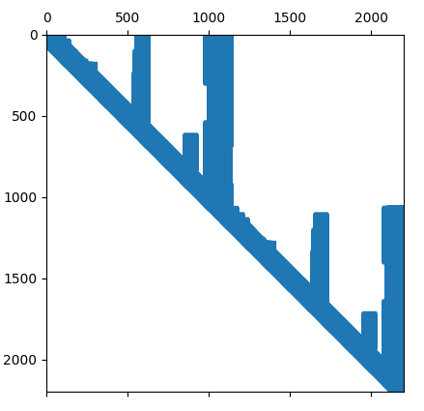

Fig 9. R matrix from QR factorization + COLAMD

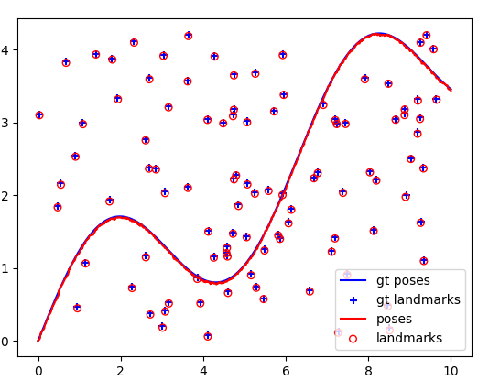Fig 10. 2d_linear_npz with QR factorization + COLAMD

1. **Linear model with loop data**
2. Default: Time to solve: 0.016s

Fig 11: 2d_linear_loop.npz with Default solver

1. Pseudo-inverse: Time to solve: 0.45s

Fig 12: 2d_linear_loop.npz with Pseudo inverse solver

1. LU: Time to solve: 0.04s

Fig 13: U (upper triangular matrix from LU decomposition)

Fig 14: 2d_linear_loop.npz with LU solver

1. LU-COLAMD: Time to solve: 0.009s

Fig 15: U (upper triangular matrix from LU-COLAMD decomposition)

Fig 16: 2d_linear_loop.npz with LU-COLAMD

e) QR: Time to solve: 0.25 s

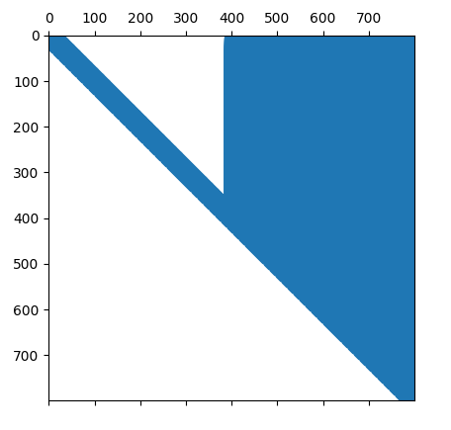

Fig 17: R Matrix from QR

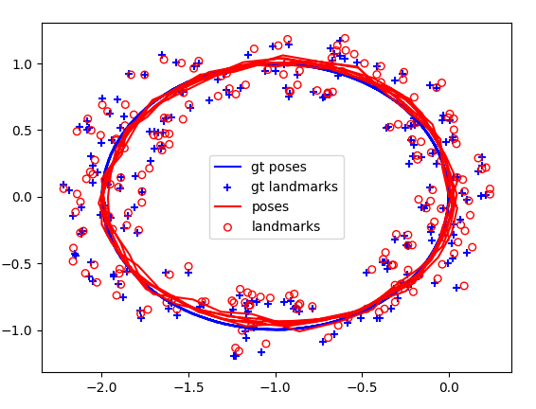Fig 18. 2d_linear_loop with QR

f) QR with COLAMD: time to solve: 0.019s

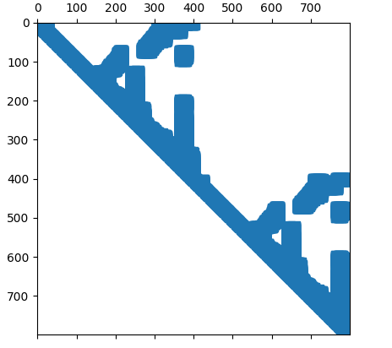

Fig 19: R Matrix from QR + COLAMD

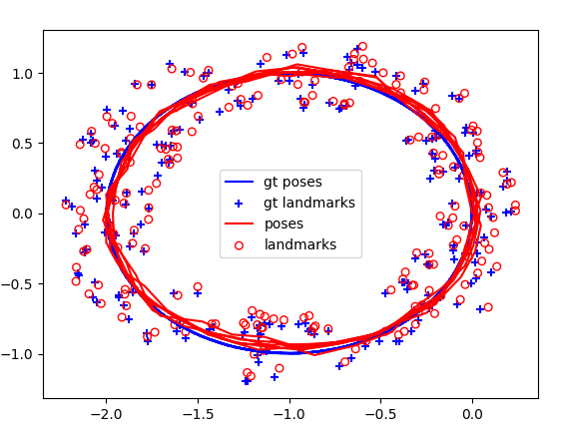

Fig 20. 2d_linear_loop with QR + COLAMD

1. **NonLinear model**

Fig 21: Before optimization

1. Default:

Fig 22: Default solver, After optimization

1. Pseudo Inverse

Fig 23: Pseudo Inverse solver, after optimization

1. LU

Fig 24: LU Solver, after optimization

1. LU- COLAMD

Fig 25:LU-COLAMD After optimization

e) QR

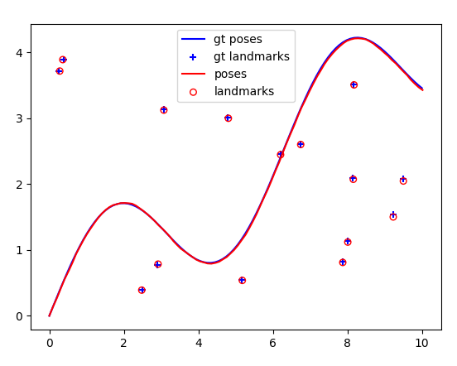

Fig 26: QR after optimization

f) QR COLAMD

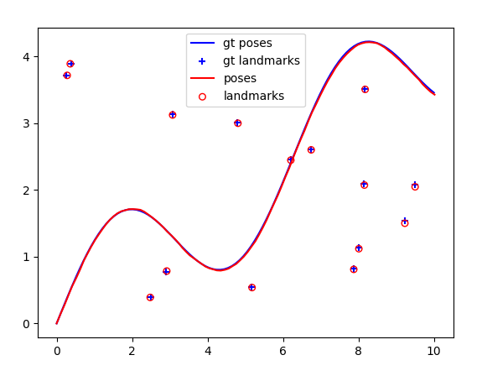Fig 27: QR after optimization