Index

|  |  |  |
| --- | --- | --- |
| S. No. | Topic | Page No. |
| 1 | Introduction to the Project | 1 |
| 2 | Software Requirements | 2 |
| 3 | Hardware Requirements | 3 |
| 4 | Coding | 4 |
| 5 | Outputs | 23 |
| 6 | Conclusion | 37 |
| 7. | Future Enhancements | 38 |
| 8. | Bibliography | 39 |

Introduction to the Project

The goal of this project is to develop a menu-driven C++ program for handling bookings of movie shows. It is required to have the following features:

**User Interface**

A user can view the details of the available movie shows, and check the booking status of any show. He can also book tickets and cancel an already booked ticket. A seat is reserved in the name of user who makes the booking.

**Admin Interface**

The admin can login with a password, which is saved with encryption. The admin can build the movie database by adding, modifying or deleting movies and shows. Every show can have its own ticket price. Admin can also view the details of the available movie shows, and view the bookings for any show. Admin has a default password of “1234”, but he can change the password.

**Data File**

The show and booking information is kept in a binary file named “show.txt”. This file is automatically created by the program if it does not exist.

Software Requirements

* Windows XP/Vista/7/8/10
* Turbo C++

Coding

#include<iostream.h>

#include<fstream.h>

#include<stdio.h>

#include<string.h>

#include<conio.h>

#include<ctype.h>

class seat

{

int stno;

char cname[30];

int c_age;

int status;

public:

seat();

void stn(int i,int j);

int retstatus();

void dispticket();

void book1(char* name,int age);

void unbook1();

};

class shows

{

int hrs;

int min;

seat st[5][5];

int price;

public:

shows();

void init();

void book2(int a,int b, char* name, int age);

void unbook2(int a,int b);

void dispsh1();

void display();

void displist();

void entershow();

int ret_hrs();

int ret_min();

};

class movie

{

char mname[30];

int numsh;

shows sh[5];

char rating[3];

public:

int book3(int s,int stno1,char* name,int age);

int unbook3(int s,int stno1);

void dispseats(int c);

void dispmovies();

void dispsh2();

void dispbook(int c);

char* retmname();

void entermovie();

void dispsh(int shno);

};

class ticket

{

public:

char* name;

int age;

movie* film;

int showno;

int count;

int seats[10];

int price;

void print();

void unbook();

ticket();

};

ticket t;

seat::seat()

{

status=0;

}

void seat::stn(int i,int j)

{

i++;j++;

stno=(10*i)+j;

}

int seat::retstatus()

{

return status;

}

void seat::dispticket()

{

cout<<" "<<stno<<"\t"<<cname<<" ("<<c_age<<") ";

}

void seat::book1(char* name,int age)

{

status=1;

strcpy(cname,name);

c_age=age;

}

void seat::unbook1()

{

status=0;

t.name=cname;

t.age=c_age;

}

void shows::entershow()

{

cout<<"\nEnter timings for show in:-"

<<"\nhours:- ";

cin>>hrs;

while(hrs<0||hrs>23)

{

cout<<"\nInvalid input, Re-enter hours:- ";

cin>>hrs;

}

cout<<"minutes:- ";

cin>>min;

while(min<0||min>59)

{

cout<<"\nInvalid input, Re-enter minutes:- ";

cin>>min;

}

cout<<"\nEnter price for 1 ticket:- ";

cin>>price;

}

shows::shows()

{

init();

}

void shows::init()

{

for(int i=0;i<5;i++)

{

for(int j=0;j<5;j++)

{

st[i][j].stn(i,j);

}

}

}

void shows::book2(int a,int b, char* name, int age)

{

if(st[a][b].retstatus()==0)

{

st[a][b].book1(name,age);

t.seats[t.count++]=((a+1)*10)+b+1;

t.price=price;

}

else

cout<<"It is already booked\n";

}

void shows::unbook2(int a,int b)

{

if(st[a][b].retstatus()==1)

{

st[a][b].unbook1();

t.seats[t.count++]=((a+1)*10)+b+1;

t.price=price;

}

else

cout<<"It is not booked";

}

void shows::dispsh1()

{

if(hrs<12)

{

if(hrs<10)

cout<<" ";

cout<<hrs<<":"<<min<<"am";

}

else if(hrs==12)

cout<<hrs<<":"<<min<<"pm";

else

{

if((hrs-12)<10)

cout<<" ";

cout<<hrs-12<<":"<<min<<"pm";

}

cout<<" Rs"<<price;

}

void shows::displist()

{

int n=0;

for(int i=0;i<5;i++)

{

for(int j=0;j<5;j++)

{

if(st[i][j].retstatus()==1)

{

n++;

cout<<endl;

st[i][j].dispticket();

}

}

}

if(n==0)

cout<<"\n\n\tNo tickets are booked for this show";

}

void shows::display()

{

cout<<"\n ";

for(int i=0;i<5;i++)

{

cout<<" "<<i+1;

}

cout<<endl;

for(i=0;i<5;i++)

{

cout<<i+1;

for(int j=0;j<5;j++)

{

if(st[i][j].retstatus()==0)

{

textbackground(4);

cout<<" ";cprintf(" ");

}

else

{

textbackground(2);

cout<<" ";cprintf(" ");

}

}

cout<<endl<<endl;

}

textbackground(BLACK);

}

int shows::ret_hrs()

{

return hrs;

}

int shows::ret_min()

{

return min;

}

void movie::dispsh(int shno)

{

sh[shno-1].dispsh1();

}

char* movie::retmname()

{

return mname;

}

void movie::entermovie()

{

cout<<"\nEnter movie name:-\n";

gets(mname);

cout<<"\nEnter rating:-\n";

cin>>rating;

cout<<"\nEnter number of shows:-\n";

cin>>numsh;

for(int i=0;i<numsh;i++)

{

again:

cout<<"\nEnter details for show "<<i+1;

sh[i].entershow();

for(int j=i-1;j>=0;j--)

{

if((sh[i].ret_hrs()==sh[j].ret_hrs())&&(sh[i].ret_min()==sh[j].ret_min()))

{

cout<<"\nA show of this timing already exists";

goto again;

}

}

}

}

int movie::book3(int s,int stno1,char* name,int age)

{

int r=stno1/10;

int c=stno1%10;

if(r>0 && r<6 && c>0 && c<6)

{

sh[s-1].book2(r-1,c-1,name,age);

return 0;

}

return 1;

}

int movie::unbook3(int s,int stno1)

{

int r=stno1/10;

int c=stno1%10;

if(r>0 && r<6 && c>0 && c<6)

{ sh[s-1].unbook2(r-1,c-1);

return 0;

}

return 1;

}

void movie::dispbook(int c)

{

sh[c-1].displist();

}

void movie::dispseats(int c)

{

sh[c-1].display();

}

void movie::dispmovies()

{

cout<<mname;

cout<<" ("<<rating<<")\n";

}

void movie::dispsh2()

{

for(int a=0;a<numsh;a++)

{

cout<<"\t"<<a+1<<". ";

sh[a].dispsh1();

cout<<endl;

}

}

void ticket::print()

{

cout<<name<<" ("<<age<<") has booked the following ticket:-\n";

film->dispmovies();

cout<<" ";

film->dispsh(showno);

cout<<"\n Seats:- ";

for(int i=0;i<count;i++)

cout<<" "<<seats[i];

cout<<"\nTotal price = "<<count*price;

}

ticket::ticket()

{

price=0;

count=0;

for(int i=0;i<10;i++)

seats[i]=0;

}

void ticket::unbook()

{

cout<<name<<" ("<<age<<") has unbooked the following ticket:-\n";

film->dispmovies();

cout<<" ";

film->dispsh(showno);

cout<<"\nSeats:- ";

for(int i=0;i<count;i++)

cout<<" "<<seats[i];

cout<<"\nTotal refund = "<<count*price;

}

void writepass(char* pass)

{

ofstream pout;

pout.open("password.txt",ios::trunc);

for(int i=0;pass[i]!='\0';i++) //password encryption

pass[i]+=5;

pout<<pass;

pout.close();

}

void readpass(char* pass)

{

ifstream pin;

pin.open("password.txt",ios::in);

pin>>pass;

for(int i=0;pass[i]!='\0';i++) //password decryption

pass[i]-=5;

}

void main()

{

movie m;

ifstream fin;

ofstream fout;

fstream fio;

char name[20],mov[30],found='f',confirm='n',pass[20],pass1[20];

char password[20]={"1234"};

fin.open("password.txt",ios::in);

if(!fin)

{

writepass(password);

}

fin.close();

int command,age,choice,mno,shno,i,stno,status;

long pos;

do

{

clrscr();

textcolor(4+BLINK);

cout<<"\t\t\t\t";

cprintf("BOOK");

textcolor(2+BLINK);

cprintf(" MY");

textcolor(3+BLINK);

cprintf(" SHOW");

cout<<"\n\n\n\t ";

textcolor(2);

cprintf("Made By Siddharth Jain XII-A and Nikhil Vats XII-E");

cout<<"\n\n\n\t\t\t ";

textcolor(4+BLINK);

cprintf("Welcome to BOOK MY SHOW");

cout<<"\n\n\n\t\t\t ";

textcolor(7);

cout<<"Please log in here";

cout<<"\n\n1.Login as admin"

<<"\n2.Login as user"

<<"\n0.Exit"

<<"\nEnter choice ";

cin>>command;

switch(command)

{

case 1:

for(i=0;i<3;i++)

{

cout<<"\nEnter Admin Password:-\n";

cin>>pass;

readpass(password);

if(strcmp(pass,password)==0)

break;

else

cout<<"\nIncorrect Password";

}

if(i==3)

cout<<"Maximum trials exceeded";

clrscr();

do

{

clrscr();

cprintf("Welcome admin what would you like to do?");

cout<<"\n1.Add a movie"

<<"\n2.Delete a movie"

<<"\n3.Modify a movie"

<<"\n4.Display all movies"

<<"\n5.Display list of booked tickets"

<<"\n6.Change admin password"

<<"\n0.Logout";

cprintf("\nEnter choice:- ");

cin>>choice;

switch(choice)

{

case 1:

fout.open("show.txt",ios::binary|ios::app);

m.entermovie();

fout.write((char*)&m,sizeof(m));

fout.close();

break;

case 2:

fin.open("show.txt",ios::binary|ios::in);

if(!fin)

{

cout<<"\nFirst add movies and shows";

break;

}

fout.open("temp.txt",ios::binary|ios::out);

cout<<"Enter name of the movie to be deleted ";

gets(mov);

found='f';confirm='N';

while(!fin.eof())

{

fin.read((char*)&m,sizeof(m));

if(fin.eof())

break;

if(strcmpi(mov,m.retmname())==0)

{

m.dispmovies();

found='t';

cout<<"Are you sure you want to delete this movie?(Y/N) ";

cin>>confirm;

if(confirm=='N')

fout.write((char*)&m,sizeof(m));

}

else

fout.write((char*)&m,sizeof(m));

}

if(found=='f')

cout<<"Movie not found!!\n";

fout.close();

fin.close();

remove("show.txt");

rename("temp.txt","show.txt");

break;

case 3:

fio.open("show.txt",ios::in|ios::out|ios::binary|ios::nocreate);

if(!fio)

{

cout<<"\nFirst add movies and shows";

break;

}

cout<<"Enter name of the movie to be modified ";

gets(mov);

while(!fio.eof())

{

pos=fio.tellg();

fio.read((char*)&m,sizeof(m));

if(fio.eof())

break;

if(strcmpi(mov,m.retmname())==0)

{

m.dispmovies();

m.dispsh2();

cout<<"\nEnter new details\n";

m.entermovie();

fio.seekg(pos);

fio.write((char*)&m,sizeof(m));

found='t';

}

}

if(found=='f')

cout<<"Movie not found!!\n";

fio.seekg(0);

fio.close();

break;

case 4:

fin.open("show.txt",ios::binary|ios::in);

i=1;

if(!fin)

{

cout<<"\nFirst add movies and shows";

break;

}

while(!fin.eof())

{

fin.read((char*)&m,sizeof(m));

if(fin.eof())

break;

cout<<i++<<". ";

m.dispmovies();

m.dispsh2();

}

fin.close();

break;

case 5:

fin.open("show.txt",ios::in|ios::binary);

if(!fin)

{

cout<<"\nFirst add movies and shows";

break;

}

cout<<"\nEnter Movie Number:- ";

cin>>mno;

cout<<"Show Number:- ";

cin>>shno;

found='t';

for(i=1;i<=mno;i++)

{

fin.read((char*)&m,sizeof(m));

if(fin.eof())

{

found='f';

break;

}

}

if(found=='t')

{

m.dispmovies();

m.dispsh(shno);

m.dispbook(shno);

}

else

cout<<"Movie not found!!\n";

fin.close();

break;

case 6:

cout<<"\nEnter old password:-\n";

cin>>pass;

readpass(password);

if(strcmp(pass,password)==0)

{

cout<<"\nEnter new password:-\n";

cin>>pass;

cout<<"\nRetype new password:-\n";

cin>>pass1;

if(strcmp(pass,pass1)==0)

{

writepass(pass);

cout<<"Password changed";

}

else

cout<<"Password does not match";

}

else

cout<<"Old password does not match";

}//end of switch

getche();

}while(choice!=0);

break;

case 2:

cout<<"\nEnter name:-\n";

gets(name);

cout<<"\nEnter Age:-\n";

cin>>age;

t.name=name;

t.age=age;

clrscr();

cprintf("Welcome user ") ;

puts(name);

do

{

clrscr();

cprintf("What would you like to do");

cout<<"\n1.View details of movies"

<<"\n2.Book a ticket"

<<"\n3.Cancel a ticket"

<<"\n4.Status of a show"

<<"\n0.Logout";

cprintf("\nEnter choice-");

cin>>choice;

switch(choice)

{

case 1:

fin.open("show.txt",ios::binary|ios::in);

i=1;

if(!fin)

{

cout<<"\nNo movies, Please check later";

break;

}

while(!fin.eof())

{

fin.read((char*)&m,sizeof(m));

if(fin.eof())

break;

cout<<i++<<". ";

m.dispmovies();

m.dispsh2();

}

fin.close();

break;

case 2:

fio.open("show.txt",ios::in|ios::out|ios::binary|ios::nocreate);

if(!fio)

{

cout<<"\nNo movies, Please check later";

break;

}

cout<<"\nEnter Movie Number:- ";

cin>>mno;

cout<<"Show Number:- ";

cin>>shno;

found='t';

for(i=1;i<=mno;i++)

{

pos=fio.tellg();

fio.read((char*)&m,sizeof(m));

if(fio.eof())

{

found='f';

break;

}

}

if(found=='t')

{

t.film=&m;

t.showno=shno;

cout<<endl;

m.dispmovies();

m.dispsh(shno);

m.dispseats(shno);

t.count=0;

cout<<"\nEnter 0 to finish\n";

do

{

cout<<"Enter seat number (rownocolno) to book:- ";

cin>>stno;

status=m.book3(shno,stno,name,age);

}while(status==0);

clrscr();

m.dispseats(shno);

t.print();

fio.seekg(pos);

fio.write((char*)&m,sizeof(m));

}

else

cout<<"Movie not found!!\n";

fio.close();

break;

case 3:

fio.open("show.txt",ios::in|ios::out|ios::binary|ios::nocreate);

if(!fio)

{

cout<<"\nNo movies, Please check later";

break;

}

cout<<"\nEnter Movie Number:- ";

cin>>mno;

cout<<"Show Number:- ";

cin>>shno;

found='t';

for(i=1;i<=mno;i++)

{

pos=fio.tellg();

fio.read((char*)&m,sizeof(m));

if(fio.eof())

{

found='f';

break;

}

}

if(found=='t')

{

t.film=&m;

t.showno=shno;

cout<<endl;

m.dispmovies();

m.dispsh(shno);

m.dispseats(shno);

t.count=0;

cout<<"\nEnter 0 to finish\n";

do

{

cout<<"Enter seat number(rownocolno) to unbook:- ";

cin>>stno;

status=m.unbook3(shno,stno);

}while(status==0);

clrscr();

m.dispseats(shno);

cout<<endl;

t.unbook();

fio.seekg(pos);

fio.write((char*)&m,sizeof(m));

}

else

cout<<"Movie not found!!\n";

fio.close();

break;

case 4:

fin.open("show.txt",ios::in|ios::binary);

if(!fin)

{

cout<<"\nNo movies, Please check later";

break;

}

cout<<"\nEnter Movie Number:- ";

cin>>mno;

cout<<"Show Number:- ";

cin>>shno;

found='t';

for(i=1;i<=mno;i++)

{

fin.read((char*)&m,sizeof(m));

if(fin.eof())

{

found='f';

break;

}

}

if(found=='t')

{

m.dispmovies();

m.dispsh(shno);

m.dispseats(shno);

}

else

cout<<"Movie not found!!\n";

fin.close();

break;

}//end of switch

getche();

}while(choice!=0);

}//end of switch

}while(command!=0);

}

Outputs

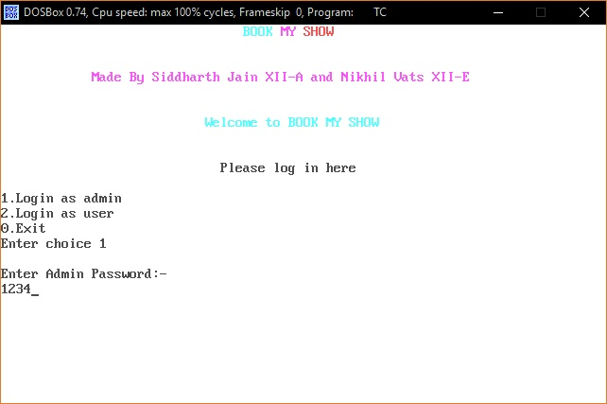

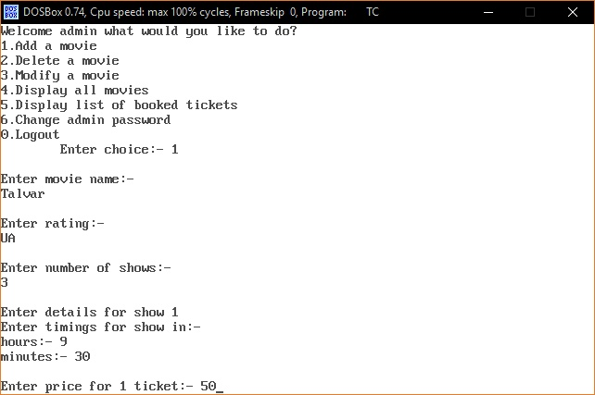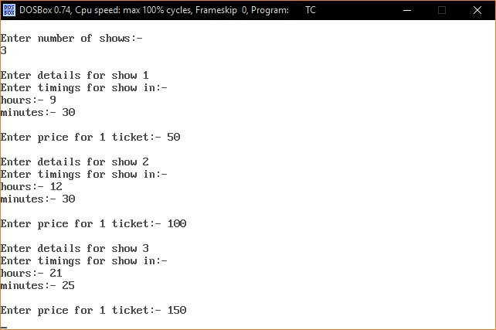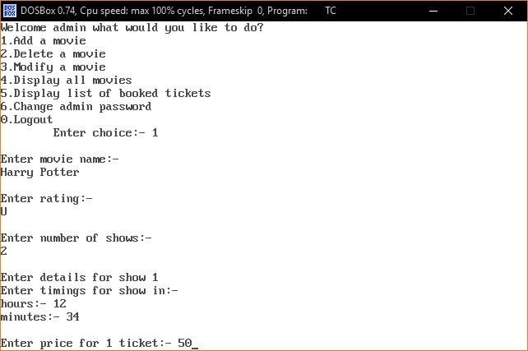

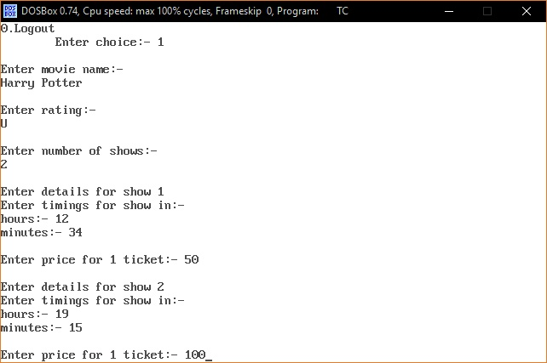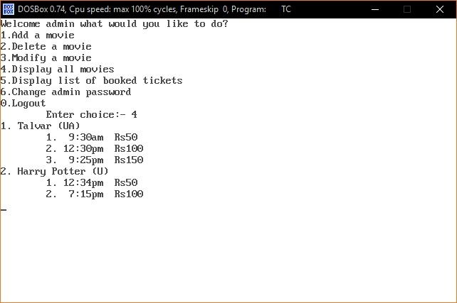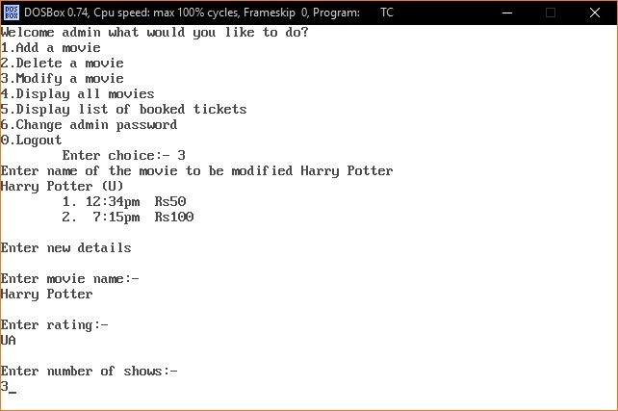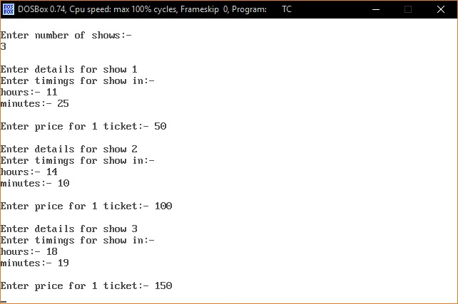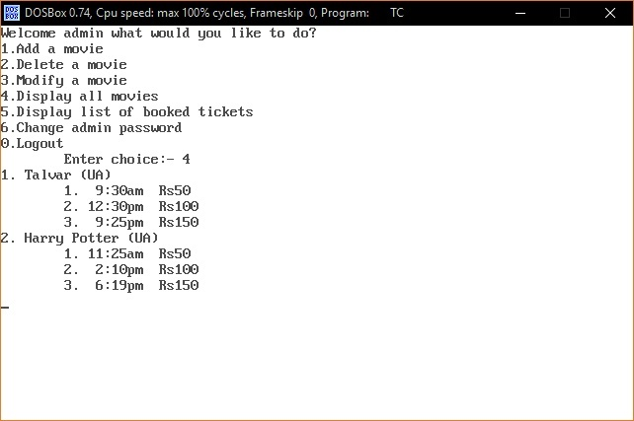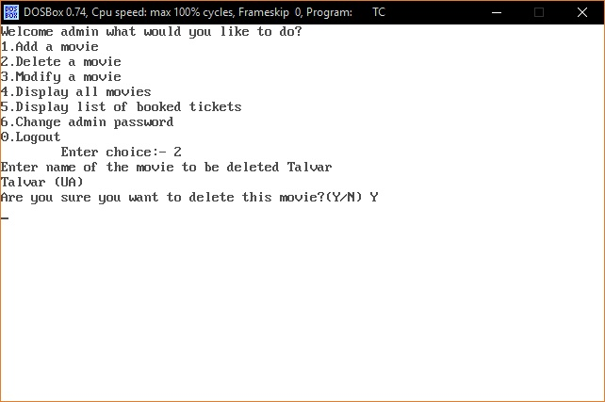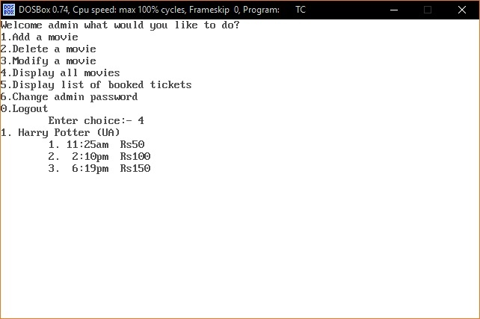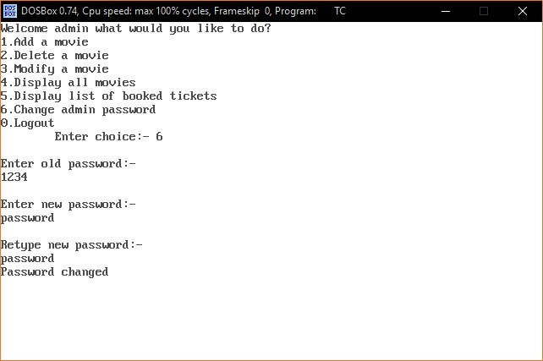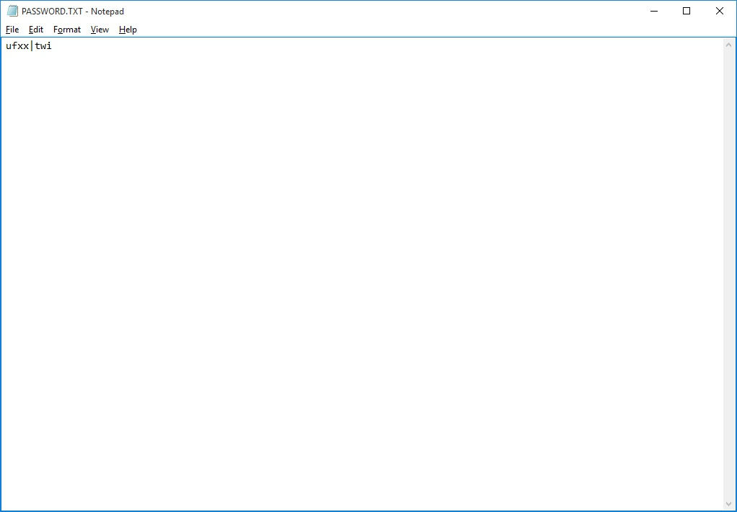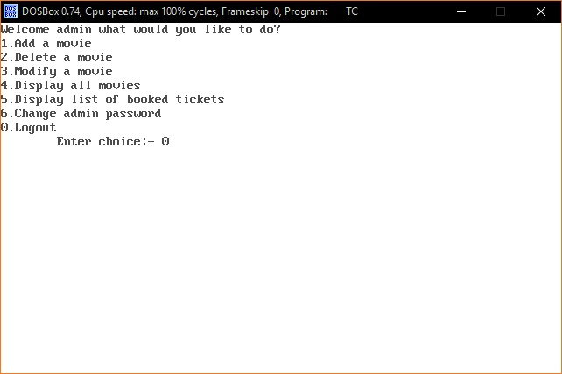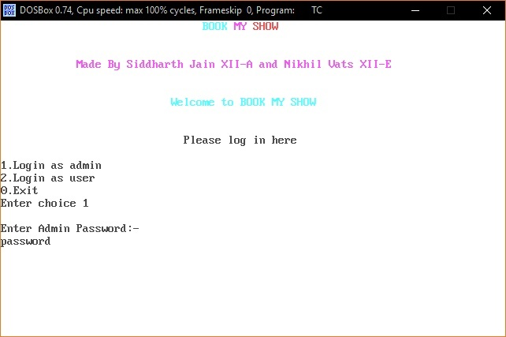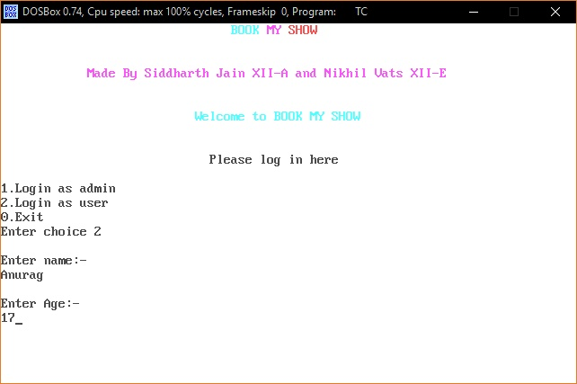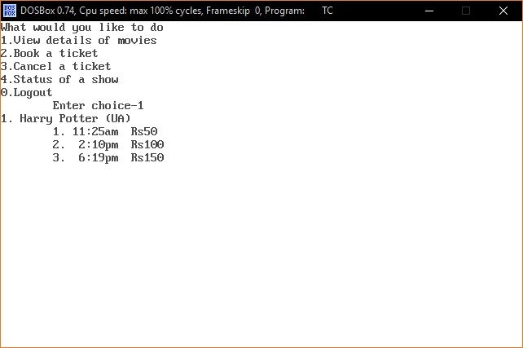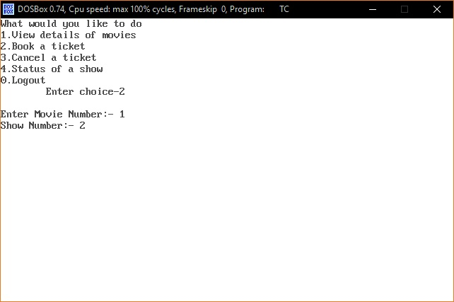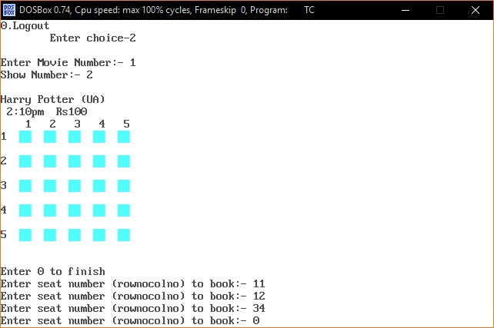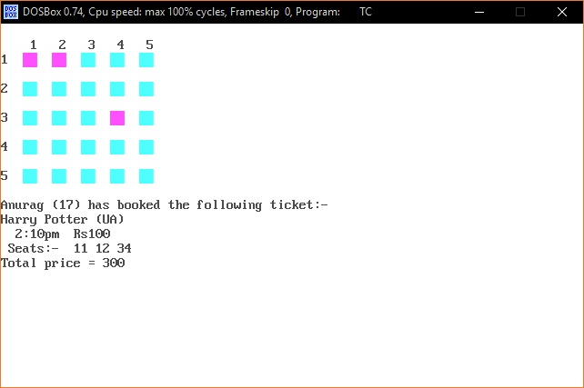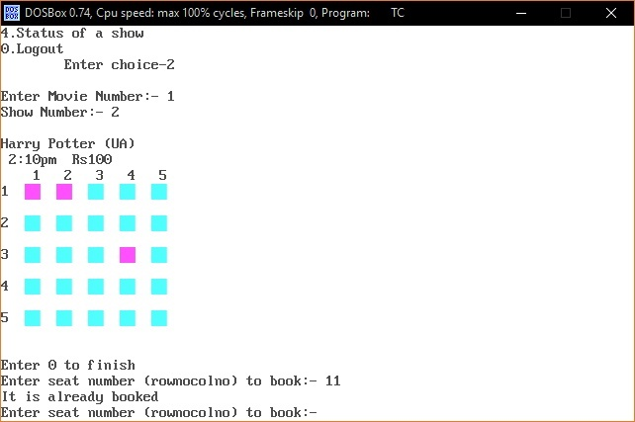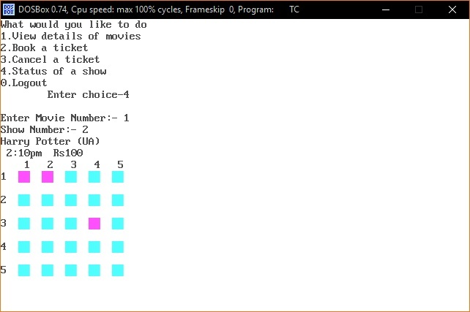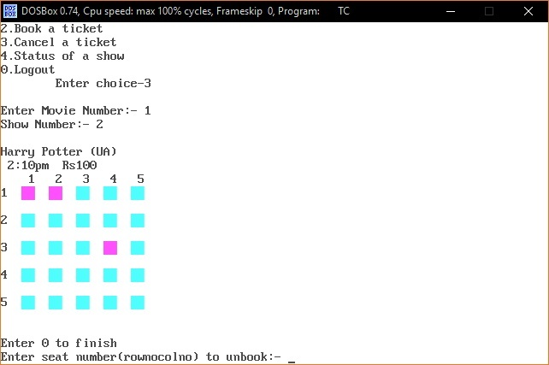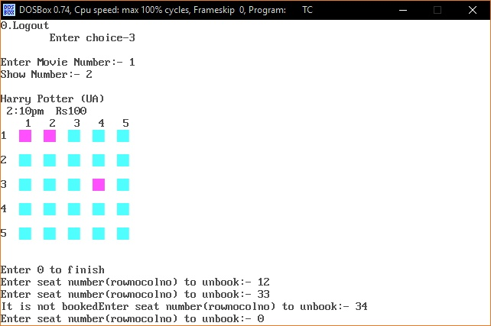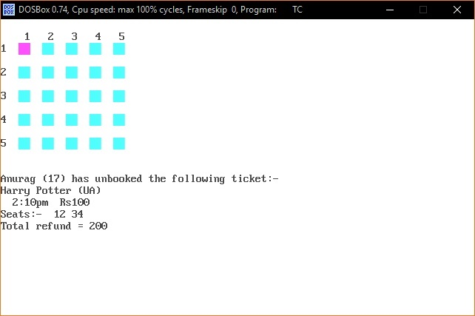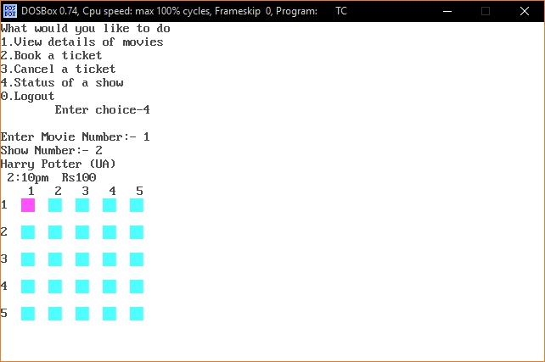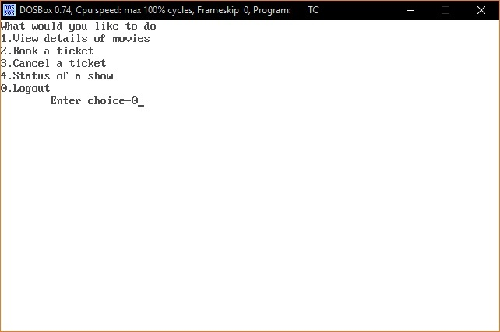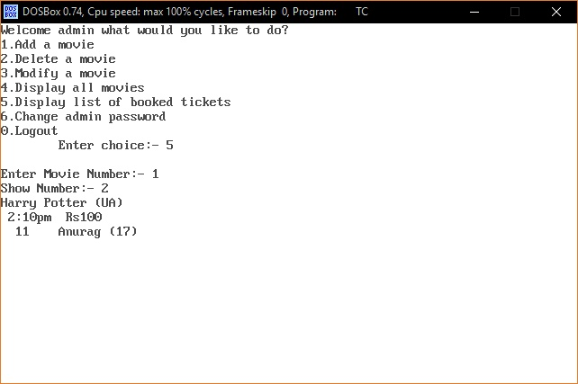

Conclusion

This project was done by Siddharth Jain, XII-A and Nikhil Vats, XII-E together.

It is said that computers can be used to solve many real life problems, and by doing this project, we realized the truth behind it.

Working on this project was a good learning exercise for us. As we tried various C++ concepts such as classes and objects, data file handling, loops, encapsulation, etc. in this project, we got a better understanding of these concepts.

The practical experience we gained while doing the project was also very valuable, as we learned how to write a large program with practical application.

Future Enhancements

* Use of graphics to make the program more user-friendly.
* Hiding of password entered by admin by symbols such as asterisk (*).
* Timer to prevent user from entering password when maximum trials are exceeded.

Bibliography

* Computer Science with C++ by Sumita Arora
* [www.stackoverflow.com](http://www.stackoverflow.com/)
* [www.dreamincode.net](http://www.dreamincode.net/)