COURSE REGISTRATION SYSTEM

UCS2265 – Fundamentals and Practice of Software Development

A PROJECT REPORT

Submitted By

S ROHITH KUMAR – 3122235001107
SIDDARTH P – 3122235001128
SIDDHAARTH M – 3122235001129



Department of Computer Science and Engineering

Sri Sivasubramaniya Nadar College of Engineering
(An Autonomous Institution, Affiliated to Anna University)
Kalavakkam – 603110

June 2024
Sri Sivasubramaniya Nadar College of Engineering
(An Autonomous Institution, Affiliated to Anna University)

BONAFIDE CERTIFICATE

Certified that this project report titled “COURSE REGISTRATION SYSTEM” is the bonafide work of “S ROHITH KUMAR (3122235001107) SIDDARTH P (3122235001128) SIDDHAARTH M (3122235001129) who carried out the project work in the UCS2265 – Fundamentals and Practice of Software Development during the academic year 2023-24.

Internal Examiner External Examiner

Date:
PROBLEM STATEMENT
Develop a software system for taking care of course registration in a university. This system should have the following features:
- Each student should log into the system to register for the chosen courses in each semester.
- Once the student logs in, a list of courses that are offered in that semester should be displayed along with the information about faculty members who are teaching each section of the course.
- Assume that each core course will have 3 sections and each elective course will have two sections. •Students can choose the courses in which they would like to register.
- Each student should register for a minimum of 4 and a maximum of 6 courses per semester
- At the end of the registration process, the list of successfully allotted courses along with the name of the teacher for each course should be displayed. In addition, the list of waitlisted courses along with waitlist number should also be displayed
CONSTRAINTS :-
- A student should be able to register in a particular course only if he/she has already completed all prerequisites for that course.
- Each course can be offered by multiple faculty members
- Every section will have a fixed strength. If the section fills up, further registration should not be allowed.
- A waitlist(10% of the class strength) will be maintained in case the allotment is not possible in the first round.
- If a student wants to add or drop any course after initial registration, it should be allowed only within the first two weeks after the semester starts.
- Students from the waitlist can be allotted their choice subsequent to the processing of drop requests.

Extended Exploration of Problem Statement
1. Contextual Background
In today's educational landscape, universities face increasing challenges in efficiently managing course registrations. Traditional methods often involve manual processes that are prone to errors, time-consuming, and do not effectively utilize available technology. The need for a robust, automated course registration system is critical to enhance administrative efficiency, improve student satisfaction, and ensure equitable access to courses.
2. Problem Scope and Challenges
The current course registration process at our university suffers from several shortcomings:
Manual Processes: Registration processes heavily reliant on paper forms or outdated software systems lead to inefficiencies and errors.
Capacity Management: Difficulty in managing course capacities and waitlists often results in either under-enrollment or over-enrollment issues.
Prerequisite Compliance: Lack of automated checks for prerequisites can lead to students enrolling in courses for which they are not qualified.
User Experience: Students and faculty often face challenges in accessing timely and accurate course information, resulting in frustration and inefficiencies.
-Administrative Burden: High administrative workload due to manual handling of registration requests, add/drop changes, and data entry tasks.
3. Stakeholder Needs and Expectations
Stakeholders affected by the course registration process include:
Students: Require a user-friendly interface to browse course offerings, check prerequisites, and register for courses efficiently.
Faculty: Need tools to manage course sections, view enrollment statistics, and communicate with registered students.
Administrators: Seek automation to streamline registration processes, manage course capacities effectively, and generate accurate enrollment reports.
IT Support: Requires a reliable, scalable system that integrates seamlessly with existing university IT infrastructure and complies with data security standards.
4. System Requirements and Constraints
To address the identified challenges and meet stakeholder needs, the course registration system must:
User Authentication and Access Control: Implement secure login mechanisms for students, faculty, and administrators.
Course Offering Management: Display comprehensive information about courses, sections, faculty instructors, and prerequisites.
Registration Rules: Enforce rules such as minimum and maximum course limits per semester, prerequisite checks, and section capacity limits.
Waitlist Management: Automatically manage waitlists ensuring fair allocation based on predefined criteria (e.g., section capacity, priority).
Add/Drop Periods: Facilitate changes to registrations within specified timelines (e.g., first two weeks of the semester).
Reporting and Analytics: Provide administrators with tools for monitoring enrollment trends, generating reports, and making data-driven decisions
5. Justification for System Development
The development of a modern course registration system is justified by:
Efficiency Gains: Automating registration processes reduces administrative workload, minimizes errors, and enhances operational efficiency.
Enhanced User Experience: Providing students and faculty with intuitive interfaces improves satisfaction and engagement.
Compliance and Security: Ensuring data security and compliance with university policies and regulations mitigates risks associated with data handling.
Strategic Alignment: Supporting the university's mission to deliver quality education by optimizing resource allocation and fostering a conducive learning environment.
6. Future Directions and Considerations
Future enhancements and considerations for the course registration system include:
Integration with Learning Management Systems: Seamless integration with existing LMS platforms to provide a holistic student experience.
Mobile Access: Development of mobile applications to enable students to access course registration functionalities on-the-go.
Predictive Analytics: Leveraging data analytics to predict course demand, optimize section offerings, and enhance resource allocation.

DATA FLOW DIAGRAMS
LEVEL-0
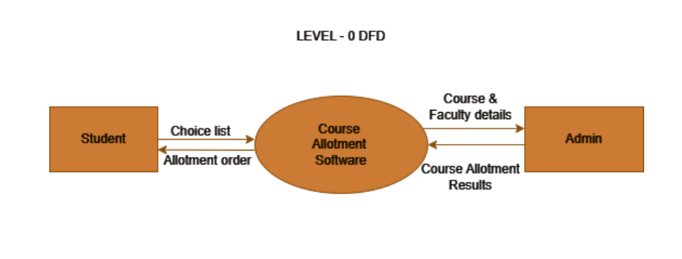
The Level-0 DFD you’ve provided represents a basic overview of a Course Allotment System. It shows interactions between Students and the Course Allotment Software where students submit their choice list and receive an allotment order. The Admin entity interacts with the software, providing course and faculty details and receiving course allotment results. This diagram helps visualize the flow of information in the system.
LEVEL-1
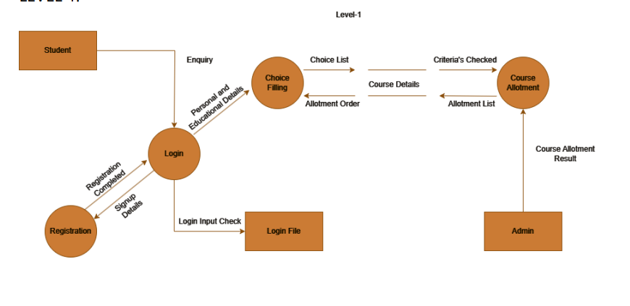
Level-2 DFD outlines a detailed process within a student course allotment system. It starts with the student’s registration, followed by login, and then an enquiry phase. Post-enquiry, students can fill in their choices, which leads to a check of course details and criteria. The process culminates in the allotment order and list, resulting in the final course allotment result. There’s also an admin path that seems to run parallel to the student’s process.

LEVEL-2
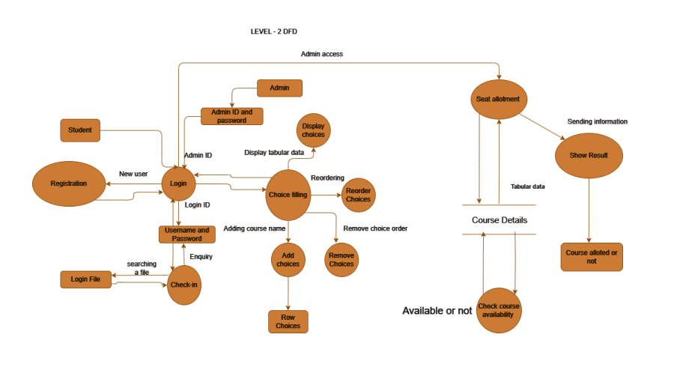
- Student Registration: Students begin by registering or logging in. New users provide details to create an account, while returning students enter their credentials to access the system.
- Course Selection: Once logged in, students can view available courses, select their preferences, and submit their choices for enrollment.
- Admin Login: Administrators use their unique ID and password to access the backend of the system, where they can manage student data and course information.
- Data Management: Admins have options to display tabular data, which likely includes student registration details, course schedules, and enrollment numbers.
- Course Management: Admins can add new courses or remove existing ones from the system, affecting the options available to students during registration.
- Seat Allotment: The system includes a process for seat allotment, determining if students get their preferred courses based on availability and other criteria.
- Decision Points: There are decision points such as verifying if an admin ID and password are correct, which dictate access to administrative functions.
- Information Flow: The flowchart indicates how information is sent and received within the system, ensuring that both students and admins are updated on course details and selections.

SYSTEM ARCHITECTURE
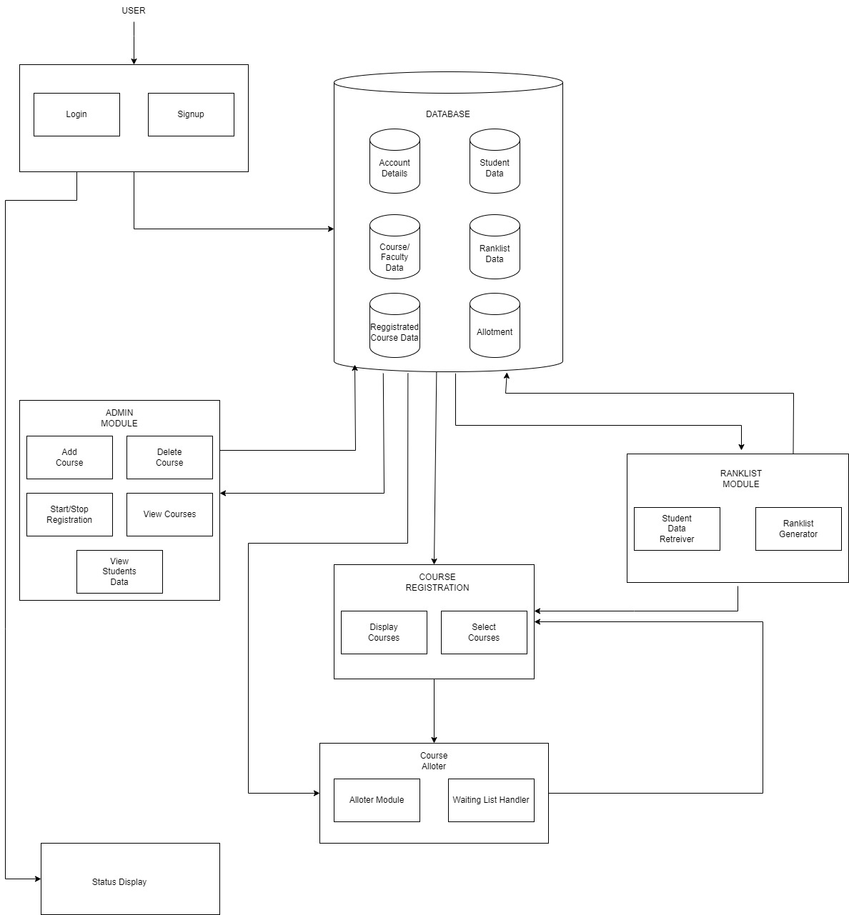

MODULES
- LOGIN MODULE
- ADMIN MODULE
- CHOICE FILLING MODULE
- STUDENT ENTRY MODULE
- RANKING MODULE
- ALLOTTER AND WAITINGLIST MODULE

LOGIN MODULE
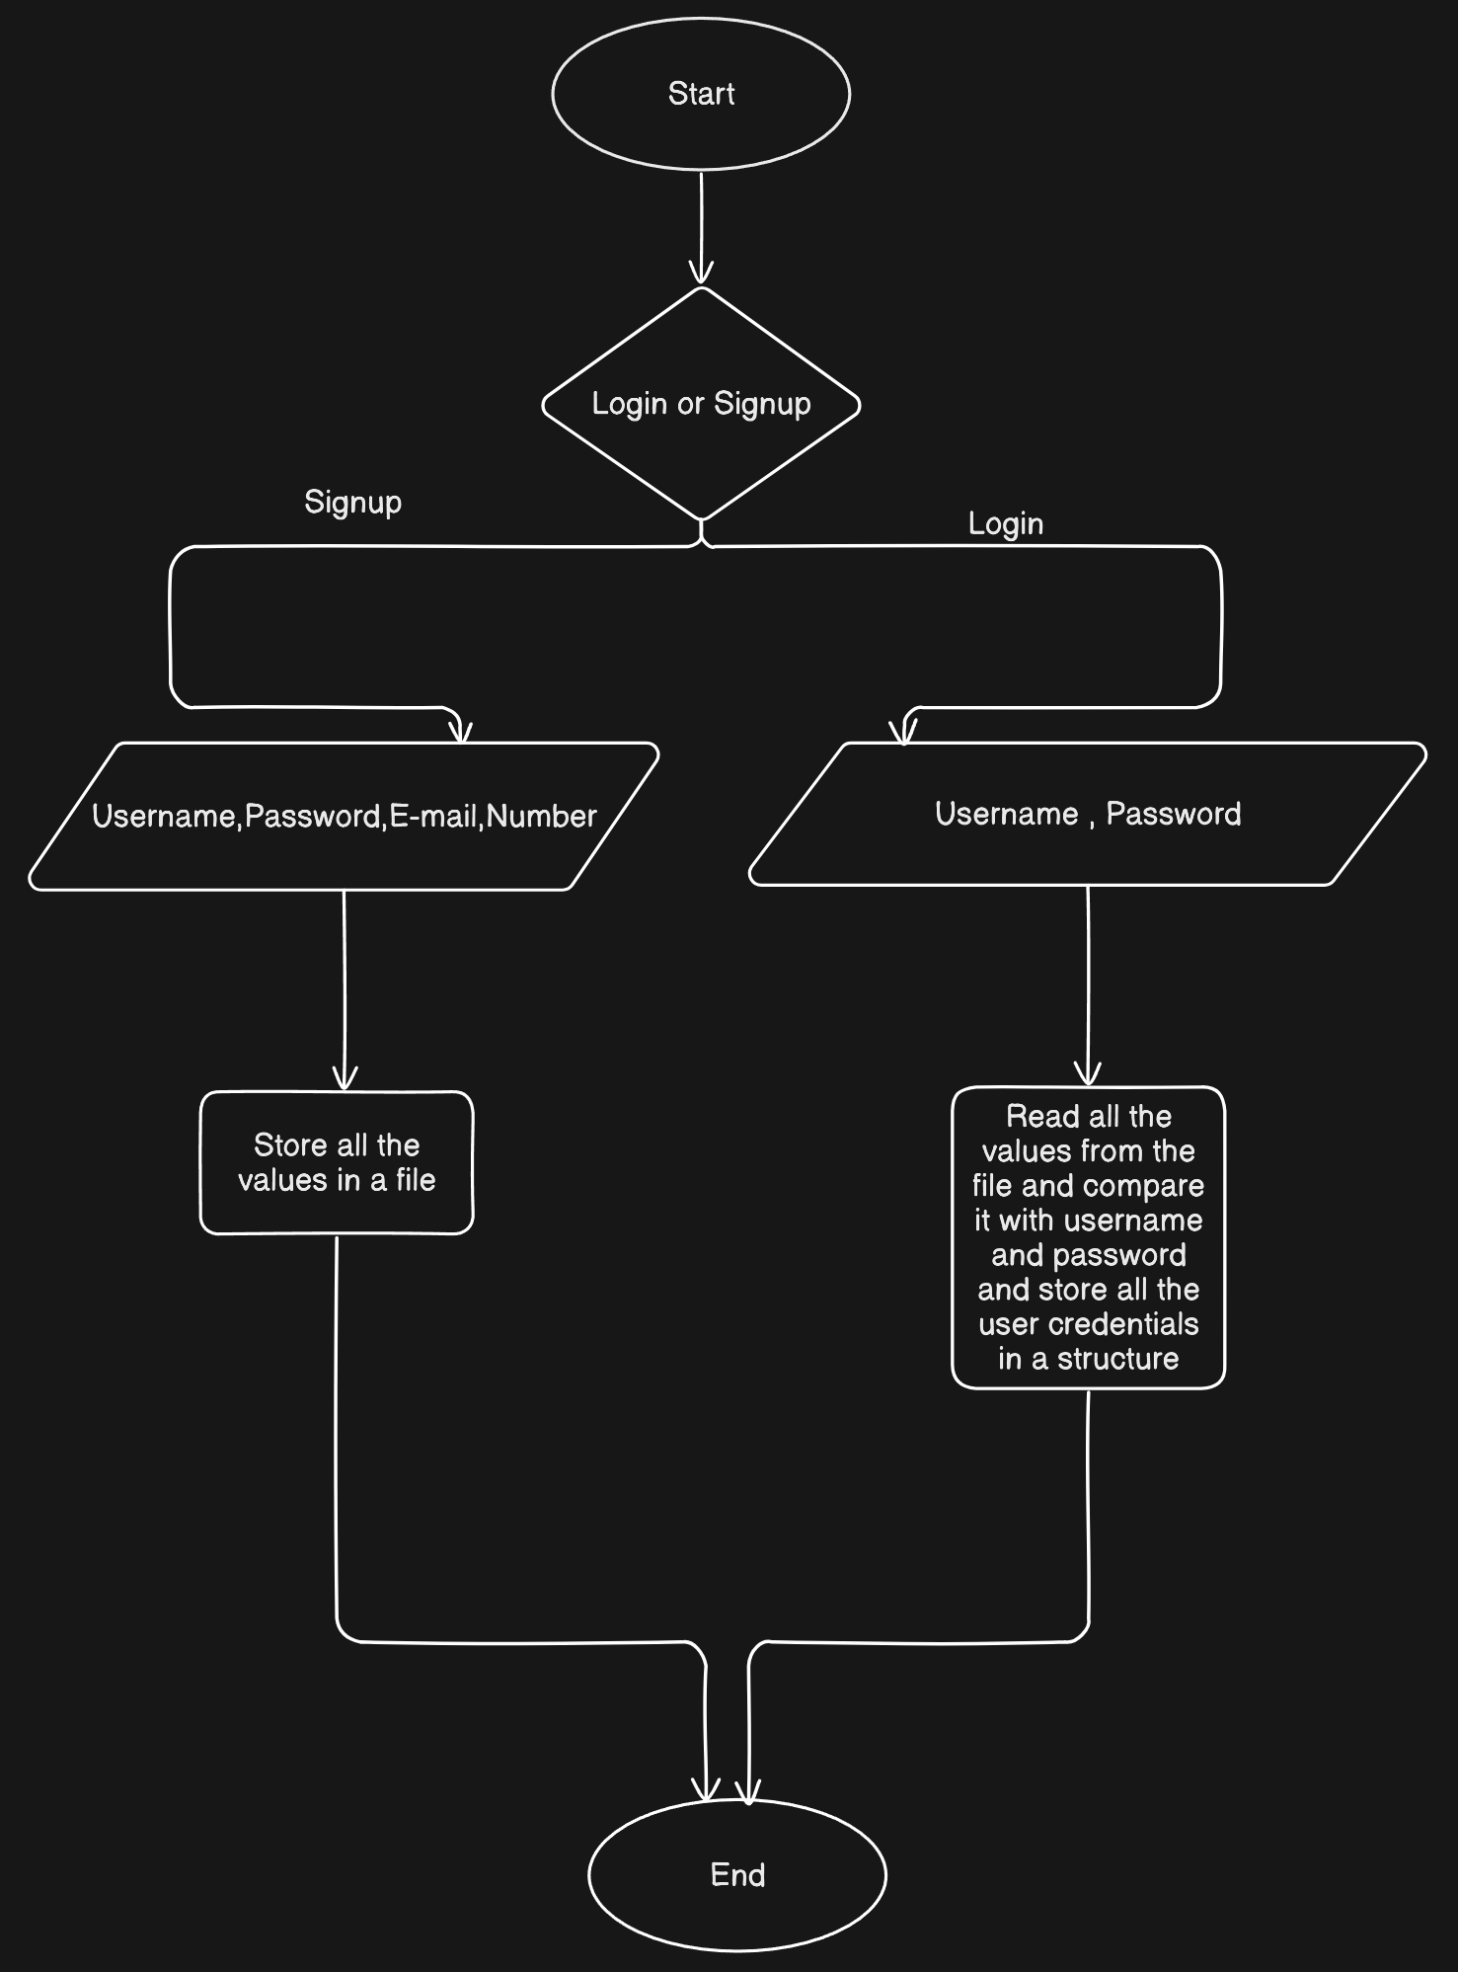

ADMIN MODULE
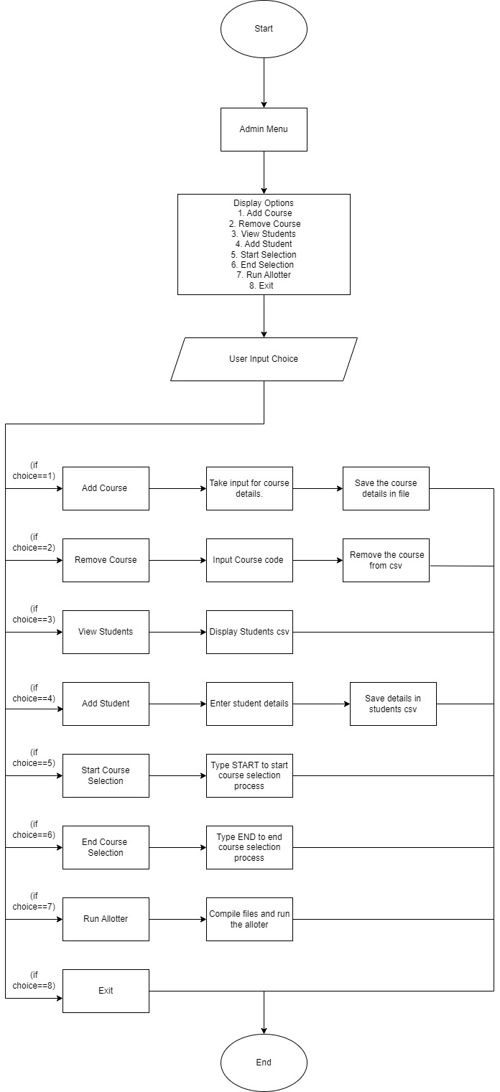
CHOICE FILLING MODULE

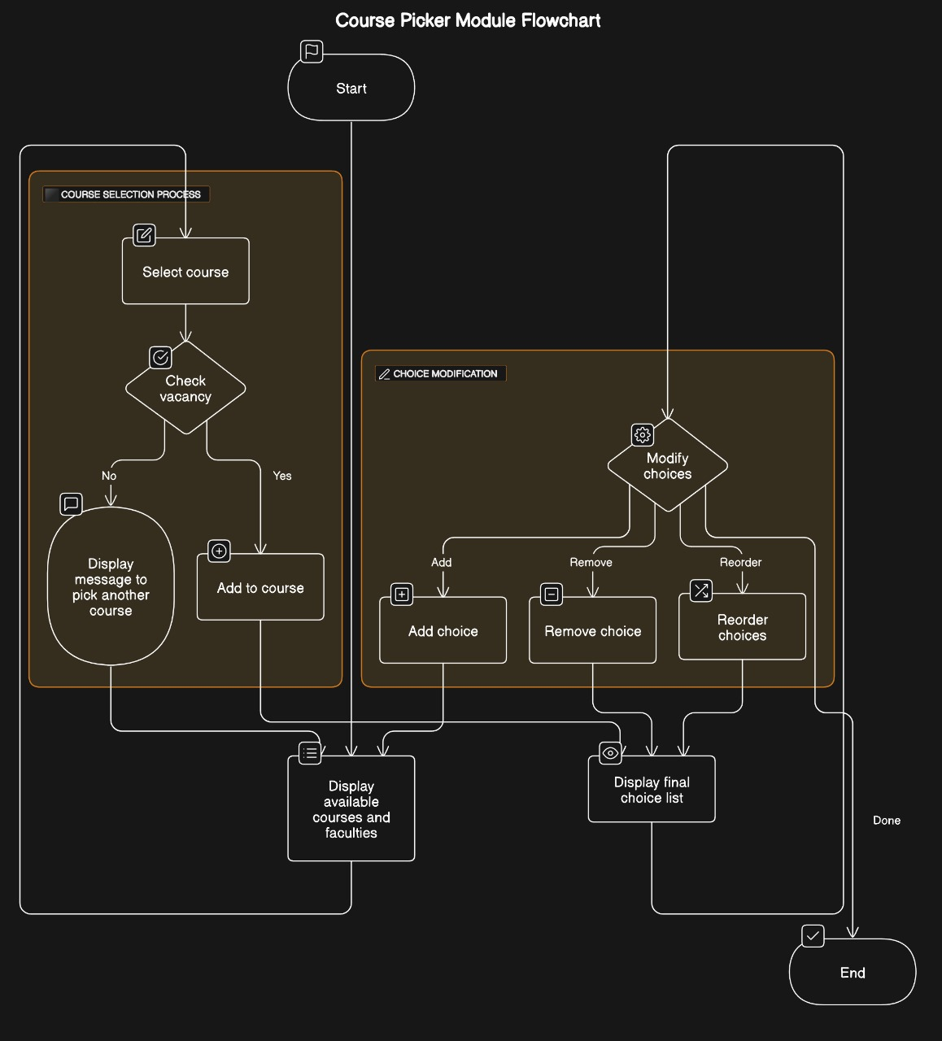

STUDENT ENTRY MODULE
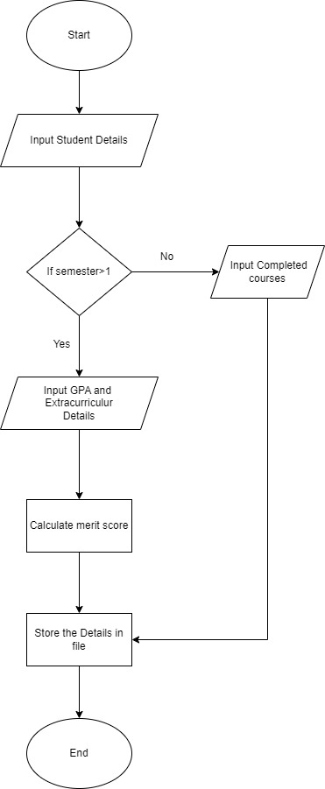
RANKING MODULE


ALLOTTER AND WAITING LIST MODULE
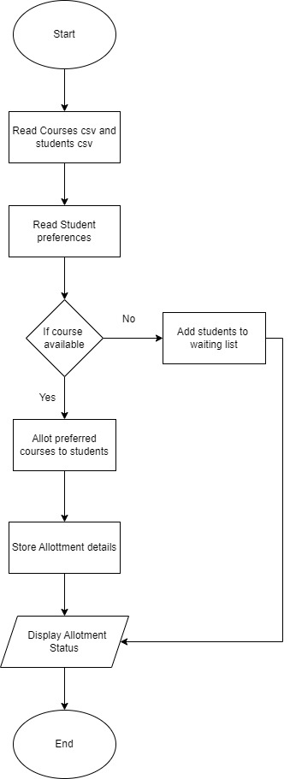
Login Module:
The Login Module is responsible for authenticating users (students, faculty, administrators) and managing their access to the course registration system. It ensures secure access to the system and verifies user credentials (e.g., username and password) against a database or authentication service.
Admin Module:
The Admin Module provides administrative functionalities to manage the course registration system. It is typically accessible to university staff responsible for configuring system settings, managing user accounts, overseeing course offerings, and generating reports.
Student Entry Module:
The Student Entry Module facilitates the entry of new students into the university system. It manages the initial registration process, including capturing student information, assigning unique identifiers, and verifying eligibility for enrollment.
Choice filling Module:
The Choice Filling Module allows students to select their preferred courses for the upcoming semester. It provides a user-friendly interface for browsing course offerings, viewing detailed course descriptions, and prioritizing their selections based on personal preferences.
Ranking Module:
The ranking module effectively handles large volumes of student data across multiple semesters and departments. It utilizes file I/O operations to read student details from CSV files, compute merit scores based on a weighted formula, sort students by merit, and then categorize them into different batches based on their ranks.
Allotter and Waiting List Module:
The Allotter and Waiting List Module manages the allocation of courses to students based on their preferences, availability of course sections, and capacity constraints. It also handles the management of waitlists for courses that exceed initial capacity limits.

IMPLEMENTATION
Structures:
- Usage: Used to represent complex entities like students, faculty, courses, and sections.
- Rationale: Structures allow for the encapsulation of multiple related attributes into a single entity. This makes the data more organized and easier to manage.
EXAMPLE:
struct student {
int reg; // Registration number
char name[50];
char date[20];
char address[100];
char dept[5];
float gpa;
int workshops;
int internships;
int certificateCourses;
int competitions;
float meritScore;
int sem;
char completedCourses[8][10]; // Array to store up to 8 completed course IDs
int completedCourseCount; // Count of completed courses
};

Files:
- Usage: Used for persistent storage of user data, course data, and registration data.
- Rationale: They help in storing large information in detail and they are easy to access and.
EXAMPLE:
Courses.csv
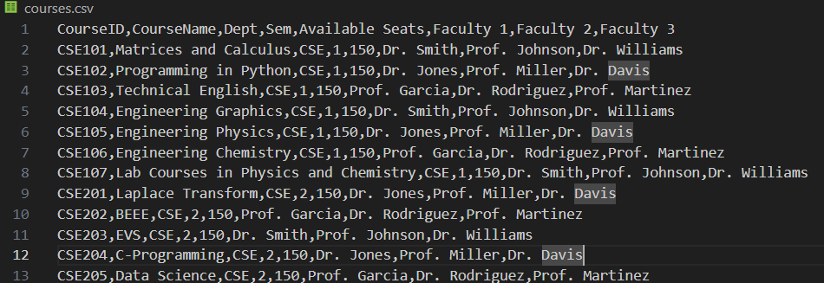

USAGE OF DIFFERENT LIBRARIES OR APIs

The additional C libraries that have been used in the Course Registration System apart from the Standard Input and Output Library <stdio.h> are:
1.<stdlib.h> - the stdlib.h library is used to provide functions for memory allocation and process control.
Functions used: malloc(), free(), realloc(),exit().
2.<string.h> - the string.h provides functions for manipulating arrays of characters.
Functions used: strlen(), strcpy(), strncpy(), strcat(), strcmp().
3.<ctype.h> - this library provides functions for testing and mapping characters.
Functions used: ispunct(), isdigit(), islower(), isupper().
4.< stdbool.h> - stdbool.h provides a standard way to work with boolean values

Platform Used for Code Development:

Visual Studio Code (VS Code)
Visual Studio Code (VS Code) is a popular and highly versatile code editor developed by Microsoft. It is well-suited for developing a comprehensive software system like the course registration system.
TEST CASES:
LOGIN MODULE
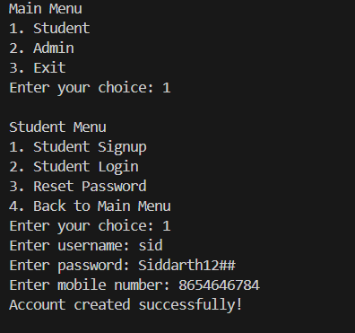

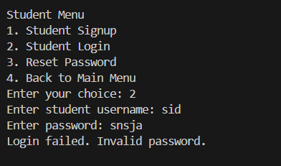
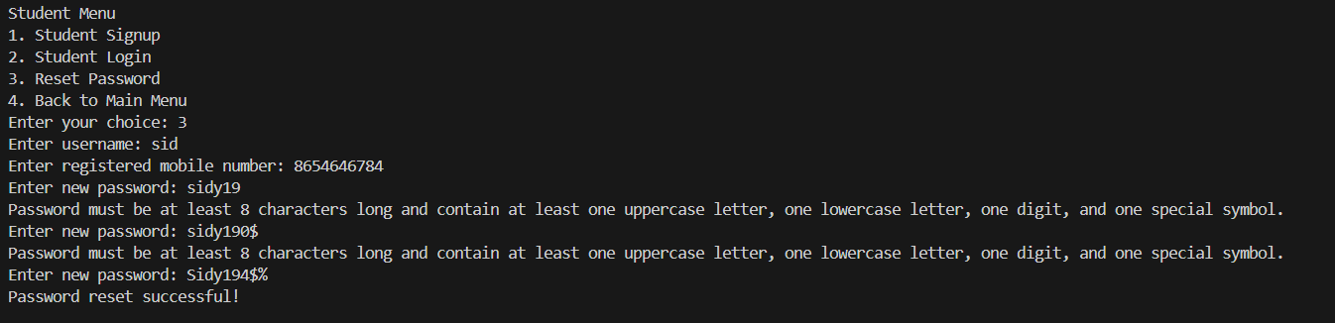

FURNISH.C
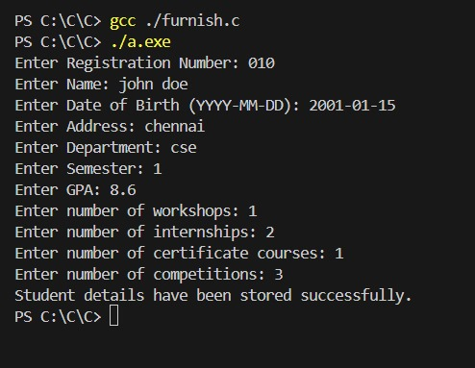

RANKDISPLAY.C
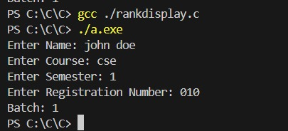
SELECTOR.C
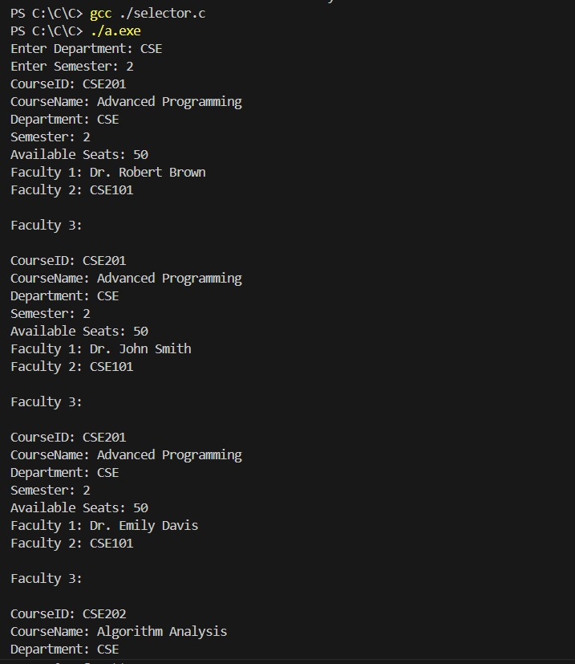

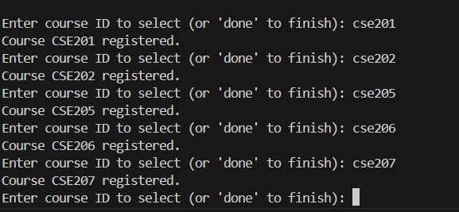

ADMIN.C
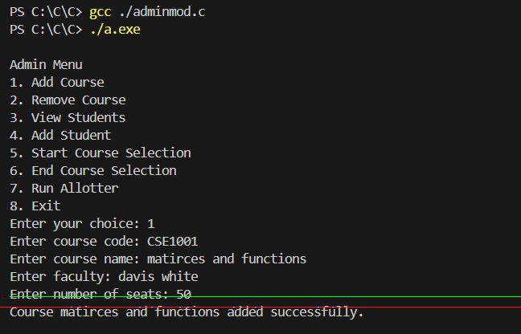

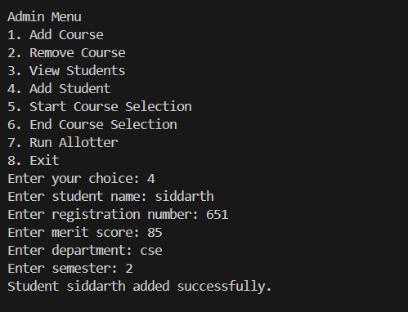

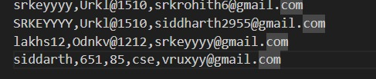

LIMITATIONS

Scalability Issues:
- Database Load: As the number of students, courses, and registrations grows, the load on the database can increase significantly, potentially leading to performance bottlenecks.
- Concurrent Users: Handling a large number of concurrent users during peak times (e.g., when registration opens) can overwhelm the server and lead to slow response times or system crashes.

Security:
- Data Breaches: Storing sensitive information like student data and hashed passwords necessitates strong security measures to prevent data breaches.
- Authentication and Authorization: Ensuring robust mechanisms to authenticate users and authorize actions within the system.

Maintenance and Upgrade:
- Regular Updates: Keeping the system up-to-date with the latest software and security patches requires continuous effort.
- Bug Fixes and Enhancements: Addressing bugs and implementing new features based on user feedback can be resource-intensive.

Observations from the Societal, Legal, Environmental and Ethical perspectives

Societal Perspective:
- Accessibility and Equity: The system should be accessible to all students, including those with disabilities or special needs. It should not discriminate based on socioeconomic status, race, gender, or other personal characteristics.
- User-Friendliness: The interface should be intuitive and easy to navigate, catering to students of varying technical proficiency. This ensures that all students can register for courses without unnecessary hurdles.
- Transparency: The registration process should be transparent, with clear guidelines on course availability, prerequisites, and registration deadlines. This helps in maintaining trust among students and faculty.
- Feedback Mechanisms: Incorporating feedback mechanisms allows students to provide input on the registration process, improving user experience and addressing any issues promptly.
- Security and Privacy: Safeguarding student data is paramount. The system should adhere to data protection laws and ensure that sensitive information (e.g., personal details, grades) is secure from unauthorized access or breaches.

Legal Perspective:
- Compliance: The system must comply with relevant laws and regulations, such as data protection regulations (e.g., GDPR, CCPA), anti-discrimination laws, and educational standards set by regulatory bodies.
- Intellectual Property: Respect intellectual property rights when displaying course descriptions, materials, or any copyrighted content within the system.
- Accessibility Laws: Ensure that the system meets accessibility standards (e.g., ADA compliance in the US) to accommodate students with disabilities.
- Contractual Obligations: If outsourcing any part of the system (e.g., hosting services), ensure that contractual agreements safeguard student data and comply with legal requirements.

Environmental Perspective:
- Sustainability: Minimize the environmental impact of the system's operations, such as energy consumption of servers and data centers. Consider using renewable energy sources and energy-efficient hardware.
- Paperless Options: Encourage digital processes to reduce paper usage. For example, electronic notifications, digital course catalogs, and online forms can replace printed materials.
- Waste Reduction: Promote practices that minimize electronic waste. Proper disposal and recycling of outdated hardware and electronic components used in the system are essential.

Ethical Perspective:
- Fairness: Ensure fairness in course allocation and registration processes. Avoid biases or favoritism in assigning courses or scheduling classes.
- Honesty and Integrity: Provide accurate and truthful information about course offerings, prerequisites, and expectations to students. Avoid misleading or deceptive practices.
- Respect for Privacy: Protect student privacy and confidentiality. Obtain consent before using or sharing personal data, and limit access to sensitive information only to authorized personnel.
- Ethical Use of Data: Use student data responsibly and ethically. Avoid using data for purposes other than those intended by students or educational institutions.
- Accountability: Establish mechanisms to hold responsible parties accountable for any errors, biases, or misconduct in the course registration process.

Learning Outcomes

Team Collaboration: Improved ability to work effectively in teams, communicate ideas, and allocate responsibilities.
Project Management: Skills in planning, prioritizing tasks, and meeting deadlines, adapting to challenges as they arise.
Problem-Solving: Enhanced ability to identify issues, analyze options, and implement solutions collaboratively.
Technical Skills: Acquired proficiency in project-specific tools and technologies, understanding industry standards.
Leadership: Experience in leadership roles, motivating team members, and fostering a positive team environment.
Reflection and Improvement: Capacity for self-assessment, recognizing strengths, and areas for personal and team development.
Adaptability: Ability to adjust to changing project requirements and overcome setbacks with resilience.
Ethical Responsibility: Understanding of ethical considerations in project work, maintaining integrity and respecting privacy.
Presentation and Documentation: Improved skills in presenting findings and documenting project processes effectively.

REFERENCES
https://github.com/
https://www.ssn.edu.in/
https://viteee.vit.ac.in/
https://www.tneaonline.org/
https://pes.edu/
https://www.bmsce.ac.in/

